**3.1.1 Monomers and polymers**

|  |  |  |  |  |
| --- | --- | --- | --- | --- |
| **Key info** | **Topic:** Monomers and polymers  **Synoptic Link:** Biological molecules,  **Text book pages:** 4 - 7 | | | |
| **Step 1** | **Use the presentation (on Teams), video links and text book to complete the pack.** | | | |
| **Step 2** | **Learning outcome** | **I understand this** | **I can recall this** | **I need to revisit this** |
| Understand that the variety of life, both past and present is extensive, but the biochemical basis of life is similar for all living things |  |  |  |
| Know that monomers are the smaller units from which larger molecules are made |  |  |  |
| Know that monosaccharides, amino acids and nucleotides are examples of monomers |  |  |  |
| Know that polymers are molecules made from a large number of monomers joined together. |  |  |  |
| * Understand that a condensation reaction joins two monomers together with the formation of a chemical bond and the elimination of a water molecule. |  |  |  |
| * Understand that a hydrolysis reaction breaks a chemical bond between two molecules and involves a molecule of water. |  |  |  |
| **Step 3** | **In lesson:** you will be undertaking activities to develop your understanding of the learning objectives and able to add to your notes. | | | |

**3.1 Biological Molecules**

All life on Earth shares a common chemistry. This provides indirect evidence for evolution.

Despite their great variety, the cells of all living organisms contain only a few groups of carbon-based compounds that interact in similar ways.

Carbohydrates are commonly used by cells as respiratory substrates. They also form structural components in plasma membranes and cell walls.

Lipids have many uses, including the bilayer of plasma membranes, certain hormones and as respiratory substrates.

Proteins form many cell structures. They are also important as enzymes, chemical messengers and components of the blood.

Nucleic acids carry the genetic code for the production of proteins. The genetic code is common to viruses and to all living organisms, providing evidence for evolution.

The most common component of cells is water; hence our search for life elsewhere in the universe involves a search for liquid water.

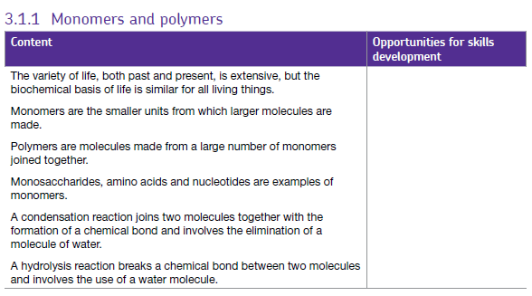

**What you should know from GCSE**

* Many small molecules (monomers) join together to form very large molecules (polymers)
* Protein molecules are made up of long chains of amino acids

**Life Shares a common Biochemistry**

All life we know of on Earth is chiefly based on molecules containing the element carbon. Molecules containing large amounts of carbon are usually referred to as organic compounds; their chemistry is organic chemistry.

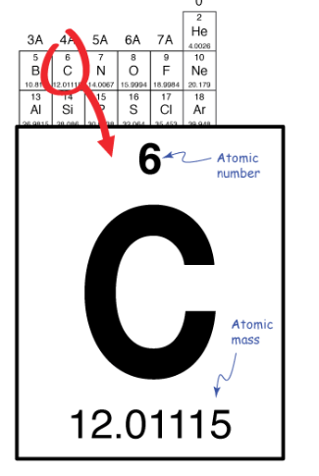

Why are all living organisms composed of carbon based compounds?

Carbon has a total of six electrons.

Two are buried in its inner electron shell, leaving four that can bond with other atoms.

Except in very special circumstances, carbon always forms four bonds.

Read the article ‘Why Life chose carbon’ by Lucy Banham and Barnard Brown, extracted from the Biological Sciences Review magazine 1988. (Found on Teams)

The article describes four special features of carbon that explain its importance to life:

1. Carbon atoms are able form stable covalent bonds to other carbon atoms. As well as straight chains, carbon can form branched chains and rings.

In the space below, draw an example of a straight chained carbon based molecule, a branched chain and a ring. Label them

2. The second special feature of carbon is that it can form covalent bonds with other atoms such as O, H, N, and S, so that a large number of **functional groups** can be introduced into organic molecules. Functional groups give **specific chemical properties** to the molecules that contain them.

Watch the video Introduction to organic molecules: functional groups by Craig Savage:

<https://www.youtube.com/watch?v=IXROzlRf284> (6.57) Link is on the presentation on Teams.

**Use the information in the video to complete the table on the next page.**

| **Functional group** | **Formula** | **Structure** | **Property** |
| --- | --- | --- | --- |
|  |  |  |  |
|  |  |  |  |
|  |  |  |  |
|  |  |  |  |

3. The third special feature of carbon is that carbon compounds have a distinctive three dimensional structure.

Because the electrons in bonds repel each other as much as possible, the bonds of carbon tend to arrange themselves in a tetrahedron. The central carbon, in this case, is surrounded by four hydrogen (H) atoms. Except when it binds to another atom with a double or triple bond, carbon "centres" in molecules always have this tetrahedral shape.

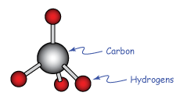

4. Describe the fourth special feature of carbon below. Explain the importance of this final feature.

———————————————————————————————————————————-

———————————————————————————————————————————-

———————————————————————————————————————————-

———————————————————————————————————————————-

———————————————————————————————————————————-

———————————————————————————————————————————-

**Monomers and Polymers**

At GCSE, as part of your learning on crude oil in Chemistry, you learnt that alkenes can be used to make polymers. Polymers are very large molecules made when many small molecules join together, end to end. The smaller molecules are called monomers.

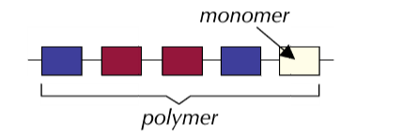

The example below from BBC Bitesize shows how the monomer chloroethene can be used to make **poly** chloroethene (PVC).

<http://www.bbc.co.uk/schools/gcsebitesize/science/aqa/substancesfromcrudeoil/polymersandethanolrev1.shtml> (see animation)

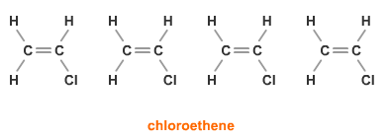

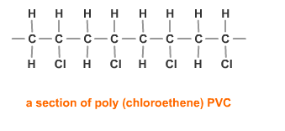

There are many important polymers In Biology too. The polymers that you will learn about this year are carbohydrates, proteins and nucleic acids

Complete the table of monomers and polymers below (extracted from [mrothery.co.uk](http://mrothery.co.uk) biochemistry)

| Group Name | Monomer | Polymer | % Dry Mass of Living Organisms |
| --- | --- | --- | --- |
| Carbohydrates |  |  |  |
| Proteins |  |  |  |
| Nucleic Acids |  |  |  |

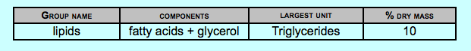You will also learn about lipids, another very important component of living organisms. Lipids are not composed of repeating monomers.

Making Polymers

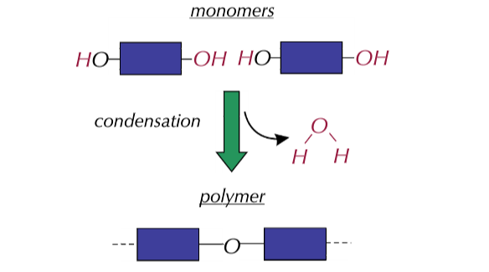Most Biological Polymers are formed from their monomers by ——————————————

reactions. The reaction forms a chemical bond between monomers releasing a

molecule of —————————————.

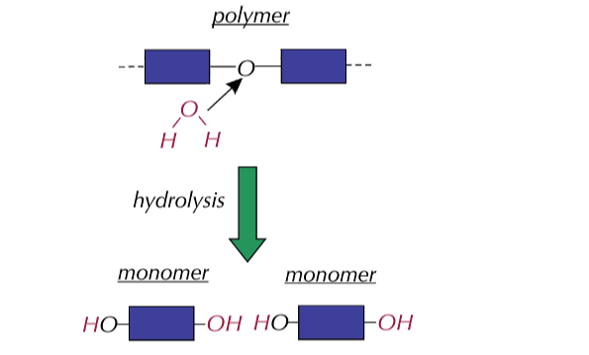Breaking down polymers

Biological polymers can be broken down into monomers by _______________________ reactions.

The reaction breaks the chemical bond between monomers using a ________________ molecule.

Summary Diagram

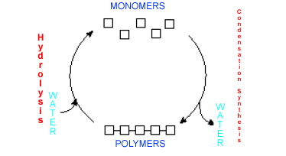

Can you identify the monomers in the diagrams of polymers below?

Place a circle around one monomer in each diagram

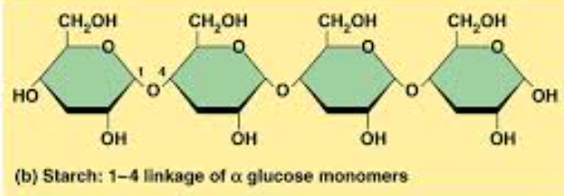1.

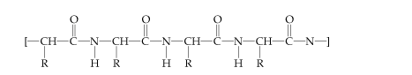2.

3.