**3.1 Biological Molecules**

**3.1.5 Nucleic Acids**

**Section 1 – Recall**

**What does this section contain and why?** Activities to develop your recall of information you covered in the previous topics that are linked to the structure of Nucleic acids. If you don’t have a mini whiteboard (MWB) please do invest in one, they are great for revision and recall. You should do this before you start the work on digestion and absorption. Once you have done the recall activity quickly check what you have done with the student booklets from that topic.

**Topics covered**: Nucleic acids and DNA replication

|  |  |  |  |
| --- | --- | --- | --- |
| **Topic** | **Recall activities** | **Understanding**  *Please write down any questions you have when completing this activity.* | **Completed** |
| **Biological molecules** | On the MWB/scrap paper, draw a eukaryotic cell and label the organelle that contains DNA |  |  |
| On the MWB/scrap paper, draw a DNA molecule. Label the base pairs. |  |  |
| On the MWB/scrap paper, explain how the structure of DNA affects the protein made |  |  |
| On the MWB/scrap paper, explain how a change in DNA structure may result in a change in the protein synthesised by a gene. |  |  |
| On the MWB/scrap paper, describe the function of non-coding DNA |  |  |

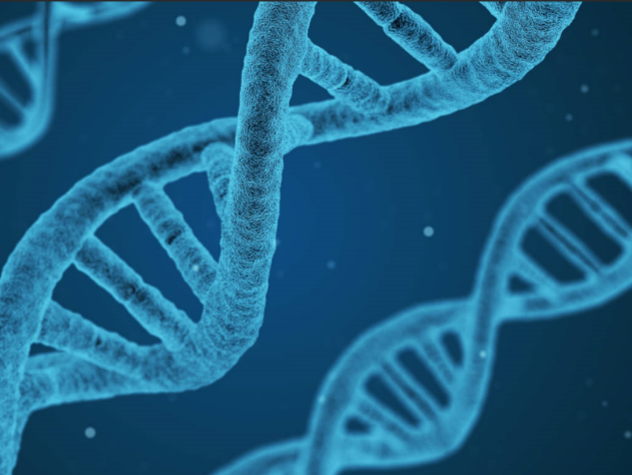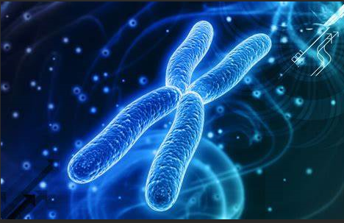

**Section 2 – Independent pack framework**

|  |  |  |  |  |
| --- | --- | --- | --- | --- |
| **Key info** | **Topic:** nucleic acids and DNA replication  **Synoptic Link:** Biological molecules, mitosis, meiosis, protein synthesis, gene technology  **Text book pages:** 36- 45 | | | |
| **Step 1** | **Use the tutorial (GOL), presentation (GOL), video links and text book to complete the pack.** | | | |
| **Step 2** | **Learning outcome** | **I understand this** | **I can recall this** | **I need to revisit this** |
| Understand that Deoxyribonucleic acid (DNA) and Ribonucleic acid (RNA) are important information carrying molecules. In all living cells, DNA holds genetic information and RNA transfers genetic information from DNA to the ribosomes, |  |  |  |
| Know that ribosomes are formed from RNA and proteins |  |  |  |
| Know that both DNA and RNA are polymers of nucleotides |  |  |  |
| Recall that the DNA molecule is a double helix with two polynucleotide chains held together by hydrogen bonds between specific complementary base pairs. |  |  |  |
| Know that an RNA molecules is a relatively short polynucleotide chain. |  |  |  |
| Know that a condensation reaction between two nucleotides forms a phosphodiester bond. |  |  |  |
|  | Appreciate that the relative simplicity of DNA led many scientists to doubt that it carried the genetic code. |  |  |  |
|  | Understand that the semi-conservative replication of DNA ensures genetic continuity between generations of cells. |  |  |  |
|  | Understand the process of semiconservative replication (unwinding of the double helix, breakage of H bonds, role of DNA helicase, attraction of new nucleotides to exposed bases, role of DNA polymerase in the condensation reaction that joins adjacent nucleotides. |  |  |  |
|  | Be able to evaluate the work of scientists in validating the Watson-Crick model of DNA replication |  |  |  |
| **Step 3** | **In lesson:** you will be undertaking activities to develop your understanding of the learning objectives and able to add to your notes. | | | |

**Preparatory Work**

1. Watch the following **Ted Talk by James Watson; How we discovered DNA (2005)**

<http://www.ted.com/talks/james_watson_on_how_he_discovered_dna/transcript?language=en>

**Biography of James Watson** (extracted from the TED website)

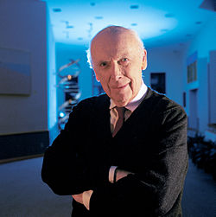

* James Watson has led a long, remarkable life, starting at age 12, when he was one of radio's high-IQ Quiz Kids. By age 15, he had enrolled in the University of Chicago, and by 25, working with Francis Crick (and drawing, controversially, on the research of Maurice Wilkins and Rosalind Franklin), he had made the discovery that would eventually win the three men the Nobel Prize.
* Watson and Crick's 1953 discovery of DNA's double-helix structure paved the way for the astounding breakthroughs in genetics and medicine that marked the second half of the 20th century. And Watson's classic 1968 memoir of the discovery, The Double Helix, changed the way the public perceives scientists, thanks to its candid account of the personality conflicts on the project.
* More than 50 years later he continues to investigate Biology’s deepest secrets.

2. Now watch **The DNA double Helix Discovery - HHMI Biointeractive video**: <https://www.youtube.com/watch?v=1vm3od_UmFg> and answer the Quiz questions that follow on the next page.

3. Make your own notes on nucleic acids. You should include the following:

**Nucleic Acids Notes**

* The name of the two types of nucleic acid.
* The name of the monomer and polymer for nucleic acids.
* A labelled diagram of a nucleotide.
* Purines and Pyramidines (structure, names of bases).
* The type of reactions that form polynucleotide chains.

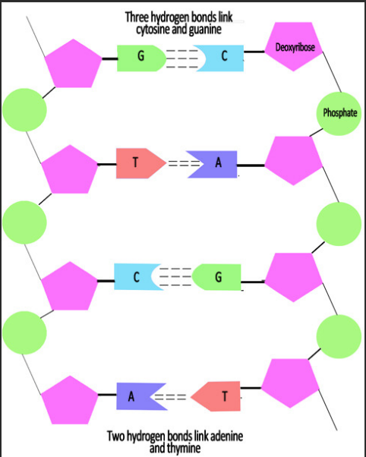**Knowledge check**

* Practice drawing a diagram of a polynucleotide chain.
* Learn the different bonds and their position
* Learn the names of the bases and the complementary base paring rules. (Chargaff rule of complementary base pairing)
* Note the anti parallel nature of the molecule.

**Questions**

1. In DNA, guanine is 10%. The content of adenine is?
2. In a DNA sample, the percentage of adenine is 40% and the percentage of thymine is 60%. What can you conclude from this?

**RNA Notes**

* Name and draw the different types. And include the roles of the different types.

Complete the table below

|  | DNA | RNA |
| --- | --- | --- |
| Number of strands |  |  |
| Name of pentose sugar |  |  |
| Names of nitrogenous bases |  |  |
| Number of different types |  |  |
| Location in cell |  |  |
| Relative length |  |  |
| Lifespan |  |  |
| Function |  |  |

**3.1.5.2 DNA Replication**

**Introduction**

The cells that make up organisms are always derived from existing cells by the process of cell division. Cell division occurs in two main stages:

* Nuclear Division is the process by which the nucleus divides.
* Cytokinesis follows nuclear division and is the process by which the whole cell divides.

Before a nucleus divides its DNA must be replicated (copied). This is to ensure that all of the daughter cells have the genetic information to produce enzymes and the other proteins they need.

The process of DNA replication is very precise to ensure that daughter cells are identical to parent cells.

**Semi-Conservative replication**

For semi-conservative replication to take pace there are four requirements:

1. The four types of **nucleotide**, each with their bases of adenine, guanine, cytosine or thymine must be present.
2. Both strands of DNA act as a **template**
3. The enzymes **DNA Polymerase** and **DNA Helicase** must be present.
4. A source of **energy** is required to drive the process

**The process is shown in the diagrams below. Spend some time looking at the process and then annotate the diagrams to explain what is happening.**

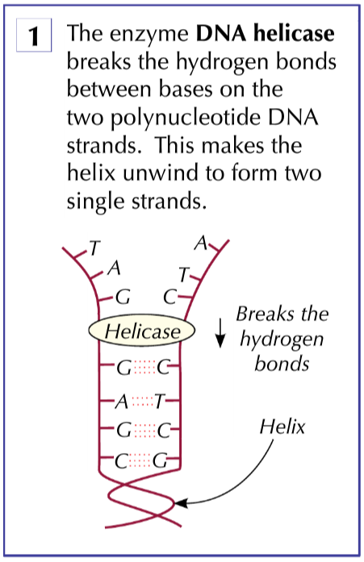**1.**

Notes

**2.**

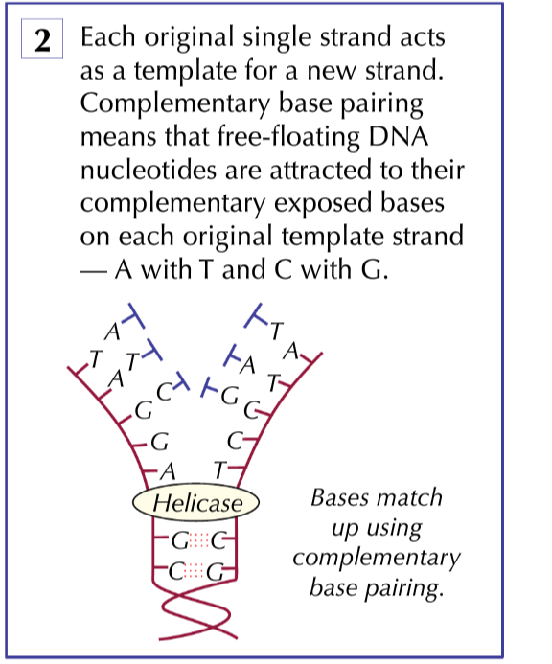

Notes

**3.**

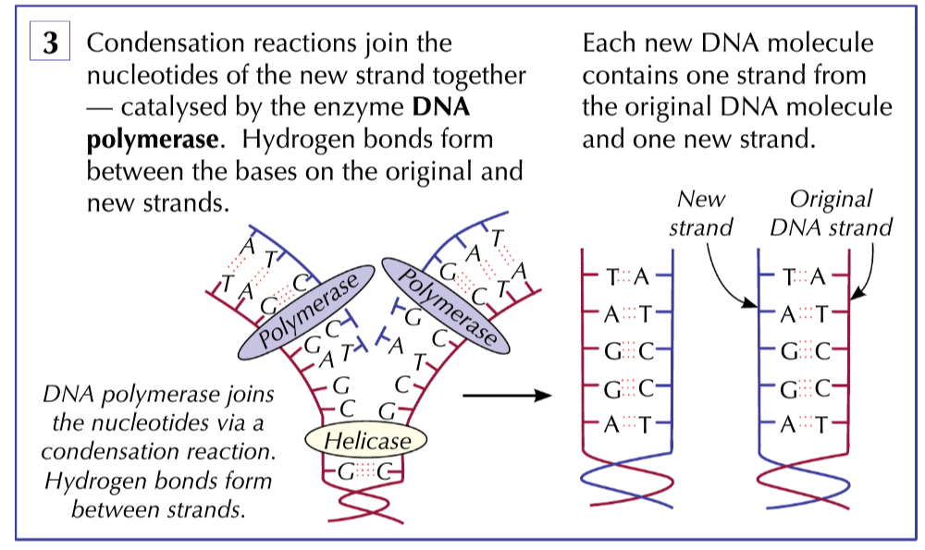

Notes

**The Action of DNA polymerase**

Recall the antiparallel nature of DNA. One end is called the 3’ end and the other end is called the 5’ end.

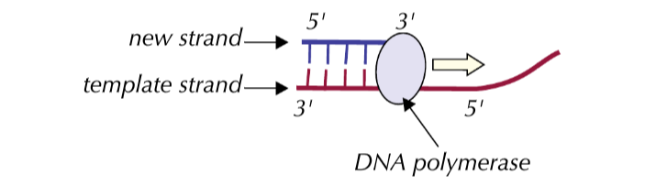

During replication the active site of DNA polymerase is only complementary to the 3’ end of the newly forming DNA strand, so it can only add nucleotides to the new strand at the 3’ end. This means the enzyme can only add nucleotides to the new strand at the 3’ end. Thus the new strand is made in the 3-5 direction.

Because both strands in DNA are antiparallel, the DNA polymerase works in different directions on each strand.

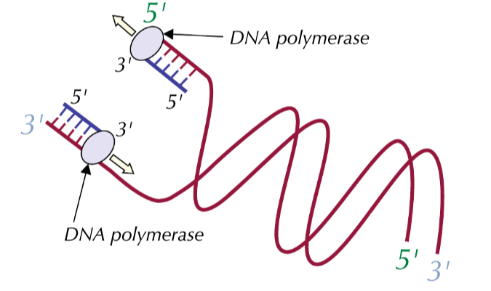

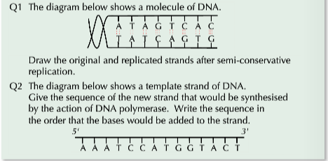

**Evidence for semi conservative replication**

Describe the experiments carried out by Meselson-Stahl which support the theory of semi-conservative replication in the space below.

**Consolidation videos**

1. Crash Course: <https://www.youtube.com/watch?v=8kK2zwjRV0M> for structure of DNA and replication DNA
2. Wiley:http://[www.wiley.com/college/pratt/0471393878/instructor/animations/dna_replication/index.html](http://www.wiley.com/college/pratt/0471393878/instructor/animations/dna_replication/index.html)for DNA replication
3. <http://www.sumanasinc.com/webcontent/animations/content/meselson.html>

for Meselson - stahl

4. Build a DNA molecule at Learn Genetics Utah website.