**3.1 Biological Molecules**

**3.1.6 & 3.1.8 ATP & Inorganic ions**

**ATP Section 1 – Recall**

**What does this section contain and why?** Activities to develop your recall of information you covered in the previous topics that are linked to the structure of ATP. If you don’t have a mini whiteboard (MWB) please do invest in one, they are great for revision and recall. You should do this before you start the work on digestion and absorption. Once you have done the recall activity quickly check what you have done with the student booklets from that topic.

**Topics covered**: Biological molecules

|  |  |  |  |
| --- | --- | --- | --- |
| **Topic** | **Recall activities** | **Understanding**  *Please write down any questions you have when completing this activity.* | **Completed** |
| **Biological molecules** | On the MWB/scrap paper, recall a simple condensation and hydrolysis reaction |  |  |
| On the MWB/scrap paper, write out the equation for respiration and photosynthesis |  |  |

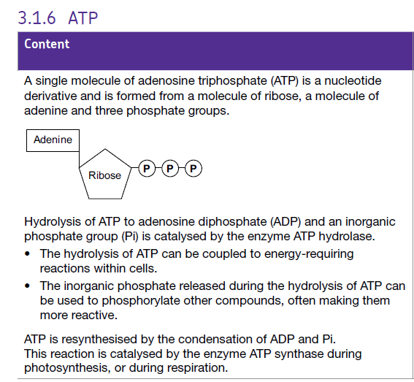

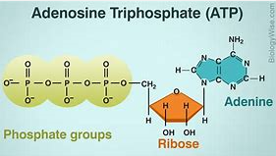

**Section 2 – Independent pack framework**

|  |  |  |  |  |
| --- | --- | --- | --- | --- |
| **Key info** | **Topic:** ATP  **Synoptic Link:** Biological molecules, enzymes, transport across membranes, absorption, respiration, photosynthesis, nervous coordination, skeletal muscle  **Text book pages:** | | | |
| **Step 1** | **Use the tutorial (GOL), presentation (GOL), video links and text book to complete the pack.** | | | |
| **Step 2** | **Learning outcome** | **I understand this** | **I can recall this** | **I need to revisit this** |
| Understand that a single molecule of adenosine triphosphate (ATP) is a nucleotide derivative and is formed from a molecule of ribose, a molecule of adenine and three phosphate groups. |  |  |  |
| Know that hydrolysis of ATP to adenosine diphosphate and an inorganic phosphate group, is catalysed by the enzyme ATP hydrolase. |  |  |  |
| Understand that the hydrolysis of ATP can be coupled to energy requiring reactions within cells. |  |  |  |
| Know that the inorganic phosphate released during the hydrolysis of ATP can be used to phosphorylate other compounds often making them more reactive. |  |  |  |
| Know that ATP is re synthesised by the condensation of ADP and Pi. |  |  |  |
| Understand that this reaction is catalysed by the enzyme ATP synthase during photosynthesis or during respiration. |  |  |  |
| **Step 3** | **In lesson:** you will be undertaking activities to develop your understanding of the learning objectives and able to add to your notes. | | | |

**ATP Introduction**

All living organisms require energy in order to remain alive. This energy comes initially from the sun. Plants use solar energy to combine water and carbon dioxide into complex organic molecules through photosynthesis.

Write the chemical equation for photosynthesis below.

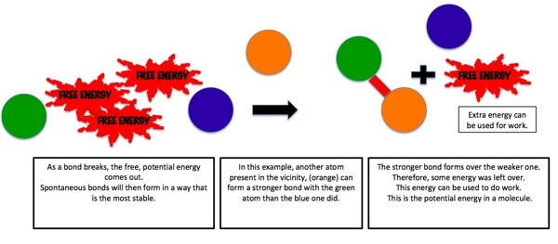———————————————————————————————————————

Living things store energy mainly in the form of chemical bonds.

Within your cells, energy is constantly moved around from one large molecule to another. The energy from the food you eat is released in a process called respiration. Write the chemical equation for respiration below.

______________________________________________________________________________

How does the energy get converted from a food molecule to a muscle molecule? The answer is ATP. Write the full name of ATP below.

______________________________________________________________________________

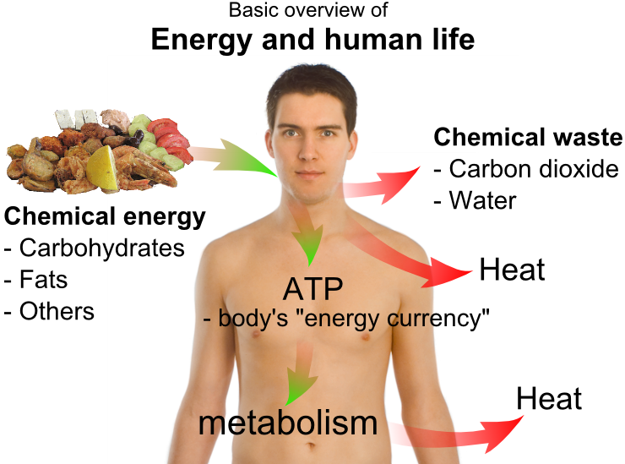ATP is often described as the universal energy currency for organisms. Explain why.

________________________________________________

________________________________________________

________________________________________________

________________________________________________

________________________________________________

**Structure of ATP**

Watch the following video from Bozeman on ATP and use it to fill in the next page of the booklet.

<https://www.youtube.com/watch?v=5GMLIMIVUvo>

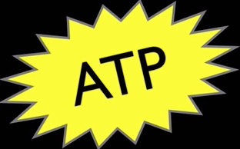Why is ATP often shown with a yellow star shape around it?

___________________________________________________________

___________________________________________________________

Draw a simplified diagram of ATP below.

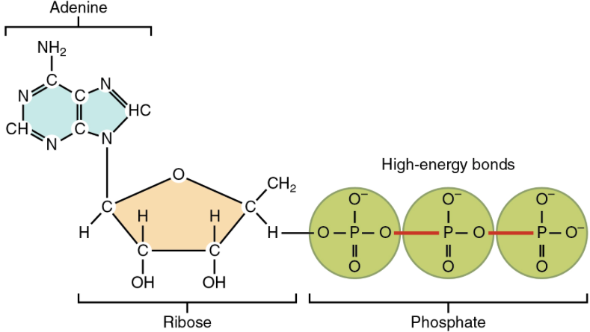

The ATP molecule is composed of adenine, ribose and three phosphate groups.

What type of molecule is adenine? ______________________________________________

What type of molecule is ribose? _______________________________________________

Together, what are adenine and ribose referred as? __________________________________

What does the structure of ATP remind you of? _____________________________________

What two elements are the phosphate group composed of? ___________________________

Using the diagram of ATP to help you, write the names of the two molecules below.

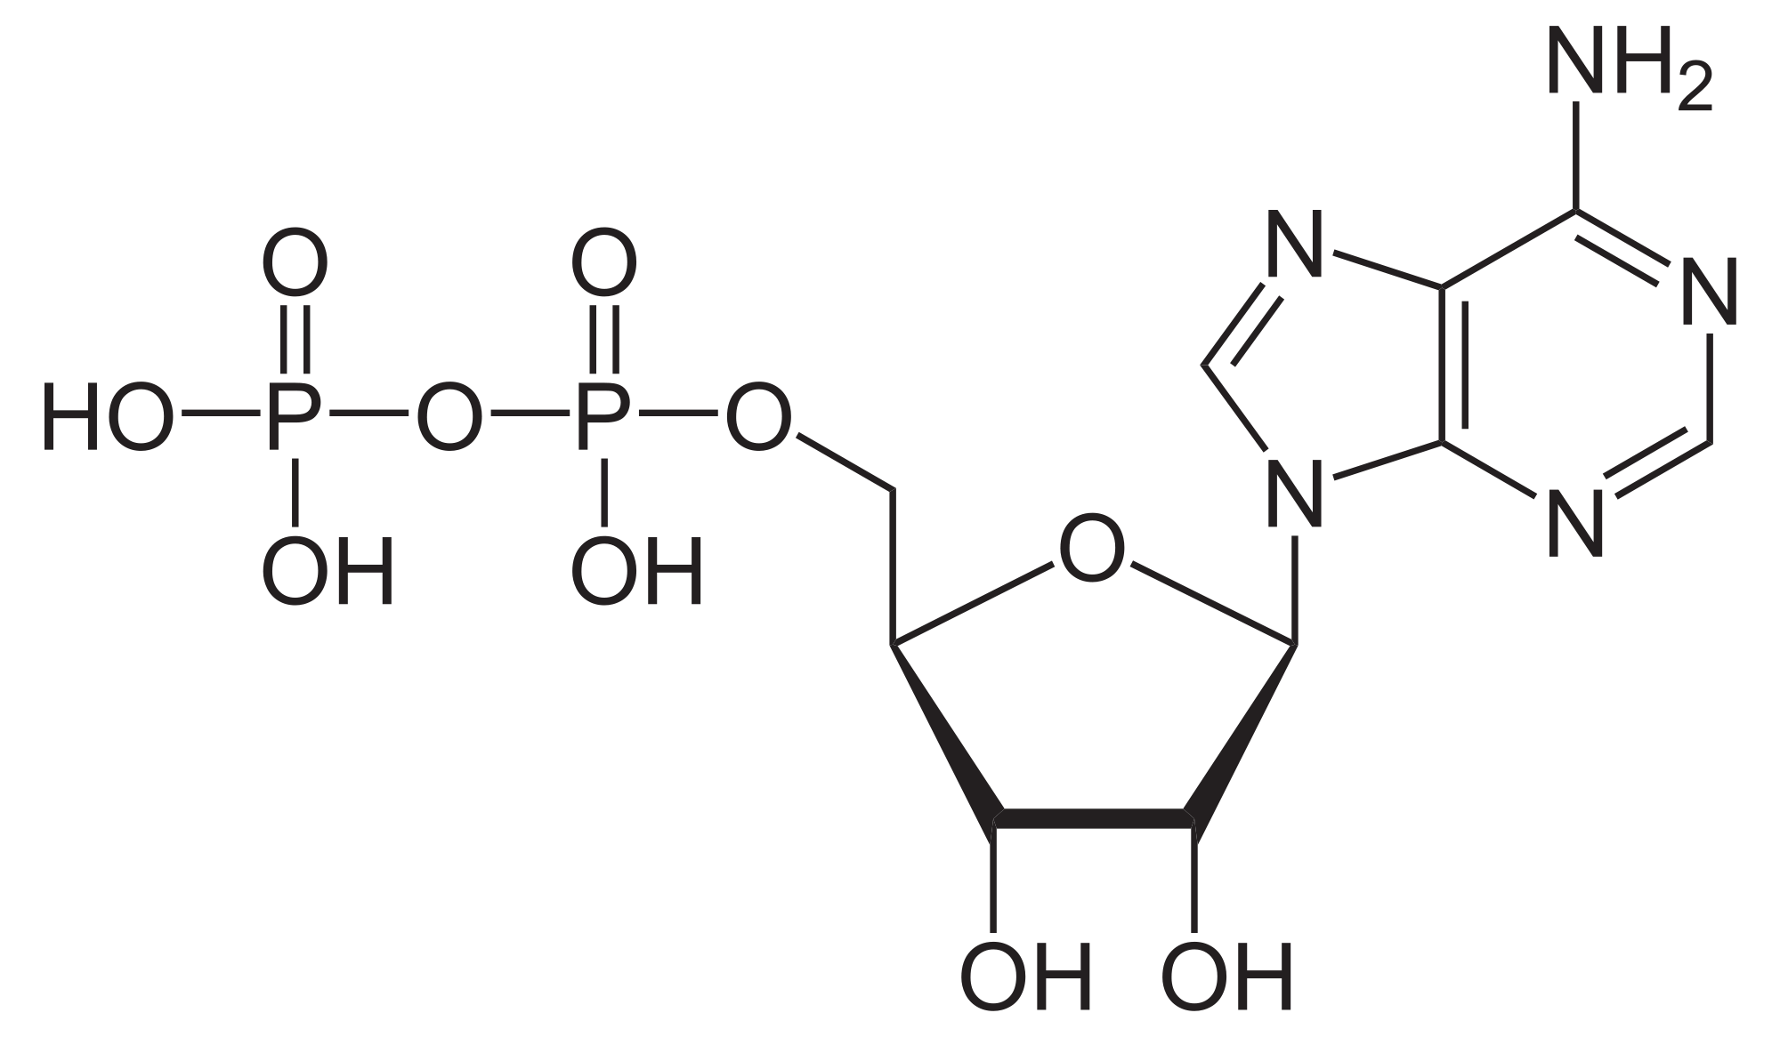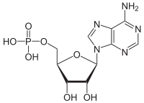

——————————————— ————————————————

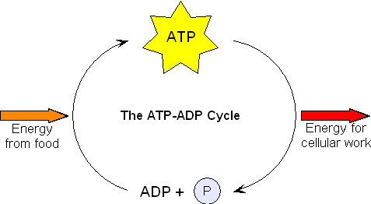

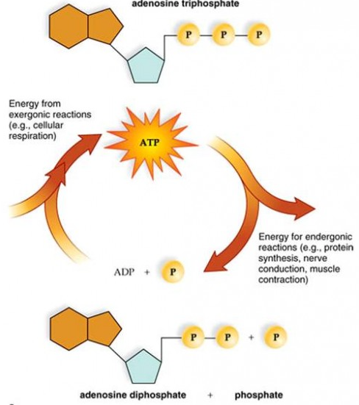

This is known as the ADP -ATP cycle, allowing energy to be stored and released as it is needed.

The bonds that link the phosphates in ATP can be thought of as coiled springs. Due to these spring like bonds, the end phosphate is straining to break away from its nearest partner. Any small addition of energy and the end phosphate springs away, releasing all the energy that is stored in the spring (the bond).

**Why use ATP?**

ATP is the immediate energy source for cells. As a result cells do not store large quantities of energy, but rather just a few seconds supply. This is not a problem as ATP is rapidly reformed form ADP and Pi and so a little goes a long way.

Why isn’t glucose used as the energy release molecule? What happens when food is burnt in a bunsen flame? What impact would this have on the cell?

________________________________________________________________________________________________________________________________________________________________________________________________________________________________________________

**Roles of ATP**

ATP is required for various processes such as synthesising macromolecules from their basic units, muscle contraction, active transport, and secretion. These topics will be covered later in the A level course. The inorganic phosphate released during the hydrolysis of ATP can be used to phosphorylate other compounds in order to make them more reactive, thus lowering the activation energy of the reaction. You will learn about this in the topic of respiration.

**3.1.8 Inorganic Ions**

**Section 1 – Recall**

**What does this section contain and why?** Activities to develop your recall of information you covered in the previous topics that are linked to the roles of inorganic ions. If you don’t have a mini whiteboard (MWB) please do invest in one, they are great for revision and recall. You should do this before you start the work on digestion and absorption. Once you have done the recall activity quickly check what you have done with the student booklets from that topic.

**Topics covered**: Biological molecules

|  |  |  |  |
| --- | --- | --- | --- |
| **Topic** | **Recall activities** | **Understanding**  *Please write down any questions you have when completing this activity.* | **Completed** |
| **Biological molecules** | On the MWB/scrap paper, list any biological molecules which contain inorganic ions |  |  |
| On the MWB/scrap paper, draw a diagram showing how plants and animals obtain these inorganic ions |  |  |

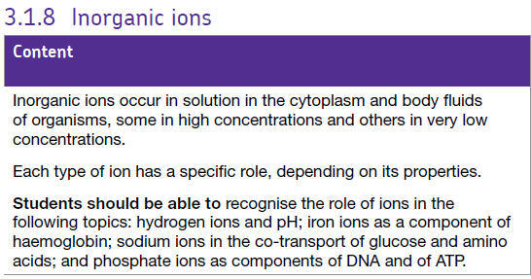

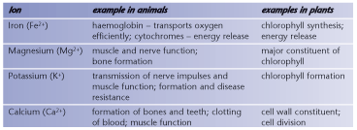

**Section 2 – Independent pack framework**

|  |  |  |  |  |
| --- | --- | --- | --- | --- |
| **Key info** | **Topic:** ATP  **Synoptic Link:** Biological molecules, enzymes, transport across membranes, absorption, respiration, photosynthesis, nervous coordination, skeletal muscle  **Text book pages:** | | | |
| **Step 1** | **Use the tutorial (GOL), presentation (GOL), video links and text book to complete the pack.** | | | |
| **Step 2** | **Learning outcome** | **I understand this** | **I can recall this** | **I need to revisit this** |
| Know that inorganic ions occur in solution in the cytoplasm and body fluids of organisms, some in high concentrations and others in very low concentrations |  |  |  |
| Understand that each type of ion has a specific role, depending on its properties. |  |  |  |
| Be able to recognise the role of ions in the following topics: iron as a component of haemoglobin, hydrogen ions and pH, sodium ions in the co transport of glucose and amino acids, phosphate ions as components of DNA and ATP |  |  |  |
| **Step 3** | **In lesson:** you will be undertaking activities to develop your understanding of the learning objectives and able to add to your notes. | | | |

**What you should know from GCSE**

* Metals lose electrons to form positive ions, whereas non metals gain electrons to form negative ions.
* Mineral ions and vitamins are needed in small amounts for healthy functioning of the body.
* Internal conditions that are controlled include the ion content of the body - ions are lost via the skin when we sweat and excess ions are lost via the kidneys in the urine.
* When atoms form chemical bonds by transferring electrons, they form ions. Atoms that lose electrons become positively charged ions. Atoms that gain electrons become negatively charged ions. Ions have the electronic structure of a noble gas.
* Hydrogen ions make solutions acidic.

**Chemical Elements**

[www.rsc.org/Education/Teachers/Resources/cfb/basicchemistry.htm](http://www.rsc.org/Education/Teachers/Resources/cfb/basicchemistry.htm).

What are the most common elements that are found in living organisms?

————————————————————————————————————————

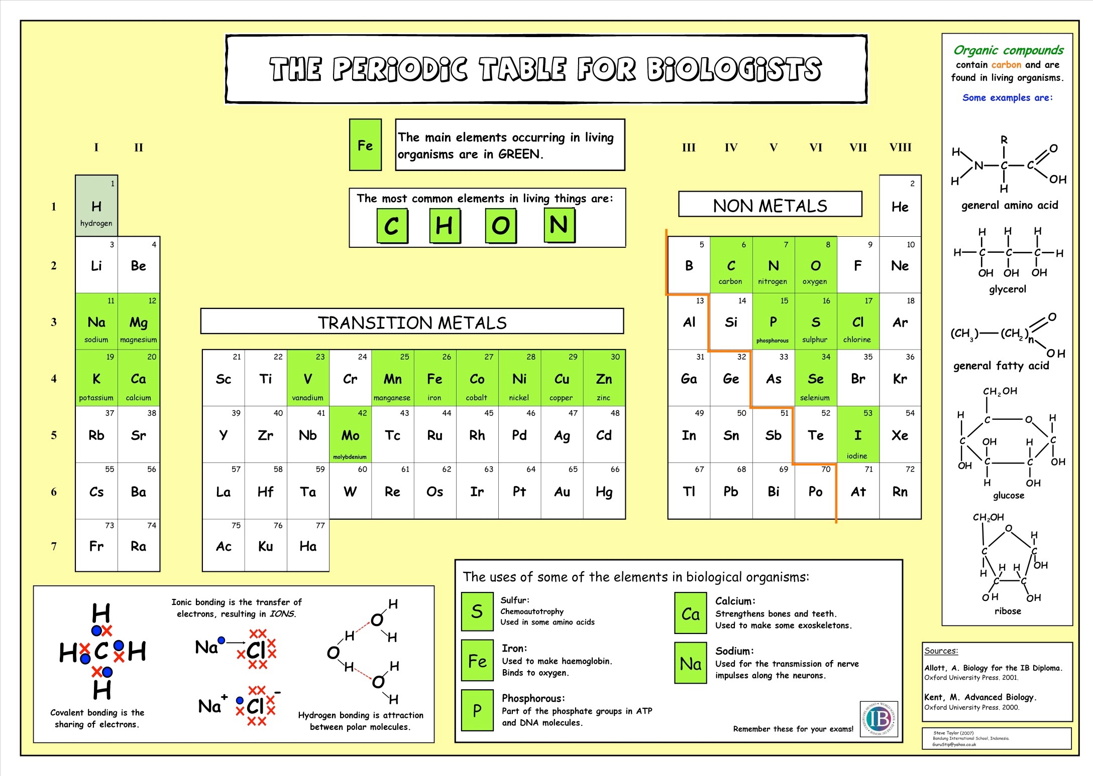

**Ions**

If you have forgotten what ions are then watch the following video:

**What’s an ion by Tyler DeWitt (7 mins):** <https://www.youtube.com/watch?v=WWc3k2723IM>

And then watch **polyatomic ions**: <https://www.youtube.com/watch?v=MJZeZvDxcx8>

Tyler has produced a number of videos that revise GCSE chemistry.

**Answer the following to recap your knowledge (the videos contain all of the answers)**

What is an ion? ___________________________________________________________

What is a cation? __________________________________________________________

What is an anion? __________________________________________________________

Write the formula for the following ions:

* Sodium ___________
* Calcium ___________
* Chloride ___________
* Iron ___________
* Hydrogen ___________

What is a polyatomic ion? ____________________________________________________

Write the formula for the following polyatomic ions

* Ammonium ___________
* Carbonate ___________
* Hydroxide ___________
* Nitrate ___________
* Nitrite ___________
* Phosphate ___________

**Inorganic Ions**

An inorganic ion is one that usually doesn’t contain ___________________________ and if it does contain carbon then it is found in small proportions. There are inorganic ions in solution, in the cytoplasm of cells and in the body fluids of organisms.

**Macronutrients and Micronutrients**

* These are inorganic ions that play important roles in cell metabolism. An ion’s role determines whether it is found in high or low concentrations.
* Macronutrients are needed in SMALL amounts e.g. Mg2+, Fe2+, PO43-, Ca2+, K+, Na+, Cl- , SO4 2-
* Micronutrients are needed in TINY (trace) amounts e.g. Cu2+ , Zn 2+

**Cations**

* Calcium ions, Ca 2+, are the most abundant cations (positive ions) in the body, making up about 1.5% of total body weight. About 99% is found in bones and teeth, largely in combination. They combine with phosphate ions to form calcium phosphate which increases the rigidity and hardness of bones and the enamel in teeth. Calcium ions are also involved in blood clotting, normal muscle contraction and nerve activity.
* Sodium ions, Na+, are the main cations in extracellular fluids. They affect the transport of water through cell membranes by osmosis. They are also part of the hydrogen carbonate buffer system.
* Potassium ions, K+, are the main cations in intracellular fluids. They contribute to the transmission of nerve impulses and muscle contraction.
* Magnesium ions, Mg2+, are important because of their role in the normal functioning of muscle and nerve tissue, bone formation and as a component of many coenzymes.

A normal diet provides sufficient quantities of calcium, sodium, potassium and magnesium ions.

**Anions**

* Chloride ions, Cl-, are important in the acid-base balance of blood and the water balance of the body, and in the formation of hydrochloric acid in the stomach. They are found in intracellular and extracellular fluids.
* 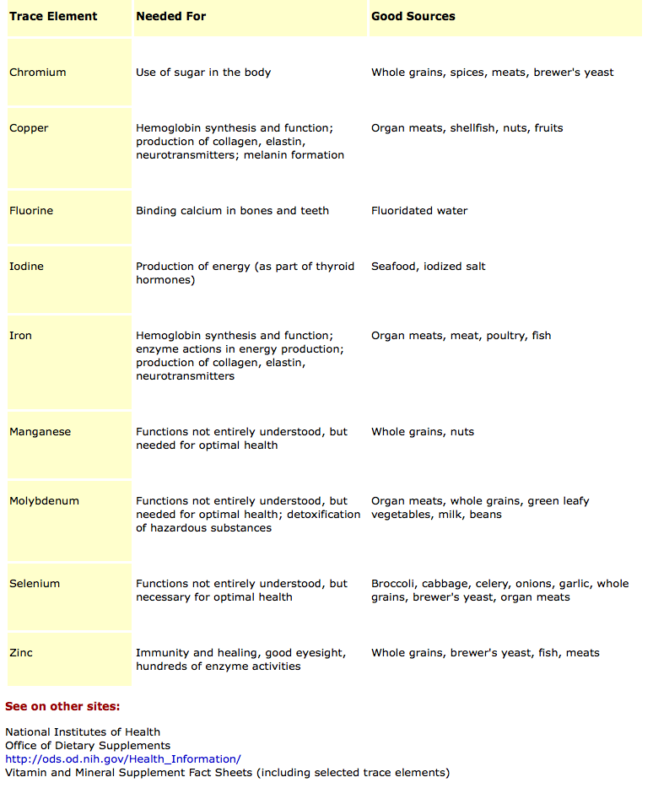Phosphate ions, PO43-, have more roles than any other inorganic ions in mammals. They are important for the formation of bones and teeth, as a buffer in blood, their role in muscle contraction and nerve impulses, as a component of many coenzymes, for their role in transfer and storage of energy in ATP, and as a component of DNA and RNA.

**Ions in the specification**

| Inorganic Ion | Role |
| --- | --- |
| Iron |  |
| Phosphate |  |
| Hydrogen |  |
| Sodium |  |

You will learn more about these ions as you move through the A level course.

**Exam Questions**

Answer these on a separate piece of paper



