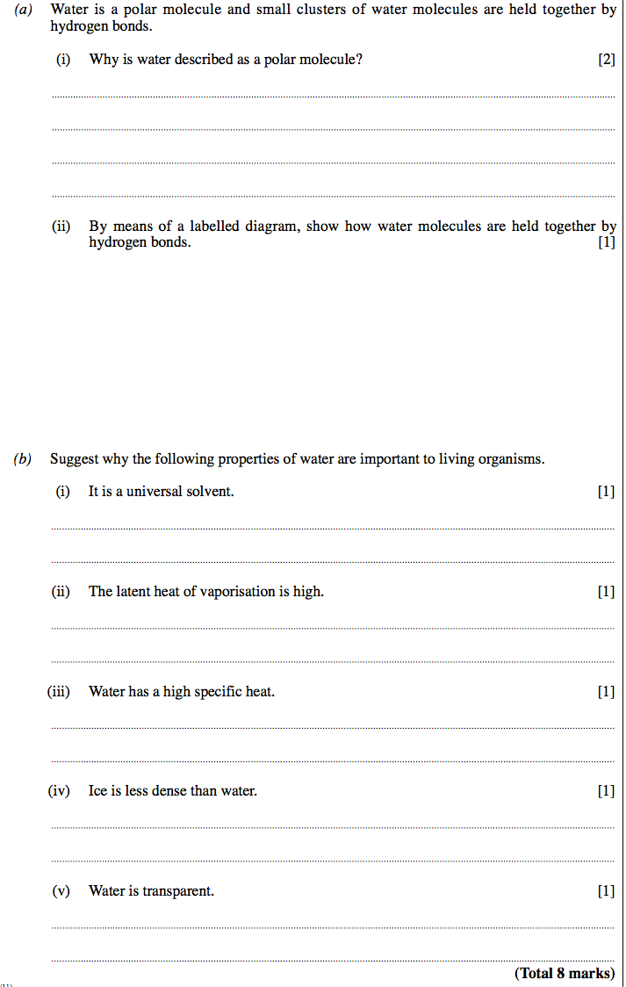**Exam Question For Water Consolidation**

**Mark Scheme for Exam Question:**