**Q1.**

Glucose is a monosaccharide. Two glucose molecules join together to form a disaccharide.

(i)      Name the products of this reaction.

___________________________________________________________________

**(2)**

(ii)     Name the type of reaction that joins the glucose molecules together.

___________________________________________________________________

**(1)**

**(Total 3 marks)**

**Q2.**

Starch and cellulose are two important plant polysaccharides.

The following diagram shows part of a starch molecule and part of a cellulose molecule.

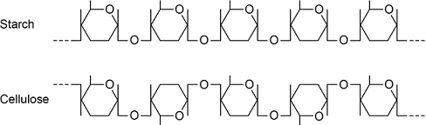

(a)     Explain the difference in the structure of the starch molecule and the cellulose molecule shown in the diagram above.

___________________________________________________________________

___________________________________________________________________

___________________________________________________________________

___________________________________________________________________

**(2)**

(b)     Starch molecules and cellulose molecules have different functions in plant cells. Each molecule is adapted for its function.

Explain **one** way in which starch molecules are adapted for their function in plant cells.

_________­­­­­­_________________________________________________________

___________________________________________________________________

___________________________________________________________________

**(2)**

(c)     Explain how cellulose molecules are adapted for their function in plant cells.

___________________________________________________________________

___________________________________________________________________

___________________________________________________________________

___________________________________________________________________

___________________________________________________________________

___________________________________________________________________

**(3)**

**(Total 7 marks)**

**Q3.**

(a)    The table shows some statements about three carbohydrates. Complete the table with a tick in each box if the statement is true.

|  |  |  |  |
| --- | --- | --- | --- |
| **Statement** | **Starch** | **Cellulose** | **Glycogen** |
| Found in plant cells |  |  |  |
| Contains glycosidic bonds |  |  |  |
| Contains β-glucose |  |  |  |

**(3)**

(b)     Name the type of reaction that would break down these carbohydrates into their monomers.

___________________________________________________________________

**(1)**

(c)     Give **one** feature of starch and explain how this feature enables it to act as a storage substance.

Feature ____________________________________________________________

Explanation _________________________________________________________

___________________________________________________________________

___________________________________________________________________

**(2)**

(d)     The picture shows starch grains as seen with an optical microscope. The actual length of starch grain **A** is 48 μm. Use this information and the arrow line to calculate the magnification of the picture. Show your working.

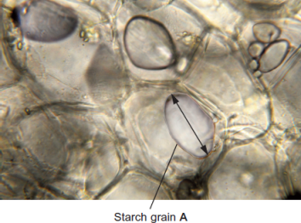  
                                                                               © iStock/Thinkstock

Magnification ____________________ times

**(2)**

**(Total 8 marks)**

**Q4.**

The diagram shows one end of a cellulose molecule.

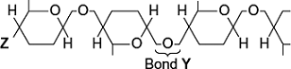

(a)     (i)      Name the monomers that form a cellulose molecule.

______________________________________________________________

**(1)**

(ii)     Name bond **Y**.

______________________________________________________________

**(1)**

(iii)    What chemical group is at position **Z**?

______________________________________________________________

**(1)**

(b)     (i)      Complete the table to show **two** ways in which the structure of cellulose is different from the structure of starch.

|  |  |
| --- | --- |
| **Starch** | **Cellulose** |
|  |  |
|  |  |

**(2)**

(ii)     Explain **one** way in which the structure of cellulose is linked to its function.

______________________________________________________________

______________________________________________________________

______________________________________________________________

______________________________________________________________

**(2)**

**(Total 7 marks)**

**Q5.**

(a)     Glycogen and cellulose are both carbohydrates.

Describe **two** differences between the structure of a cellulose molecule and a glycogen molecule.

1. _________________________________________________________________

___________________________________________________________________

___________________________________________________________________

2. _________________________________________________________________

___________________________________________________________________

___________________________________________________________________

**(2)**

(b)     Starch is a carbohydrate often stored in plant cells.

Describe and explain **two** features of starch that make it a good storage molecule.

1. _________________________________________________________________

___________________________________________________________________

___________________________________________________________________

2.________________________________________________________________

___________________________________________________________________

**(2)**

(c)     Tick (✔) the box that identifies the test which would be used to show the presence of starch.

|  |  |
| --- | --- |
| Acid hydrolysis test |  |
| Benedict’s test |  |
| Emulsion test |  |
| Iodine/potassium iodide test |  |

**(1)**

(d)     The diagram shows a section through a plant tissue at a magnification of ×500.

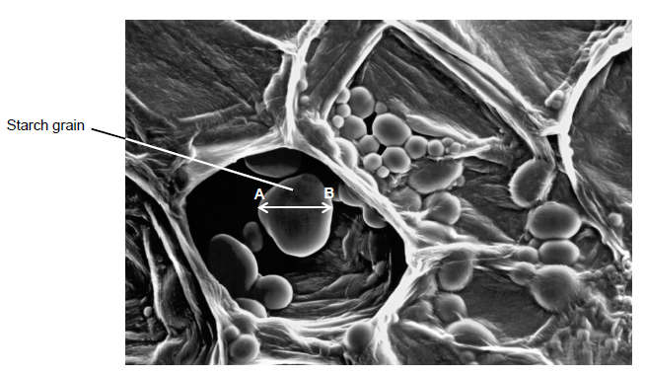

Calculate the actual diameter of the starch grain between points **A** and **B**.

Answer = ____________________ μm

**(2)**

(e)     What type of microscope was used to obtain the image shown in the diagram above?

Give **one** piece of evidence to support your answer.

Type of microscope _______________________________________________

Evidence ________________________________________________________

**(2)**

**(Total 9 marks)**

**Q6.**

(a)     Name the monomers from which a maltose molecule is made.

___________________________________________________________________

**(1)**

(b)     Name the type of chemical bond that joins the **two** monomers to form maltose.

___________________________________________________________________

**(1)**

A student wanted to produce a dilution series of a maltose solution so he could plot a calibration curve. He had a stock solution of maltose of concentration 0.6 mol dm−3 and distilled water. He made a series of dilutions from 0.1 to 0.6 mol dm−3.

(c)     Complete the table below by giving all headings, units and the concentration of the maltose solution produced.

|  |  |  |
| --- | --- | --- |
| **Concentration of maltose solution**  **/ ____________** | **Volume of 0.6 mol dm−3 maltose solution / cm3** | **_______________**  **______ / _______** |
| ____________ | 5 | 10 |

**(2)**

The student performed the Benedict’s test on six maltose solutions ranging from 0.1 mol dm−3 to 0.6 mol dm−3. He placed a sample of each solution in a colorimeter and recorded the light absorbance.

His results are shown in the graph below.

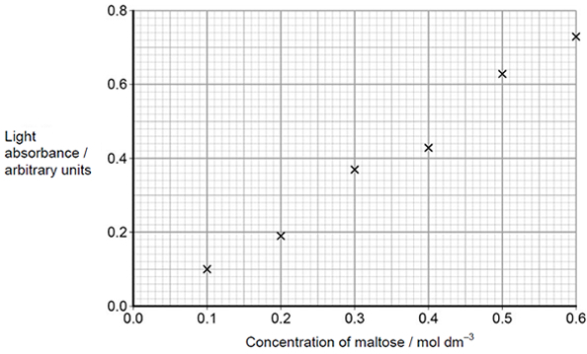

(d)     Explain how you would use the graph to determine the maltose concentration with a light absorbance of 0.45 arbitrary units.

___________________________________________________________________

___________________________________________________________________

___________________________________________________________________

___________________________________________________________________

**(2)**

**(Total 6 marks)**

**Q7.**

The diagram represents a triglyceride.

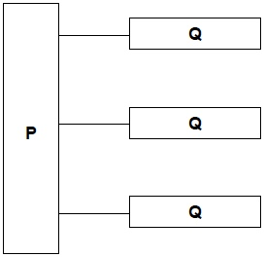

(a)     Name the molecules represented in the diagram by:

Box **P** _____________________________________________________________

Box **Q** _____________________________________________________________

**(2)**

(b)     Name the type of bond between **P** and **Q** in the diagram.

___________________________________________________________________

**(1)**

(c)     Describe how you would test a liquid sample for the presence of lipid **and** how you would recognise a positive result.

___________________________________________________________________

___________________________________________________________________

___________________________________________________________________

___________________________________________________________________

___________________________________________________________________

___________________________________________________________________

___________________________________________________________________

___________________________________________________________________

**(2)**

**(Total 5 marks)**

**Q8.**

(a)  The general structure of a fatty acid is RCOOH.

Name the group represented by COOH.

___________________________________________________________________

**(1)**

(b)  **Figure 1** shows the structure of a fatty acid R group.

**Figure 1**

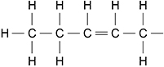

Name the type of R group shown in **Figure 1**.

Explain your answer.

Type of R group  _____________________________________________________

___________________________________________________________________

Explanation  ________________________________________________________

___________________________________________________________________

**(2)**

(c)  Describe how you would test for the presence of a lipid in a liquid sample of food.

___________________________________________________________________

___________________________________________________________________

___________________________________________________________________

___________________________________________________________________

___________________________________________________________________

___________________________________________________________________

**(2)**

In 1935, scientists suggested a model for the chemical structure of a cell-surface membrane. **Figure 2** shows the membrane structure the scientists suggested.

**Figure 2**

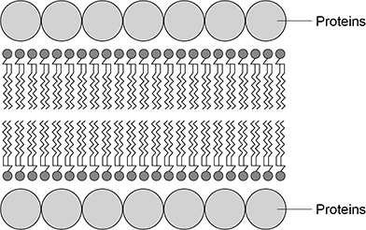

(d)  Give **one** similarity and **two** differences between the membrane structure shown in **Figure 2** and the fluid-mosaic model of membrane structure.

Similarity  __________________________________________________________

___________________________________________________________________

Difference 1  ________________________________________________________

___________________________________________________________________

Difference 2  ________________________________________________________

___________________________________________________________________

**(3)**

**(Total 8 marks)**

**Q9.**

(a)     Some seeds contain lipids. Describe how you could use the emulsion test to show that a seed contains lipids.

___________________________________________________________________

___________________________________________________________________

___________________________________________________________________

___________________________________________________________________

___________________________________________________________________

___________________________________________________________________

___________________________________________________________________

**(3)**

(b)     A triglyceride is one type of lipid. The diagram shows the structure of a triglyceride molecule.

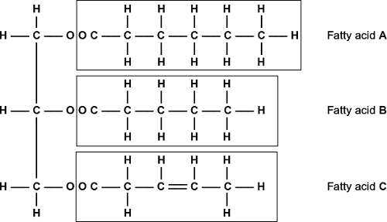

(i)      A triglyceride molecule is formed by condensation. From how many molecules is this triglyceride formed?



**(1)**

(ii)     The structure of a phospholipid molecule is different from that of a triglyceride.  
Describe how a phospholipid is different.

______________________________________________________________

______________________________________________________________

______________________________________________________________

______________________________________________________________

______________________________________________________________

**(2)**

(iii)    Use the diagram to explain what is meant by an unsaturated fatty acid.

______________________________________________________________

______________________________________________________________

______________________________________________________________

______________________________________________________________

______________________________________________________________

**(2)**

**(Total 8 marks)**

**Q10.**

(a)     Describe how you would test a piece of food for the presence of lipid.

___________________________________________________________________

___________________________________________________________________

___________________________________________________________________

**(2)**

The figure below shows a phospholipid.

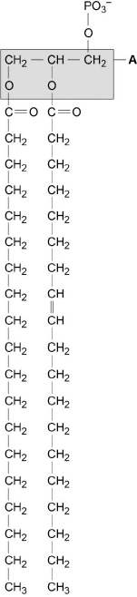  
 **X**         **Y**

(b)     The part of the phospholipid labelled **A** is formed from a particular molecule. Name this molecule.

___________________________________________________________________

**(1)**

(c)     Name the type of bond between **A** and fatty acid **X**.

___________________________________________________________________

**(1)**

(d)     Which of the fatty acids, **X** or **Y**, in the figure above is unsaturated? Explain your answer.

___________________________________________________________________

___________________________________________________________________

___________________________________________________________________

___________________________________________________________________

**(1)**

Scientists investigated the percentages of different types of lipid in plasma membranes from different types of cell. The table shows some of their results.

|  |  |  |  |
| --- | --- | --- | --- |
| **Type of lipid** | **Percentage of lipid in plasma membrane by mass** | | |
| **Cell lining ileum of mammal** | **Red blood cell of mammal** | **The bacterium *Escherichia coli*** |
| Cholesterol | 17 | 23 | 0 |
| Glycolipid | 7 | 3 | 0 |
| Phospholipid | 54 | 60 | 70 |
| Others | 22 | 14 | 30 |

(e)     The scientists expressed their results as **Percentage of lipid in plasma membrane by mass**. Explain how they would find these values.

___________________________________________________________________

___________________________________________________________________

___________________________________________________________________

___________________________________________________________________

**(2)**

Cholesterol increases the stability of plasma membranes. Cholesterol does this by making membranes less flexible.

(f)     Suggest **one** advantage of the different percentage of cholesterol in red blood cells compared with cells lining the ileum.

_______________________________________________________________

___________________________________________________________________

___________________________________________________________________

**(1)**

(g)     *E. coli* has no cholesterol in its cell-surface membrane. Despite this, the cell maintains a constant shape. Explain why.

___________________________________________________________________

___________________________________________________________________

___________________________________________________________________

___________________________________________________________________

**(2)**

**(Total 10 marks)**

**Q11.**

(a)     Omega-3 fatty acids are unsaturated. What is an unsaturated fatty acid?

___________________________________________________________________

___________________________________________________________________

___________________________________________________________________

___________________________________________________________________

**(2)**

(b)     Scientists investigated the relationship between the amount of omega-3 fatty acids eaten per day and the risk of coronary heart disease. The graph shows their results.

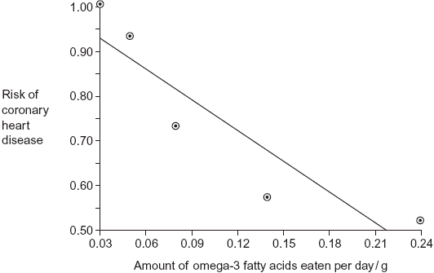

Do the data show that eating omega-3 fatty acids prevents coronary heart disease? Explain your answer.

___________________________________________________________________

___________________________________________________________________

___________________________________________________________________

___________________________________________________________________

___________________________________________________________________

___________________________________________________________________

___________________________________________________________________

**(3)**

(c)     Olestra is an artificial lipid. It is made by attaching fatty acids, by condensation, to a sucrose molecule. The diagram shows the structure of olestra. The letter **R** shows where a fatty acid molecule has attached.

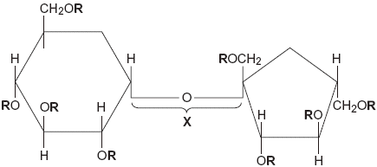

(i)      Name bond **X**.

______________________________________________________________

**(1)**

(ii)     A triglyceride does **not** contain sucrose or bond **X**. Give **one** other way in which the structure of a triglyceride is different to olestra.

______________________________________________________________

______________________________________________________________

**(1)**

(iii)     Starting with separate molecules of glucose, fructose and fatty acids, how many molecules of water would be produced when one molecule of olestra is formed?



**(1)**

**(Total 8 marks)**

**Q12.**

(a)     Explain the arrangement of phospholipids in a cell-surface membrane.

___________________________________________________________________

___________________________________________________________________

___________________________________________________________________

___________________________________________________________________

___________________________________________________________________

___________________________________________________________________

___________________________________________________________________

___________________________________________________________________

**(2)**

(b)     Describe how an ester bond is formed in a phospholipid molecule.

___________________________________________________________________

___________________________________________________________________

___________________________________________________________________

___________________________________________________________________

**(2)**

(c)     State and explain the property of water that helps to prevent temperature increase in a cell.

Property  __________________________________________________________

Explanation  ________________________________________________________

___________________________________________________________________

___________________________________________________________________

___________________________________________________________________

**(2)**

**(Total 6 marks)**