**Q1.**

(a)     Describe how a peptide bond is formed between two amino acids to form a dipeptide.

___________________________________________________________________

___________________________________________________________________

___________________________________________________________________

___________________________________________________________________

___________________________________________________________________

___________________________________________________________________

___________________________________________________________________

**(2)**

(b)     The secondary structure of a polypeptide is produced by bonds between amino acids.

Describe how.

___________________________________________________________________

___________________________________________________________________

___________________________________________________________________

___________________________________________________________________

___________________________________________________________________

___________________________________________________________________

**(2)**

(c)     Two proteins have the same number and type of amino acids but different tertiary structures.

Explain why.

___________________________________________________________________

___________________________________________________________________

___________________________________________________________________

___________________________________________________________________

___________________________________________________________________

___________________________________________________________________

___________________________________________________________________

___________________________________________________________________

**(2)**

**(Total 6 marks)**

**Q2.**

(a)     Explain how the shape of an enzyme molecule is related to its function.

___________________________________________________________________

___________________________________________________________________

___________________________________________________________________

___________________________________________________________________

___________________________________________________________________

___________________________________________________________________

**(3)**

(b)     Bacteria produce enzymes which cause food to decay. Explain how vinegar, which is acidic, can prevent the action of bacterial enzymes in some preserved foods.

___________________________________________________________________

___________________________________________________________________

___________________________________________________________________

___________________________________________________________________

___________________________________________________________________

___________________________________________________________________

**(3)**

**(Total 6 marks)**

**Q3.**

(a)     Explain how the active site of an enzyme causes a high rate of reaction.

___________________________________________________________________

___________________________________________________________________

___________________________________________________________________

___________________________________________________________________

___________________________________________________________________

___________________________________________________________________

___________________________________________________________________

___________________________________________________________________

___________________________________________________________________

___________________________________________________________________

**(3)**

The action of the enzyme catalase is shown below.



A student investigated the effect of hydrogen peroxide concentration on the rate of this reaction. He used catalase from potato tissue.

The student:

•   put five potato chips in a flask

•   added 20 cm3 of 0.5 mol dm–3 hydrogen peroxide solution to the flask

•   measured the time in seconds for production of 10 cm3 of oxygen gas

•   repeated this procedure with four different concentrations of hydrogen peroxide solution.

His results are shown in the table.

|  |  |  |
| --- | --- | --- |
| **Hydrogen peroxide concentration / mol dm–3** | **Time for production of 10 cm3 of oxygen gas / seconds** | **Rate of reaction / arbitrary units** |
| 0.5 | 18 |  |
| 1.0 | 10 |  |
| 1.5 | 7 |  |
| 2.0 | 6 |  |
| 2.5 | 6 |  |

(b)  Other than those stated, give **one** factor the student would have controlled in his investigation.

___________________________________________________________________

___________________________________________________________________

**(1)**

(c)  The student gave the maximum rate of reaction a value of 1.0 arbitrary units.

Complete the table above by calculating the rate of reaction in arbitrary units at each hydrogen peroxide concentration. Record the rates using an appropriate number of significant figures.

**(2)**

(d)  Plot a suitable graph of your processed data shown in the table.



**(3)**

(e)  Suggest a change the student could make to his procedure so that 10 cm3 of oxygen would be produced in less than 6 seconds.

___________________________________________________________________

___________________________________________________________________

___________________________________________________________________

___________________________________________________________________

**(1)**

**(Total 10 marks)**

**Q4.**

The diagram represents an enzyme molecule and three other molecules that could combine with it.

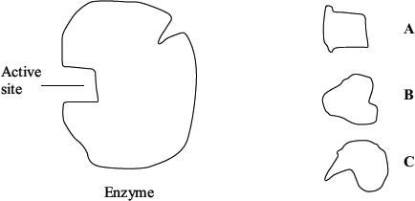

(a)     Which molecule is the substrate for the enzyme? Give a reason for your answer.

___________________________________________________________________

___________________________________________________________________

___________________________________________________________________

**(1)**

(b)     Use the diagram to explain how a **non-competitive** inhibitor would decrease the rate of the reaction catalysed by this enzyme.

___________________________________________________________________

___________________________________________________________________

___________________________________________________________________

___________________________________________________________________

___________________________________________________________________

___________________________________________________________________

**(3)**

(c)     Lysozyme is an enzyme. A molecule of lysozyme is made up of 129 amino acid molecules joined together. In the formation of its active site, the two amino acids that are at positions 35 and 52 in the amino acid sequence need to be close together.

(i)      Name the bonds that join amino acids in the primary structure.

______________________________________________________________

**(1)**

(ii)     Suggest how the amino acids at positions 35 and 52 are held close together to form the active site.

______________________________________________________________

______________________________________________________________

______________________________________________________________

______________________________________________________________

**(2)**

**(Total 7 marks)**

**Q5.**

A technician investigated the effect of temperature on the rate of an enzyme-controlled reaction. At each temperature, he started the reaction using the same volume of substrate solution and the same volume of enzyme solution.

The figure below shows his results.

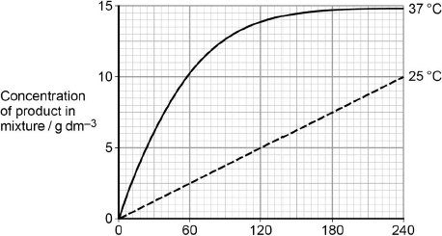  
                Time after start of reaction / s

(a)     Give **one** other factor the technician would have controlled.

___________________________________________________________________

**(1)**

(b)     Calculate the rate of reaction at 25 °C.

Answer ____________________

**(2)**

(c)     Describe and explain the differences between the two curves.

___________________________________________________________________

___________________________________________________________________

___________________________________________________________________

___________________________________________________________________

___________________________________________________________________

___________________________________________________________________

___________________________________________________________________

___________________________________________________________________

**(5)**

**(Total 8 marks)**

**Q6.**

(a)     A student investigated starch hydrolysis using the enzyme amylase.

During the procedure, the student:

•        treated the starch to make it soluble

•        prepared 10 cm3 of different concentrations (mg dm−3) of starch solution

•        added an identical concentration of amylase to each starch solution

•        measured the time in minutes to completely hydrolyse starch.

He repeated the procedure and calculated the mean time to completely hydrolyse starch in each concentration of starch solution.

Draw a table the student could use to record all of his results.

You only need to show completed column headings.

**(2)**

(b)     Describe the results you would expect the student to obtain.

___________________________________________________________________

___________________________________________________________________

___________________________________________________________________

**(1)**

(c)     A competitive inhibitor decreases the rate of an enzyme-controlled reaction.

Explain how.

___________________________________________________________________

___________________________________________________________________

___________________________________________________________________

___________________________________________________________________

___________________________________________________________________

___________________________________________________________________

___________________________________________________________________

**(3)**

(d)     When bread becomes stale, the structure of some of the starch is changed. This changed starch is called retrograded starch.

Scientists have suggested retrograded starch is a competitive inhibitor of amylase in the small intestine.

Assuming the scientists are correct, suggest how eating stale bread could help to reduce weight gain.

___________________________________________________________________

___________________________________________________________________

___________________________________________________________________

___________________________________________________________________

___________________________________________________________________

___________________________________________________________________

___________________________________________________________________

___________________________________________________________________

___________________________________________________________________

**(3)**

**(Total 9 marks)**

**Q7.**

Many humans are unable to digest lactose. A scientist investigated the production of lactose-free milk. He produced gel beads containing the enzyme lactase and placed the beads in a column. He poured milk (Milk **A**) into the column and collected the milk (Milk **B**) after it had moved through the column over the beads. This is shown in the diagram below.

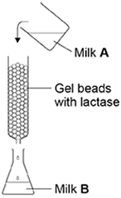

(a)     Milk **A** contains no glucose. Milk **B** contains glucose. Explain why Milk **B** contains glucose.

___________________________________________________________________

___________________________________________________________________

**(1)**

(b)     The enzyme was trapped within the gel beads. Suggest **one** advantage of trapping the enzyme within the gel beads.

___________________________________________________________________

___________________________________________________________________

___________________________________________________________________

**(1)**

The scientist varied the flow rate of the milk through the column. The effect of flow rate on the concentration of glucose in Milk **B** is shown in the table below.

|  |  |
| --- | --- |
| **Flow rate of milk through the column / cm3 minute−1** | **Concentration of glucose in Milk B / arbitrary units** |
| 50 | 45 |
| 100 | 6 |

(c)     Explain the difference in the results in the table.

___________________________________________________________________

___________________________________________________________________

___________________________________________________________________

**(1)**

(d)     The gel beads were all similar sizes. Use the formula below to calculate the volume of one of the beads with a 3.0 mm diameter.

Volume of sphere =  πr3

Volume = _____________________ mm3

**(1)**

(e)     Galactose has a similar structure to part of the lactose molecule.

Explain how galactose inhibits lactase.

___________________________________________________________________

___________________________________________________________________

___________________________________________________________________

___________________________________________________________________

___________________________________________________________________

**(2)**

**(Total 6 marks)**

**Q8.**

(a)     Formation of an enzyme-substrate complex increases the rate of reaction.

Explain how.

___________________________________________________________________

___________________________________________________________________

___________________________________________________________________

___________________________________________________________________

___________________________________________________________________

___________________________________________________________________

___________________________________________________________________

___________________________________________________________________

**(2)**

(b)     A scientist measured the rate of removal of amino acids from a polypeptide with and without an enzyme present. With the enzyme present, 578 amino acids were released per second. Without the enzyme, 3.0 × 10–9 amino acids were released per second.

Calculate by how many times the rate of reaction is greater with the enzyme present.

Give your answer in standard form.

Answer = ____________________ times faster

**(2)**

Another scientist investigated an enzyme that catalyses the following reaction.

ATP → ADP + Pi

The scientists set up two experiments, **C** and **L**.

Experiment **C** used

•        the enzyme

•        different concentrations of ATP.

Experiment **L** used

•        the enzyme

•        different concentrations of ATP

•        a sugar called lyxose.

The scientists measured the rate of reaction in each experiment. Their results are shown in the graph.

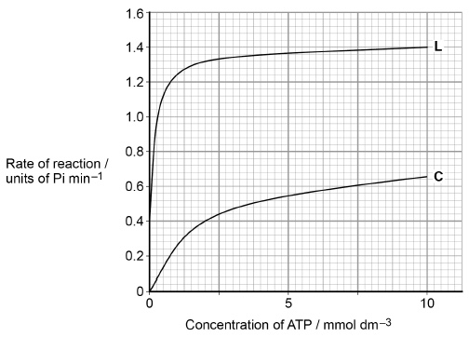

(c)     Calculate the rate of reaction of the enzyme activity with no lyxose at 2.5 mmol dm–3 of ATP as a percentage of the maximum rate shown with lyxose.

Answer = ____________________ %

**(2)**

(d)     Lyxose binds to the enzyme.

Suggest a reason for the difference in the results shown in the graph with and without lyxose.

___________________________________________________________________

___________________________________________________________________

___________________________________________________________________

___________________________________________________________________

___________________________________________________________________

___________________________________________________________________

___________________________________________________________________

___________________________________________________________________

___________________________________________________________________

**(3)**

**(Total 9 marks)**