**Q1.**

(a)     Draw **and** label a single DNA nucleotide.

**(2)**

(b)     Give **two** features of DNA **and** explain how each one is important in the semi-conservative replication of DNA.

1. _________________________________________________________________

___________________________________________________________________

___________________________________________________________________

___________________________________________________________________

___________________________________________________________________

2. _________________________________________________________________

___________________________________________________________________

___________________________________________________________________

___________________________________________________________________

___________________________________________________________________

**(2)**

(c)     Replication of mitochondrial DNA (mtDNA) is different from that of nuclear DNA.

The replication of the second strand of mtDNA **only** starts after two-thirds of the first strand of mtDNA has been copied.

A piece of mtDNA is 16 500 base pairs long and is replicated at a rate of 50 nucleotides per second.

Tick (**✓**) the box that shows how long it would take to copy this mtDNA.

|  |  |  |
| --- | --- | --- |
| **A** | 330 seconds |  |
| **B** | 440 seconds |  |
| **C** | 550 seconds |  |
| **D** | 660 seconds |  |

**(1)**

**(Total 5 marks)**

**Q2.**

(a)     The diagram shows one pair of nucleotides of a DNA molecule.

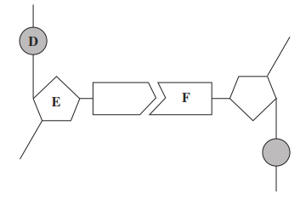

Name

**D** _________________________________________

**E**  _________________________________________

**F**  _________________________________________

**(3)**

(b)     Complete the table to give **two** differences between the structure of DNA and the structure of RNA.

|  |  |  |
| --- | --- | --- |
|  | **DNA** | **RNA** |
| **1** |  |  |
| **2** |  |  |

**(2)**

**(Total 5 marks)**

**Q3.**

The diagram shows part of a DNA molecule.

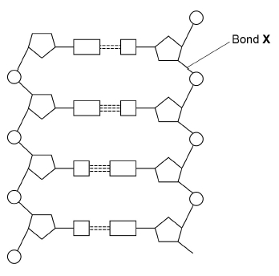

(a)     How many nucleotides are shown in the diagram above?

___________________________________________________________________

**(1)**

(b)     Name the type of bond labelled **X** in the diagram.

___________________________________________________________________

**(1)**

(c)     The enzymes DNA helicase and DNA polymerase are involved in DNA replication.

Describe the function of each of these enzymes.

DNA helicase _______________________________________________________

___________________________________________________________________

___________________________________________________________________

___________________________________________________________________

DNA polymerase _____________________________________________________

___________________________________________________________________

___________________________________________________________________

___________________________________________________________________

**(2)**

(d)     Adenosine triphosphate (ATP) is a nucleotide derivative.

Contrast the structures of ATP and a nucleotide found in DNA to give **two** differences.

1. _________________________________________________________________

___________________________________________________________________

___________________________________________________________________

2. _________________________________________________________________

___________________________________________________________________

___________________________________________________________________

**(2)**

**(Total 6 marks)**

**Q4.**

(a)     Name the **two** scientists who proposed models of the chemical structure of DNA and of DNA replication.

___________________________________________________________________

**(1)**

A scientist replicated DNA in a test tube. To do this, he mixed an enzyme with identical single-stranded DNA fragments and a solution containing DNA nucleotides.

(b)  Name the enzyme used in this DNA replication.

___________________________________________________________________

**(1)**

(c)  Use your knowledge of semi-conservative replication of DNA to suggest:

1. the role of the single-stranded DNA fragments ____________________________

___________________________________________________________________

___________________________________________________________________

___________________________________________________________________

2. the role of the DNA nucleotides. _______________________________________

___________________________________________________________________

___________________________________________________________________

___________________________________________________________________

___________________________________________________________________

**(3)**

**(Total 5 marks)**

**Q5.**

The diagram shows part of a DNA molecule.

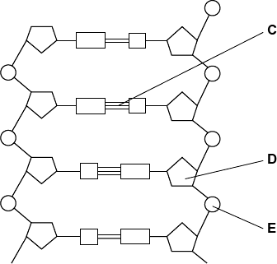

(a)     (i)      DNA is a polymer. What is the evidence from the diagram that DNA is a polymer?

______________________________________________________________

______________________________________________________________

______________________________________________________________

**(1)**

(ii)     Name the parts of the diagram labelled **C**, **D** and **E**.

Part **C**                       ________________________

Part **D**                       ________________________

Part **E**                       ________________________

**(3)**

(iii)    In a piece of DNA, 34% of the bases were thymine.

Complete the table to show the names and percentages of the other bases.

|  |  |
| --- | --- |
| **Name of base** | **Percentage** |
| Thymine | 34 |
|  |  |
|  | 34 |
|  |  |

**(2)**

(b)     A polypeptide has 51 amino acids in its primary structure.

(i)      What is the minimum number of DNA bases required to code for the amino acids in this polypeptide?



**(1)**

(ii)     The gene for this polypeptide contains more than this number of bases.

Explain why

______________________________________________________________

______________________________________________________________

______________________________________________________________

**(1)**

**(Total 8 marks)**

**Q6.**

The following figure represents part of a DNA molecule.

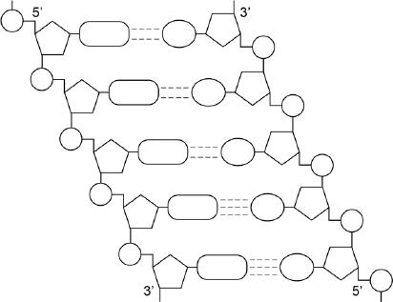

(a)     Draw a box around a single nucleotide.

**(1)**

The table below shows the percentage of bases in each of the strands of a DNA molecule.

|  |  |  |  |  |
| --- | --- | --- | --- | --- |
| **DNA strand** | **Percentage of each base** | | | |
| **A** | **C** | **G** | **T** |
| Strand **1** | 16 |  |  |  |
| Strand **2** |  | 21 | 34 |  |

(b)     Complete the table by adding the missing values.

**(2)**

(c)     During replication, the two DNA strands separate and each acts as a template for the production of a new strand. As new DNA strands are produced, nucleotides can only be added in the 5’ to 3’ direction.

Use the figure in part **(a)** and your knowledge of enzyme action and DNA replication to explain why new nucleotides can only be added in a 5’ to 3’ direction.

___________________________________________________________________

___________________________________________________________________

___________________________________________________________________

___________________________________________________________________

___________________________________________________________________

___________________________________________________________________

___________________________________________________________________

___________________________________________________________________

**(4)**

**(Total 7 marks)**

**Q7.**

(a)     DNA helicase is important in DNA replication. Explain why.

___________________________________________________________________

___________________________________________________________________

___________________________________________________________________

___________________________________________________________________

___________________________________________________________________

**(2)**

Scientists investigating DNA replication grew bacteria for several generations in a nutrient solution containing a heavy form of nitrogen (15N). They obtained DNA from a sample of these bacteria.

The scientists then transferred the bacteria to a nutrient solution containing a light form of nitrogen (14N). The bacteria were allowed to grow and divide twice. After each division, DNA was obtained from a sample of bacteria.

The DNA from each sample of bacteria was suspended in a solution in separate tubes. These were spun in a centrifuge at the same speed and for the same time. The diagram shows the scientists’ results.

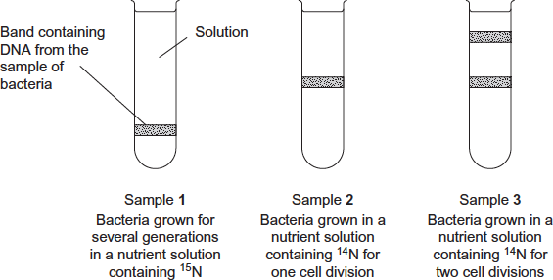

(b)     The table shows the types of DNA molecule that could be present in samples **1** to **3**.  
Use your knowledge of semi-conservative replication to complete the table with a tick if the DNA molecule is present in the sample.

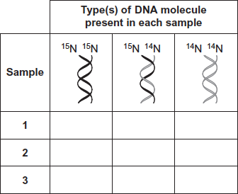

**(3)**

(c)     Cytarabine is a drug used to treat certain cancers. It prevents DNA replication. The diagram shows the structures of cytarabine and the DNA base cytosine.

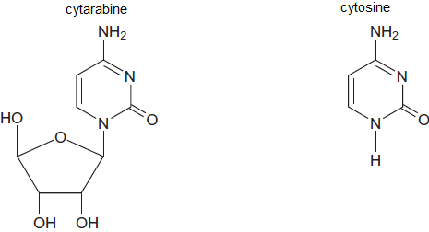

(i)      Use information in the diagram to suggest how cytarabine prevents DNA replication.

______________________________________________________________

______________________________________________________________

______________________________________________________________

______________________________________________________________

______________________________________________________________

**(2)**

(ii)     Cytarabine has a greater effect on cancer cells than on healthy cells. Explain why.

______________________________________________________________

______________________________________________________________

______________________________________________________________

**(1)**

**(Total 8 marks)**

**[8]**