**Q1.**

(a)     Describe a biochemical test to confirm the presence of protein in a solution.

___________________________________________________________________

___________________________________________________________________

___________________________________________________________________

___________________________________________________________________

___________________________________________________________________

___________________________________________________________________

**(2)**

(b)  A dipeptide consists of two amino acids joined by a peptide bond. Dipeptides may differ in the type of amino acids they contain.

Describe **two other** ways in which all dipeptides are similar and one way in which they might differ.

Similarities

1  _________________________________________________________________

___________________________________________________________________

___________________________________________________________________

2  _________________________________________________________________

___________________________________________________________________

___________________________________________________________________

Difference  _________________________________________________________

___________________________________________________________________

**(3)**

A solution contained a mixture of **three** different amino acids. A scientist passed an electric current through the solution to separate the amino acids.

She placed a drop of the mixture at one end of a piece of filter paper, attached an electrode to each end of the paper and switched on the current. She switched off the current after 20 minutes and stained the paper to show spots of the amino acids at new positions.

Her results are shown in the diagram.

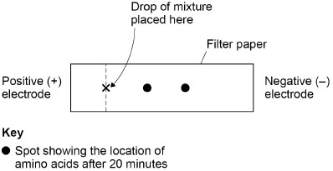

(c)  Explain what the positions of the spots in the diagram show about these amino acids.

___________________________________________________________________

___________________________________________________________________

___________________________________________________________________

___________________________________________________________________

___________________________________________________________________

___________________________________________________________________

___________________________________________________________________

___________________________________________________________________

___________________________________________________________________

___________________________________________________________________

___________________________________________________________________

___________________________________________________________________

**(3)**

**(Total 8 marks)**

**Q2.**

(a)     Bacteria are often used in industry as a source of enzymes. One reason is because bacteria divide rapidly, producing a large number of them in a short time.

Describe how bacteria divide.

___________________________________________________________________

___________________________________________________________________

___________________________________________________________________

___________________________________________________________________

**(2)**

(b)     Washing powders often contain enzymes from bacteria. These enzymes include proteases that hydrolyse proteins in clothing stains.

The graph shows the effect of temperature on a protease that could be used in washing powder.

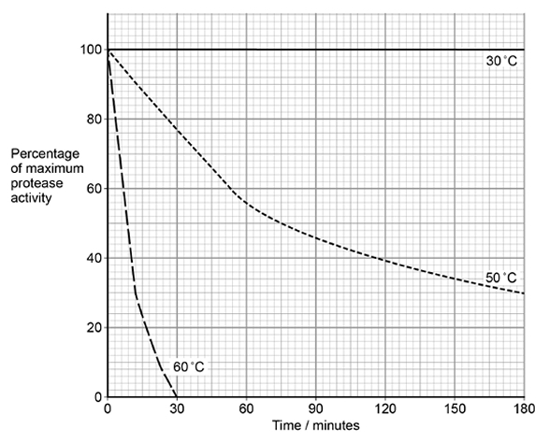

Explain the shape of the curves at 50 °C and 60 °C.

___________________________________________________________________

___________________________________________________________________

___________________________________________________________________

___________________________________________________________________

___________________________________________________________________

___________________________________________________________________

___________________________________________________________________

___________________________________________________________________

**(4)**

(c)     Some proteases are secreted as extracellular enzymes by bacteria.

Suggest **one** advantage to a bacterium of secreting an extracellular protease in its natural environment.

Explain your answer.

___________________________________________________________________

___________________________________________________________________

___________________________________________________________________

___________________________________________________________________

**(2)**

(d)     Mammals have some cells that produce extracellular proteases. They also have cells with membrane-bound dipeptidases.

Describe the action of these membrane-bound dipeptidases and explain their importance.

___________________________________________________________________

___________________________________________________________________

___________________________________________________________________

___________________________________________________________________

**(2)**

**(Total 10 marks)**

**Q3.**

A biochemist isolated a protease from a bacterium. He investigated the effect of temperature on the rate of hydrolysis of a protein by this protease. He measured the mass of protein hydrolysed in **5 minutes** at each temperature.

The results are shown in the table below.

|  |  |  |
| --- | --- | --- |
| **Temperature / °C** | **Mass of protein hydrolysed / g** | **Rate of hydrolysis /**  **_______________** |
| 5 | 0.48 |  |
| 10 | 1.11 |  |
| 15 | 1.23 |  |
| 20 | 1.05 |  |
| 30 | 0.78 |  |
| 45 | 0.12 |  |

(a)     Process the data in the table. Plot the processed data on the graph paper.



**(4)**

(b)     A student concluded from a graph of the data in the table that the bacterium lives at 15 °C.

Does the data support the student’s conclusion? Give reasons for your answer.

___________________________________________________________________

___________________________________________________________________

___________________________________________________________________

___________________________________________________________________

___________________________________________________________________

___________________________________________________________________

___________________________________________________________________

___________________________________________________________________

___________________________________________________________________

**(4)**

(c)     Suggest **two** variables the biochemist controlled when investigating the effect of temperature on the rate of breakdown of a protein by the protease.

1. _________________________________________________________________

2. _________________________________________________________________

**(1)**

**(Total 9 marks)**

**Q4.**

A student investigated the effect of substrate concentration on the initial rate of an enzyme-catalysed reaction.

She added 10 cm3 of an enzyme solution to 10 cm3 of substrate solutions of different concentrations. At 30-second intervals, she tested samples of each mixture for the presence of substrate.

•        **A** – in the absence of an inhibitor.

•        **B** – with a competitive inhibitor added to the substrate solution.

•        **C** – with a non-competitive inhibitor added to the substrate solution.

Her results are shown in the graph below.

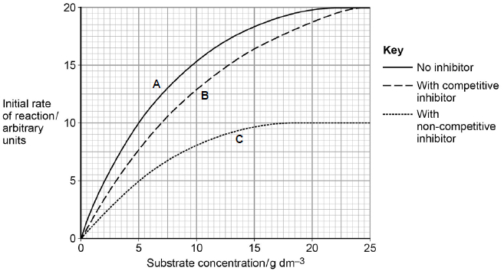

(a)     Explain the results **without** inhibitor (curve **A**) shown in the graph.

___________________________________________________________________

___________________________________________________________________

___________________________________________________________________

___________________________________________________________________

___________________________________________________________________

___________________________________________________________________

**(2)**

(b)     The graph shows that the maximum initial rate of reaction (Vmax) when a competitive inhibitor was present (curve **B**) is different from that when a non-competitive inhibitor was present (curve **C**).

Explain this difference.

___________________________________________________________________

___________________________________________________________________

___________________________________________________________________

___________________________________________________________________

___________________________________________________________________

___________________________________________________________________

**(4)**

(c)     The Michaelis constant (Km) is the substrate concentration at which the initial rate of reaction is half its maximum value (Vmax).

How could you use the Michaelis constant to determine the type of inhibition occurring in an enzyme-catalysed reaction?

Use information from the graph to support your answer.

___________________________________________________________________

___________________________________________________________________

___________________________________________________________________

**(1)**

**(Total 7 marks)**

**Q5.**

A technician investigated the effect of temperature on the rate of an enzyme-controlled reaction. At each temperature, he started the reaction using the same concentration of substrate.

The following graph shows his results.

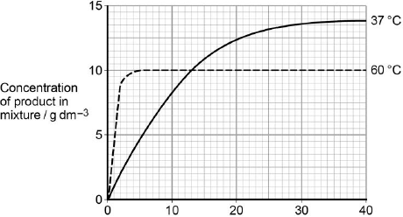  
                     Time after start of reaction / minutes

(a)     Give **two** other factors the technician would have controlled.

1. _________________________________________________________________

2. _________________________________________________________________

**(1)**

(b)     Draw a tangent on each curve to find the initial rates of reaction.  
Use these values to calculate the ratio of the initial rates of reaction at 60 °C : 37 °C.  
Show your working.

Ratio = ____________________ :1

**(2)**

(c)     Explain the difference in the initial rate of reaction at 60 °C and 37 °C.

___________________________________________________________________

___________________________________________________________________

___________________________________________________________________

___________________________________________________________________

**(2)**

(d)     Explain the difference in the rates of reaction at 60 °C and 37 °C between 20 and 40 minutes.

___________________________________________________________________

___________________________________________________________________

___________________________________________________________________

___________________________________________________________________

___________________________________________________________________

___________________________________________________________________

___________________________________________________________________

___________________________________________________________________

**(4)**

**(Total 9 marks)**

**Q6.**

(a)     Describe the induced-fit model of enzyme action.

___________________________________________________________________

___________________________________________________________________

___________________________________________________________________

___________________________________________________________________

___________________________________________________________________

**(2)**

(b)     A scientist investigated the hydrolysis of starch.  
He added amylase to a suspension of starch and measured the concentration of maltose in the reaction mixture at regular intervals.

His results are shown in the graph below.

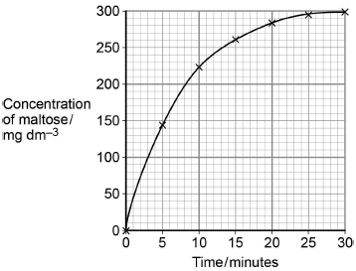

Determine the rate of the reaction **at** 10 minutes.

Show how you obtained your answer.

Rate of reaction ____________________ mg dm−3 min−1

**(2)**

(c)     Explain the results shown in the graph.

___________________________________________________________________

___________________________________________________________________

___________________________________________________________________

___________________________________________________________________

**(2)**

(d)     A quantitative Benedict’s test produces a colour whose intensity depends on the concentration of reducing sugar in a solution. A colorimeter can be used to measure the intensity of this colour.

The scientist used quantitative Benedict’s tests to produce a calibration curve of colorimeter reading against concentration of maltose.

Describe how the scientist would have produced the calibration curve and used it to obtain the results in the graph.

Do **not** include details of how to perform a Benedict’s test in your answer.

___________________________________________________________________

___________________________________________________________________

___________________________________________________________________

___________________________________________________________________

___________________________________________________________________

___________________________________________________________________

___________________________________________________________________

___________________________________________________________________

___________________________________________________________________

___________________________________________________________________

___________________________________________________________________

**(3)**

**(Total 9 marks)**

Mark schemes

**Q1.**

(a)  1.   Add biuret (reagent);

*Accept sodium hydroxide (solution) and copper sulphate (solution)*

*Reject addition of other incorrect chemicals*

2.   (Positive result) purple/lilac/violet /mauve;

*Reject other colours*

*Ignore references to heating*

**2**

(b)  Similarities

*2 max for similarities*

*Accept for three marks, a labelled diagram of a dipeptide showing NH2/NH3+, COOH/COO− and different R groups.*

1.   Amine/NH2 (group at end);

*Accept amino/NH3+*

2.   Carboxyl/COOH (group at end);

*Accept carboxylic / COO−*

3.   Two R groups;

4.   All contain C **and** H **and** N **and** O;

*Accept examples of different R groups*

Difference

5.   Variable/different R group(s);

**3**

(c)  1.   Moved to negative (electrode) **because** positive(ly charged);

2.   (Spots move) different distances/rates **because** (amino acids) different charge/mass;

*Accept size for mass.*

3.   Two spots (not three) **because** (amino acids) same charge/mass

**OR**

One spot has 2 amino acids **because** (amino acids) same charge/mass;

*Accept size for mass.*

**3**

**[8]**

**Q2.**

(a)     1.      Binary fission;

2.      Replication of (circular) DNA;

3.      Division of cytoplasm to produce 2 daughter cells;

4.      Each with single copy of (circular) DNA;

*1.      Ignore reference to ‘chromosome’*

*2.      Ignore ‘copy’.*

*4.      Ignore references to number of plasmids.*

**2 max**

(b)     1.      Both denatured (by high temperature);

2.      Denaturation faster at 60 °C due to more (kinetic) energy;

3.      Breaks hydrogen / ionic bonds (between amino acids / R groups);

4.      Change in shape of the active site / active site no longer complementary **so** fewer enzyme-substrate complexes formed / substrate does not fit;

*3.      Ignore references to disulphide bonds*

*3.      Accept (at 60 °C) Change in shape of the active site / active site no longer complementary* ***so*** *no enzyme-substrate complexes formed / substrate does not fit;*

**4**

(c)     1.      To digest protein;

2.      (So) they can absorb amino acids for growth / reproduction / protein synthesis / synthesis of named cell component;

**OR**

(So) they can destroy a toxic substance / protein;

*1.      For ‘digest’ accept ‘break down’ here.*

*2.      Accept ‘(so) they can destroy antibodies / antibiotics / viral antigens / bacterial antigens’*

**2**

(d)     1.      Hydrolyse (peptide bonds) to release amino acids;

2.      Amino acids can cross (cell) membrane;

**OR**

Dipeptides cannot cross (cell) membrane;

**OR**

Maintain concentration gradient of amino acids for absorption;

**OR**

Ensure (nearly) maximum yield from protein breakdown;

*2.      Ignore references to crossing gut membranes.*

*2.      Accept ‘there are carrier proteins for amino acids’*

*2.      Accept ‘no carrier proteins for dipeptides’*

**2**

**[10]**

**Q3.**

(a)     1.      IV on x axis and DV on y axis **and** both axes on linear scales;

2.      Axes labelled clearly and with correct units separated from variable by solidus or in brackets;

3.      All rates calculated correctly;

4.      Points plotted correctly **and** joined by ruled lines and no extrapolation;

**4**

(b)     Yes:

1.      Expect optimum temperature of enzyme to be same

**OR**

Similar to temperature where bacterium lives;

2.      Optimum temperature for enzyme (appears to be around) 15 °C;

No:

3.      Need data from more temperatures (between 10 °C and 20 °C);

4.      Data for only isolated enzyme

**OR**

Isolation may affect activity;

**4**

(c)     1.      Initial / starting substrate concentration

2.      Enzyme concentration

3.      pH.

*Any* ***2*** *for* ***1*** *mark*

**1 max**

**[9]**

**Q4.**

(a)     1.      Increases because more enzyme-substrate complexes formed;

*Neutral; more collisions*

2.      Levels off because all enzyme molecules involved in enzyme-substrate complexes (at a given time)

*1. and 2. Accept ES*

*2. Reject enzymes are used up*

**OR**

Levels off because no free active sites (at a given time)

**OR**

Levels off because enzyme (concentration) is limiting factor.

**2**

(b)     1.      Competitive inhibitor binds to active sites of enzyme but non-competitive inhibitor binds at allosteric site / away from active site;

2.      (Binding of) competitive inhibitor does not cause change in shape of active site but (binding of) non-competitive does (cause change in size of active site);

3.      So with competitive inhibitor, at high substrate concentrations (active) enzyme still available but with non-competitive inhibitor (active) enzymes no longer available;

4.      At higher substrate concentrations likelihood of enzyme-substrate collisions increases with competitive inhibitor but this is not possible with non-competitive inhibitor;

**4**

(c)     Reaction with non-competitive inhibitor has the same value of Km as with no inhibitor / value is 5 (g dm–3) / reaction with competitive inhibitor has higher Km value than with no inhibitor / value is 7 (g dm–3).

**1**

**[7]**

**Q5.**

(a)     Any **two** of the following:

Concentration of enzyme

Volume of substrate solution

pH.

*Allow same concentration of substrate*

**1**

(b)     Ratio between 5.18:1 and 5.2:1

Initial rates incorrect but correctly used = 1 mark.

*Allow 1 mark if rate at:*

*60°C = 0.83g dm–3 s–1 /49.8g dm–3 minute–1*

***OR***

*37°C = 0.16g dm–3 s–1 /9.6g dm–3 minute–1*

**2**

(c)     At 60 °C:

1.      More kinetic energy;

2.      More E–S complexes formed.

*Allow converse for 37 °C*

**2**

(d)     Different times:

1.      Higher temperature / 60 °C causes denaturation of all of enzyme;

*Accept converse for 37 °C*

2.      Reaction stops (sooner) because shape of active site changed;

*Reject if active site on substrate*

Different concentrations of product (at 60 °C)

3.      Substrate still available (when enzyme denatured);

4.      But not converted to product.

**4**

**[9]**

**Q6.**

(a)     1.      (before reaction) active site not complementary to/does   
not fit substrate;

2.      Shape of active site changes as substrate binds/as   
enzyme-substrate complex forms;

*Note. Points 1 and 2 may be made in one statement and ‘complementary’ introduced at any point.*

*Points 1&2 – active site mentioned once applies for both points*

*Point 2 – Ignore references to how shape change is caused*

3.      Stressing/distorting/bending bonds (in substrate leading to reaction);

**2 max**

(b)     1.      Tangent to curve drawn;

*Tangent drawn at about 10 minutes*

2.      Value in range of 8 to 11;

*1 mark only for correct answer*

**2**

(c)     1.      (Rate of) increase in concentration of maltose slows as substrate/starch is used up

**OR**

High initial rate as plenty of starch/substrate/more E-S complexes;

*Reject ref. to amylase being used up*

2.      No increase after 25 minutes/at end/levels off because no substrate/starch left;

*Accept ‘little’*

*Ignore references to substrate a limiting factor*

**2**

(d)     1.      Make/use maltose solutions of known/different concentrations   
(and carry out quantitative Benedict’s test on each);

2.      (Use colorimeter to) measure colour/colorimeter value of each   
solution and plot calibration curve/graph described;

*Axes must be correct if axes mentioned, concentration on x-axis and colorimeter reading on y-axis*

3.      Find concentration of sample from calibration curve;

**3**

**[9]**