**Q1.**

The bases in DNA nucleotides contain nitrogen.

Researchers grew bacteria on a medium containing 15N (‘heavy’ nitrogen) for several generations. They then transferred the bacteria to a medium containing 14N (‘ordinary’ nitrogen). They analysed DNA from the bacteria at three stages:

1. whilst the bacteria were growing on the 15N medium

2. after one division of the bacteria on the 14N medium

3. after two divisions of the bacteria on the 14N medium

The diagram shows their results.

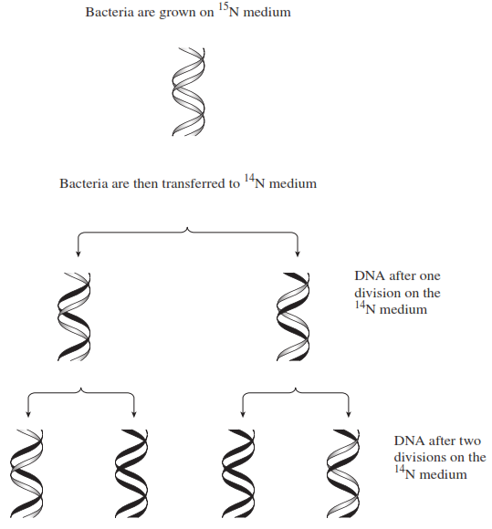

(a)     Describe how the proportion of DNA that contained 15N changed at each division when bacteria were grown on the 14N medium.

___________________________________________________________________

___________________________________________________________________

___________________________________________________________________

___________________________________________________________________

**(2)**

(b)     The change in the proportion of DNA containing 15N is due to the way in which DNA replicates. Explain how.

___________________________________________________________________

___________________________________________________________________

___________________________________________________________________

**(2)**

**(Total 4 marks)**

**Q2.**

The diagram shows a molecule of DNA.  It is replicating.

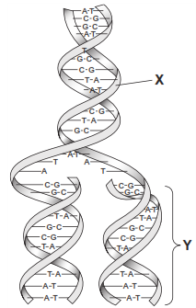

(a)     Name **two** substances in the region labelled **X**.

1. _________________________________________________________________

2. _________________________________________________________________

**(1)**

(b)     Describe how, after the parent DNA strands separated, the second strand of DNA in region **Y** was formed.

___________________________________________________________________

___________________________________________________________________

___________________________________________________________________

___________________________________________________________________

___________________________________________________________________

___________________________________________________________________

(*Extra space*) ________________________________________________________

**(3)**

**(Total 4 marks)**

**Q3.**

The diagram shows part of a DNA molecule.

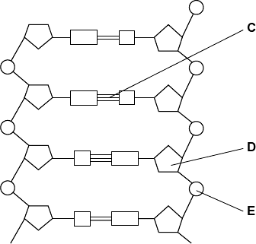

(a)     (i)      DNA is a polymer. What is the evidence from the diagram that DNA is a polymer?

______________________________________________________________

______________________________________________________________

______________________________________________________________

**(1)**

(ii)     Name the parts of the diagram labelled **C**, **D** and **E**.

Part **C**                       ________________________

Part **D**                       ________________________

Part **E**                       ________________________

**(3)**

(iii)    In a piece of DNA, 34% of the bases were thymine.

Complete the table to show the names and percentages of the other bases.

|  |  |
| --- | --- |
| **Name of base** | **Percentage** |
| Thymine | 34 |
|  |  |
|  | 34 |
|  |  |

**(2)**

(b)     A polypeptide has 51 amino acids in its primary structure.

(i)      What is the minimum number of DNA bases required to code for the amino acids in this polypeptide?



**(1)**

(ii)     The gene for this polypeptide contains more than this number of bases.

Explain why

______________________________________________________________

______________________________________________________________

______________________________________________________________

**(1)**

**(Total 8 marks)**

**Q4.**

The following figure represents part of a DNA molecule.

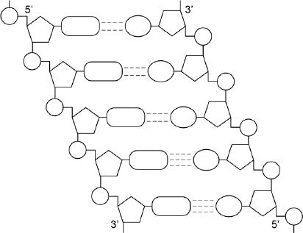

(a)     Draw a box around a single nucleotide.

**(1)**

The table below shows the percentage of bases in each of the strands of a DNA molecule.

|  |  |  |  |  |
| --- | --- | --- | --- | --- |
| **DNA strand** | **Percentage of each base** | | | |
| **A** | **C** | **G** | **T** |
| Strand **1** | 16 |  |  |  |
| Strand **2** |  | 21 | 34 |  |

(b)     Complete the table by adding the missing values.

**(2)**

(c)     During replication, the two DNA strands separate and each acts as a template for the production of a new strand. As new DNA strands are produced, nucleotides can only be added in the 5’ to 3’ direction.

Use the figure in part **(a)** and your knowledge of enzyme action and DNA replication to explain why new nucleotides can only be added in a 5’ to 3’ direction.

___________________________________________________________________

___________________________________________________________________

___________________________________________________________________

___________________________________________________________________

___________________________________________________________________

___________________________________________________________________

___________________________________________________________________

**(4)**

**(Total 7 marks)**

**Q5.**

**Figure 1** shows one base pair of a DNA molecule.

**Figure 1**

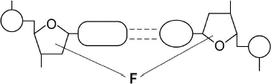

(a)     Name part **F** of each nucleotide.

___________________________________________________________________

**(1)**

(b)     Scientists determined that a sample of DNA contained 18% adenine.

What were the percentages of thymine and guanine in this sample of DNA?

|  |  |
| --- | --- |
| Percentage of thymine |  |
| Percentage of guanine |  |

**(2)**

During replication, the two strands of a DNA molecule separate and each acts as a template for the production of a new strand.

**Figure 2** represents DNA replication.

**Figure 2**

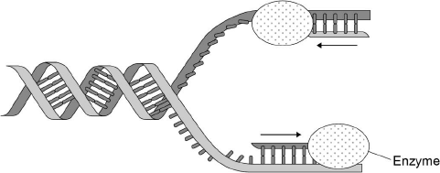

(c)     Name the enzyme shown in **Figure 2**.

___________________________________________________________________

**(1)**

The arrows in **Figure 2** show the directions in which each new DNA strand is being produced.

(d)     Use **Figure 1, Figure 2** and your knowledge of enzyme action to explain why the arrows point in opposite directions.

___________________________________________________________________

___________________________________________________________________

___________________________________________________________________

___________________________________________________________________

___________________________________________________________________

___________________________________________________________________

___________________________________________________________________

___________________________________________________________________

**(4)**

**(Total 8 marks)**

Mark schemes

**Q1.**

(a)     Decreases by 50%;

Per generation / per division;

*Only accessible if linked to first marking point*

***OR***

15N makes up ½ after 1 division;

Makes up ¼ after 2nd division;

**2**

(b)     In DNA replication strands separate;  
Each acts as template (for formation of new strand);  
One strand in each new molecule / semi-conservative replication;  
New strands made using 14N.

**2 max**

**[4]**

**Q2.**

(a)     (Pentose) sugar/deoxyribose and phosphate;

*Reject ribose and phosphorus*

**1**

(b)     Semi-conservative replication;  
Complementary pairing;  
Hydrogen bonding (of bases/nucleotides);  
Condensation/described of nucleotides;  
DNA polymerase involved;

*Accept example (A, T and C, G)*

**3 max**

**[4]**

**Q3.**

(a)     (i)     Repeating units / nucleotides / monomer / molecules;

*Allow more than one, but reject two*

**1**

(ii)     1.      C = hydrogen bonds;

2.      D = deoxyribose;

*Ignore sugar*

3.      E = phosphate;

*Ignore phosphorus, Ignore molecule*

**3**

(iii)

|  |  |  |
| --- | --- | --- |
|  | **Name of base** | **Percentage** |
|  | Thymine | 34 |
|  | Cytosine / Guanine | 16 |
|  | Adenine | 34 |
|  | Cytosine / Guanine | 16 |

*Spelling must be correct to gain MP1*

*First mark = names correct*

*Second mark = % correct, with adenine as 34%*

**2**

(b)     (i)     153;

**1**

(ii)     Some regions of the gene are non-coding / introns / start / stop code / triplet / there are two DNA strands;

*Allow addition mutation*

*Ignore unqualified reference to mutation*

*Accept reference to introns and exons if given together*

*Ignore ‘junk’ DNA / multiple repeats*

**1**

**[8]**

**Q4.**

(a)      Box around single nucleotide.

**1**

(b)

|  |  |  |  |  |
| --- | --- | --- | --- | --- |
| **DNA strand** | **Percentage of each base** | | | |
| **A** | **C** | **G** | **T** |
| Strand **1** | (16) | **34** | **21** | **29** |
| Strand **2** | **29** | (21) | (34) | **16** |

2 rows correct = 2 marks;

1 row correct = 1 mark.

**2**

(c)     1.      Reference to DNA polymerase;

2.      (Which is) specific;

3.      Only complementary with / binds to 5’ end (of strand);

*Reject hydrogen bonds / base pairing*

4.      Shapes of 5’ end and 3’ end are different / description of how different.

**4**

**[7]**

**Q5.**

(a)     Deoxyribose.

**1**

(b)     1.      Thymine 18 (%);

2.      Guanine 32 (%).

**2**

(c)     DNA polymerase.

**1**

(d)     1.      (**Figure 1** shows) DNA has antiparallel strands / described;

2.      (**Figure 1** shows) shape of the nucleotides is different / nucleotides aligned  differently;

3.      Enzymes have active sites with specific shape;

4.      Only substrates with complementary shape / only the 3’ end can bind with active site of enzyme / active site of DNA polymerase.

**4**

**[8]**