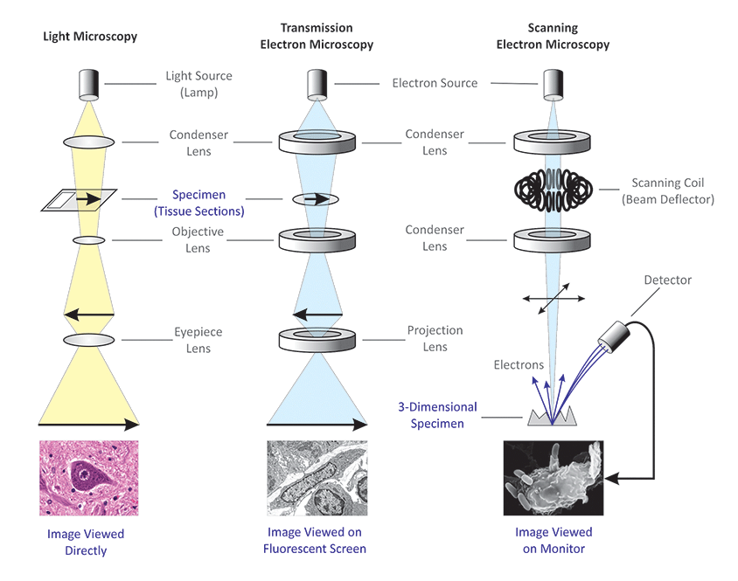

**3.2.1 Cell Structure**

|  |  |  |  |  |
| --- | --- | --- | --- | --- |
| **Key info** | **Topic:** Cell structure  **Synoptic Link:** Biological molecules, enzymes, transport across membranes  **Text book pages: 56-82** | | | |
| **Step 1** | **Use the tutorial (GOL), presentation (GOL), video links and text book to complete the independent pack.** | | | |
| **Step 2** | **Learning outcome** | **I understand this** | **I can recall this** | **I need to revisit this** |
| Recall the structure of eukaryotic cells (plant and animal) |  |  |  |
| Describe the role of the main organelles in a cell |  |  |  |
| Recall the structure of a prokaryotic cell |  |  |  |
| Recall the structure of a virus |  |  |  |
| Describe the differences between optical and electron microscopes, and explain their limitations |  |  |  |
| Calculate magnification and actual size of organelles from micrographs |  |  |  |
| Explain how cell fractionation and ultracentrifugation can be used to study individual organelles |  |  |  |
| **Step 3** | **In lesson:** you will be undertaking activities to develop your understanding of the learning objectives and able to add to your notes. | | | |

**Specification Content**

|  |
| --- |
| **3.2.1.1 Structure of eukaryotic cells**  The structure of eukaryotic cells, restricted to the structure and function of:  • cell-surface membrane  • nucleus (containing chromosomes, consisting of protein-bound, linear DNA, and one or more nucleoli)  • mitochondria  • chloroplasts (in plants and algae)  • Golgi apparatus and Golgi vesicles  • lysosomes (a type of Golgi vesicle that releases lysozymes)  • ribosomes  • rough endoplasmic reticulum and smooth endoplasmic reticulum  • cell wall (in plants, algae and fungi)  • cell vacuole (in plants).  In complex multicellular organisms, eukaryotic cells become specialised for specific functions. Specialised cells are organised into tissues, tissues into organs and organs into systems.  Students should be able to apply their knowledge of these features in explaining adaptations of eukaryotic cells. |
| **3.2.1.2 Structure of prokaryotic cells and of viruses**  Prokaryotic cells are much smaller than eukaryotic cells. They also differ from eukaryotic cells in having:  • cytoplasm that lacks membrane-bound organelles  • smaller ribosomes  • no nucleus; instead they have a single circular DNA molecule that is free in the cytoplasm and is not associated with proteins  • a cell wall that contains murein, a glycoprotein.  In addition, many prokaryotic cells have:  • one or more plasmids  • a capsule surrounding the cell  • one or more flagella.  Details of these structural differences are not required.  Viruses are acellular and non-living. The structure of virus particles to include genetic material, capsid and attachment protein. |
| **3.2.1.3 Methods of studying cells**  The principles and limitations of optical microscopes, transmission electron microscopes and scanning electron microscopes.  Measuring the size of an object viewed with an optical microscope. The difference between magnification and resolution.  Use of the formula: magnification = size of image size of real object  Principles of cell fractionation and ultracentrifugation as used to separate cell components.  Students should be able to appreciate that there was a considerable period of time during which the scientific community distinguished between artefacts and cell organelles. |

**3.2.1.1 Structure of eukaryotic cells**

Each cell can be thought of as a metabolic compartment where chemical processes take place. Cells are often adapted to perform particular functions. Each cell type has a particular internal structure to do its job and this is known as the ultrastructure. Eukaryotic cells have distinct membrane-bound organelles. Electron microscopes have allowed biologists to see the structure of organelles within cells.

There are four types of Eukaryotic cell:

1. Plants
2. Animals
3. Fungi
4. Algae

Label the general diagram of a eukaryotic animal cell below:-

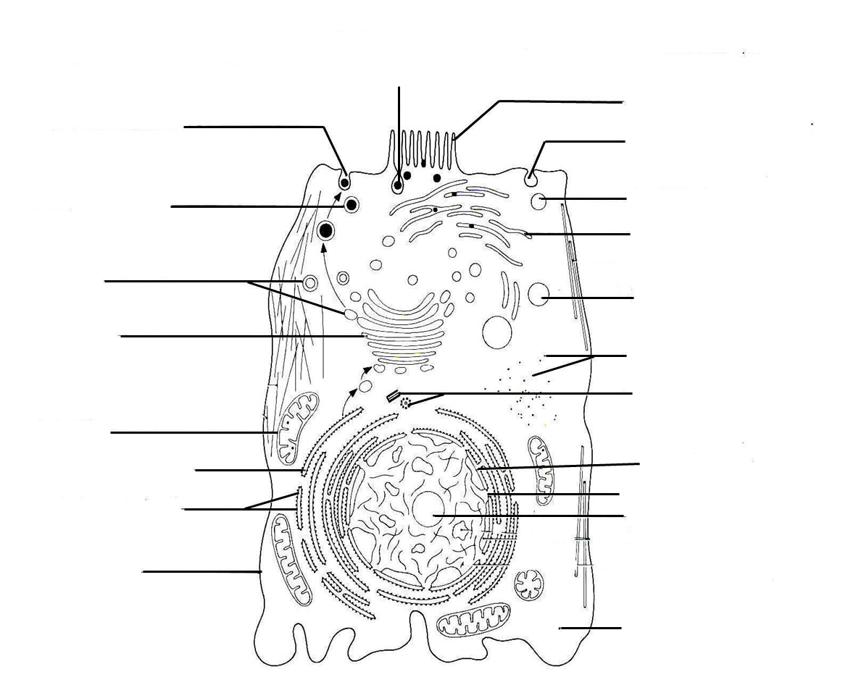

Label the general diagram of a eukaryotic plant cell below:-

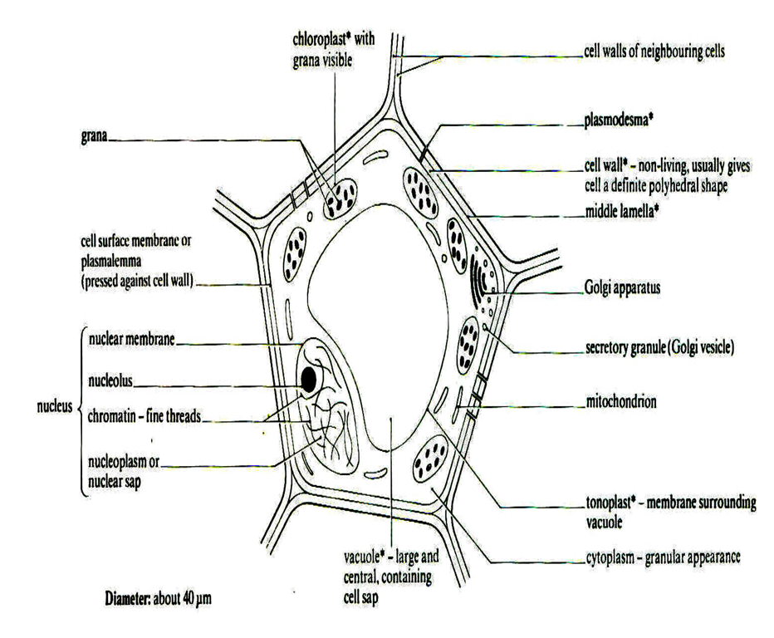

Fungal cells as similar to plant cell but:

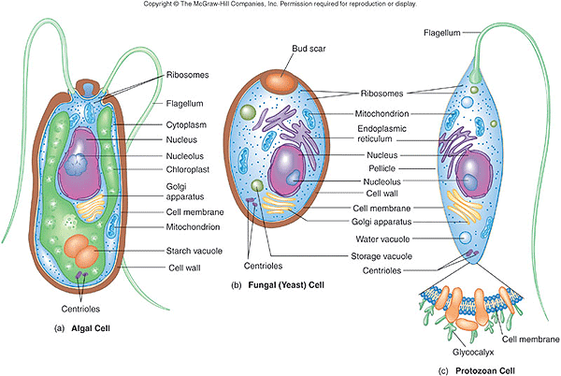

* Have no chloroplasts
* Cell wall made of chitin not cellulose.
* Can be unicellular (yeast) or multicellular

Algal cells have the same organelles as plant cells but:

* Can be multicellular (seaweed) and unicellular (algae)
* Chloroplasts are a different size and shape
* May have a flagella that moves them towards the light

**Eukaryotic cell structure research activity**

**References**

Genetics Utah – Amazing cells section

<http://learn.genetics.utah.edu/content/cells/>

Inside the Cell-National Institute of General Medicine Sciences website – An owners guide to the cell

<http://publications.nigms.nih.gov/insidethecell/>

Visit Bozeman and watch his video

<http://www.bozemanscience.com/043-cellular-organelles>

Other videos

<https://www.youtube.com/watch?v=URUJD5NEXC8>

<http://martinezbio.weebly.com/cell-organelles.html>

Make sure that you have completed and understood the structure and function of the organelles within a cell and have filled out the table below

| Organelle | Description | Function | Size (µm) |
| --- | --- | --- | --- |
| **Cell surface membrane**  Ha08lnew |  |  |  |
| **Nucleus**  http://www.lifesci.sussex.ac.uk/home/Julian_Thorpe/tem29.jpg  Nuclear envelope  Nuclear pores  Nucleoplasm  Chromosomes  Nucleolus |  |  |  |
| **Mitochondria**  Cristae  Matrix  粒線體 |  |  |  |
| **Chloroplasts**  The Chloroplast envelope  The grana  Thylakoids  Stroma  http://www.uic.edu/classes/bios/bios100/lecturesf04am/em-chloroplast1.gif |  |  |  |
| **Golgi apparatus**  [Picture](http://awkwardrevision.weebly.com/uploads/1/2/3/6/12361647/266072223_orig.jpg?255) |  |  |  |
| **Golgi vesicles** |  |  |  |
| **Lysosomes**  Picture |  |  |  |
| **Ribosomes 70s and 80s**  http://awkwardrevision.weebly.com/uploads/1/2/3/6/12361647/5034489_orig.jpg |  |  |  |
| **Rough endoplasmic reticulum**  [Picture](http://awkwardrevision.weebly.com/uploads/1/2/3/6/12361647/290105_orig.jpg) |  |  |  |
| **Smooth endoplasmic reticulum**  Picture |  |  |  |
| vacuole electron microscope view**Cell vacuole** |  |  |  |
| **Cell Wall** Plant  Fungi  Algal  Middle lamella  Plasmodesmata |  |  |  |
| **Centrioles**  [http://madsci.org/posts/archives/2008-08/1218812179.Cb.3.jpg](http://www.google.co.uk/url?sa=i&rct=j&q=&esrc=s&frm=1&source=images&cd=&cad=rja&uact=8&ved=0CAcQjRxqFQoTCIKPqO70yMcCFYJdGgodQvQCLw&url=http://madsci.org/posts/archives/2008-08/1218812179.Cb.r.html&ei=cNPeVYKXCYK7acLoi_gC&psig=AFQjCNGUGLG5gHUa6yjlPf2YHXC6aN_tpg&ust=1440752875210494) |  |  |  |

**Cell specialisation and organisation**

As each organelle has its own function it is possible to deduce the role of a cell by looking at the number and size of the organelles it contains.

**Group work**

Look at the picture of your cell

Are there large numbers of any organelles?

What are the functions of these organelles?

Are any of the cell structures a strange shape?

How are the structures related to the function of the cell?

1. Type of cell: Neutrophil

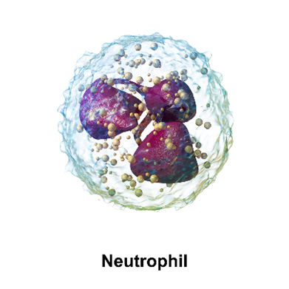

|  |  |
| --- | --- |
| Structure | Relate the structure to function |
|  |  |

Type of cell : **Epithelial cell**

|  |  |
| --- | --- |
| Structure | Relate the structure to function |
|  |  |

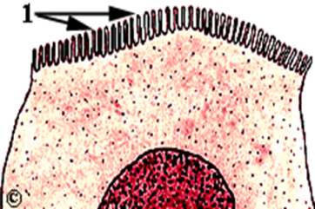

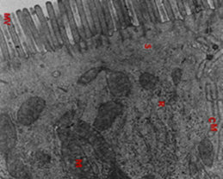

1. Type of cell: Red blood cell

|  |  |
| --- | --- |
| Structure | Relate the structure to function |
|  |  |

[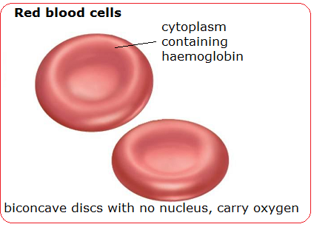](http://biology-igcse.weebly.com/blood-cells---structure-and-functions.html)

1. Type of Cell : **Pancreatic cell**

|  |  |
| --- | --- |
| Structure | Relate the structure to function |
|  |  |

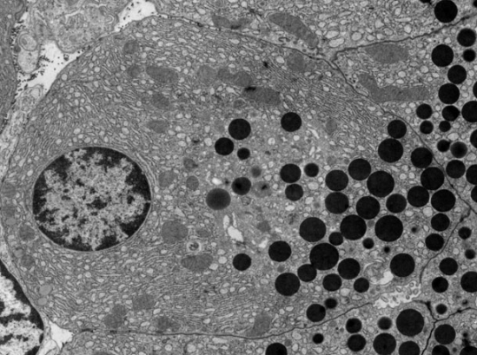

1. Type of cell: **Liver cell**

|  |  |
| --- | --- |
| Structure | Relate the structure to function |
|  |  |

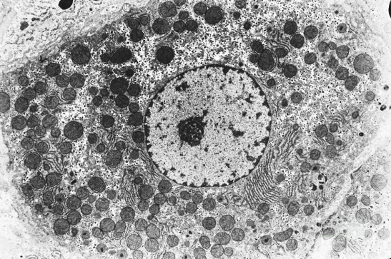

[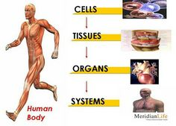](https://www.google.co.uk/url?sa=i&rct=j&q=&esrc=s&source=images&cd=&cad=rja&uact=8&ved=0CAcQjRxqFQoTCObzvemF9sYCFdMH2wodm3wPFQ&url=https://www.pinterest.com/ilovecarrie/ordering-cells-tissue-organs/&ei=J2GzVabECNOP7Aab-b2oAQ&bvm=bv.98717601,d.d24&psig=AFQjCNHJ4yF6Lw4-kUjVoOgm6cjT2SPScQ&ust=1437905566629004)**Cell organisation**

**Cells** are specialised to perform specific functions.

**Tissues** are similar cells similar cells performing a similar function **Organs** are tissues aggregated together that perform a particular function.

**Organ systems** are organs that are group and work together to perform a particular function

An example of cell organisation is shown below:

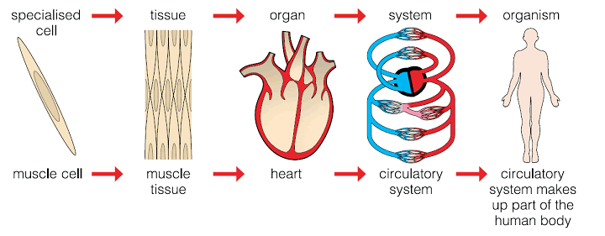

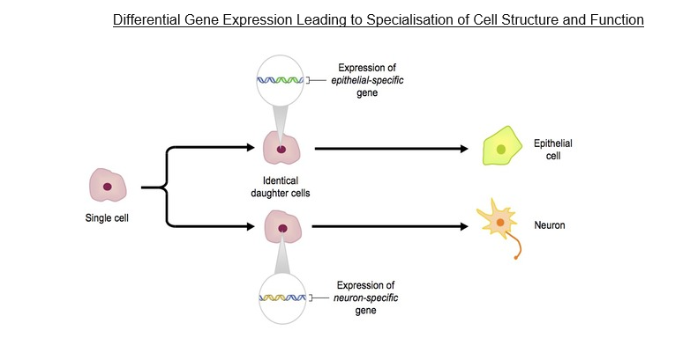

**How do cells become specialised?**

Once an egg is fertilized all cells produced are the product of mitosis so they contain identical genes. In certain cells, only some genes are switch on in any one cell at any one time. Different genes are switch on in each type of specialised cell. The rest of the genes are switched off.

**Tissues**

Which cells work together to make muscle tissue? ......................................................................................

**Epithelial cells** are specialised depending on their function. They line surfaces of organs and often have a secretory or protective function.

|  |  |
| --- | --- |
| Type of epithelial cell | Where it is found, function related to structure |
| Squamous epithelium | Flat thin cells that line the organs where diffusion takes place e.g. lungs |
| Ciliated epithelium | Lines ducts such as the trachea. Cilia are used to move mucus over the epithelial surface |
| Simple columnar epithelium with microvilli | Increases the surface area of the cell by the folding of the plasma membrane. Lines area where absorption/secretion occurs such as the small intestine. |

**Organ**

List the tissues that make up the stomach.

…………………………………………………………………………………………………………………………………………………………

List the tissues that make up a leaf.

…………………………………………………………………………………………………………………………………………………………

**Organ Systems**

Which organs make up the digestive system?

…………………………………………………………………………………………………………………………………………………………

Which organs make up the respiratory system?

…………………………………………………………………………………………………………………………………………………………

Which organs make up the circulatory system?

…………………………………………………………………………………………………………………………………………………………

**Structure of Prokaryotic cells**

Prokaryotic cells are single celled organisms that are much **smaller (0.1-10µm in length)** and simpler than eukaryotic cells. Bacteria (eg *E.coli*) are prokaryotes. They all **do not have any membrane bound organelles** like a nucleus in their cytoplasm.

Label the generalised prokaryotic cell below

*cytoplasm, cell wall, capsule, flagella, pili, plasmid, ribosomes (70s), mesosome, large circular DNA (nucleoid), and cell membrane.*

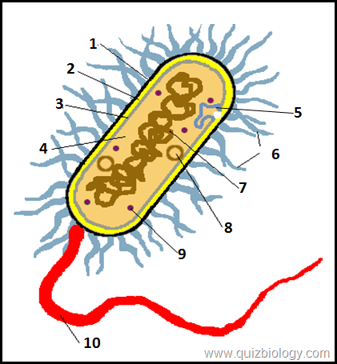

Complete the table below explaining the structure and role of the difference structures of bacterial cells.

|  |  |  |
| --- | --- | --- |
| **Cell structure** | **Description structure** | **Function** |
| Cell membrane |  |  |
| Cell wall |  |  |
| Capsule |  |  |
| Ribosomes |  |  |
| Circular DNA |  |  |
| Plasmid |  |  |

Complete the table below that shows a comparison of prokaryotic and eukaryotic cells.

|  |  |  |
| --- | --- | --- |
| **Structure** | **Prokaryotic cells** | **Eukaryotic cells** |
| Nucleus |  |  |
| DNA |  |  |
| Organelles |  |  |
| Chloroplasts |  |  |
| Ribosomes |  |  |
| Cell wall |  |  |
| Capsule |  |  |

**Structure of Viruses**

* 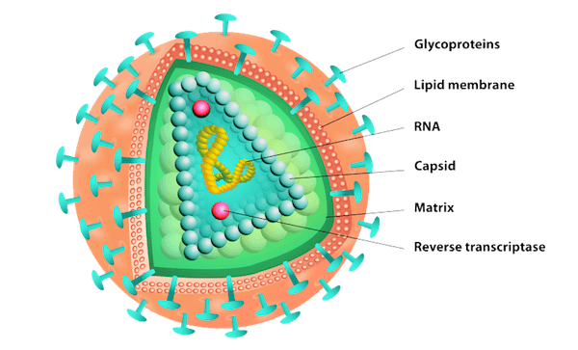Viruses are acellular, non-living particles. They are smaller than prokaryotes (**20-300nm).**
* They contain **nucleic acids such as DNA or RNA**. They can only replicate (multiply) inside a **living host cell**.
* The nucleic acid is enclosed within a protein coat called a **capsid.**
* Some viruses like HIV or Influenza are surrounded by a **lipid envelope.** The lipid envelope helps the virus avoid the host’s immune system.
* f the virus is not surrounded by a **lipid envelope** the capsid contains **attachment proteins** which are essential to allow the virus to identify and **attach to the host cell** (e.g. adenoviruses).

**3.2.1.3 Methods of studying cells**

**Preparatory work: video on history of microscopes and cell biology**

<https://www.youtube.com/watch?v=nc9aSq22nmo>

**Microscopy**

Cells were first seen in 1665 by **Robert Hooke** (who named them after monks' cells in a monastery), and were studied in more detail by Leeuwehoek using a primitive microscope. The cell is the basic unit of life. However with a few exceptions cells are not visible to the naked eye. Therefore microscopes are used to produce a magnified image.

There are 2 types of microscope – electron and light microscopes

[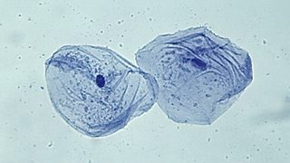](http://www.google.co.uk/url?sa=i&rct=j&q=&esrc=s&source=images&cd=&cad=rja&uact=8&ved=0CAcQjRxqFQoTCIuu74Lv-sYCFYkq2wod78EFxw&url=http://www.bbc.co.uk/education/guides/z9hyvcw/revision/2&ei=Vei1VcuvA4nV7Abvg5e4DA&bvm=bv.98717601,d.d24&psig=AFQjCNH8BZKaL-90r26zPpkhIphwIa_wHw&ust=1438071223561179)[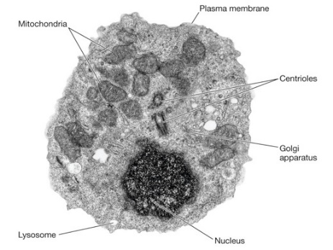](http://www.google.co.uk/url?sa=i&rct=j&q=&esrc=s&source=images&cd=&cad=rja&uact=8&ved=0CAcQjRxqFQoTCJzU0Onv-sYCFcFL2wodUdQNHQ&url=http://technewz.co/aabbdc3/animal-cell-under-electron-microscope.html&ei=LOm1VZyOIsGX7QbRqLfoAQ&psig=AFQjCNGG1s6OVlQjg49QOSPgqKz4l8r7gQ&ust=1438071312424251)Image A –Electron microscope Image B – Light microscope

What are the differences between Image A and image B?

…………………………………………………………………………………………………………………………………………………………

…………………………………………………………………………………………………………………………………………………………

In biology small molecules are measured in mm, µm and nm. A light microscope can magnify an image up to 100nm while an electron microscope can magnify an image up to 1nm

|  |  |  |
| --- | --- | --- |
| Unit | Symbol | Equivalent in metres |
| Kilometre | Km | 1000m |
| Metre | M | 1m |
| millimetre | Mm | 0.001m |
| micrometre | µm | 0.000001m |
| nanometre | nm | 0.000000001m |

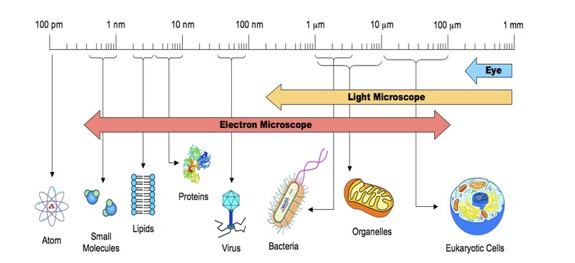

**Magnification and resolution**

Definition **Object:** …………………………………………………………………………..

Definition **Image:** ……………………………………………………………………………

Definition**: Magnification** is the increase in the apparent size of the object. I.e. the extent to which the image has been enlarged.

Definition**: Resolution** is the ability to distinguish between 2 objects that are close together so it is an indication of the degree of DETAIL that can be seen. In other words greater resolution means greater clarity, that is the image is clearer and more precise.

These pictures have the same magnification but different resolution.



What type of microscope gives better resolution? .......................................................................

Why?

………………………………………………………………………………………………………………………………………………………………………………………………………………………………………………………………………………………………………………………………………………………………………………………………………………………………………………………………………………

What is the resolution of a light microscope? ............................................

What is the resolution of an electron microscope? ......................................

Increasing magnification does not always lead to an increase in resolution in fact the object can become more blurred. The resolution of an image is limited by the wavelength of radiation used to view the sample.

**Calculating the size of organelles**

**The Log Scale**

When measuring the real size of organelles we use the Log scale of measurement.

The Log scale:

|  |  |  |
| --- | --- | --- |
| Unit | Symbol | Equivalent in metres |
| Kilometre | Km | 103 (1000m) |
| Metre | M | 1m |
| millimetre | Mm | 10-3 (0.001m) |
| micrometre | µm | 10-6 (0.000001m) |
| nanometre | nm | 10-9 (0.000000001m) |

**Standard form**: A general term meaning "written down in the way most commonly accepted"

<http://www.icoachmath.com/math_dictionary/standard_form.html>

In Biology standard form is used for very large numbers or very small numbers .i.e. Instead of writing 0.0001m, you would write 1x10-4 m or instead of 5000km you would write 5x103

When using standard form the first number always has to be between 1 and 10

67x 104 is **not** standard form

What would standard form of 67x 104  be? ………………………………………….

**Practice questions:**

1. Convert the following measurements into mm.
   1. 5m……………… b. 0.8m ………………………

c. 500 µm …………. D. 10 000nm ………………..

1. Convert the following measurements into µm
   1. 0.75mm…………………. b. 0.3mm…………………………….

c.1500nm……………………... d. 10 000nm…………………………

1. Convert the following measurements into nm
   1. 0.75µm…………………….. b. 0.5mm………………………………

c. 3 µm …………………………..d. 0.1 µm………………………………

**Magnification triangle**

Fill in the equation triangle for calculating the size of image, magnification and size of object.

1. To calculate the actual **size** of an organelle you must:-
2. measure the photograph of the organelle in mm and divide by x1000 to get µm
3. the measured length must be divided by the magnification of the photograph:

e.g. length of organelle = 44 mm, magnification of photograph = x11, 000

**Actual length = image length**

**magnification of photograph**

44 x1000 = 44,000 **µm**

Actual length = 44,000 = 4 **µm**

11,000

1. To calculate the **magnification** of an organelle you must:

**magnification = size of image**

**real object size**

Magnification = Size of image (with ruler) ÷ Actual size of object (according to scale bar)

Or you can:-

1. measure the actual length of the scale provided in mm
2. multiply this length by x1000 to convert to **µm**
3. divide this figure by the scale value

e.g. actual length of scale = 16 mm

scale value = 0.1um

**magnification = actual length of scale x 1000 (size of image) scale value (real object size)**

16 mm x 1000 = x160,000 (magnification)

* 1. µm

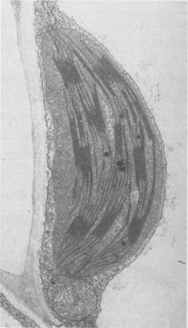**Now identify and then calculate the size and magnification of these organelles**

1. **Calculating size of organelles**

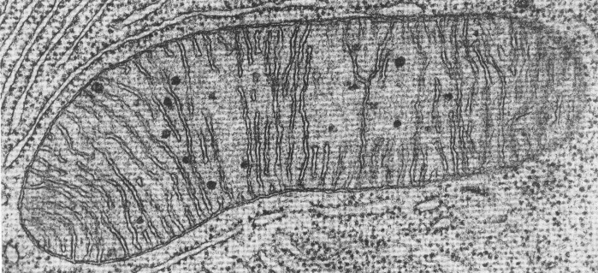

Magnification x

5,000

Magnification x 30,000

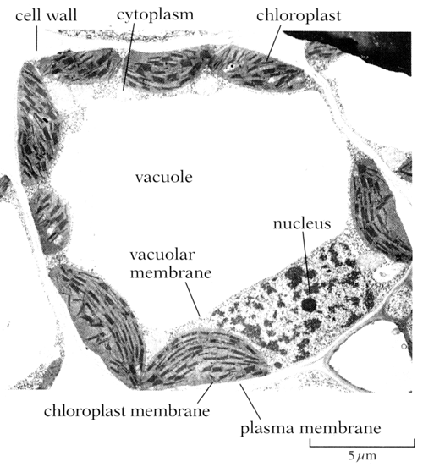

**Calculating magnification of organelles**

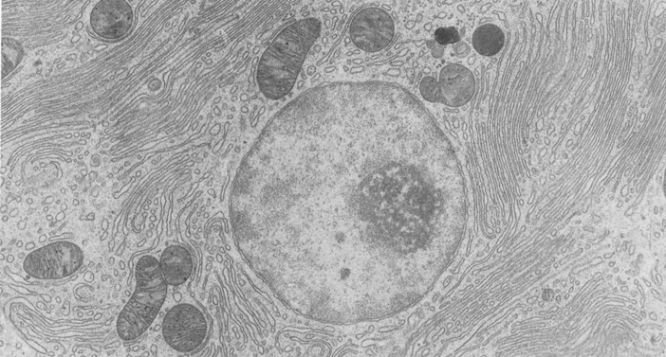

1 um

**The Light microscope**

Light microscopes have relatively poor resolution as the result of the **relatively long wavelength of light.**



How does a light microscope work?

**Eyepiece lens** which magnifies and focuses the image from the objective onto the eye.

**Objective lens** which collects light passing through the specimen and produces a magnified image.

**Condenser lens** which focuses light onto the specimen.

Light microscopes also known as compound microscopes, which means that several lenses are used to obtain high magnification. Light microscopes have two lenses combined to give greater magnification (objective and eye piece lenses). To work out the total magnification of an object under a light microscope multiply the eyepiece magnification with the objective lens magnification.

E.g. Eyepiece x10, Objective x 5 (5x10) = Total magnification x50

Some optical microscopes provide Magnification up to x1500.

Fill in the missing blanks in the table below.

|  |  |  |
| --- | --- | --- |
| Eyepiece Lens | Objective Lens | Magnification |
| X 10 | X 4 |  |
|  | X 4 | X 20 |
| X 10 | X 10 |  |
| X 10 |  | X 400 |

**The Electron microscope Preparatory work**

Look at the following website for information on electron microscope

<http://sciencelearn.org.nz/Contexts/Exploring-with-Microscopes/Sci-Media/Interactives/Which-microscope>

**The Electron microscope**

Light microscopes have a poor resolution as a result of the relatively long wavelength of light. In the 1930’s a microscope was developed that used an **electron beam** rather than light. Electron microscopes use a beam of electrons to "illuminate" the specimen. This may seem strange, but electrons behave like waves and can easily be produced (using a hot wire), focused (using **electromagnets**) and detected (using **photographic film**). Electrons have a smaller wavelength and so have a better resolving power than light microscopes. The best modern electron microscopes can now resolve objects 0.1nm apart which is 2000 times better than a light microscope.

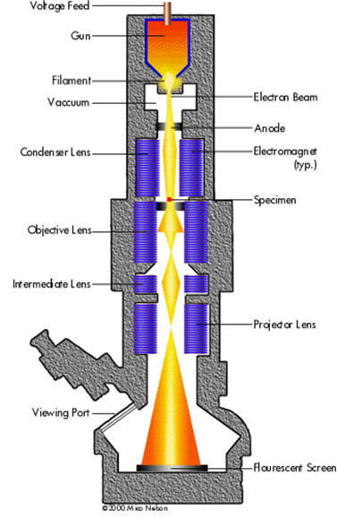

**How does an electron microscope work?**

Uses a beam of electronsto give a resolution of 1nm

Electrons have a negative charge and therefore the electron microscopes can use electromagnets to focus the beam.

Magnification up to 500 000 times.

Many biological molecules are larger than **1nm** so can be seen by EM

Because electrons are **absorbed** or **deflected** by molecules in the air a vacuum has to be created within the chamber of the electron microscope for it to work effectively.

There are two types of electron microscope.

1. Transmission electron microscopes (TEM)

2. Scanning electron microscopes (SEM)

[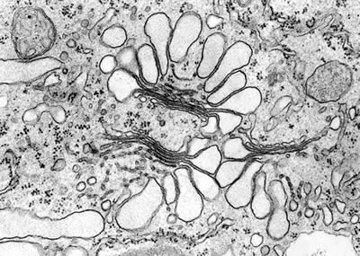](http://www.google.co.uk/url?sa=i&rct=j&q=&esrc=s&source=images&cd=&cad=rja&uact=8&ved=0CAcQjRxqFQoTCIbG0OSl-8YCFScq2wodaZAHwQ&url=http://bms.brookes.ac.uk/research/groups/researchimages/plantcellbiologyimage/golgitem&ei=wSG2VcbhI6fU7AbpoJ6IDA&bvm=bv.98717601,d.ZGU&psig=AFQjCNE8hpLiUFZwypGIilys2bczWTrAOg&ust=1438085905592159)**Transmission Electron microscope (TEM)**

In the space below research and write notes on the TEM. Focus on the following areas.

* + How the microscope works and produces images (Both 2D and 3D)
  + Resolving power of the TEM
  + Limitations of using a TEM

[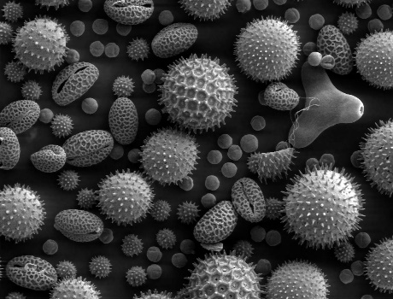](https://www.google.co.uk/url?sa=i&rct=j&q=&esrc=s&source=images&cd=&cad=rja&uact=8&ved=0CAcQjRxqFQoTCNaVodin-8YCFY4t2wodLjMPOQ&url=https://en.wikipedia.org/wiki/Scanning_electron_microscope&ei=wCO2Vda1H47b7Aau5rzIAw&bvm=bv.98717601,d.ZGU&psig=AFQjCNE8YXhnRPnf_BaT3nTkZXgY2_h8Qg&ust=1438086442136160)**Scanning electron microscope (SEM)**

In the space below research and write notes on the SEM. Focus on the following areas.

* + How the microscope works and produces images
  + Resolving power of the SEM
  + Limitations of using a SEM

**Microscope Artefacts**

[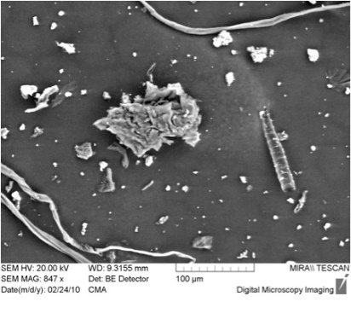](http://www.google.co.uk/url?sa=i&rct=j&q=&esrc=s&source=images&cd=&cad=rja&uact=8&ved=0CAcQjRxqFQoTCOfX8u2p-8YCFegI2wodcIUAUA&url=http://www.tcd.ie/Library/about/exhibitions/preservation-conservation/whystudydust.php&ei=Bia2Vee8LuiR7AbwioKABQ&bvm=bv.98717601,d.ZGU&psig=AFQjCNF63TD3BPawHJk5mBtFgSViiuRdCg&ust=1438087030052479)Dust particles on SEM

Artefacts are things you can see down the microscope that are not part of the cell or specimen. They can be ……………………………………........................................

………………………………………..................................

……………………………………………………………….

Usually made during the …………………………………………………………………..

Very common in ………………………………………….

Why?..............................................................................................................................

How did scientists overcome this problem? .......................................................................................................................................

**Advantages and disadvantages of light and electron microscopes**

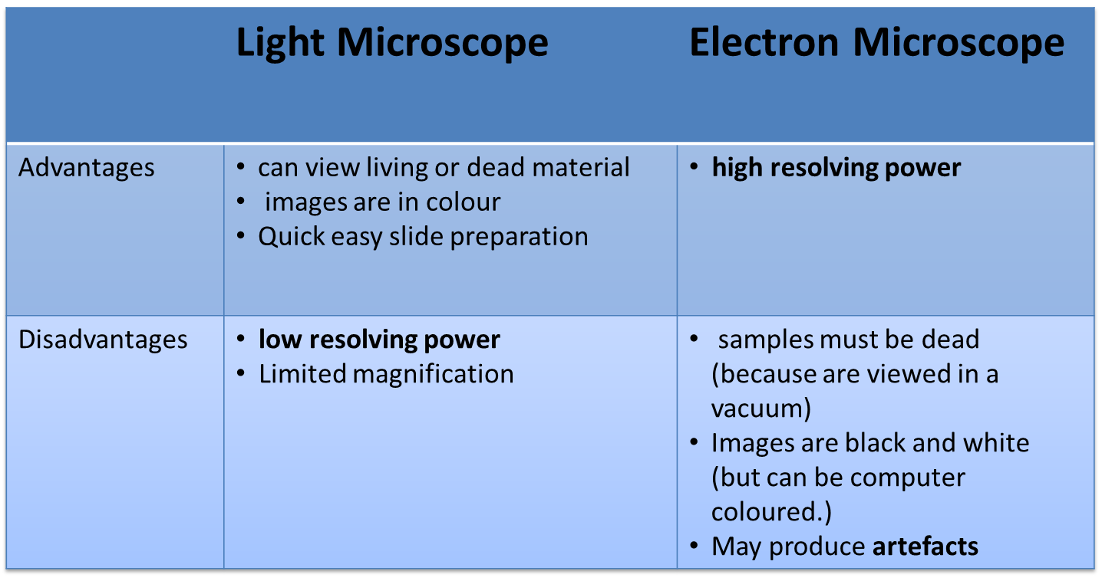

**Cell fractionation**

[**http://www.biologymad.com/master.html?http://www.biologymad.com/cells/cells.htm**](http://www.biologymad.com/master.html?http://www.biologymad.com/cells/cells.htm)

Cell fractionation is a process where cells are broken up and the different organelles they contain are separated out. It is a technique that is used to help study cell structure and function as large numbers of isolated organelles are needed for these studies. The most common method of fractionating cells is to use **differential centrifugation.** It is a two stage process:

1. **Homogenisation**

2. **Ultracentrifugation**

**Homogenisation**

Homogenisation means the breaking open of cells to release their contents.

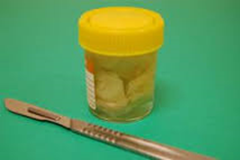

First step is to cut tissue in **ice cold isotonic buffer**. Why?

1. Cold..………………………………………………………

2. Isotonic……………………………………………………

3. Buffer………………………………………………………

The next step is **Homogenisation** which breaks open the cells to release the organelles. The tissue is Ground in a blender to break open cells.

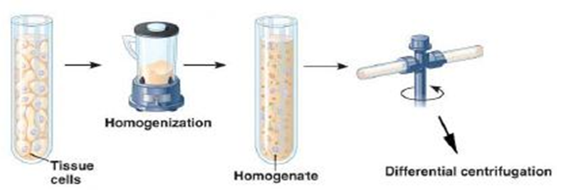What is done to the homogenate before it is centrifuged?

…………………………………

Why?………………………………………………………………………………………...

**Ultracentrifugation**

Ultracentrifugation is the process by which the fragments in the **filtered homogenate** are separated in a **centrifuge**.

Method

1. A suspension of homogenate is placed in a test tube and then centrifuged-The faster the speed at which the tube is spun, the greater the force generated
2. At slow speeds large fragments collect at the bottom of the tube and smaller ones remain near the top in a liquid called the ……………………….
3. These larger fragments (…………………………………………..) are then removed and the **supernatant** remaining is re-spun at a faster speed (more force) and some of the smaller fragments collect at the bottom forming a new pellet
4. By continuing in this way smaller and smaller fragments will be recovered. This is known as ……………………………………………………………… i.e. repeated centrifugation at progressively higher speed will fractionate cell homogenate into their components.

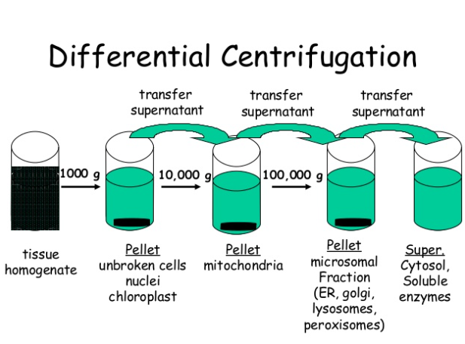

Using the diagram above fill in the blanks:-

At low Speeds the first pellet will contain the large organelles such as nuclei and whole cells. The supernatant will contain:-………………………………………………………………………………………………..

At medium speed the pellet will contain ……………………. and the supernatant will contain:-

…………………………………………………………………………………………………

At high speed the pellet will contain …………………………………… and the supernatant will contain:-

…………………………………………………………………………………………………..

At very high speed the pellet will contain ……………………………, ……………………………… and ……………………………………….. and the supernatant will contain …………………………………………………………

Remember if the sediment contains one type of organelle than the supernatant will contain all the others (if they have not been previously removed).

A more sophisticated separation can be performed by **density gradient centrifugation**. In this method, the cell-free extract is centrifuged in a dense solution (such as sucrose or caesium chloride). The fractions don't pellet, but instead separate out into layers with the most dense fractions near the bottom of the tube. The desired layer can then be pipetted off. This is the technique used in the Meselson-Stahl experiment and it is also used to separate the two types of ribosomes. The terms 70S and 80S refer to their positions in a density gradient.