**3.2 Cells**

**3.2.2 All cells arise from other cells**

|  |  |  |  |  |
| --- | --- | --- | --- | --- |
| **Key info** | **Topic: All cells arise from other cells**  **Resources:**  **Powerpoints on GoL**  3.2.2 All cells arise from other cells  **Synoptic Link:** 3.1 Biological molecules; Nucleic Acids. 3.2.1 Structure of eukaryotic cells  **Text book pages: 77---82** | | | |
| **Step 1** | **Use the notes (GOL), presentation (GOL), video links and text book to complete the independent pack.** | | | |
| **Step 2** | **Learning outcome: tick these off as you go through to highlight your strengths and weaknesses** | **I understand this** | **I can recall this** | **I need to revisit this** |
| Describe the processes that occur during interphase to prepare a cell for division |  |  |  |
| Recognise and explain the appearance of the chromosomes during each phase of mitosis. |  |  |  |
| Calculate the mitotic index from images of cells undergoing mitosis |  |  |  |
| Explain how uncontrolled mitosis can lead to cancer, and define benign and malignant tumours |  |  |  |
| Describe the replication of bacteria and viruses |  |  |  |
| Calculate the actual sizes of cells from micrographs |  |  |  |
| **Step 3** | **In lesson:** you will be undertaking activities to develop your understanding of the learning objectives and able to add to your notes. | | | |

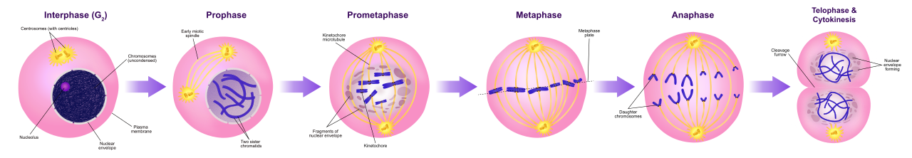

**Specification Content 3.2.2 All cells arise from other cells**

|  |
| --- |
| Within multicellular organisms, not all cells retain the ability to divide. Eukaryotic cells that do retain the ability to divide show a cell cycle.   * DNA replication occurs during the interphase of the cell cycle. * Mitosis is the part of the cell cycle in which a eukaryotic cell divides to produce two daughter cells, each with the identical copies of DNA produced by the parent cell during DNA replication. * The behaviour of chromosomes during interphase, prophase, metaphase, anaphase and telophase of mitosis. The role of spindle fibres attached to centromeres in the separation of chromatids. |
| Students should be able to:  • recognise the stages of the cell cycle: interphase, prophase, metaphase, anaphase and telophase (including cytokinesis)  • explain the appearance of cells in each stage of mitosis. |
| Mitosis is a controlled process. Uncontrolled cell division can lead to the formation of tumours and of cancers. Many cancer treatments are directed at controlling the rate of cell division. |
| Binary fission in prokaryotic cells involves:  • Replication of the circular DNA and of plasmids  • Division of the cytoplasm to produce two daughter cells, each with a single copy of the circular DNA and a variable number of copies of plasmids.  Being non-living, viruses do not undergo cell division. Following injection of their nucleic acid, the infected host cell replicates the virus particles. |
| **Required practical 2**: Preparation of stained squashes of cells from plant root tips; set-up and use of an optical microscope to identify the stages of mitosis in these stained squashes and calculation of a mitotic index.  Students should measure the apparent size of cells in the root tip and calculate their actual size using the formula:  *Actual size=size of image*  *magnification* |

**Preparatory work**

Watch the following video <https://www.youtube.com/watch?v=1cVZBV9tD-A>

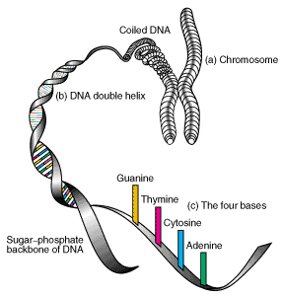**Structure of chromosomes**

Chromosomes are composed of long strands of………… tightly coiled many times around proteins called ……………………. that support its structure and a small amount of RNA

The DNA is in the form of a ……………

……………….. running up the centre of the chromosome

Before division (in interphase) the DNA is partly uncoiled and appears as thin tangled threads. Individual chromosomes can’t be seen. When not distinguishable as individual chromosomes nuclear genetic material is termed …………………………

Draw and label a chromosome:

After replication, but before cell division the chromosomes can be seen as double structures, attached by the ………………………………………………………………….

The 2 strands are called ……………………………………………………………………

Before replication chromosomes are always found in matching pairs, one from the mother and one from the father. What are they called?

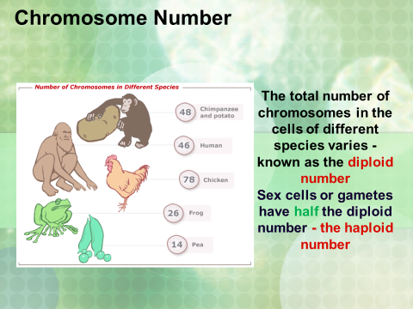…………………………………………………………………………………………………

What is the diploid number (2n)? …………………………………………  
 Does every species have the same diploid number?……………

What is the haploid number?………………………………………………

What type of cell has the haploid number?………………………………

What is the diploid and haploid number for humans?

…………………………………………………………………

**Mitosis and Meiosis**

**Eukaryotic cells**

Eukaryotic cellsdivide either by mitosis or meiosis.

* Mitosis produces …………………………………………………………………………………………………………………………………………………………………………………………………………………………………………………………………………
* Meiosis produces

..............................................................................................................................................................................................................................................................................................

**Mitosis**

Why is the significance of mitosis?

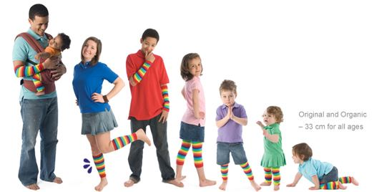1.……………………………………

2. …………………………………..

3. ……………………………………

4 …………………………………….

**Asexual reproduction**

List any advantages or disadvantages of producing genetically identical offspring

Advantages :

………………………………………………………………………………………………………………………………………………………………………………………………………………………………………………………………………………………………

Disadvantages :

………………………………………………………………………………………………………………………………………………………………………………………………………………………………………………………………………………………………

**The cell cycle**

Not all cells in a multicellular organism retain the ability to divide. An example of a cell that retains its ability to divide is a **stem cell**. A cell that has the ability to continuously divide follows a process called the cell cycle.

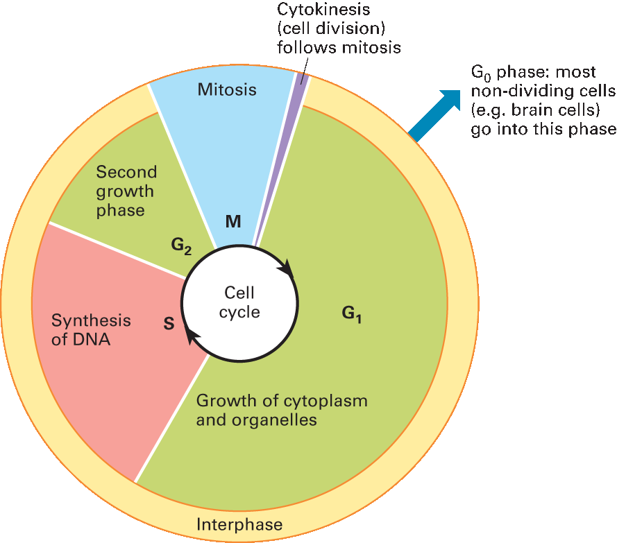

The cell cycle involves three phases

1 …………………………………………………..

2 …………………………………………………..

3 ………………………………………………….

**Interphase**

Interphase is the …………………..phase of the cell cycle. A lot of activity occurs in this stage. The proteins required for ………………………………. are produced in this phase, organelles are …………………… and the cell grows therefore a lot of …………… is required and produced during interphase.

Interphase is split into three phases. They are:-

1. ………………………………………………………………………………………………

2. ………………………………………………………………………………………………

3. ………………………………………………………………………………………………

The processes that take place during interphase are:

1. Synthesis of DNA
2. Synthesis of ATP
3. Synthesis of protein
4. Replication of organelles

**Mitosis**

Mitosis is a relatively short phase of the cell cycle where nuclear division occurs. It consists of four phases

1. ………………………………
2. ………………………………
3. ……………………………….
4. ……………………………….

Complete the following table with a description of each phase.

|  |  |
| --- | --- |
| Phase | Description |
| Prophase |  |
| earlymetaphaseMetaphase |  |
| Anaphase |  |
| Telophase | . |

**Cytokinesis**

It is the physical process of………………………., where the parental cytoplasm divides and ………………………………. are produced.

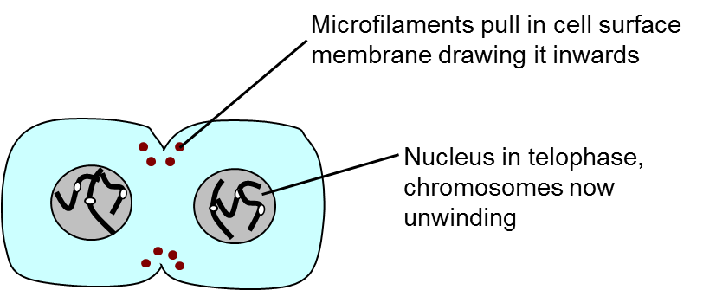

In plant cells cytokinesis is slightly different. Golgi vesicles carrying materials to make the cell wall accumulate in the centre region of the cell. The vesicles then ……………………………………………………to form a ……………….. Inside the vesicles a middle lamella forms with cellulose either side of it. Two separate cells are formed.

**Recall** : In 3.2.1 you should know that the middle lamella is a pectin (gelatinous polysaccharide) layer which functions to cement the cell walls together of two adjoining cells. This is essential to plants as it gives them stability, and allows plants to form plasmodesmata between cells

Differences in mitosis in plant and animal cells

|  |  |
| --- | --- |
| **Animal cell** | **Plant cell** |
|  |  |
|  |  |

**DNA content within the cell cycle**

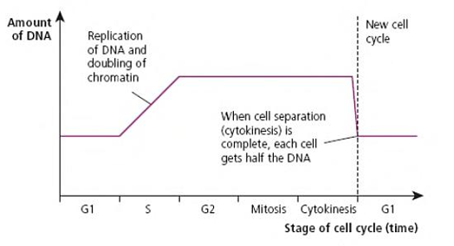

In which phase does DNA replication occur?

………...................

What is the phase when the DNA content is halved?

……………………..

**Cell cycle timing**

Every cell that divides goes through the cell cycle. Interphase is always the longest part of the cycle, followed by telophase, prophase, metaphase and anaphase, however how long they are in each stage depends on the type of cell.

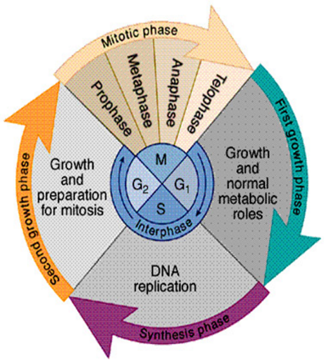Intestinal cells: Divide every 8hrs

Liver cells: divide once per year

Skin epidermal cells: Divide every 24hrs

Onion root tip cells: divide every 20hrs

Nerve cells: do not divide

**Question:**

A scientist is looking at a tissue sample under a microscope. She counts 150 cells undergoing mitosis. Of those 12 cells are in prophase. One complete cycle lasts 0.70 days. How long do the cells spend in prophase? Give your answer in hours. Show your workings.

**Cancer**

Cancer is a group of diseases caused by a growth disorder of cells

Caused by:-

1. …………………………………………………………………………………………………………………………………………..
2. ………………………………………………………………………………………………………………………………….……….

Mutations can be harmless or pathogenic

**How do you measure if a tissue is cancerous or not?**

Measure **Mitotic index** which is the proportion of cells in a tissue sample undergoing mitosis. Some tissues you would expect a high mitotic index like root tip cells (meristem cells) and others you would not (liver cells).

Write down the equation for mitotic index below:

**What Causes Cancer?**

A …………………. in a gene that controls the cell cycle causing ………………………………. leading to the development of a tumour. Cancer is a group of about 200 diseases and can occur in any organ but is most common in lungs, prostate gland, breast, ovaries, stomach, oesophagus and pancreas.

Two Types of tumour

1. **Benign** (non Cancerous) tumours. These ……………………………………… from their point of origin but they may still be painful because they compress surrounding tissues and displace them. Benign tumours are usually encased in a ………………………… and do not ……………… the tissue in which they originate. They do not cause cancer and do not metastasise.
2. **Malignant (Cancerous) tumours.** These divide in a more uncontrolled way than benign tumours and can be carried by the………………… …………………………. to invade other tissues, causing secondary cancers. This process is called metastasis.

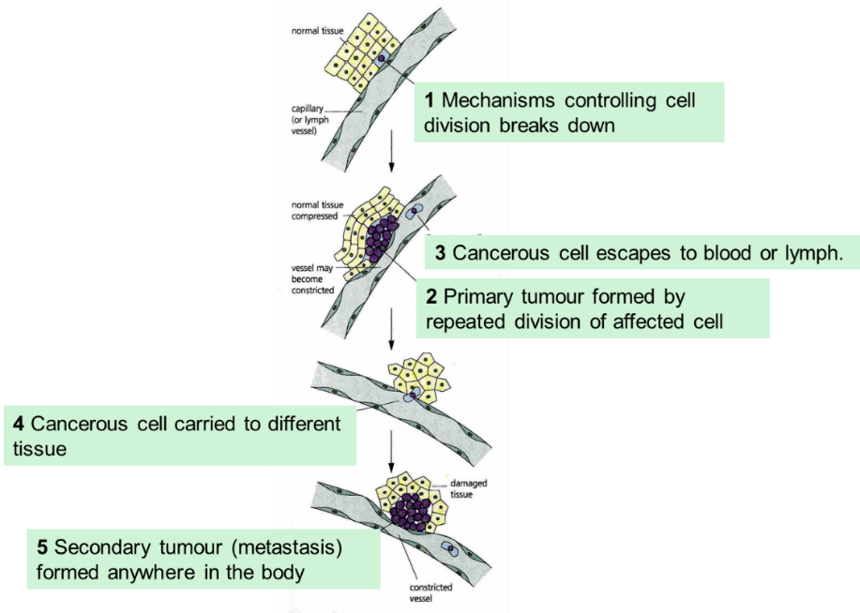Both tumours my damage the organ concerned, cause blockages and exert pressure on other organs.

**Malignant tumour**

The two families of genes that control the cell cycle are:

1. …………………………………………………………………………………….
2. ……………………………………………………………………………………

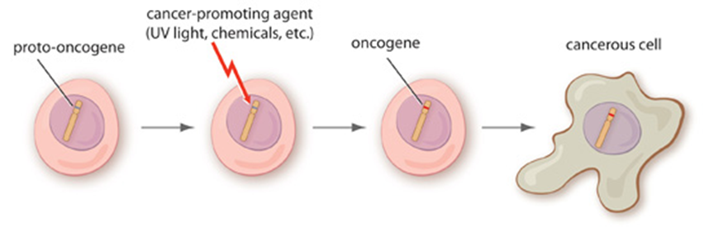A proto-oncogene is a gene that encodes a protein that is involved in …………………………………....

……………………………………..

It can be mutated into a cancer promoting ……………………where the gene is stuck in a state of constant activity leading to uncontrolled growth

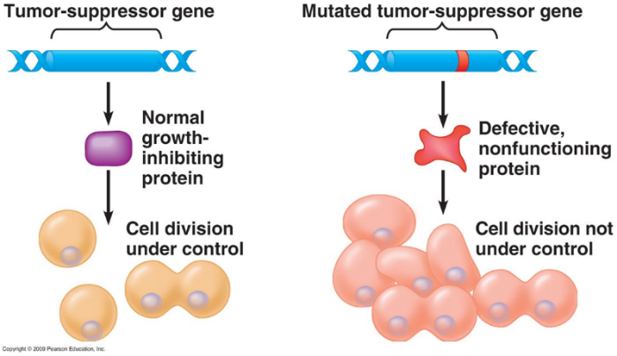

Tumour suppressor genes encode proteins that …………………. ………………………………… Loss of these genes can contribute to the development of cancer

Treatments for cancer are designed to …………………………………………………

……………………………………………………………………………………………….. Will normal cells be killed by cancer treatments?

…………………………………………………………………………………………………..

Why are treatments more effective against cancerous cells than normal cells?

………………………………………………………………………………………………………………………………………………………………………………………………………………………………………………………………………………………………………………………………………………………………………………………………………………………………………………………………………………

**How to treat cancer**

Currently there are three approaches to cancer treatment

1. ……………………………………………………………………………………………………………………………………………
2. ……………………………………………………………………………………………………………………………………………
3. ……………………………………………………………………………………………………………………………………………

**Chemotherapy**

Two types of chemotherapy:

1. Prevent the DNA from replicating

………………………………………………………………………………………………………………………………………………………………………………………………………………………………………………………………………………………………………………………………………………………………………………………………………………………………………

1. Inhibit the metaphase stage of mitosis by interfering with spindle formation

………………………………………………………………………………………………………………………………………………………………………………………………………………………………………………………………………………………………………………………………………………………………………………………………………………………………………

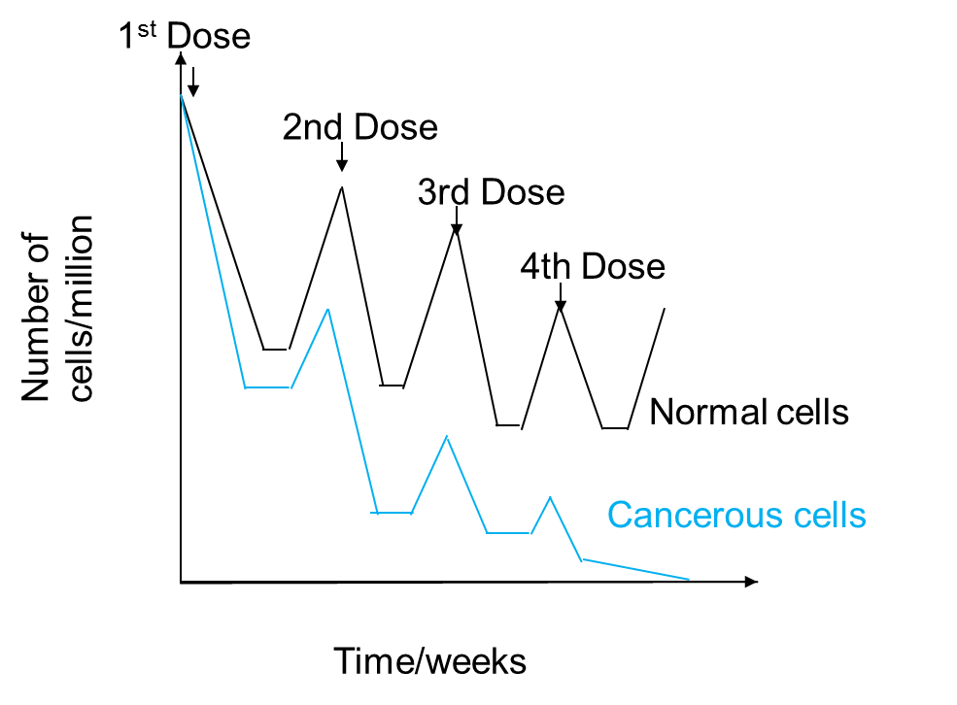

**Question**

Suggest why:

1. The drug was not given more frequently?

………………………………………………………………………………

………………………………………………………………………………

1. The dose of the drug was not increased?

……………………………………………………………………………………………………………………………………………………………………………………………………………………………………………………………………………………………………………………

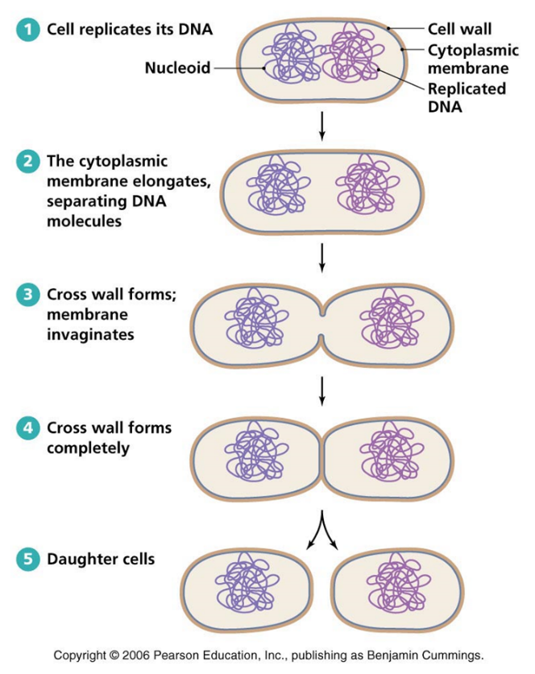**Cell Division in Prokaryotes (Binary Fission)**

Binary fission is a form of ………………………………………………………

Write down the stages of Binary fission

…………………………………………………………………………..

…………………………………………………………………………..

…………………………………………………………………………..

…………………………………………………………………………..

…………………………………………………………………………..

…………………………………………………………………………..

…………………………………………………………………………..

…………………………………………………………………………..

…………………………………………………………………………..

**Write a synopsis of viral replication (recall)**

Remember as viruses are non living they do not undergo cell ………………………... Host cell replicates the virus particle.

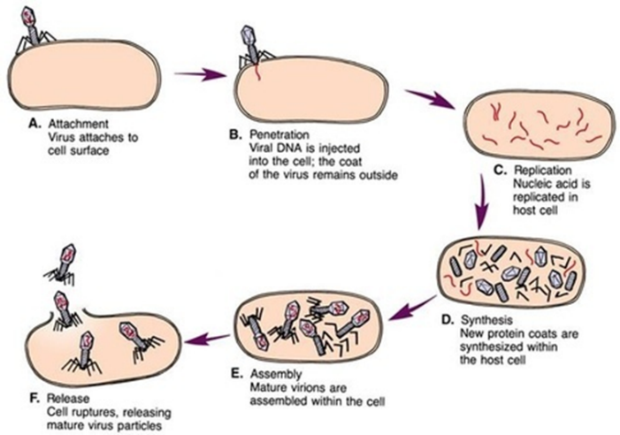Attachment: …………….................................

………………………………………………………………..

………………………………………………………………..

………………………………………….…………………….

Entry:

………………………………………………………………..

………………………………………….…………………….

………………………………………………………………………………………………………………………………………………………

Synthesis: ……………………………………………………………………………………………………………………………………………………………………………………………………………………………………………………………………………………………………………………

Assembly:

………………………………………………………………………………………………………………………………………………………..

Release: …………………………………………………………………………………………………………………………………………………………

**Required Practical 2 - Root Tip Squash**

***Do not forget that you need to learn the methods for all of your required practicals as they form part of your exams. Answer the questions below and learn the method.***

What are meristems?

…………………………………………………………………………………………………………………………………………………………

Why do you add 1M Hydrochloric acid?

…………………………………………………………………………………………………………………………………………………………

Why do you heat the Hydrochloric acid before adding the root tip?

…………………………………………………………………………………………………………………………………………………………

Why do you add acetic orcein stain?

…………………………………………………………………………………………………………………………………………………………

Why do you squash the root tip?

…………………………………………………………………………………………………………………………………………………………

**Summary Method**

**Making your slide**

1. Stand the beaker on a bench mat before adding approx. 10ml of hydrochloric acid (5 mol dm-3)
2. Place about 2 cm of root tip in the acid and leave for 15 minutes.
3. Set up your microscope while you are waiting.
4. Rinse the root tip in distilled water in the watch glass.
5. Cut off the root tip (1mm) and place on a microscope slide.
6. Cover the section with toluidene blue stain and macerate with the mounted needle to separate the cells.
7. Continue to macerate until the tissue is well broken and the cells are stained dark blue.
8. Add a cover slip and with gentle finger pressure ‘spread’ the material and blot at the same time by using a folded filter paper between finger and slide.
9. Look carefully at all slides for cells undergoing mitosis. Chromosomes should stain dark blue. Repeat for several fields of view.
10. Calculate the mitotic index.

**Good websites:**

* <http://highered.mcgraw-hill.com/sites/0072495855/student_view0/chapter2/animation__mitosis_and_cytokinesis.html> about 2 minutes long. Clear but includes two features beyond specification including lengthening of unattached microtubules (spindle fibres) and use of term kinetochores rather than centromere.
* <http://www.cellsalive.com/mitosis.htm> very quick visual. Clear no words.
* <http://www.johnkyrk.com/mitosis.html> clear visual animation. No words.
* <https://www.youtube.com/watch?v=pOsAbTi9tHw/> mitosis rap
* <http://www.youtube.com/watch?v=L0k-enzoeOM> crash course biology

**Glossary**

|  |  |
| --- | --- |
| Meiosis |  |
| Mitosis |  |
| Binary Fission |  |
| Chromosome |  |
| Chromatin |  |
| Centromere |  |
| Histone |  |
| Cancer |  |
| Benign tumour |  |
| Malignant tumour |  |
| Proto oncogene |  |
| Oncogene |  |
| Chemotherapy |  |
| Radiotherapy |  |
| Interphase |  |
| Gap 1 phase |  |
| Gap 2 phase |  |
| S phase |  |
| Prophase |  |
| Metaphase |  |
| Anaphase |  |
| Telophase |  |
| Cytokinesis |  |
| Spindle fibre | . |
| Meristem |  |