**3.2 Cells**

**3.2.3 Transport across Cell Membranes**

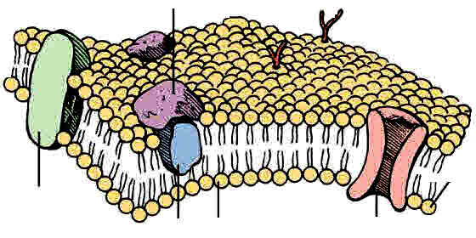

|  |  |  |  |  |
| --- | --- | --- | --- | --- |
| **Key info** | **Topic: Transport across cell membranes**  **Resources: Powerpoints on GoL**  3.2.3 Transport across cell membranes  **Synoptic Link:** 3.1 Biological molecules, 3.2.1 Structure of eukaryotic cells,  **Text book pages: 84-99** | | | |
| **Step 1** | **Use the notes (GOL), presentation (GOL), video links and text book to complete the independent pack.** | | | |
| **Step 2** | **Learning outcome: tick these off as you go through to highlight your strengths and weaknesses** | **I understand this** | **I can recall this** | **I need to revisit this** |
| Recall the structure of the cell-surface membrane, and the different roles of the component molecules |  |  |  |
| Explain the features of the fluid mosaic model |  |  |  |
| Describe movement across cell membranes by:   1. Simple diffusion 2. Facilitated diffusion 3. Osmosis 4. Active transport 5. Co-transport |  |  |  |
| Describe and explain how cells are specialised to ensure rapid absorption |  |  |  |
| **Step 3** | **In lesson:** you will be undertaking activities to develop your understanding of the learning objectives and able to add to your notes. | | | |

**Specification Content 3.2.3 Transport across cell membranes**

|  |
| --- |
| The basic structure of all cell membranes, including cell-surface membranes and the membranes around the cell organelles of eukaryotes, is the same.  The arrangement and any movement of phospholipids, proteins, glycoproteins and glycolipids in the fluid-mosaic model of membrane structure. Cholesterol may also be present in cell membranes where it restricts the movement of other molecules making up the membrane. |
| Movement across membranes occurs by:   * simple diffusion (involving limitations imposed by the nature of the phospholipid bilayer) * facilitated diffusion (involving the roles of carrier proteins and channel proteins) * osmosis (explained in terms of water potential) * active transport (involving the role of carrier proteins and the importance of the hydrolysis of ATP) * co-transport (illustrated by the absorption of sodium ions and glucose by cells lining the mammalian ileum).   Cells may be adapted for rapid transport across their internal or external membranes by an increase in surface area of, or by an increase in the number of protein channels and carrier molecules in, their membranes. |
| |  | | --- | | **Students should be able to:**   1. explain the adaptations of specialised cells in relation to the rate of transport across their internal and external membranes 2. explain how surface area, number of channel or carrier proteins and differences in gradients of concentration or water potential affect the rate of movement across cell membranes. | |
| **Required practical 3:** Production of a dilution series of a solute to produce a calibration curve with which to identify the water potential of plant tissue.  **Required practical 4:** Investigation into the effect of a named variable on the permeability of cell-surface membranes. |

**Preparatory Work:**

**What Do You Know From GCSE?**

1. Where are membranes found? .................................................................................
2. What is the purpose of cell membranes? ..................................................................

………………………………………………………………………………………………

1. Do plants have cell membranes? .............................................................................
2. Do bacteria have cell membranes? ..........................................................................
3. How can dissolved substances pass across membranes? ......................................
4. How can water pass across membranes? ................................................................
5. Name 4 substances required by cells and what each is needed for.

…………………………………………………...............................................................

………………………………………..……………………………………………………..

…………………………………………...………………………………………………….

………………………………………………………………………………………………

………………………………………………………………………………………………

1. Name 3 end products of metabolic processes that may pass out of a cell.

…....................................................……………….

…………………………….………………………….

………………………………………………..………

**Watch the Bozeman video on cell membranes and answer the questions below**:

<http://www.bozemanscience.com/015-cell-membrane>

1. Why does soap dissolve the membranes easily?
2. What is selective permeability? How does the cell achieve this?
3. What are the 2 main molecules that make up cell membranes?
4. Phospholipids are described as AMPHIPATHIC. What does this mean?
5. What sort of particles do phospholipids allow to pass between themselves?
6. What is the role of many membrane proteins?
7. What is the role of cholesterol?

**NOTE**: Bozeman talks about water passing through the membrane by **Aquaporins** rather than through the phospholipids. Aquaporins are small membrane proteins that allow passage of water and were discovered in 1992 by Peter Agre who was awarded a **Nobel Prize in Chemistry** for this in 2002. There have now been discovered many different varieties of aquaporins.

However **our syllabus** does **not include aquaporins** and it is thought some water can pass through the phospholipids, because although it is polar it is small enough to pass through slowly. However membranes that possess aquaporins can increase the rate of water movement and this is very important in cells like kidney tubule cells.

**Where do we find a cell membrane?**

plasma membrane

tonoplast

outer mitochondrial membrane

inner mitochondrial membrane

outer chloroplast membrane

nuclear envelope

**What are the functions of cell Membranes?** List the 6 functions of **cell surface** membranes:-

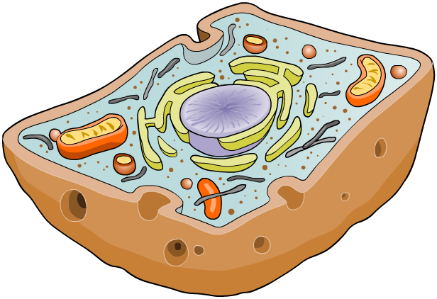

1. ………………………………..………………………………………...…………….....
2. ………………………………..………………………………………...…………….....
3. ………………………………..………………………………………...…………….....
4. ………………………………..………………………………………...…………….....
5. ………………………………..………………………………………...…………….....
6. ………………………………..………………………………………...…………….....

List 3 functions of **internal membranes:-**

1. …………………………………………………………………………………………………………………………………………….…
2. ………………………………………………………………………………………………………………………………….……………
3. ………………………………………………………………………………………………………………………….……………………

**The Structure of the cell Surface Membrane**

Describe what a membrane looks like when seen under an electron microscope.

………………………………………………………………………………………………………..

**Label** the diagram of the membrane as seen under the electron microscope.

What do the arrows represent and what does the clear line in the middle represent?

What is the width of the cell membrane?



*EM of a plasma membrane*

In 1972 a model was suggested to describe the structure of the cell surface membrane. What is the name of this model? …….......................................…………

What is another name for a cell membrane?...............................................................

**The Molecular Components of a membrane**

**List** the main molecular components of a membrane :-

1.

2.

3.

4.

5

**Structure related to function**

1. **Phospholipids**

In Biological molecules we had a look at the molecular structure of phospholipids. They are important components of the cell membrane. Draw a diagram to show the orientation of phospholipids in a cell membrane. Remember it is a bilayer. Label hydrophobic and hydrophilic regions.

What are the three functions of phospholipids?

1.

2.

3.

1. **Proteins**

Proteins are interspersed throughout the cell surface membrane. They are embedded in the phospholipid bilayer in two ways:

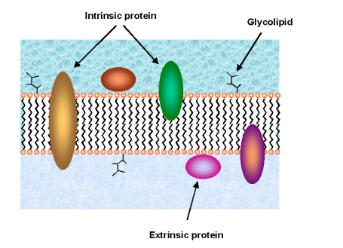

**Intrinsic proteins** span the phospholipid bilayer

**Extrinsic proteins** are found on the surface of the cell membrane.

What are the functions of extrinsic proteins?

**…………………………………………………………………………………………………………………………………………………………………………………………………………………………………………………………………………………………………………**

What are the functions of intrinsic proteins?

………………………………………………………………………………………………………………………………………………………………………………………………………………………………………………………………………………………………………………

What type of molecule uses intrinsic proteins to move across the cell membrane?

………………………………………………..

1. **Cholesterol**

Cholesterol is a …………………….. and is found within the phospholipid bilayer. They add ………….. to the membranes. Cholesterol molecules are very hydrophobic and therefore play an important role in ………… …………..

Function of cholesterol:

1………………………………….…………………………………………………………………………….

…………………………………..………………………………………………………………………………

2…………………………………………………………………………………………………………………

………………………………………………………………………………………………………………….

3. …………………………………………………………………………………………………………........

**4. Glycolipids**

[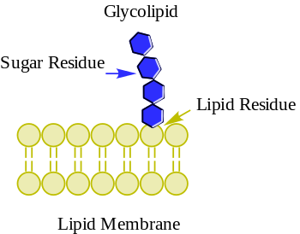](https://www.google.co.uk/url?sa=i&rct=j&q=&esrc=s&source=images&cd=&cad=rja&uact=8&ved=0ahUKEwix7eLXw-vPAhVElxoKHW_wBQEQjRwIBw&url=https://en.wikipedia.org/wiki/Glycolipid&bvm=bv.136499718,d.ZGg&psig=AFQjCNEXmD2uKPKj0u9Rpp28E7yJQ50ojQ&ust=1477126621912208)What are glycolipids made of?

……………………………………………………

Function of glycolipids

……………………………………………………

……………………………………………………

……………………………………………………

1. **Glycoproteins**

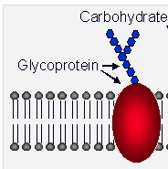What are glycoproteins made of?

………………………………………………………….

Function of glycoproteins.

......................................................................................

………………………………………………………………………………….

……………………………………………………………………………….…

…………………………………………………………………………………..

**The Fluid Mosaic Model of Membrane Structure**

The way in which the various molecules combine into the structure of the cell surface membrane is known as the fluid mosaic model.

**Label** the 2D diagram

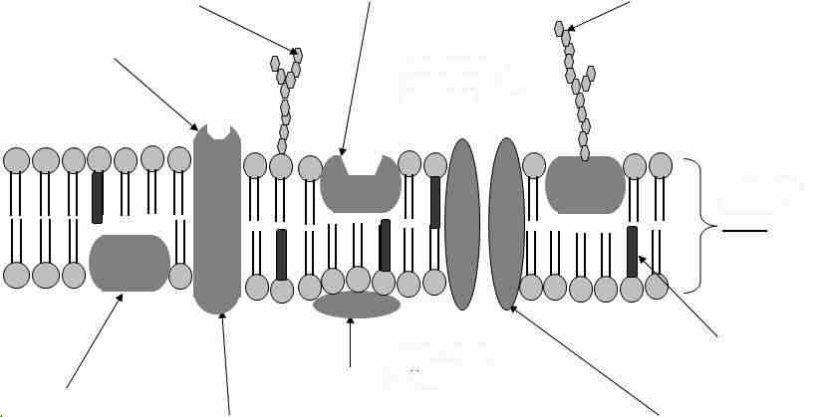

What Does the Model Name **Fluid Mosaic** mean?

* Fluid …….............................................................................................…………………................

.............................................................................................................................................

* Mosaic …..........................……………………………………………………………....................................

..............................................................................................................................................

* What is meant by saying the membrane forms a bilayer? …....…………………………………….

...........................................................................................................................................

Some organelles have a double membrane. **Name** these organelles.

…………………………………………………………………………………………………………………………………………………..

**Consolidation questions:**

Answer the consolidation questions below:

1. State the overall function of the cell surface membrane?
2. State which end of the phospholipid lies towards the inside of the cell surface membrane
3. State through which molecule in the cell surface membrane each of the following are likely to pass in order to get in or out of the cell.
   1. A molecule that is soluble in lipids
   2. A mineral ion
4. From your knowledge of cell surface membranes suggest two properties a drug should possess if it is to enter a cell rapidly.

**Transport across Membranes**

Watch the animations

<http://highered.mheducation.com/sites/0072495855/student_view0/chapter2/animation__how_diffusion_works.html>

<http://highered.mcgraw-hill.com/sites/0072495855/student_view0/chapter2/animation__how_osmosis_works.html>

<https://www.youtube.com/watch?v=5KOkt9dyN1w> 7 min 32 s Leslie Walters tutorial Water potential calculation explanation

The cell membrane is said to be selectively permeable. It forms a boundary between the cell cytoplasm and the environment. It controls the movement of substances in and out of the cell.

There are two major ways that molecules can be moved across a membrane, and the distinction has to do with whether or not cell energy is used. Passive mechanisms like diffusion use no energy, while active transport requires energy to get done.

List 5 ways that substances cross membranes and say whether each is an active or passive process.

1. …………………………………………………
2. …………………………………………………
3. …………………………………………………
4. …………………………………………………

5. ……………………………………………………….

**1 Diffusion (Simple or Facillitated)**

**Simple diffusion (passive)**

All particles are constantly in motion due to the kinetic energy they possess. This movement is random and therefore particles that are concentrated together in a closed vessel will distribute themselves evenly throughout the vessel as a result of diffusion.

What is the definition of diffusion?

………………………………………………………………………………………………………………………………………………………………………………………………………………………………………………………………………………………………………………………………………………………………………………………………………………………………………………………………………………………………………………………………………………………………………………………………………………………………………..

What is meant by NET Movement of particles? ……...........................................................................................................................................................................................................................................................................................................................

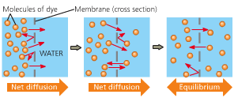

What molecules can diffuse through the cell membrane?

………………………………………………………………………………..

Why can small polar molecules diffuse?

………………………………………………………………………………..

The molecules diffuse from an area of high concentration to an area of …… concentration.

**What Affects the Rate of Diffusion?**

Complete the following table on factors that affect diffusion.

|  |  |
| --- | --- |
| **Factor** | **Effect** |
| Temperature |  |
| Concentration gradient |  |
| Stirring |  |
| Surface area |  |
| Diffusion distance |  |
| Size of molecule |  |

**How Does Diffusion Occur Through a Membrane?**

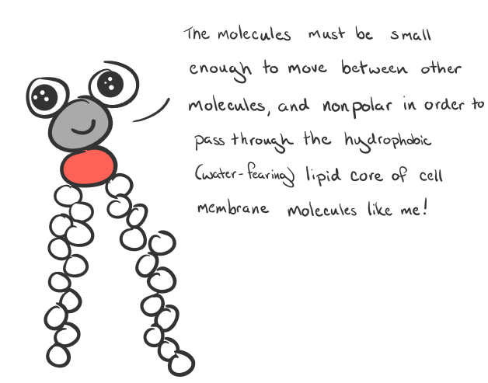

Between which molecules of a membrane does simple diffusion occur? ..............................................................

Name some examples of particles that pass through this way…..............................................................................

Oxygen and Carbon dioxide can pass through the phospholipid bilayer of membranes by simple diffusion. They are both soluble in lipids.

One molecule most likely to be involved in simple diffusion is water - it can easily pass through cell membranes. When water undergoes simple diffusion, it is known as **osmosis**.

**Fick’s law**

Fick’s law states that the rate of diffusion is dependent on the surface area where diffusion is to occur, the difference in concentration of the particles involved in diffusion and the thickness of the diffusion surface.

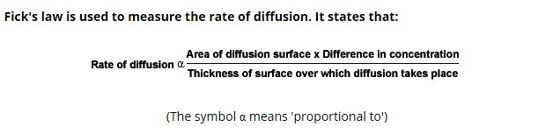

**Surface area**: - the greater the surface area, the ......................the rate of diffusion

**Difference in concentration**: - the greater the difference in concentration, the ........................ the rate of diffusion.

**Thickness of membrane**: - the thicker the membrane the ......................... the rate of diffusion

**2. Osmosis (a type of simple diffusion only to do with water)**

What is osmosis?

………………………………………………………………………………………………………………………………………………………………………………………………………………………………………………………………………………………………………………………………………………………………………………………………………………………………………………………………………………

What are the similarities and differences between simple diffusion and osmosis?

|  |  |
| --- | --- |
| Similarities | Differences |
|  |  |
|  |  |

Cell membranes are **permeable** to water molecules.

What is a solute? ………………………………………………………………………………

What is a solvent? ……………………………………………………………………………..

What is a solution? ……………………………………………………………………………

Diagram to illustrate Osmosis

**Label** the water molecules and the solute molecules. Use the slide to label which solution is **hypertonic** and which is **hypotonic**.

What is the definition of hypotonic?

NET movement of Water

…………………………………………………………………………………………………..

…………………………………………………………………………………………………..

What is the definition of hypertonic?

………………………………………………………………………………………………..……

……………………………………………………………………………………………………….

What is meant by saying that 2 solutions are **isotonic**? ………………………………………..

**Water Potential**

This is a measure of the tendency of water molecules to move from one place to another. The symbol used for water potential is the Greek letter psi, Ψ.

Water always moves from a region of higher water potential to one of lower water potential or down the concentration gradient. In the diagram above label which solution (hypotonic or hypertonic) has the highest water potential?

A solution with a high water potential has many…….. water molecules. They are free to move and can exert a …………… on the membrane. This pressure is known as **WATER POTENTIAL**. A solution with a low water potential has few free water molecules.

**Label** the diagrams below either **high** or **low** water potential and also state which has a high solute concentration and which has a low one. Also label the partially permeable membrane.

…......…Water Potential ..........… Water Potential

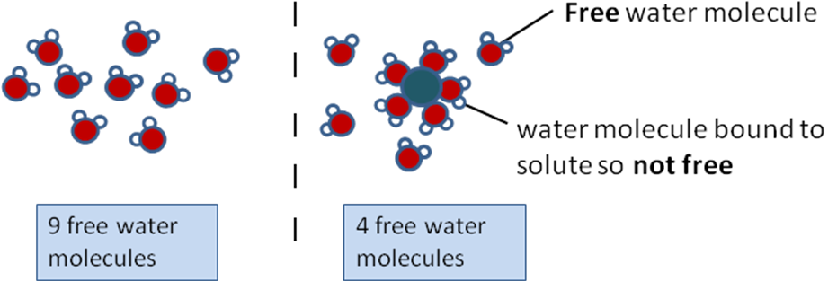

……………Solute Concentration …..........…. Solute Concentration.

Water Potential Definition

**Water potential** is …….................................................................................................

.....................................................................................................................................

.....................................................................................................................................*. ….p89)*……………………………………………

**Water potential (ᴪ or psi)** is measured in units of ...................... eg.................................

**Complete** the next statements and highlight them.

**Water Potential of Pure Water** is ....................

**Water Potential of Solutions** is .......................

A concentrated solution has a more **negative** water potential than a dilute solution.

**Concentrated Solutions** have a **very negative** water potential

**Dilute Solutions** have a **less negative** water potential

**Pure water** has the **highest** possible water potential of **zero**.

Very negative less negative zero

Water potential water potential water potential

**Concentrated solution** **dilute solution** **pure water**

The rule is that water always ‘falls from a high to a low water potential ie in the direction of

the arrows in the above diagram until the water potentials on either side of the plasma membrane are equal.

**Applying This to Cell Water Potential Questions**

1. a) Show the direction of the net movement of water molecules by an arrow drawn on the two cells below.

b) Label the **cell solutions** as concentrated or dilute appropriately.

c) Label the cells as having high or low water potentials appropriately.

**Cell A**

**       = - 400 kPa**

**Cell B**

** = - 350 kPa**

2 Why does water have a higher water potential in dilute solutions than in concentrated solutions?

....................................................................................................................................

....................................................................................................................................

3 If **cell X** has a water potential of – 500 kPa, and **cell Y** next to it has a water potential of – 800 kPa which way will water move by osmosis and what will the water potential of each one be when equilibrium is reached?

........................................................................................................

........................................................................................................

4 What would be the effect on the water potential of a cell if starch present in a cell is hydrolysed to sugar?

....................................................................................................................................

**Effects of Osmosis on cells.**

What happens to cells when placed in solutions that are hypertonic, isotonic or hypotonic to the cell contents?

**Osmosis and animal cells.**

Animal cells such as red blood cells contain a variety of solutes dissolved in the cytoplasm. The cell membrane is very thin. If you put red blood cells into a solution with a higher water potential than the cell they will burst. To prevent haemolysis of our red blood cells they normally live in a liquid which has the same water potential as the cells known as blood plasma.

|  |  |  |  |
| --- | --- | --- | --- |
| WATER POTENTIAL OF EXTERNAL SOLUTION | In Higher Water potential than Cell ie a …...................…  solution | In Equal Water potential to Cell ie a ........................  solution | In Lower Water potential than Cell ie a ..........................solution |
| NET MOVEMENT OF WATER |  |  |  |
| STATE OF CELL |  |  |  |
|  |  |  |  |

**Osmosis and plant cells**

Plant cells also contain a variety of solutes but plant cells have two main differences to animal cells.

These are the presence of a …………………… and the presence of a cellulose …………..

Plant cells, unlike animal cells can not control the composition of fluid around their cells. In fact they are almost permanently bathed in almost pure water.

Is a plant cell wall permeable, impermeable or semi-permeable? …................……………..

What is meant by the word PROTOPLAST …........................................................................

................................................................................................................................................

What happens to a plant cell’s protoplast when it is placed in a solution with a lower water potential?

………………………………………………………………………………………………………

What is incipient plasmolysis?

………………………………………………………………………………………………………..

How can you tell in an experiment when plant cells are showing incipient plasmolysis?

…………………………………………………………………………………………………………………………………………………………………………………………………………………………………………………………………………………………………………………………………………………………………………………………………………………………………………

|  |  |  |  |
| --- | --- | --- | --- |
| WATER POTENTIAL OF EXTERNAL SOLUTION | In Higher Water potential than Cell ie a …...................…  solution | In Equal Water potential to Cell ie a ........................  solution | In Lower Water potential than Cell ie a .......................... solution |
| NET MOVEMENT OF WATER |  |  |  |
| PROTOPLAST |  |  |  |
| STATE OF CELL |  |  |  |

In your own words explain why an animal cell placed in pure water bursts while a plant cell placed in pure water does not.

…………………………………………………………………………………………………………………………………………………………………………………………………………………………………………………………………………………………………………………………………………………………………………………………………………………………………………………………………………………………………………………………………………………………………………………………………………………………………………………………………………………………………………………………………………………………………………………………………………………………………………………………………………………………………………………………………………………………………………………………………………………………………………………………………………………………………………………………………………………………………………………………………………………………………………………………………………………………………………………………………………………………………………………………………………………………………………………………………………………………………………………………………………………………………………………………………………

**3 Facilitated Diffusion**

This is a type of diffusion. Plasma membranes are not readily permeable to molecules. Only small or non-polar molecules can diffuse across them easily. **Charged ions and polar molecules** do not easily diffuse through the hydrophobic fatty acids tails of the phospholipids. The movement of these molecules is made easier (facilitated) by channel and carrier proteins.

Facilitated diffusion is a ………………. process, and occurs **down a concentration gradient** (from high to low)

**Channel proteins**

Channel proteins are water filled hydrophilic channels that span the membrane.

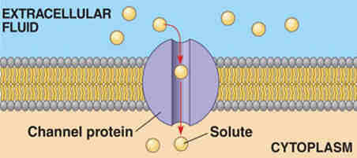What types of particles are transported by channel proteins? …..............…………….

What is meant by saying that the channels are selective? .................................................…………………………………..

........................................................................................

How does the channel protein shut? ……………………………………………………………………………………..

**Carrier proteins**

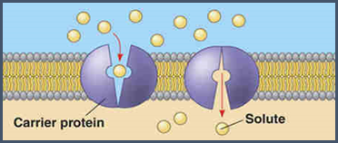

What types of particles are transported by carrier proteins?............................................................

Give an example/s…………………………………

How do these proteins work? ……......................................................................................................................................................

...........................................................................................................................................................

……………………………………………………………………………………………………………………………………………………..

**Comparing channel and carrier proteins**

|  |  |
| --- | --- |
| **CHANNEL PROTEIN** | **CARRIER PROTEIN** |
|  |  |
|  |  |
|  |  |

**Fill in the table** to make notes on these two types of facilitated diffusion proteins.

**Comparing Rate of Uptake Graphs of Simple and Facilitated Diffusion**

External Concentration

Rate of Uptake into Cell

Rate of Uptake Graph for a Molecule that enters a cell By Simple Lipid Diffusion

External Concentration

Rate of Uptake into Cell

Rate of Uptake Graph for a Molecule that enters a cell By Facilitated Diffusion

Explain why these two graphs differ………...............................................................................................

................................................................................................................................................................

...............................................................................................................................................................

...............................................................................................................................................................

...............................................................................................................................................................

…………………………………………………………………………………………………………………………………………………………………………………………………………………………………………………………………………………………………………………………………………………………………………………………………………………………………………………………………………………………………………………………………………………………………………………………………………………………………………

**4 Active Transport**

What is the definition of active transport?

……………………………………………………………………………………………………………………………………………………………………………………………………………………………………………………………………………………………………………………………………………………………………………………………………………………………………………………………………………..

In active transport ATP is used to:

1. …………………………………………………………………………………………………
2. …………………………………………………………………………………………………

How does active transport differ from passive transport (simple and facilitated diffusion)?

1. Metabolic energy in the form of **ATP** is needed.
2. Substances are moved **against** a concentration gradient
3. Only uses **carrier proteins**
4. Process is very selective

[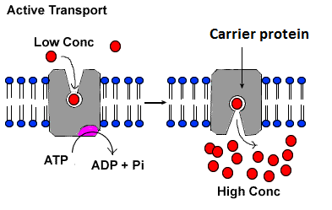](https://www.google.co.uk/url?sa=i&rct=j&q=&esrc=s&source=images&cd=&cad=rja&uact=8&ved=0ahUKEwjXnuXj4PDPAhVCOhQKHXB7DbwQjRwIBw&url=https://y12hb.wordpress.com/2013/04/07/active-transport/&psig=AFQjCNGhhTjseRqs-exiEVQzQEKWyRcgWw&ust=1477306013812148)

What does ATP stand for?.

...............................................................

What does Pi stand for?

...............................................................

What does ADP stand for?

...............................................................

The presence of many mitochondria is typical of cells carrying out active transport. Why?

…………………………………………………………………………………………………………………………………………………………..

…………………………………………………………………………………………………………………………………………………………..

Direct active transport of a single molecule or ion is described below. Fill in the blanks using the following words; carrier protein, receptor sites, ATP, change in shape, released, phosphate molecule, original shape, ADP.

The …………. ……………. spans the plasma membrane and binds to the molecule or ion to be transported. The molecule binds to a …………….. ……….. on the carrier protein. On the inside of the cell ……… binds to the protein causing it to split into ADP and a ………… ………………. The phosphate molecule binds to the carrier protein (phoshorylating it) and as a result the protein molecule ………… ………….and opens to the opposite side of the membrane. The molecule or ion is …………….. The phosphate molecule is released from the protein which causes the protein to revert to it’s …………… …………………… The phosphate molecule recombines with ……….. to form ATP during respiration.

**Consolidation-Comparison of active and passive transport**

[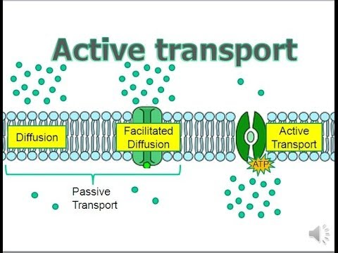](https://www.google.co.uk/url?sa=i&rct=j&q=&esrc=s&source=images&cd=&cad=rja&uact=8&ved=0ahUKEwjNqpaD4PDPAhVHWhQKHSo9CrIQjRwIBw&url=https://www.youtube.com/watch?v%3DEmPfjfmw_O8&psig=AFQjCNGhhTjseRqs-exiEVQzQEKWyRcgWw&ust=1477306013812148)Name the three main differences between passive and active transport.

………………………………………….......................................

..................................................................................

……………………………………………………………………………….

………………………………………………………………………………

………………………………………………………………………………

………………………………………………………………………………

**Rich Questions for You to Work Out**

Why do poisons which inhibit respiration, result in active transport stopping? …………………………………………………………………………………………………………………………………………………….

…………………………………………………………………………………………………………………………………………………….…………………………………………………………………………………………………………………………………………………….

Suggest why overwatering of plants can kill the plant

…………………………………………………………………………………………………………………………………………………….

…………………………………………………………………………………………………………………………………………………….

1. **Co-transport**

Co-transport is the name of a process in which two substances are simultaneously transported across a membrane by one protein.

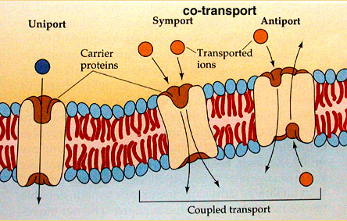What is Uniport?

……………………………………………………

What is Symport

……………………………………………………

What is Antiport?

……………………………………………………

The example you need to know and understand is the co-transport of glucose from the ileum (small intestine) into the epithelial cells that line the ileum and into the blood. Intestinal epithelium cells must allow transportation of soluble products of digestion from the lumen of the gut to the blood capillaries where they can then be transported to the liver. Diffusion alone would be too slow and inefficient. The cells are adapted to ensure efficient transportation across their structure.

How are the cells that line the ileum adapted for absorption?

……………………………………………………………………………………………………………………………………………………………………………………………………………………………………………………………………………………………………………………………………………………………………………………………………………………………………………………………………………..

As carbohydrates and proteins are being digested continuously there is a greater concentration of glucose and amino acids within the ileum than in the blood. Some glucose can be transported down a concentration gradient by **facilitated diffusion** into the blood. Given that blood is constantly being circulated by the heart the concentration gradient is maintained. However, diffusion stops once equilibrium is reached and blood will always contain some glucose. This means not all available glucose or amino acids can be absorbed this way. To increase the amount of absorption **active transport** is also involved. The mechanism used is a type of co-transport (symport). The two molecules co-transported are glucose or amino acid molecules with sodium ions.

Sodium ions diffuse **down** a concentration gradient (high in ileum to low inside the epithelial cell) pulling glucose molecules into the epithelial cells **against** a concentration gradient. To maintain a low sodium concentration inside the epithelial cells sodium ions are pumped out of the epithelial cells and into the blood using the **sodium potassium pump** which requires ATP as sodium ions are transported into the blood **against** a concentration gradient while potassium ions move into the epithelial cell **against** a concentration gradient. Glucose moves into the blood **down** a concentration gradient by **facilitated diffusion** as the concentration of glucose inside the epithelial cell is always higher than in the blood (due to the constant movement of blood)



Potassium ions

Glucose molecule

Sodium ions

**Past Exam Question**: (Biol 1 June 11 listed in SOW).

The epithelial cells that line the small intestine are adapted for the absorption of glucose. Explain how. (6 marks)

Use the diagram, your own existing knowledge and the text to answer the question.

……………………………………………………………………………………………..…..

……………………………………………………………………………………………..…..

……………………………………………………………………………………………..…..

……………………………………………………………………………………………..…..

………………………………………………………………………………………..………..

………………………………………………………………………………………..………..

…………………………………………………………………………………………….......

…………………………………………………………………………………………………..

…………………………………………………………………………………………………..

EXTENSION:

Oral rehydration therapy is used to treat diarrhoeal diseases that infect the intestine. Diarrhoea kills many people especially the very young, and yet treatment to prevent death is relatively simple. Carry out some independent research to find out what diarrhoeal diseases do to the gut, why oral rehydration therapy is important, what oral rehydration therapy is, and why just drinking water could be fatal.

……………………………………………………………………………………………………………………………………………………………………………………………………………………………………………………………………………………………………………………………………………………………………………………………………………………………………………………………………………………………………………………………………………………………………………………………………………………………………………………………………………………………………………………………………………………………………………………………………………………………………………………………………………………………………………………………………………………………………………………………………………………………………………………………………………………………………………………………………………………………………………………………………………………………………………………………………………………

**Membranes Glossary**

|  |  |
| --- | --- |
| **Glycoprotein** |  |
| **Glycolipid** |  |
| **Phospholipid** |  |
| **Extrinsic Protein** |  |
| **Intrinsic Protein** |  |
| **Peripheral Protein** |  |
| **Integral Protein** |  |
| **Hydrophobic** |  |
| **Hydrophilic** |  |
| **Hypotonic Solution** |  |
| **Hypertonic Solution** |  |
| **Isotonic Solution** |  |
| **Plasmolysed** |  |
| **Incipient Plasmolysis** |  |
| **Flaccid Plant Cell** |  |
| **Haemolysed** |  |
| **Turgid Plant Cell** |  |
| **Crenate** |  |
| **Protoplast** |  |