**3.2.4 Cell Recognition and the Immune System**

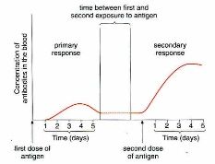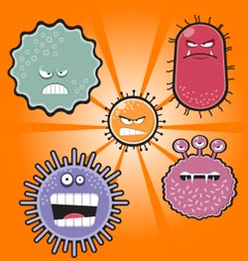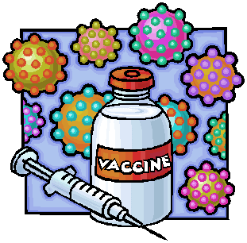

Complete these recall activities before starting the booklet. Make a note of any questions you have

|  |  |  |  |
| --- | --- | --- | --- |
| **Topic** | **Recall activities** | **Understanding**  *Please write down any questions you have when completing this activity.* | **Completed** |
| **Cell recognition and the immune system** | List the bonds involved in primary, secondary, tertiary and quaternary structure proteins |  |  |
| Define the words “specific” and “complimentary” in the context of proteins |  |  |
| Draw a eukaryotic cell, and label all the organelles involved in producing and secreting a protein |  |  |
| Define the terms “antigen” and “antibody” |  |  |

|  |  |  |  |  |
| --- | --- | --- | --- | --- |
| **Key info** | **Topic: Cell recognition and the immune system**  **Resources:**  **Powerpoints on GoL**  3.2.4 Cell recognition and the immune system  **Additional resources**  Biofactsheet 99 Vaccines, BIR Article on MMR vaccine, Biofactsheet 219 Monoclonal Antibodies an Update, New Scientist article on MMR  **Synoptic Link:** 3.1 Proteins, 3.2 Structure of eukaryotic cells  **Text book pages: 102-124** | | | |
| **Step 1** | **Use the notes (GOL), presentation (GOL), video links and text book to complete the independent pack.** | | | |
| **Step 2** | **Learning outcome: tick these off as you go through to highlight your strengths and weaknesses** | **I understand this** | **I can recall this** | **I need to revisit this** |
| Describe the cells involved in both the humoral and cell-mediated response |  |  |  |
| Explain how the action of phagocytes, T and B lymphocytes fights an infection |  |  |  |
| Explain the difference between primary and secondary immune responses |  |  |  |
| Explain how a vaccine can protect an individual, and a whole population through herd immunity |  |  |  |
| Recall the stages of HIV replication, and explain why its treatment is difficult |  |  |  |
| Describe the use of monoclonal antibodies in medicine, and how they can be used in ELISA testing to diagnose disease |  |  |  |
| **Step 3** | **In lesson:** you will be undertaking activities to develop your understanding of the learning objectives and able to add to your notes. | | | |

**Preparatory Work**

**Watch** the Introductory video overview **Virtual body – The Immune System** on e- stream then **answer** the questions below about the video. <http://estream.godalming.ac.uk/View.aspx?id=1298~4u~vx7bUQN6&chapID=1582>

**Questions On the Video – The Immune System**

1. Give 4 mechanisms that are part of the body’s first line of defence.

* ...................................................................................................................
* ...................................................................................................................
* ...................................................................................................................
* ...................................................................................................................

1. State 3 chemical defence mechanisms

* ...................................................................................................................
* ...................................................................................................................
* ...................................................................................................................

1. Name 2 white cells produced in the bone marrow ………………………………………………….
2. What is puss made up of? ……………………………………………………………………………………….

………………………………………………………………………………………………………………………………….

1. What is an antigen? …………………………………………………………………………………………………...

…………………………………………………………………………………………………………………………………..

1. What is a toxin? …………………………………………………………………………………………………………
2. Name a bacterium that releases a toxin. …………………………………………………………………
3. What is a toxoid? ……………………………………………………………………………………………………..
4. How do killer T cells kill pathogens and also infected body cells? ……………………………

………………………………………………………………………………….................................................

**Overview of defence Mechanisms**

* **Complete** the overview map of the body’s defence mechanisms

**Defence mechanisms**

* **Suggest 2 ways** that the specific response differs from the non-specific response.

1…………………………………………………………………………………………… …………………………………………………………………………………………….

2…………………………………………………………………………………..………

**Antigens and Self-antigens**

Self-antigens are ………………………………………………………………………………..

Antigens (non-self-antigens) are ………………………………………………………………. ……………………………………………………………………………………………………..

* **Complete** the definition of an antigen.

**Definition of an Antigen**

* **List below** the types of molecules that act as antigens and trigger an immune response.

…………………………………………………………………………………………….

..................................................................................................................................

………………………………………………………………………………………………

………………………………………………………………………………………………

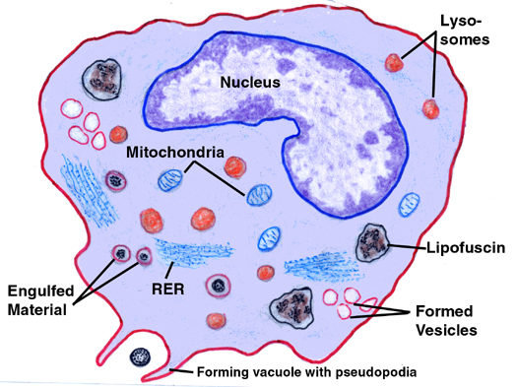**Phagocytosis – A non-specific response**

**Watch:**

1. <http://www.dnatube.com/video/116/Neutrophil-attacts-on-bacteria> 1 min video clip of neutrophil chasing a bacterium and then engulfing it by phagocytosis.
2. <http://highered.mheducation.com/sites/0072495855/student_view0/chapter2/animation__phagocytosis.html> 1 min detailed animation of phagocytosis including coating with complement (opsonisation) to enhance phagocytosis.

A phagocyte, e.g. a **macrophage** is a type of **white blood cell** that carries out phagocytosis (engulfment of a pathogen). They’re found in the **blood** and in the **tissues** and are the first cells to respond to a pathogen inside the body.

* **Arrange the following statements** into the correct order and write them again below to describe the process of **phagocytosis.**

**Jumbled Statements:**

1. The phagocyte then **presents** the pathogen’s antigens – it sticks the antigens on its **surface** to **activate** other immune cells.
2. The phagocyte **recognises** the **antigens** on a pathogen and binds to it.
3. A **lysosome** (containing **lysozymes**) **fuses** with the phagocytic vesicle. The lysozymes **hydrolyse** the pathogen.
4. The cytoplasm of the phagocyte moves round the pathogen, **engulfing** it in a phagocytic vesicle within the cytoplasm.
5. A phagocyte moves towards a pathogen as it is attracted to chemicals released by the pathogen

**Write them in the correct order here:**

1. …………………………………………………………………………………………………………………………………………………………………………………….
2. …………………………………………………………………………………………………………………………………………………………………………………….
3. …………………………………………………………………………………………………………………………………………………………………………………….
4. …………………………………………………………………………………………………………………………………………………………………………………….
5. …………………………………………………………………………………………………………………………………………………………………………………….

What are lysozymes? …………………………………………………………………………..

**The Cellular Response and the Role of T-Lymphocytes (T-cells)**

The diagrams below represent a story board of the cell mediated response. Write a description of these events incorporating the following words in your description. ***Mitosis; clonal selection; helper T cell; antigen presentation; cytokines; clones***

* **Give** each diagram a **suitable title**

**1** ………………………………… **2** ………………………………

Phagocyte

Pathogenic bacterium

Antigen presenting phagocyte

……………………………………………….. ……………………………………………

………………………………………………. ……………………………………………

……………………………………………….. ……………………………………………

……………………………………………….. ……………………………………………

**3** ……………………………………. **4** ……………………………………

Antigen presenting phagocyte

T-Cell

……………………………………………….. …………………………………………….

……………………………………………….. …………………………………………….

……………………………………………….. …………………………………………….

……………………………………………….. …………………………………………….

………………………………………………. …………………………………………….

List the 4 main roles of the cell resulting in diagram 4*.*

1. ……………………………………………………………………………………………..
2. ……………………………………………………………………………………………..
3. ……………………………………………………………………………………………..
4. ……………………………………………………………………………………………...

**Action of Cytotoxic T cells**

* Use text or slides to explain how cytotoxic T-cells kill infected cells.

……………………………………………………………………………………………… ……………………………………………………………………………………………

* What is the name of the protein involved in this process? …………………………

**Antibodies and the Humoral Response**

**Antibody Structure**

* **Label** the diagram of an antibody.

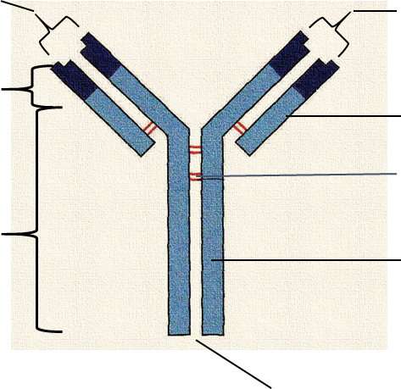

* What type of molecule is an antibody? ...................………………………………….

………………………………………………………………………………………………

**Topic cross link Question:** Does it have tertiary structure? Explain your answer

**…**…………………………………………………………………….**.**…

Does it have Quaternary structure? Explain your answer.

………………………………………………………………………. …

* What type of cells produce antibodies? …………………………….

**The Action of Antibodies**

* Using the words **antibody antigen complex**, **antigen binding site**, and **complementary,** write a brief description in your own words about how antibodies bind with antigens. (ref slides

**Watch the animations**

1. <http://highered.mheducation.com/sites/0072507470/student_view0/chapter22/animation__the_immune_response.html> same link as in cell mediated response as does both.
2. <http://www.sbs.utexas.edu/psaxena/MicrobiologyAnimations/Animations/HumoralImmunity/micro_humoral.swf> good clear animation. Some screen shots shown in PowerPoint and booklet diagrams

* Describe 2 ways that antigens prepare an antigen for destruction.

……………………………………………………………………………………………………………………………………………………………………………………………………………………………………………………………………………………………………………………………………………………………………………………………………………………………………………………………………..

**Definition of an Antibody**

**An antibody is**

**Fill in the gaps in the passage about antibodies**

***Constant; variable; protein; peptide; complementary; amino acid***

Antibodies are made of …………..…. They’re made up of chains of …….. ………….. monomers linked by …………………..bonds.

The specificity of an antibody depends on its ………………. ... regions. Each antibody has a different shaped variable region (due to different amino acid sequences), that’s ………………..….. to one specific antigen. The ……………..… regions are the same in all antibodies.

**Diagrams of Main Events in Stimulating the Humoral Response**

Add annotations after looking at the presentation on GoL

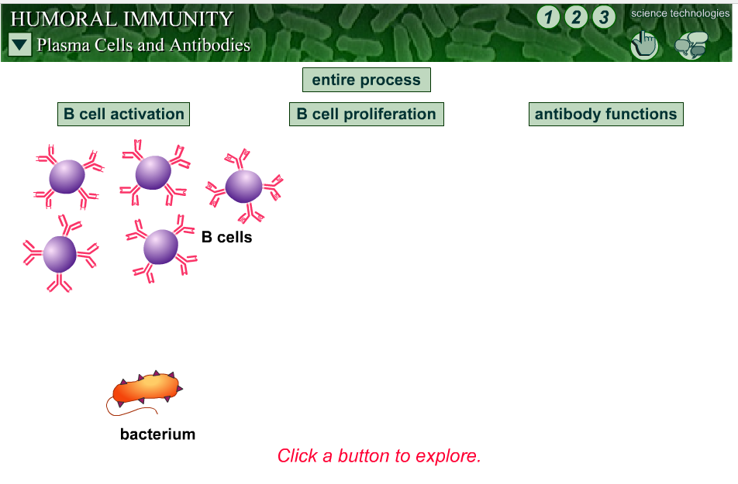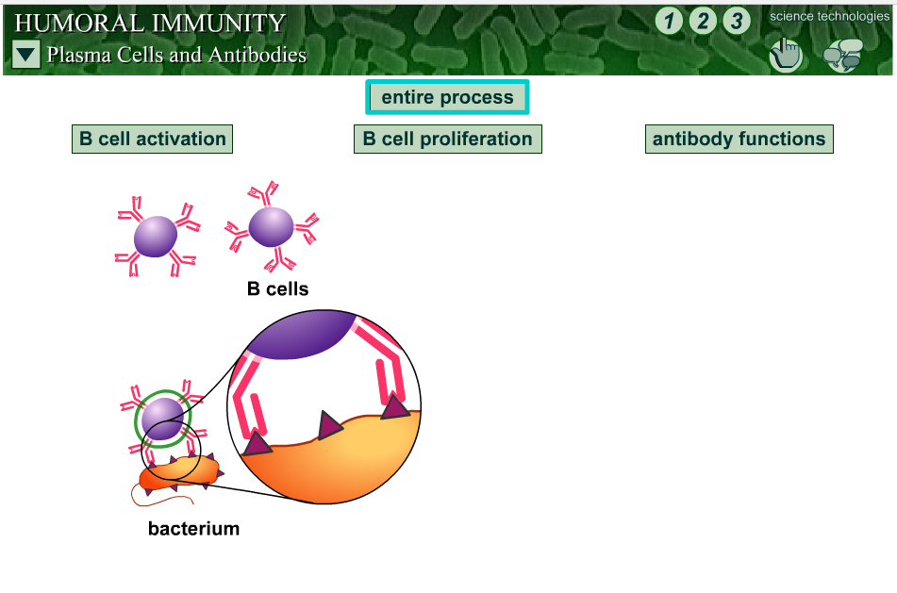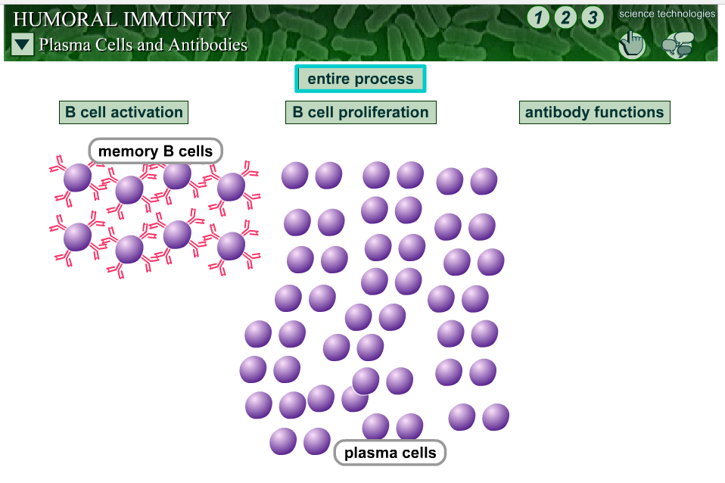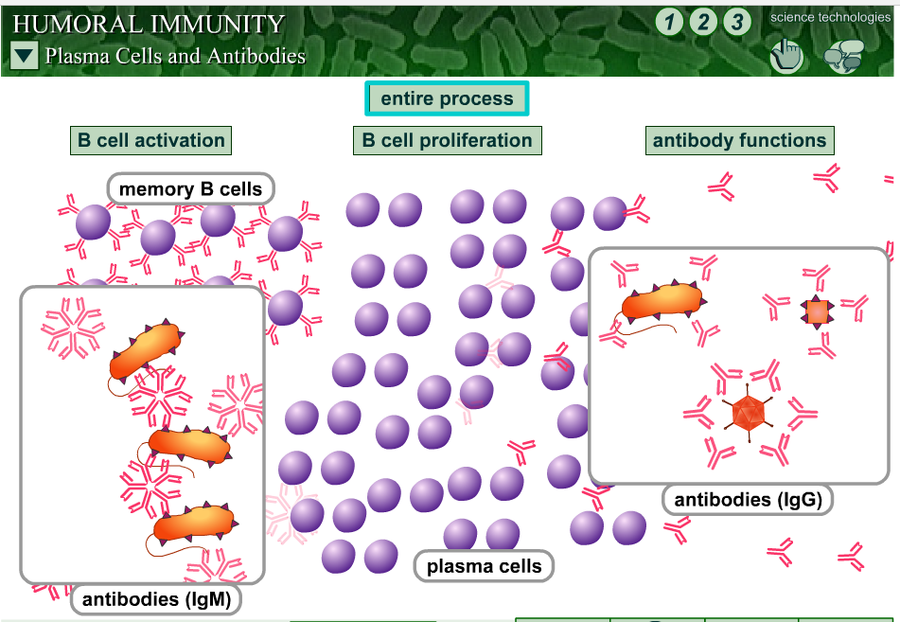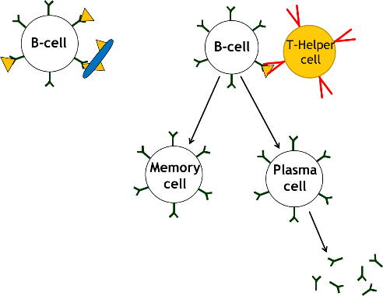

**1**

**2**

Action of T-Helper Cell

**3**

**4**

Annotations for stages above:

1.

2.

3.

4.

* What is the main type of lymphocyte is involved in the humoral response?

……………………………….………………………………………………………………………………………………..

* By what process does this cell take up the antigens and then what does it do with the antigens?

………………………………………………………………………………………………………………………………... ………………………………………………………………………………………………………………………………….

* What other type of lymphocyte binds to the processed presented antigens and helps to activate the presenting cell (……………..…) to divide by **mitosis**?

.............................................………………………………………………………………………………………

* Now explain what is meant by **CLONAL SELECTION** …………………………………………....…………………………………………………………………………………………………………………………………………………………………………………………………………………………………………………

**The Primary and Secondary Response**

The graph shows the concentration of antibodies in the blood of a person after a first infection with a particular antigen and then again after a second exposure some time later.

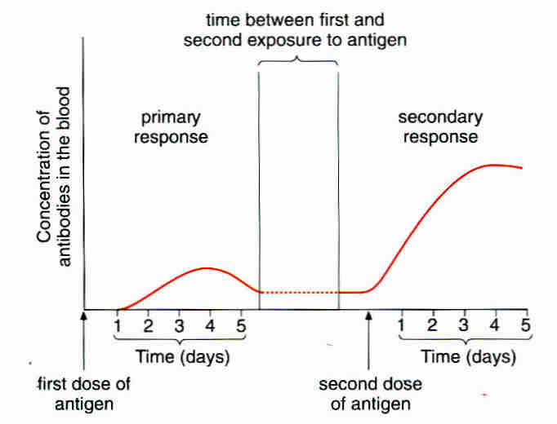

**Study** the graph and explain what is happening in the body using the headings provided

**Primary Response**: ……………………………………………………………………………..

………………………………………………………………………………………………………

………………………………………………………………………………………………………

**Secondary response**:-…………………………………………………………………………..

……………………………………………………………………………………………………....

………………………………………………………………………………………………………

………………………………………………………………………………………………………

Using the graph, give 3 differences between the primary and secondary responses.

* ...............................................................................................................................................
* ...............................................................................................................................................
* ...............................................................................................................................................

**Antigenic Variability**

Antigens on the surface of **pathogens** activate the **primary response**. When you’re infected a second time with the same pathogen they activate the **secondary response** and you don’t usually get ill.

However some pathogens change their **surface antigens**. This is called **antigenic variation**. This means that when you are infected for a second time, the memory cells produced from the first infection will not recognise the different antigens. So the immune system has to start from the beginning and carry out a primary response against these new antigens.

* Can you think of any pathogens who use this tactic to avoid immune responses?

………………………………………….….

**Types of Immunity and Vaccines**

**Types of Immunity**

1. Active Immunity ………………………………………………………………….…………………………………………..

...............................................................................................................................................

...............................................................................................................................................

1. Passive Immunity ………………………………………………………………….……………………………………….

...............................................................................................................................................

...............................................................................................................................................

1. Herd Immunity ………………………………………………………………….……………………………………………

...............................................................................................................................................

...............................................................................................................................................

|  |  |
| --- | --- |
| **Vaccinated Not vaccinated Infected**  **But healthy** | |
| **Population with few people vaccinated** | **Population with many people vaccinated** |
| C:\Users\Kaykays PC\Documents\My PaperPort Documents\School\Defence and Immune Response\Copy 3 of Herd Immunity Diagrama.jpg | C:\Users\Kaykays PC\Documents\My PaperPort Documents\School\Defence and Immune Response\Copy 4 of Herd Immunity Diagrama.jpg |

<http://www.nhs.uk/conditions/vaccinations/pages/how-vaccines-work.aspx> NHS information including 2 short (2 min) videos Video 2 explains herd immunity.

**Comparison of Active and Passive Immunity**

* **Complete** the table below answering **Yes** or **NO**

|  |  |  |
| --- | --- | --- |
| **Features** | **Active Immunity** | **Passive Immunity** |
| Requires exposure to an antigen |  |  |
| Requires time for immunity to develop |  |  |
| Memory cells produced |  |  |
| Protection is long term or short term |  |  |

**Natural and Artificial Immunity**

* Both Active and Passive immunity can be natural or artificial. What is artificial Immunity?

**Active Artificial Immunity** ………………………………………………………… ………………………………………………………………………………………….. ………………………………………………………………………………………….. …………………..……………………………………………………………………..

**Passive Artificial Immunity** is gained by being injected with antibodies from another person. You don’t make memory cells and it only fights an infection that is already present e.g. tetanus.

**Vaccines**

A vaccine is a preparation of antigens from a pathogen.

**Read Biofactsheet 99 ‘Vaccines’** and make your own notes about vaccines and immunity

* Explain how vaccines work

………………………………….................................................................................................................

………………………………….................................................................................................................

………………………………….................................................................................................................

………………………………….................................................................................................................

* How are vaccines made harmless?

1. …………………………………………………………………………………………………………………………………..

…………………………………………………………………………………………………………………………………..

1. …………………………………………………………………………………………………………………………………..

…………………………………………………………………………………………………………………………………..

1. …………………………………………………………………………………………………………………………………..

…………………………………………………………………………………………………………………………………..

* Suggest a disadvantage of taking vaccines orally. ………….…………………………………………………………….

…………………………………………………………………………………………………………………………………………………….

**Maths Skills – (MS 0.5)** ‘Calculate and understand the use of percentages or values per 100 000 when looking at data within populations’

The graph below shows the results of a study in Japan by **Hideo Honda** in 2005. It shows the number of children diagnosed with autism before the age of seven in the Yokohama region of Japan. It involved a study of more than 30 000 children.

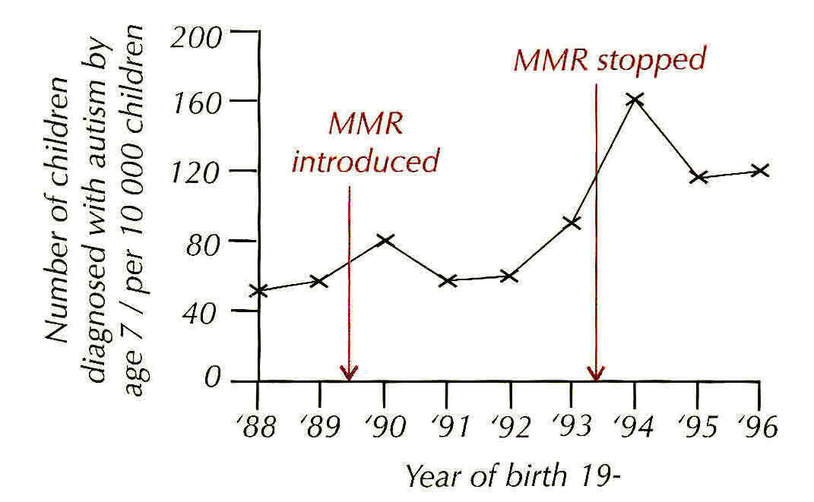

What happened to the incidence of children with autism after the MMR vaccine was stopped? …………………………………………..………………………………………………………………………………………………...

In 1994 the incidence of autism peaked in this region.

1. What percentage of the study population were diagnosed with autism in 1994?

……………………………………………………………………………………………………………………………

1. What was the lowest percentage diagnosed with autism during the time the vaccine was in use?

……………………………………………………………………………………………………………………………

1. Does this information suggest there is any link between autism and MMR?

……………………………………………………………………………………………………………………………

1. Explain your reasons and using information given in the introductory sentences and the information on the graph.

……………………………………………………………………………………………………………………………

……………………………………………………………………………………………………………………………

……………………………………………………………………………………………………………………………

……………………………………………………………………………………………………………………………

……………………………………………………………………………………………………………………………

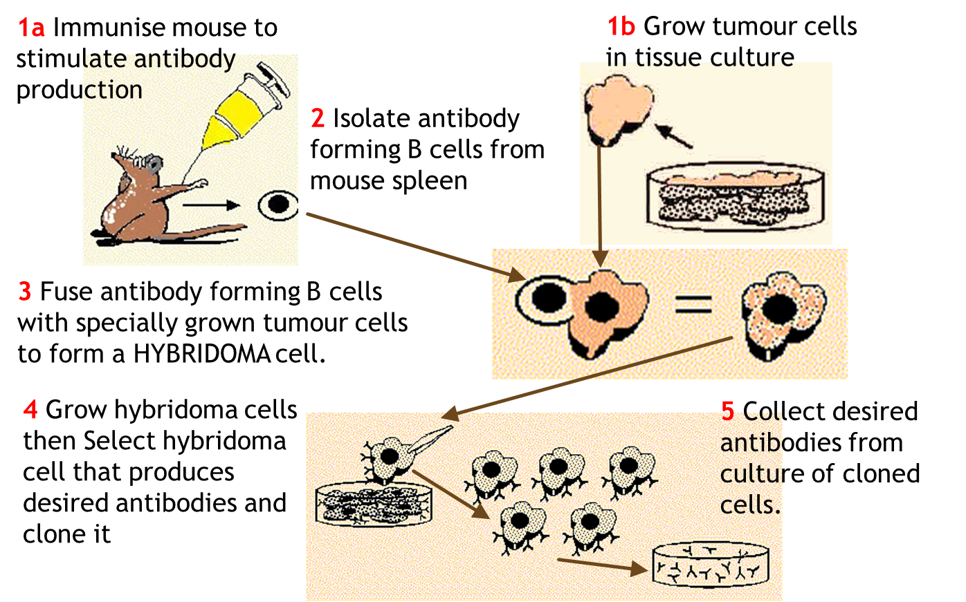**Monoclonal Antibodies**

* What are monoclonal antibodies?

……………………………………………………………………………………….

……………………………………………………………………………………..

* What are they used for?

………………………………………………............…………………………………………………………………………………………

………………………………………………............…………………………………………………………………………………………

* State some examples of their uses.

………………………………………………………………………………………………………………………………………………………………………………………………………............…………………………………………………………………………………………

………………………………………………............……………………………………………………………………………………

* How do they work?

1. Direct Monoclonal Antibody Therapy ……………………………………….…………………………………………

………………………………………………............……………………………………………………………………………………

………………………………………………............……………………………………………………………………………………………………………………………………............……………………………………………………………………………………

………………………………………………............……………………………………………………………………………………

1. 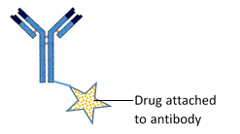Indirect Monoclonal Antibody Therapy…………………………………. ………………………………….………………………………………………………….

……………………………………………………………………………………………..

…………………………………………………………………………………………….

………………………………………………............……………………………………………………………………………………

1. Pregnancy testing ……………………………………………………………………………………………………………………

………………………………………………............……………………………………………………………………………………………………………………………………............……………………………………………………………………………………………………………………………………............……………………………………………………………………………………

………………………………………………............……………………………………………………………………………………

**Note**: Determining the amount of a chemical in a mixture is known as an **immunoassay**

**Definition of Immunoassay –“**A biochemical test that measures the presence or concentration of a macromolecule in a solution through the use of an antibody or immunoglobulin.” *(Wikipedia)*

**Ethical Issues Surrounding the Use of Monoclonal Antibodies**

Discuss and write down a list of issues related monoclonal antibody use.

**The ELISA Test (Enzyme Linked Immunosorbent Assay)**

This enables you to see if a patient has a particular antibody to a certain antigen and so diagnose the presence of a disease.

Explain how the test works using the diagrams below to guide you as a story board

|  |  |
| --- | --- |
| KEY | |
|  | Antibody with enzyme attached |
|  | antigen |
|  | Substrate for enzyme |
|  | Coloured product acts as a marker |

Start with an antibody with an attached enzyme!

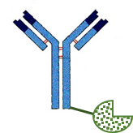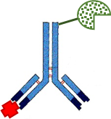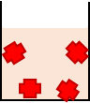

Antigens in sample are bound to the surface of the container

+ =

2 …

1

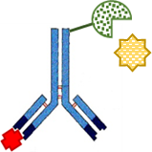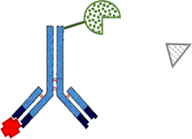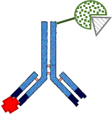

5

4

3

Since the antibodies added to the sample all contained the enzyme, all could have reacted with the substrate that was also added to produce a colour marker. How can this technique prove the presence of the antigen in the sample?

…………………….……………………………………………………………………………………………………………………………………………………………………………………………………………………………………………………………………………………………………………………………………………………………………………………………………………………………………………………………………………………………………………………………………………………………………………………………………………………

**Practice Question - Diagnosis**

**1.** (a) What is vaccination?

....................................................................................................................................

....................................................................................................................................

....................................................................................................................................

(2)

(b) A test has been developed to find out whether a person has antibodies against the mumps virus. The test is shown in the diagram.



(i) Explain why this test will detect mumps antibodies, but not other antibodies in the blood.

...........................................................................................................................

...........................................................................................................................

(1)

(ii) Explain why it is important to wash the well at the start of **Step 4**.

...........................................................................................................................

...........................................................................................................................

...........................................................................................................................

(2)

(iii) Explain why there will be no colour change if mumps antibodies are not present in the blood.

...........................................................................................................................

...........................................................................................................................

...........................................................................................................................

(2)

(Total 7 marks)

**HIV - The Human Immunodeficiency Virus**

This virus causes AIDS (Acquired Immune deficiency Syndrome) and was first diagnosed in 1981.

**Structure**

Label the structure of HIV*.*

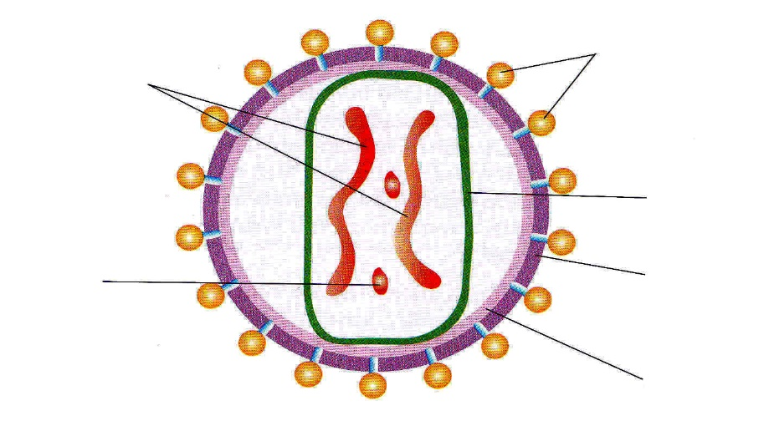

**Topic Cross Link Questions –**

* What is the **Capsid** of a virus? ........…………………….………………………………………………………..…
* What is the function of the **lipid envelope**? ...........…..…………………………………………………..

……………………………………………………………………………………………………………………………………..

* What type of proteins are the attachment proteins? ………………………..…………………………
* What is the name of the host receptors that these attachment proteins bind to? ………………………………………………………………………………………………………………………………………
* Which type of white blood cell contains these receptors? …………………………………………...

**Action of HIV in the Body**

It causes the symptoms of AIDS. Explain below how it does this.

…………………………………………………………………………………………………………………………………………………………………………………………………………………………………………………………………………………………………………………………………………………………………………………………………………………………………………………………

……………………………………………………………………………………………………………………………………………………………………………………………………………………………………………………………………………………………………

………………………………………………………………………………………………………………………………………………

**HIV Life Cycle**

**Jumbled Statements** – write the following statements in order 1 to 9 in the boxes of the HIV life cycle diagram.

* *m-RNA goes to cytoplasm and makes viral proteins and RNA for new virus*
* *Immature HIV.*
* *Attaches to white blood cell.*
* *Viral strand made double stranded.*
* *New virus buds off human cell*
* *Fusion of cell membrane and viral envelope.*
* *Viral DNA enters nucleus.*
* *Viral DNA integrates into human chromosomes and makes viral m-RNA*
* *Released viral RNA copied into single stranded DNA.*

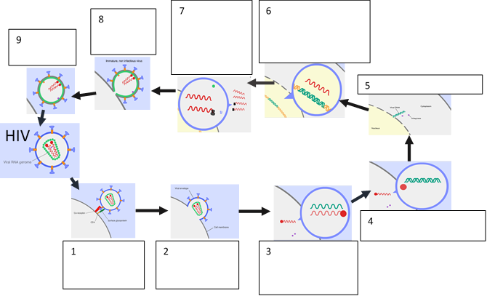

**Why Antibiotics are Ineffective against Viral Diseases.**

First consider the structure of bacterial cells. Topic Crosslink!

* + Bacterial cell wall made of ………….……………………………………..
  + Water enters by …..……………………………………………………………
  + Cell wall prevents excessive expansion because it is ………………….………………………….

Some Antibiotics inhibit enzymes needed for cell wall synthesis. This means the cell wall is weakened, too much water enters by osmosis and the cell suffers osmotic lysis. (Death by osmosis!)

Others bind to bacterial ribosomes, so inhibit protein synthesis.

Some antibiotics inhibit DNA replication.

Some work by disrupting cell membranes.

**IE they all interfere with the bacterial metabolism!**

Now explain below why antibiotics are no use against viruses.

………………………………………………………………………………………………………………………………………………………………………………………………………………………………………………………………………………………………………………………………………………………………………………………………………………………………………………………………………………

**Cell Recognition and the Immune System Glossary**

|  |  |
| --- | --- |
| **antigen** |  |
| **antibody** |  |
| **Antigenic variation** |  |
| **lysozymes** |  |
| **lymphocytes** |  |
| **phagocytes** |  |
| **phagocytosis** |  |
| **Cytotoxic T-cells** |  |
| **Helper T-cells** |  |
| **B-cells** |  |
| **Plasma cells** |  |
| **Memory cells** |  |
| **Monoclonal antibodies** |  |
| **ELISA test** |  |
| **agglutination** |  |
| **Clonal selection** |  |
| **Antigen presentation** |  |
| **phagosome** |  |
| **toxin** |  |
| **Self-antigen** |  |
| **cytokines** |  |
| **perforin** |  |
| **immunoglobulin** |  |
| **Primary response** |  |
| **Secondary response** |  |
| **Pandemic** |  |
| **epidemic** |  |
| **attenuation** |  |
| **Hybridoma cell** |  |
| **ELISA test** |  |
| **agglutination** |  |