**Q1.**

(a)  The table shows cell wall components in plants, algae, fungi and prokaryotes.

Complete the table by putting a tick (**✓**) where a cell wall component is present.

|  |  |  |  |  |
| --- | --- | --- | --- | --- |
| **Cell wall component** | **Plants** | **Algae** | **Fungi** | **Prokaryotes** |
| Cellulose |  |  |  |  |
| Murein |  |  |  |  |
| Chitin |  |  |  |  |

**(3)**

**Q2.**

The diagram shows a eukaryotic cell.

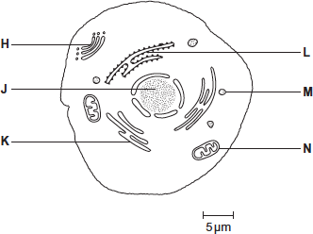

(a)     Complete the table by giving the letter labelling the organelle that matches the function.

|  |  |
| --- | --- |
| **Function of organelle** | **Letter** |
| Protein synthesis |  |
| Modifies protein (for example, adds carbohydrate to protein) |  |
| Aerobic respiration |  |

**(3)**

(b)     Use the scale bar in the diagram above to calculate the magnification of the drawing.  
Show your working.

 Answer = ____________________

**(2)**

**(Total 5 marks)**

**Q3.**

The diagram shows part of a prokaryotic cell.

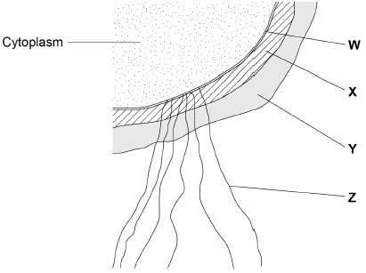

(a)     Name the structures labelled **W** to **Z** in the diagram.

**W** ________________________________________________________________

**X** _________________________________________________________________

**Y** _________________________________________________________________

**Z** _________________________________________________________________

**(2)**

(b)     Name the main biological molecule in:

**W** ________________________________________________________________

**X** _________________________________________________________________

**(2)**

(c)     Name the process by which prokaryotic cells divide.

___________________________________________________________________

**(1)**

(d)     Some prokaryotic cells can divide every 30 minutes. A liquid culture contained a starting population of 1.35 × 104 cells.

Assuming each cell divides every 30 minutes, calculate how many cells there will be after 3 hours. Assume no cells die during this time.

Answer = ____________________

**(2)**

**(Total 7 marks)**

**Q4.**

(a)     Eukaryotic cells produce and release proteins.

Outline the role of **organelles** in the production, transport and release of proteins from eukaryotic cells.

Do **not** include details of transcription and translation in your answer.

___________________________________________________________________

___________________________________________________________________

___________________________________________________________________

___________________________________________________________________

___________________________________________________________________

___________________________________________________________________

___________________________________________________________________

___________________________________________________________________

___________________________________________________________________

___________________________________________________________________

___________________________________________________________________

**(4)**

The image below is a transmission electron micrograph of a plant cell.

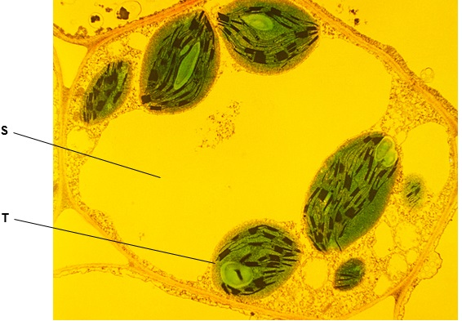

(b)     Suggest why a nucleus is **not** visible in above image.

___________________________________________________________________

___________________________________________________________________

___________________________________________________________________

**(1)**

(c)     Name the organelles labelled **S** and **T** in the image above.

Organelle **S** _______________________________________________________

Organelle **T** _______________________________________________________

**(1)**

(d)     Give **one** advantage of viewing a biological specimen using a transmission electron microscope compared with using a scanning electron microscope.

___________________________________________________________________

___________________________________________________________________

___________________________________________________________________

**(1)**

(e)     The cells in the diagram below are part of a continuous layer of cells forming the upper surface of a leaf.

The shaded area of cell **U** is 150 µm2

The total area of the upper surface of the leaf is 70.65 cm2

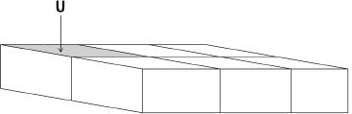

Calculate the number of cells in the upper surface of the leaf.

Give the answer in standard form.

Assume that all these cells are identical in size.

Show your working.

Number of cells _______________

**(2)**

**(Total 9 marks)**

**Q5.**

(a)     Describe and explain how cell fractionation and ultracentrifugation can be used to isolate mitochondria from a suspension of animal cells.

___________________________________________________________________

___________________________________________________________________

___________________________________________________________________

___________________________________________________________________

___________________________________________________________________

___________________________________________________________________

___________________________________________________________________

___________________________________________________________________

___________________________________________________________________

___________________________________________________________________

**(5)**

(b)     Describe the principles and the limitations of using a transmission electron microscope to investigate cell structure.

___________________________________________________________________

___________________________________________________________________

___________________________________________________________________

___________________________________________________________________

___________________________________________________________________

___________________________________________________________________

___________________________________________________________________

___________________________________________________________________

___________________________________________________________________

___________________________________________________________________

**(5)**

**(Total 10 marks)**

**Q6.**

(a)     Describe how you could make a temporary mount of a piece of plant tissue to observe the position of starch grains in the cells when using an optical (light) microscope.

___________________________________________________________________

___________________________________________________________________

___________________________________________________________________

___________________________________________________________________

___________________________________________________________________

___________________________________________________________________

___________________________________________________________________ **(4)**

The figure below shows a microscopic image of a plant cell.

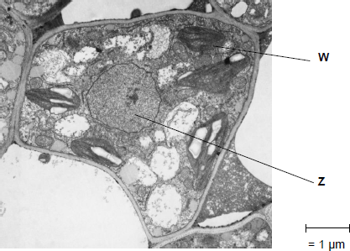

© Science Photo Library

(b)     Give the name and function of the structures labelled **W** and **Z**.

Name of **W**__________________________________________________________

Function of **W**________________________________________________________

Name of **Z** __________________________________________________________

Function of **Z** ________________________________________________________

**(2)**

(c)     A transmission electron microscope was used to produce the image in the figure above.   
Explain why.

___________________________________________________________________

___________________________________________________________________

___________________________________________________________________

___________________________________________________________________

**(2)**

(d)     Calculate the magnification of the image shown in the figure in part (a).

Answer = ____________________

**(1)**

**(Total 9 marks)**

**Q7.** (c)     **Figure 2** shows a photograph of part of a mitochondrion from a mouse liver cell taken using a transmission electron microscope at × 62 800 magnification.

**Figure 2**

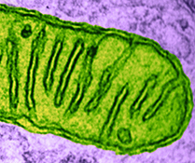

Produce a scientific drawing of the mitochondrion in **Figure 2** in the box below.

Label the following parts of the mitochondrion on your drawing.

•        Matrix

•        Crista



**(4)**

**(Total 8 marks)**

**Q8.**

(a)     Describe how you could use cell fractionation to isolate chloroplasts from leaf tissue.

___________________________________________________________________

___________________________________________________________________

___________________________________________________________________

___________________________________________________________________

___________________________________________________________________

**(3)**

The figure below shows a photograph of a chloroplast taken with an electron microscope.

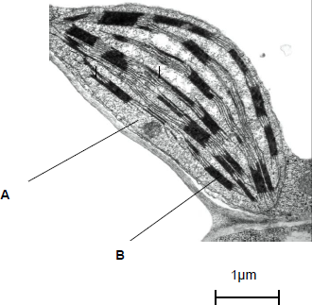

© Science Photo Library

(b)     Name the parts of the chloroplast labelled **A** and **B**.

Name of **A** ________________________________________________________

Name of **B** ________________________________________________________

**(2)**

(c)     Calculate the length of the chloroplast shown in the figure above.

Answer ____________________

**(1)**

(d)     Name **two** structures in a eukaryotic cell that **cannot** be identified using an optical microscope.

1. _________________________________________________________________

2. _________________________________________________________________

**(1)**

**(Total 7 marks)**

**Q9.**

Below is a diagram of an animal cell.

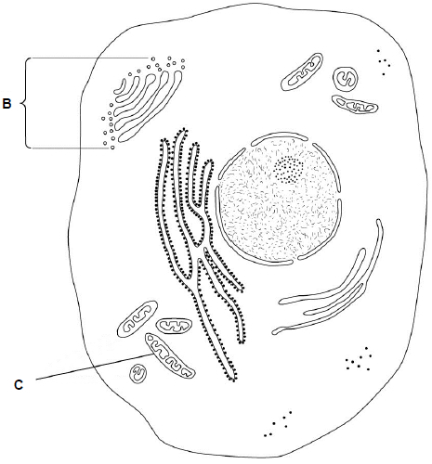

(a)     Name the organelles labelled:

**B** _________________________________

**C** _________________________________

**(2)**

(b)     Name **two** structures present in plant cells that are **not** present in animal cells.

1. _________________________________________________________________

2. _________________________________________________________________

**(1)**

A biologist prepared a sample of organelles labelled **C** from liver. He used the following method.

1.      Added to the liver tissues an ice-cold, buffered solution with the same water potential as the liver tissue.

2.      Mixed the liver and solution in a blender.

3.      Filtered the mixture from the blender.

4.      Spun the filtered liquid in a centrifuge at a low speed. A pellet appeared in the bottom of the centrifuge tube.

5.      Poured off the liquid above the pellet into a second centrifuge tube and spun this at a higher speed to obtain the sample of organelles labelled **C**.

(c)     Explain why the solution the biologist used was ice-cold, buffered and the same water potential as the liver tissue (step 1).

Ice-cold____________________________________________________________

___________________________________________________________________

Buffered

________________________________________________________________

Same water potential__________________________________________________

___________________________________________________________________

**(3)**

(d)     Explain why the biologist used a blender and then filtered the mixture (steps 2 and 3).

___________________________________________________________________

___________________________________________________________________

___________________________________________________________________

**(2)**

(e)     Name the organelle that made up most of the first pellet after centrifuging at a low speed (step 4).

___________________________________________________________________

**(1)**

(f)     The second centrifuge tube was spun at a higher speed to obtain the sample of organelles labelled **C** in the diagram (step 5).

Suggest why.

___________________________________________________________________

**(1)**

**(Total 10 marks)**

**Q10.**

(a)     Structures **A** to **E** are parts of a plant cell.

**A**     Cell Wall

**B**     Chloroplast

**C**     Nucleus

**D**     Mitochondrion

**E**     Golgi apparatus

Complete the table by putting the correct letter, **A**, **B**, **C**, **D** or **E** in the box next to each statement.

|  |  |
| --- | --- |
| **Statement** | **Letter** |
| Has stacked membranes arranged in parallel and contains DNA. |  |
| Is made of polysaccharide. |  |
| Is an organelle and is **not** surrounded by two membranes. |  |

**(3)**

(b)     Human breast milk is produced and secreted by gland cells. These gland cells have adaptations that include many mitochondria and many Golgi vesicles. The milk contains a high concentration of protein.

Explain the role of these cell adaptations in the production and secretion of breast milk.

___________________________________________________________________

___________________________________________________________________

___________________________________________________________________

___________________________________________________________________

___________________________________________________________________

___________________________________________________________________

**(2)**

**(Total 5 marks)**