**Q1.**

(a)     The diagram shows a chromosome at the start of mitosis.

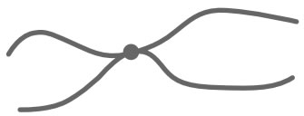

Describe and explain the appearance of the chromosome.

___________________________________________________________________

___________________________________________________________________

___________________________________________________________________

___________________________________________________________________

**(2)**

(b)     The photographs show two stages in mitosis.

Stage **A**                                                   Stage **B**

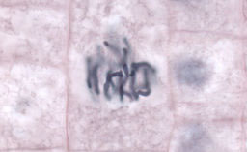 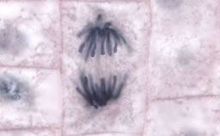

By Dr. phil.nat Thomas Geier, Fachgebiet Botanik der Forschungsanstalt Geisenheim.  
[CC-BY-SA-3.0], via Wikimedia Commons

Name stages **A** and **B**. Describe what is happening to the chromosomes in each stage.

(i)      Stage **A** ___________________________

______________________________________________________________

______________________________________________________________

______________________________________________________________

**(2)**

(ii)     Stage **B** ___________________________

______________________________________________________________

______________________________________________________________

______________________________________________________________

**(2)**

**(Total 6 marks)**

**Q2.**

Yeast is a single-celled eukaryotic organism. When yeast cells are grown, each cell forms a bud. This bud grows into a new cell. This allows yeast to multiply because the parent cell is still alive and the new cell has been formed.

Scientists grew yeast cells in a culture. They counted the number of cells present and measured the total concentration of DNA in the culture over a period of 6 hours. Their results are shown in the graph.

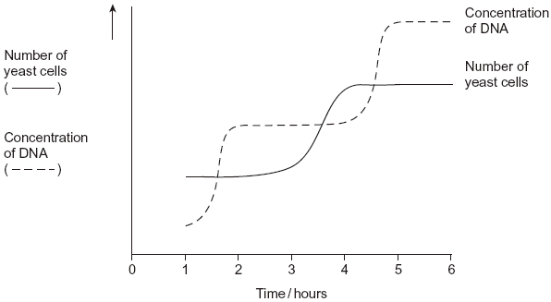

(a)     Use your knowledge of the cell cycle to explain the shape of the curve for the number of yeast cells

(i)      between 1 and 2 hours

______________________________________________________________

______________________________________________________________

**(1)**

(ii)     between 3 and 4 hours.

______________________________________________________________

______________________________________________________________

**(1)**

(b)     Use the curve for the concentration of DNA to find the length of a cell cycle in these yeast cells. Explain how you arrived at your answer.

Length of cell cycle ___________________________________________________

Explanation _________________________________________________________

___________________________________________________________________

___________________________________________________________________

___________________________________________________________________

**(3)**

**(Total 5 marks)**

**Q3.**

(a)     The diagram shows a stage of mitosis in an animal cell.

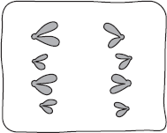

(i)      Name this stage.

______________________________________________________________

**(1)**

(ii)     Describe what happens during this stage that results in the production of two genetically identical cells.

______________________________________________________________

______________________________________________________________

______________________________________________________________

______________________________________________________________

______________________________________________________________

**(2)**

(b)     A sample of epithelial tissue from the small intestine of an animal was analysed.  
Some of the cells had 8.4 units of DNA, others had only 4.2 units.

(i)      Use your knowledge of the cell cycle to explain why some cells had 8.4 units of DNA and others had only 4.2 units.

______________________________________________________________

______________________________________________________________

______________________________________________________________

______________________________________________________________

______________________________________________________________

**(2)**

(ii)     How many units of DNA would you expect to be present in a gamete formed in this animal as a result of meiosis?



**(1)**

**(Total 6 marks)**

**Q4.**

(a)     A student prepared a stained squash of cells from the tip of an onion root and observed it using an optical microscope.

During the preparation of the slide, he:

•        cut the first 5 mm from the tip of an onion root and placed it on a glass slide

•        covered this tip with a drop of stain solution and a cover slip

•        warmed the glass slide

•        pressed down firmly on the cover slip.

He identified and counted nuclei in different stages of the cell cycle.

Explain why the student:

1. used only the first 5 mm from the tip of an onion root.

___________________________________________________________________

___________________________________________________________________

___________________________________________________________________

___________________________________________________________________

2. pressed down firmly on the cover slip.

___________________________________________________________________

___________________________________________________________________

___________________________________________________________________

___________________________________________________________________

**(2)**

**Figure 1** shows the cells the student saw in one field of view. He used this field of view to calculate the length of time these onion cells spent in anaphase of mitosis.

**Figure 1**

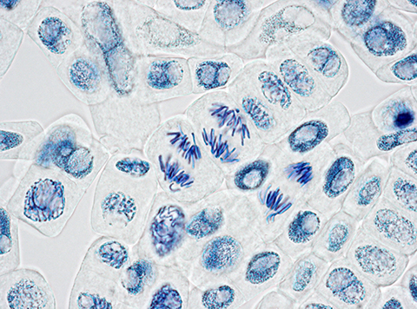

(b)     Scientists have found the mean length of time spent by onion cells in anaphase of mitosis is 105 minutes. They also found the cell cycle of cells in the onion root shown in **Figure 1** takes 1080 minutes.

32 whole cells are shown in **Figure 1**.

Use this information and **Figure 1** to calculate the length of time the cells of this onion root are in anaphase **and** then calculate the percentage difference between your answer and the mean length of time found by the **scientists**.

Show your working.

Answer = ____________________ %

**(2)**

(c)     Tick (**✓**) the name given to the division of cytoplasm during the cell cycle.

|  |  |  |
| --- | --- | --- |
| **A** | Binary fission |  |
| **B** | Cytokinesis |  |
| **C** | Phagocytosis |  |
| **D** | Segregation |  |

**(1)**

(d)     Describe and explain what the student should have done when counting cells to make sure that the mitotic index he obtained for this root tip was accurate.

___________________________________________________________________

___________________________________________________________________

___________________________________________________________________

___________________________________________________________________

___________________________________________________________________

___________________________________________________________________

___________________________________________________________________

___________________________________________________________________

___________________________________________________________________

**(2)**

(e)     A scientist treated growing tips of onion roots with a chemical that stops roots growing. After 24 hours, he prepared a stained squash of these root tips.

**Figure 2** is a drawing showing the chromosomes in a single cell observed in the squash of one of these root tips in anaphase. This cell was typical of other cells in anaphase in these root tips.

**Figure 2**

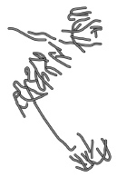

Use all of this information to suggest how the chemical stops the growth of roots.

___________________________________________________________________

___________________________________________________________________

___________________________________________________________________

___________________________________________________________________

___________________________________________________________________

___________________________________________________________________

___________________________________________________________________

___________________________________________________________________

___________________________________________________________________

___________________________________________________________________

___________________________________________________________________

___________________________________________________________________

___________________________________________________________________

___________________________________________________________________

**(3)**

**(Total 10 marks)**

**Q5.**

The photograph shows cells from an onion root tip. The root tip has been squashed and stained to show the stages of mitosis.

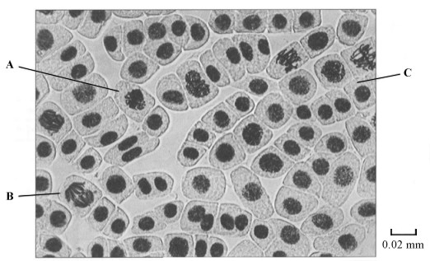

(a)     (i)      At what stage of mitosis is cell **A**?

______________________________________________________________

**(1)**

(ii)     What is the evidence that cell **B** is in anaphase?

______________________________________________________________

______________________________________________________________

**(1)**

(iii)     Cell **C** is in interphase. Give **two** processes which occur during interphase that enable cell division to occur.

1. ____________________________________________________________

______________________________________________________________

2. ____________________________________________________________

______________________________________________________________

**(2)**

(b)     Explain how you would calculate the magnification of the photograph.

___________________________________________________________________

___________________________________________________________________

**(1)**

(c)     The number of cells at each stage of mitosis was counted. The results are shown in the table.

|  |  |
| --- | --- |
| **Stage of mitosis** | **Number of cells** |
| Interphase | 123 |
| Prophase | 32 |
| Metaphase | 12 |
| Anaphase | 6 |
| Telophase | 27 |

One complete cell cycle takes 24 hours. The number of cells at each stage is proportional to the time spent at that stage. Calculate the length of time spent in metaphase. Show your working.

Answer ____________________ hours

**(2)**

**(Total 7 marks)**

**Q6.**

A student investigated mitosis in the tissue from an onion root tip.

(a)     The student prepared a temporary mount of the onion tissue on a glass slide. She covered the tissue with a cover slip. She was then given the following instruction.

“Push down hard on the cover slip, but do not push the cover slip sideways.”

Explain why she was given this instruction.

___________________________________________________________________

___________________________________________________________________

___________________________________________________________________

___________________________________________________________________

**(2)**

The image below shows one cell the student saw in the onion tissue.

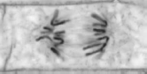

© Ed Reschke/  
Oxford Scientific/Getty Images

(b)     The student concluded that the cell in the image above was in the anaphase stage of mitosis.  
Was she correct? Give **two** reasons for your answer.

1. _________________________________________________________________

___________________________________________________________________

2. _________________________________________________________________

___________________________________________________________________

**(2)**

(c)     The student counted the number of cells she observed in each stage of mitosis.  
Of the 200 cells she counted, only six were in anaphase.

One cell cycle of onion root tissue takes 16 hours. Calculate how many minutes these cells spend in anaphase.

Show your working.

Answer = ____________________ minutes

**(2)**

**(Total 6 marks)**

**Q7.**

The diagram shows a cell cycle.

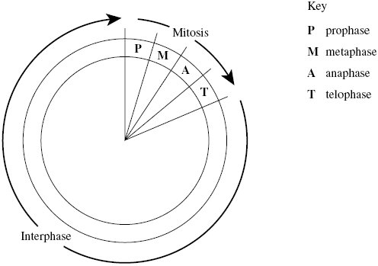

(a)     The table shows the number of chromosomes and the mass of DNA in different nuclei.

All the nuclei come from the same animal. Complete this table.

|  |  |  |
| --- | --- | --- |
| **Nucleus** | **Number of chromosomes** | **Mass of DNA / arbitrary units** |
| At prophase of mitosis | 26 | 60 |
| At telophase of mitosis |  |  |
| From a sperm cell |  |  |

**(4)**

(b)     If the DNA of the cell is damaged, a protein called p53 stops the cell cycle.

Mutation in the gene for p53 could cause cancer to develop. Explain how.

___________________________________________________________________

___________________________________________________________________

___________________________________________________________________

___________________________________________________________________

___________________________________________________________________

**(3)**

(c)     Drugs are used to treat cancer. At what phase in the cell cycle would each of the following drugs act?

(i)      A drug that prevents DNA replication

______________________________________________________________

**(1)**

(ii)     A drug that prevents spindle fibres shortening

______________________________________________________________

**(1)**

**(Total 9 marks)**

**Q8.**

(a)     Mitosis is important in the life of an organism. Give **two** reasons why.

___________________________________________________________________

___________________________________________________________________

___________________________________________________________________

___________________________________________________________________

___________________________________________________________________

**(2)**

A biologist used a microscope to investigate plant tissue where some of the cells were dividing by mitosis. She examined 200 cells and counted the number of cells in interphase and in each stage of mitosis.

The table shows some of the cells she saw, and the percentage of cells in interphase and in two stages of mitosis, **A** and **B**.

|  |  |  |
| --- | --- | --- |
| **Stage of cell cycle** | | **Percentage of cells** |
| Interphase |  | 90 |
| Stage **A** |  | 3 |
| Stage **B** |  | 1 |

                                              Images by Edmund Beecher Wilson [Public domain], via Wikimedia Commons

(b)     (i)      Explain why the biologist chose to examine 200 cells.

______________________________________________________________

______________________________________________________________

______________________________________________________________

**(1)**

(ii)     Name Stage **A** and Stage **B**. Give the evidence from the photograph that you used to identify the stage.

Name of Stage **A**________________________________________________

Evidence ______________________________________________________

______________________________________________________________

Name of Stage **B**________________________________________________

Evidence ______________________________________________________

______________________________________________________________

**(4)**

(c)     In this tissue one complete cell cycle took 20 hours.  
Using information from the table, calculate the mean time for these cells to complete mitosis. Show your working.

Answer ____________________

**(2)**

**(Total 9 marks)**

**Q9.**

Read the following passage.

In laboratory tests, scientists investigated the effects of a new drug called ABZ

on stomach tumour cells. They found ABZ stopped mitosis by preventing the

formation of spindle fibres. They also found that ABZ affected some healthy

cells.

Mitosis is a controlled process. Cyclin B is a protein found in a cell’s nucleus.     5

It regulates the timing of mitosis during the cell cycle. Mitosis starts when the

concentration of Cyclin B in the nucleus rises sharply and ends when it falls.

The scientists found that ABZ increased, and maintained, a high concentration

of Cyclin B in stomach tumour cells.

Programmed cell death is called apoptosis. Two nuclear proteins, Bcl-2 and     10

Bax, are involved in controlling apoptosis. Apoptosis is prevented when the

ratio of Bcl-2 to Bax is high and is promoted when this ratio is low. The

scientists found that ABZ decreased the concentration of Bcl-2 and increased

the concentration of Bax in stomach tumour cells.

From their results the scientists claimed that ABZ could be used for the       15

successful treatment of stomach cancer.

Use information from the passage and your own understanding to answer the

questions.

(a)  Suggest why preventing the formation of spindle fibres (lines 2–3) stopped the cell cycle.

___________________________________________________________________

___________________________________________________________________

___________________________________________________________________

___________________________________________________________________

___________________________________________________________________

___________________________________________________________________

**(2)**

(b)  Suggest and explain why ABZ could be used as a treatment for cancer even though it affects some healthy cells (lines 3–4).

___________________________________________________________________

___________________________________________________________________

**(1)**

(c)  What can you conclude about the effect of ABZ on tumour cells?

Use information about changes in the concentrations of Cyclin B (lines 6–7), and Bcl-2 and Bax (lines 10–14).

___________________________________________________________________

___________________________________________________________________

___________________________________________________________________

___________________________________________________________________

___________________________________________________________________

___________________________________________________________________

___________________________________________________________________

___________________________________________________________________

___________________________________________________________________

___________________________________________________________________

___________________________________________________________________

**(4)**

(d)  Evaluate the scientists’ suggestion that ABZ could be used for the successful treatment of stomach cancer.

___________________________________________________________________

___________________________________________________________________

___________________________________________________________________

___________________________________________________________________

___________________________________________________________________

___________________________________________________________________

___________________________________________________________________

___________________________________________________________________

___________________________________________________________________

**(3)**

**(Total 10 marks)**

**Q10.**

The diagrams show four stages of mitosis.

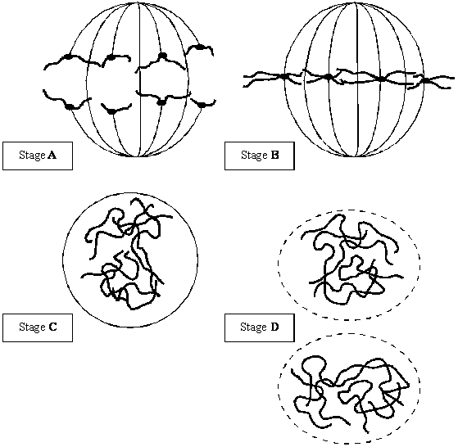

(a)     (i)      Name stage **A**.

______________________________________________________________

**(1)**

(ii)     Starting with stage **C**, give the stages **A** to **D** in the correct order.

**C** ______   ______   ______

**(1)**

(iii)     Describe and explain the appearance of one of the chromosomes in stage **B**.

______________________________________________________________

______________________________________________________________

______________________________________________________________

______________________________________________________________

**(2)**

(b)     Colchicine is a substance that prevents the formation of the spindle in mitosis. Dividing cells were treated with colchicine. This stopped them dividing. After a few hours, the colchicine was removed and the cells began to divide again. The diagram shows the chromosomes from one of the treated cells at stage **B** after the cell began dividing again.

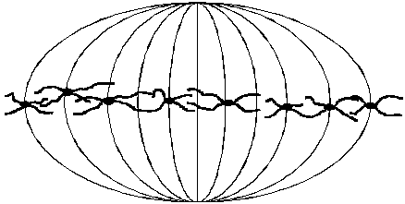

(i)      What has happened to the chromosome number?

______________________________________________________________

**(1)**

(ii)     Suggest an explanation for the change in the chromosome number.

______________________________________________________________

**(1)**

**(Total 6 marks)**

**Q11.**

(a)     Nucleus **A** and nucleus **B** come from the same organism. The diagram shows these nuclei immediately before division and the nuclei formed immediately after their division. The table gives information about some of the nuclei shown in the diagram.

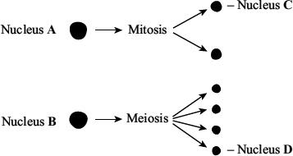

|  |  |  |
| --- | --- | --- |
| **Nucleus** | **Number of chromosomes** | **Mass of DNA / arbitrary units** |
| **A** | 8 | 600 |
| **B** | 8 | 600 |
| **C** |  |  |
| **D** |  |  |

          Complete the table for nuclei **C** and **D**.

**(2)**

(b)     A student investigated the process of meiosis by observing cells on a microscope slide. The cells on the slide had been stained.

(i)      Name an organ from which the cells may have been obtained.

______________________________________________________________

**(1)**

(ii)     Explain why a stain was used.

______________________________________________________________

______________________________________________________________

**(1)**

**(Total 4 marks)**