Q1.
The image below shows the cell-surface membrane of a red blood cell seen with a transmission electron microscope.
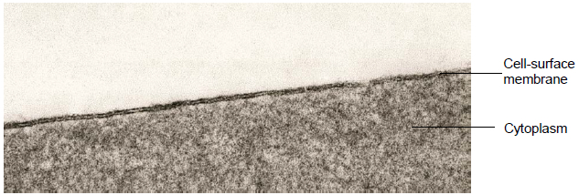
(a) The cell-surface membrane can be seen with a transmission electron microscope but not with an optical microscope.
Explain why.
___________________________________________________________________
___________________________________________________________________
(1)
(b) No organelles are visible in the cytoplasm of this red blood cell.
Suggest why.
___________________________________________________________________
___________________________________________________________________
(1)
(c) Before the cell was examined using the electron microscope, it was stained. This stain caused parts of the structure of the cell-surface membrane to appear as two dark lines.
Suggest an explanation for the appearance of the cell-surface membrane as two dark lines.
___________________________________________________________________
___________________________________________________________________
___________________________________________________________________
___________________________________________________________________
___________________________________________________________________
___________________________________________________________________
(3)
(d) Describe how substances move across cell-surface membranes by facilitated diffusion.
___________________________________________________________________
___________________________________________________________________
___________________________________________________________________
___________________________________________________________________
___________________________________________________________________
___________________________________________________________________
___________________________________________________________________
___________________________________________________________________
(3)
(Total 8 marks)
Q2.
The diagram shows part of a plasma membrane.
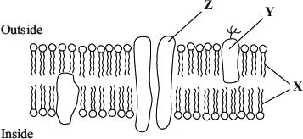
(a) Describe two functions of the structure made from the parts labelled X.
1. _________________________________________________________________
___________________________________________________________________
2. _________________________________________________________________
___________________________________________________________________
(2)
(b) Give one function of the molecule labelled Y.
___________________________________________________________________
___________________________________________________________________
(1)

(c) The part labelled Z is involved in facilitated diffusion of substances across the membrane.
(i) Give one similarity in the way in which active transport and facilitated diffusion transport substances across the membrane.
______________________________________________________________
______________________________________________________________
(ii) Give one way in which active transport differs from facilitated diffusion.
______________________________________________________________
______________________________________________________________
(2)
(iii) The graph shows the relationship between the concentration of a substance outside a cell and the rate of entry of this substance into the cell.
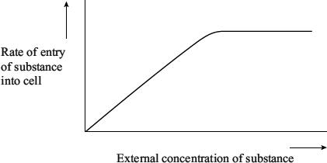
Explain the evidence from the graph that this substance is entering the cell by facilitated diffusion and not by simple diffusion.
______________________________________________________________
______________________________________________________________
______________________________________________________________
______________________________________________________________
(2)
(Total 7 marks)

Q3.
Tradescantia is a house plant. There are small hairs on its flowers. These hairs are made of cells. Figure 1 shows the appearance of cells from one of these hairs after 20 minutes in distilled water. Figure 2 shows cells from another hair after 20 minutes in a solution of potassium nitrate.
Figure 1 (in distilled water)
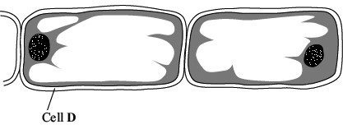
Figure 2 (in potassium nitrate solution)
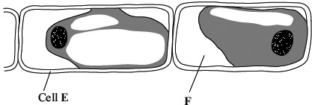
(a) What does Figure 2 suggest about the permeability of the plasma membranes surrounding these cells?
___________________________________________________________________
___________________________________________________________________
(1)
(b) What is present in the space labelled F? Explain your answer.
___________________________________________________________________
___________________________________________________________________
___________________________________________________________________
(2)
(c) How would the water potential of the sap in the vacuole of cell E differ from the water potential of the sap in the vacuole of cell D? Explain your answer.
___________________________________________________________________
___________________________________________________________________
___________________________________________________________________
___________________________________________________________________
___________________________________________________________________
(3)
(Total 6 marks)
Q4.
Glasswort is a plant that grows in salt marshes. The plants are covered by seawater at each high tide. The roots grow in mud which contains a high concentration of salt. The drawing shows a shoot of the plant.
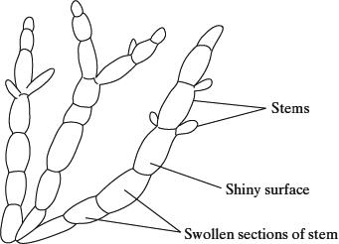
In glasswort cells, sodium ions are transported from the cytoplasm outwards across the cell surface membrane and also into the cell vacuole. The concentration of sodium ions is greater inside the vacuole than in the intercellular fluid, which is the fluid between the cells in tissues. High sodium ion concentrations would disrupt metabolic processes in the cytoplasm. This information is summarised in the diagram below.
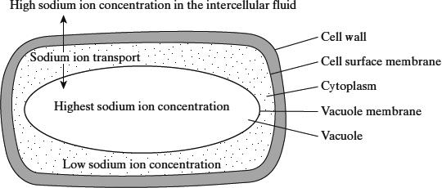
(a) The total concentration of all ions in the cytoplasm is higher than in the intercellular fluid. Explain how this allows the cell to take up water.
___________________________________________________________________
___________________________________________________________________
___________________________________________________________________
___________________________________________________________________
(2)
(b) (i) Explain how sodium ions are transported through the membranes.
______________________________________________________________
______________________________________________________________
______________________________________________________________
______________________________________________________________
(2)
(ii) There is a higher concentration gradient between the cytoplasm and the vacuole than between the cytoplasm and the intercellular fluid. Suggest how the vacuole membrane maintains this higher concentration gradient.
______________________________________________________________
______________________________________________________________
______________________________________________________________
______________________________________________________________
(2)
(Total 6 marks)
Q5.
Figure 1 shows a cell from the lining of the ileum specialised for absorption of products of digestion.
SGLT1 is a carrier protein found in the cell-surface membrane of this cell, it transports glucose and sodium ions (Na⁺) into the cell.
Figure 1
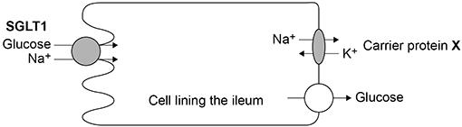
(a) The action of the carrier protein X in Figure 1 is linked to a membrane-bound ATP hydrolase enzyme.
Explain the function of this ATP hydrolase.
___________________________________________________________________
___________________________________________________________________
___________________________________________________________________
___________________________________________________________________
(2)
(b) The movement of Na⁺ out of the cell allows the absorption of glucose into the cell lining the ileum.
Explain how.
___________________________________________________________________
___________________________________________________________________
___________________________________________________________________
___________________________________________________________________
(2)
(c) Describe and explain two features you would expect to find in a cell specialised for absorption.
1 _________________________________________________________________
___________________________________________________________________
___________________________________________________________________
___________________________________________________________________
2 _________________________________________________________________
___________________________________________________________________
___________________________________________________________________
___________________________________________________________________
(2)
Figure 2 is a diagram of one SGLT1 carrier protein.
Figure 2

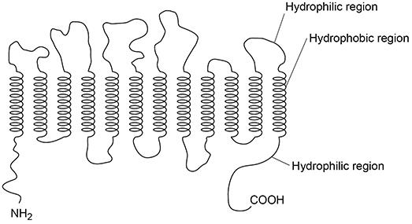

(d) Draw phospholipids on Figure 2 to show how the carrier protein, SGLT1, would fit into the cell-surface membrane.
Do not draw more than eight phospholipids.
(2)

(e) Figure 2 shows the SGLT1 polypeptide with NH₂ at one end and COOH at the other end.
Describe how amino acids join to form a polypeptide so there is always NH₂ at one end and COOH at the other end.
You may use a diagram in your answer.
___________________________________________________________________
___________________________________________________________________
___________________________________________________________________
___________________________________________________________________
___________________________________________________________________
Space for diagram:

(2)
(Total 10 marks)
Q6.
Anthocyanins are coloured pigments found in the cell vacuole of some plant cells. Anthocyanins cannot move across undamaged cell membranes.
A student investigated how to extract anthocyanins from blueberries.
She mixed 10 g of crushed, fresh blueberries with 100 cm³ of extraction solvent for 1 hour.
She investigated three different extraction solvents:
• E – Ethanol, water and acid
• F – Ethanol and water
• G – Water

(a) When making up extraction solvent E, the student used a volume ratio of 70:30:1 ethanol:water:acid.
Tick (✓) one box that shows the most appropriate volumes she would use to make up 100 cm³ of extraction solvent E.

63.6 cm³ ethanol, 27.3 cm³ water, 9.1 cm³ acid | 
69.3 cm³ ethanol, 29.7 cm³ water, 1.0 cm³ acid
70.0 cm³ ethanol, 30.0 cm³ water, 1.0 cm³ acid
70.7 cm³ ethanol, 30.3 cm³ water, 1.0 cm³ acid
(1)
(b) The student kept constant:
• the mass of fresh blueberries
• the volume of extraction solvent
• the time for the mixture to stand.
Name two other variables the student should have kept constant during this investigation.
1 _________________________________________________________________
2 _________________________________________________________________
(2)
(c) After 1 hour, the student filtered the samples.
She placed the filtrate in a colorimeter and measured the light absorbance.
Her results are shown in the graph below.
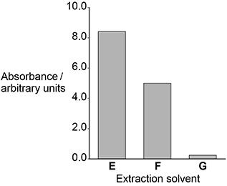

Use your knowledge of membrane structure to explain the results in the graph above.
___________________________________________________________________
___________________________________________________________________
___________________________________________________________________
___________________________________________________________________
___________________________________________________________________
___________________________________________________________________
___________________________________________________________________
___________________________________________________________________
___________________________________________________________________
___________________________________________________________________
___________________________________________________________________
___________________________________________________________________
(4)
(d) A different student did this investigation. He did not have a colorimeter.
Describe a method this student could use to prepare colour standards and use them to give data for the total anthocyanin extracted.
___________________________________________________________________
___________________________________________________________________
___________________________________________________________________
___________________________________________________________________
___________________________________________________________________
___________________________________________________________________
___________________________________________________________________
___________________________________________________________________
___________________________________________________________________
___________________________________________________________________
___________________________________________________________________
___________________________________________________________________
(3)
(Total 10 marks)

