**Q1.**

(a)     Describe how phagocytosis of a virus leads to presentation of its antigens.

___________________________________________________________________

___________________________________________________________________

___________________________________________________________________

___________________________________________________________________

___________________________________________________________________

___________________________________________________________________

**(3)**

(b)     Describe how presentation of a virus antigen leads to the secretion of an antibody against this virus antigen.

___________________________________________________________________

___________________________________________________________________

___________________________________________________________________

___________________________________________________________________

___________________________________________________________________

___________________________________________________________________

___________________________________________________________________

**(3)**

(c)     Collagen is a protein produced by cells in joints, such as the knee.

Rheumatoid arthritis (RA) is an auto-immune disease. In an auto-immune disease, a person’s immune system attacks their own cells. RA causes pain, swelling and stiffness in the joints.

Scientists have found a virus that produces a protein very similar to human collagen.

Suggest how the immune response to this viral protein can result in the development of RA.

___________________________________________________________________

___________________________________________________________________

___________________________________________________________________

___________________________________________________________________

___________________________________________________________________

**(2)**

**(Total 8 marks)**

**Q2.**

(a)     Describe how B-lymphocytes respond when they are stimulated by antigens.

___________________________________________________________________

___________________________________________________________________

___________________________________________________________________

___________________________________________________________________

___________________________________________________________________

___________________________________________________________________

___________________________________________________________________

**(4)**

(b)     The table gives information about some components of a red blood cell.

|  |  |  |  |
| --- | --- | --- | --- |
| **Component** | Glycoprotein | Phospholipid | Haemoglobin |
| **Location in cell** | on outer surface of plasma membrane | within plasma membrane | in cytoplasm |

Suggest which component of an intact red blood cell is most likely to act as an antigen during a blood transfusion. Explain your answer.

Component _________________________________________________________

Explanation _________________________________________________________

___________________________________________________________________

___________________________________________________________________

**(2)**

**(Total 6 marks)**

**Q3.**

The diagram shows an antibody molecule.

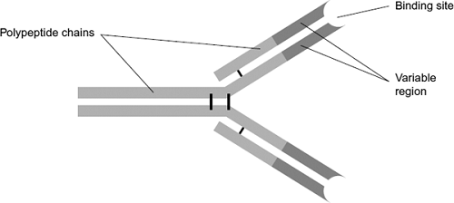

(a)     What is the evidence from the diagram that this antibody has a quaternary structure?

___________________________________________________________________

___________________________________________________________________

**(1)**

(b)     Scientists use this antibody to detect an antigen on the bacterium that causes stomach ulcers. Explain why the antibody will only detect this antigen.

___________________________________________________________________

___________________________________________________________________

___________________________________________________________________

___________________________________________________________________

___________________________________________________________________

___________________________________________________________________

**(3)**

**(Total 4 marks)**

**Q4.**

(a)     When a vaccine is given to a person, it leads to the production of antibodies against a disease-causing organism. Describe how.

___________________________________________________________________

___________________________________________________________________

___________________________________________________________________

___________________________________________________________________

___________________________________________________________________

___________________________________________________________________

___________________________________________________________________

___________________________________________________________________

___________________________________________________________________

___________________________________________________________________

**(5)**

(b)     Describe the difference between active and passive immunity.

___________________________________________________________________

___________________________________________________________________

___________________________________________________________________

___________________________________________________________________

___________________________________________________________________

___________________________________________________________________

___________________________________________________________________

___________________________________________________________________

___________________________________________________________________

___________________________________________________________________

**(5)**

**(Total 10 marks)**

**Q5.**

Malaria is a disease caused by parasites belonging to the genus *Plasmodium*. Two species that cause malaria are *Plasmodium falciparum* and *Plasmodium vivax*.

A test strip that uses monoclonal antibodies can be used to determine whether a person is infected by *Plasmodium*. It can also be used to find which species of *Plasmodium* they are infected by.

•        A sample of a person’s blood is mixed with a solution containing an antibody, **A**, that binds to a protein found in both species of *Plasmodium*. This antibody has a coloured dye attached.

•        A test strip is then put into the mixture. The mixture moves up the test strip by capillary action to an absorbent pad.

•        Three other antibodies, **B**, **C** and **D** are attached to the test strip. The position of these antibodies and what they bind to is shown in **Figure 1**.

**Figure 1**

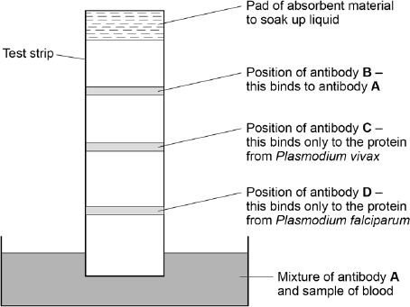

(a)     Explain why antibody **A** attaches only to the protein found in species of *Plasmodium*.

___________________________________________________________________

___________________________________________________________________

___________________________________________________________________

___________________________________________________________________

**(2)**

(b)     Antibody **B** is important if this test shows a person is not infected with *Plasmodium*.

Explain why antibody **B** is important.

___________________________________________________________________

___________________________________________________________________

___________________________________________________________________

___________________________________________________________________

**(2)**

(c)     One of these test strips was used to test a sample from a person thought to be infected with *Plasmodium*. **Figure 2** shows the result.

**Figure 2**

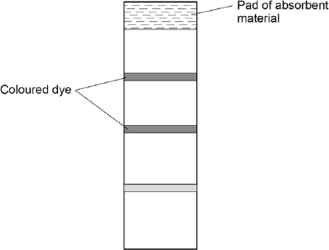

What can you conclude from this result?

Explain how you reached your conclusion.

___________________________________________________________________

___________________________________________________________________

___________________________________________________________________

___________________________________________________________________

___________________________________________________________________

___________________________________________________________________

___________________________________________________________________

___________________________________________________________________

**(4)**

**(Total 8 marks)**

**Q6.**

The diagram below shows the structure of the human immunodeficiency virus (HIV).

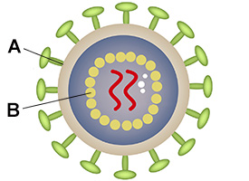

(a)  Name structures **A** and **B**.

**A** _________________________________________________________________

**B** _________________________________________________________________

**(2)**

(b)  Describe how HIV is replicated.

___________________________________________________________________

___________________________________________________________________

___________________________________________________________________

___________________________________________________________________

___________________________________________________________________

___________________________________________________________________

___________________________________________________________________

___________________________________________________________________

___________________________________________________________________

___________________________________________________________________

**(4)**

**(Total 6 marks)**