**Q1.**

*Uronema marinum* is a single-celled eukaryotic organism. The diagram below is a photograph of *U. marinum* taken through an optical microscope.

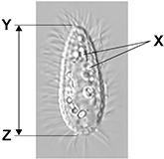

(a)  Explain why it is not possible to determine the identity of the structures labelled **X** using an optical microscope.

___________________________________________________________________

___________________________________________________________________

___________________________________________________________________

___________________________________________________________________

**(2)**

(b)  *U. marinum* cells ingest bacteria and digest them in the cytoplasm.

Describe the role of **one** named organelle in digesting these bacteria.

___________________________________________________________________

___________________________________________________________________

___________________________________________________________________

___________________________________________________________________

___________________________________________________________________

___________________________________________________________________

___________________________________________________________________

**(3)**

(c)  Calculate the actual length of the cell shown between **Y** and **Z** in the diagram above.

The magnification of the image is × 900 Give your answer in μm **and** to **2** significant figures. Show your working.

Answer __________ μm

**(2)**

(d)  In large cells of *U. marinum*, most mitochondria are found close to the cell-surface membrane. In smaller cells, the mitochondria are distributed evenly throughout the cytoplasm. Mitochondria use oxygen during aerobic respiration.

Use this information and your knowledge of surface area to volume ratios to suggest an explanation for the position of mitochondria in **large** *U. marinum* cells.

___________________________________________________________________

___________________________________________________________________

___________________________________________________________________

___________________________________________________________________

___________________________________________________________________

___________________________________________________________________

**(2)**

**(Total 9 marks)**

**Q2** The flowchart shows how chloroplasts may be obtained from leaves.

|  |
| --- |
| Leaves homogenised by grinding in cold buffer solution |

**↓**

|  |
| --- |
| Homogenised leaves filtered. Filtrate centrifuged at low speed |

**↓                               ↓**

|  |  |  |
| --- | --- | --- |
| Pellet **A** |  | Supernatant centrifuged at high speed |

**↓              ↓**

|  |  |  |
| --- | --- | --- |
| Pellet **B** containing chloroplast |  | Supernatant C |

(a)     In the first step in this procedure, the leaves were homogenised by grinding in cold buffer solution. Explain why

(i)      the leaves were homogenised,

______________________________________________________________

______________________________________________________________

**(1)**

(ii)     a buffer solution was used.

______________________________________________________________

______________________________________________________________

______________________________________________________________

______________________________________________________________

**(2)**

(b)     The table shows some of the organelles present in the leaf cells.

|  |  |  |  |
| --- | --- | --- | --- |
| Organelle | **X** | **Y** | **Z** |
| Fraction containing organelle |  |  |  |

(i)      Complete the table to show in which of pellet **A**, pellet **B** or supernatant **C** you would expect to find each of these organelles.

**(2)**

(ii)     Organelle **X** is found in large numbers in cells which take up substances by active transport. Explain why.

______________________________________________________________

______________________________________________________________

______________________________________________________________

______________________________________________________________

**(2)**

**(Total 7 marks)**

**Q3.**

(a)  Place a tick (**✓**) in the box next to the sequence that shows the correct order of magnitude of these measurements.

|  |  |
| --- | --- |
| 50 nm < 0.5 μm < 5 × 10–2 mm < 0.5 × 10–5 m |  |
| 50 nm < 0.5 μm < 0.5 × 10–5 m < 5 × 10–2 mm |  |
| 0.5 μm < 50 nm < 0.5 × 10–5 m < 5 × 10–2 mm |  |
| 0.5 μm < 50 nm < 5 × 10–2 mm < 0.5 × 10–5 m |  |

**(1)**

The diagram below is an electron micrograph of a chloroplast.

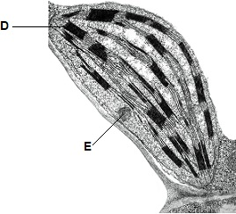

(b)  Identify structures labelled **D** and **E**.

**D** ___________________________________

**E** ___________________________________

**(2)**

(c)  The detail shown in the diagram above would not be seen using an optical microscope.

Explain why.

___________________________________________________________________

___________________________________________________________________

___________________________________________________________________

___________________________________________________________________

___________________________________________________________________

**(2)**

(d)  Name an organelle found in both a chloroplast and a prokaryotic cell.

___________________________________________________________________

**(1)**

(e)  A scientist determined the volume of a plant cell and the volume of organelles it contained.

They found:

•   the volume of a plant cell is 17 500 µm3

•   the volume of all the mitochondria in a plant cell is 262.5 µm3

•   the volume of all the mitochondria and all the chloroplasts in a plant cell is 44.1% of the volume of a plant cell.

Use this information to calculate the volume of all the chloroplasts in a plant cell.

Answer = ______________________________ µm3

**(2)**

(f)   A biologist separated cell components to investigate organelle activity. She prepared a suspension of the organelles in a solution that prevented damage to the organelles.

Describe **three** properties of this solution and explain how each property prevented damage to the organelles.

Property 1 __________________________________________________________

Explanation

___________________________________________________________________

___________________________________________________________________

___________________________________________________________________

___________________________________________________________________

Property 2 __________________________________________________________

Explanation

___________________________________________________________________

___________________________________________________________________

___________________________________________________________________

___________________________________________________________________

Property 3 __________________________________________________________

Explanation

___________________________________________________________________

___________________________________________________________________

___________________________________________________________________

___________________________________________________________________

**(3)**

**(Total 11 marks)**

**Q4.**

(a)     Glycogen and cellulose are both carbohydrates.

Describe **two** differences between the structure of a cellulose molecule and a glycogen molecule.

1. _________________________________________________________________

___________________________________________________________________

___________________________________________________________________

2. _________________________________________________________________

___________________________________________________________________

___________________________________________________________________

**(2)**

(b)     Starch is a carbohydrate often stored in plant cells.

Describe and explain **two** features of starch that make it a good storage molecule.

1. _________________________________________________________________

___________________________________________________________________

___________________________________________________________________

2. _________________________________________________________________

___________________________________________________________________

___________________________________________________________________

**(2)**

(c)     Tick (✔) the box that identifies the test which would be used to show the presence of starch.

|  |  |
| --- | --- |
| Acid hydrolysis test |  |
| Benedict’s test |  |
| Emulsion test |  |
| Iodine/potassium iodide test |  |

**(1)**

(d)     The diagram shows a section through a plant tissue at a magnification of ×500.

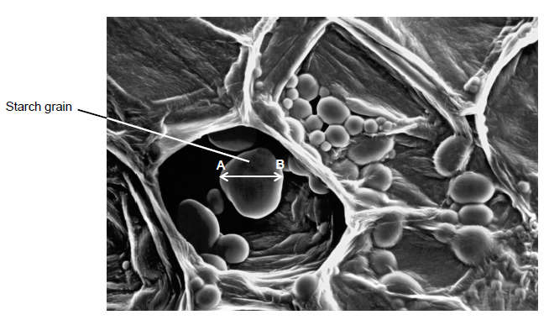

Calculate the actual diameter of the starch grain between points **A** and **B**.

Answer = ____________________ μm

**(2)**

(e)     What type of microscope was used to obtain the image shown in the diagram above?

Give **one** piece of evidence to support your answer.

Type of microscope _______________________________________________

Evidence ________________________________________________________

**(2)**

**(Total 9 marks)**

**Q5.**

Bacteriophages are viruses that kill bacteria.

The diagram below shows drawings of a bacteriophage and a bacterium.

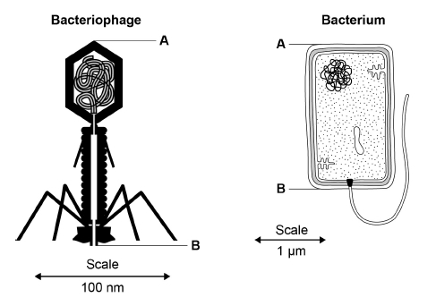

(a)     Using the diagram and your own knowledge, put a tick (✔) in the box next to the **only** correct statement about the structures of the bacteriophage and the bacterium

|  |  |
| --- | --- |
| Both have ribosomes. |  |
| Both have a cell-surface membrane. |  |
| The bacteriophage has a capsid and the bacterium has a cell-surface membrane. |  |
| The bacteriophage has a cell wall and the bacterium has a capsid. |  |

**(1)**

(b)     Using the scales in the diagram above, calculate how many times longer the bacterium is than the bacteriophage.

Use the distance between the points labelled **A** and **B** on each drawing in your calculations. Show your working.

The bacterium is ____________________ times longer

**(2)**

**Q6.**

(a)     Describe how you could use cell fractionation to isolate chloroplasts from leaf tissue.

___________________________________________________________________

___________________________________________________________________

___________________________________________________________________

___________________________________________________________________

___________________________________________________________________

___________________________________________________________________

**(3)**

The figure below shows a photograph of a chloroplast taken with an electron microscope.

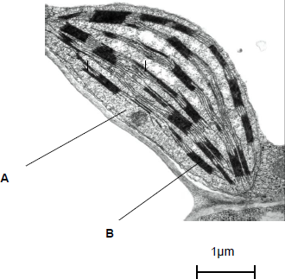

© Science Photo Library

(b)     Name the parts of the chloroplast labelled **A** and **B**.

Name of **A** ________________________________________________________

Name of **B** ________________________________________________________

**(2)**

(c)     Calculate the length of the chloroplast shown in the figure above.

Answer ____________________

**(1)**

(d)     Name **two** structures in a eukaryotic cell that **cannot** be identified using an optical microscope.

1. _________________________________________________________________

2. _________________________________________________________________

**(1)**

**(Total 7 marks)**

**Q7.**

(a)     The table shows some parts of cells and two different types of cell.

Complete the table by putting a tick in a box if the structure is present in the type of cell.

|  |  |  |  |
| --- | --- | --- | --- |
|  | **Cell wall** | **Cell-surface membrane** | **Nucleus** |
| White blood cell |  |  |  |
| Bacterial cell |  |  |  |

**(2)**

(b)     The diagram is of a mitochondrion at a magnification of × 30 000.

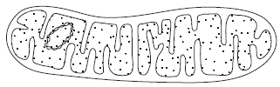

Calculate the actual length of this mitochondrion in micrometres (µm). Show your working.

Answer = ____________________ µm

**(2)**

(c)     Some scientists support the theory that mitochondria are organelles that evolved from prokaryotic cells.

(i)      Give **one** piece of evidence that supports the theory that mitochondria evolved from prokaryotic cells.

______________________________________________________________

______________________________________________________________

______________________________________________________________

**(1)**

(ii)      What is the advantage to cells of having mitochondria?

______________________________________________________________

______________________________________________________________

______________________________________________________________

______________________________________________________________

______________________________________________________________

**(2)**

**(Total 7 marks)**

**Q8.**

The diagram shows part of an epithelial cell from an insect’s gut.

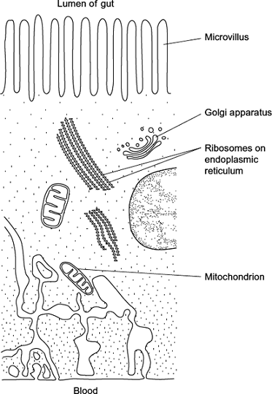

This cell is adapted for the three functions listed below. Use the diagram to explain how this cell is adapted for each of these functions.

Use a **different** feature in the diagram for each of your answers.

(a)      the active transport of substances from the cell into the blood

___________________________________________________________________

___________________________________________________________________

___________________________________________________________________

___________________________________________________________________

___________________________________________________________________

___________________________________________________________________

**(2)**

(b)     the synthesis of enzymes

___________________________________________________________________

___________________________________________________________________

___________________________________________________________________

___________________________________________________________________

**(2)**

(c)    rapid diffusion of substances from the lumen of the gut into the cytoplasm

___________________________________________________________________

___________________________________________________________________

___________________________________________________________________

**(1)**

**(Total 5 marks)**

**Q9.**

The diagram shows the outer layers of three different cells, **A**, **B** and **C**.

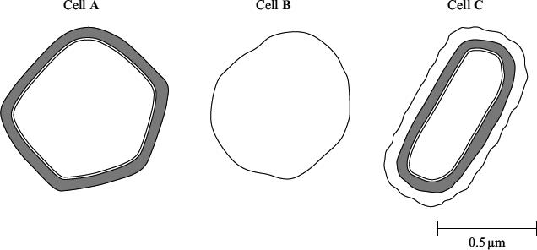

(a)     What is the evidence from the diagram that

(i)      cell **B** is an animal cell,

______________________________________________________________

______________________________________________________________

**(1)**

(ii)     cell **C** is a prokaryotic cell?

______________________________________________________________

______________________________________________________________

**(1)**

(b)     Explain how you would calculate the magnification of cell **C**.

___________________________________________________________________

___________________________________________________________________

**(1)**

(c)     Cell **A** is a plant cell. Name a polysaccharide which may be found in cell **A** but would not be found in the animal cell.

___________________________________________________________________

**(1)**

(d)     Penicillin is an antibiotic. It prevents the formation of bacterial cell walls. As a result, bacterial cells that have been treated with penicillin swell and burst as water enters.

(i)      Explain how water enters a bacterial cell.

______________________________________________________________

______________________________________________________________

______________________________________________________________

______________________________________________________________

**(2)**

(ii)     Suggest why penicillin has no effect on plant cells.

______________________________________________________________

______________________________________________________________

**(1)**

**(Total 7 marks)**

Mark schemes

**Q1.**

(a)     1.      Resolution (too) low;

2.      Because wavelength of light is (too) long;

**2**

(b)     1.      Lysosomes;

2.      Fuse with vesicle;

*Accept phagosome for vesicle*

3.      (Releases) hydrolytic enzymes;

*Accept lysozymes for "hydrolytic enzymes"*

*Accept ‘Ribosomes/ Rough endoplasmic reticulum form hydrolytic enzymes = 2 marks*

*Accept ‘Golgi body forms lysosomes’ = 2 marks*

*Accept ‘Golgi body / ribosomes / rough endoplasmic reticulum’ for 1 mark if no other mark awarded.*

**3**

(c)     Correct answer for 2 marks = 32;;

Accept for 1 mark,

29 000 (correct conversion to μm)

**OR**

32.2 (correct answer but incorrect significant figures)

**OR**



**OR**

An incorrect answer that shows division by 900

**2**

(d)     1.      Large(r) cells have small(er) surface area to volume ratio;

2.      (Takes) longer for oxygen to diffuse (to mitochondria)

**OR**

Less/no oxygen diffuses (to mitochondria)

**OR**

Diffusion distance/pathway is long(er);

*Accept converse for all marking points.*

**2**

**[9]**

**Q2.**

(a)     (i)      break open cells / release cell contents;

**1**

(ii)     keep pH the same / controls pH;  
prevent change to / denaturing of proteins / enzymes;

**2**

(b)     (i)

|  |  |  |
| --- | --- | --- |
| (supernatant) **C** | (pellet) **B**; | (pellet) **A**; |

**2**

(ii)     site of respiration which releases energy / ATP;  
required for movement against concentration gradient;  
*ignore first point for thermodynamically incorrect statements   
such as “making energy”.*

**2**

**[7]**

**Q3.**

(a)  Row 2;

**1**

(b)  **D** - Granum/grana/thylakoid(s);

**E** - starch/lipid;

*Accept oil for E*

**2**

(c)

*Accept converse in context of electron microscope*

1.   Light has long(er) wavelength;

*Ignore: optical microscope has long(er) wavelength.*

2.   (So) low(er) resolution;

*Accept poor resolution*

*Ignore: weaker resolution*

*Ignore references to magnification*

*Accept correct references to values for resolution.*

*E.g optical 0.2µm – 0.3 µm*

**2**

(d)  (70S) Ribosome;

*Reject: (80S) Ribosome*

**1**

(e)  Correct answer of 7455 = 2 marks;;

Accept for 1 mark answers in range:

7717.5 to 7718 (44.1% of 17500)

If incorrect answer, accept for 1 mark working shows an attempt to subtract 262.5

**2**

(f)   1.   (Ice) cold to prevent/reduce enzyme activity;

*For 1, 2 and 3 reject context of cell*

2.   Buffered to prevent denaturing of enzyme/protein;

*Accept description of buffer.*

*Accept: prevent change of tertiary structure.*

3.   Same water potential/ Ψ to prevent lysis/bursting (of organelle);

*Accept: isotonic for same water potential.*

*Reject: references to turgor or plasmolysis or crenation.*

**3**

**[11]**

**Q4.**

(a)     1.      Cellulose is made up of β-glucose (monomers) **and** glycogen is made up of *α*-glucose (monomers);

2.      Cellulose molecule has straight chain **and** glycogen is branched;

3.      Cellulose molecule has straight chain **and** glycogen is coiled;

4.      glycogen has 1,4- and 1,6- glycosidic bonds **and** cellulose has only 1,4- glycosidic bonds;

*Ignore ref. to H bonds / microfibrils*

**2 max**

(b)    Any **two** from:

1.      Insoluble (in water), so doesn’t affect water potential;

2.      Branched / coiled / (*α*-)helix, so makes molecule compact;

**OR**

Branched / coiled / (*α*-)helix so can fit many (molecules) in small area;

3.      Polymer of (*α*-)glucose so provides glucose for respiration;

4.      Branched / more ends for fast breakdown / enzyme action;

5.      Large (molecule), so can’t cross the cell membrane

*Require feature* ***and*** *explanation for 1 mark*

*1.      Accept Ψ or WP*

*1.      Accept Insoluble so doesn’t affect osmosis*

*1.      Do* ***not*** *allow ref to ‘doesn’t affect water leaving cells*

*4.      Ignore ‘surface area’*

*4.      Accept ‘branched so glucose readily released’*

**2 max**

(c)     Iodine/potassium iodide;

**1**

(d)     For correct answer of 40 (μm) award 2 marks;

Evidence of division by 500: award 1 mark

*Allow tolerance of 0.5mm i.e. 20±0.5mm*

**2**

(e)     1.      Scanning electron (microscope);

2.      3D (image);

*Accept SE(M)*

*2.      Ignore any other correct features*

**2**

**[9]**

**Q5.**

(a)

|  |  |
| --- | --- |
| The bacteriophage has a capsid and the bacterium has a cell-surface membrane; |  |

Third box down

*Reject if more than one box with tick. Ignore crossed-out ticks*

*Accept tick to right or left of correct box*

**1**

(b)     Correct number of times between

13.0 / 12.96 **and** 13.9 / 13.92 scores 2 marks;

One mark if correct sizes in ranges of

150.7nm to 154.4nm / 0.151μm to 0.154μm

**and** 1953.5nm to 2097.6nm / 1.954μm to 2.098μm;

***Both*** *lengths required for 1 mark credit*

*Accept refs to 150 / 0.15 and 2000 / 2*

*Ignore number of sig fig*

**2**

(c)     The bacteriophage makes no difference to the number of (living) bacteria / there will be no difference in the number of (live) bacteria in treated and untreated mice / there will be no difference in the number of (live) bacteria in A and B;

*Ignore no difference between mice*

**1**

(d)     1.      Log scale (on graph) shows big range in number of bacteria

**OR**

Use of suitable data from log scale to give the range in number of bacteria;

2.      Some samples too many to count (so dilute) but some countable (so don’t dilute)

**OR**

Use of figures from graph relating to ease (or otherwise) of counting

Example. 631 000 000 bacteria would be too big to count (without serial dilution), 100 000 bacteria is small enough to count;

*1 and 2* ***Do not*** *accept simple statements of log10 values from graph*

*Look for answers in standard form*

***Group A***

*Mean between 79 million and 100 million*

*Range 4 million to 631 million*

***Group B***

*Mean between 100 thousand and 126 thousand*

*Range 3.98/4 up to 251 thousand*

**2**

(e)     1.      (Bacteriophage) reduces number of bacteria;

2.      (In all cases / mice because) ranges don’t overlap;

3.      But big range of effect/some mice a big reduction/a few mice with big falls in number

**OR**

Doesn’t bring bacteria down to 0 in any / works for some (mice) but not for all;

*Do not accept just quotes of log10 figures direct from graph*

*Ignore refs to significance*

*Range 3.98/4 up to 251 thousand*

*2.      Reject ref to SD / SE*

**3**

**[9]**

**Q6.**

(a)     1.      How to break open cells and remove debris;

2.      Solution is cold / isotonic / buffered;

3.      Second pellet is chloroplast.

**3**

(b)     1.      **A** stroma;

2.      **B** granum.

*Accept thylakoid*

**2**

(c)      μm

**1**

(d)     **Two** of the following for **one** mark:

Mitochondrion / ribosome / endoplasmic reticulum / lysosome / cell-surface membrane.

**1 max**

**[7]**

**Q7.**

(a)

|  |  |  |  |
| --- | --- | --- | --- |
| White blood cell |  | ✔ | ✔ |
| Bacteria cell | ✔ | ✔ |  |

**2**

(b)     2.80 (μm);;

*Answer in range 2.76–2.83 scores 2 marks*

*If length incorrect but divided by 30 000, allow 1 mark*

**2**

(c)     (i)      Circular DNA / smaller/70S ribosomes / no introns / no histones/proteins associated with DNA;

*Ignore reference to plasmids*

**1**

(ii)     1.    Able to respire aerobically;

2.    So make (more) ATP/ release (more) energy;

*Reject ‘producing energy’ unqualified*

**2**

**[7]**

**Q8.**

(a)     1.      Mitochondria respire to release energy / produce ATP;

*1. Do not credit make energy*

2.      Transport against gradient;

*2. Do not credit active transport as this is given in question.*

*2. Do not accept diffusion against.*

***OR***

3.      Infolding of membrane increases area;

*3. Reject microvilli but if mentioned can still accept point 4.*

4.      More proteins for active transport;

**2 max**

(b)     1.      Ribosomes make proteins / enzymes;

*Ignore references to Golgi or rough ER.*

2.      Enzymes are proteins;

***OR***

3.      Mitochrondria respire;

4.      Release energy / produce ATP;

5.      (Energy / ATP) for protein / enzyme synthesis;

**2**

(c)     Microvilli increase area / have large area;

*Ignore references to other properties of microvilli.*

**1**

**[5]**

**Q9.**

(a)     (i)      no cell wall / only has (plasma) membrane;

**1**

(ii)     has capsule / slime layer;

**1**

(b)     correct approach which makes use of scalebar; *ignore* reference to units.

**1**

(c)     cellulose / starch / amylose / amylopectin;

**1**

(d)     (i)      water potential lower / more negative in cell;  
(water enters by) osmosis;

**2**

(ii)     plant cell wall made of a different substance / cellulose / penicillin  
does not affect cellulose;

**1[7]**