**Q1.**

(a)     Describe the relationship between size and surface area to volume ratio of organisms.

___________________________________________________________________

___________________________________________________________________

___________________________________________________________________

___________________________________________________________________

___________________________________________________________________

**(1)**

(b)     A scientist calculated the surface area of a large number of frog eggs. He found that the mean surface area was 9.73 mm2. Frog eggs are spherical.

The surface area of a sphere is calculated using this equation

Surface area = 4*π*r2

where r is the radius of a sphere

*π* = 3.14

Use this equation to calculate the mean diameter of a frog egg.

Show your working.

Diameter = ____________________ mm

**(2)**

The scientist calculated the ratio of surface area to mass for eggs, tadpoles and frogs. He also determined the mean rate of oxygen uptake by tadpoles and frogs.

His results are shown in the table.

|  |  |  |
| --- | --- | --- |
| **Stage of frog development** | **Ratio of surface area to mass** | **Mean rate of oxygen uptake / μmol g–1 h–1** |
| Egg | 2904 : 1 | no information |
| Tadpole | 336 : 1 | 5.7 |
| Adult | 166 : 1 | 1.3 |

(c)     The scientist used units of μmol g–1 h–1 for the rate of oxygen uptake.

Suggest why he used μmol in these units.

___________________________________________________________________

___________________________________________________________________

___________________________________________________________________

___________________________________________________________________

**(1)**

(d)     The scientist decided to use the ratio of surface area to mass, rather than the ratio of surface area to volume. He made this decision for practical reasons.

Suggest **one** practical advantage of measuring the masses of frog eggs, tadpoles and adults, compared with measuring their volumes.

___________________________________________________________________

___________________________________________________________________

___________________________________________________________________

___________________________________________________________________

___________________________________________________________________

**(1)**

(e)     Explain why oxygen uptake is a measure of metabolic rate in organisms.

___________________________________________________________________

___________________________________________________________________

___________________________________________________________________

___________________________________________________________________

**(1)**

(f)      A student who looked at these results said that they could not make a conclusion about the relationship between stage of development and metabolic rate.

Use information in the table to explain reasons why they were unable to make a conclusion.

___________________________________________________________________

___________________________________________________________________

___________________________________________________________________

___________________________________________________________________

___________________________________________________________________

___________________________________________________________________

___________________________________________________________________

**(3)**

**(Total 9 marks)**

**Q2.**

(a)  Explain the advantage for larger animals of having a specialised system that facilitates oxygen uptake.

___________________________________________________________________

___________________________________________________________________

___________________________________________________________________

___________________________________________________________________

___________________________________________________________________

___________________________________________________________________

**(2)**

**Figure 1** shows two models of oxygen uptake found in animals.

**Figure 1**

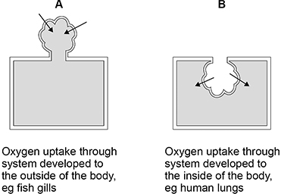

(b)  Suggest how the environmental conditions have resulted in adaptations of systems using **Model A** rather than **Model B**.

___________________________________________________________________

___________________________________________________________________

___________________________________________________________________

___________________________________________________________________

___________________________________________________________________

___________________________________________________________________

**(2)**

(c)  **Figure 2** shows changes in concentration of oxygen in two gas exchange systems.

**Figure 2**

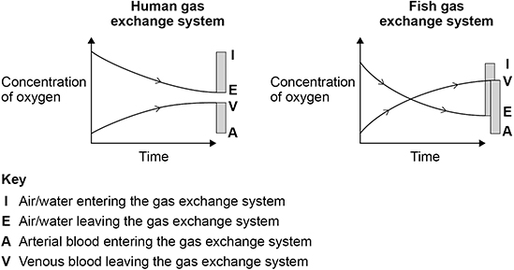

A student studied **Figure 2** and concluded that the fish gas exchange system is more efficient than the human gas exchange system.

Use **Figure 2** to justify this conclusion.

___________________________________________________________________

___________________________________________________________________

___________________________________________________________________

___________________________________________________________________

___________________________________________________________________

**(2)**

(d)  Explain how the counter-current principle allows efficient oxygen uptake in the fish gas exchange system.

___________________________________________________________________

___________________________________________________________________

___________________________________________________________________

___________________________________________________________________

___________________________________________________________________

___________________________________________________________________

**(2)**

(e)  The table below shows features of two mammals.

Bats are flying mammals; shrews are ground-living mammals.

|  |  |  |
| --- | --- | --- |
| **Mammal** | **Mean body mass / kg** | **Mean lung volume / cm3** |
| Bat | 0.096 | 12.48 |
| Shrew | 0.024 | 0.72 |

Calculate how many times the lung volume per unit of body mass of the bat is greater than that of the shrew.

Give your answer to an appropriate number of significant figures.

Give **one** suggestion to explain this difference.

Answer _______________

Explanation  ________________________________________________________

___________________________________________________________________

**(3)**

**(Total 11 marks)**

**Q3.**

(a)     (i)      Name the structure through which gases enter and leave the body of an insect.

______________________________________________________________

**(1)**

(ii)     Name the small tubes that carry gases directly to and from the cells of an insect.

______________________________________________________________

**(1)**

(b)     Explain the movement of oxygen into the gas exchange system of an insect when it is at rest.

___________________________________________________________________

___________________________________________________________________

___________________________________________________________________

___________________________________________________________________

___________________________________________________________________

___________________________________________________________________

___________________________________________________________________

**(3)**

(c)     Abdominal pumping takes place during vigorous activity in insects. This causes regular squeezing of the tubes of the gas exchange system.

A scientist investigated the effect of abdominal pumping on the pressure in the tubes and the volume of carbon dioxide released by the insect.

Her results are shown below.

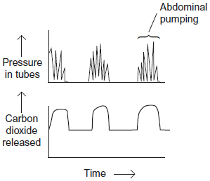

Describe and explain these results.

___________________________________________________________________

___________________________________________________________________

___________________________________________________________________

___________________________________________________________________

___________________________________________________________________

___________________________________________________________________

___________________________________________________________________

**(3)**

**(Total 8 marks)**

**Q4.**

**Figure 1** shows the stages of development of an insect called a damselfly.

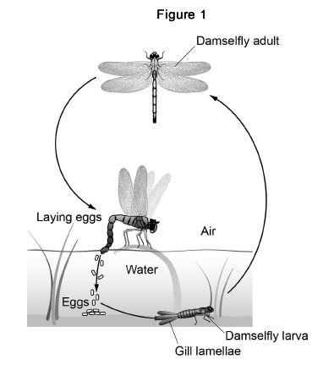

(a)     The adult damselfly uses a tracheal system for gas exchange.

Explain **three** ways in which an insect’s tracheal system is adapted for efficient gas exchange.

1. _________________________________________________________________

___________________________________________________________________

___________________________________________________________________

2. _________________________________________________________________

___________________________________________________________________

___________________________________________________________________

3. _________________________________________________________________

___________________________________________________________________

___________________________________________________________________

**(3)**

(b)     The damselfly larva is a carnivore that actively hunts prey. It has gills to obtain oxygen from water.

Some other species of insect have larvae that are a similar size and shape to damselfly larvae and also live in water. These larvae do **not** actively hunt prey and do **not** have gills.

Explain how the presence of gills adapts the damselfly to its way of life.

___________________________________________________________________

___________________________________________________________________

___________________________________________________________________

___________________________________________________________________

___________________________________________________________________

**(2)**

(c)     A scientist measured the size of each gill lamella of the gills of 40 damselfly larvae.

His results are shown in the table.

|  |  |
| --- | --- |
| Mean width / mm  (± uncertainty / mm) | 1.61  (± 0.19) |
| Mean width / mm  (± uncertainty / mm) | 6.12  (± 0.41) |

Calculate the mean surface area of **one side** of one gill lamella. Assume that a gill lamella is rectangular and give your answer to an **appropriate number of significant figures**.

Include the percentage error (uncertainty) of surface area in your answer.

Show your working.

Mean surface area = ____________________

Percentage error (uncertainty) of surface area = ____________________

**(3)**

(d)     A student used an optical microscope to observe part of a damselfly larva gill.

**Figure 2** shows the drawing the student produced.

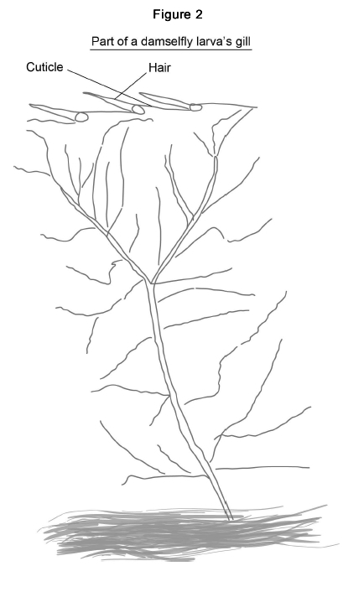

Suggest **two** ways the student could improve the quality of her scientific drawing of this gill.

1. _________________________________________________________________

___________________________________________________________________

___________________________________________________________________

2. _________________________________________________________________

___________________________________________________________________

___________________________________________________________________

**(2)**

**(Total 10 marks)**

**Q5.**

Scientists measured the rate of carbon dioxide release by three groups of insects of the same species at 10 °C, 20 °C and 30 °C. They also determined the mean mass of each group of insects.

The scientists results are shown in the table.

|  |  |  |  |
| --- | --- | --- | --- |
| **Temperature / °C** | **Mean mass / g** | **Rate of carbon dioxide release / µdm3 minute−1** | **Rate of carbon dioxide**  **release per gram /**  **µdm3 g−1 minute−1** |
| 10 | 0.047 | 0.12 |  |
| 20 | 0.046 | 0.33 |  |
| 30 | 0.048 | 0.56 |  |

(a)     Complete the table above and plot a graph of your calculated values against temperature on the graph paper. Express your calculated rates with the appropriate number of significant figures.



**(3)**

The body temperature of the insects was largely determined by the temperature they were kept at. At each temperature, the scientists recorded rate of carbon dioxide release by individual insects over time. This rate depends upon spiracles opening or closing.

The graphs below show results for three insects.

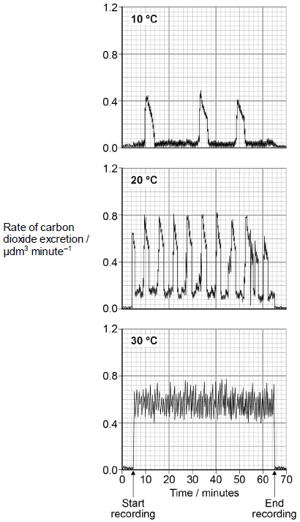

(b)     Calculate the change in the rate per hour of opening of the spiracles between 10 °C and 20 °C.

___________________________________________________________________

___________________________________________________________________

**(1)**

(c)     Explain how you could determine the total amount of carbon dioxide secreted at 30 °C during the period of recording.

___________________________________________________________________

___________________________________________________________________

**(1)**

(d)     Suggest an explanation for the effect of temperature on the rate of carbon dioxide release.

___________________________________________________________________

___________________________________________________________________

___________________________________________________________________

___________________________________________________________________

___________________________________________________________________

___________________________________________________________________

**(3)**

**(Total 8 marks)**

**Q6.**

Below is an image of a fish gill taken using a scanning electron microscope.

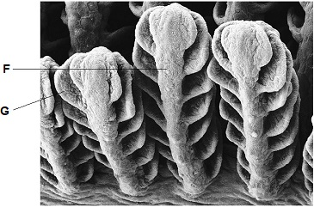

(a)  Identify structures labelled **F** and **G**.

**F** __________________________________

**G** __________________________________

**(1)**

(b)  Describe and explain the advantage of the counter-current principle in gas exchange across a fish gill.

___________________________________________________________________

___________________________________________________________________

___________________________________________________________________

___________________________________________________________________

___________________________________________________________________

___________________________________________________________________

___________________________________________________________________

___________________________________________________________________

**(3)**

**(Total 4 marks)**

**Q7.**

A biologist investigated the effect of water temperature on the rate of ventilation of gills in a species of fish. She kept four fish in a thermostatically controlled aquarium and measured the mean ventilation rate by counting movements of their gill covers.

Her results are shown in **Figure 1**.

**Figure 1**

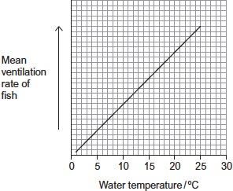

In this investigation, the biologist also monitored the concentration of oxygen in the water in the aquarium. The concentration of oxygen in water changes with temperature of the water. **Figure 2** shows how it changes.

**Figure 2**

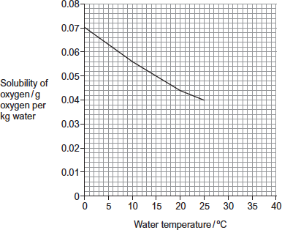

(a)     Suggest a difficulty of counting movements of gill covers as a method of measuring rate of ventilation in fish.

___________________________________________________________________

___________________________________________________________________

**(1)**

(b)     The biologist concluded that there was a correlation between rate of ventilation of the gills and temperature of the water. A scatter diagram can be used to look for a correlation but, in this investigation, it was **not** the appropriate graph for her data.  
Explain why.

___________________________________________________________________

___________________________________________________________________

**(1)**

(c)     (i)      Describe the relationship between temperature of water, oxygen in water and rate of ventilation.

______________________________________________________________

______________________________________________________________

______________________________________________________________

**(1)**

(ii)     Use **Figure 1** and **Figure 2** to explain the advantage to the fish of the change in its rate of ventilation.

______________________________________________________________

______________________________________________________________

______________________________________________________________

______________________________________________________________

______________________________________________________________

**(3)**

**(Total 6 marks)**

**Q8.**

Scientists studied three species of plant.

They selected fully grown leaves from five different plants of each species.

For each leaf they measured:

•        leaf surface area

•        leaf thickness

•        the number of stomata per mm2.

The scientists’ results are shown in the table below.

|  |  |  |  |
| --- | --- | --- | --- |
| **Plant species** | **Mean leaf surface area / mm2** | **Mean leaf thickness / µm** | **Mean number of stomata per mm2** |
| **A** | 218.0 | 191.5 | 380.0 |
| **B** | 17.0 | 296.3 | 136.0 |
| **C** | 2.2 | 354.8 | 419.0 |

(a)     How did the scientists ensure they could make a valid comparison between leaves from different species?

___________________________________________________________________

___________________________________________________________________

**(1)**

(b)     Describe a method you could use to find the surface area of a leaf.

___________________________________________________________________

___________________________________________________________________

___________________________________________________________________

___________________________________________________________________

___________________________________________________________________

**(3)**

(c)     (i)      Which species, **A** or **B**, would you predict grew in a drier environment?

Explain **one** feature that caused you to choose this species.

Species _______________________________________________________

Explanation ____________________________________________________

______________________________________________________________

**(1)**

(ii)     Other than the features of leaves in the table above, give **two** features of leaves of xerophytes.

For each feature explain how it reduces water loss.

Feature 1 ______________________________________________________

Explanation ____________________________________________________

______________________________________________________________

Feature 2 ______________________________________________________

Explanation ____________________________________________________

______________________________________________________________

**(2)**

(d)     Species **C** has a high number of stomata per mm2. Despite this it loses a small amount of water.

Use the data to explain why.

___________________________________________________________________

___________________________________________________________________

**(1)**

**(Total 8 marks)**

**Q9.**

Scientists investigated stomatal density on leaves of one species of tree.

**Figure 1** shows three examples of the square fields of view the scientists used to calculate a mean stomatal density.

|  |  |  |  |  |  |  |
| --- | --- | --- | --- | --- | --- | --- |
| **Figure 1** | | | | | | |
|  | |  |  |  | |  |
| **Key** | | | | |
|  | Stomata | | | |
|  | White lines show the counting field for stomata (each edge of white square = 250 *µ*m) | | | |

(a)     Calculate the mean stomatal density in the three fields of view in **Figure 1**.

Give your answer as number of stomata per mm2

Show your working.

Stomatal density _______________ per mm2

**(2)**

The scientists used leaves from individual trees that had grown in different areas of the world in different years. Each tree had grown in an area and year with known carbon dioxide concentration.

Their results are shown in **Figure 2**.

**Figure 2**

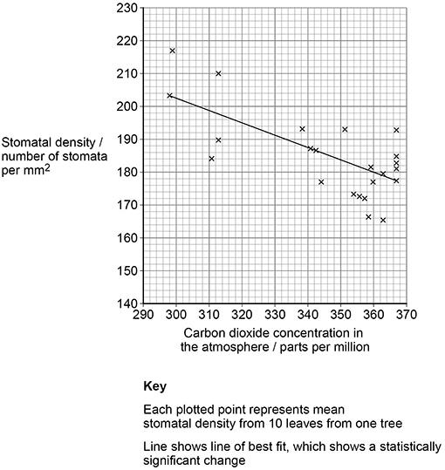

(c)     From 1910 to 2000, the carbon dioxide concentration in the atmosphere increased from 300 parts per million to 365 parts per million.

Use **Figure 2** to calculate the mean rate of change in stomatal density from 1910 to 2000.

Give your answer as number of stomata per mm2 per 10-year period.

Show your working.

Number of stomata per mm2 per 10-year period _______________

**(2)**

(d)     A journalist saw **Figure 2** and suggested that future increases in atmospheric carbon dioxide concentration could result in less transpiration.

Evaluate his suggestion.

___________________________________________________________________

___________________________________________________________________

___________________________________________________________________

___________________________________________________________________

___________________________________________________________________

___________________________________________________________________

___________________________________________________________________

___________________________________________________________________

___________________________________________________________________

___________________________________________________________________

___________________________________________________________________

___________________________________________________________________

**(4)**

**(Total 10 marks)**

**Q10.**

Scientists used fossil leaves from one species of pine tree to investigate whether changes in the concentration of carbon dioxide in the air over long periods of time had led to changes in the number of stomata in the leaves.

Their method is outlined below.

•        They selected sites of different ages.

•        They collected between 11 and 24 fossil leaves from each site.

•        They found the mean number of stomata per mm2 on the leaves from each site.

•        They estimated the age of each sample by dating organic remains around the leaves at each site.

They compared results from the fossil leaves with leaves from the same species of pine tree growing today.

They knew the concentration of carbon dioxide in the air at different times in the past.

Their results are shown in the table.

|  |  |  |
| --- | --- | --- |
| **Age of sample/years** | **Concentration of carbon dioxide in the air/%** | **Mean number of stomata per mm2  (± standard deviation)** |
| present day | 0.0350 | 92 (±2) |
| 5000 | 0.0270 | 87 (±4) |
| 10 000 | 0.0250 | 95 (±2) |
| 15 000 | 0.0205 | 108 (±6) |
| 20 000 | 0.0195 | 115 (±4) |
| 25 000 | 0.0188 | 118 (±6) |
| 30 000 | 0.0190 | 130 (±6) |

(a)     The concentration of carbon dioxide in the air has changed with time. Use the data to describe how.

___________________________________________________________________

___________________________________________________________________

___________________________________________________________________

___________________________________________________________________

___________________________________________________________________

**(2)**

(b)     The scientists calculated the mean number of stomata per mm2 and the standard deviation.

What does the standard deviation show?

___________________________________________________________________

___________________________________________________________________

___________________________________________________________________

___________________________________________________________________

___________________________________________________________________

**(2)**

(c)     The scientists found the age of the fossil leaves by dating the organic remains around them.  
Would this have affected the accuracy of their data? Explain your answer.

___________________________________________________________________

___________________________________________________________________

___________________________________________________________________

**(1)**

(d)     30 000 years ago the mean number of stomata per mm2 on the lower epidermis of pine tree leaves was much higher than it is today. This would have enabled the plant to grow faster when the carbon dioxide concentration of the air was low.

Explain why.

___________________________________________________________________

___________________________________________________________________

___________________________________________________________________

**(1)**

(e)     A student who saw these results concluded that as the carbon dioxide concentration of the air had increased the number of stomata per mm2 in leaves had decreased.  
Do the results support this conclusion?

___________________________________________________________________

___________________________________________________________________

___________________________________________________________________

___________________________________________________________________

___________________________________________________________________

___________________________________________________________________

**(3)**

(f)      The leaves of plants that grow in dry areas usually have a low number of stomata per mm2. Use your knowledge of leaf structure to suggest **three** other adaptations that the leaves might have that enable the plants to grow well in dry conditions.

1. _________________________________________________________________

2. _________________________________________________________________

3. _________________________________________________________________

**(3)**

**(Total 12 marks)**