**Q1.**

The diagram shows a section through the heart. The main blood vessels are labelled **A**, **B**, **C** and **D**.

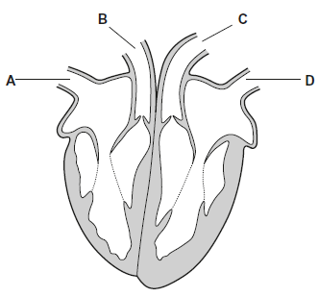

(a)     Write a letter, **A**, **B**, **C** or **D**, in the box to represent the correct blood vessel.

(i)      Which blood vessel carries oxygenated blood away from the heart?



**(1)**

(ii)      Which blood vessel carries deoxygenated blood to the heart?



**(1)**

(b)     Explain how the highest blood pressure is produced in the left ventricle.

___________________________________________________________________

___________________________________________________________________

**(1)**

(c)     Some babies are born with a hole between the right and the left ventricles.

These babies are unable to get enough oxygen to their tissues.

Suggest why.

___________________________________________________________________

___________________________________________________________________

___________________________________________________________________

___________________________________________________________________

___________________________________________________________________

**(2)**

**(Total 5 marks)**

**Q2.**

(a)  Give the pathway a red blood cell takes when travelling in the human circulatory system from a kidney to the lungs.

Do **not** include descriptions of pressure changes in the heart or the role of heart valves in your answer.

___________________________________________________________________

___________________________________________________________________

___________________________________________________________________

___________________________________________________________________

___________________________________________________________________

___________________________________________________________________

___________________________________________________________________

___________________________________________________________________

___________________________________________________________________

___________________________________________________________________

**(3)**

The figure below shows a section through two types of blood vessels observed using an optical microscope.

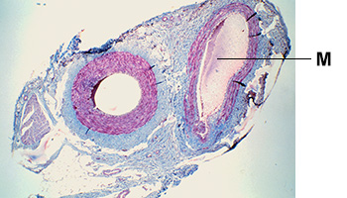

(b)  Identify the type of blood vessel labelled **M** in the figure above.

Explain your answer.

Type of blood vessel __________________________________________________

Explanation _________________________________________________________

___________________________________________________________________

___________________________________________________________________

**(2)**

(c)  Tissue fluid is formed from blood at the arteriole end of a capillary bed.

Explain how water from tissue fluid is returned to the circulatory system.

___________________________________________________________________

___________________________________________________________________

___________________________________________________________________

___________________________________________________________________

___________________________________________________________________

___________________________________________________________________

___________________________________________________________________

___________________________________________________________________

___________________________________________________________________

___________________________________________________________________

**(4)**

**(Total 9 marks)**

**Q3.**

(a)     Explain how an arteriole can reduce the blood flow into capillaries.

___________________________________________________________________

___________________________________________________________________

___________________________________________________________________

___________________________________________________________________

___________________________________________________________________

**(2)**

The image below shows heart valves during one stage of a cardiac cycle.

Ventricles are visible through the open valves.

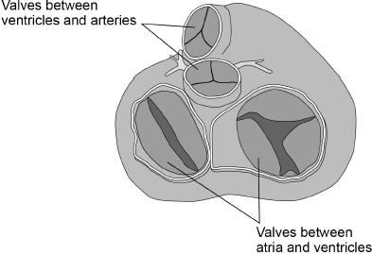

(b)     What can you conclude from the appearance of valves in the image above about heart muscle activity and blood movement between:

1. ventricles and arteries?

___________________________________________________________________

___________________________________________________________________

___________________________________________________________________

___________________________________________________________________

___________________________________________________________________

___________________________________________________________________

**(2)**

2. atria and ventricles?

___________________________________________________________________

___________________________________________________________________

___________________________________________________________________

___________________________________________________________________

___________________________________________________________________

___________________________________________________________________

**(2)**

(c)     Tick (**✓**) **one** box next to the blood vessel carrying blood at the lowest blood pressure.

|  |  |
| --- | --- |
| Capillary |  |
| Pulmonary vein |  |
| Renal vein |  |
| Vena cava |  |

**(1)**

(d)     A scientist measured the heart rate and the volume of blood pumped in a single heart beat (stroke volume) of an athlete before exercise and calculated the cardiac output.

Cardiac output is calculated using this equation.

cardiac output = heart rate × stroke volume

Her results are shown in the table below.

|  |  |  |
| --- | --- | --- |
| **Heart rate / beats minute−1** | **Stroke volume / cm3** | **Cardiac output / cm3 minute−1** |
| 62 | 80 | 4960 |

After exercise, the athlete’s stroke volume increased by 30% and the cardiac output was 13 832 cm3 minute **–**1

Calculate the athlete’s heart rate after exercise.

Give the answer to 2 significant figures. Show your working.

Heart rate _______________ beats minute –1

**(2)**

**(Total 9 marks)**

**Q4.**

The diagram below shows pressure and blood flow during the cardiac cycle in a dog.

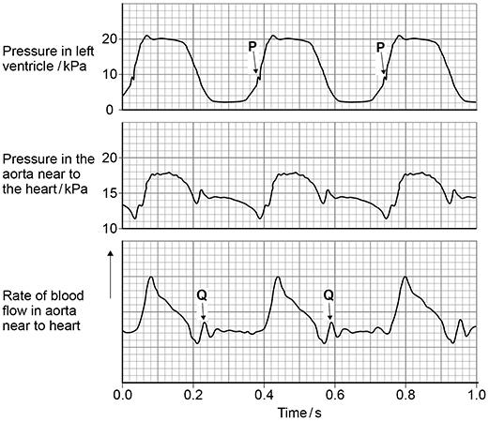

(a)     At **P** on the diagram above, the pressure in the left ventricle is increasing. At this time, the rate of blood flow has not yet started to increase in the aorta.

Use evidence from diagram above to explain why.

___________________________________________________________________

___________________________________________________________________

___________________________________________________________________

___________________________________________________________________

___________________________________________________________________

**(2)**

(b)     At **Q** on the diagram above there is a small increase in pressure **and** in rate of blood flow in the aorta.

Explain how this happens **and** its importance.

___________________________________________________________________

___________________________________________________________________

___________________________________________________________________

___________________________________________________________________

___________________________________________________________________

**(2)**

(c)     A student correctly plotted the right ventricle pressure on the same grid as the left ventricle pressure in diagram above.

Describe **one** way in which the student’s curve would be similar to and **one** way it would be different from the curve shown in the diagram above.

Similarity ___________________________________________________________

___________________________________________________________________

___________________________________________________________________

___________________________________________________________________

Difference __________________________________________________________

___________________________________________________________________

___________________________________________________________________

___________________________________________________________________

**(2)**

(d)     Use information from the diagram above to calculate the heart rate of this dog.

Heart rate _______________ beats minute-1

**(1)**

**(Total 7 marks)**

**Q5.**

Lung cancer, chronic bronchitis and coronary heart disease (CHD) are associated with smoking. **Tables 1** and **2** give the total numbers of deaths from these diseases in the UK in 1974.

**Table 1 Men**

|  |  |  |  |
| --- | --- | --- | --- |
| **Age/years** | **Number of deaths (in thousands)** | | |
|  | lung cancer | chronic bronchitis | coronary heart disease |
| 35 - 64 | 11.5 | 4.2 | 31.7 |
| 65 - 74 | 12.6 | 8.5 | 33.3 |
| 75+ | 5.8 | 8.1 | 29.1 |
| Total (35 - 75+) | 29.9 | 20.8 | 94.1 |

**Table 2 Women**

|  |  |  |  |
| --- | --- | --- | --- |
| **Age/years** | **Number of deaths (in thousands)** | | |
|  | lung cancer | chronic bronchitis | coronary heart disease |
| 35 – 64 | 3.2 | 1.3 | 8.4 |
| 65 – 74 | 2.6 | 1.9 | 18.2 |
| 75+ | 1.8 | 3.5 | 42.3 |
| Total (35 – 75+) | 7.6 | 6.7 | 68.9 |

(i)      Using an example from the tables, explain why it is useful to give data for men and women separately.

___________________________________________________________________

___________________________________________________________________

___________________________________________________________________

**(2)**

(ii)     Data like these are often given as percentages of people dying from each cause.

Explain the advantage of giving these data as percentages.

___________________________________________________________________

___________________________________________________________________

___________________________________________________________________

___________________________________________________________________

**(2)**

**(Total 4 marks)**

**Q6.**

(a)     Describe and explain the effect of increasing carbon dioxide concentration on the dissociation of oxyhaemoglobin.

___________________________________________________________________

___________________________________________________________________

___________________________________________________________________

___________________________________________________________________

___________________________________________________________________

___________________________________________________________________

___________________________________________________________________

**(2)**

Seals are diving mammals. They fill their lungs with air before they dive and hold their breath during the dive.

The graph shows the dissociation curves for seal oxyhaemoglobin and seal myoglobin. Myoglobin is an oxygen-carrying protein found in muscles.

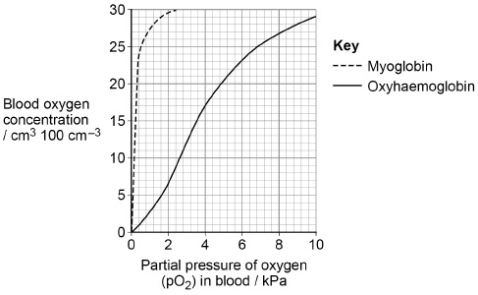

(b)  Use information in the graph to explain how the seal’s myoglobin dissociation curve shows the seal is adapted for diving.

___________________________________________________________________

___________________________________________________________________

___________________________________________________________________

___________________________________________________________________

___________________________________________________________________

___________________________________________________________________

**(2)**

(c)  Scientists measured the oxygen carrying capacity of seal blood.

They found the haemoglobin in a 190 kg seal contained 1.07 × 104 cm3 oxygen.

When the seal dived, it used 5.2 cm3 oxygen per minute per kg of body mass.

Use this information to calculate the maximum number of minutes the seal can remain under water. Assume that all of the oxygen attached to the haemoglobin is released during the dive.

Answer = __________________________ minutes

**(2)**

**(Total 6 marks)**

**Q7.**

(a)     Explain **four** ways in which the structure of the aorta is related to its function.

___________________________________________________________________

___________________________________________________________________

___________________________________________________________________

___________________________________________________________________

___________________________________________________________________

___________________________________________________________________

___________________________________________________________________

___________________________________________________________________

___________________________________________________________________

**(4)**

**Figure 1** shows the oxyhaemoglobin dissociation curves for two different species, **A** and **B**.

**Figure 1**

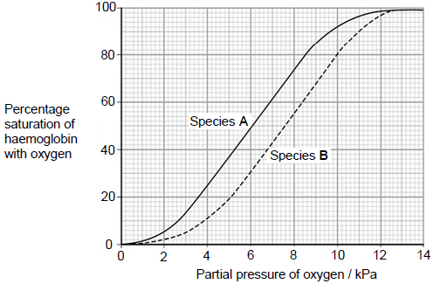

(b)     Species **B** is more active than species **A**. Use **Figure 1** to explain how the haemoglobin of species **B** allows a greater level of activity.

___________________________________________________________________

___________________________________________________________________

___________________________________________________________________

___________________________________________________________________

___________________________________________________________________

___________________________________________________________________

___________________________________________________________________

___________________________________________________________________

**(4)**

(c)     An electrocardiogram (ECG) shows the electrical activity of the heart. **Figure 2** shows an ECG for an animal of species **B** at rest. Each large spike represents a contraction of the ventricles.

**Figure 2**

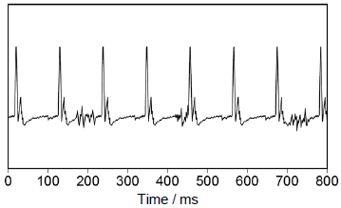

For species **B**, the mean volume of blood leaving the left ventricle during each contraction is 0.03 cm3.

Calculate the mean volume of blood leaving the left ventricle per minute.

Volume of blood = ___________________________ cm3 minute−1

**(2)**

**(Total 10 marks)**

**Q8.**

The graph shows the oxyhaemoglobin dissociation curves for fetal haemoglobin (HbF) and adult haemoglobin (HbA).

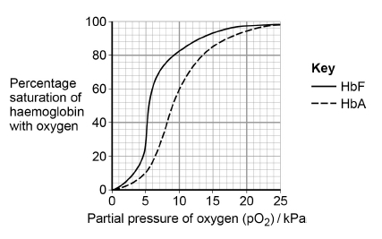

(a)     Explain how changes in the shape of haemoglobin result in the S-shaped (sigmoid) oxyhaemoglobin dissociation curve for HbA.

___________________________________________________________________

___________________________________________________________________

___________________________________________________________________

___________________________________________________________________

___________________________________________________________________

**(2)**

(b)     At birth 98% of the haemoglobin is HbF. By the age of 6 months, the HbF has usually completely disappeared from the baby’s blood and been replaced by HbA.

Use the graph above to explain why this change is an advantage for the baby.

___________________________________________________________________

___________________________________________________________________

___________________________________________________________________

___________________________________________________________________

___________________________________________________________________

**(2)**

(c)     Sickle cell disease (SCD) is caused by production of faulty HbA. This results in a reduced ability to transport oxygen to tissues. Scientists investigated the use of a substance called hydroxyurea to treat babies with SCD. Hydroxyurea changes the concentration of HbF in the blood.

The scientists carried out an investigation with 122 babies who had SCD. Each baby was given hydroxyurea for 41 months. The scientists then found the mean change in the concentration of HbF in the babies’ blood.

Their results are shown in the table.

|  |  |
| --- | --- |
| **Mean concentration of HbF in the babies’ blood / arbitrary units** | |
| **Before treatment with hydroxyurea (± 1 standard deviation)** | **After treatment with hydroxyurea (± 1 standard deviation)** |
| 7.6  (± 4.5) | 19.1  (± 6.5) |

The scientists concluded that treatment with hydroxyurea would increase the concentration of oxygen in the blood of babies with SCD.

Suggest how the graph and table above support this conclusion.

___________________________________________________________________

___________________________________________________________________

___________________________________________________________________

___________________________________________________________________

___________________________________________________________________

___________________________________________________________________

___________________________________________________________________

**(3)**

**(Total 7 marks)**