**Q1.**

(a)     The table shows the transpiration rate of a group of plants exposed to different humidities at a temperature of 25°C.

|  |  |
| --- | --- |
| **Humidity / %** | **Transpiration rate / arbitrary units** |
| 20 | 26.0 |
| 40 | 21.0 |
| 50 | 16.5 |
| 60 | 11.0 |
| 70 | 9.5 |

Describe and explain the relationship between humidity and transpiration rate.

___________________________________________________________________

___________________________________________________________________

___________________________________________________________________

___________________________________________________________________

___________________________________________________________________

___________________________________________________________________

**(3)**

(b)     The diagrams show a section through a typical leaf and a section through a leaf from a xerophytic plant. The xerophytic leaf has a lower transpiration rate than the typical leaf.

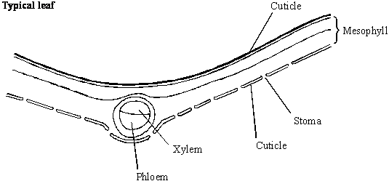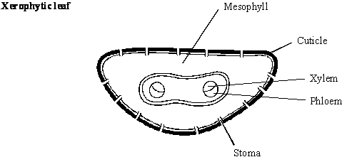

Describe **two** features shown in the diagram of the xerophytic leaf which reduce transpiration rate. Explain how each of these features contributes to a lower transpiration rate.

Feature 1___________________________________________________________

Explanation _________________________________________________________

___________________________________________________________________

Feature 2___________________________________________________________

Explanation _________________________________________________________

___________________________________________________________________

**(4)**

**(Total 7 marks)**

**Q2.**

A student investigated the rate of transpiration from a leafy shoot. She used a potometer to measure the rate of water uptake by the shoot. The diagram shows the potometer used by the student.

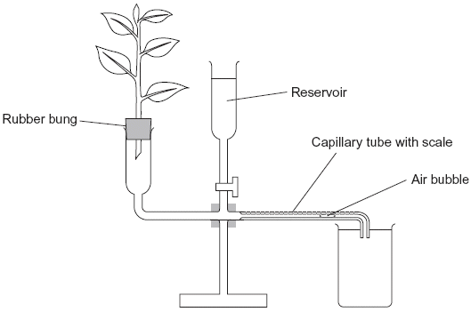

(a)     Give **one** environmental factor that the student should have kept constant during this investigation.

___________________________________________________________________

**(1)**

(b)     The student cut the shoot and put it into the potometer under water. Explain why.

___________________________________________________________________

___________________________________________________________________

**(1)**

(c)     The student wanted to calculate the rate of water uptake by the shoot in cm3 per minute. What measurements did she need to make?

___________________________________________________________________

___________________________________________________________________

___________________________________________________________________

___________________________________________________________________

**(2)**

(d)     The student assumed that water uptake was equivalent to the rate of transpiration.

Give **two** reasons why this might **not** be a valid assumption.

1. _________________________________________________________________

___________________________________________________________________

2. _________________________________________________________________

___________________________________________________________________

**(2)**

(e)     The student measured the rate of water uptake three times.

(i)      Suggest how the reservoir allows repeat measurements to be made.

______________________________________________________________

______________________________________________________________

**(1)**

(ii)     Suggest why she made repeat measurements.

______________________________________________________________

______________________________________________________________

**(1)**

**(Total 8 marks)**

**Q3.**

A student used the apparatus shown in **Figure 1** and a digital balance to determine the rate of water movement in a celery stalk in grams per hour per group of xylem vessels.

**Figure 1**

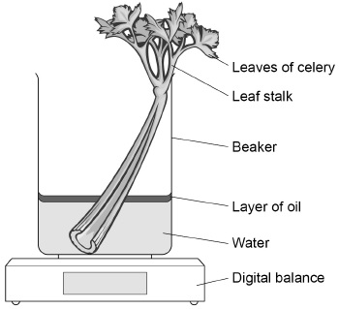

(a)  The student measured the time taken for water movement.

Give **two** other measurements he made to calculate the rate of water movement.

1  _________________________________________________________________

___________________________________________________________________

___________________________________________________________________

2  _________________________________________________________________

___________________________________________________________________

___________________________________________________________________

**(2)**

(b)  Give the reason for adding a layer of oil to the water in the beaker.

___________________________________________________________________

___________________________________________________________________

___________________________________________________________________

___________________________________________________________________

**(1)**

(c)  A different student used coloured water to investigate the movement of water in leaf stalks of celery.

During the procedure she:

•   cut equal lengths of stalk from each plant

•   put the cut end of each stalk into coloured water

•   left these stalks to take up the coloured water for 20 minutes

•   used a sharp scalpel to cut slices from the stalks at 1 mm intervals until she reached a slice with no coloured water.

**Figure 2** shows a slice of leaf stalk with coloured water inside groups of xylem vessels.

**Figure 2**

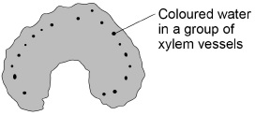

Explain why coloured water moved up the stalks.

___________________________________________________________________

___________________________________________________________________

___________________________________________________________________

___________________________________________________________________

___________________________________________________________________

___________________________________________________________________

___________________________________________________________________

___________________________________________________________________

___________________________________________________________________

___________________________________________________________________

**(3)**

(d)  The student used a sharp scalpel to cut the celery. Describe how she should ensure she handled the scalpel safely during this procedure.

___________________________________________________________________

___________________________________________________________________

___________________________________________________________________

___________________________________________________________________

___________________________________________________________________

**(2)**

The student measured the distance the coloured water had travelled in eight celery stalks.

Her results are shown in the table.

|  |  |  |  |  |  |  |  |
| --- | --- | --- | --- | --- | --- | --- | --- |
| **Distance / mm** | | | | | | | |
| 70 | 35 | 40 | 35 | 30 | 80 | 42 | 44 |

(e)  The student had to choose whether to summarise her measurements by calculating the mean, the median or the mode.

Circle the most appropriate measure for this set of measurements.

Give a reason for your choice and find the value using the measurements from all eight stalks.

Mean*   Median*   Mode*

*circle one word.

Reason:  ___________________________________________________________

___________________________________________________________________

___________________________________________________________________

Calculation:

Answer = ______________________________

**(2)**

**(Total 10 marks)**

**Q4.**

(a)     Describe how water is moved through a plant according to the *cohesion-tension* hypothesis.

___________________________________________________________________

___________________________________________________________________

___________________________________________________________________

___________________________________________________________________

___________________________________________________________________

___________________________________________________________________

___________________________________________________________________

___________________________________________________________________

**(4)**

(b)     The mass of water lost from a plant was investigated. The same plant was used in every treatment and the plant was subjected to identical environmental conditions. In some treatments, the leaves were coated with a type of grease. This grease provides a waterproof barrier. The results of the investigation are given in the table.

|  |  |
| --- | --- |
| **Treatment** | **Mass lost in 5 days / g** |
| No grease applied | 10.0 |
| Grease applied only to the upper surface of every leaf | 8.7 |
| Grease applied to both surfaces of every leaf | 0.1 |

(i)      What is the advantage of using the same plant in every treatment?

______________________________________________________________

______________________________________________________________

**(1)**

(ii)     Why was it important to keep the environmental conditions constant?

______________________________________________________________

______________________________________________________________

**(1)**

(iii)     What is the evidence that the grease provides a waterproof barrier?

______________________________________________________________

______________________________________________________________

**(1)**

(c)     (i)      Calculate the mass of water lost in 5 days through the upper surface of the leaves.

Answer ___________________________________

**(1)**

(ii)     Use your knowledge of leaf structure to explain why less water is lost through the upper surface of leaves than is lost through the lower surface.

______________________________________________________________

______________________________________________________________

______________________________________________________________

______________________________________________________________

**(2)**

**(Total 10 marks)**

**Q5.**

Students investigated the effect of removing leaves from a plant shoot on the rate of water uptake. Each student set up a potometer with a shoot that had eight leaves. All the shoots came from the same plant. The potometer they used is shown in the diagram.

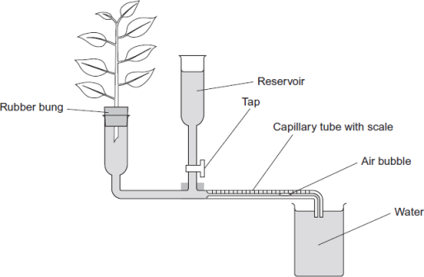

(a)     Describe how the students would have returned the air bubble to the start of the capillary tube in this investigation.

___________________________________________________________________

___________________________________________________________________

___________________________________________________________________

**(1)**

(b)     Give **two** precautions the students should have taken when setting up the potometer to obtain reliable measurements of water uptake by the plant shoot.

1. _________________________________________________________________

2. _________________________________________________________________

**(2)**

(c)     A potometer measures the rate of water uptake rather than the rate of transpiration. Give **two** reasons why the potometer does **not** truly measure the rate of transpiration.

1. _________________________________________________________________

2. _________________________________________________________________

**(2)**

(d)     The students’ results are shown in the table.

|  |  |
| --- | --- |
| **Number of leaves removed from the plant shoot** | **Mean rate of water uptake /  cm3 per minute** |
| 0 | 0.10 |
| 2 | 0.08 |
| 4 | 0.04 |
| 6 | 0.02 |
| 8 | 0.01 |

Explain the relationship between the number of leaves removed from the plant shoot and the mean rate of water uptake.

___________________________________________________________________

___________________________________________________________________

___________________________________________________________________

___________________________________________________________________

___________________________________________________________________

___________________________________________________________________

**(3)**

**(Total 8 marks)**

**Q6.**

Organic compounds synthesised in the leaves of a plant can be transported to the plant’s roots.  
This transport is called translocation and occurs in the phloem tissue of the plant.

(a)     One theory of translocation states that organic substances are pushed from a high pressure in the leaves to a lower pressure in the roots.

Describe how a high pressure is produced in the leaves.

___________________________________________________________________

___________________________________________________________________

___________________________________________________________________

___________________________________________________________________

___________________________________________________________________

___________________________________________________________________

**(3)**

PCMBS is a substance that inhibits the uptake of sucrose by plant cells.

Scientists investigated the effect of PCMBS on the rate of translocation in sugar beet.  
The figure below shows their results.

Time / minutes

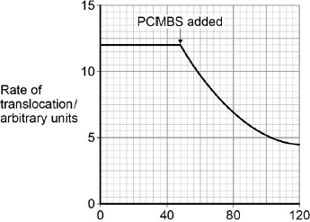

(b)     During their experiment, the scientists ensured that the rate of photosynthesis of their plants remained constant.  
Explain why this was important.

___________________________________________________________________

___________________________________________________________________

___________________________________________________________________

___________________________________________________________________

**(2)**

(c)     The scientists concluded that some translocation must occur in the spaces in the cell walls.  
Explain how the information in the figure above supports this conclusion.

___________________________________________________________________

___________________________________________________________________

___________________________________________________________________

___________________________________________________________________

___________________________________________________________________

**(2)**

**(Total 7 marks)**

**Q7.**

(a)     Describe the mass flow hypothesis for the mechanism of translocation in plants.

___________________________________________________________________

___________________________________________________________________

___________________________________________________________________

___________________________________________________________________

___________________________________________________________________

___________________________________________________________________

___________________________________________________________________

___________________________________________________________________

**(4)**

Scientists measured translocation in the phloem of trees. They used carbon dioxide labelled with radioactive 14C.

They put a large, clear plastic bag over the leaves and branches of each tree and added 14CO2. The main trunk of the tree was not in the plastic bag.

At regular intervals after adding the 14CO2 to the bag, the scientists measured the amount of 14CO2 released from the top and bottom of the main trunk of the tree. On the surface of the trunk of these trees, there are pores for gas exchange.

The following figure shows the scientists’ results.

                               Time after 14C labelled CO2 given / hours

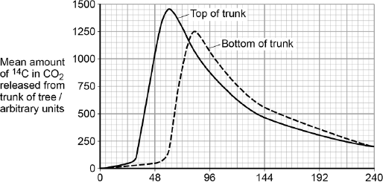

(b)     Name the process that produced the 14CO2 released from the trunk.

___________________________________________________________________

**(1)**

(c)     How long did it take the 14C label to get from the top of the trunk to the bottom of the trunk? Explain how you reached your answer.

___________________________________________________________________

___________________________________________________________________

___________________________________________________________________

___________________________________________________________________

**(2)**

(d)     What other information is required in order to calculate the mean rate of movement of the 14C down the trunk?

___________________________________________________________________

___________________________________________________________________

**(1)**

**(Total 8 marks)**

**Q8.**

(a)     (i)      Give **two** ways in which the structure of starch is **similar** to cellulose.

1. ____________________________________________________________

2. ____________________________________________________________

**(2)**

(ii)     Give **two** ways in which the structure of starch is **different** from cellulose.

1. ____________________________________________________________

2. ____________________________________________________________

**(2)**

(b)     In plants, mass transport of sugars takes place through columns of sieve cells in the phloem. Other cells, called companion cells, transport sugars into, and out of, the sieve cells.

The diagram shows the structure of phloem.

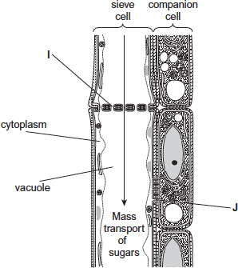

Structures **I** and **J** allow the transport of sugars between cells.

(i)      Using the diagram, suggest and explain **one** other way in which sieve cells are adapted for mass transport.

______________________________________________________________

______________________________________________________________

______________________________________________________________

______________________________________________________________

______________________________________________________________

**(2)**

(ii)     Using the diagram, suggest and explain **one** other way in which companion cells are adapted for the transport of sugars between cells.

______________________________________________________________

______________________________________________________________

______________________________________________________________

______________________________________________________________

______________________________________________________________

**(2)**

**(Total 8 marks)**