**Q1.**

(a)     Gas exchange in fish takes place in gills. Explain how **two** features of gills allow efficient gas exchange.

1. _________________________________________________________________

___________________________________________________________________

2. _________________________________________________________________

___________________________________________________________________

**(2)**

(b)     A zoologist investigated the relationship between body mass and rate of oxygen uptake in four species of mammal. The results are shown in the graph.

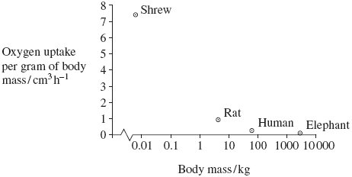

(i)      The scale for plotting body mass is a logarithmic scale. Explain why a logarithmic scale was used to plot body mass.

______________________________________________________________

______________________________________________________________

**(1)**

(ii)     Describe the relationship between body mass and oxygen uptake.

______________________________________________________________

______________________________________________________________

**(1)**

(iii)     The zoologist measured oxygen uptake per gram of body mass. Explain why he measured oxygen uptake per gram of body mass.

______________________________________________________________

______________________________________________________________

______________________________________________________________

______________________________________________________________

**(2)**

**(Total 6 marks)**

**Q2.**

(a)     Flatworms are small animals that live in water. They have no specialised gas exchange or circulatory systems.  
The drawing shows one type of flatworm.

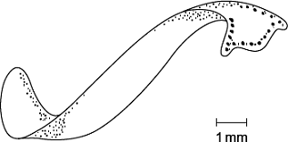

(i)      Name the process by which oxygen reaches the cells inside the body of this flatworm.

______________________________________________________________

**(1)**

(ii)     The body of a flatworm is adapted for efficient gas exchange between the water and the cells inside the body.  
Using the diagram, explain how **two** features of the flatworm’s body allow efficient gas exchange.

1. ____________________________________________________________

______________________________________________________________

2. ____________________________________________________________

______________________________________________________________

**(2)**

(b)     (i)      A leaf is an organ. What is an organ?

______________________________________________________________

______________________________________________________________

______________________________________________________________

**(1)**

(ii)     Describe how carbon dioxide in the air outside a leaf reaches mesophyll cells inside the leaf.

______________________________________________________________

______________________________________________________________

______________________________________________________________

______________________________________________________________

______________________________________________________________

**(3)**

**(Total 7 marks)**

**Q3.**

Many insects release carbon dioxide in short bursts even though they produce it at a constant rate. The diagram shows how this is achieved in one particular insect.

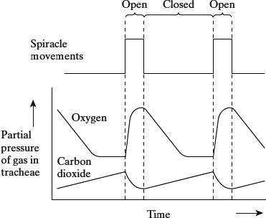

(a)     Using information from the diagram, suggest what stimulates the spiracles to open.

___________________________________________________________________

___________________________________________________________________

**(1)**

(b)     Explain what causes the oxygen concentration in the tracheae to fall when the spiracles are closed.

___________________________________________________________________

___________________________________________________________________

___________________________________________________________________

___________________________________________________________________

**(2)**

(c)     The insect lives in dry conditions. Suggest an advantage of the pattern of spiracle movements shown in the diagram.

___________________________________________________________________

___________________________________________________________________

___________________________________________________________________

___________________________________________________________________

**(2)**

**(Total 5 marks)**

**Q4.**

A scientist used grasshoppers to investigate the effect of composition of air on breathing rate in insects. He changed the composition of air they breathed in by varying the concentrations of oxygen and carbon dioxide.

The scientist collected 20 mature grasshoppers from a meadow. He placed the grasshoppers in a small chamber where he could adjust and control the composition of air surrounding them. The small chamber restricted the movement of the grasshoppers.

His results for three of the grasshoppers are shown in the table below in the form in which he presented them.

|  |  |  |  |  |  |
| --- | --- | --- | --- | --- | --- |
|  |  | **Percentage of oxygen and carbon dioxide in  different types of air breathed in by grasshoppers** | | | |
|  |  | **A Air from atmosphere** | **B Pure oxygen** | **C Gas mixture 1** | **D Gas mixture 2** |
| **Gas** | **Oxygen** | 20.9 | 100.0 | 91.0 | 84.0 |
| **Carbon dioxide** | 0.1 | 0.0 | 9.0 | 16.0 |
|  | | | | | |
| **Breathing rate of grasshopper in different types of air / breaths per  minute** | **Grasshopper 1** | 53 | 11 | 99 | 107 |
| **Grasshopper 2** | 48 | 25 | 88 | 99 |
| **Grasshopper 3** | 61 | 13 | 96 | 93 |

(a)     The percentages of oxygen and carbon dioxide in Column **A** do **not** add up to 100% but in columns **C** and **D** they do.

Suggest **two** reasons for this difference.

1. _________________________________________________________________

___________________________________________________________________

2. _________________________________________________________________

___________________________________________________________________

**(2)**

(b)     Use all the data to describe the effect of concentration of carbon dioxide on the breathing rate of grasshoppers.

___________________________________________________________________

___________________________________________________________________

___________________________________________________________________

___________________________________________________________________

___________________________________________________________________

___________________________________________________________________

**(3)**

(c)     One of the different types of air was similar to the air in the meadow where the grasshoppers were collected. It provides data that might be used to calculate a mean breathing rate for grasshoppers in the meadow.

(i)      Use the data to estimate the mean breathing rate of the three grasshoppers in the meadow. Show your working.

Mean breathing rate = ____________________ breaths per minute

**(2)**

(ii)     The estimate does not provide a reliable value for the mean breathing rate of all insect species in the meadow.

Other than being an estimate, suggest and explain **three** reasons why this value would **not** be reliable.

1. ____________________________________________________________

______________________________________________________________

______________________________________________________________

2. ____________________________________________________________

______________________________________________________________

______________________________________________________________

3. ____________________________________________________________

______________________________________________________________

______________________________________________________________

**(3)**

**(Total 10 marks)**

**Q5.**

(a)     Describe and explain how the countercurrent system leads to efficient gas exchange across the gills of a fish.

___________________________________________________________________

___________________________________________________________________

___________________________________________________________________

___________________________________________________________________

___________________________________________________________________

___________________________________________________________________

**(3)**

(b)     Amoebic gill disease (AGD) is caused by a parasite that lives on the gills of some species of fish. The disease causes the lamellae to become thicker and to fuse together.

AGD reduces the efficiency of gas exchange in fish. Give **two** reasons why.

1. _________________________________________________________________

___________________________________________________________________

2. _________________________________________________________________

___________________________________________________________________

**(2)**

(c)     The table below shows some features of gas exchange of a fish at rest.

|  |  |
| --- | --- |
| Volume of oxygen absorbed by the gills from each dm3 of water / cm3 | 7 |
| Mass of fish / kg | 0.4 |
| Oxygen required by fish / cm3 kg–1 hour–1 | 90 |

(i)      Calculate the volume of water that would have to pass over the gills each hour to supply the oxygen required by the fish. Show your working.

____________________ dm3

**(2)**

(ii)     The volume of water passing over the gills increases if the temperature of the water increases. Suggest why.

______________________________________________________________

______________________________________________________________

______________________________________________________________

**(1)**

**(Total 8 marks)**

**Q6.**

(a)     The photograph shows part of the gill of a fish as seen through a light microscope. It is magnified × 400.

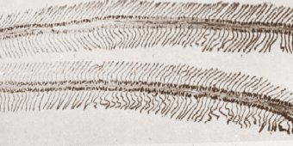

(i)      Explain how the structure of the gill makes oxygen uptake efficient.

______________________________________________________________

______________________________________________________________

______________________________________________________________

**(2)**

(ii)     Water containing dissolved oxygen flows over the gill in the opposite direction to the blood flow inside. Explain why this arrangement is important for efficient oxygen uptake.

______________________________________________________________

______________________________________________________________

______________________________________________________________

______________________________________________________________

**(2)**

(b)     There is a one-way flow of water over the gills of a fish whereas there is a two-way flow of air in the lungs of a mammal. Suggest **one** advantage to a fish of this one-way flow of water over its gills.

___________________________________________________________________

___________________________________________________________________

**(1)**

**(Total 5 marks)**

**Q7.**

(a)     The diagram represents the flow of water and blood through the gills of a fish. The figures give relative oxygen concentrations.

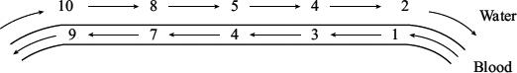

Use the information in the diagram to explain the advantage of the countercurrent flow.

___________________________________________________________________

___________________________________________________________________

___________________________________________________________________

___________________________________________________________________

___________________________________________________________________

**(2)**

(b)     In the ventilation cycle of a fish, water enters the mouth cavity and then passes through the gills into the opercular cavity. The graph shows the difference in pressure between the mouth cavity and the opercular cavity.

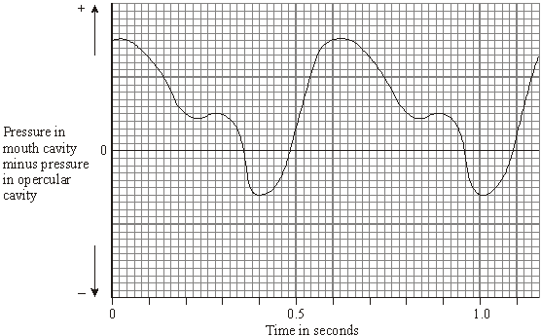

Calculate the number of ventilation cycles per minute of the fish. Show your working.

Answer ____________________

**(2)**

**(Total 4 marks)**

**Q8.**

The drawing shows part of the lower leaf epidermis of sorghum.

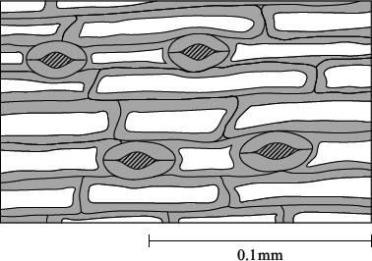

(a)     Calculate the number of stomata per mm2 of the leaf surface. Show your working.

Answer ____________________ stomata per mm2

**(2)**

(b)     Sorghum has few stomata per mm2 of leaf surface area. Explain how this is an adaptation to the conditions in which sorghum grows.

___________________________________________________________________

___________________________________________________________________

___________________________________________________________________

___________________________________________________________________

___________________________________________________________________

___________________________________________________________________

**(3)**

**(Total 5 marks)**

**Q9.**

**Figure 1** shows a single stoma and surrounding cells from the leaf of a xerophytic plant.

**Figure 1**

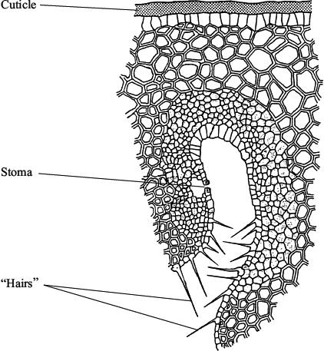

(i)      Explain how the cuticle reduces water loss.

___________________________________________________________________

___________________________________________________________________

**(1)**

(ii)     Explain how **one** of the other labelled parts reduces water loss.

___________________________________________________________________

___________________________________________________________________

___________________________________________________________________

___________________________________________________________________

**(2)**

**(Total 3 marks)**

**Q10.**

Scientists studied the rate of carbon dioxide uptake by grape plant leaves. Grape leaves have stomata on the lower surface but no stomata on the upper surface.

The scientists recorded the carbon dioxide uptake by grape leaves with three different treatments:

**Treatment 1** − No air-sealing grease was applied to either surface of the leaf.

**Treatment 2** − The lower surface of the leaf was covered in air-sealing grease that prevents gas exchange.

**Treatment 3** − Both the lower surface and the upper surface of the leaf were covered in air–sealing grease that prevents gas exchange.

The scientists measured the rate of carbon dioxide uptake by each leaf for 60 minutes in light and then for 20 minutes in the dark.

The scientists’ results are shown in the diagram below.

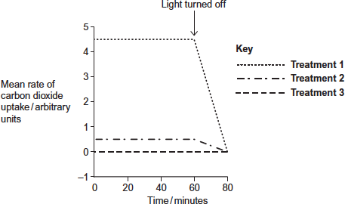

(a)     Suggest the purpose of each of the three leaf treatments.

**Treatment 1** ___________________________________________________________________

___________________________________________________________________

___________________________________________________________________

**Treatment 2** ___________________________________________________________________

___________________________________________________________________

___________________________________________________________________

**Treatment 3** ___________________________________________________________________

___________________________________________________________________

___________________________________________________________________

**(3)**

(b)     (i)      Describe the results shown for **Treatment 1**.

______________________________________________________________

______________________________________________________________

______________________________________________________________

______________________________________________________________

______________________________________________________________

**(2)**

(ii)     The stomata close when the light is turned off.

Explain the advantage of this to the plant.

______________________________________________________________

______________________________________________________________

______________________________________________________________

______________________________________________________________

______________________________________________________________

**(2)**

(c)     (i)      **Treatment 2** shows that even when the lower surface of the leaf is sealed there is still some uptake of carbon dioxide.

Suggest how this uptake of carbon dioxide continues.

______________________________________________________________

______________________________________________________________

______________________________________________________________

**(1)**

(ii)     In both **Treatment 1** and **Treatment 2**, the uptake of carbon dioxide falls to zero when the light is turned off.

Explain why.

______________________________________________________________

______________________________________________________________

______________________________________________________________

______________________________________________________________

______________________________________________________________

**(2)**

**(Total 10 marks)**

Mark schemes

**Q1.**

(a)     Filaments / lamellae provide large surface area;

Thin / flattened epithelium / one / two cell layers so short diffusion pathway (between water and blood);

Countercurrent / blood flow maintains concentration / diffusion gradient;

***Q*** *Do not credit thin cell walls / membranes*

**2 max**

(b)     (i)      Large / wide range of values (so can fit on graph);

**1**

(ii)     Decrease in uptake with increase in mass / negative correlation;

**1**

(iii)    Enables comparison;

As animals differ in size / mass;

**2**

**[6]**

**Q2.**

(a)     (i)     Diffusion;

*Ignore references to structures, membrane components etc*

*Allow simple diffusion*

*Reject facilitated diffusion*

**1**

(ii)     1.      (Thin / flat body) so short distance for diffusion / short diffusion pathway;

*Ignore references to membrane, wall, body surface*

2.      (Thin / flat body so) large surface area to volume ratio;

*‘It’ refers to flatworm’s body*

**2**

(b)     (i)     A group of tissues;

*Ignore references to function Group = more than one*

**1**

(ii)     1.      (Carbon dioxide enters) via stomata;

*Reject stroma*

2.      (Stomata opened by) guard cells;

3.      Diffuses through air spaces;

*Allow concentration gradient. Reject along gradient unless direction made clear*

4.      Down diffusion gradient;

**3 max**

**[7]**

**Q3.**

(a)     increasing carbon dioxide concentration / partial pressure;  
*(decrease in oxygen negates)*

**1**

(b)     (oxygen is used in) respiration therefore diffuses (from tracheae) to tissues;  
oxygen unable to enter organism;

**2**

(c)     spiracles not open all the time;  
therefore there is less water loss  
(by diffusion through spiracles);

**2**

**[5]**

**Q4.**

(a)     1.      Other gases / nitrogen / water vapour in atmosphere / **A**;

2.      Only oxygen and carbon dioxide in gas mixtures / **C** and **D**;

3.      Composition of / gases in **A** not controlled / composition of gas mixtures / **C** and **D** controlled.

**2 max**

(b)     1.      Breathing rate *lowest* when no carbon dioxide / in (pure) oxygen /  
         B;

*Idea of ‘lowest’ must be stated.*

2.      (Generally) presence of carbon dioxide increases breathing rate / as concentration of carbon dioxide increases breathing rate increases / there is a positive correlation;

*A general point incorporating all concentrations.*

3.      Breathing rate increases when (carbon dioxide) higher than 0.1% / concentration in atmosphere / A;

*This MP requires a specific comparison to 0.1% or the atmospheric concentration.*

*Accept ‘gas mixtures 1 and 2 / C and D’ for ‘higher carbon dioxide’.*

4.      Breathing rate of **grasshopper 3** falls in D / 16% / gas mixture 2 (whereas others increase).

*Restating data alone is insufficient for any mark point.*

**3 max**

(c)     (i)      54;

***OR***

1.      Correct data / column **A** chosen;

*A correct answer of 54 gets 2 marks.*

*MP1 and MP2 allow a possible mark for an incorrect calculation or choice of wrong data.*

2.      Correct calculation of mean from data chosen;

*Check − the three values must be from same column.*

**2 max**

(ii)     1.      Small sample / only 3 (grasshoppers)

*so* may not be representative (of all grasshoppers / insects);

2.      Grasshoppers are not the only insects / species;

*so* genetic / behavioural / metabolic differences;

3.      (Insects) not all mature / are at different stages of development / different sizes;

*so* different metabolic rates;

4.      Movement not restricted / not at rest in meadow;

*so* (rate of) respiration higher;

5.      (Naturally-occurring) carbon dioxide concentration lower in meadow;

*so* breathing rate lower;

*Explanations required, therefore both parts of answer required for credit in each marking point.*

*Accept appropriate converse answers.*

*Accept ‘respiration’ for ‘metabolism’ and vice versa.*

**3 max**

**[10]**

**Q5.**

(a)     1.      Water and blood flow in opposite directions;

*Accept: diagram if clearly annotated*

2.      Maintains concentration / diffusion gradient / equilibrium not reached / water always next to blood with a lower concentration of oxygen;

*Must have the idea of ‘maintaining’ or ‘always’ in reference to concentration / diffusion gradient*

*Accept: constant concentration / diffusion gradient*

3.      Along whole / length of gill / lamellae;

*Accept: gill plate / gill filament*

**3**

(b)     1.      (Thicker lamellae so) greater / longer diffusion distance / pathway;

***Q*** *Neutral: ‘thicker’ diffusion pathway*

2.      (Lamellae fuse so) reduced surface area;

*Accept: reduced SA:VOL*

**2**

(c)     (i)      Correct answer of **5.1** or **5.14(2857)** (dm3) = 2 marks;;

*Allow 1 mark max for an answer of* ***5*** *if the correct answer of* ***5.1*** *or* ***5.14(2857)*** *is* ***not*** *shown*

One mark for incorrect answers that show **36** or **0.4 × 90** or **90 ÷ 7;**

**2**

(ii)     1.      Increased metabolism / respiration / enzyme activity;

*Accept: enzymes work more efficiently*

2.      Less oxygen (dissolved in water);

*Neutral: references to increased kinetic energy (of water molecules)*

**1 max**

**[8]**

**Q6.**

(a)     (i)      one feature;

then linked Explanation;

(many) filaments / lamellae / secondary lamellae;

so large surface area;

large number of capillaries; (NOT “good blood supply”)

maintains a diffusion gradient / removes oxygen;

thin epithelium / lamellae wall;

short diffusion pathway;

**2**

(ii)     maintains diffusion / concentration gradient / equilibrium  
not reached;

diffusion occurs across whole length (of lamellae / gill);

**2**

(b)     less energy needed / continuous flow of water or O2;

**1**

**[5]**

**Q7.**

(a)     (diffusion) gradient will be maintained all the way along the gill / the amount of oxygen in the water is always higher than in the blood / the numbers in the water are always higher than in the blood;  
more oxygen will diffuse into the blood;

**2**

(b)     100 cycles per minute;

*(principle of 60 / x or 0.6 seen gains one mark)*

**2**

**[4]**

**Q8.**

(a)     235–240;;  
*(one mark for an answer between 200-300  
based on 2 - 3 stomata in 0.01mm2Alternatively, one mark for calculating the area of the  
rectangle correctly as 0.016 – 0.017mm2)*

**2**

(b)     grows in arid / dry conditions;  
less surface area;  
(rate of) transpiration / water loss would be reduced;

**3**

**[5]**

**Q9.**

(i)      (waxy so) impermeable to water / waterproof / stops water  
passing through;

**1**

(ii)     reference to hairs / position of stomata (sunken stomata /   
stomata in pits )  
LINKED to reduced air movement / trap layer of air /   
trap water vapour (*reject water) /* maintains humidity;

reduces diffusion gradient / concentration gradient of water /   
water potential gradient;

*OR*

stoma can close;  
reduces area for evaporation or transpiration;

**2**

**[3]**

**Q10.**

(a)     1.      (No grease)

            means stomata are open

            OR

            allows normal CO2 uptake;

*Allow ‘gas exchange’ for CO2 uptake.*

*‘As a control’ is insufficient on its own.*

2.      (Grease on lower surface)

seals stomata

OR

stops CO2 uptake through

stomata

OR

to find CO2 uptake through

stomata

OR

shows CO2 uptake through cuticle / upper surface;

3.      (Grease on both surfaces) shows sealing is effective

OR

stops all CO2 uptake.

**3**

(b)     (i)      1.      (Mean rate of) carbon dioxide uptake was constant *and* fell after the light turned off;

*Ignore absence of arbitrary units in both marking points.*

*Both ideas needed for mark.*

*Accept ‘stayed at 4.5’ as equivalent to ‘was constant’.*

2.      Uptake fell from 4.5 to 0 / uptake started to fall at 60 minutes and reached lowest at 80 minutes / uptake fell over period of 20 minutes;

*One correct use of figures required.*

*Accept fell to nothing / no uptake for 0.*

**2**

(ii)     1.      (Because) water is lost through stomata;

2.      (Closure) prevents / reduces water loss;

3.      Maintain water content of cells.

*This marking point rewards an understanding of reducing water loss e.g. reduce wilting, maintain turgor, and is not related to photosynthesis.*

**2 max**

(c)     (i)      (Carbon dioxide uptake) through the upper surface of the leaf / through cuticle.

**1**

(ii)     1.      No use of carbon dioxide in photosynthesis (in the dark);

2.      No diffusion gradient (maintained) for carbon dioxide into leaf / there is now a diffusion gradient for carbon dioxide out of leaf (due to respiration).

**2**

**[10]**

Examiner reports

**Q1.**

(a)     Most candidates gained at least one mark often by explaining that filaments and/or lamellae in the gills provide a large surface area allowing efficient gas exchange. The failure of many candidates to gain both marks was often due to poor use of terminology particularly in relation to the short diffusion pathway between the blood and water and the countercurrent flow mechanism.

(b)     (i)      Approximately half the candidates obtained this mark appreciating that a logarithmic scale enabled the plotting of a large range of values.

(ii)     The vast majority of candidates correctly described the relationship between body mass and oxygen uptake.

(iii)     It was surprising that only one in every five candidates obtained both marks for this question. Many candidates obtained a mark for indicating that measuring oxygen uptake per gram of body mass would enable a comparison to be made. However, only better candidates linked this to the difference in body mass or size of the animals.

**Q2.**

(a)      (i)      The term diffusion was known well, with the majority of students answering correctly.

(ii)     This question was successfully answered by the vast majority of students. Where students failed to gain a mark it was because they referred to the flatworm having a large surface area rather than a large surface area to volume ratio.

(b)     (i)      Many students could recall that an organ is a group of tissues.

(ii)     Few students gained all three marks for this question but most achieved one or two marks in clearly appreciating that carbon dioxide enters a leaf through the stomata. Students clearly understood the process of diffusion but failed to gain credit where they stated that diffusion occurs across or along, rather than down, the gradient.

**Q3.**

(a)     Most candidates correctly spotted the rise in the partial pressure of carbon dioxide.

(b)     Most candidates produced a good logical account and achieved both marks.

(c)     Again most candidates clearly knew what was expected and produced clear logical answers.

Many candidates who produced answers that did not actually relate water loss to spiracles movements failed to gain the second mark. Some candidates confused spiracles with stomata.

**Q4.**

(a)     Most were able to suggest two correct reasons for the difference. A minority misunderstood the question and attempted to suggest biological factors which may have brought about a change in the composition of the gas mixtures.

(b)     Many students made full use of all the data and were able to clearly describe the key effects shown. Only the best answers made a specific comparison to the breathing rate at the 0.1% carbon dioxide concentration. A number repeated all the data without describing the effect of a change in carbon dioxide concentration. A minority seemed unable to make any valid analysis of the data and made only simplistic statements about the general trend.

(c)     The majority of students produced an accurate calculation of breaths per minute. Incorrect answers included working out the mean for all grasshoppers or selecting data from the wrong column.

In part (b) most students were able suggest reasons why the mean may not be reliable but failed to go on and give a suitable biological explanation for the reason given. Many answers included references to possible anomalies and lack of reliability despite this being given in the question. Very few suggested that the carbon dioxide level may be lower in the meadow

**Q5.**

Parts (a), (b) and (c)(i) proved to be good discriminators.

(a)     60% of students scored at least two marks. This was usually for appreciating that water and blood flow in opposite directions to maintain a concentration or diffusion gradient. However, relatively few students mentioned that this occurs along the whole length of the gill. Those who scored zero often gave an account of how the gills are adapted for efficient gas exchange, or did not convey the importance of *maintaining* a concentration or diffusion gradient. There were also some lengthy descriptions of ventilation in fish. It should be noted that this topic is not included in the specification content for BIOL2.

(b)     70% of students scored full marks for linking thicker lamellae to a greater diffusion distance and the fusion of lamellae to a reduced surface area. However, some failed to pick up a second mark due to a lack of precision; for example, ‘less diffusion occurs’ and ‘the diffusion pathway is thicker’.

(c)    (i)      A third of students obtained the correct answer of **5.14** and scored both marks outright. However, many students obtained the principle mark for showing 90 × 0.4 or 90 ÷ 7 in their method.

(ii)     Very few students obtained the marks by suggesting that an increase in the temperature of the water would increase the fish’s metabolism, or rate of respiration, or cause less oxygen to dissolve in the water. The majority of students referred to an increase in kinetic energy, or that water molecules would be moving faster.

**Q6.**

The quality of the answers here were very centre-specific.

(a)     Candidates frequently scored high marks in part (i), but some candidates failed to mention a specific feature. The most common answer was that filaments or lamellae increased the surface area. In part (ii), the idea of maintaining the gradient was often recognised, but not over the whole length of the gill.

(b)     There was only an occasional reference to energy or that there would be a continuous flow. There were many vague answers to ‘it being less efficient’.

**Q7.**

There were mixed responses to this question on ventilation in fish.

(a)     Few candidates gained full marks. Many of them simply stated that the diffusion gradient was maintained, or failed to appreciate that the fish obtain more oxygen.

(b)     Many candidates gained two marks for the number of ventilation cycles in a minute. The most common mistake was 2 cycles per minute.

**Q8.**

(a)     Very few candidates correctly worked out the area as 0.0167mm2 and many seemed to have a basic problem with calculating areas. It was common to see 0.1 x 0.1 = 0. l mm2. Many candidates failed to gain credit by carrying out calculations that were not clearly identified. A common approach was to estimate the number of stomata in an area 0. 1mm x 0. 1mm, which gained credit if done correctly. Many gave answers that were clearly incorrect, such as 20-25 or even 0.25!

(b)     Most candidates picked up the 2 marking points but some failed to gain the second point by incorrectly stating that ‘fewer stomata prevent water loss’. Few answers referred to the idea of there being a reduced surface area.

**Q9.**

The role of the cuticle was well known. Some candidates failed to gain marks through incomplete answers such as ‘the cuticle reduces transpiration’ rather than relating water loss to the impermeable nature of the cuticle. In part (ii), most candidates were able to describe a feature that reduces water loss, but only the more able candidates explained how the feature reduces transpiration by affecting the water diffusion gradient.

**Q10.**

(a)     Most students gave reasonable suggestions for the purpose of treatments 1 and 2 but found the purpose of treatment 3 more difficult to explain. In this question and in question (c)(i), it was important that students had read the information in Resource B stating that these leaves have stomata only on their lower surface.

(b)     (i)      Students still find it difficult to describe a trend on a graph such as this accurately. Many students failed to state clearly that the rate stayed constant for the first 60 minutes and then fell (as required for mark point 1).

(ii)     Some students were not explicit enough in their answer that the water is lost through the stomata in order to achieve mark point 1.

(c)     (i)      Students who stated that there were stomata on the upper surface of the leaf could not be awarded this mark, as Resource B stated that these leaves have stomata only on their lower surface.

(ii)     Most students achieved mark point 1 but only better answers went on to explain why this meant there was no uptake of carbon dioxide.