**Q1.**

The diagram shows some blood vessels in muscle tissue.

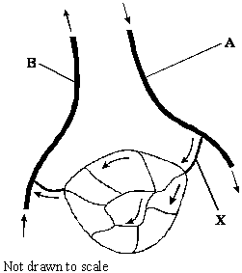

(a)     (i)      Which type of blood vessel is **X**?

______________________________________________________________

**(1)**

(ii)     Name **two** substances which are at a higher concentration in the blood at **A** than in the blood at **B**.

1. ____________________________________________________________

2. ____________________________________________________________

**(1)**

(b)     The table shows the mean diameter of the lumen and the rate of blood flow in some types of human blood vessel.

|  |  |  |
| --- | --- | --- |
| **Type of blood vessel** | **Mean diameter of lumen / μm** | **Rate of blood flow / cm s–1** |
| Artery | 400 | 10 – 40 |
| Arteriole | 30 | 0.1 – 10 |
| Capillary | 8 | less than 0.1 |

Using information in the table, explain what causes the rate of blood flow to be slower in capillaries than in other vessels.

___________________________________________________________________

___________________________________________________________________

___________________________________________________________________

___________________________________________________________________

**(2)**

(c)     (i)      Which type of blood vessel has most elastic tissue in its wall?

______________________________________________________________

**(1)**

(ii)     How does this elastic tissue help to smooth out the flow of blood in the blood vessel?

______________________________________________________________

______________________________________________________________

______________________________________________________________

______________________________________________________________

**(2)**

**(Total 7 marks)**

**Q2.**

This question should be answered in continuous prose.

Quality of Written Communication will be assessed in these answers.

(a)     Describe and explain **four** ways in which the structure of a capillary adapts it for the exchange of substances between blood and the surrounding tissue.

___________________________________________________________________

___________________________________________________________________

___________________________________________________________________

___________________________________________________________________

___________________________________________________________________

___________________________________________________________________

___________________________________________________________________

___________________________________________________________________

**(4)**

(b)     Explain how tissue fluid is formed and how it may be returned to the circulatory system.

___________________________________________________________________

___________________________________________________________________

___________________________________________________________________

___________________________________________________________________

___________________________________________________________________

___________________________________________________________________

___________________________________________________________________

___________________________________________________________________

___________________________________________________________________

___________________________________________________________________

___________________________________________________________________

___________________________________________________________________

**(6)**

**(Total 10 marks)**

**Q3.**

The diagram shows the pathways in the heart for the conduction of electrical impulses during the cardiac cycle.

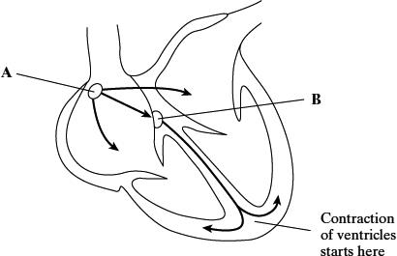

(a)     The table shows the blood pressure in the left atrium, the left ventricle and the aorta at different times during part of a cardiac cycle.

|  |  |  |  |
| --- | --- | --- | --- |
|  | **Blood pressure / kPa** | | |
| **Time / s** | **Left atrium** | **Left ventricle** | **Aorta** |
| 0.0 | 0.5 | 0.4 | 10.6 |
| 0.1 | 1.2 | 0.7 | 10.6 |
| 0.2 | 0.3 | 6.7 | 10.6 |
| 0.3 | 0.4 | 17.3 | 16.0 |
| 0.4 | 0.8 | 8.0 | 12.0 |

(i)      At which time is blood flowing into the aorta?

______________________________________________________________

**(1)**

(ii)     Between which times are the atrioventricular valves closed?

______________________________________________________________

**(1)**

(b)     The maximum pressure in the left ventricle is higher than the maximum pressure in the right ventricle. What causes this difference in pressure?

___________________________________________________________________

___________________________________________________________________

**(1)**

(c)     The information below compares some features of different blood vessels.

|  |  |  |  |  |
| --- | --- | --- | --- | --- |
|  | | **Blood vessel** | | |
|  | | **Artery** | **Capillary** | **Vain** |
| **Property** | Mean diameter of vessel | 4.0 mm | 8.0 μm | 5.0 mm |
| Mean thickness of wall | 1.0 mm | 0.5 μm | 0.5 mm |
|  | | **Relative thickness (shown by length of bar)** | | |
| **Tissues present in wall** | Endothelium |  |  |  |
| Elastic tissue |
| Muscle |

Use the information to explain how the structures of the walls of arteries, veins and capillaries are related to their functions.

___________________________________________________________________

___________________________________________________________________

___________________________________________________________________

___________________________________________________________________

___________________________________________________________________

___________________________________________________________________

___________________________________________________________________

___________________________________________________________________

___________________________________________________________________

___________________________________________________________________

**(6)**

**(Total 9 marks)**

**Q4.**

The graph shows the changes in pressure which take place in the aorta of a mouse during several heartbeats.

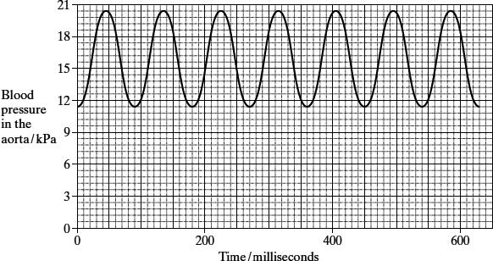

(a)     Which chamber of the heart produces the increase in pressure recorded in the aorta?

___________________________________________________________________

**(1)**

(b)     The pressure of blood in the aorta decreases during each heartbeat but does not fall below 10 kPa. Explain what causes the pressure of blood to

(i)      decrease during each heartbeat;

______________________________________________________________

______________________________________________________________

**(1)**

(ii)     stay above 10 kPa.

______________________________________________________________

______________________________________________________________

______________________________________________________________

______________________________________________________________

**(2)**

(c)The heart rate of a mouse is much higher than the heart rate of a human. Use the graph to calculate the heart rate of the mouse. Show your working.

Heart rate = ____________________ beats per minute

**(2)**

(d)     The cardiac output is the volume of blood pumped by a heart in one minute. The stroke volume is the volume of blood pumped by a heart in a single heartbeat.

cardiac output = stroke volume × heart rate

The cardiac output for a mouse with a heart rate of 550 beats per minute is 16.6 cm3 per minute. Calculate the stroke volume for this mouse. Show your working.

Stroke volume = ____________________ cm3

**(2)**

**(Total 8 marks)**

**Q5.**

The graph shows changes in pressure in the aorta, left ventricle and left atrium during one heart beat.

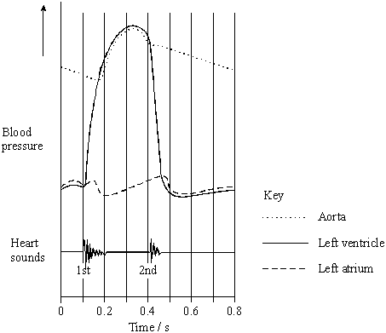

(a)     The maximum pressure in the left atrium is lower than the maximum pressure in the left ventricle. What causes this difference in maximum pressure?

___________________________________________________________________

___________________________________________________________________

**(1)**

(b)     A stethoscope can be used to listen to the sounds made by the heart.

(i)      What is the evidence from the graph that the first heart sound is caused by the atrioventricular valve closing?

______________________________________________________________

______________________________________________________________

**(1)**

(ii)     What causes the second heart sound? Give the reason for your answer.

______________________________________________________________

______________________________________________________________

______________________________________________________________

______________________________________________________________

**(2)**

**(Total 4 marks)**

**Q6.**

(a)     The graph shows the heart rates of two men with hypertension. They were watching television. One of the men had taken a beta blocker and the other had taken a placebo (dummy pill).

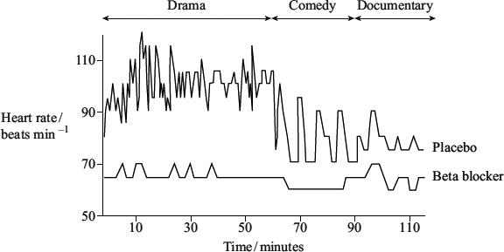

(i)      Use the graph to describe the effects of the beta blocker on heart rate.

______________________________________________________________

______________________________________________________________

______________________________________________________________

______________________________________________________________

**(2)**

(ii)     In this investigation, it was important that neither man knew which type of pill he had taken. Suggest why.

______________________________________________________________

______________________________________________________________

**(1)**

(b)     The table shows the results of an investigation into the effects of prescribing beta blockers to patients who had suffered a myocardial infarction.

|  |  |  |
| --- | --- | --- |
| Patient age at time of myocardial infarction / years | Under 60 | 60 – 69 |
| Percentage reduction in mortality within the next 2 years compared with groups who had taken a placebo | 19 | 33 |

(i)      Give **one** conclusion which may be drawn from these data.

______________________________________________________________

______________________________________________________________

**(1)**

(ii)     Explain how the percentage reduction in mortality would have been calculated.

______________________________________________________________

______________________________________________________________

______________________________________________________________

______________________________________________________________

**(2)**

**(Total 6 marks)**

**Q7.**

The graph shows dissociation curves for haemoglobin in a fetus and in an adult.

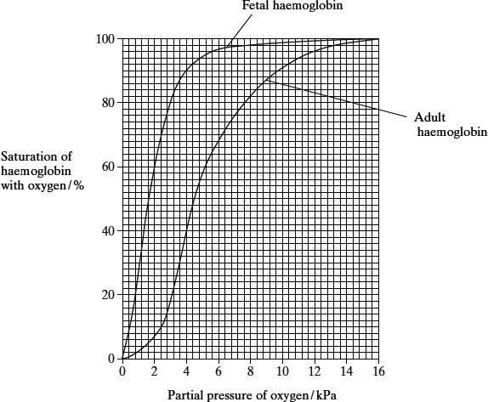

(a)     (i)      What is the difference in percentage saturation between fetal haemoglobin and adult haemoglobin at a partial pressure of 3 kPa?

______________________________________________________________

**(1)**

(ii)     Explain the advantage of the curve for fetal haemoglobin being different from the curve for adult haemoglobin.

______________________________________________________________

______________________________________________________________

______________________________________________________________

______________________________________________________________

**(2)**

(b)     The dissociation curve for adult haemoglobin changes during vigorous exercise.

(i)      Sketch on the graph the position of the curve during vigorous exercise.

**(1)**

(ii)     Explain the advantage of this change in position.

______________________________________________________________

______________________________________________________________

______________________________________________________________

**(2)**

**(Total 6 marks)**

**Q8.**

Erythropoietin (EPO) is a substance produced in the body. It increases the production of red blood cells. Synthetic EPO is made artificially. It is used to treat patients who have a form of anaemia in which there is a reduced number of red blood cells. Scientists investigated the effect of synthetic EPO on volunteers with this form of anaemia.

•        The scientists injected synthetic EPO in a salt solution into patients in the experimental groups. They also set up control groups.

•        They gave the different experimental groups different doses of synthetic EPO and different lengths of treatment.

•        At the beginning and end of the treatment, the scientists measured each patient’s haemoglobin concentration. From these measurements, they calculated the mean increase in haemoglobin concentration.

Some of the results are shown in the table.

|  |  |  |  |
| --- | --- | --- | --- |
| **Number of volunteers** | **Length of treatment / weeks** | **Dose of synthetic EPO / units per kilogram per week** | **Mean increase in haemoglobin concentration / arbitrary units** |
| 58 | 8 | 85 | 19.0 |
| 18 | 8 | 170 | 26.0 |
| 40 | 12 | 150 | 12.5 |
| 82 | 12 | 450 | 34.2 |
| 46 | 24 | 120 | 23.0 |
| 53 | 24 | 240 | 31.0 |

(a)     Explain why treatment with synthetic EPO affects the haemoglobin concentration in these volunteers.

___________________________________________________________________

___________________________________________________________________

___________________________________________________________________

___________________________________________________________________

___________________________________________________________________

**(2)**

(b)Suggest how the control groups should have been treated in this investigation.

___________________________________________________________________

___________________________________________________________________

___________________________________________________________________

___________________________________________________________________

___________________________________________________________________

**(2)**

(c)The scientists measured the dose of synthetic EPO per kilogram per week.

Explain why they measured the dose per unit mass and per unit time.

___________________________________________________________________

___________________________________________________________________

___________________________________________________________________

___________________________________________________________________

___________________________________________________________________

**(2)**

(d)Explain how the information that the scientists collected might be useful in treating patients with anaemia.

___________________________________________________________________

___________________________________________________________________

___________________________________________________________________

___________________________________________________________________

___________________________________________________________________

**(2)**

(e)Some athletes have used synthetic EPO as a performance enhancer. Explain how synthetic EPO may improve performance in long-distance events.

___________________________________________________________________

___________________________________________________________________

___________________________________________________________________

___________________________________________________________________

___________________________________________________________________

___________________________________________________________________

___________________________________________________________________

**(4)**

(f)      Athletes may be tested to see if the concentration of EPO in their blood is above normal. Suggest how scientists determine the normal concentration of EPO in blood.

___________________________________________________________________

___________________________________________________________________

___________________________________________________________________

___________________________________________________________________

___________________________________________________________________

**(2)**

(g)     Synthetic EPO can increase blood pressure. Suggest why.

___________________________________________________________________

___________________________________________________________________

___________________________________________________________________

**(1)**

**(Total 15 marks)**

**Q9.**

A decrease in the pH of blood plasma reduces the affinity of haemoglobin for oxygen.

(a)     (i)      Explain how aerobic respiration in cells leads to a change in the pH of blood plasma.

______________________________________________________________

______________________________________________________________

______________________________________________________________

______________________________________________________________

**(2)**

(ii)     What is the advantage to tissue cells of a reduction in the affinity of haemoglobin for oxygen when the plasma pH decreases?

______________________________________________________________

______________________________________________________________

______________________________________________________________

______________________________________________________________

**(2)**

(b)     Deer mice are small mammals which live in North America. One population lives at high altitude and another at low altitude. Less oxygen is available at high altitude. The graph shows the oxygen haemoglobin dissociation curves for the two populations of deer mice.

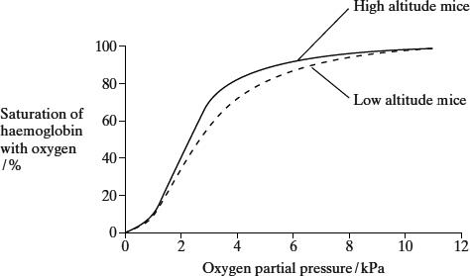

(i)      Explain the advantage for mice living at high altitude in having a dissociation curve which is to the left of the curve for mice living at low altitude.

______________________________________________________________

______________________________________________________________

______________________________________________________________

______________________________________________________________

**(2)**

(ii)     Suggest why it would be a disadvantage for the curve to be much further to the left.

______________________________________________________________

______________________________________________________________

**(1)**

**(Total 7 marks)**

**Q10.**

(a)     The graph shows a dissociation curve for human haemoglobin at pH 7.4. The position of the curve is different at pH 7.2.

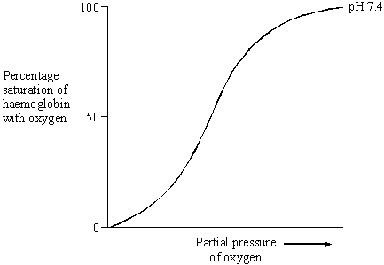

(i)      Sketch a curve on the graph to show the likely position of the dissociation curve at pH 7.2.

**(1)**

(ii)     Explain how a change in pH from 7.4 to 7.2 affects the supply of oxygen by haemoglobin to the tissues.

______________________________________________________________

______________________________________________________________

______________________________________________________________

______________________________________________________________

______________________________________________________________

______________________________________________________________

**(2)**

(b)     Explain what causes the pH to be reduced from 7.4 to 7.2 in a tissue.

___________________________________________________________________

___________________________________________________________________

___________________________________________________________________

___________________________________________________________________

___________________________________________________________________

___________________________________________________________________

**(3)**

**(Total 6 marks)**

Mark schemes

**Q1.**

(a)     (i)      arteriole;

**1**

(ii)     *any two*oxygen / glucose / amino acids / fatty acids / glycerol / minerals;

**1**

(b)     small diameter / lumen / small mean cross sectional area / increase in  
(total) cross sectional area;  
more surface in contact with blood / greater friction / resistance;

**2**

(c)     (i)      artery;

**1**

(ii)     stretches / expands to accommodate increase in blood  
volume / when ventricle contracts / increase in blood pressure;  
recoils when blood volume decreases / when ventricle  
relaxes / blood pressure decreases;

**2**

**[7]**

**Q2.**

(a)     1.      permeable capillary wall / membrane;

2.      single cell thick / thin walls, reduces diffusion distance;

3.      flattened (endothelial) cells, reduces diffusion distance;

4.      fenestrations, allows large molecules through;

5.      small diameter / narrow, gives a large surface area to volume / short diffusion distance;

6.      narrow lumen, reduces flow rate giving more time for diffusion;

7.      red blood cells in contact with wall / pass singly, gives short diffusion distance / more time for diffusion;

*(allow 1 mark for 2 features with no explanation)*

**4 max**

(b)     1.      (hydrostatic) pressure of blood high at arterial end;

2.      fluid / water / soluble molecules pass out (*reject plasma*);

3.      proteins / large molecules remain;

4.      this lowers the water potential / water potential becomes more negative;

5.      water moves back into venous end of capillary (*reject tissue fluid*) by osmosis / diffusion;

6.      lymph system collects any excess tissue fluid which returns to blood / circulatory system / link with vena cava / returns tissue fluid to vein;

**6**

**[10]**

**QWC 1**

**Q3.**

(a)     (i)      0.3 s;

**1**

(ii)     0.2 - 0.4 s;

**1**

(b)     thicker / more muscle in the left ventricle;

**1**

(c)     Artery

1. thickest wall, enabling it to carry blood at high pressure / withstand  
    pressure surges;  
2. most elastic tissue, which smoothes out flow / maintains pressure;  
3. most muscle which maintains pressure;  
4. muscle in wall to control blood flow;

Vein

5. thin wall does not have to withstand high pressure;

Capillary

6. thin wall, allowing diffusion / exchange;  
7. only endothelium present, allowing short diffusion pathway;

All vessels

8. have endothelium that reduces friction;

**6 max**

**[9]**

**Q4.**

(a)     left ventricle;

**1**

(b)     (i)      (left) ventricle / heart relaxes / diastole / filling / not contracting;

**1**

(ii)     elastic tissue / wall;  
recoils / springs back (to maintain pressure);  
(“*contraction / muscle causing recoil*” *negates second point*)

**2**

(c)     correct answer, 666 to 667 *gains 2 marks*; *allow 1 mark for principle;*correct time for 1 heartbeat as 90 (ms) or 630÷7 /   
60 ÷ incorrect time identified from graph;

**2**

(d)     correct answer, 0.03, *gains 2 marks*;

*(allow 1 mark for correct working, 16.6 ÷ 550, if answer wrong)*

**2**

**[8]**

**Q5.**

(a)     less muscle / thin(ner) wall in left atrium;

**1**

(b)     (i)      pressure of left ventricle higher than pressure of left atrium;

**1**

(ii)     closing of the semi-lunar valves / pocket valves;  
pressure in artery / aorta is higher than ventricle;

**2**

**[4]**

**Q6.**

(a)     (i)     1        Reduces heart rate;

2        Keeps heart rate stable / reduces variation in heart rate;

3        Nullifies external stimulus;

*Individual points must be supported with information from the graph  
If no information quoted max 1 mark*

**2**

(ii)     To ensure change in heart rate due to beta blocker and not person’s behaviour / knowing may affect heart rate;

**1**

(b)     (i)      Beta blockers reduce mortality (following myocardial infarction) /   
Greater reduction in the older group;

**1**

(ii)

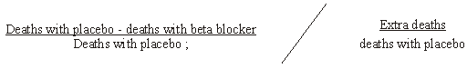

x100;

**2**

**[6]**

**Q7.**

(a)     (i)      62

*ignore units*

**1**

(ii)     fetal haemoglobin has higher affinity for oxygen / takes up oxygen  
(becomes saturated) at lower partial pressure;  
at partial pressures when adult haemoglobin dissociates fetal  
haemoglobin takes up oxygen;

**2**

(b)     (i)      new ‘S’ shaped curve draw to the right of the adult curve;

**1**

(ii)     haemoglobin dissociates / unloads more readily /   
more oxygen delivered to cell / muscles / respiring tissue;  
at a particular partial pressure more oxygen is released;

**2**

**[6]**

**Q8.**

(a)     More red blood cells;

More haemoglobin;

**2**

(b)     Given (only) salt solution;

(Otherwise) treated the same way;

*Accept: ‘Placebo’ in salt solution.*

*Reference to salt solution is essential for first marking point.*

**2**

(c)     Allows comparison to be made;

Different masses / weights (of volunteers) / different weeks / lengths of treatment;

*Accept: ‘Both were different’ for one mark.*

*Neutral: Size for second marking point.*

**2**

(d)     To determine (most effective) dose / length of treatment / to find the most cost effective treatment;  
Investigate long term effect / toxicity / side effects;

*Do not credit marks for descriptions of the information in the table in terms of dose and length of treatment.*

**2**

(e)     More haemoglobin / more red blood cells;

(More) oxygen can be absorbed / transported (for) respiration / to respiring tissues / cells;

(More) energy released / more ATP for muscle contraction;

Delays anaerobic respiration / delays build up of  
lactate / lactic acid;

*Reject: ‘Energy produced or made’ but allow ‘energy made in form of ATP’.*

**4**

(f)      Large sample / wide range (of individuals tested);  
Random (sampling);

Tested at different times / more than once;

Mean / average value determined;

Idea of establishing a range for the normal concentration / reference  
to use of standard deviation;

**2 max**

(g)     Blood thicker / denser / more viscous / more ‘concentrated’ / heart  
contraction greater / increases volume of blood;

*Accept: More blood cells in same volume / ’space’.*

*Neutral: ‘more red blood cells’ / ‘more blood’ on its own.*

*Neutral: ‘Heart pumps / beats more / harder’.*

**1**

**[15]**

**Q9.**

(a)     (i)      CO2 isproduced (in respiration);  
forms carbonic acid / hydrogen ions released;  
(*lactic acid produced negates both points*)

**2**

(ii)     low pH because high rate of respiration;  
cells need more O2;  
more O2 released / O2 released faster;

**2 max**

(b)     (i)      high altitudes have a low partial pressure of O2;  
high saturation / affinity of Hb with O2 (at low partial pressure O2);  
so sufficient / enough O2 supplied to cells / tissues;

**2**

(ii)     difficult to unload / dissociate O2 (at tissues);

**1**

**[7]**

**Q10.**

(a)     (i)      curve to right of curve for pH 7.4;

**1**

(ii)     more oxygen unloaded / given up / affinity decreased / reduced saturation; oxyhaemoglobin dissociates at higher oxygen concentration / partial pressure / more oxygen unloaded at the same ppO2;

**2**

(b)     (aerobic) respiration will produce carbon dioxide / anaerobic respiration produces lactate;  
carbon dioxide dissolves in blood forming acid;  
increases hydrogen ion concentration;

**3**

**[6]**

Examiner reports

**Q1.**

Most candidates scored highly on this question, with only the weakest having problems.

(a)     Few candidates were unable to identify the blood vessel labelled X and the substances it carried.

(b)     Most correctly identified the small diameter of capillaries as a cause of slow flow rate, but only the more able candidates were able to relate the small diameter to increased friction or resistance.

(c)     Again most were able to identify the type of blood vessel in part (i) but part (ii) discriminated well with only the more able candidates being able to explain fully the role of elastic tissue in smoothing out the flow of blood. Many candidates correctly described that elastic tissue expands and recoils but only the better candidates explained that the expansion of arteries accommodates increased blood flow, and recoil when blood flow decreases. Errors such as elastic tissue contracting and relaxing were common.

**Q2.**

There were many very clear and accurate answers to both parts (a) and (b), showing an excellent understanding and a high standard of communication skills.

(a)     This part of the question required candidates to describe and explain the features of a single capillary, which adapt it for exchange. Good answers described a feature, such as a wall, which is only one cell thick, and then explained how it enables efficient exchange, such as the reduction of diffusion distance. Many answers described a feature but then gave an incomplete explanation, such as ‘makes diffusion more efficient’. The narrow lumen of capillaries and red blood cells in contact with the capillary wall were frequently described as features, but with no explanation of how these features affect the exchange of substances.

(b)     The explanations of how tissue fluid is formed and how it is returned to the blood system indicate that this topic is well understood by many candidates. There were many excellent explanations of how hydrostatic pressure causes the loss of fluid from capillaries at the arterial end and how changes in water potential bring about the return of fluid at the venous end of a capillary. Candidates failed to gain marks by using inaccurate language, such as ‘plasma’ being lost from capillaries, or ‘tissue fluid’ being returned to them.

**Q3.**

This question was well answered with many attaining very high marks.

(a)     (i)      This was well done, with many candidates giving the correct answer.

(ii)     It is surprising that many candidates had difficulty applying their understanding of the cardiac cycle to interpret the data provided, as only the more able candidates gave the correct response. Ranges of 0.2 – 0.3 or 0.3 – 0.4 were frequently given rather than the correct maximum range of 0.2 – 0.4.

(b)     This question was well answered, although there were many answers referring to blood from the left ventricle going all round the body rather than giving the cause of the difference in pressure as asked. Candidates failed to gain credit here by not specifying more muscle, but writing in rather more general terms of ‘bigger’ or ‘stronger’.

(c)     This question was well answered by only the better candidates. Many answers simply gave an explanation of how the structures of the blood vessels are related to their function, without any reference to the information provided in the table. Many candidates gave a good explanation of how the structure of capillaries is related to their function but the structure and function of arteries and veins was less well understood. Some candidates incorrectly thought that veins actively pump blood back to the heart using their muscle layer. Answers frequently referred to the thick wall of arteries, but only the most able candidates gave answers relating the amount of muscle or elastic tissue to the function of these vessels. Although reference was made to elastic tissue smoothing out blood flow or maintaining pressure, it was rarely linked to more or thicker elastic or muscle tissue in the arteries as seen in the table. Many candidates also failed to gain marks because they wrote about thick or thin vessels and compared the diameter of the lumens when the question required a comparison of the walls.

**Q4.**

This question discriminated well, rewarding those who knew the basics of heart anatomy and heart function and those who could apply this understanding in a novel context.

(a)     A surprisingly high proportion of candidates failed to state ‘left’ ventricle, which was needed to achieve the mark. Many confused ventricles with atria.

(b)     (i)      This was answered well by the majority of candidates. Some correctly referred to ‘diastole’ in their answer, which is not a term required in this specification.

(ii)     Relatively few candidates achieved both marks, often by incorrectly involving elastic tissue in muscle function. Many failed to apply their understanding to the action of the aorta, but tried to explain how heart activity prevented blood pressure falling or how the closing of heart valves somehow maintained blood pressure.

(c)     Many candidates understood how to perform this calculation, including the need to convert the time unit from milliseconds to seconds, but using the graph to determine the time of a single heartbeat proved to be the downfall for many.

(d)     This calculation was much more accessible to many candidates, and it was often the only marks achieved on this question. It appears the mathematical skill required to rearrange the components of an equation is understood well by most candidates.

**Q5.**

Answers to this question indicate that many candidates have a good knowledge and understanding of the events occurring during the cardiac cycle.

(a)     Many answers correctly identified the thinner muscle wall of the atrium as the cause of the lower pressure.

(b)     Many candidates scored maximum marks but there were some answers with vague explanations. For example, in part (i) good candidates correctly stated that the evidence from the graph is that the pressure in the left ventricle is *higher* than the pressure in the left atrium but many answers gave vague references to the pressure in the ventricle increasing and the pressure in the atrium decreasing. In part (ii) good answers correctly identified closing of the semi-lunar valves as the second heart sound, which was caused by the pressure in the aorta rising above the pressure in the ventricle.

**Q6.**

(a)     Although candidates clearly understood what the graph showed, only the minority actually used it to quantify their answers in part (i). There were many very vague responses to part (ii). Few candidates correctly linked the effect of the men’s knowledge of which pill they had taken on their subsequent heart rate. Many vague answers simply stated it would affect results.

(b)     Part (i) produced many correct responses. One common error involved statements linking reduction in mortality and age that went well beyond the table provided. Examiners were looking for a statement that related to the age groups shown in the table. Part (ii) proved a bridge too far for most candidates and they could not explain the calculation that should be performed.

**Q7.**

Many candidates attained good marks for this question, showing an understanding of the oxygen haemoglobin dissociation curves presented. However only the better candidates attained maximum marks by being able to explain clearly how the relationship between the percentage saturation of haemoglobin and oxygen partial pressure gave an advantage to the fetus or to the adult during exercise.

(a)     (i)      Although most candidates answered this with an appropriate calculation, there were many examples which fell outside the accepted range due to inaccurate reading of the graph. A few candidates attempted to answer in prose and failed to give a figure.

(ii)     Many candidates explained that fetal haemoglobin has a high affinity for oxygen, but only the better candidates went on to explain that this means that fetal haemoglobin takes up oxygen when adult oxygen haemoglobin dissociates.

(b)     (i)      Many candidates were able to draw correctly the change in the position of the curve as a result of vigorous exercise; however a significant number sketched a shift to the left.

(ii)     Whilst most candidates explained the advantage of this change in terms of oxygen haemoglobin releasing more oxygen to the cells, only the most able related this to the fact that this amount of oxygen was released at a higher partial pressure of oxygen. A sizeable proportion of candidates referred incorrectly to the oxyhaemoglobin loading more easily or having a higher affinity for oxygen and so being able to carry more around the body.

**Q8.**

(a)     This was well answered with almost eighty percent of candidates obtaining both marks for explaining that EPO would increase the number of red blood cells and consequently the concentration of haemoglobin. Less than five percent of candidates scored zero.

(b)     Most candidates gained at least one mark by stating that the control group would be treated in exactly the same way as the experimental group apart from being given EPO. Approximately a third of candidates gained the second mark by indicating that the control group would be injected only with salt solution. Many candidates simply referred to a placebo without mentioning the salt solution.

(c)     This proved quite challenging with over forty percent of candidates scoring zero. Many of these candidates limited their response to the idea that the investigators would be able to see if EPO was effective. The idea of allowing a ‘comparison’ was the most common marking point awarded. Relatively few candidates considered the different masses of the volunteers or the different weeks of treatment.

(d)     Over half the candidates failed to gain any marks on this question because they limited their answers to descriptions of the data in the table. Better candidates realised that the information provided would enable the investigators to determine the most effective dose and length of treatment.

(e)     This question was well answered with over seventy five percent of candidates gaining three or more of the four marks available. Candidates realised that EPO would increase the amount of oxygen being transported to the respiring tissues because of an increase in the number of red blood cells. This was often linked to an increase in the energy released. Better candidates had often gained maximum marks before mentioning that this energy would be available for muscle contraction or that anaerobic respiration could be delayed.

(f)      This question proved more demanding than expected. Most candidates did gain at least one of the two marks available but a significant number of responses lacked detail. These answers often suggested testing one or two athletes or one athlete and a non-athlete. The most common scoring marking points related to random sampling, determining a mean value and testing a large sample of individuals. It was pleasing to see some high quality answers which included the use of standard deviation when establishing the normal concentration of EPO.

(g)     Most candidates failed to gain this mark as they simply referred to ‘more blood’ being present. Better candidates often suggested that an increase in blood pressure would be due to an increase in the volume of the blood or ‘thicker’ or ’denser’ blood.

**Q9.**

(a)     Very few candidates considered the full context of this question in their answer. Most gained credit for making an appropriate link between the reduction in haemoglobin’s affinity for oxygen and its ability to unload oxygen more readily, but why it is advantageous to tissue cells for oxygen to be readily unloaded when the pH of plasma is low was not often considered.

(b)     (i)      The increased affinity of haemoglobin for oxygen in animals whose habitats occur at high altitudes is understood well by the majority of candidates. Unfortunately, very few candidates were able to apply this understanding to the context of the question, i.e. that it is essential if sufficient oxygen is going to reach (respiring) tissue cells when the partial pressure of oxygen in the air breathed by the animal is low.

(ii)     This was answered well by the majority of candidates.

**Q10.**

(a)     In part (i) most candidates were able to identify the position of the dissociation curve at pH 7. 2. However, in part (ii) only the most able candidates were able to explain how the pH change affects the supply of oxygen to tissues. Many answers correctly explained how the pH change causes more oxygen to be unloaded, but very few answers related this to the oxygen haemoglobin dissociation curve.

(b)     There were many very good answers with clear explanations of how an increase in the rate of respiration leads to a decrease in pH.

**Q11.**

In part (i) most candidates were aware that there are differences in the figures for men and women. However, despite being asked to use an example from the tables, many failed to do so. In part (ii) many candidates were aware that percentages lead to ease of comparison, but few referred to differing sample sizes.