**Q1.**

Scientists investigated the effect of a heat treatment on mass transport in barley plants.

•        They applied steam to one short section of a leaf of the heat-treated plants. This area is shown by the arrows in **Figure 1**.

•        They did not apply steam to the leaves of control plants.

•        They then supplied carbon dioxide containing radioactively-labelled carbon to each plant in the area shown by the rectangular boxes in **Figure 1**.

•        After 4 hours, they:

◦        found the position of the radioactively-labelled carbon in each plant. These results are shown in **Figure 1**.

◦        recorded the water content of the parts of the leaf that were supplied with radioactively-labelled carbon dioxide. These results are shown in the table.

**Figure 1**

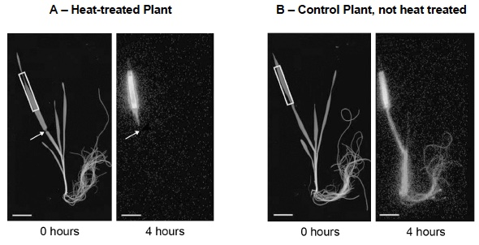

|  |  |
| --- | --- |
| **Plant from which the leaf was taken** | **Water content of leaf / % of maximum**  **(± 2 standard deviations)** |
| **Heat-treated Plant**  **A** | 84.6  (±11.3) |
| **Control Plant, not heat treated**  **B** | 92.8  (±8.6) |

(a)     The scientists concluded that this heat treatment damaged the phloem.

Explain how the results in **Figure 1** support this conclusion.

___________________________________________________________________

___________________________________________________________________

___________________________________________________________________

___________________________________________________________________

___________________________________________________________________

___________________________________________________________________

___________________________________________________________________

**(2)**

(b)     The scientists also concluded that this heat treatment did not affect the xylem.

Explain how the results in the table support this conclusion.

___________________________________________________________________

___________________________________________________________________

___________________________________________________________________

___________________________________________________________________

___________________________________________________________________

___________________________________________________________________

___________________________________________________________________

___________________________________________________________________

___________________________________________________________________

___________________________________________________________________

**(2)**

(c)     The scientists then investigated the movement of iron ions (Fe3+) from the soil to old and young leaves of heat-treated barley plants and to leaves of plants that were not heat treated. Heat treatment was applied half way up the leaves. The scientists determined the concentration of Fe3+ in the top and lower halves of the leaves of each plant.

Their results are shown in **Figure 2**.

**Figure 2**

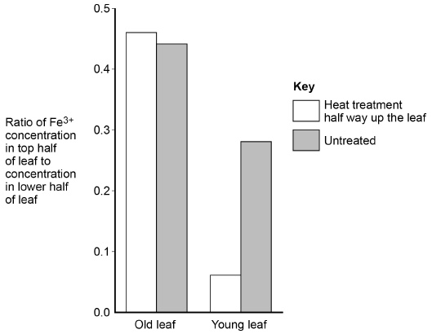

What can you conclude about the movement of Fe3+ in barley plants?

Use all the information provided.

___________________________________________________________________

___________________________________________________________________

___________________________________________________________________

___________________________________________________________________

___________________________________________________________________

___________________________________________________________________

___________________________________________________________________

___________________________________________________________________

___________________________________________________________________

___________________________________________________________________

___________________________________________________________________

___________________________________________________________________

___________________________________________________________________

___________________________________________________________________

___________________________________________________________________

___________________________________________________________________

___________________________________________________________________

___________________________________________________________________

___________________________________________________________________

___________________________________________________________________

___________________________________________________________________

___________________________________________________________________

___________________________________________________________________

___________________________________________________________________

___________________________________________________________________

**(4)**

**(Total 8 marks)**

**Q2.**

A student investigated the rate of transpiration from privet leaves.

•        She obtained two sets of ten privet leaves.

•        She left the ten leaves in set **A** untreated. She covered the upper surfaces of the ten leaves in set **B** with grease.

•        She weighed each set of leaves and then tied all the leaves in each set to a separate length of thread. This is shown in the diagram.

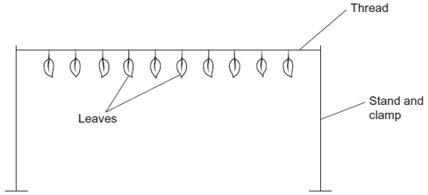

•        She then weighed each set of leaves every 20 minutes over a period of 2 hours and plotted a graph of her results.

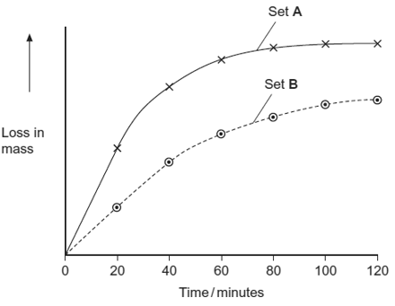

(a)Give **two** environmental conditions that the student should have kept constant during this investigation.

1. _________________________________________________________________

2. _________________________________________________________________

**(2)**

(b)The student measured the water loss in milligrams. Explain the advantage of using ten leaves when taking measurements in milligrams.

___________________________________________________________________

___________________________________________________________________

**(1)**

(c)Explain the change in mass of untreated leaves in set **A** shown in the graph.

___________________________________________________________________

___________________________________________________________________

___________________________________________________________________

___________________________________________________________________

___________________________________________________________________

___________________________________________________________________

**(3)**

(d)The results that the student obtained for the leaves in set **B** were different from those for set **A**. Suggest an explanation for this difference.

___________________________________________________________________

___________________________________________________________________

___________________________________________________________________

___________________________________________________________________

___________________________________________________________________

**(2)**

**(Total 8 marks)**

**Q3.**

The drawing shows part of the lower leaf epidermis of sorghum.

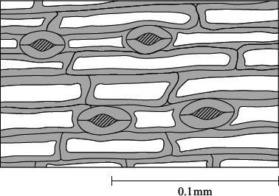

(a)     Calculate the number of stomata per mm2 of the leaf surface. Show your working.

Answer ____________________ stomata per mm2

**(2)**

(b)     Sorghum has few stomata per mm2 of leaf surface area. Explain how this is an adaptation to the conditions in which sorghum grows.

___________________________________________________________________

___________________________________________________________________

___________________________________________________________________

___________________________________________________________________

___________________________________________________________________

___________________________________________________________________

**(3)**

**(Total 5 marks)**

**Q4.**

(a)     The diameter of a branch of a tree and the rate of flow of water through the branch were measured over a 24-hour period. The results are shown in the graph.

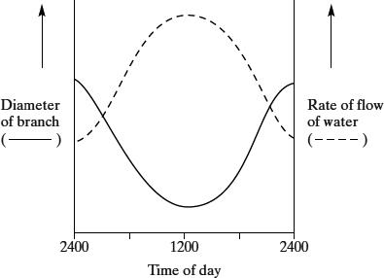

Using your knowledge of cohesion-tension theory

(i)      describe and explain the changes in rate of flow of water in the branch over the 24 hour period;

______________________________________________________________

______________________________________________________________

______________________________________________________________

______________________________________________________________

______________________________________________________________

______________________________________________________________

**(3)**

(ii)     explain why the diameter of the branch decreased during the first 12 hours.

______________________________________________________________

______________________________________________________________

**(1)**

(b)     A stem was cut from a transpiring plant. The cut end of the stem was put into a solution of picric acid, which kills plant cells. The transpiration stream continued. Suggest an explanation for this observation.

___________________________________________________________________

___________________________________________________________________

___________________________________________________________________

___________________________________________________________________

**(2)**

**(Total 6 marks)**

**Q5.**

Under the correct conditions, new roots grow from the cut end of a plant stem. A scientist investigated the effect of substance X on the growth of new roots.

She used a ringing experiment to investigate the movement of substance X in stems taken from lemon plants. She cut out a length of stem from each plant. She then put a small block of agar on the top of each length of stem. Some agar blocks contained substance X.

The diagram below shows how she treated each length of stem.

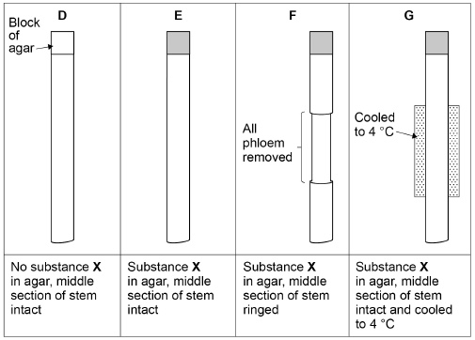

She grew the lengths of stem in the same environmental conditions for 6 weeks, and then found the number of roots per length of stem. Roots grew at the other end of the stem from where the agar blocks were placed.

The table below shows the scientist’s results.

|  |  |
| --- | --- |
| **Treatment** | **Mean number of roots per length of stem** |
| **D** | 5 |
| **E** | 11 |
| **F** | 4 |
| **G** | 3 |

(a)     Treatment **D** is a control. Explain how the measurement obtained from this control is used by the scientist.

___________________________________________________________________

___________________________________________________________________

___________________________________________________________________

___________________________________________________________________

___________________________________________________________________

___________________________________________________________________

___________________________________________________________________

___________________________________________________________________

___________________________________________________________________

**(2)**

(b)     Using the diagram and the table above, what can you conclude from treatments **D** and **E** about root growth?

___________________________________________________________________

___________________________________________________________________

___________________________________________________________________

___________________________________________________________________

___________________________________________________________________

___________________________________________________________________

___________________________________________________________________

___________________________________________________________________

___________________________________________________________________

___________________________________________________________________

**(3)**

(c)     The mass flow hypothesis is used to explain the movement of substances through phloem.

Evaluate whether the information from this investigation supports this hypothesis.

Do **not** consider statistical analysis in the answer.

___________________________________________________________________

___________________________________________________________________

___________________________________________________________________

___________________________________________________________________

___________________________________________________________________

___________________________________________________________________

___________________________________________________________________

___________________________________________________________________

___________________________________________________________________

___________________________________________________________________

___________________________________________________________________

___________________________________________________________________

___________________________________________________________________

**(4)**

**(Total 9 marks)**

**Q6.**

Environmental factors can affect the density of stomata in the lower epidermis of leaves of plants of the same species.

Scientists investigated how growing plants at different temperatures affected the density of stomata in the lower epidermis of leaves. They grew plants of the same species from seeds.

Their method is outlined below.

•        They took 8 trays containing soil and planted 50 seeds in each tray.

•        They put each tray in a controlled environment at a different temperature.

•        When the plants had grown from the seeds, they selected 20 fully grown leaves from the plants in each tray.

•        They determined the mean number of stomata per mm2 in the lower epidermis for each group of leaves.

Their results are shown in the graph.

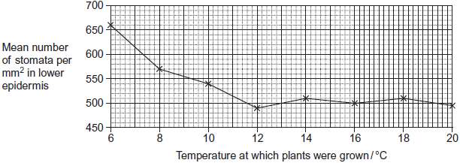

(a)     Give **three** environmental variables, other than temperature, that the scientists would have controlled when growing the plants.

1. _________________________________________________________________

2. _________________________________________________________________

3. _________________________________________________________________

**(3)**

(b)     The scientists used a range of temperatures from 6 to 20 °C.  
Using their data, explain why they did not use temperatures above 20 °C.

___________________________________________________________________

___________________________________________________________________

___________________________________________________________________

**(1)**

(c)     The scientists only selected fully grown leaves from the plants.

Suggest why.

___________________________________________________________________

___________________________________________________________________

___________________________________________________________________

**(1)**

(d)     The plants grown at higher temperatures had a lower number of stomata per mm2.  
This would be an advantage to the plant because the transpiration rate increases as the temperature increases.

Explain why the transpiration rate increases when the temperature increases.

___________________________________________________________________

___________________________________________________________________

___________________________________________________________________

___________________________________________________________________

___________________________________________________________________

**(2)**

**(Total 7 marks)**

Mark schemes

**Q1.**

(a)     **EITHER**

1.      The radioactively labelled carbon is converted into sugar/organic substances during photosynthesis;

*For ‘organic substance’ accept named organic substance, eg glucose, sucrose, amino acid.*

2.      Mass flow/translocation in the phloem throughout the plant only in plants that were untreated/**B**/control

**OR**

Movement of sugar/organic substances in the phloem throughout the plant only in plants that were untreated/B/control;

*Accept ‘translocation/mass transport in the phloem past the heat treatment only in the untreated plant/****B****/control’.*

*Accept converse for heat-treated plant/A ie Movement of sugar/organic substances/mass flow/translocation in the phloem stops (beyond the heat treatment) in treated plants/A.*

**OR**

3.      Movement in phloem requires living cells/respiration/active transport/ATP;

4.      Heat treatment damages living cells **so** transport in the phloem throughout the plant only in plants that were untreated/**B**/control

**OR**

Heat treatment stops respiration/active transport/ATP production **so** transport in the phloem throughout the plant only in plants that were untreated/**B**/control;

*Do not mix and match – award either mp1 and mp2 or mp3 and mp4.*

**2**

(b)     1.      (The water content of the leaves was) not different because (means ± 2) standard deviations overlap;

*For ‘not different’ accept ‘difference is not significant’ or ‘difference due to chance’.*

2.      Water is (therefore) still being transported in the xylem (to the leaf)

**OR**

Movement in xylem is passive **so** unaffected by heat treatment;

**2**

(c)     1.      Heat treatment has a greater effect on young leaves than old;

*Accept description of no/little/(slight) increase effect in old leaves and change in young leaves.*

2.      Heat treatment damages the phloem;

3.      Fe3+ moves up the leaf/plant;

4.      (Suggests) Fe3+ is transported in the xylem in older leaf;

5.      In young leaf, some in xylem, as some still reaches top part of leaf;

6.      (Suggests) Fe3+ is (mostly) transported in phloem in young leaf

**OR**

Xylem is damaged in young leaf

**OR**

Xylem is alive in young leaf;

7.      Higher ratio of Fe3+ in (all/untreated) old leaves than (all/untreated) young;

*Accept ‘more at the top’ for ‘higher ratio’.*

8.      All ratios show there is less Fe3+ in the top than the lower part of leaves;

9.      (But) no statistical test to show if the difference(s) is significant;

*Accept ‘(But) no standard deviations to show if the difference(s) is significant’.*

**4 max**

**[8]**

**Q2.**

(a)     Light;

Humidity / moisture in air;

Air movement / wind;

Temperature;

**2 max**

(b)     Decreases chance of error / larger difference in mass / improves  
accuracy / precision;

*Neutral: Reliability, references to anomalies.*

**1**

(c)     1.      Stomata open, (water) transpired / evaporates / diffuses out (via) water potential gradient / leaf has higher water potential;

2.      Water potential / diffusion gradient reduces (during investigation) as water not being replaced / no water supply;

3.      Stomata close / closing;

*Must clearly indicate that stomata are open for third marking point. However, allow correct descriptions of guard cells being turgid or flaccid as being equivalent to stomata being open or closed. ‘Loss through stomata’ on its own is not sufficient.*

*Neutral: Any reference to ‘loss by osmosis’.*

**3**

(d)     Stomata (on upper surface) covered / stomata close due to lack of  
light / (grease provides) longer diffusion pathway;

Less evaporation / transpiration / diffusion out;

*Accept: Evaporation / transpiration / diffusion ‘stops’ for second point as this could be referring to upper surface.*

**2**

**[8]**

**Q3.**

(a)     235–240;;  
*(one mark for an answer between 200-300  
based on 2 - 3 stomata in 0.01mm2Alternatively, one mark for calculating the area of the  
rectangle correctly as 0.016 – 0.017mm2)*

**2**

(b)     grows in arid / dry conditions;  
less surface area;  
(rate of) transpiration / water loss would be reduced;

**3**

**[5]**

**Q4.**

(a)     (i)      rate of flow increases to max at 1200 and then decreases;  
increasing transpiration / evaporation from leaves;  
transpiration creates tension / increases transpirational pull;  
water molecules are cohesive / stick together;  
produces a water column;

**3 max**

(ii)     (increase transpiration) produce a higher tension / reduces the  
pressure in the xylem reducing the diameter / adhesive forces   
between xylem and water;

**1**

(b)     water moves in dead cells / xylem is non-living tissue;  
the process is passive / no energy is needed;

**2**

**[6]**

**Q5.**

(a)     1.      Used to compare effect of other treatments / as a baseline;

*Accept for 2 marks, substance (X) and not agar / block / water that caused the difference in the number of roots.*

*Do not accept unqualified reference to “compare results”.*

2.      Shows / Measures effect of substance (X);

**OR**

Accounts for effect of substances produced naturally;

*Accept measures effect of independent variable*

**2**

(b)     1.      (**D** shows) substance (X) is not required for (some) root growth / production of roots;

**OR**

Substances (already) present in stem cause (some) root growth;

2.      Substance X moves through plant;

*Accept X moves through stem / phloem*

3.      (**E** shows) substance (X) causes / increases / doubles number of roots / root growth;

**3**

(c)     **In support of mass flow hypothesis**

1.      (**F** shows) phloem is involved;

2.      (**G** shows) respiration / active transport is involved (in flow / movement);

3.      Because 4 °C / cooling reduces / slows / stops flow / movement;

4.      The agar block is the source;

5.      Roots are the sink;

**Against the mass flow hypothesis**

6.      No bulge above ringing (in **F**);

7.      No (role for) osmosis / hydrostatic pressure / water movement;

*Accept no turgor pressure*

8.      Movement could be due to gravity;

9.      Roots still grow without (intact/functioning) phloem;

10.    No leaves / sugars / photosynthesis to act as a source;

*Each point must be clearly made in the context of support or against.*

*Ignore sugar / sucrose*

*3 max for “support” and 3 max for “against”*

**4 max**

**[9]**

**Q6.**

(a)     Any **three** from:

1.      Light;

2.      Carbon dioxide;

3.      Type of soil;

4.      Minerals / nutrients;

*Accept named example*

5.      Water (in soil);

6.      Humidity (of air);

7.      pH (of soil)

8.      Planting density;

*Idea of equally spaced*

**3 max**

(b)     Already levelled out (before 20 °C);

**1**

(c)     Young leaves (may) have different number of stomata (per mm2) / number of stomata (per mm2) changes during development (of leaf);

*Accept reference to density of stomata*

**1**

(d)     Any **two** from:

*Points 1 and 2 need context of ‘more’*

1.      Molecules have more kinetic energy;

*Accept KE*

2.      Faster diffusion of water / more evaporation of water (as temperature increases in leaf);

*For this point, diffusion must relate to movement of water*

3.      For this point, diffusion must relate to movement of water

**2 max**

**[7]**

Examiner reports

**Q1.**

Again most candidates scored highly on this question, with many achieving maximum marks.

(a)     Most candidates were able to describe the relationship between humidity and transpiration rate, and then to explain this relationship in terms of how high humidity increases the amount of water in the air, and therefore decreases the diffusion gradient, resulting in a slower rate of water loss. Marks were often not awarded for incorrect or vague explanations, such as ‘water is lost to the air by osmosis’ or ‘humidity affects the aperture of the stomata’.

(b)     There were many excellent answers relating features evident in the diagrams with clear explanations of how each feature contributes to a lower rate of transpiration. For example, many candidates correctly recognised the thicker cuticle of the xerophytic leaf and explained how the waterproof property of the cuticle reduces water loss. A lack of precision often resulted in few marks, such as the vague statement that the cuticle reduces water loss with no explanation of how this is achieved. Sunken stomata reducing the diffusion gradient of water and the shape of the leaf resulting in a smaller surface area:volume ratio, were correctly identified as other explanations, but they were less common.

**Q2.**

The role of the cuticle was well known. Some candidates failed to gain marks through incomplete answers such as ‘the cuticle reduces transpiration’ rather than relating water loss to the impermeable nature of the cuticle. In part (ii), most candidates were able to describe a feature that reduces water loss, but only the more able candidates explained how the feature reduces transpiration by affecting the water diffusion gradient.

**Q3.**

(a)     The vast majority of candidates was able to give one correct environmental factor that the student should have kept constant during the investigation.

(b)     Answers to this question were generally disappointing with only a third of candidates appreciating that it was important to prevent air entering the shoot, xylem or potometer.

(c)     Approximately half the candidates obtained a mark for indicating that distance and time have to be measured. Very few candidates obtained a second mark by indicating that the radius, diameter or area of the capillary tube had to be measured.

(d)     Surprisingly, this proved the most difficult question on the paper. Seventy five percent of candidates scored zero with many candidates simply stating that not all the water is used in transpiration. Candidates obtaining one mark often referred to water being used in photosynthesis. Very few candidates obtained a second mark by indicating that water is used to provide support or that it may evaporate or ‘leak’ from the apparatus.

(e)     (i)      Most candidates simply suggested that the reservoir would allow water to be added. Fewer candidates gained the mark by linking this to moving the position of the bubble.

(ii)     Most candidates gained this mark by indicating that repeat measurements would enable the reliability of the results to be assessed.

**Q4.**

(a)  This question tested a practical skill of using apparatus to record quantitative measurements and it proved to be very difficult for the majority of students: only about 2% achieved both marks. Students did not appreciate that the question wanted a practical solution using the apparatus shown, so suggestions such as, ‘measure volume’ or ‘record the drop in water level inside the beaker’ were common and gained no mark. Many suggested incorrectly that the dimensions or mass of the celery would change or they used poor expressions such as ‘measure changes in the mass of the beaker’ rather than record the initial and final mass of the beaker and all of its contents.

A relatively small number of students successfully referred to the units given for determining the rate of water movement; consequently, few mentioned counting the xylem vessels.

(b)  This question was answered correctly by around 65% of students, but did not discriminate particularly well. Examiners suspected that success in applying a good understanding of practical techniques in the novel context of using a weight potometer was centre-dependent. Some students confused the weight potometer with a bubble potometer by, for example, commenting on ‘the movement of bubbles through the oil’ or that ‘oil prevented bubbles forming inside the xylem’. Others suggested incorrectly that the oil lubricated water movement or it prevented unwanted substances from entering the beaker.

(c)  In this question, students were asked to apply their understanding of the cohesion-tension theory to a problem set in an investigation. It discriminated very well. A relatively small number of students showed an excellent understanding of the cohesion-tension theory and succinctly articulated the details of this process.

The question performed well for those who realised that water movement in the celery began with evaporation. Unfortunately, about a third of all students scored no marks and many gave explanations that skirted around the cohesion-tension theory, and confused its stages. Some of the misconceptions observed in many answers included cohesion or evaporation creating the tension in water, or descriptions of tension being a force that pulls up a water column, or evaporation reduces hydrostatic pressure. Many also suggested incorrectly that water moved along xylem vessels down an osmotic gradient. Some confused transpiration and translocation by mentioning the idea of a ‘source’ and ‘sink’.

(d)  This question tested an understanding of using dissection instruments safely and, judging from the high level of detail provided in many answers, it appears that scalpels are being used in AS practical work. Most students achieved at least one mark, usually for describing how to cut celery without causing injury. Far fewer considered a type of surface against which to make the cut and, for this reason, the question did not discriminate well between students of different ability. Those who achieved no marks tended to describe how to safely transport or store the blade, which did not address the question. Answers that suggested wearing gloves to protect fingers while cutting were common and achieved no mark.

(e)  Only around 10% of students failed to score at least one mark, but the majority chose to calculate a mean which limited them to one mark and, for this reason, the question did not discriminate well. 15% of students gave the correct answer, ‘median’, and most of them recognised the relevance of the outliers. A very small number selected the mode and they invariably identified its correct value.

**Q5.**

(a)     There were some very good answers achieving maximum marks. However, many answers used very vague language, such as ‘water is pulled up by cohesion-tension’, with no description of what cohesion involves, or what creates the tension. Water was said by many to be ‘sticky’. This was the lowest level of answer accepted for a mark about cohesion. Root pressure was often included in the description of cohesion-tension, which cost candidates time but gained no credit.

(b)     (i)      Many candidates appear to confuse the concept of fair testing with reliability; both terms being used interchangeably.

(ii)     More able candidates answered in terms of how an environmental variable could affect the rate of transpiration, or the rate of evaporation, rather than just stating ‘to keep water loss the same’.

(iii)     Most candidates gave the correct answer.

(c)     (i)      Most candidates calculated the mass of water lost accurately.

(ii)     Many candidates missed marks by failing to give a comparison between the upper and lower surfaces of leaves. There were many references to ‘pores’ rather than ‘stomata’, or a ‘waxy layer’ rather than a ‘cuticle’, indicating a poor knowledge of leaf structure.

**Q6.**

This question was all based on section 3.3.4.2 of the specification, linked to interpreting evidence from tracer experiments.

The majority of students limited their answer to question (a) to a description of the data rather than an explanation. They simply stated that radioactive carbon dioxide was not visible throughout the plant in A and therefore had not been transported through the phloem. As this question required the students to explain the results, all the marking points required use of the students’ knowledge. The first point was for the idea that the radioactive carbon dioxide would be used in the leaf to produce sugar in photosynthesis. The second point was then that sugar is transported in the phloem. If the first point was not appreciated, then students could score the second marking point for appreciating that mass flow/translocation happens in the phloem and that is what has stopped in this case. The alternative valid approach to the question for marking points 3 and 4 was not seen. Nearly 60% of students failed to make any headway in this question.

In question (b), many students could use the standard deviations to explain that there was no (significant) difference between the water content of the leaves. Some did suggest that this showed they were ‘not very different’ or were ‘similar’; this was insufficient to gain credit. As with question (a), this part required students to explain the data, so answers required application of knowledge in the context of the question. Some did not sufficiently link their knowledge that water moves to the leaf in the xylem with these data to achieve the second marking point, i.e. that water is still moving into the leaf in the xylem.

**Figure 2**, in question (c), was a complex graph, with much to interpret. Many students did not relate this investigation to that in **Figure 1** and discussed heat-treatment half way up the plant that, therefore, affected young leaves at the top of the plant more than the old leaves at the bottom of the plant. This would gain marking point one and many students gained this mark for a description of the difference in effect of heat treatment on old and young leaves. Some excellent answers were seen, with students fully understanding the differences in transport mechanisms in old and young leaves, but many were thrown by the ratio data on the y-axis and struggled to access most of the marking points. Pleasingly, just over 10% of students were able to score at least three marks here.

**Q7.**

It appeared that some students had not used a potometer. The investigative and practical skills section of the specification for this unit clearly states that students require specific knowledge of the use of a potometer to measure the rate of water uptake. It also makes clear that students can be tested on this in the examination.

(a)     Many students were aware that opening the tap would return the air bubble to the start. Students who appeared unfamiliar with a potometer usually made incorrect guesses from the diagram, e.g. ‘add water to the reservoir’, ‘remove the plant’ or ‘remove the bung’.

(b)     60% of students gained at least one mark. Better responses usually went beyond ensuring that the apparatus was airtight. The question asked for specific precautions that should have been taken when *setting* up the potometer. Despite this, weaker responses typically named factors that should be kept constant.

(c)     Given that this question has been asked in a previous series, it is disappointing that over 60% of students scored zero. Better responses showed appreciation that water is used for support and photosynthesis and produced during respiration. However, weaker responses seemed to focus on the word ‘transpiration’ in the question stem. Consequently, references to the opening and closing of stomata, effects of environmental factors and not all water being used in transpiration were widespread. Similarly, some students thought that water is used in respiration, or produced during photosynthesis.

(d)     This proved to be an excellent discriminator. Just under half of students scored at least two marks. This was usually for appreciating that removing more leaves meant fewer stomata, less transpiration and less tension. Unfortunately, weaker responses often did no more than describe the relationship between the number of leaves removed and the rate of transpiration. Some students had difficulty in applying their knowledge to an unfamiliar context. They wrote all they knew about cohesion-tension, without linking this directly to the data in the table.

**Q8.**

(a)     Many candidates appeared to understand the principles that were being tested in the two parts of this question but explanations often fell short of the required standard. In part (i) a reference was required to the dispersal of water vapour and the consequences of this on the diffusion or water potential gradient. Many less able candidates offered explanations in terms of moving air forcing water out of the leaf or involving water moving out of the leaf by osmosis. Those who appreciated, in part (ii), that an increase in temperature increased kinetic energy usually progressed to refer to an increase in the rate of movement of water molecules. Others, perhaps inevitably, attempted to link temperature with enzyme activity

(b)     Most candidates followed the instruction in part (i) and described the relationship with sufficient precision to gain the mark. They were also able to link movement through the xylem to increased light intensity and stomatal opening with some success. However, by far the most popular response to part (ii) was to suggest that there would be an increase in the rate of photosynthesis and therefore more water would be needed by the plant. The terms cohesion and tension were frequently used in such a way as to suggest little real understanding. It was not uncommon to read about water molecules being pulled through the xylem because “they stick to each other by cohesion-tension”. The idea conveyed in part (iii) appeared to be unfamiliar to all but the best candidates. The structure of the question should have lead candidates to realise that it was testing the same basic principle. The question was worded in such a way as to encourage candidates to explain the lower diameter at 12.00. Many opted however to explain the converse of this and based their answers on suggestions involving storage of water in the xylem.

(c)     Responses to this question were very disappointing as evidenced by the large number of candidates who were unable to gain credit. Many answers were very general and did little more than suggest, often at great length, that “strong” walls meant that blood vessels did not burst under pressure. Such answers often established this point for arteries, then repeated it for arterioles. Only the very best candidates appeared aware of the presence of muscle and elastic tissue within the walls and could describe the roles of these particular tissues. There was also much emphasis on valves. They were correctly described as not being present in arteries and arterioles but then discussed in terms of what they would have done if they had been present. Those candidates who referred to the endothelium were generally able to point out its functions in reducing friction. There were others, however, who considered the lumen to be a fundamental component of the wall.

**Q11.**

(a)     This part discriminated more than was, perhaps, intended. In both (i) and (ii), many students did not read the question carefully enough and included comparisons of properties or function, rather than structure. For example, many wrote about starch and cellulose being insoluble but this is not a similarity of structure. About 40% obtained both marks in (i) and 60% in (ii).

(b)     This required students to use the figure and apply some basic concepts. As in (a), some students did not read the stem of the question carefully enough and couched their answers in terms of structures I and J.

(i)      Many students described (in various ways) the large open space in the sieve cell and some went on to suggest that this would lead to a (relatively) unrestricted flow; about 30% obtained 2 marks and 40% 1 mark.

(ii)     This was where more students failed to score because of answers based around plasmodesmata (J), which are precluded by the stem of the question. Over 40% obtained 2 marks by linking energy from mitochondria to active transport. Some students missed one mark because the examiners rejected references to mitochondria creating or making energy.

**Q12.**

(a)     This was a straightforward question with over ninety percent of candidates gaining both marks and very few scoring zero.

(b)     A third of the candidates gained this mark for clearly indicating that measuring water loss in milligrams would improve precision or accuracy. Incorrect responses often mentioned reliability, anomalous results, or calculating a mean.

(c)     Some answers were limited to descriptions of the graph and scored zero, or referred in general terms to transpiration for one mark. Candidates scoring three marks often provided a clear, detailed explanation of the results including reference to changing water potential gradients and the opening and closing of stomata. A significant number of candidates also realised that water was not replaced in the leaves as they were detached.

(d)     Most candidates gained one mark for indicating that there would be less transpiration or evaporation. Far fewer candidates, however, suggested that the grease had covered the stomata or had increased the diffusion pathway. Many candidates failed to get this mark as they simply stated that the grease provided a waterproof layer.

**Q13.**

(a)     Very few candidates correctly worked out the area as 0.0167mm2 and many seemed to have a basic problem with calculating areas. It was common to see 0.1 x 0.1 = 0. l mm2. Many candidates failed to gain credit by carrying out calculations that were not clearly identified. A common approach was to estimate the number of stomata in an area 0. 1mm x 0. 1mm, which gained credit if done correctly. Many gave answers that were clearly incorrect, such as 20-25 or even 0.25!

(b)     Most candidates picked up the 2 marking points but some failed to gain the second point by incorrectly stating that ‘fewer stomata prevent water loss’. Few answers referred to the idea of there being a reduced surface area.

**Q14.**

(a)     (i)      This question was answered well by only the better candidates. The description of water flow was not well done; often the information in the graph was not used to give an A level standard description. For example, although many candidates noted that it increased and decreased few wrote that water flow peaked at midday. To explain this pattern many answers used the phrase ‘cohesion tension’ very loosely. However, good answers explained clearly the relationship between the rate of transpiration, the movement of water and the cohesive properties of water molecules. There were many confused accounts which involved general descriptions of water flow and diameter changes which were not creditworthy. The fact that transpiration increased during the day was often missed, and the link between that and an increased tension was tenuous at best.

(ii)     Very few candidates gained credit for explaining why the diameter of the branch decreased. A common misconception was that the change was due to lack of turgor. The effect of cohesion and adhesion confused many candidates with few making references to a reduction in pressure; far more candidates thought that there was an increase in pressure.

(b)     Many answers correctly stated that picric acid would have no effect on xylem as this is non-living or dead tissue. Better answers went on to relate this observation to the passive nature of the transpiration stream.

**Q15.**

In (a), most students (60.4%) were able to obtain at least one mark, either for explaining that treatment D was used to compare the effects of other treatments, or that it enabled the scientists to see the effect of substance X. A much smaller number of students included both of these ideas in their answer. A small number of students showed excellent awareness of how best to use a control when they subtracted the figure given for roots growing in D from figures obtained in other treatments. There were good discussions related to comparing treatments, and ‘active substance versus agar alone’. Several made good use of terms such as `independent variable’.

Most students achieved a mark on question (b) for recognising that the presence of substance X increased root growth, so had successfully made a conclusion by analysing data. Many went as far as subtracting the figure for the ‘control’ from the result for treatment E. The limitation in many answers, however, and the reason why relatively few candidates achieved two marks was their inability to explain what was shown by the ‘control’. Most tried to do this by describing the data (for example, ‘…while D only had 5 roots’), rather than make a conclusion along the lines of, ‘D shows roots are still produced without the substance’. Fewer still achieved the mark for substance transport in the stem because substance movement was implied rather than stated explicitly.

The best answers to (c) provided a clear description of the evidence and linked it precisely and immediately to a context, either in support of, or against the mass flow hypothesis. However, only 0.6% of students scored all four marks. Many students gave detailed and accurate descriptions of the hypothesis, without linking their knowledge to the outcomes of the investigation and without applying what they knew of mass flow in the evaluation. The answers tended to be lengthy, but usually only made a single valid point, and in the majority of cases this was: “F shows phloem is required, so this supports the hypothesis”. Very few students considered aspects of the mass flow hypothesis other than the requirement for intact phloem. Many correctly said bulging occurred above the ringed section according to the hypothesis, but bulging was not present in the figure, so students had not considered either the information given or applied their understanding with sufficient care. Many mentioned the idea of a source and sink, but rarely applied it to this investigation, so very few stated the agar was the source (to support the hypothesis) and roots were the sink. Some referred to leaves as the source of the assimilate, even though leaves were not shown in the figure. The small number of students who did refer to Treatment G chose to link vaguely their ideas of enzymes to explain these results, but they rarely referred to processes, like respiration or active transport which they should know are involved in mass flow.

**Q16.**

(a)     Invariably, students could offer three appropriate environmental variables that scientists would have controlled. Some assessors credited what they considered valid, as a general reaction to control of variables, without considering the conditions that would apply as outlined in the resource materials with seeds sown in trays and kept in controlled conditions. Students who failed to achieve full credit were usually guilty of producing a stereotyped response.

(b)     This question troubled many, but the higher scoring students recognised that the curve had already levelled out and, in effect, it would serve no purpose to continue at higher temperatures.

(c)     Many students chose the wrong reasoning considering the growing conditions to be the relevant factor as opposed to potential differences in the number of stomata at different stages of leaf development.

(d)     In marking point 1, ‘kinetic’ was underlined. This means that use of the term is essential before the marking point can be awarded. Students often identified the effect of a temperature increase on evaporation rate but few expressed this in terms of diffusion rate. As a consequence, most students failed to gain marking point 3.