**3.3.4.1 Mass Transport in Animals**

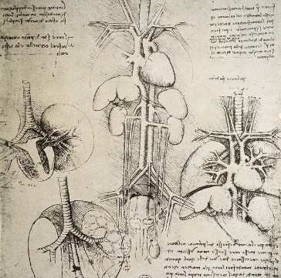

**Section 1 - Recall Activities**

These are activities to develop your recall of information you covered in the previous topics that are linked to mass transport in animals. You should do this before you start the work on this topic. Once you have done the recall activities, quickly check what you have done with the student booklets from that topic.

|  |  |  |  |
| --- | --- | --- | --- |
| **Topic** | **Recall activities** | **Understanding**  *Please write down any questions you have when completing this activity.* | **Completed** |
| **Biological molecules** | On the MWB/scrap paper, describe the structure of proteins |  |  |
| **Cells** | On a MWB/scrap paper draw, describe and explain the difference between simple diffusion, facilitated diffusion & osmosis |  |  |
| On a MWB/scrap paper, draw a diagram to show how different water potentials of fluid surrounding cells affects movement of water within the cell |  |  |
| On a MWB/scrap paper explain using fick’s law and specific examples how cells are adapted for rapid transport across their membranes. Us |  |  |
| **Gas Exchange** | On a MWB/scrap paper give examples to explain the relationship between the size of an organism or structure and its surface area: volume ratio |  |  |
| On a MWB/scrap paper draw and annotate a diagram to show how ventilation in humans works. |  |  |

**Section 2 – Independent pack framework**

|  |  |  |  |  |
| --- | --- | --- | --- | --- |
| **Key info** | **Topic:** Mass Transport in Animals  **Synoptic Link:** Biological molecules, cells, transport across membranes, gas exchange,  **Text book pages:** 161-182 | | | |
| **Step 1** | **Use the tutorial (GOL), presentation (GOL), video links and text book to complete the pack.** | | | |
| **Step 2** | **Learning outcome** | **I under-stand this** | **I can recall this** | **I need to revisit this** |
| Understand that the haemoglobins are a group of chemically similar molecules found in many different organisms. Haemoglobin is a protein with a quaternary structure. |  |  |  |
| Understand the role of haemoglobin and red blood cells in the transport of oxygen. The loading, transport and unloading of oxygen in relation to the oxyhaemoglobin dissociation curve |  |  |  |
| Explain the cooperative nature of oxygen binding to show that the change in shape of  haemoglobin caused by binding of the first oxygens makes the binding of further oxygens easier |  |  |  |
| Describe and explain The effects of carbon dioxide concentration on the dissociation of oxyhaemoglobin (the Bohr effect). |  |  |  |
| Be able to label thr general pattern of blood circulation in a mammal. Names are required only of the coronary arteries and of the blood vessels  entering and leaving the heart, lungs and kidneys. |  |  |  |
| Be able to label the heart and explain the pressure and volume changes and associated valve movements during the cardiac cycle that maintain a unidirectional flow of blood. |  |  |  |
| Be able to draw the structure of arteries, arterioles and veins and explain their structure in relation to their function. |  |  |  |
| Describe the structure of capillaries and explain the importance of capillary beds as exchange surfaces and the formation of tissue fluid and its return to the circulatory system. |  |  |  |
| Know the methodology, safety precautions and other procedures for required practical 5: Dissection of animal or plant gas exchange system or mass transport system or of organ within such a system. |  |  |  |
| **Step 3** | **In lesson:** you will be undertaking activities to develop your understanding of the learning objectives and able to add to your notes. | | | |

**Circulatory System Notes**

**Why need a transport system?**

**____________________________________________________________________________________________________________________________________________________________________________________________________________________________________________________________________________________________________________________________________**

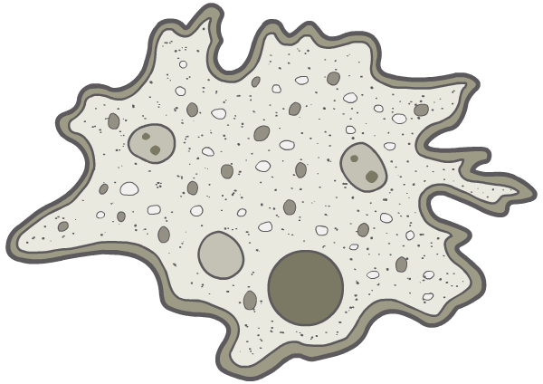





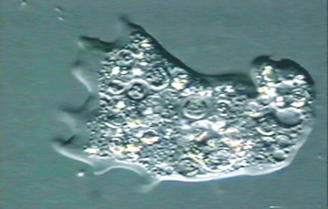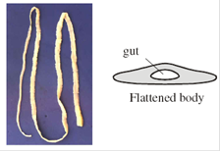

**The need for a circulatory system**

What 2 factors will cause diffusion of materials in an organism to become too slow to meet the needs of body cells?

1. _____________________________________________

2. _____________________________________________

Multicellular organisms need specialised circulatory systems with a pump (mass flow systems) to link exchange surfaces with cells.

**Mass flow systems**

The transport of substances is the flow of a fluid which is generated by a force, which requires energy (as opposed to diffusion, which is the random motion of molecules in a stationary fluid).

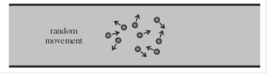

Mass flow systems work with specialised gas exchange systems (Unit 3.3.2)



**Features of transport systems**

**Common features of transport systems:**

1. __________________________________________________________________________
2. __________________________________________________________________________
3. __________________________________________________________________________
4. __________________________________________________________________________

**How the above is achieved:**

1. __________________________________________________________________________
2. __________________________________________________________________________
3. __________________________________________________________________________
4. __________________________________________________________________________

**Circulatory systems**

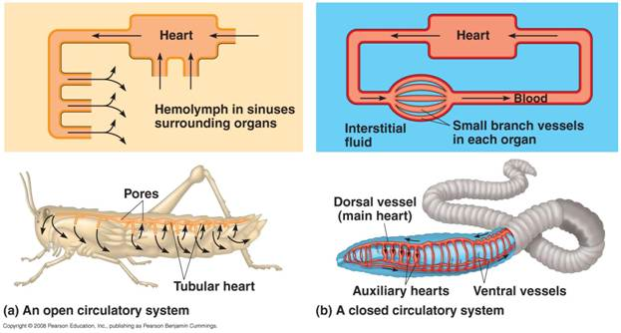

**Two Types of Circulatory Systems**

1. **­­­­­­­__________________________________________**
2. **__________________________________________**

**Open Blood Systems**

An open circulatory system consists of a heart that pumps a fluid called haemolymph through short vessels and into a large cavity called the haemocoel

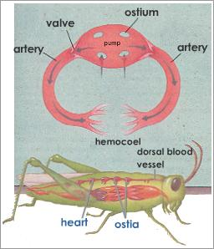In the haemocoel the haemolymph bathes the organs and tissues directly

When the heart relaxes the haemolymph is sucked back into pores called ostia

The vessels are open ended

**Closed Circulatory systems**

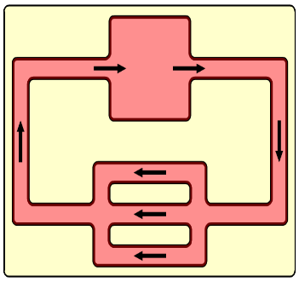**____________________________________________________________________________________________________________________________________________________________________________________________________________________________________________________________________________________________________________________________________**

**____________________________________________________________________________________________________________________________________________________________________________________________________________________________________________________________________________________________________________________________________**

Single circulatory systems are found in ____________________

Double circulatory systems are found in _______________________________________________

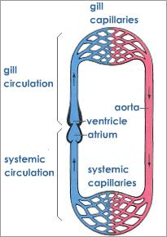

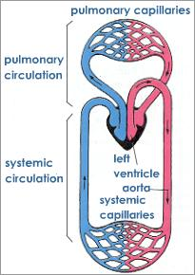

**Circulatory systems in mammals**

Can you think of any advantages to the mammalian system?

**____________________________________________________________________________________________________________________________________________________________________________________________________________________________________________________________________________________________________________________________________**

**____________________________________________________________________________________________________________________________________________________________________________________________________________________________________________________________________________________________________________________________________**

**Complete the diagram below of the mammalian circulatory system**

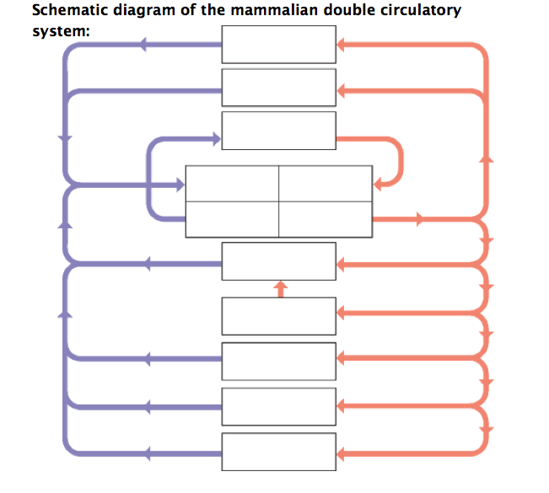

Upper/fore limbs

Lower/hind limbs

Gonads

Head and neck

Deoxygenated blood

Oxygenated blood

**Task: Research the structure and function of arteries, veins and capillaries and complete the table below.**

|  |  |  |
| --- | --- | --- |
| **Blood vessel** | **Artery** | **Arteriole** |
| **Labelled diagram** |  |  |
| **General function** |  |  |
| **Outer layer structure and function** |  |  |
| **Muscle and elastic layer structure and function** |  |  |
| **Inner layer structure and function** |  |  |
| **Lumen size and function** |  |  |
| **Diameter of vessel** |  |  |
| **Valves structure and function** |  |  |
| **Pressure** |  |  |

|  |  |  |
| --- | --- | --- |
| **Blood vessel** | **Vein** | **Capillary** |
| **Labelled diagram** |  |  |
| **General function** |  |  |
| **Outer layer structure and function** |  |  |
| **Muscle and elastic layer structure and function** |  |  |
| **Inner layer structure and function** |  |  |
| **Lumen size and function** |  |  |
| **Diameter of vessel** |  |  |
| **Valves structure and function** |  |  |
| **Pressure** |  |  |

**Heart Structure**

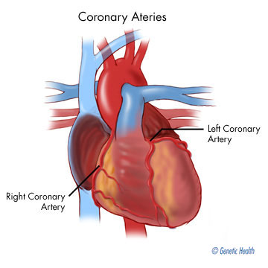

External structure of the human heart.

Label the diagram below.

**Questions:**

1. Which blood vessel do the coronary arteries branch off from? ________________________
2. Explain what happens when a coronary artery gets blocked. ______________________________________________________________________________________________________________________________________________________
3. What is the medical term for a heart attack? ______________________________________

**Label the diagram**

***By means of red and blue arrows draw the direction of oxygenated and deoxygenated blood flow***

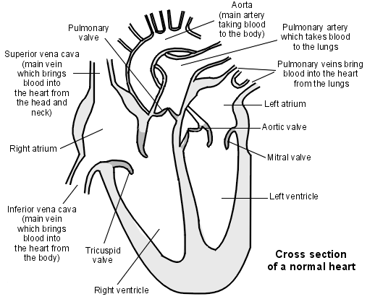

**Questions:**

1. Why does the heart have a double pump?

____________________________________________________________________________________________________________________________________________________________

1. What is the purpose of the thicker muscular wall of the left ventricle compared to the right

ventricle (use the graph below to help with this question)?

____________________________________________________________________________________________________________________________________________________________

1. What is the purpose of the valves in the heart?

____________________________________________________________________________________________________________________________________________________________

1. Describe the structure of the atrial walls completed to the ventricle walls and explain why they are different in relation to their function.

____________________________________________________________________________________________________________________________________________________________

**Cardiac Cycle**

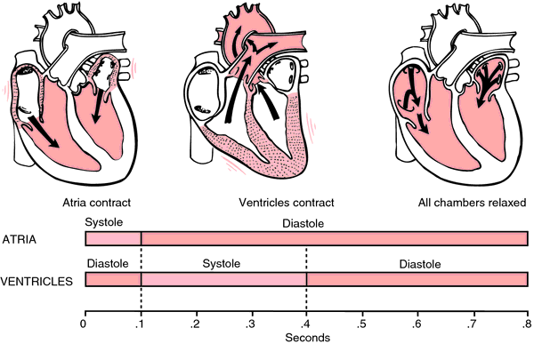

Annotate the boxes below outlining the events in the cardiac cycle

|  |  |  |
| --- | --- | --- |
| Atrial Systole | Ventricular Systole | Diastole |
|  |  |  |

**Complete the summary table below.**

|  |  |  |  |
| --- | --- | --- | --- |
|  | **Arial systole** | **Ventricular diastole** | **Diastole** |
| **Chamber** | Atria |  |  |
| **Volume** | Decreases |  |  |
| **Pressure** | Increases |  |  |
| **Pressure Gradient** | Atria to ventricles |  |  |
| **Valves** | A/V valves open |  |  |

**Complete the table summarising the pressure changes that cause valves to open and close**

|  |  |  |  |
| --- | --- | --- | --- |
| **Atrioventricular valves open because:** | **Atrioventricular valves close because:** | **Semilunar valves open because:** | **Semilunar valves close because:** |
| **Pressure is higher in the atria than the ventricles.** |  |  |  |
| **Blood will flow from the atria to the ventricles** |  |  |  |

**Pressure changes in the cardiac cycle – rules to remember**

* Blood flows from an area of high pressure to an area of low pressure, unless flow is blocked by a valve.
* Events on the right and left sides of the heart are the same, but pressures are lower on the right. Do you know why?
* As a chamber fills with blood the pressure will rise
* When a chamber contracts the pressure will rise further
* Small volume = high pressure/large volume = small pressure
* Changes in pressure affect whether a valve is open or closed

**Cardiac output**

The amount of blood pumped around the body is called the **cardiac output**, and depends on two factors:

1. **stroke volume**

______________________________________________________________________________________________________________________________________________________

1. **heart rate**

______________________________________________________________________________________________________________________________________________________

**cardiac output = stroke volume × heart rate**

A typical resting cardiac output is 4–6 litres per minute. This can rise to as much as 40 litres per minute in highly trained endurance athletes.

**Cardiac output questions.**

|  |  |  |
| --- | --- | --- |
|  | **Time / s** | **Volume of blood / cm3** |
|  | 0.0 | 125 |
|  | 0.1 | 148 |
|  | 0.2 | 103 |
|  | 0.3 | 70 |
|  | 0.4 | 56 |
|  | 0.5 | 55 |
|  | 0.6 | 98 |
|  | 0.7 | 125 |

1. The table shows the volume of blood in a man's right ventricle at different times during one cardiac cycle.

(a)     (i)      Use the data in the table to calculate the man’s heart rate.

                 Heart rate = ............................................. beats per minute

(ii)     Use the data in the table and your answer to part (a) (i) to calculate the man’s cardiac output. Show your working.

                 Cardiac output = ........................................ cm3 per minute

2.   The table shows the cardiac output and resting heart rate of an athlete before and after completing a training programme.

|  |  |  |  |
| --- | --- | --- | --- |
|  |  | **Before training** | **After training** |
|  | Cardiac out/cm3 | 5000 | 5000 |
|  | Resisting heart rate/beats per minute | 70 | 55 |

(i)      Calculate the athlete’s stroke volume after training. Show your working.

.............................. cm3

**(2)**

**3.**     When a stethoscope is placed on the chest wall, sounds are heard as the heart beats. These heart sounds are caused by valves shutting. The diagram shows the heart sounds from a resting person.

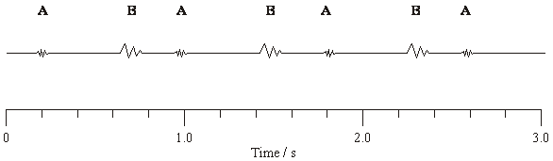(a)     In this person, the stroke volume is 70 cm3. Calculate the cardiac output. Show your working.

Cardiac output ............................... cm3 per minute **(3)**

**Pressure and volume changes and associated valve moments in the heart.**

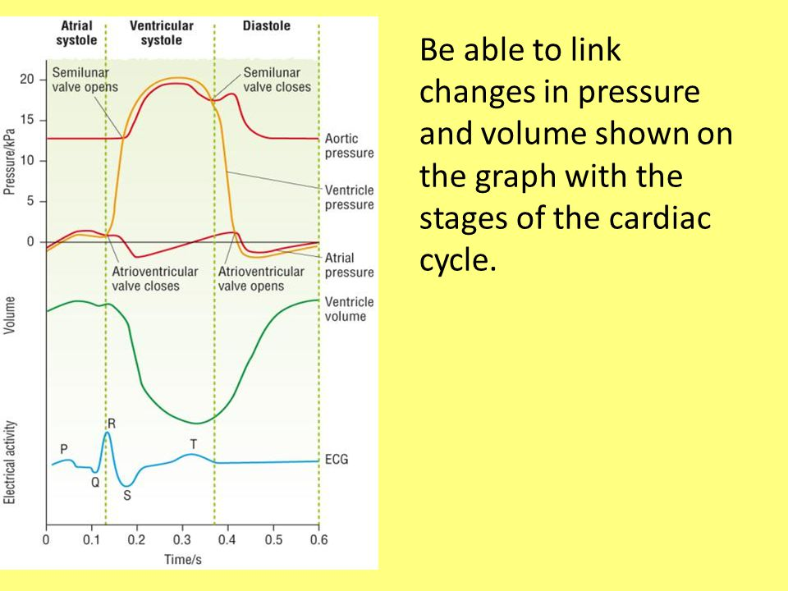

**Ventricle Pressure Changes**

* Atrial systole - The ventricle walls are relaxed and pressure is low but gradually increases as the ventricles fill with blood and atria contract.
* Ventricular systole - the ventricle wall contracts and the pressure shoots up. The AV valve will close when the pressure exceeds that in the atrium.
* As the pressure rises above that of the aorta the semi lunar valve is forced open and the blood is pushed out into aorta.
* Diastole - the ventricle walls relax just after this point when the pressure in the aorta is higher the semilunar valve closes.

**Fill in the information about atrial pressure changes, aorta pressure changes and ventricle volume changes.**

**Atrial Pressure Changes**

1. _______________________________________________________________________________

_________________________________________________________________________________

_________________________________________________________________________________

2. _______________________________________________________________________________

_________________________________________________________________________________

_________________________________________________________________________________

3. _______________________________________________________________________________

_________________________________________________________________________________

_________________________________________________________________________________

4. _______________________________________________________________________________

_________________________________________________________________________________

_________________________________________________________________________________

**Aorta Pressure Changes**

______________________________________________________________________________________________________________________________________________________________________________________________________________________________________________________________________________________________________________________________________________________________________________________________________________________________________________________________________________________________________

**Ventricle Volume Changes**

____________________________________________________________________________________________________________________________________________________________________________________________________________________________________________________________________________________________________________________________________

____________________________________________________________________________________________________________________________________________________________________________________________________________________________________________________________________________________________________________________________________

**Tissue Fluid Formation**

**The Blood Vessel System – Recall activity**

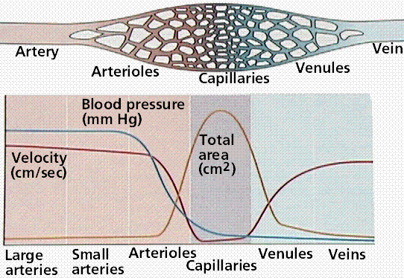

**Questions:**

Describe and explain the changes in blood pressure as blood moves from arteries to veins

____________________________________________________________________________________________________________________________________________________________________________________________________________________________________________________________________________________________________________________________________

___________________________________________________________________________________________________________________________________________________________________________________________________________________________________________________

Describe and explain the changes in the speed of transport as blood moves from arteries to veins

____________________________________________________________________________________________________________________________________________________________________________________________________________________________________________________________________________________________________________________________________

____________________________________________________________________________________________________________________________________________________________________________________________________________________________________________________________________________________________________________________________________

Where is the total surface area the highest?

___________________________________________________________________________________________________________________________________________________________________________________________________________________________________________________

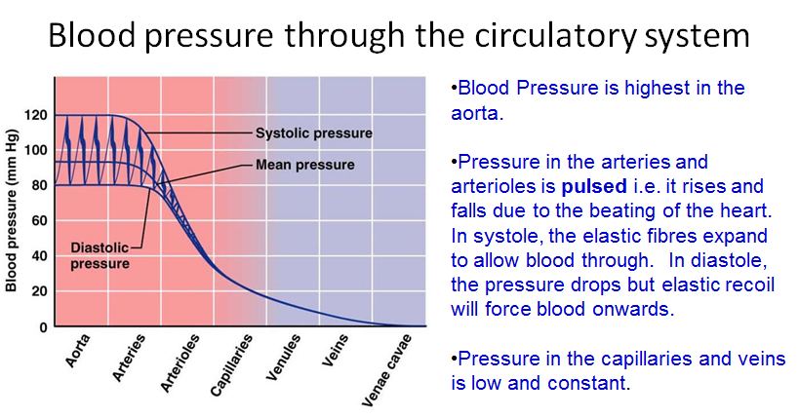

**Blood Pressure in the Circulatory System**

Blood pressure is highest in the aorta.

* Pressure is **pulsed** i.e.it rises and falls due to beating of the hearts.
* In systoles, the elastic fibres expand to allow blood through.
* In diastole, the pressure drops but the elastic recoil will force blood onwards.
* Pressure in the capillaries and veins is low and constant.

**What is Tissue fluid?**

There are three types of fluid associated with the circulatory system. These are:-

1. _______________

2. _______________

3. _______________

What does blood contain?

|  |  |
| --- | --- |
| Contents of Blood | |
|  |  |
|  |  |
|  |  |
|  |  |
|  |  |

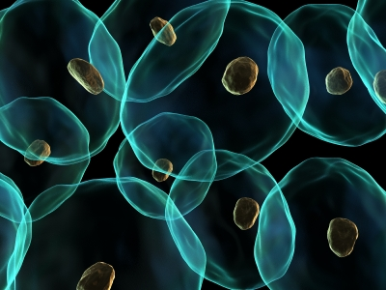Cells are bathed or surrounded with a fluid that comes from the blood containing a supply of materials they require and possessing an ability to absorb materials that needs to be removed from the cell. This fluid is known as tissue fluid.

Therefore tissue fluid is the means by which materials are exchanged between the blood and cells

Tissue fluid has a very similar consistency to blood plasma without the **large plasma proteins**

Tissue fluid is also known as intercellular or interstitial fluid

What substances do you think tissue fluid would contain?

___________________________________________________________________________________________________________________________________________________________________________________________________________________________________________________

Tissue fluid is formed via the capillaries. Below is a reminder of why capillaries are a good exchange surface.

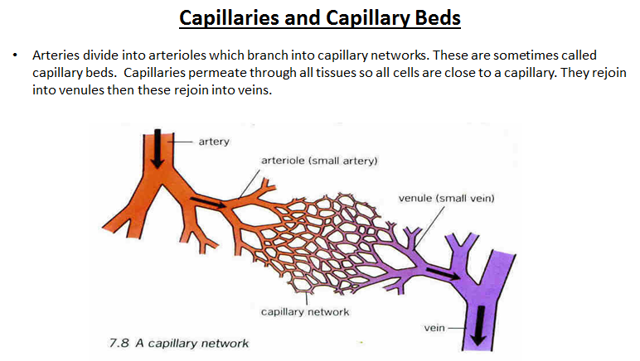**Capillaries & Capillary Beds**

Arteries divide into arterioles which branch into capillary networks. These are sometimes called capillary beds. Capillaries permeate through all tissues so all cells are close to a capillary. They rejoin into venules then these rejoin into veins.

Explain how the structure & function of capillaries satisfy Fick’s Law to ensure efficient exchange of materials by diffusion.

___________________________________________________________________________________________________________________________________________________________________________________________________________________________________________________

___________________________________________________________________________________________________________________________________________________________________________________________________________________________________________________

Capillary walls are partially permeable, allowing some things to pass from the blood to the tissue. This is a key factor in the formation of tissue fluid. Tissue fluid is formed by the interplay of two pressures. These are:

1. **Hydrostatic pressure**-This is the pressure within the blood capillaries that forces out tissue fluid into the surrounding cells. This pressure is created by the contraction of the left ventricle..
2. **Osmotic pressure**-This is the pressure that causes the diffusion of water through semi-permeable membranes This causes the movement of tissue fluid back into the capillaries

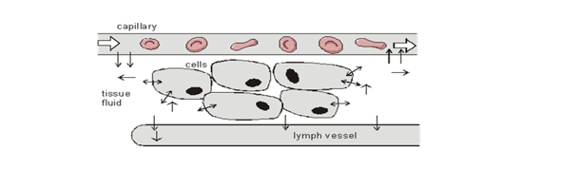

Capillaries can be given directionality. The end of the capillary coming from the arteriole is known as the **arteriole end** and the capillary end returning to the venule is know as the **venous end.**

Using the following diagram can you describe and explain what is happening at the arterial end and venous end?

Outline some things that move *with* the fluid, and some things that do not.

___________________________________________________________________________________________________________________________________________________________________________________________________________________________________________________

|  |  |
| --- | --- |
| **Arteriole end** | **Venous end** |
|  |  |

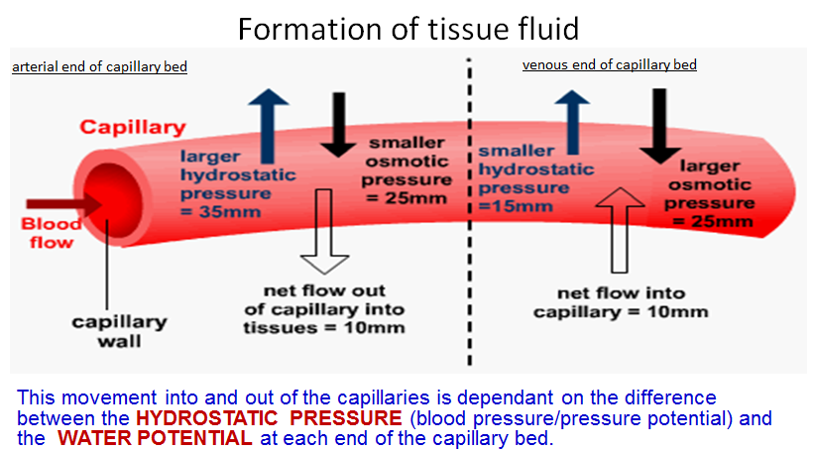

**Overall picture**

**The Lymphatic System**

The fluid that does not return to the capillaries drains into the lymphatic system. It is returned eventually to the bloodstream via the thoracic duct which empties into a veins near the heart

The lymphatic system is a secondary circulatory system and a major part of the immune system. It consists of:

1. lymphatic capillaries and vein-like lymph vessels, containing valves
2. 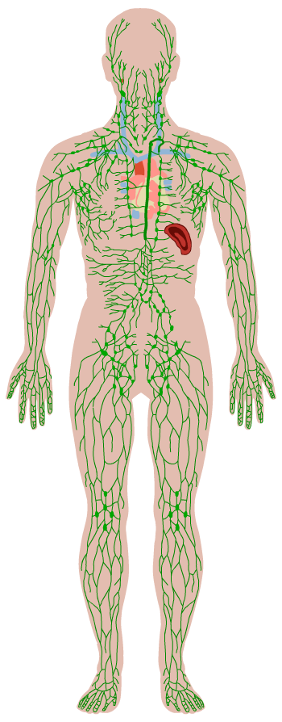lymph nodes – sac-like organs that trap pathogens and foreign substances, and which contain large numbers of white blood cells
3. lymphatic tissue in the spleen, thymus and tonsils – these also contain large numbers of white blood cells and are involved in their development

Movement of lymphatic contents: there is no pump to move the contents so it flows by

1. Hydrostatic pressure of the tissue fluid that has left the capillaries
2. Contraction of body muscles which squeeze the lymph vessels moving fluid in the direction of the heart.

**Summary questions**

1. State what forces tissue fluid out of the blood plasma in capillaries and into the surrounding tissues.

__________________________________________________________________________________________________________________________________________________________________________________________________________________________________________

1. List the **two** routes by which tissue fluid returns to the blood stream.

__________________________________________________________________________________________________________________________________________________________________________________________________________________________________________

**Risk factors associated with cardiovascular disease**

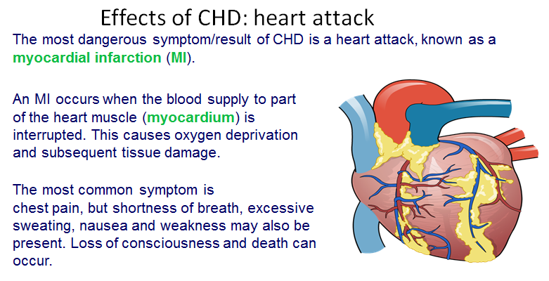**Effects of CHD: Heart Attack**

The most dangerous symptom/result of CHD is a heart attack, known as a myocardial infarction (MI).

An MI occurs when the blood supply to part of the heart muscle (myocardium) is interrupted. This causes oxygen deprivation and subsequent tissue damage.

The most common symptom is chest pain, but shortness of breath, excessive sweating, nausea and weakness may also be present. Loss of consciousness and death can occur.

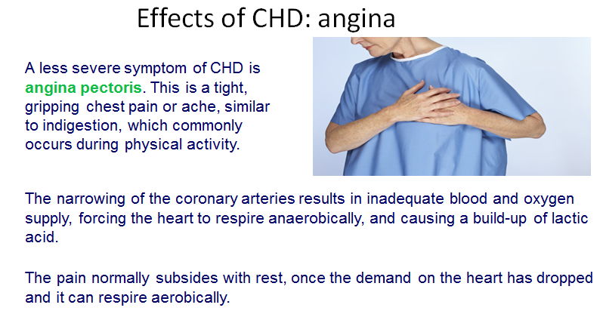**Effects of CHD: angina**

A less severe symptom of CHD is angina pectoris. This is a tight, gripping chest pain or ache, similar to indigestion, which commonly occurs during physical activity.

The narrowing of the coronary arteries results in inadequate blood and oxygen supply, forcing the heart to respire anaerobically, and causing a build-up of lactic acid.

The pain normally subsides with rest, once the demand on the heart has dropped and it can respire aerobically.

**What is coronary heart disease?**

**Coronary heart disease** (**CHD**) is a disease of the arteries supplying the heart (**coronary arteries**). Almost one-fifth of all deaths in the UK in 2005 were due to CHD.

The major cause of CHD is **atherosclerosis**: a thickening of arteries caused by a build-up of fatty plaques (**atheromas**) on the inside walls.

Atherosclerosis can eventually lead to a reduced blood supply (**ischaemia**) to tissues, with potentially fatal consequences.

**Risk Factors**

A **risk factor** is anything that increases the chance of developing a disease.

Hundreds of risk factors for CHD and stroke have been identified. The major ones are

|  |  |
| --- | --- |
| **Can be prevented** | **Can’t be prevented** |
|  |  |
|  |  |
|  |  |
|  |  |
|  |  |
|  |  |
|  |  |

**Correlation versus Cause**

Explain the difference between correlation and cause.

**___________________________________________________________________________________________________________________________________________________________________________________________________________________________________________________**

**___________________________________________________________________________________________________________________________________________________________________________________________________________________________________________________**

**Research Task**

Using A’level specific sites research the following risks factors and how they are associated with heart disease. Make summary notes in the table provided.

1.Hypertension (highblood pressure)

2. Smoking

3. Blood cholesterol (LDL and HDL)

4. Diet high salt and high saturated fats)

|  |
| --- |
| **Hypertension** |
| **Smoking** |
| **Blood cholesterol** |
| **Diet** |

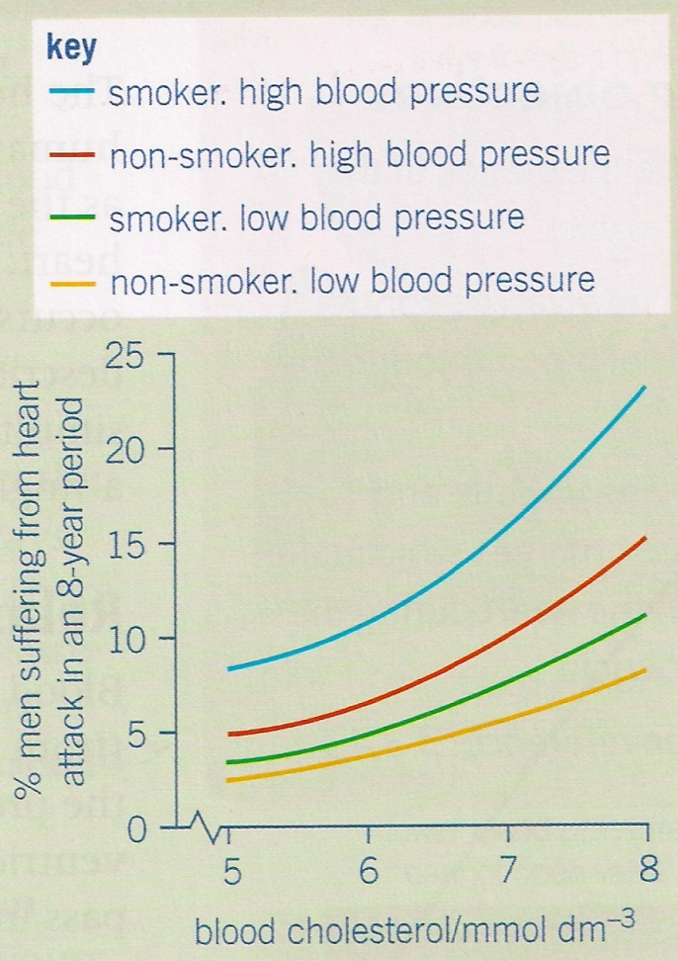**Question: Evaluating Risk**

1. A smoker with high blood pressure wishes to reduce his risk of heart attack. If he could only alter one factor, would he be better giving up smoking or reducing his blood pressure? Explain your answer.

_______________________________________________

_______________________________________________

_______________________________________________

_______________________________________________

_______________________________________________

_______________________________________________

_______________________________________________

_______________________________________________

_______________________________________________

_______________________________________________

_______________________________________________­­­­­­­­­­­­­­­­

1. A non-smoker with high blood pressure has a blood cholesterol level of 5mmdol-3. Over a period of 3 years this concentration increases to 8mmoldm-3. Calculate how many times greater his risk of heart disease is. Show your working.

**___________________________________________________________________________________________________________________________________________________________________________________________________________________________________________________**

**___________________________________________________________________________________________________________________________________________________________________________________________________________________________________________________**

1. Two non-smoking men with low blood pressure both have a blood cholesterol level of 5mmdm-3. One of them starts to smoke and the blood cholesterol level of the other increases to 7 mmdm-3. State which man is now at the greater risk from heart disease. Explain your answer.

**___________________________________________________________________________________________________________________________________________________________________________________________________________________________________________________**

**___________________________________________________________________________________________________________________________________________________________________________________________________________________________________________________**

**Haemoglobin and oxygen dissociation curves**

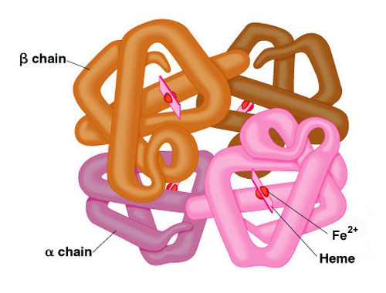

In the next part of the booklet you will find information about haemoglobin and oxygen dissociation curves, together with an assortment of questions on the topic.

Using the information in this booklet, presentation from GOL (used in your lessons), and the other A level specific websites **complete all of the questions**

Haemoglobin is a protein that carries oxygen around the body.

Different species have different forms of haemoglobin, depending on where each species lives, and within a species there may be more than one version of the molecule.

Haemoglobin is found in all vertebrates as well as earthworms, starfish, some insects, some plants and even some bacteria. The red colour of haemoglobin comes from its iron content. Lobsters use a different oxygen carrying pigment called hemocyanin which uses copper instead of iron which gives them a blue colour, turning red when boiled as the copper oxidises.

Haemoglobin is a quaternary protein made of 4 polypeptide chains, each chain containing iron. The molecule has a high affinity for oxygen (this means it likes to combine with oxygen molecules), and each molecule can carry 4 oxygen molecules:

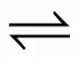Hb + 4O2 HbO8



Haemoglobin + oxygen oxyhaemoglobin

This is a reversible reaction. Oxyhaemoglobin is formed in the lungs, then when oxygen dissociates (leaves) haemoglobin in the body tissues it turns back to haemoglobin.

**Partial Pressure of O2**: The partial pressure of oxygen (pO2) is a measure of oxygen concentration. pO2 will be high in the lungs, and lower in body tissues such as muscle.

Haemoglobin's affinity for oxygen depends on the pO2. Oxygen combines with haemoglobin to form oxyhaemoglobin where there's a high pO2 (lungs), and oxyhaemoglobin breaks down to haemoglobin and oxygen where there's a lower pO2 (tissues),

This means haemoglobin picks up oxygen in the lungs (high pO2) and delivers oxygen to respiring tissues where pO2 is lower as cells use up oxygen.

**Questions**

1. Haemoglobin is a protein with a quaternary structure. Explain what this means.

**__________________________________________________________________________________________________________________________________________________________________**

2. How many oxygen molecules can each molecule carry? _________________________________

3. Where in the body would you find a lower partial pressure of oxygen? _____________________

4. The blood system carries the red cells through the pulmonary vein, to the heart and out through arteries and arterioles to the tissues where oxygen is finally unloaded. Explain why the haemoglobin does not unload its oxygen until it reaches the capillaries in the tissues.

**__________________________________________________________________________________________________________________________________________________________________**

**__________________________________________________________________________________________________________________________________________________________________**

**Oxygen Dissociation Curves**

These show how saturated with oxygen the haemoglobin is at any given pO2.

This is experimental data as in a body all these different partial pressures of oxygen are not observed only high partial pressures pO2 in the lungs and low partial pressures pO2 in the tissues.

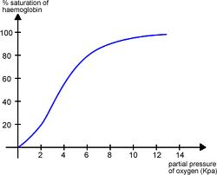

Lungs

Tissues

The graph is S-shaped because when haemoglobin combines with the first oxygen molecule it changes shape in a way that makes it easier for other oxygen molecules to join. However, as the molecule adds more oxygen to it (becomes more saturated) it then gets harder for more oxygen molecules to join. This means the curve has a steep part in the middle, where it's easy for oxygen to combine, and shallow parts at each end where it's harder for oxygen to combine.

When the curve is steep a small change in pO2 causes a big change in the amount of O2 carried.

**Questions**

1. Explain what positive cooperativity means.

**__________________________________________________________________________________________________________________________________________________________________**

**__________________________________________________________________________________________________________________________________________________________________**

1. The graph on the previous page shows the oxygen dissociation curve for human Hb. On the graph **sketch the curve you would expect for an earthworm** (lives in low oxygen environment). Explain the position of your curve in terms of oxygen associating and disassociating with oxygen.

**__________________________________________________________________________________________________________________________________________________________________**

**__________________________________________________________________________________________________________________________________________________________________**

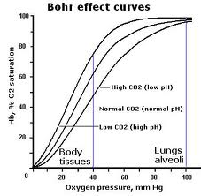**The Effect of Carbon Dioxide**

To complicate matters the CO2 concentration also affect how haemoglobin functions!

Haemoglobin gives up its oxygen more readily at high partial pressure of CO2 (pCO2). This enables more oxygen to get to cells that are respiring at a high rate.

When cells respire they produce CO2, therefore increasing pCO2

This increases the rate of oxygen dissociation and the dissociation curves 'shift' to the right.

This means the saturation of blood with O2 at a given pO2 is lower because more oxygen is being released.

We call this the Bohr effect.

**Question**

1. You can see from the above graph there is also a reference to pH. Explain this in terms of how CO2 levels affect the pH of the blood.

**__________________________________________________________________________________________________________________________________________________________________**

**__________________________________________________________________________________________________________________________________________________________________**

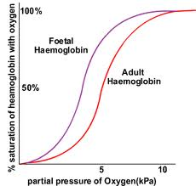**Foetal Haemoglobin**

Foetal haemoglobin has a higher affinity for oxygen than maternal haemoglobin, so the oxygen dissociation curve for foetal haemoglobin is to the left of the maternal one. This means maternal haemoglobin will dissociate itself in the placenta and the foetal haemoglobin will load with oxygen.

**Question**

1. Explain why it is essential for the survival of the foetus that the foetal curve is to the left of the maternal curve.

**__________________________________________________________________________________________________________________________________________________________________**

**__________________________________________________________________________________________________________________________________________________________________**

**Oxygen Dissociation Curve and Other Species**

Organisms that live in low oxygen environments have haemoglobin with a **higher affinity** for O2 than human haemoglobin. The dissociation curve is to **the left** of ours which means at a **lower pO2 the haemoglobin moleculeloads more readily** than human haemoglobin

Organisms that are very active (high respiration rate) have a high oxygen demand and haemoglobin with a **lower affinity** for oxygen than human haemoglobin. Their curve lies to the **right** of ours which means that at **higher partial pressures of oxygen it unloads more readily** than human haemoglobin

**Questions**

1. Think about the respiratory needs and environment of the following animals; Human, llama and hawk. Now sketch the oxygen dissociation curves of these 3 animals (on the same graph).

1. Explain in terms of respiratory needs and loading of oxygen, the position you draw the different curve on the graph for question 1.

**__________________________________________________________________________________________________________________________________________________________________**

**__________________________________________________________________________________________________________________________________________________________________**

**__________________________________________________________________________________________________________________________________________________________________**

**__________________________________________________________________________________________________________________________________________________________________**

1. Explain how DNA leads to different haemoglobin molecules having different affinities for oxygen.

**__________________________________________________________________________________________________________________________________________________________________**

**__________________________________________________________________________________________________________________________________________________________________**

**__________________________________________________________________________________________________________________________________________________________________**

**__________________________________________________________________________________________________________________________________________________________________**

1. When the body is at rest, only one of the four oxygen molecules carried by haemoglobin is normally released into tissues. Suggest why this could be an advantage when the organism becomes more active?

**__________________________________________________________________________________________________________________________________________________________________**

**__________________________________________________________________________________________________________________________________________________________________**

**__________________________________________________________________________________________________________________________________________________________________**

**__________________________________________________________________________________________________________________________________________________________________**

1. Describe the effect of increased carbon dioxide concentration on oxygen dissociation

**__________________________________________________________________________________________________________________________________________________________________**

**__________________________________________________________________________________________________________________________________________________________________**

1. A rise in temperature shifts the oxygen dissociation curve to the right. Suggest how this enables an exercising muscle to work more effectively.

**__________________________________________________________________________________________________________________________________________________________________**

**__________________________________________________________________________________________________________________________________________________________________**

**_________________________________________________________________________________**

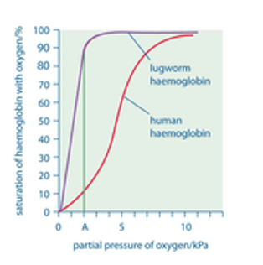

1. In the following figure line A is drawn at a partial pressure of oxygen of 2Kpa. This is the partial pressure of oxygen found in lugworm burrows after the sea no longer covers them. Use the figures from the graph to explain why a lugworm can survive at these concentrations of oxygen while a human could not.

**____________________________________________**

**____________________________________________**

**____________________________________________**

**____________________________________________**

**____________________________________________**

**____________________________________________**

**____________________________________________**

**_________________________________________________________________________________**

**__________________________________________________________________________________________________________________________________________________________________**

**__________________________________________________________________________________________________________________________________________________________________**

**__________________________________________________________________________________________________________________________________________________________________**