**3.3.4.2 Mass Transport in Plants**

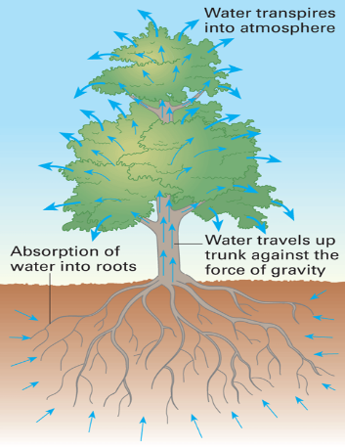

**Section 1 - Recall Activities**

These are activities to develop your recall of information you covered in the previous topics that are linked to mass transport in animals. You should do this before you start the work on this topic. Once you have done the recall activities, quickly check what you have done with the student booklets from that topic.

|  |  |  |  |
| --- | --- | --- | --- |
| **Topic** | **Recall activities** | **Understanding**  *Please write down any questions you have when completing this activity.* | **Completed** |
| **Biological molecules** | On a MWB/scrap paper, describe the properties of water and explain why these occur. |  |  |
| **Cells** | On a MWB/scrap paper draw, label and annotate a plant cell explaining the function of all of the organelles. |  |  |
| On a MWB/scrap paper describe the 4 (main) methods of substances moving into cells. |  |  |
| **Gas Exchange** | On a MWB/scrap paper draw and label a cross section of a leaf. |  |  |
| On a MWB/scrap paper describe and explain gas exchange in a leaf. |  |  |

**Section 2 – Independent pack framework**

|  |  |  |  |  |
| --- | --- | --- | --- | --- |
| **Key info** | **Topic:** Mass Transport in Plants  **Synoptic Link:** Biological molecules, cells, transport across membranes, gas exchange  **Text book pages:** 183-193 | | | |
| **Step 1** | **Use the tutorial (GOL), presentation (GOL), video links and text book to complete the pack.** | | | |
| **Step 2** | **Learning outcome** | **I under-stand this** | **I can recall this** | **I need to revisit this** |
| Know that xylem is the tissue that transports water in the stem and leaves of plants. |  |  |  |
| Explain the cohesion-tension theory of water transport in the xylem. |  |  |  |
| Know that phloem is the tissue that transports organic substances in plants. |  |  |  |
| Describe and explain the mass flow hypothesis for the mechanism of translocation in plants. |  |  |  |
| Understand the use of tracers and ringing experiments to investigate transport in plants. |  |  |  |
| Be able to recognise correlations and causal relationships |  |  |  |
| Be able to interpret evidence from tracer and ringing experiments and to evaluate the evidence for and against the mass flow hypothesis. |  |  |  |
| **Step 3** | **In lesson:** you will be undertaking activities to develop your understanding of the learning objectives and able to add to your notes. | | | |

**References**

Have a look at the following websites to help support your learning with this topic:

<http://www.a-levelnotes.co.uk/biology-aqa-as-notes-organisms-exchange-substances-with-their-environment-mass-transport-in-plants.html>

<https://studyrocket.co.uk/revision/a-level-biology-aqa/organisms-environment/mass-transport-in-plants>

<https://www.s-cool.co.uk/a-level/biology/transport/revise-it/transport-in-plants>

These videos will give you a verbal explanation as well:

<https://www.youtube.com/watch?v=F9uqgOtIe84>

<https://www.youtube.com/watch?v=KHUrQ6qKpxQ>

<https://www.youtube.com/watch?v=jtuX7H05tmQ>

**Transport of water in plants**

Diffusion is too slow to supply the needs of multicellular plants so a mass flow system is needed but unlike animals there is no pump. Plants have evolved two distinct systems of tubes:

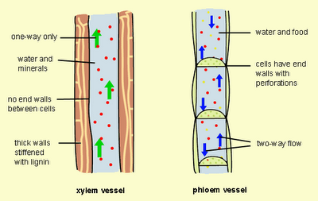

**xylem** to transport ­­­­­­­­­­­­­____________________________________

**phloem** to transport ___________________________________

Vascular tissue

Being able to identify both xylem and phloem in cross section is made easier by how the tissues are arranged. Dicotyledons (dicots) are the type of plant you need to be able to recognize and label. The vascular tissue is arranged in bundles in the stem and in the centre of a root in an area called the stele.

Sketch and label both a stem and root cross section to show vascular tissue:

**Transport of Water**

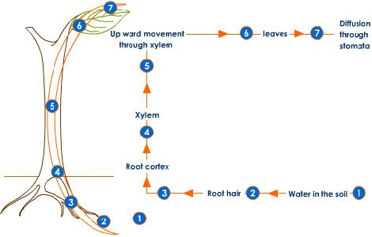Vast amounts of water pass through plants. A large tree can use water at a rate of 1 dm³ min-1. Only 1% of this water is used by the plant cells for photosynthesis and turgor, and the remaining 99% evaporates from the leaves and is lost to the atmosphere. This evaporation from leaves is called transpiration.

The movement of water through a plant can be split into sections:

* + Movement of water out through the stomata
  + Movement of water across the cells of a leaf
  + Movement of water up the stem in the xylem
  + (Movement of water into the roots)

**Movement of water out through the stomata**

**Annotate** the diagram to show and explain the movement of water out of the stomata. Make sure to include how stomata change shape.

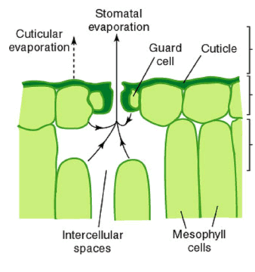

**Movement of water across the cells of a leaf**

Outline in the space below how water moves across a leaf ______________________________________________________________________________________________________________________________________________________________________________________________________________________________________________________________________________________________________________________________________________________________________________________________________________________________________________________________________________________________________

What is the difference between the symplast and apoplast pathways?

______________________________

______________________________

______________________________

______________________________

______________________________

______________________________

______________________________

______________________________

______________________________

______________________________

**Movement of water up the stem in the xylem**

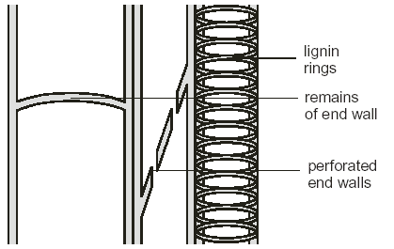**Structure of Xylem Vessels**

Xylem is composed of dead cells that are joined together to form long narrow tubes.

The walls of the tubes become thickened with lignin to allow them to withstand the strong pressures that occur in water transport.

As lignin is impermeable materials cannot pass into xylem cells and so the protoplasm dies leaving a hollow tube.

Xylem is found in the root, the stem and the leaves. Its distribution gives valuable mechanical support. In the stem it is located in peripheral vascular bundles for flexible support, in the leaves the arrangement of vascular tissues are in the midrib and veins and in the roots the central arrangement helps to anchor the plant

**Cohesion-Tension Theory**

Put the following statements that explain the cohesion – tension theory in order by numbering each sentence.

|  |  |
| --- | --- |
| A= | Water is hence pulled up the xylem as a result of transpiration. This is known as transpirational pull. |
| B = | As water evaporates from the mesophyll cells in the leaf into the air spaces beneath the stomata, more molecules of water are drawn up behind it as a result of this cohesion. |
| C = | Water forms a continuous, unbroken pathway across the mesophyll cells and down the xylem. |
| D = | Transpiration pull puts the xylem under tension, i.e. there is an upwards force, hence the name cohesion-tension theory. |
| E = | Water molecules are polar and so form hydrogen bonds between the hydrogen atom of one molecule of water and an oxygen atom of another molecule of water. The water molecules are attracted to each other. This is known as cohesion. |
| F = | Water evaporates from leaves as a result of transpiration. |
| G = | Water molecules stick to the inside of the xylem vessel. This is known as adhesion. |

Describe three pieces of evidence that support the cohesion – tension theory.

1. _______________________________________________________________________________

___________________________________________________________________________________________________________________________________________________________________________________________________________________________________________________

2. _______________________________________________________________________________

___________________________________________________________________________________________________________________________________________________________________________________________________________________________________________________

3. _______________________________________________________________________________

___________________________________________________________________________________________________________________________________________________________________________________________________________________________________________________

**Movement of water into roots**

* Plants must absorb enough water to replace transpiration losses.
* Root systems have evolved to maximise the ability to absorb water from the soil water.
* Water absorption occurs mainly by root hairs which are cellular extensions of epidermal cells.

How does water move into root hair cells?

_________________________________________________________________________________

How do mineral salts enter root hair cells?

_________________________________________________________________________________

What is the advantage to the plant of mineral salts entering the root hair cells?

_________________________________________________________________________________

_________________________________________________________________________________

_________________________________________________________________________________

**Investigating transpiration**

The potometer is used for measuring the rate of transpiration

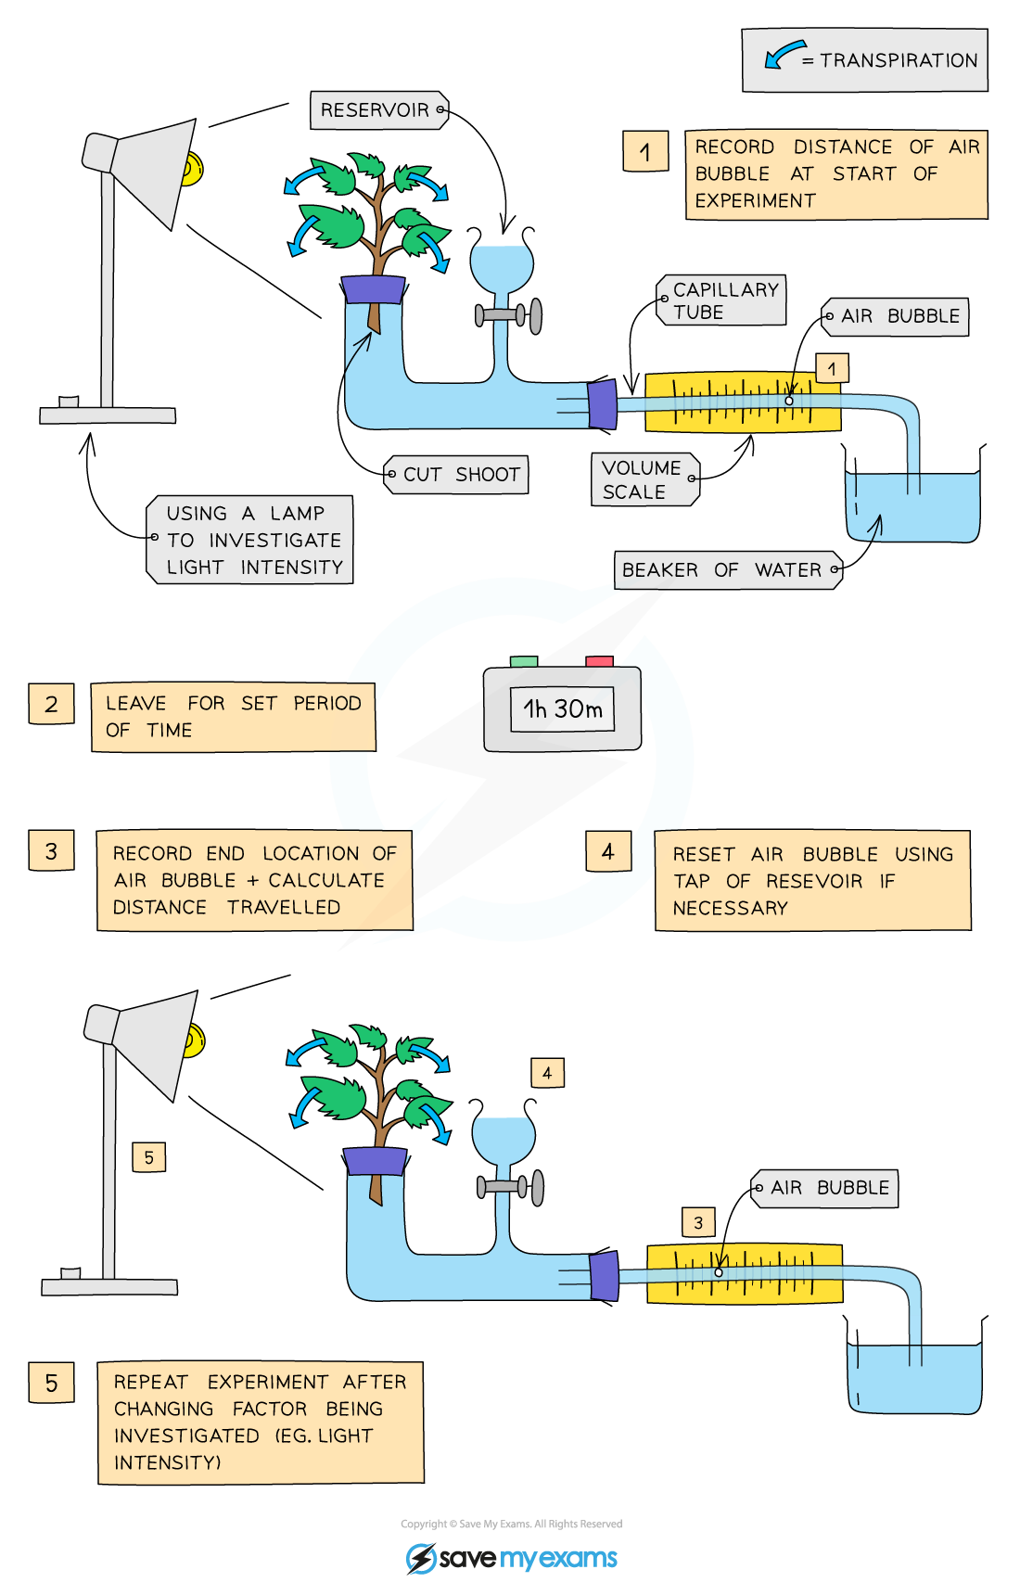

How would you introduce the bubble to the tube?

__________________________________________________________________________________________________________________________________________________________________

How do you ensure that no air enters the xylem when setting up the equipment?

__________________________________________________________________________________________________________________________________________________________________

How do you ensure no air enters the apparatus once set up?

__________________________________________________________________________________________________________________________________________________________________

What factors would you need to control if your independent variable is the humidity that the plant is in. Name as many as you can.

__________________________________________________________________________________________________________________________________________________________________

__________________________________________________________________________________________________________________________________________________________________

A plant was set up for 10 minutes and the bubble moved 9.8 cm. What volume of water would have transpired from the plant in an hour? The diameter of the tube was 0.5 mm. State your units.

__________________________________________________________________________________________________________________________________________________________________

_________________________________________________________________________________

**Knowledge Check Questions**

Read the factsheet called transpiration on GOL and answer the following questions.

__________________________________________________________________________________________________________________________________________________________________

_________________________________________________________________________________

__________________________________________________________________________________________________________________________________________________________________

__________________________________________________________________________________________________________________________________________________________________

_________________________________________________________________________________

__________________________________________________________________________________________________________________________________________________________________

__________________________________________________________________________________________________________________________________________________________________

_________________________________________________________________________________

__________________________________________________________________________________________________________________________________________________________________

__________________________________________________________________________________________________________________________________________________________________

_________________________________________________________________________________

____________________________________________________________________________________________________________________________________________________________________________________________________________________________________________________________________________________________________________________________________

__________________________________________________________________________________________________________________________________________________________________

_________________________________________________________________________________

__________________________________________________________________________________________________________________________________________________________________

__________________________________________________________________________________________________________________________________________________________________

_________________________________________________________________________________

__________________________________________________________________________________________________________________________________________________________________

__________________________________________________________________________________________________________________________________________________________________

_________________________________________________________________________________

__________________________________________________________________________________________________________________________________________________________________

**Transport of organic substances in the phloem.**

**Structure and function of Phloem**

What organic molecules are transported in the phloem?

_________________________________________________________________________________

What is the transport of these solutes in the phloem called?

_________________________________________________________________________________

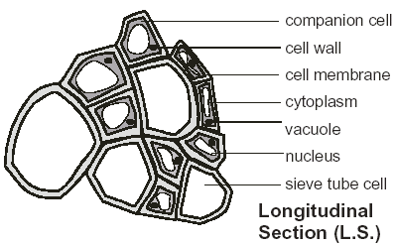

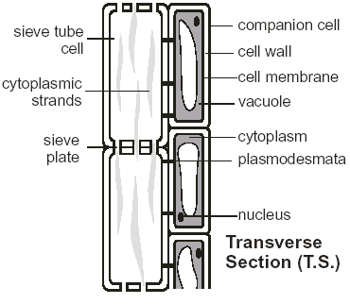

## Phloem Tissue

Summarise the structure of phloem tissue below.

__________________________________________________________________________________________________________________________________________________________________

_________________________________________________________________________________

__________________________________________________________________________________________________________________________________________________________________

__________________________________________________________________________________________________________________________________________________________________

**Mass flow theory**

* The rate of movement in the phloem is too fast to be explained by diffusion. Therefore there must be another mechanism to explain this.
* Currently **mass flow theory** is the favoured theory to explain this. It has 3 stages:
  1. Transfer of sucrose into sieve elements from photosynthesising tissues
  2. Mass flow of sucrose through sieve tube elements
  3. Transfer of sucrose from the sieve tube elements into storage of other sink cells

**Transfer of sucrose into sieve elements from photosynthesising tissue**

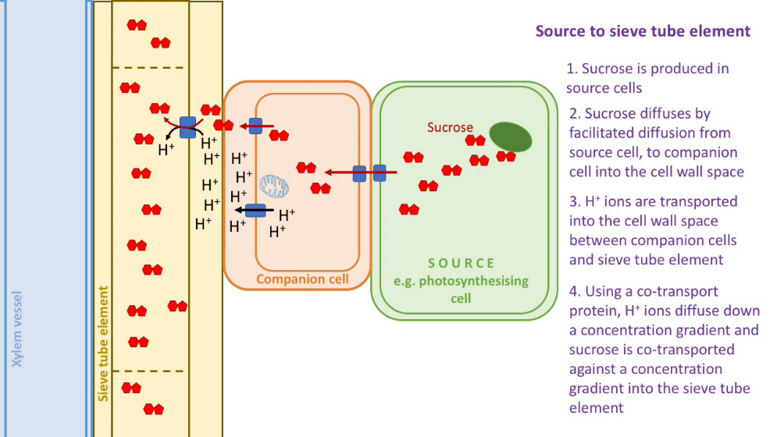Explain how sucrose is loaded into the sieve elements.

____________________________________________

____________________________________________

____________________________________________

____________________________________________

____________________________________________

____________________________________________

____________________________________________

____________________________________________

_________________________________________________________________________________

__________________________________________________________________________________________________________________________________________________________________

_________________________________________________________________________________

**Mass flow of sucrose through sieve tube elements**

Unlike the water in the xylem, the contents of the phloem can move both up or down a plant stem, often simultaneously (but not in the same sieve tube). The Mass Flow theory tries to explain how this is possible.

Where in a plant are source cells found?

__________________________________________________________________________________________________________________________________________________________________

_________________________________________________________________________________

__________________________________________________________________________________________________________________________________________________________________

Where in a plant are sink cells found?

__________________________________________________________________________________________________________________________________________________________________

_________________________________________________________________________________

__________________________________________________________________________________________________________________________________________________________________

**Transfer of sucrose into sink cells from sieve tube elements**

Outline the major steps in the mass flow theory below

____________________________________________________

____________________________________________________

____________________________________________________

____________________________________________________

____________________________________________________

____________________________________________________

____________________________________________________

____________________________________________________

____________________________________________________

____________________________________________________

_________________________________________________________________________________

__________________________________________________________________________________________________________________________________________________________________

_________________________________________________________________________________

_________________________________________________________________________________

#### Transfer of sucrose into sieve elements into storage or other sink cells

#### How is sucrose transferred into respiring sink cells?

_________________________________________________________________________________

_________________________________________________________________________________

#### Translocation experiments

Evidence for this theory was first obtained from ringing experiments.

**1. Ringing experiments**

* + Since the phloem vessels are outside the xylem vessels, they can be selectively removed by cutting a ring in a stem just deep enough to cut the phloem but not the xylem.
  + *Link to previous learning about structure of stems*

Describe what happens in this experiment. How does this support the theory that sugars are transported in the phloem

**Method:**

_________________________________________________________________________________

_________________________________________________________________________________

**Results:**

_________________________________________________________________________________

_________________________________________________________________________________

**Conclusions:**

_________________________________________________________________________________

_________________________________________________________________________________

_________________________________________________________________________________

_________________________________________________________________________________

**2. Using Radioactive tracers**

* Radioactive isotopes can be used trace precisely where different compounds are being transported from and to, as well as measuring the rate of transport. The radioactivity can be traced using photographic film (an autoradiograph). This techniques can be used to trace sugars, ions or even water.
* In a typical experiment a plant is grown in the lab and one leaf is exposed for a short time to carbon dioxide containing the radioactive isotope 14C. This 14CO2 will be taken up by photosynthesis and the 14C incorporated into glucose and then sucrose.



Describe what the photographic film will show.

__________________________________________________________________________________________________________________________________________________________________

_________________________________________________________________________________

_________________________________________________________________________________

**Additional Evidence**

1. 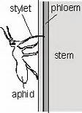When phloem is cut, a solution of organic molecules flows out.
2. Aphids have needle like mouthparts which penetrate the phloem. They can extract contents of sieve tubes. These contents show daily variations in the sucrose content of leaves that are mirrored a little later by identical changes in the sucrose content of the phloem

**Evidence for and against mass flow theory.**

|  |  |
| --- | --- |
| **Evidence supporting mass flow theory** | **Evidence questioning mass flow theory** |
|  |  |
|  |  |
|  |  |
|  |  |
|  |  |
|  |  |