**Lung disease**

**Define the following terms:**

Asthma: ..................................................................................................................................................................... ...................................................................................................................................................................................

Causation: ................................................................................................................................................................. ...................................................................................................................................................................................

Correlation: ............................................................................................................................................................... ...................................................................................................................................................................................

Emphysema: ............................................................................................................................................................. ...................................................................................................................................................................................

Pulmonary fibrosis: ................................................................................................................................................... ...................................................................................................................................................................................

Pulmonary tuberculosis: ........................................................................................................................................... ...................................................................................................................................................................................

Risk factor: ................................................................................................................................................................ ...................................................................................................................................................................................

**Complete the sentences using the words in bold:**

**aerobic allergens allergic antibiotics breathing coincidence consume correlation cough death diffusion droplets dust elastic elasticity epithelial exhalation expand and recoil fibrous gradient incurable indirect infectious inflammatory longer merge mucus muscular mutate narrowing overcrowding pollen protease relax reproducing scar smaller smaller smoking spread tobacco tumour**

**Pulmonary tuberculosis**

Pulmonary Tuberculosis (or TB) is an _____________ disease caused by the bacterium Mycobacterium tuberculosis. In 19th-century England one in five died of TB and is still a major killer in the developing nations. The symptoms are a persistent _________ with chest pains, tiredness, a loss of appetite and weight loss, and in serious cases coughing up blood, wasting away and __________.

*Course of Disease*

1. TB is transmitted by aerosol ___________ from coughs and sneezes of infected people.
2. The bacterial cells are breathed in and invade the ____________ tissue of the alveoli and bronchioles. Here they multiply to form lumps called tubercles, in which the bacteria remain alive but dormant.
3. The tubercles stimulate an inflammatory response by the white blood cells of the immune system, resulting in the formation of __________ scar tissue. This scar tissue reduces the ____________ of the alveoli and thickens their walls, so reducing the rate of oxygen diffusion.
4. After a delay of months to years the bacteria emerge from the tubercles and start _____________ inside the lung epithelial cells, killing them. The damaged alveoli have a ___________ surface area, so further reducing the rate of gas exchange.
5. The TB bacteria can also ________ through the bloodstream to other organs, which are destroyed as well. This causes weakness as the body wastes away and the bacteria appear to “_________” the body.

*Risk Factors*

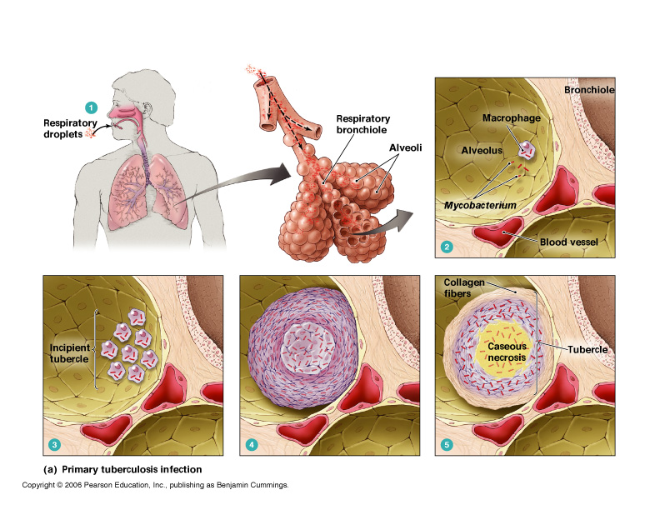The main risk factor for TB is _____________, such as in slums or hospitals, as this allows TB to spread rapidly between hosts. Other factors include poor diet and AIDS, as these both impair the immune system. Since it is a bacterial disease, TB can be treated by _____________, and can also be prevented by the BCG vaccine. Unfortunately, the incidence of TB is currently rising due to resistance of the bacterium to antibiotics.

**Pulmonary Fibrosis**

Pulmonary fibrosis is a severe shortness of breath caused by inhalation of fine _______ particles or chemicals.

*Course of Disease*

1. The particles stimulate an inflammatory response in the lungs, which results in the growth of fibrous ______ tissue around the alveoli.
2. This scar tissue thickens the alveolar walls so that there is a _________ diffusion pathway and a __________ surface area for oxygen diffusion.
3. The scar tissue also reduces the elasticity of the alveoli so normal ____________ is prevented. This means there is a smaller oxygen diffusion gradient, so less oxygen reaches the blood.

*Risk factors*

Risk factors include exposure to fine dust particles, such as in coal mines.

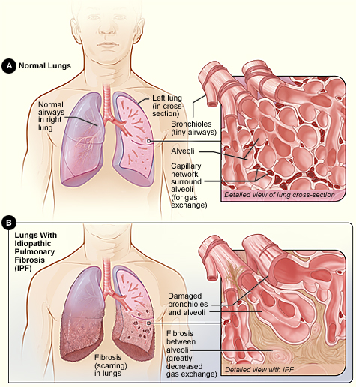

**Asthma**

Asthma is an ___________ response that causes difficulty breathing, wheezing, tight chest and coughing. It is thought to affect 10% of the world's population.

*Course of Disease*

1. Asthma is caused by allergens in the environment, including ___________, dust mites faeces and fur.
2. These allergens trigger an _______________ response by the immune system, which causes the smooth circular muscles of the bronchioles to contract, ______________ the airways.
3. The epithelial cells also secrete more __________, which further blocks the airways.
4. The constrictions reduce the tidal volume, so alveolar air is only replaced slowly. The oxygen concentration ____________ across the alveolar epithelium is reduced, so the rate of ___________ is reduced. Less oxygen diffuses into the blood, so less oxygen is available for ___________ respiration.

*Risk Factors*

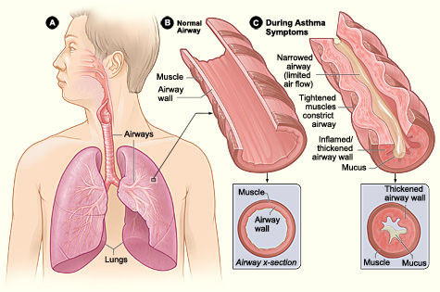The risk factor for asthma is exposure to_____________. Other factors that can contribute to asthma include polluting gases like sulphur dioxide, exercise, cold weather, infection and stress. Asthma can be treated by inhaling drugs that _________ the smooth muscles and by anti-inflammatory drugs.

**Emphysema**

Emphysema is a lung disease characterised by severe _____________ difficulties. It caused by ____________ and 20% of all smokers suffer from emphysema and it kills 20,000 people per year in the UK.

*Course of Disease*

1. The tar in cigarette smoke stimulates the white blood cells to release inflammatory __________ enzymes in the lungs.
2. These enzymes digest the __________ tissue in the epithelial cells of the alveoli. The alveoli can no longer _________ _____ _________, reducing the tidal volume in ventilation. This reduces the oxygen diffusion gradient, so less oxygen diffuses into the blood.
3. 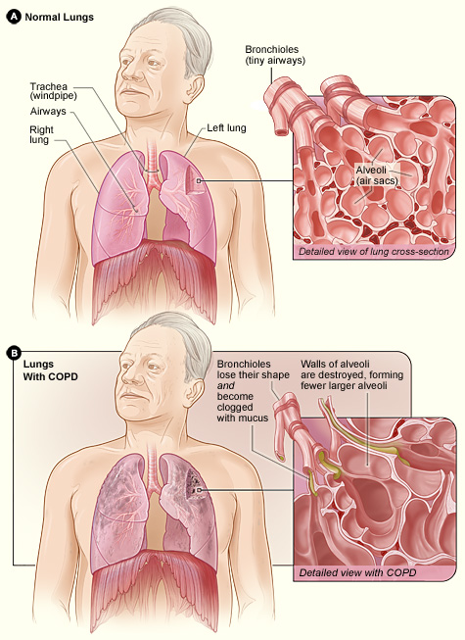In more severe cases the epithelial cells are completely destroyed, so alveoli ________ to form large air sacs with a much smaller surface area and thicker walls. These all reduce the rate of oxygen diffusion, so less oxygen is available for cellular respiration and ___________ activity is very difficult.

*Risk Factors*

By far the most important risk factor for emphysema is smoking. Emphysema is ___________, though giving up smoking prevents the symptoms getting any worse.

**Smoking and lung cancer**

Lung cancer is the growth of excess tissue in the lungs due to uncontrolled cell division of the epithelial cells. Mutagenic agents in the environment cause epithelial cells to __________ and start to divide continuously and uncontrollably, forming a __________. As the tumour grows it can constrict the bronchioles and alveoli, so slowing the rate of gas exchange. Lung cancers often spread to other parts of the body and are a major cause of death in the developed world.

*Risk Factors*

The risk factor for lung cancer is exposure to the mutagenic agents. These agents include ____________ smoke, asbestos and radon gas, which is present in the air of some locations.

Correlation and causation

The first step to identifying risk factors for a particular disease is to look for a ____________ (or association) between the incidence of the disease and some factor. However, correlation is not evidence of causation (i.e. that smoking causes lung cancer). The correlation may be _____________ or it may be due to another factor. For example, there is also a correlation between alcohol consumption and lung cancer but laboratory studies have failed to show any causal link between alcohol and lung cancer – alcohol is not a risk factor. Instead, the correlation is __________: heavy drinkers tend also to be heavy smokers and the smoking causes lung cancer. These theories apply to all studies looking for causal effects.

**Answer the exam questions:**

Q1. Miner’s lung is a disease caused by breathing in dust in coal mines. The dust causes the alveolar epithelium to become thicker. People with miner’s lung have a lower concentration of oxygen in their blood than healthy people.

(a) (i) Describe the path by which oxygen goes from an alveolus to the blood. [2]

.........................................................................................................................................................................................................................................................................................................................................................................................................................................................................................................................................................

(ii) Explain why people with miner’s lung have a lower concentration of oxygen in their blood. [1]

......................................................................................................................................................................................................................................................................................................................................................................

(b) In healthy lungs, a gradient is maintained between the concentration of oxygen in the alveoli and the concentration of oxygen in the lung capillaries.

(i) Describe how ventilation helps to maintain this difference in oxygen concentration. [2]

.........................................................................................................................................................................................................................................................................................................................................................................................................................................................................................................................................................

(ii) Give one other way that helps to maintain the difference in oxygen concentration. [1]

...................................................................................................................................................................................

(c) Scientists investigated the number of cases of miner’s lung reported in Britain between 1992 and 2006.

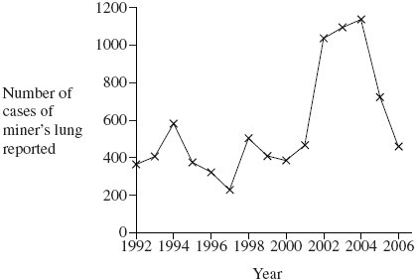

Coal mining in Britain had been dramatically reduced by 1990. Some scientists concluded that the rise in reported cases of miner’s lung after 1992 shows that the disease takes a long time to develop.

Evaluate this conclusion. [2]

............................................................................................................................................................................................................................................................................................................................................................................................................................................................................................................................................................................................................................................................................................................................................

(Total 8 marks)

Q2. (a) Pulmonary tuberculosis is spread from one person to another by droplet infection.

Explain how tuberculosis is spread by droplet infection. [2]

.........................................................................................................................................................................................................................................................................................................................................................................................................................................................................................................................................................

(b) The table shows the number of cases of tuberculosis in different regions of England between 2000 and 2005

|  |  |  |  |  |  |
| --- | --- | --- | --- | --- | --- |
| **Region** | **Number of cases of tuberculosis per 100 000 of the population** | | | | |
| **2000** | **2001** | **2002** | **2003** | **2004** |
| East Midlands | 10.6 | 11.1 | 11.9 | 7.9 | 9.9 |
| West Midlands | 13.7 | 13.1 | 14.9 | 15.0 | 16.2 |
| North East | 5.7 | 7.7 | 6.4 | 6.1 | 6.7 |
| North West | 10.0 | 10.0 | 9.4 | 9.0 | 9.3 |
| South East | 6.1 | 6.6 | 7.3 | 7.4 | 7.3 |
| South West | 4.6 | 4.0 | 4.8 | 4.5 | 5.3 |

(i) The number of cases of tuberculosis varies between different regions. Suggest two reasons for this. [2]

1 ................................................................................................................................................................................ ...................................................................................................................................................................................

2 ................................................................................................................................................................................ ...................................................................................................................................................................................

(ii) Calculate the percentage increase on the number of cases of tuberculosis in the south west region of England from 2000 to 2004. Show your working. [2]

Answer................................................

(Total 6 marks)

Q3. Read the following passage.

Several diseases are caused by inhaling asbestos fibres. Most of these

diseases result from the build up of these tiny asbestos fibres in the lungs.

One of these diseases is asbestosis. The asbestos fibres are very small and

enter the bronchioles and alveoli. They cause the destruction of phagocytes

and the surrounding lung tissue becomes scarred and fibrous. The fibrous

tissue reduces the elasticity of the lungs and causes the alveolar walls

to thicken. One of the main symptoms of asbestosis is shortness of breath

caused by reduced gas exchange.

People with asbestosis are at a greater risk of developing lung cancer. The time

between exposure to asbestos and the occurrence of lung cancer is 20–30 years.

Use information in the passage and your own knowledge to answer the following questions.

(a) Destruction of phagocytes (lines 4–5) causes the lungs to be more susceptible to infection. Explain why. [2]

.........................................................................................................................................................................................................................................................................................................................................................................................................................................................................................................................................................

(b) (i) The reduced elasticity of the lungs (lines 6–7) causes breathing difficulty. Explain how. [2]

.........................................................................................................................................................................................................................................................................................................................................................................................................................................................................................................................................................

(ii) Apart from reduced elasticity, explain how changes to the lung tissue reduce the efficiency of gas exchange. [4]

...............................................................................................................................................................................................................................................................................................................................................................................................................................................................................................................................................................................................................................................................................................................................................................................................................................................................................................................................

(c) (i) Doctors did not make the link between exposure to asbestos and an increased risk of developing lung cancer for many years. Use information in the passage to explain why. [1]

......................................................................................................................................................................................................................................................................................................................................................................

(ii) Give one factor, other than asbestos, which increases the risk of developing lung cancer. [1]

...................................................................................................................................................................................

(Total 10 marks)

Q4. (a) Scientists who investigate disease may look at risk factors. What is a risk factor? [1]

......................................................................................................................................................................................................................................................................................................................................................................

Scientists investigated the link between pollution from vehicle exhausts and the number of cases of asthma. Between 1976 and 1996, the scientists recorded changes in the following

• the concentration in the air of substances from vehicle exhausts

• the number of cases of asthma.

The graph shows their results

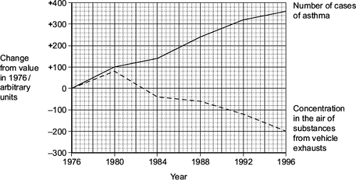

(b) Between which years on the graph was there

(i) a positive correlation between the number of cases of asthma and the concentration in the air of substances from vehicle exhausts. [1]

...................................................................................................................................................................................

(ii) a negative correlation between the number of cases of asthma and the concentration in the air of substances from vehicle exhausts? [1]

...................................................................................................................................................................................

(c) The scientists concluded that substances in the air from vehicle exhausts did not cause the increase in asthma between 1976 and 1980. Explain why. [3]

..................................................................................................................................................................................................................................................................................................................................................................................................................................................................................................................................................................................................................................................................................................................................................................................................................................................................................................................................................................................................................................................................................................................

(Total 6 marks)

M1. (a) (i) Through alveolar epithelium;

Through capillary epithelium/endothelium; [2]

(ii) (Thicker alveolar wall) – no mark

(So) Longer diffusion pathway/slower diffusion; [1]

(b) (i) (In alveolus)

Brings in air containing a high(er) oxygen concentration;

Removes air with a low(er) oxygen concentration; [2]

(ii) Circulation of blood/moving blood; [1]

(c) Long time between decrease in mining and increase in cases;

Graph shows fluctuations;

Correlation does not prove causation/there may be other causes of miner’s lung;

Improved diagnosis methods;

Do not know number of cases/baseline before 1990;

Not all cases reported/not all individuals with miner’s lung visit a doctor; [2 max]

(Total 8)

M2. (a) Bacteria attached to/carried by;

Droplets of mucus/water; [2]

(b) Vaccination rates;

Immigration;

Different strains of TB;

Living conditions related to transmission / diet; [2 max]

(c)

15.2; [2]

(Total 6)

M3. (a) Phagocytes engulf/ingest pathogens/microorganisms/bacteria/viruses;

Phagocytes destroy pathogens/microorganisms/bacteria/viruses;

Lung diseases are caused by pathogens/microorganisms/bacteria/viruses; [2 max]

(b) (i) Alveoli/lungs will not inflate/deflate fully/reduced lung capacity;

Breathing out particularly affected/no longer passive;

Concentration/diffusion gradient / rate of diffusion reduced; [2 max]

(ii) Alveolar walls thicken;

Longer diffusion pathway;

Scarred/fibrous tissue;

Reduces surface area (for gaseous exchange); [4]

(c) (i) Cancer develops 20 – 30 years after exposure (to asbestos); [1]

(ii) Smoking / air pollution / specified industrial source; [1]

(Total 10)

M4. (a) Something that increases chance / increases probability / makes it more likely; [1]

(b) (i) 1976 - / to / and 1980; [1]

(ii) 1980 - / to / and 1996; [1]

(c) 1. Correlation does not mean that there is a causal relationship;

2. May be some other factor / named factor;

3. Associated with vehicles and asthma / producing rise in both;

4. (After 1980) asthma continues to rise but exhaust concentration falls / negative correlation (after 1980); [3 max]

(Total 6)