**3.3.2 Gas Exchange in Humans**

|  |  |  |  |  |
| --- | --- | --- | --- | --- |
| **Key info** | **Topic:** Gas Exchange in Humans  **Synoptic Link:** Biological molecules, transport across membranes, mass transport  **Text book pages: Toole & Toole p.142-p.150** | | | |
| **Step 1** | **Use the tutorial (GOL), presentation (GOL), video links and text book to complete the independent pack.** | | | |
| **Step 2** | **Learning outcome** | **I understand this** | **I can recall this** | **I need to revisit this** |
| Label the key structures of the respiratory system, and describe the function of each |  |  |  |
| Relate adaptations of alveoli to maximizing diffusion rate (Fick’s Law) |  |  |  |
| Describe the process of inspiration and expiration in terms of muscle contractions and pressure changes |  |  |  |
| Interpret a Spirograph trace in order to calculate tidal volumes, vital capacity and inspiratory reserve volume |  |  |  |
| Use Spirograph data to calculate pulmonary ventilation rate |  |  |  |
| Explain the effects of various lung diseases and how they impact oxygen diffusion |  |  |  |
| Evaluate data on risk factors for lung disease |  |  |  |
| **Step 3** | **In lesson:** you will be undertaking activities to develop your understanding of the learning objectives and able to add to your notes. | | | |

3.3.2 Gas exchange

|  |  |
| --- | --- |
| **Content** | **Opportunities for skills development** |
| * The gross structure of the human gas exchange system limited to the alveoli, bronchioles, bronchi, trachea and lungs. * The essential features of the alveolar epithelium as a surface over which gas exchange takes place. * Ventilation and the exchange of gases in the lungs. The mechanism of breathing to include the role of the diaphragm and the antagonistic interaction between the external and internal intercostal muscles in bringing about pressure changes in the thoracic cavity.   **Students should be able to:**   * interpret information relating to the effects of lung disease on gas exchange and/or ventilation * interpret data relating to the effects of pollution and smoking on the incidence of lung disease * analyse and interpret data associated with specific risk factors and the incidence of lung disease * evaluate the way in which experimental data led to statutory restrictions on the sources of risk factors * recognise correlations and causal relationships. | **MS 2.2**  Students could be given values of pulmonary ventilation rate (PVR) and one other measure, requiring them to change the subject of the equation:  *PVR* = *tidal volume* × *breathing rate* |

**The mammalian respiratory system**

**Define the following terms:**

Alveoli (alveolus): ...................................................................................................................................................... ...................................................................................................................................................................................

Breathing: ................................................................................................................................................................. ...................................................................................................................................................................................

Bronchi (bronchus): .................................................................................................................................................. ...................................................................................................................................................................................

Bronchioles: .............................................................................................................................................................. ...................................................................................................................................................................................

Diaphragm: ............................................................................................................................................................... ...................................................................................................................................................................................

Epithelium: ................................................................................................................................................................ ...................................................................................................................................................................................

Exhalation: ................................................................................................................................................................ ...................................................................................................................................................................................

Inhalation: ................................................................................................................................................................. ...................................................................................................................................................................................

Intercostal muscles: .................................................................................................................................................. ...................................................................................................................................................................................

Lungs: ........................................................................................................................................................................ ...................................................................................................................................................................................

Lung capacity: ........................................................................................................................................................... ...................................................................................................................................................................................

Pulmonary ventilation: ............................................................................................................................................. ...................................................................................................................................................................................

Residual volume: ....................................................................................................................................................... ...................................................................................................................................................................................

Tidal volume: ............................................................................................................................................................ ...................................................................................................................................................................................

Trachea: .................................................................................................................................................................... ...................................................................................................................................................................................

Ventilation rate: ........................................................................................................................................................ ...................................................................................................................................................................................

**Complete the sentences using the words in bold:**

**aerobic capillaries carbon dioxide cartilage ciliated closer constant contracts decreases diaphragm dome entrance exchange exercise expiration flattened flattens in and down increases inspiration intercostals muscles lung oxygen pH ratio relaxes surfactant thin thorax tidal volume touching tube up and out ventilation ventilation rate**

The respiratory system in mammals is made up of:

* The mouth and nose - ____________ to the rest of the respiratory system
* The trachea - connects the mouth and nose to the lungs; a tough ________, surrounded by c-shaped rings of ____________ to prevent kinking, also lined with ____________ epithelial cells to trap dust and pathogens and waft back to the mouth in a sea of mucus
* The bronchi - two branches from the trachea that transfer air to and from each _________; these are similar in structure to the trachea
* The bronchioles - increasingly smaller branches from the bronchi that transfer air to and from the alveoli; these start with a similar structure to the bronchi but lose the cartilage lining and ciliated epithelial cells the ___________ they get to the alveoli
* The alveoli - the site of ____________ of the gases oxygen and carbon dioxide; they are tiny sacs, lined with _____________ epithelial cells and surrounded by a dense network of ______________

The primary function of the lungs and breathing is to supply ______________ for ____________ respiration. Removal of __________ ___________, one of the waste products of respiration, is also a vital function of breathing. Carbon dioxide produces an acid solution and as it accumulates the _____ of the cells and blood is lowered that could interfere with enzymatic function.

Efficient gas exchange in the lungs is achieved by a number of adaptations:

* The millions of alveoli in the lungs have a combined area of approximately 70m², thereby significantly increasing the surface area to volume ________ of the Human body. To prevent the walls of the alveolus from sticking together a substance called ___________ is secreted by cells in the alveolar walls, which consists of phospholipids that reduces the surface tension of the water.
* A short distance for diffusion is achieved by the alveolar epithelial cells and capillary endothelial cells being very ________. The capillaries are also _____________ the alveoli so the oxygen and carbon dioxide have to travel through very little or no tissue fluid.
* The constant movement of blood through the capillaries, as well as breathing movements, ensure that a steep concentration gradient in maintained.The flow of air in and out of the lungs is called ____________ and has two stages: ____________ and ____________. Lungs are not muscular and cannot ventilate themselves, but instead the whole __________ moves and changes size, due to the action of two sets of muscles: the ___________ _________ and the ______________.

During inspiration:

* The diaphragm _________ and _________
* The external intercostal muscles contract, pulling the ribs ___ ____ _____
* The volume of the thorax ______________ and pressure in the lungs decreases
* Air is pushed in to equalise the pressure.

During normal expiration:

* The diaphragm _________ and forms a _________ shape
* The external intercostal muscles relax, pulling the ribs ___ ____ _______
* The volume of the thorax ______________ and the pressure in the lungs increases
* Air is pushed out to equalise the pressure.

The volume of air inspired is known as the_______ _________. The volume of air inspired per minute is known as the ______________ _______ .

Ventilation rate is approximately ____________ when at rest but increases during _____________ since both the tidal volume and number of breaths per minute increase.

**Answer the questions:**

1. Label the parts of the respiratory system on the diagram below. [13]

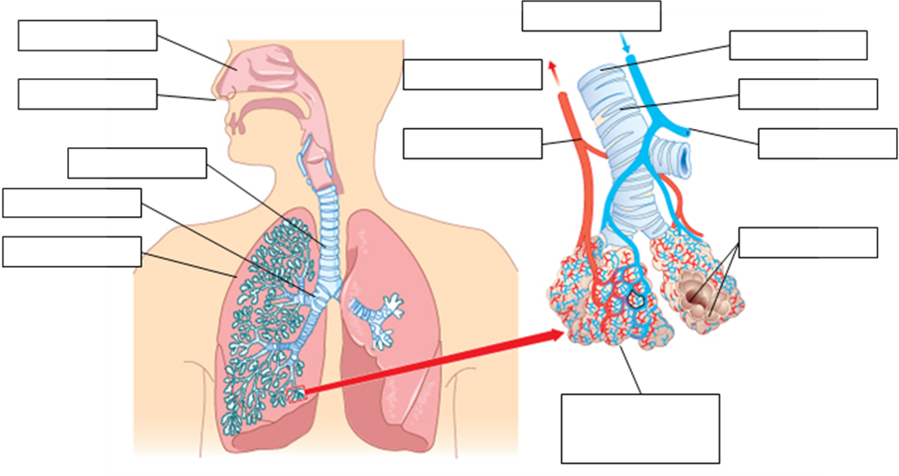

1. Look at the diagram of the alveoli. Explain how the lung structure is adapted for gas exchange. [3]

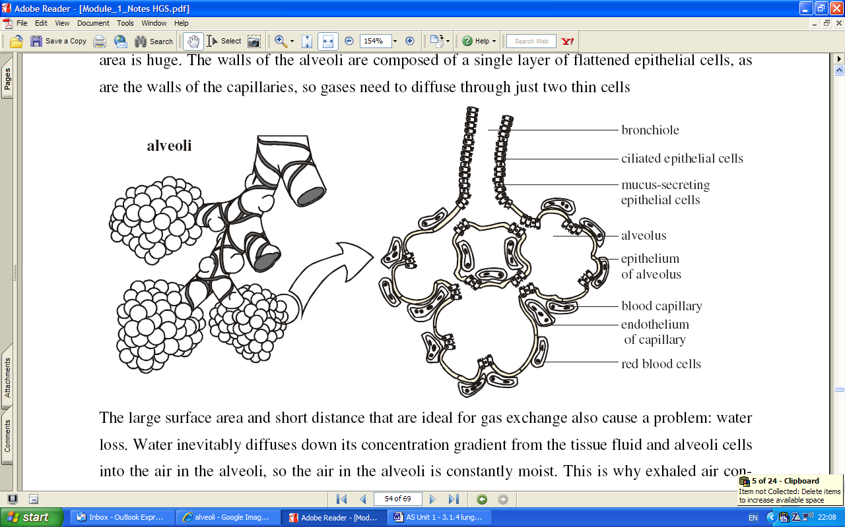

...............................................................................................................................................................................................................................................................................................................................................................................................................................................................................................................................................................................................................................................................................................................................................................................................................................................................................................................................

1. Complete the table to show the ventilation rate [2]

|  |  |  |  |
| --- | --- | --- | --- |
|  | Breathing rate (breaths/min) | Tidal volume (cm³/breath) | Minute ventilation rate (cm³/min) |
| **At rest** | 12 | 500 |  |
| **At exercise** | 18 | 1000 |  |

1. Look at the spirometry trace.

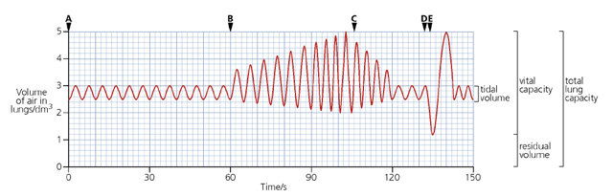

Calculate:

1. The rate of breathing at rest between 0-60s.

...................................................................................................................................................................................

1. The tidal volume at rest between 0-60s.

...................................................................................................................................................................................

1. The breathing rate during exercise between 90-100s.

...................................................................................................................................................................................

1. Total volume of air taken into the lungs during exercise between 90 – 100s.

...................................................................................................................................................................................

1. The inspiratory reserve volume, the expiratory reserve volume, the vital capacity and the total lung capacity of the subject.

...................................................................................................................................................................................

**Answer the exam questions:**

Q1.(a) The diagram shows the structure of the human gas exchange system.

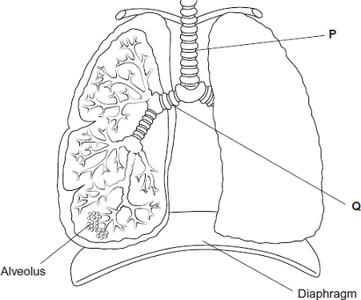

Name organs [1]

P ...................................................

Q ...................................................

(b) (i) Name the process by which oxygen passes from an alveolus in the lungs into the blood. [1]

...................................................................................................................................................................................

(ii) Describe two adaptations of the structure of alveoli for efficient gas exchange.[2]

1................................................................................................................................................................................. ...................................................................................................................................................................................

2................................................................................................................................................................................. ...................................................................................................................................................................................

(Total 4 marks)

Q2. The diagram shows the position of the diaphragm at times P and Q.

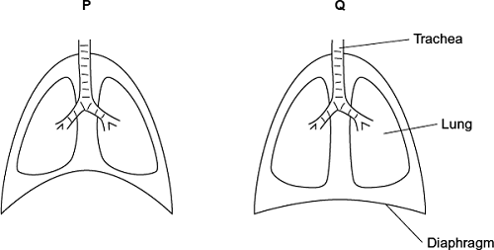

(a) Describe what happens to the diaphragm between times P and Q to bring about the change in its shape. [2]

............................................................................................................................................................................................................................................................................................................................................................................................................................................................................................................................................................................................................................................................................................................................................

(b) Air moves into the lungs between times P and Q. Explain how the diaphragm causes this. [3]

...............................................................................................................................................................................................................................................................................................................................................................................................................................................................................................................................................................................................................................................................................................................................................................................................................................................................................................................................

(c) Describe how oxygen in air in the alveoli enters the blood in capillaries. [2]

............................................................................................................................................................................................................................................................................................................................................................................................................................................................................................................................................................................................................................................................................................................................................

(Total 7 marks)

Q3. The graph shows changes in the volume of air in a person’s lungs during breathing.

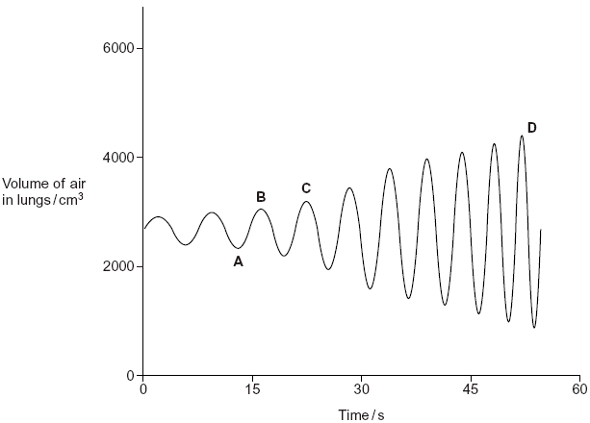

(a) The person was breathing in between times A and B on the graph.

(i) Explain how the graph shows that the person was breathing in between times A and B. [1]

......................................................................................................................................................................................................................................................................................................................................................................

(ii) Describe and explain what happens to the shape of the diaphragm between times A and B. [2]

.........................................................................................................................................................................................................................................................................................................................................................................................................................................................................................................................................................

(b) The person’s pulmonary ventilation changed between times C and D. Describe how the graph shows that the pulmonary ventilation changed. [3]

............................................................................................................................................................................................................................................................................................................................................................................................................................................................................................................................................................................................................................................................................................................................................

(Total 6 marks)