**The mammalian respiratory system**

**Define the following terms:**

Alveoli (alveolus): ...................................................................................................................................................... ...................................................................................................................................................................................

Breathing: ................................................................................................................................................................. ...................................................................................................................................................................................

Bronchi (bronchus): .................................................................................................................................................. ...................................................................................................................................................................................

Bronchioles: .............................................................................................................................................................. ...................................................................................................................................................................................

Diaphragm: ............................................................................................................................................................... ...................................................................................................................................................................................

Epithelium: ................................................................................................................................................................ ...................................................................................................................................................................................

Exhalation: ................................................................................................................................................................ ...................................................................................................................................................................................

Inhalation: ................................................................................................................................................................. ...................................................................................................................................................................................

Intercostal muscles: .................................................................................................................................................. ...................................................................................................................................................................................

Lungs: ........................................................................................................................................................................ ...................................................................................................................................................................................

Lung capacity: ........................................................................................................................................................... ...................................................................................................................................................................................

Pulmonary ventilation: ............................................................................................................................................. ...................................................................................................................................................................................

Residual volume: ....................................................................................................................................................... ...................................................................................................................................................................................

Tidal volume: ............................................................................................................................................................ ...................................................................................................................................................................................

Trachea: .................................................................................................................................................................... ...................................................................................................................................................................................

Ventilation rate: ........................................................................................................................................................ ...................................................................................................................................................................................

**Complete the sentences using the words in bold:**

**aerobic capillaries carbon dioxide cartilage ciliated closer constant contracts decreases diaphragm dome entrance exchange exercise expiration flattened flattens in and down increases inspiration intercostals muscles lung oxygen pH ratio relaxes surfactant thin thorax tidal volume touching tube up and out ventilation ventilation rate**

The respiratory system in mammals is made up of:

* The mouth and nose - ____________ to the rest of the respiratory system
* The trachea - connects the mouth and nose to the lungs; a tough ________, surrounded by c-shaped rings of ____________ to prevent kinking, also lined with ____________ epithelial cells to trap dust and pathogens and waft back to the mouth in a sea of mucus
* The bronchi - two branches from the trachea that transfer air to and from each _________; these are similar in structure to the trachea
* The bronchioles - increasingly smaller branches from the bronchi that transfer air to and from the alveoli; these start with a similar structure to the bronchi but lose the cartilage lining and ciliated epithelial cells the ___________ they get to the alveoli
* The alveoli - the site of ____________ of the gases oxygen and carbon dioxide; they are tiny sacs, lined with _____________ epithelial cells and surrounded by a dense network of ______________

The primary function of the lungs and breathing is to supply ______________ for ____________ respiration. Removal of __________ ___________, one of the waste products of respiration, is also a vital function of breathing. Carbon dioxide produces an acid solution and as it accumulates the _____ of the cells and blood is lowered that could interfere with enzymatic function.

Efficient gas exchange in the lungs is achieved by a number of adaptations:

* The millions of alveoli in the lungs have a combined area of approximately 70m², thereby significantly increasing the surface area to volume ________ of the Human body. To prevent the walls of the alveolus from sticking together a substance called ___________ is secreted by cells in the alveolar walls, which consists of phospholipids that reduces the surface tension of the water.
* A short distance for diffusion is achieved by the alveolar epithelial cells and capillary endothelial cells being very ________. The capillaries are also _____________ the alveoli so the oxygen and carbon dioxide have to travel through very little or no tissue fluid.
* The constant movement of blood through the capillaries, as well as breathing movements, ensure that a steep concentration gradient in maintained.The flow of air in and out of the lungs is called ____________ and has two stages: ____________ and ____________. Lungs are not muscular and cannot ventilate themselves, but instead the whole __________ moves and changes size, due to the action of two sets of muscles: the ___________ _________ and the ______________.

During inspiration:

* The diaphragm _________ and _________
* The external intercostal muscles contract, pulling the ribs ___ ____ _____
* The volume of the thorax ______________ and pressure in the lungs decreases
* Air is pushed in to equalise the pressure.

During normal expiration:

* The diaphragm _________ and forms a _________ shape
* The external intercostal muscles relax, pulling the ribs ___ ____ _______
* The volume of the thorax ______________ and the pressure in the lungs increases
* Air is pushed out to equalise the pressure.

The volume of air inspired is known as the_______ _________. The volume of air inspired per minute is known as the ______________ _______ .

Ventilation rate is approximately ____________ when at rest but increases during _____________ since both the tidal volume and number of breaths per minute increase.

**Answer the questions:**

1. Label the parts of the respiratory system on the diagram below. [13]

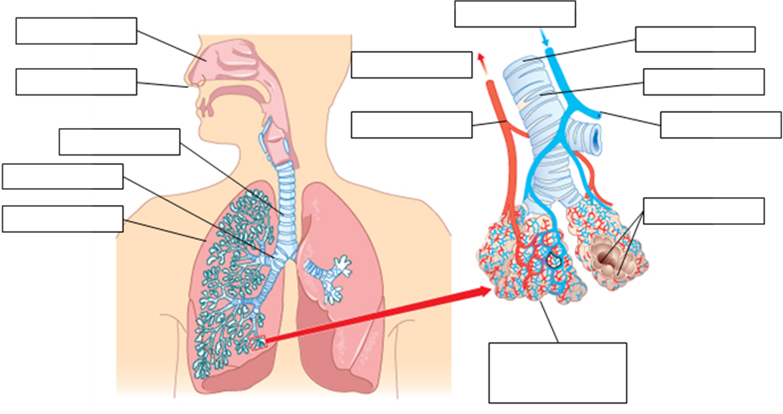

1. Look at the diagram of the alveoli. Explain how the lung structure is adapted for gas exchange. [3]

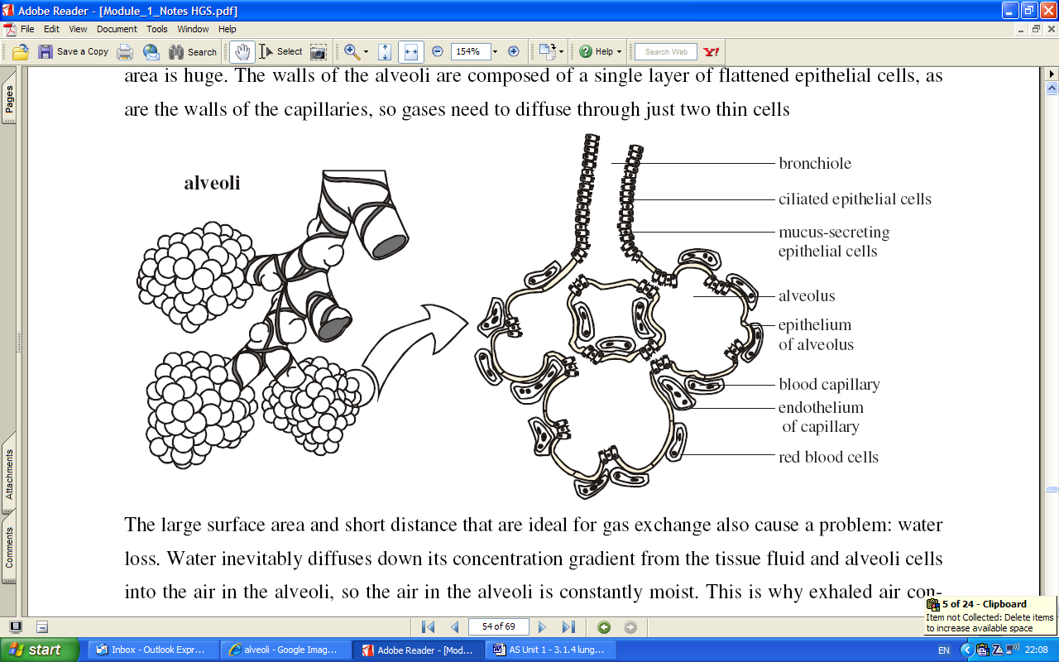

...............................................................................................................................................................................................................................................................................................................................................................................................................................................................................................................................................................................................................................................................................................................................................................................................................................................................................................................................

1. Complete the table to show the ventilation rate [2]

|  |  |  |  |
| --- | --- | --- | --- |
|  | Breathing rate (breaths/min) | Tidal volume (cm³/breath) | Minute ventilation rate (cm³/min) |
| **At rest** | 12 | 500 |  |
| **At exercise** | 18 | 1000 |  |

1. Look at the spirometry trace.

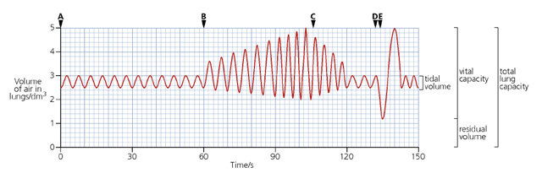

Calculate:

1. The rate of breathing at rest between 0-60s.

...................................................................................................................................................................................

1. The tidal volume at rest between 0-60s.

...................................................................................................................................................................................

1. The breathing rate during exercise between 90-100s.

...................................................................................................................................................................................

1. Total volume of air taken into the lungs during exercise between 90 – 100s.

...................................................................................................................................................................................

1. The inspiratory reserve volume, the expiratory reserve volume, the vital capacity and the total lung capacity of the subject.

...................................................................................................................................................................................

**Answer the exam questions:**

Q1.(a) The diagram shows the structure of the human gas exchange system.

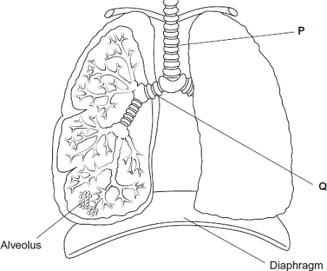

Name organs [1]

P ...................................................

Q ...................................................

(b) (i) Name the process by which oxygen passes from an alveolus in the lungs into the blood. [1]

...................................................................................................................................................................................

(ii) Describe two adaptations of the structure of alveoli for efficient gas exchange.[2]

1................................................................................................................................................................................. ...................................................................................................................................................................................

2................................................................................................................................................................................. ...................................................................................................................................................................................

(Total 4 marks)

Q2. The diagram shows the position of the diaphragm at times P and Q.

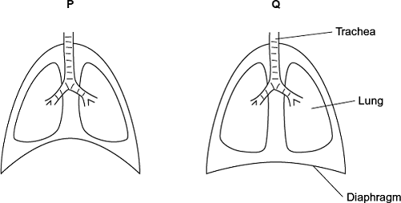

(a) Describe what happens to the diaphragm between times P and Q to bring about the change in its shape. [2]

............................................................................................................................................................................................................................................................................................................................................................................................................................................................................................................................................................................................................................................................................................................................................

(b) Air moves into the lungs between times P and Q. Explain how the diaphragm causes this. [3]

...............................................................................................................................................................................................................................................................................................................................................................................................................................................................................................................................................................................................................................................................................................................................................................................................................................................................................................................................

(c) Describe how oxygen in air in the alveoli enters the blood in capillaries. [2]

............................................................................................................................................................................................................................................................................................................................................................................................................................................................................................................................................................................................................................................................................................................................................

(Total 7 marks)

Q3. The graph shows changes in the volume of air in a person’s lungs during breathing.

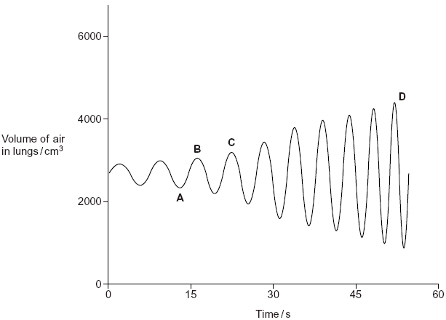

(a) The person was breathing in between times A and B on the graph.

(i) Explain how the graph shows that the person was breathing in between times A and B. [1]

......................................................................................................................................................................................................................................................................................................................................................................

(ii) Describe and explain what happens to the shape of the diaphragm between times A and B. [2]

.........................................................................................................................................................................................................................................................................................................................................................................................................................................................................................................................................................

(b) The person’s pulmonary ventilation changed between times C and D. Describe how the graph shows that the pulmonary ventilation changed. [3]

............................................................................................................................................................................................................................................................................................................................................................................................................................................................................................................................................................................................................................................................................................................................................

(Total 6 marks)

M1.(a) (P) Trachea / windpipe and (Q) bronchus;

For P or Q, accept (ring of) cartilage (i.e. not for both) [1]

(b) (i) (Simple) diffusion; [1]

(ii) 1. Thin walls / cells;

2. (Total) surface area is large; [2]

(Total 4)

M2. (a) 1. Flatten / moves down;

2. (Diaphragm muscle) contracts; [2]

(b) 1. Diaphragm contracts / moves down / flattens;

2. Increases volume (of thorax);

3. Decrease in pressure;

4. Air moves from high to lower pressure / down pressure gradient; [3 max]

(c) 1. Diffusion;

2. Across (alveoli) epithelium / (capillary) endothelium; [2 max]

(Total 7)

M3. (a) (i) (Lung volume) increases/reaches a maximum (at B); [1]

(ii) Flattens/lowers/moves down;

(Diaphragm/muscle) contracts; [2]

(b) Pulmonary ventilation = tidal volume × breathing rate;

Breathing rate increases/more breaths per min (between C and D)/peaks get closer;

Tidal volume/volume of air (inhaled) per breath increases (between C and D)/deeper breaths;

(Tidal volume increase) qualified by data from graph e.g. approximate three-fold increase/appropriate calculation; [3 max]

(Total 6)