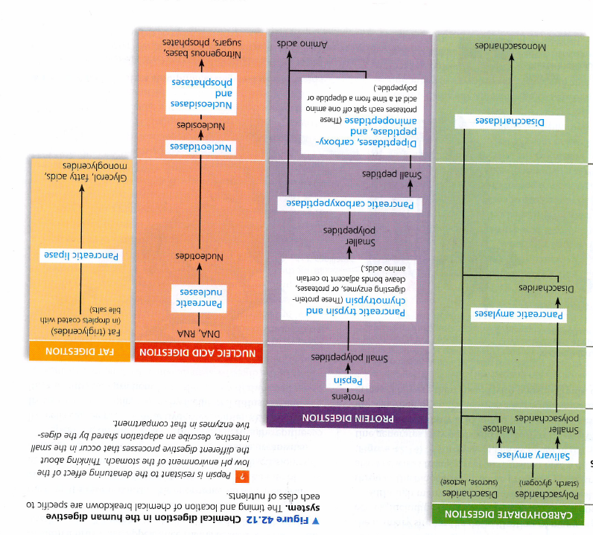

Exopeptidases

Endopeptidases pepsin and trypsin

Stomach

Small intestine (enzymes from pancreas).

Small intestine (enzymes from epithelial cells).

Mouth, oesophagus