**3.4.1 & 3.4.2 DNA, Genes and Chromosomes and Protein Synthesis**

[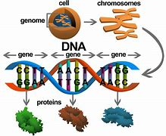](https://www.bing.com/images/search?view=detailV2&ccid=NhYzu/B/&id=C4350EAE550F146F34855CD4741D8B906C9F9A29&thid=OIP.NhYzu_B_k4wGL3gfonbhWwHaGT&mediaurl=http://thinnergene.com/wp-content/uploads/2014/06/geneimageWIP007.png&exph=681&expw=800&q=dna+genes+and+chromosomes&simid=608043968927172475&selectedIndex=8&cbir=sbi)

**Section 1 – Recall**

**What does this section contain and why?** Activities to develop your recall of information you covered in the previous topics that are linked to DNA, genes and chromosomes, and protein synthesis. You should do this before you start the work on these topics. Once you have done the recall activity quickly check what you have done with the student booklets from that topic.

**Topics covered**: Biological molecules and cells

|  |  |  |  |
| --- | --- | --- | --- |
| **Topic** | **Recall activities** | **Understanding**  *Please write down any questions you have when completing this activity.* | **Completed** |
| **Biological molecules** | On the MWB/scrap paper draw and label a DNA molecule. Name the bonds that are found in the molecule |  |  |
| On the MWB/scrap paper draw the basic structure of an amino acid |  |  |
| On the MWB/scrap paper list the different structures of a protein |  |  |
| **Cells** | On the MWB/scrap paper draw a eukaryotic cell. Label and describe the function of each organelle |  |  |

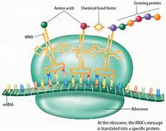

**Section 2 – Independent pack framework**

|  |  |  |  |  |
| --- | --- | --- | --- | --- |
| **Key info** | Topic: DNA, Genes and Chromosomes and Protein Synthesis  Synoptic Link: Biological molecules, cells, gene technologies, | | | |
| **Step 1** | Use the tutorial (GOL), presentation (GOL), video links and text book to complete the pack. | | | |
| **Step 2** | **Learning outcome** | **I understand this** | **I can recall this** | **I need to revisit this** |
| Know that in prokaryotic cells, DNA molecules are short, circular and not associated with proteins. |  |  |  |
| Know that in the nucleus of eukaryotic cells, DNA molecules are very long, linear and associated with proteins, called histones. Together a DNA molecule and its associated proteins form a chromosome. |  |  |  |
| Know that the mitochondria and chloroplasts of eukaryotic cells also contain DNA which, like the DNA of prokaryotes, is short, circular and not associated with protein. |  |  |  |
| Understand that a gene is a base sequence of DNA that codes for:   * the amino acid sequence of a polypeptide * a functional RNA (including ribosomal RNA and tRNAs) |  |  |  |
| Understand that a gene occupies a fixed position, called a locus, on a particular DNA molecule. |  |  |  |
| Understand that a sequence of three DNA bases, called a triplet, codes for a specific amino acid. The genetic code is universal, non-overlapping and degenerate. |  |  |  |
| Understand that in eukaryotes, much of the nuclear DNA does not code for polypeptides and explain the difference between non-coding multiple repeats of base sequences between genes, exons and introns. |  |  |  |
| Explain what the terms genome and proteome. |  |  |  |
| Know the structure of molecules of messenger RNA (mRNA) and of transfer RNA (tRNA). |  |  |  |
| Understand the process of transcription as the production of mRNA from DNA. The role of RNA polymerase in joining mRNA nucleotides. |  |  |  |
| Differentiate between transcription; in prokaryotes, which results directly in the production of mRNA from DNA.  And eukaryotes, transcription results in the production of pre-mRNA; this is then spliced to form mRNA. |  |  |  |
| Understand the process of translation as the production of polypeptides from the sequence of codons carried by mRNA. The roles of ribosomes, tRNA and ATP. |  |  |  |
| **Step 3** | In lesson: you will be undertaking activities to develop your understanding of the learning objectives and able to add to your notes. | | | |

**3.4.1 DNA, Genes and Chromosomes**

**Read the article: What is a chromosome? (Biological sciences review September 2011) and answer the following questions on file paper. Staple your answers to the back of the booklet.**

1. What is the difference in the way that prokaryotic and eukaryotic DNA is arranged and stored?
2. In non-dividing eukaryotic cells the chromosomes are unraveled and genetically active. What is their appearance at the beginning of mitosis?
3. What is the length of the total DNA in a newly divided human cell?
4. How many base pairs would this accommodate?
5. What is ‘junk’ DNA now called?
6. What is the non coding DNA thought to be needed for?
7. What analogy is given to describe the first stage of DNA packaging in humans?
8. What analogy is given to demonstrate the amazing feat of shortening and supercoiling chromatin into a chromosome?
9. Do all species have the same number of chromosomes? Provide evidence for your answer.
10. Human DNA is arranged in 23 pairs of chromosomes (homologous pairs, one from mum and one from dad, each carrying the same genes but not necessarily the same alleles of the genes). How many base pairs of DNA are there in our largest pair of chromosomes (pair1)? And our smallest pair (pair 21)?
11. Why is chromosome pair 1 medically important?

**DNA storage in Eukaryotes and Prokaryotes**

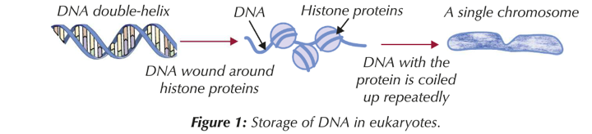

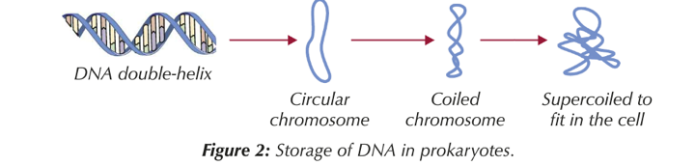

**Complete the table to compare and contrast prokaryotic and eukaryotic DNA**

|  |  |  |
| --- | --- | --- |
| **Feature** | **Eukaryotic** | **Prokaryotic** |
| **Location** |  |  |
| **Length** |  |  |
| **Shape** |  |  |
| **Histones** |  |  |

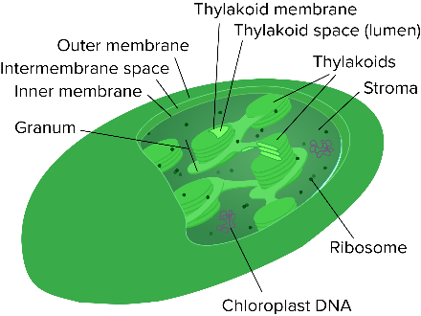**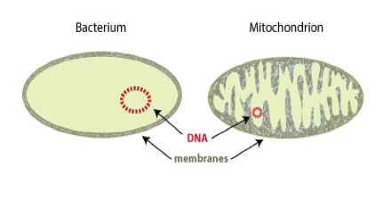Mitochondria and Chloroplasts**

How does the DNA in mitochondria and chloroplasts resemble prokaryotic DNA?

…………………………………………………………………………………………………………………………………………………………………………………………………………………………………………………………………………………………………………………………………………………………………………

What does this suggest about the origin of these eukaryotic organelles?

…………………………………………………………………………………………………………………………………………………………………………………………………………………………………………………………………………………………………………………………………………………………………………

What’s the name of this theory?

…………………………………………………………………………………………



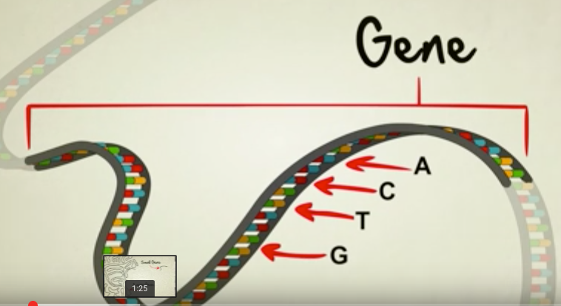**What is a gene?**

What is a **gene?**

……………………………………………………………………………………………………………………………………………………………………………………………………………………

What is an **allele?**

……………………………………………………………………………………………………………………………………………………………………………………………………………………

What is a l**ocus?**

……………………………………………………………………………………………………………………………………………………………………………………………………………………

What does **homologous** pair of chromosomes mean?

……………………………………………………………………………………………………………………………………………………………………………………………………………………

…………………………………………………………………………………………………………

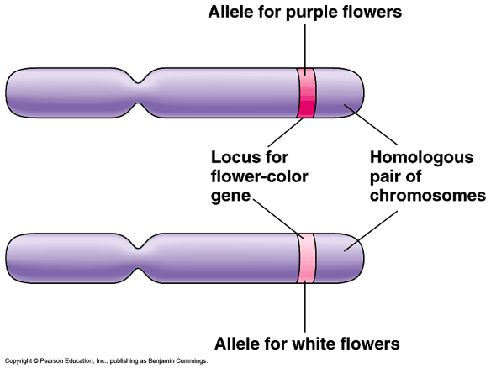

Watch the following 5 minute video

**(**[**https://www.youtube.com/watch?v=5MQdXjRPHmQ**](https://www.youtube.com/watch?v=5MQdXjRPHmQ)**) by *Stated clearly*** and answer the questions that follow:

1. What do genes code for?

..........................................................................................................................................................................................................................................................................................................

1. What letters provide the basic code?

.....................................................................................................................................................

1. Can genes vary in size?

..........................................................................................................................................................................................................................................................................................................

1. What determines the size and shape of a protein?

..........................................................................................................................................................................................................................................................................................................

1. Humans and chimps share 96% of their genetic code. What percentage of genes does a fruit fly have in common with a human?

..................................................................................................................................................... **The Genetic Code**

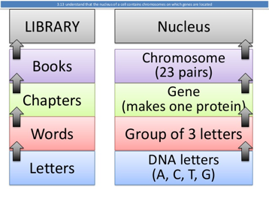The genetic code is known as a **triplet code**. Why is this?

…………………………………………………………………………………………………

…………………………………………………………………………………………………

What other word is used for ‘triplet’?

…………………………………………………………………………………………………

What does each triplet code for?

…………………………………………………………………………………………………

Why wouldn’t a doublet code work?

…………………………………………………………………………………………………………………………………………………………

…………………………………………………………………………………………………………………………………………………………

If a polypeptide is made up of 24 amino acids, what is the minimum number of bases that the gene coding for it must have had?

…………………………………………………………………………………………………………………………………………………………

**Features of the genetic code**

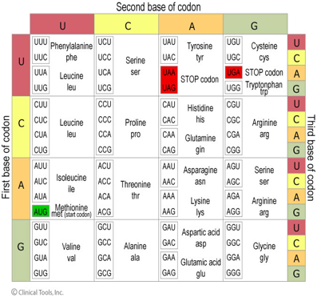1. **Degenerate**

Most amino acids are coded for by more than one triplet. A triplet is always read in the same direction along the DNA.

Start and stop codes operate, rather like capital letters and full stops in sentences.

What are the three stop codons?

……………………………………………………………………………

What is the start codon that codes for the amino acid methionine?

……………………………………………………………………………

2. **Non overlapping**

Each base in the sequence is only read once.

Show below how TACGCTCCGCTGTAC would be read.

………………………………………………………………………………..

How could it be read if the code was an overlapping code?

………………………………………………………………………………..

3. **Universal** (providing indirect evidence for the process of evolution)

With a few minor exceptions each triplet codes for the same amino acid in all organisms.

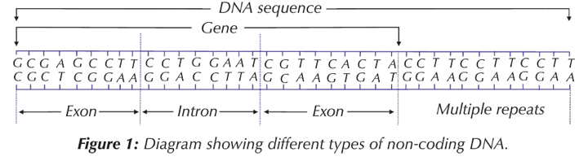

**Eukaryotic DNA**

* Much of the DNA in eukaryotes does not code for polypeptides.
* Between genes there are non-coding regions of multiple repeats of base sequences.
* Even within genes, only certain sequences code for amino acids.
* Coding sequences are called exons.
* Within a gene, non coding sequences are called introns.
* Some genes code for RNA (ribosomal and transfer RNA).
* Introns are thought to be remnants of sequences earlier in evolution and needed for gene regulation. They are no longer considered to be ‘junk’ sequences; damage to non-coding regions can cause cell death.

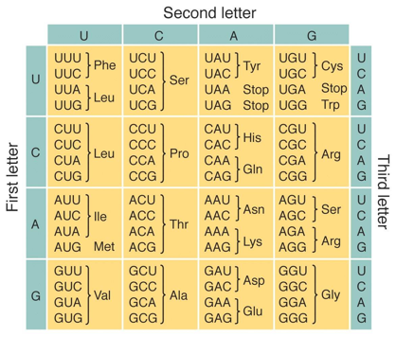**Exam Question**

1. List the two amino acids that have only one codon and state what it is in each case

………………………………………………………………………………

2. Name the amino acids that have each of the following codons: CUC, AAA, GAU

………………………………………………………………………………

3. For each of the following base sequences on the DNA molecule, deduce the sequences of amino acids in the order they would occur in the resulting polypeptide. (You need to work out the mRNA code first)

1. ATGCGTTAAGGCAGT

…………………………………………………………………………………………………..……………………………………………………………………

b) GCTAAGTTTCCAGAT

…………………………………………………………………………………………………..……………………………………………………………………

**What is the genome and the proteome?**

**Genome:**

…………………………………………………………………………………………………………………………………………………………

…………………………………………………………………………………………………………………………………………………………

**Proteome:**

…………………………………………………………………………………………………………………………………………………………

…………………………………………………………………………………………………………………………………………………………

**3.4.2 DNA, Genes and Protein Synthesis**

There are 2 types of RNA that are important in protein synthesis. In the space provided makes notes on the structure and function of these 2 types of RNA.

|  |  |
| --- | --- |
| **Messenger RNA (mRNA)** | **Transfer RNA (tRNA)** |
| See the source image | See the source image |
|  |  |

**Independent Work**

Watch or read the following and then make notes in the appropriate sections below. Ensure that you come to the lesson with specific questions to ask your teacher.

1. Watch <https://www.youtube.com/watch?v=zwibgNGe4aY>
2. Read Pgs. 211 – 214 of the text book AQA Biology, Toole & Toole
3. Watch Crash course <http://www.youtube.com/watch?v=itsb2SqR-R0>

|  |  |
| --- | --- |
| **Transcription** | |
| **Translation** | |
| **Key Words** | **Questions** |

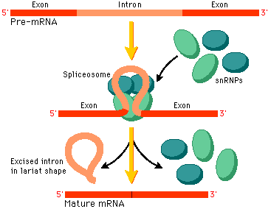**Transcription Questions**

What are start and stop codons?

……………………………………………………………………………………………………

……………………………………………………………………………………………………

Why is splicing of pre mRNA necessary?

……………………………………………………………………………………………………

Which organisms do not need to splice and why?

…………………………………………………………………………………………………………

…………………………………………………………………………………………………………

…………………………………………………………………………………………………………

Explain how splicing occurs.

…………………………………………………………………………………………………………………………………………………………

…………………………………………………………………………………………………………………………………………………………

…………………………………………………………………………………………………………………………………………………………

…………………………………………………………………………………………………………………………………………………………

Once the mature mRNA is made where does it go in the cell?

…………………………………………………………………………………………………………………………………………………………

Complete the table below with 3 similarities and 4 difference between transcription and DNA replication

|  |  |
| --- | --- |
| **Similarities** | **Differences** |
|  |  |
|  |  |
|  |  |
|  |  |

**Translation**



Where does a ribosome attach itself onto the mRNA molecule?

………………………………………………………………………………………………

………………………………………………………………………………………………

What are the A, E and P sides on the ribosome for?

………………………………………………………………………………………………

………………………………………………………………………………………………

………………………………………………………………………………………………

………………………………………………………………………………………………

How does a peptide bond form between 2 amino acids in translation?

…………………………………………………………………………………………………………………………………………………………

…………………………………………………………………………………………………………………………………………………………

…………………………………………………………………………………………………………………………………………………………

…………………………………………………………………………………………………………………………………………………………

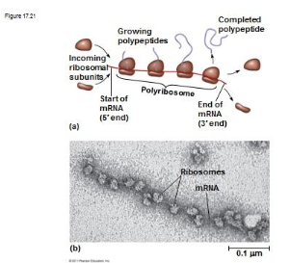

**Polysome System**

Up to 50 ribosomes can pass immediately behind the first, so that many poly peptides can be assembled simultaneously.

**Assembling the protein**

Sometimes a single polypeptide chain is a functional protein.

It is coiled or folded producing what structures? ………………………………. or ……………………………….

That structure is then further folded to form what structure? ……………………………….

What bonds are formed? ……………………………….……………………………….……………………………….……………………………….

What type of protein will be made if more than one polypeptide chain is brought together and bonded?

……………………………….……………………………….

What organelle is used to modify the protein if necessary? ……………………………….