**3.4.3 Genetic diversity can arise as a result of mutation or during meiosis**

**Section 1 – Recall**

**What does this section contain and why?** Activities to develop your recall of information you covered in the previous topics that are linked to mutations and meiosis. You should do this before you start the work on these topics. Once you have done the recall activity quickly check what you have done with the student booklets from that topic.

**Topics covered**: Biological molecules and cells

|  |  |  |  |
| --- | --- | --- | --- |
| **Topic** | **Recall activities** | **Understanding**  *Please write down any questions you have when completing this activity.* | **Completed** |
| **Biological molecules** | On the MWB/scrap paper draw and label a DNA molecule. Name the bonds that are found in the molecule |  |  |
| On the MWB/scrap paper draw the basic structure of an amino acid |  |  |
| **Cells** | On the MWB/scrap paper draw the cell cycle and list all the activities and metabolic processes that occur in interphase |  |  |
| On the MWB/scrap paper draw the stages of mitosis and annotate what is happening in the cells at each stage. |  |  |
| **Genetic code** | On the MWB/scrap paper explain the 3 features of the genetic code: degenerate, non-overlapping and universal |  |  |

[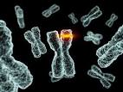](https://www.google.co.uk/url?url=https://www.thoughtco.com/dna-mutations-1224595&rct=j&frm=1&q=&esrc=s&sa=U&ved=0ahUKEwj9mYTc_9faAhUoIsAKHQZvBOsQwW4IFjAA&usg=AOvVaw3uZfwTP-F4hAnMv6b5WX7O)[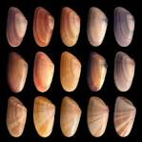](http://www.google.co.uk/url?url=http://www.industrytap.com/unfortunate-side-effects-evolution-unwanted-genetic-variations/35196&rct=j&frm=1&q=&esrc=s&sa=U&ved=0ahUKEwjGzoCPgNjaAhXCJMAKHfhHBUwQwW4IIDAF&usg=AOvVaw0jVQdDOiidRSwAfDP_l6nD)

**Section 2 – Independent pack framework**

|  |  |  |  |  |
| --- | --- | --- | --- | --- |
| **Key info** | Topic: Genetic diversity can arise as a result of mutation or during meiosis  Synoptic Link: Biological molecules, cells, gene technologies | | | |
| **Step 1** | Use the tutorial (GOL), presentation (GOL), video links and text book to complete the pack. | | | |
| **Step 2** | **Learning outcome** | **I understand this** | **I can recall this** | **I need to revisit this** |
| Know that gene mutations involve a change in the base sequence of chromosomes. |  |  |  |
| Understand that mutations can arise spontaneously during DNA replication and include base deletion and base substitution. |  |  |  |
| Explain that due to the degenerate nature of the genetic code, not all base substitutions cause a change in the sequence of encoded amino acids. |  |  |  |
| Know that mutagenic agents can increase the rate of gene mutation and be able to name some mutagenic agents. |  |  |  |
| Understand that mutations in the number of chromosomes can arise spontaneously by chromosome non-disjunction during meiosis. |  |  |  |
| Understand that meiosis produces daughter cells that are genetically different from each other. |  |  |  |
| Explain the process of meiosis only in sufficient detail to show how:   * two nuclear divisions result usually in the formation of four haploid daughter cells from a single diploid parent cell * genetically different daughter cells result from the independent segregation of homologous chromosomes * crossing over between homologous chromosomes results in further genetic variation among daughter cells. |  |  |  |
| Be able to complete diagrams showing the chromosome content of cells after the first and second meiotic division, when given the chromosome content of the parent cell. |  |  |  |
| Be able to explain the different outcome of mitosis and meiosis. |  |  |  |
| Be able to recognise where meiosis occurs when given information about an unfamiliar life cycle |  |  |  |
| Be able to explain how random fertilisation of haploid gametes further increases genetic variation within a species. |  |  |  |
| **Step 3** | In lesson: you will be undertaking activities to develop your understanding of the learning objectives and able to add to your notes. | | | |

**Mutations**

Mutations are changes in the quantity or structure of DNA. There are 2 types:

1. **Gene (point) mutations** - a change in one or more nucleotide bases or a change in the sequence of bases, a gene. They can be caused by mutagens or errors during DNA replication.
2. **Chromosome mutation** – a change in the number or structure of the chromosomes, caused by error that occur during cell division.

**Gene Mutations**

Gene mutations may involve a single nucleotide (a point mutation) or a change to a triplet.

Point mutations occur by:

* + Base substitution
  + Base deletion
  + Base insertion

The diagram below shows what happens in these point mutations.

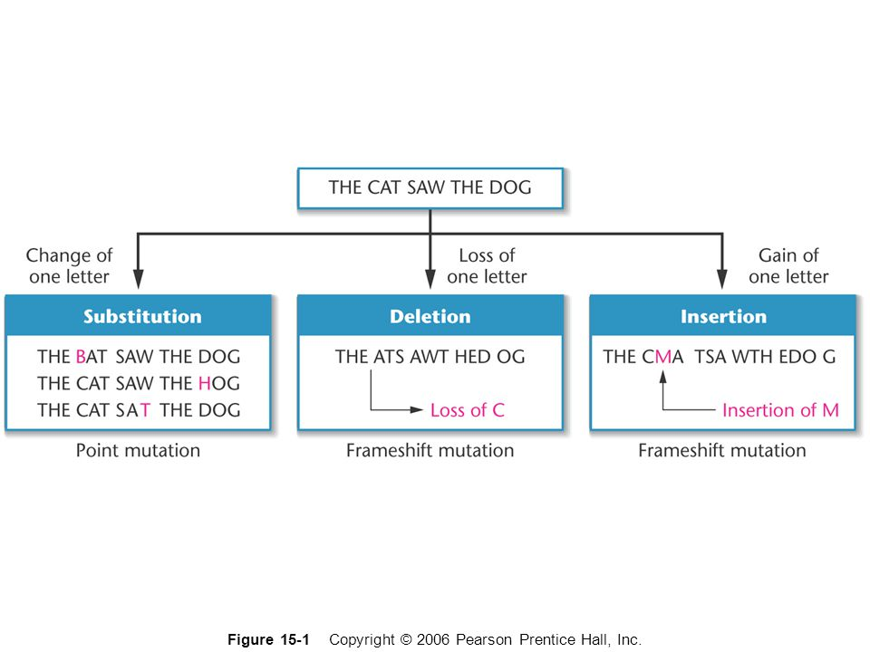

These changes alter the mRNA transcribed but, because the genetic code is degenerate it may not alter the amino acid sequence. Mutations are the ultimate source of new alleles, although those that cause a change in the amino acid sequence can be harmful. Mutations that occur in gametes have the potential to be passed on to offspring and will affect the next generation.

Mutations can have 3 effects:

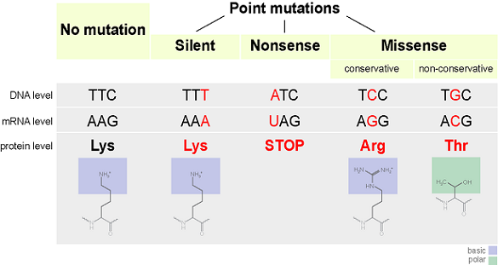

1. **Silent mutations** - those that do not alter the amino acid sequence of the polypeptide even through the nucleotide sequence has changed.
2. **Missense mutations** – those that do alter the amino acid sequence of the polypeptide.
3. **Nonsense mutations** – involve a change from a normal codon to a termination codon. They cause the synthesis of the polypeptide to be terminated.

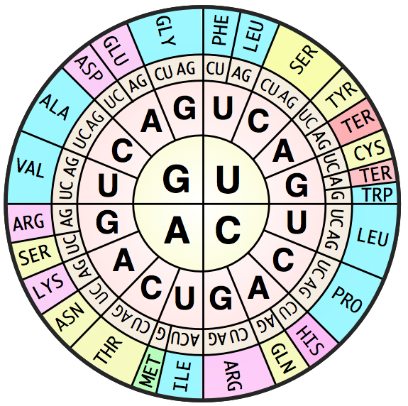**Mutation Activity**

**STOP**

* Sometimes mutations cause only minor changes to a gene and therefore make only minor changes in the protein produced from that gene.
* These types of mutations may cause minor effects to the phenotype of an organisms.
* But sometimes mutations can cause great changes to the gene and therefore greatly alter the protein that is made from that gene.
* This will likely have great effects on the organism, since the protein will not be able to perform its normal function.
* This may lead to the inheritance of a genetic disease.

Work through the following activities and answer the questions.

Below is a template strand of DNA with its complementary mRNA strand and translated amino acid sequence. During these activities you will be referring back to this original sequence of amino acids.

|  |  |  |  |  |  |  |  |  |  |  |  |  |  |  |  |  |  |  |  |  |  |  |  |  |  |  |  |
| --- | --- | --- | --- | --- | --- | --- | --- | --- | --- | --- | --- | --- | --- | --- | --- | --- | --- | --- | --- | --- | --- | --- | --- | --- | --- | --- | --- |
| **DNA** | **T** | **A** | **C** | **T** | **G** | **A** | **G** | **C** | **T** | **C** | **T** | **G** | **C** | **A** | **G** | **C** | **C** | **T** | **G** | **T** | **G** | **T** | **A** | **A** | **A** | **C** | **T** |
| **mRNA** | **A** | **U** | **G** | **A** | **C** | **U** | **C** | **G** | **A** | **G** | **A** | **C** | **G** | **U** | **C** | **G** | **G** | **A** | **C** | **A** | **C** | **A** | **U** | **U** | **U** | **G** | **A** |
| **Amino acid** | **MET** | | | **THR** | | | **ARG** | | | **ASP** | | | **VAL** | | | **GLY** | | | **HIS** | | | **ILE** | | | **STOP** | | |

**Point mutations:** Where one base of DNA is copied incorrectly during DNA replication.

1. The DNA template strand below simulates a point mutation where G was replicated to C on base 15. Using the codon table work out the remaining amino acid sequence and answer the questions below.

|  |  |  |  |  |  |  |  |  |  |  |  |  |  |  |  |  |  |  |  |  |  |  |  |  |  |  |  |
| --- | --- | --- | --- | --- | --- | --- | --- | --- | --- | --- | --- | --- | --- | --- | --- | --- | --- | --- | --- | --- | --- | --- | --- | --- | --- | --- | --- |
| DNA | T | A | C | T | G | A | G | C | T | C | T | G | C | A | C | C | C | T | G | T | G | T | A | A | A | C | T |
| mRNA | A | U | G | A | C | U | C | G | A | G | A | C | G | U | G | G | G | A | C | A | C | A | U | U | U | G | A |
| Amino acid | MET | | | THR | | | ARG | | | ASP | | |  | | |  | | |  | | |  | | |  | | |

Did this change in the DNA sequence cause any significant change to the protein produced? Explain.

………………………………………………………………………………………………………………………………………………………………………………………………………………………………………………………………………………………………………………………………………………………………………………………………………………………………………………………………………………

What is the name of this type of point mutation and why is it referred to by this meaning?

………………………………………………………………………………………………………………………………………………………………………………………………………………………………………………………………………………………………………………………………………………………………………………………………………………………………………………………………………………

1. The DNA template strand below simulates a point mutation where G was replicated to A on base 7. Using the codon table work out the remaining amino acid sequence and answer the questions below.

|  |  |  |  |  |  |  |  |  |  |  |  |  |  |  |  |  |  |  |  |  |  |  |  |  |  |  |  |
| --- | --- | --- | --- | --- | --- | --- | --- | --- | --- | --- | --- | --- | --- | --- | --- | --- | --- | --- | --- | --- | --- | --- | --- | --- | --- | --- | --- |
| DNA | T | A | C | T | G | A | A | C | T | C | T | G | C | A | G | C | C | T | G | T | G | T | A | A | A | C | T |
| mRNA | A | U | G | A | C | U | U | G | A | G | A | C | G | U | C | G | G | A | C | A | C | A | U | U | U | G | A |
| Amino acid | MET | | | THR | | |  | | |  | | |  | | |  | | |  | | |  | | |  | | |

Did this change in the DNA sequence cause any significant change to the protein produced? Explain.

………………………………………………………………………………………………………………………………………………………………………………………………………………………………………………………………………………………………………………………………………………………………………………………………………………………………………………………………………………

What is the name of this type of point mutation and why is it referred to by this terminology

………………………………………………………………………………………………………………………………………………………………………………………………………………………………………………………………………………………………………………………………………………………………………………………………………………………………………………………………………………

1. The DNA template strand below simulates a point mutation where G was replicated to T on base 12. Using the codon table work out the remaining amino acid sequence and answer the questions below.

|  |  |  |  |  |  |  |  |  |  |  |  |  |  |  |  |  |  |  |  |  |  |  |  |  |  |  |  |
| --- | --- | --- | --- | --- | --- | --- | --- | --- | --- | --- | --- | --- | --- | --- | --- | --- | --- | --- | --- | --- | --- | --- | --- | --- | --- | --- | --- |
| DNA | T | A | C | T | G | A | G | C | T | C | T | T | C | A | G | C | C | T | G | T | G | T | A | A | A | C | T |
| mRNA | A | U | G | A | C | U | C | G | A | G | A | A | G | U | C | G | G | A | C | A | C | A | U | U | U | G | A |
| Amino acid | MET | | | THR | | | ARG | | |  | | |  | | |  | | |  | | |  | | |  | | |

Did this change in the DNA sequence cause any significant change to the protein produced? Explain.

………………………………………………………………………………………………………………………………………………………………………………………………………………………………………………………………………………………………………………………………………………………………………………………………………………………………………………………………………………

What is the name of this type of point mutation?

…………………………………………………………………………………………………………………………………………………………

Why could a mutation in a gamete have more of a profound biological consequence than a mutation in a somatic cell?

………………………………………………………………………………………………………………………………………………………………………………………………………………………………………………………………………………………………………………………………………………………………………………………………………………………………………………………………………………

**Frameshift mutation:** Where at least one base is either added or deleted from the DNA as it is copied during DNA replication.

1. The DNA template strand has an additional base between the original 18th & 19th base. The base A was added. Translate the mRNA into its amino acid sequence.

|  |  |  |  |  |  |  |  |  |  |  |  |  |  |  |  |  |  |  |  |  |  |  |  |  |  |  |  |  |
| --- | --- | --- | --- | --- | --- | --- | --- | --- | --- | --- | --- | --- | --- | --- | --- | --- | --- | --- | --- | --- | --- | --- | --- | --- | --- | --- | --- | --- |
| DNA | T | A | C | T | G | A | G | C | T | C | T | G | C | A | G | C | C | T | A | G | T | G | T | A | A | A | C | T |
| mRNA | A | U | G | A | C | U | C | G | A | G | A | C | G | U | C | G | G | A | U | C | A | C | A | U | U | U | G | A |
| A. acid | MET | | | THR | | | ARG | | | ASP | | | VAL | | | GLY | | |  | | |  | | |  | | |  |

Did this change in the DNA sequence cause any significant change to the protein produced? Explain

………………………………………………………………………………………………………………………………………………………………………………………………………………………………………………………………………………………………………………………………………………………………………………………………………………………………………………………………………………

Why are insertions and deletions called ‘frameshift’ mutations?

………………………………………………………………………………………………………………………………………………………………………………………………………………………………………………………………………………………………………………………………………………………………………………………………………………………………………………………………………………

1. The original DNA template strand has had base 4 deleted (between the highlighted bases). Translate the mRNA strand to its amino acid sequence.

|  |  |  |  |  |  |  |  |  |  |  |  |  |  |  |  |  |  |  |  |  |  |  |  |  |  |  |  |
| --- | --- | --- | --- | --- | --- | --- | --- | --- | --- | --- | --- | --- | --- | --- | --- | --- | --- | --- | --- | --- | --- | --- | --- | --- | --- | --- | --- |
| DNA | T | A | C | G | A | G | C | T | C | T | G | C | A | G | C | C | T | G | T | G | T | A | A | A | C | T |  |
| mRNA | A | U | G | C | U | C | G | A | G | A | C | G | U | C | G | G | A | C | A | C | A | U | U | U | G | A |  |
| Amino acid | MET | | |  | | |  | | |  | | |  | | |  | | |  | | |  | | |  | | |

Did this change in the DNA sequence cause any significant change to the protein produced? Explain.

………………………………………………………………………………………………………………………………………………………………………………………………………………………………………………………………………………………………………………………………………………………………………………………………………………………………………………………………………………

Which do you think would cause a more profound biological impact: 1) a deletion/insertion near the beginning of a gene, or 2) a deletion/insertion towards the end of a gene? Explain.

………………………………………………………………………………………………………………………………………………………………………………………………………………………………………………………………………………………………………………………………………………………………………………………………………………………………………………………………………………

**Mutagenic Agents**



Gene and chromosome mutations occur naturally and generally have a low frequency. However, certain chemicals and rays can increase the rate of frequency of mutation. These are called mutagenic agents and include:

Chemicals: such as mustard gas, caffeine, Benzopyrene found in tobacco smoke and colchicine

Irradiation: such as U-V radiation, X-rays and gamma rays

Infection agents: such as HPV and *Helicobacter pylori*

**Meiosis**

Meiosis is cell division that produces 4 daughter cells each with half the number of chromosomes as the parent cell.

**Importance of Meiosis**

In sexual reproduction gametes are able to fuse and result in a new organism, it is essential that the number of chromosomes should stay constant. Humans have 46 chromosomes in each cell. If each gamete had 46 chromosomes, then fusing 2 together would result in a zygote with 92 chromosomes, whose offspring would have 184 chromosomes and so on. Therefore the number of chromosomes must be halved at some stage in a lifecycle.

This halving occurs as a result of meiosis.

The terms **diploid (2n)** and **haploid (n)** refer to the number of sets of chromosomes. In humans, **somatic** cells (i.e. cells other than gametes) are diploid because there are **two** sets of chromosomes. Gametes are haploid because they have only **one** set of chromosomes.

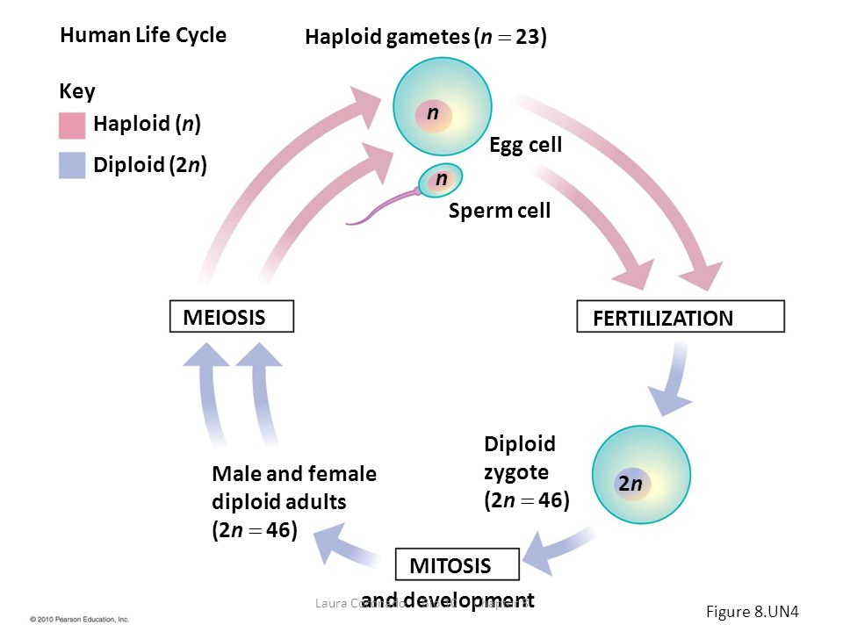Human life cycle

Fern life cycle

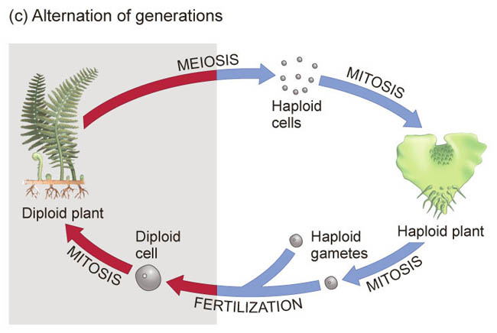

**Exam Question**

The diagram shows the life cycle of a fern plant. Drawings of the chromosomes during cell division are shown for the stages that give the spore-producing plant and the gamete-producing plant.

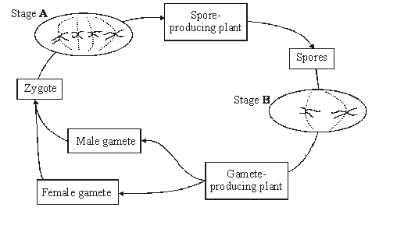

(i)      What is the diploid number of chromosomes in this fern plant?

_________________________________________________________________________

**(1)**

(ii)     Explain the difference in the number of chromosomes at stages **A** and **B**.

_________________________________________________________________________

_________________________________________________________________________

**(1)**

(iii)     Are the male and female gametes produced by mitosis or meiosis?

Explain your answer.

_________________________________________________________________________

_________________________________________________________________________

_________________________________________________________________________

**(2)**

**The Process of Meiosis**

Annotate the stages of meiosis in the diagram below.

Describe the appearance and behaviour of the chromosomes at each stage.

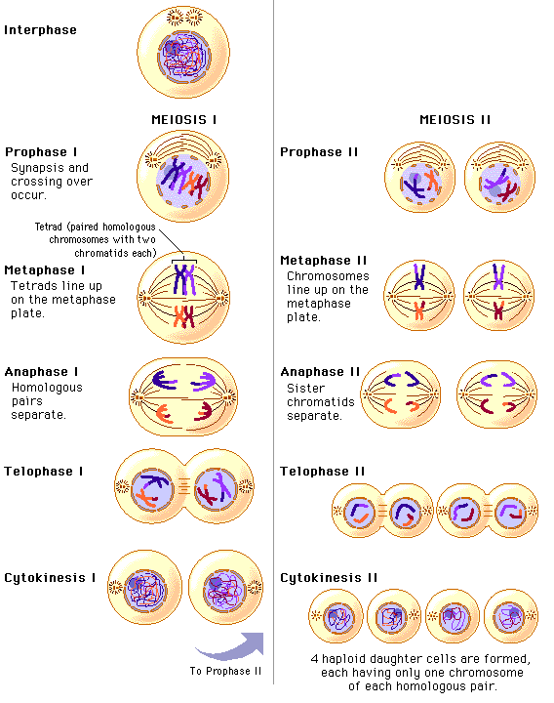



**Meiosis and genetic variation**

**Crossing over**

Label the diagram below and describe the process of crossing over and explain why it is so important in meiosis.

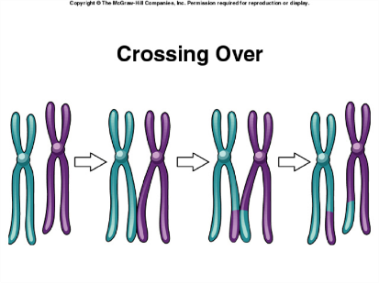

**Independent segregation** (random assortment)

Explain how independent segregation produced new genetic combinations.

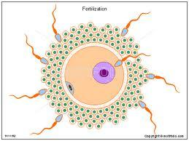**Random fertilisation**

Further genetic combinations are increased through the random pairing of male and female gametes at fertilisation.

**Crossing over problems**

Crossing over can occur in multiple places in chromosomes and produce a huge amount of genetic variation. The diagram below shows a pair of homologous chromosomes about to undergo chiasma formation. These crossover points happen along the length of a chromatid. Use the diagram to work through the questions below.

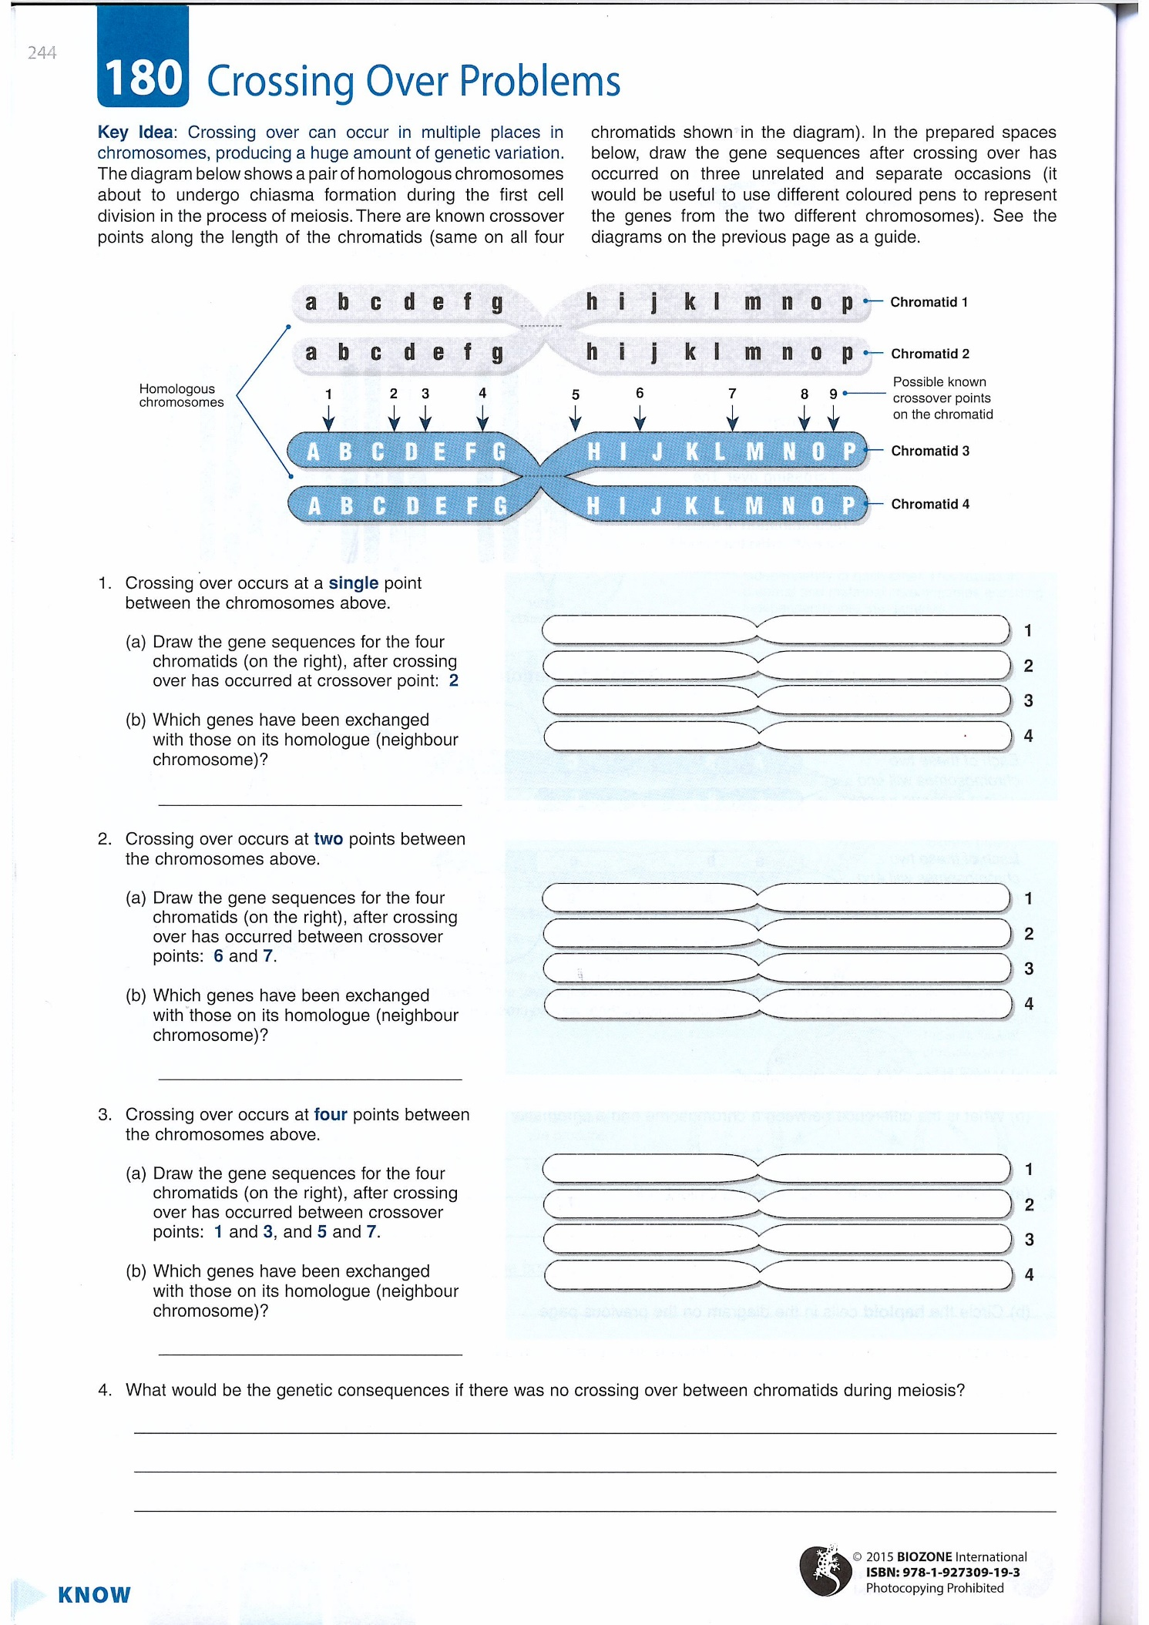

1. 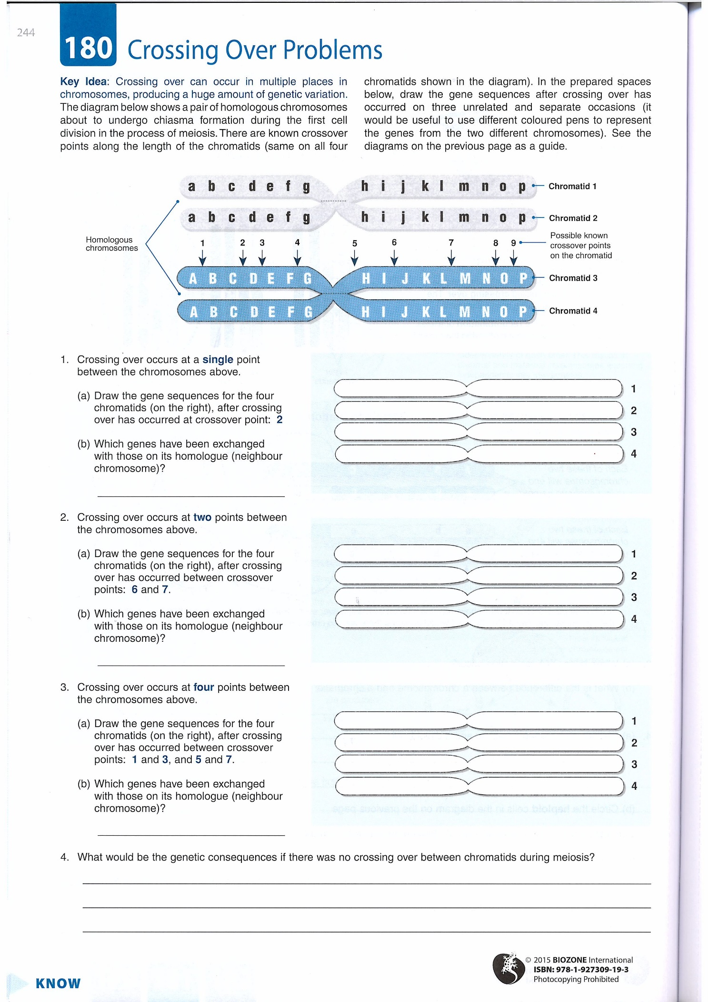Crossing over occurs at a single point between the chromosomes above.
   1. Draw the gene sequence for the four chromatids (on the right), after crossing over has occurred at crossover point 2.
   2. Which genes have been exchanged with those on its homologue (neighbour chromosome)
2. Crossing over occurs at two points between the chromosomes above.
   1. Draw the gene sequence for the four chromatids (on the right), after crossing over has occurred at crossover points 6 & 7.
   2. Which genes have been exchanged with those on its homologue (neighbour chromosome).
3. Crossing over occurs at four between the chromosomes above.
   1. Draw the gene sequence for the four chromatids (on the right), after crossing over has occurred at crossover points 1 & 3 and 5 & 7.
   2. Which genes have been exchanged with those on its homologue (neighbour chromosome)
4. What would be the consequence if there was no crossing over between chromatids during meiosis?

………………………………………………………………………………………………………………………………………………………………………………………………………………………………………………………………………………………………

**Mathematical calculations of chromosome combinations**

1. Homologous pairs of chromosomes line up at the equator of a cell and each one of the pair can pass onto a daughter cell (independent segregation) and there are a large number of possible combinations in any daughter cell.

To calculate the possible combinations use the formula:

2n where n = the number of pairs of homologous chromosomes

1. Possible combinations of chromosomes from random fertilisation where gametes come from different parents with different alleles combined provides variation.

To calculate the possible combinations use the formula:

(2n)2 where n = the number of pairs of homologous chromosomes

This formula is based on no crossing over occurring which causes even more chromosome combinations in gametes.

**Worked example**

Calculate the number of possible chromosome combinations produced from the fertilisation of 2 gametes from separate individuals whose diploid number is 12 (assume no crossing over)

12 = diploid number

Therefore the number of pairs of homologous chromosomes = 12÷2 = 6

Using (2n)2 so (26)2 = 4096

**Practise questions**

1. Calculate the number of possible chromosome combinations produced from the fertilisation of 2 gametes, each of which contains 5 chromosomes.

………………………………………………………………………………………………………………………………………………………………………………………………………………………………………………………………………………………………………………………………………………………………………………………………………………………………………………

1. **Figure 1** and **Figure 2** show the chromosomes from a single cell at different stages of meiosis.

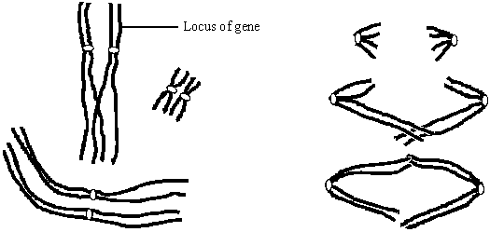

**Figure 1                                                                    Figure 2**

(a)     What is the diploid number of chromosomes in the organism from which this cell was taken?

___________________________________________________________________

**(1)**

(c)     (i)      The genotype of this organism is **Bb**. The locus of this pair of alleles is shown in **Figure 1**.

Label **two** chromosomes on **Figure 2** to show the location of the **B** allele and the location of the **b** allele.

**(1)**

(ii)     How many genetically different gametes can be produced by meiosis from a cell with the genotype, **Bb Cc Dd**? Assume these genes are located on different pairs of homologous chromosomes. Show your working.

______________________________________________________________

**(2)**

**(Total 8 marks)**

**Chromosome mutations**

Chromosome mutations are changes in structure or number of whole chromosomes. They can take 2 forms:

1. **Changes in whole sets of chromosomes**.

When organisms have 3 or more sets of chromosomes rather than the usual 2 and is known as polyploidy.

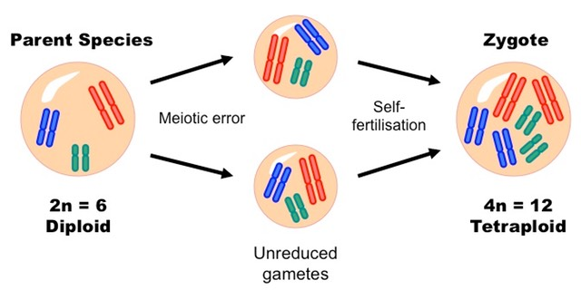

Polyploidy occurs in some animals (goldfish, salamanders and salmon) but is common among ferns and flowering plants. Wheat has diploid (2n), tetraploid (4n) and hexaploid (6n) species. Polyploidy can be induced in plants and cell cultures by using chemicals such as colchicine which results in chromosome doubling.

(Extension article on polyploidy on GOL)

1. **Change in the number of individuals chromosomes**.

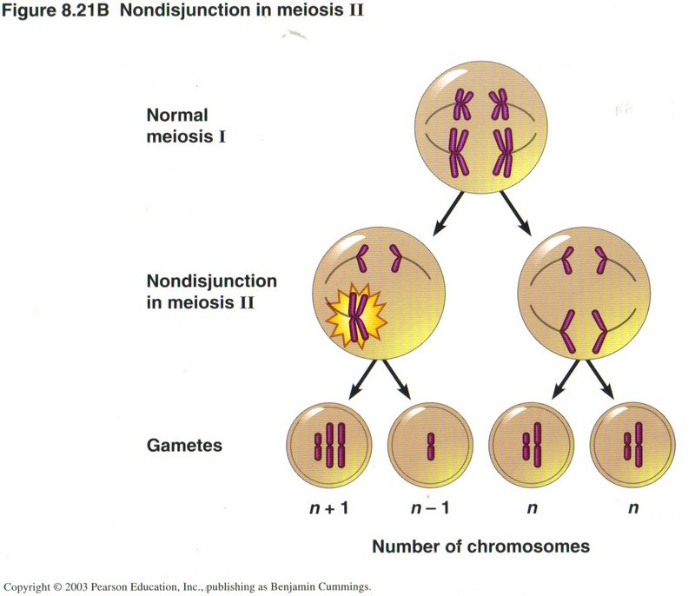Sometimes individual homologous pairs of chromosomes fail to separate during meiosis. This is known as non-disjunction and usually results in a gamete having either one more of one fewer chromosomes. On fertilisation these gametes offspring will have more of fewer chromosomes than their body cells. Downs syndrome is an example of non-disjunction where individuals have an additional chromosome 21.