**3.4 Genetic Diversity and Adaptation**

**Section 1 – Recall**

**What does this section contain and why?** Activities to develop your recall of information you covered in the previous topics that are linked to Genetic diversity and adaptation. You should do this before you start the work on these topics. Once you have done the recall activity quickly check what you have done with the student booklets from that topic.

**Topics covered:** Biological molecules, meiosis and protein synthesis

|  |  |  |  |
| --- | --- | --- | --- |
| **Topic** | **Recall activities** | **Understanding**  *Please write down any questions you have when completing this activity.* | **Completed** |
| **Biological molecules** | On the MWB/scrap paper draw and label a DNA molecule. Name the bonds that are found in the molecule |  |  |
| On the MWB/scrap paper describe and explain protein structure |  |  |
| **Genetic code** | On the MWB/scrap paper draw and label a pair of homologous chromosomes after DNA replication. |  |  |
| On the MWB/scrap paper give definitions of an allele, a gene, a chromosome and a chromatid. |  |  |
| On the MWB/scrap paper describe how the DNA base sequence is linked to protein structure. |  |  |

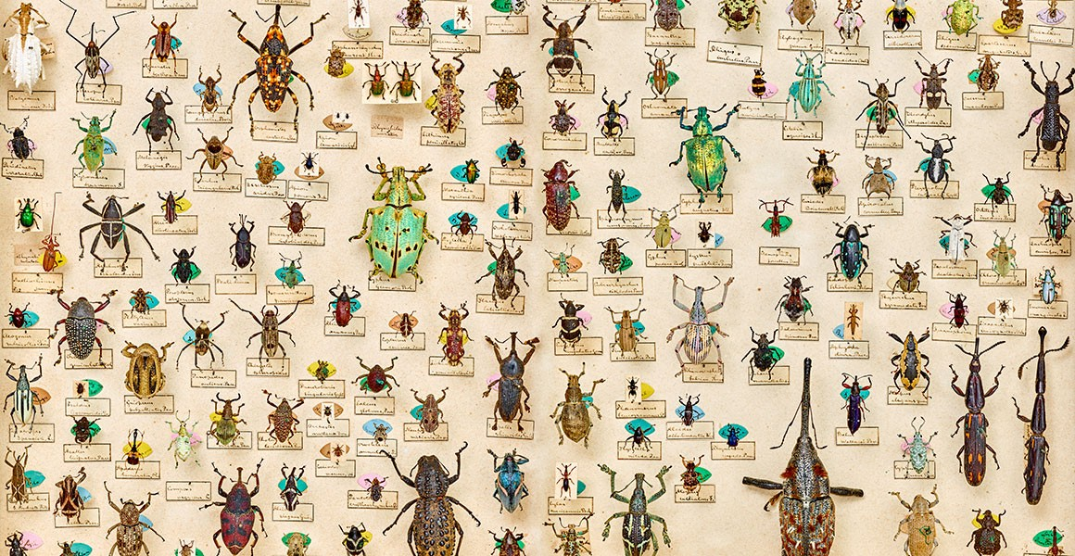

**Section 2 - Independent pack framework**

|  |  |  |  |  |
| --- | --- | --- | --- | --- |
| **Key Info** | **Topic**: Genetic variation and relationships between organisms  **Synoptic link**: Biological molecules, mitosis, meiosis and protein synthesis | | | |
| **Step 1** | Use the tutorial (GOL) presentation, video links and textbook to complete the independent pack | | | |
| **Step 2** | **Learning outcome** | I understand this | I can recall this | I need to revisit this |
| Understand that genetic diversity is the number of different alleles of genes in a population. |  |  |  |
| Understand that genetic diversity is a factor enabling natural selection to occur. |  |  |  |
| Explain the principles of natural selection in the evolution of populations as:  • Random mutation can result in new alleles of a gene.  • Many mutations are harmful but, in certain environments, the new allele of a gene might benefit its possessor, leading to increased reproductive success.  • The advantageous allele is inherited by members of the next generation.  • As a result, over many generations, the new allele increases in frequency in the population. |  |  |  |
| Explain directional selection as exemplified by antibiotic resistance in  bacteria. |  |  |  |
| Explain stabilising selection as exemplified by human birth weights. |  |  |  |
| Describe how natural selection results in species that are better adapted to their environment and that these adaptations may be anatomical, physiological or behavioural. |  |  |  |
| Students should be able to:  • use unfamiliar information to explain how selection produces changes within a population of a species  • interpret data relating to the effect of selection in producing change within populations  • show understanding that adaptation and selection are major factors in evolution and contribute to the diversity of living organisms. |  |  |  |
| **Step 3** | **In Lesson**: You will be undertaking activities to develop your understanding of the learning objectives and able to add to your notes | | | |

**Genetic diversity and adaptation**

**Preparatory work**

Watch the tree of life (<https://www.youtube.com/watch?v=H6IrUUDboZo>)

Answer the following questions:

1. What was the first multicellular organism?

________________________________________________________________________________

2. When did creatures move from water to land?

________________________________________________________________________________

3. What was the first species of animals that was able to move away from the sea because it laid watertight eggs?

________________________________________________________________________________

4. What is the only ancestor of the dinosaur still alive today?

________________________________________________________________________________

**Organisms Show Variation**

We now know that:

* DNA determines the proteins of an organism.
* Proteins determine the features of an organism.
* Similarities and differences between organisms mean *variations* in the DNA sequence.
* Genes code for amino acids to make polypeptide chains
* Members of the same species will have the same genes but may have different alleles

Hence changes in the feature of an organism are due to changes in its DNA. Therefore, differences in DNA lead to the vast genetic diversity that we find on Earth.

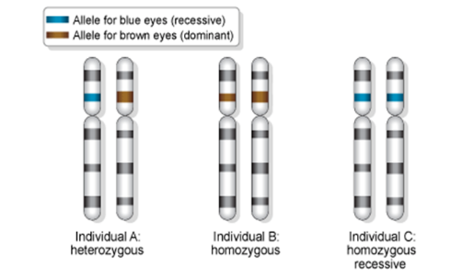

What is an Allele?

________________________________________________________________________________

________________________________________________________________________________

What is meant by recessive and dominant?

________________________________________________________________________________

________________________________________________________________________________

________________________________________________________________________________

________________________________________________________________________________

What is meant by heterozygous and homozygous?

________________________________________________________________________________

________________________________________________________________________________

________________________________________________________________________________

________________________________________________________________________________

What is an example of different alleles in Humans?

________________________________________________________________________________

________________________________________________________________________________

Recall: How are different alleles formed?

________________________________________________________________________________

________________________________________________________________________________

________________________________________________________________________________

________________________________________________________________________________

**Glossary of terms**

|  |  |
| --- | --- |
| **Genetic diversity** |  |
| **Population** |  |
| **Species** |  |
| **Population bottleneck** |  |
| **Founder effect** |  |
| **Gene pool** |  |
| **Genotype** |  |
| **Phenotype** |  |

Organisms of the same species differ in their *alleles* NOT their *genes*. The combination of alleles makes individuals of the same species different from each other.

The greater the number of different alleles within all members of a species, the greater the genetic diversity. The greater the genetic diversity the more likely the species will be able to adapt to changes. **Explain why this is below.**

1. ______________________________________________________________________________

________________________________________________________________________________

________________________________________________________________________________

2. ______________________________________________________________________________

________________________________________________________________________________

________________________________________________________________________________

3. ______________________________________________________________________________

________________________________________________________________________________

________________________________________________________________________________

**Increasing genetic diversity**

In your own words, explain how genetic diversity is increased.

__________________________________________________________________________________________________________________________________________________________________

__________________________________________________________________________________________________________________________________________________________________

__________________________________________________________________________________________________________________________________________________________________

__________________________________________________________________________________________________________________________________________________________________

__________________________________________________________________________________________________________________________________________________________________

What factors reduce genetic diversity?

1. _____________________________

2. _____________________________

3. _____________________________

**Genetic Bottlenecks**

In the space below the diagram, explain what a genetic bottleneck is.

__________________________________________________________________________________________________________________________________________________________________

__________________________________________________________________________________________________________________________________________________________________

__________________________________________________________________________________________________________________________________________________________________

__________________________________________________________________________________________________________________________________________________________________

What factors can substantially reduce a population?

__________________________________________________________________________________________________________________________________________________________________

What has happened to the number of alleles found in the reduced population after the bottleneck?

__________________________________________________________________________________________________________________________________________________________________

What is reduced in the new population?

_________________________________________________________________________________

**Selective breeding** (Artificial selection)

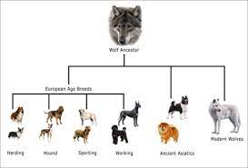Individuals are chosen with desired characteristics and ONLY those individuals are allowed reproduce. Offspring without the desired characteristics are killed or prevented from reproducing. Therefore, unwanted alleles are bred out of the population. This has been used to breed dogs and domesticated animals. Future generations of selectively bred organisms will all share very **similar genes**. This could make some **diseases** more dangerous as all the organisms would be affected. Also, there's increased risk of genetic disease caused by **recessive genes**. Some genes would be lost, making it more difficult to produce new varieties in the future.

Why is selective breeding still used today?

__________________________________________________________________________________________________________________________________________________________________

**The Founder Effect**

What does the word founder mean?

__________________________________________________________________________________________________________________________________________________________________

It occurs when a few individuals from a population colonise a new region

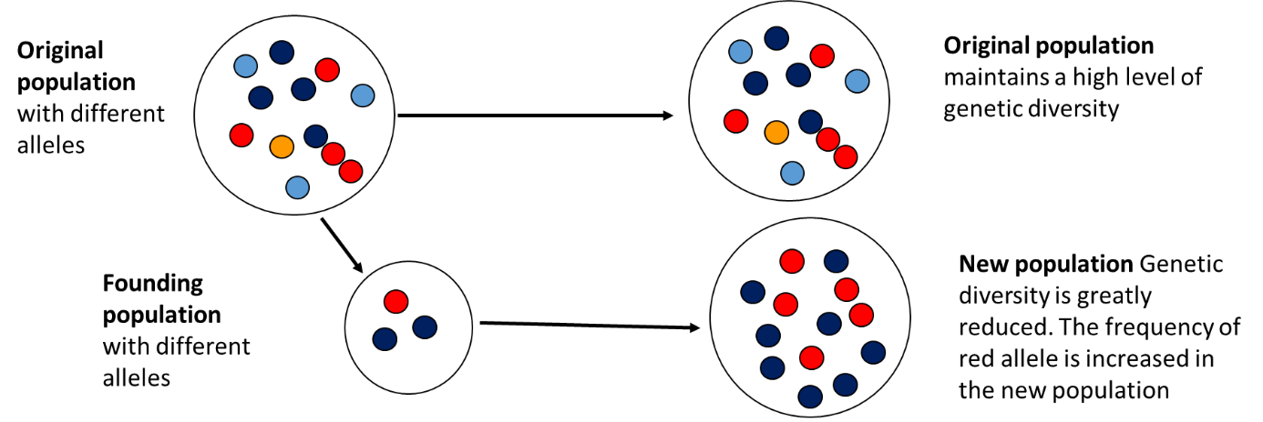

Using the diagram above try and answer the following questions

1. What does the founding effect mean in terms of alleles?

______________________________________________________________________________________________________________________________________________________________

1. Will all of the alleles in the population be present in the founders?

______________________________________________________________________________________________________________________________________________________________

1. What does this mean for the genetic diversity of the new colony?

______________________________________________________________________________________________________________________________________________________________

1. Can you give an example of a founding population?

____________________________________________________________________________________________________________________________________________________________________________________________________________________________________________________________________________________________________________________________

**Natural selection and evolution**

Genetic diversity allows for natural selection which drives evolution. How?

* Not all alleles of a population are equally likely to be passed to the next generation.
* This is because only certain individuals are reproductively successful and so pass on their alleles. This is known as **differential reproductive success**
* Therefore, differences between the reproductive success of individuals affects the allele frequency in a population.

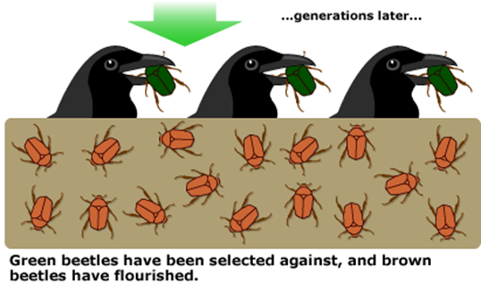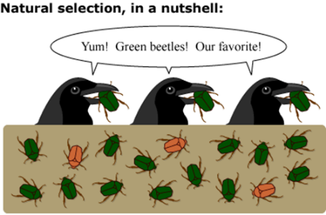

Can you explain what is happening in this diagram above in relation to natural selection?

__________________________________________________________________________________________________________________________________________________________________

__________________________________________________________________________________________________________________________________________________________________

_________________________________________________________________________________

**The process of Natural Selection**

* Within a population there will be a _________ _________containing a wide variety of alleles.
* ___________ _____________of alleles within this gene pool may result in a new allele of a gene which in most cases will be harmful
* However, in certain environments the new allele may give the possessor an ____________ over other individuals in the population
* These individuals will be better ____________and therefore more likely to survive in their competition with others
* These individuals are more likely to obtain the available resources and grow more rapidly, live longer and __________ ____________ producing more offspring
* Only those individuals that reproduce successfully will pass on their alleles to the next generation
* Therefore, it is the new allele that gave the parents an advantage in the competition for survival that is most likely to be passed to the next generation.
* As these individuals have ‘new’ allele more likely to survive and reproduce
* Over many generations the __________________of the ’new’ allele will increase while the non advantageous one will decrease.

**Questions**

**1**. Caribou were taken from the arctic to an area with a warmer climate. In 1810 their mean fur length was 3.5 cm and in 1960 their mean fur length was 2.1 cm.

Using your understanding of natural selection and the information given, explain how natural selection has changed the fur length of caribou.

__________________________________________________________________________________________________________________________________________________________________

__________________________________________________________________________________________________________________________________________________________________

_________________________________________________________________________________

__________________________________________________________________________________________________________________________________________________________________

__________________________________________________________________________________________________________________________________________________________________

**2.** There are many different species of rat snake, all found in different habitats and with slightly different colourings. The black rat snake lives in woodland habitat and has a dark, brown black colouring.

Describe how natural selection could explain the evolution of a rat snake with black colouring in a wooded area? (6 marks)

__________________________________________________________________________________________________________________________________________________________________

__________________________________________________________________________________________________________________________________________________________________

_________________________________________________________________________________

__________________________________________________________________________________________________________________________________________________________________

__________________________________________________________________________________________________________________________________________________________________

__________________________________________________________________________________________________________________________________________________________________

__________________________________________________________________________________________________________________________________________________________________

_________________________________________________________________________________

**Types of adaptations**

**1. Behavioural** – is how an organism acts to increase its chance of survival

Animals playing dead-possum.

Courtship e.g., scorpions dance before mating

**2. Physiological** – These are processes inside an organism that increase its chance of survival

Oxidation of fat rather than carbohydrate in kangaroo rats produces additional water in a desert environment.

**3. Anatomical** -These are structural features of an organism that increases its chance of survival

Shorter ears and thicker fur in arctic foxes compared to foxes in warmer climates.

**Types of selection**

There are two types of selection. Give examples for each one.

1. Directional

__________________________________________________________________________________________________________________________________________________________

1. Stabilising

__________________________________________________________________________________________________________________________________________________________

**Directional Selection**

In the space provided explain what is meant by directional selection

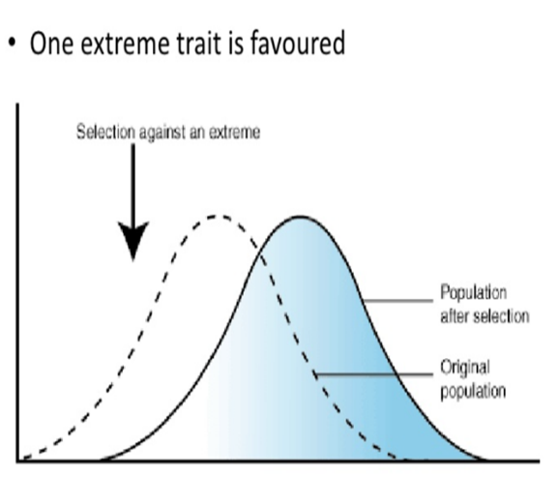__________________________________________________________________________________________________________________________________________________________________

__________________________________________________________________________________________________________________________________________________________________

__________________________________________________________________________________________________________________________________________________________________

__________________________________________________________________________________________________________________________________________________________________

_________________________________________________________________________________

__________________________________________________________________________________________________________________________________________________________________

__________________________________________________________________________________________________________________________________________________________________

**An example where directional selection occurs is in bacteria where the antibiotic resistance allele is a selective advantage.**

**Questions.**

1. How do antibiotics work to kill prokaryotic organisms?

______________________________________________________________________________________________________________________________________________________________________________________________________________________________________________________________________________________________________________________

1. How does resistance to antibiotics occur?

____________________________________________________________________________________________________________________________________________________________

1. Explain why an antibiotic resistant strain of bacteria may be lost within a population?

____________________________________________________________________________________________________________________________________________________________

____________________________________________________________________________________________________________________________________________________________

1. Explain how natural selection increases the frequency of antibiotic resistant bacteria within a population?

____________________________________________________________________________________________________________________________________________________________

____________________________________________________________________________________________________________________________________________________________

____________________________________________________________________________________________________________________________________________________________

**Required Practical 6 – Investigating Microbial Growth**

**Make sure that you learn the method of this investigation and how to analyse the results.**

Testing for bacterial antibiotic resistance using the disc diffusion method is commonly used to test for antibiotic resistance in bacteria.

It allows for multiple antibiotics to be tested at once.

The Aseptic technique needs to be used (see below).

Method

* Pre-soak paper discs in the different antibiotic solutions
* The different antibiotic solutions need to be the same concentration so that the effects of the different antibiotics can be compared
* Spread a sample of the diluted bacterial broth onto the surface of the sterile agar plate
* Lightly press the paper discs onto the surface of the agar
* Make sure the discs are evenly distributed in the plate
* They should not be touching the edges of the plate or any other discs
* Keep the agar plate in the incubator overnight
* The incubator maintains an optimum temperature for bacterial growth
* Remove the agar plate from the incubator and examine the results with the petri dish lid on

Results

* Overnight the antibiotics will diffuse outwards from each paper disk so that a gradient of antibiotic forms. The antibiotic is most concentrated where the paper disk is located
* If the bacteria being investigated is vulnerable to an antibiotic, then a clear area will be visible around the disc
* There are no bacteria present in the clear area
* The clear area will end when the concentration of antibiotic reaches a level that the bacteria are no longer susceptible to
* More effective antibiotics require a lower concentration to kill bacteria and so they will produce larger clear zones
* If a bacterium is completely resistant to an antibiotic, then there will be no clear zone around that particular paper disk

**Aseptic Technique**

This is a technique that is used to prevent contamination of cultures by unwanted microorganisms.

* Washing hands thoroughly with soap
* Disinfecting work surfaces with disinfectant or alcohol
* Using flamed loops or sterile swabs when transferring cultures
* Wearing gloves and goggles
* Flaming culture bottlenecks to prevent contamination
* Sterilising or disposing of all used equipment
* Having a lit Bunsen burner near where you work so convection currents carry bacteria away from the work area.
* Only removing petri dish lids when necessary

**Stabilizing Selection**

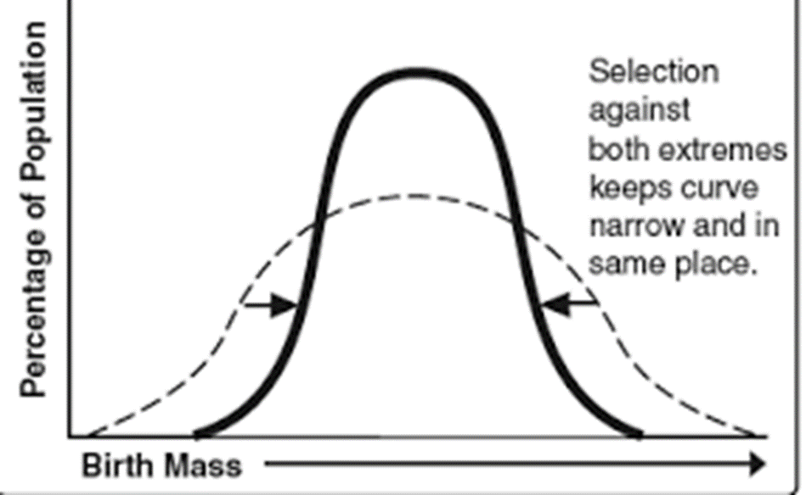In the space provided explain what is meant by stabalising selection

__________________________________________________________________________________________________________________________________________________________________

__________________________________________________________________________________________________________________________________________________________________

__________________________________________________________________________________________________________________________________________________________________

__________________________________________________________________________________________________________________________________________________________________

_________________________________________________________________________________

__________________________________________________________________________________________________________________________________________________________________

**Example of stabalising selection – birth weight**

Why is high and low birth rate detrimental?

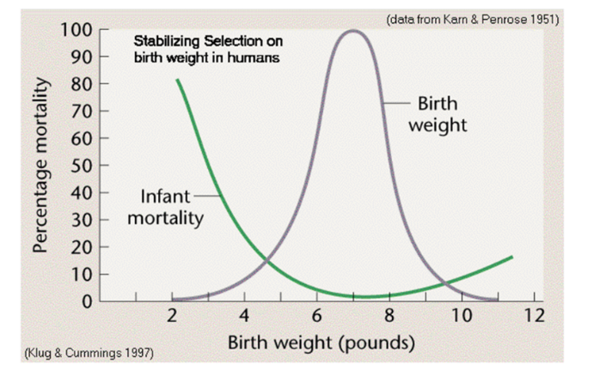__________________________________________________________________________________________________________________________________________________________________

__________________________________________________________________________________________________________________________________________________________________

_________________________________________________________________________________

__________________________________________________________________________________________________________________________________________________________________

**Exam Questions**

**Q1.**

A scientist investigated birth mass in a population of babies. She determined the birth mass (*b*) of babies and grouped this information into different ranges of birth mass.

Her results are shown in the table below.

|  |  |  |
| --- | --- | --- |
| **Birth mass** ***b*** **/ kg** | **Range of mass / kg** | **Frequency density** |
| 0.0 < *b* ⩽ 2.0 | 2.0 | 5 000 |
| 2.0 < *b* ⩽ 2.5 | 0.5 | 20 000 |
| 2.5 < *b* ⩽ 3.0 | 0.5 | 90 000 |
| 3.0 < *b* ⩽ 3.5 | 0.5 | 260 000 |
| 3.5 < *b* ⩽ 4.5 | 1.0 | 200 000 |
| 4.5 < *b* ⩽ 5.5 | 1.0 | 20 000 |

Frequency density is calculated using this equation



(a)     Draw, on **Figure 1**, a **suitable** chart to show the distribution of birth mass for this population of babies.

**Figure 1**

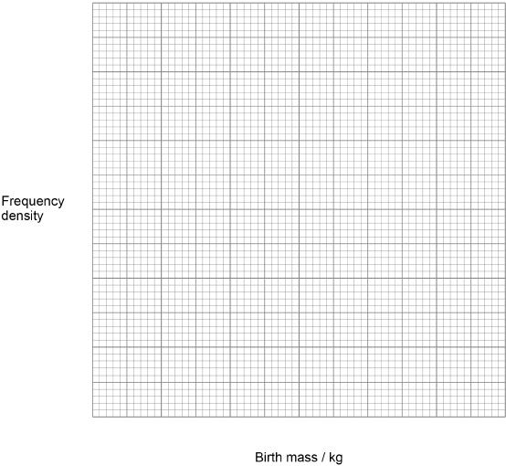

**(4)**

(b)     Babies with birth mass less than 2.5 kg are classified as low birth mass.

Use information in the table above and the equation to calculate the number of babies born with low birth mass in this population.

Show your working.

Answer _______________

**(2)**

The scientist also measured the relationship between birth mass and babies surviving less than 4 weeks. She determined if the mothers of these babies smoked cigarettes during pregnancy. Her results are shown in **Figure 2**.

**Figure 2**

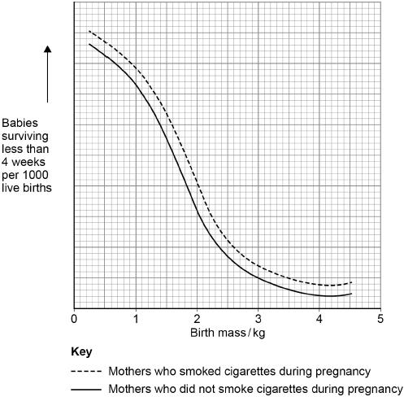

(c)     State **three** conclusions that can be drawn from the data in **Figure 2**.

1 _________________________________________________________________

___________________________________________________________________

___________________________________________________________________

2 _________________________________________________________________

___________________________________________________________________

___________________________________________________________________

3.  ________________________________________________________________

___________________________________________________________________

___________________________________________________________________

**(3)**

**(Total 9 marks)**

**Q2.**

A scientist crossed a strain of the fungus *Neurospora* producing pink spores with a strain of *Neurospora* producing white spores.

To cross these strains, he used aseptic techniques. He moved a small agar cube containing one strain of the fungus onto a new agar plate. Then he placed a second agar cube containing the other strain of fungus next to the first agar cube.

(a)  Describe and explain **three** ways in which the scientist would ensure he used aseptic techniques to move each cube of agar onto a new agar plate.

1  _________________________________________________________________

___________________________________________________________________

___________________________________________________________________

2  _________________________________________________________________

___________________________________________________________________

___________________________________________________________________

3  _________________________________________________________________

___________________________________________________________________

___________________________________________________________________

**(3)**

In the life cycle of *Neurospora* most stages are haploid. Fusion of two haploid strains of this fungus produces diploid zygotes. Nuclear division in these zygotes occurs by meiosis.

(b)  Give **two** differences between mitosis and meiosis.

1  _________________________________________________________________

___________________________________________________________________

___________________________________________________________________

___________________________________________________________________

2  _________________________________________________________________

___________________________________________________________________

___________________________________________________________________

___________________________________________________________________

**(2)**

At the end of meiosis, this fungus produces cells called spores.

The spores are produced in narrow tubes that restrict their movement. As a result, each tube contains a single line of spores. The spores are coloured either pink or white.

The spore colour gene is located on a pair of homologous chromosomes. Each zygote produced in this cross has one chromosome with a pink allele (p) and one chromosome with a white allele (w).

This is shown in the diagram.

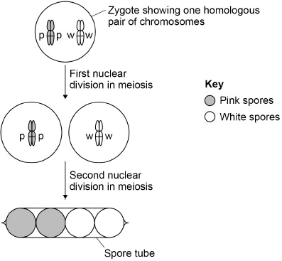

(c)  There are seven chromosomes in a spore nucleus.

Place a tick (**✓**) in the box next to the number that represents the number of **chromatids** present in the zygote shown in the diagram above.

|  |  |
| --- | --- |
| 7 |  |
| 14 |  |
| 21 |  |
| 28 |  |

**(1)**

The scientist recorded the arrangement of coloured spores inside many narrow tubes. His results are shown in the table.

|  |  |  |
| --- | --- | --- |
| **Type of spore tube** | **Arrangement of coloured spores** | **Number of narrow tubes** |
| **1** |  | 81 |
| **2** |  | 78 |
| **3** |  | 10 |

(d)  Using all the information in this question, what can you conclude from the scientist’s results about the movement of chromosomes in meiosis in this fungus?

___________________________________________________________________

___________________________________________________________________

___________________________________________________________________

___________________________________________________________________

___________________________________________________________________

___________________________________________________________________

___________________________________________________________________

___________________________________________________________________

___________________________________________________________________

___________________________________________________________________

___________________________________________________________________

___________________________________________________________________

**(3)**

**(Total 9 marks)**

**Q3.**

Iodine has many uses. One use is as an antiseptic to kill bacteria and another is helping apple farmers decide when to harvest their apples.

Iodine solution has been used as an antiseptic on wounds for over 150 years. At first, its use in hospitals was limited because it irritated people’s skin. In the 1950s, iodine solution was made into providone iodine that caused less skin irritation. A surgeon investigated how effective providone iodine was at killing bacteria on skin.

The surgeon treated the forearms of 25 people in 4 ways.

Treatment **A**   −   no washing

Treatment **B**   −   washed with soap and water only

Treatment **C**   −   washed with soap and water then rubbed with Hex scrub for 5 minutes (Hex scrub was the treatment the surgeon used at that time to wash a patient’s skin before surgery)

Treatment **D**   −   washed with soap and water then rubbed with providone iodine for 5 minutes

After each treatment, the surgeon collected bacteria by rubbing each person’s skin with a sterile cotton swab. He put the swab into sterile liquid agar. He then poured the agar into a Petri dish and allowed it to set. He incubated the Petri dish and when bacterial colonies had grown, he counted them.

The surgeon’s results are shown in the table below.

|  |  |
| --- | --- |
| **Treatment** | **Mean number of bacterial colonies (± standard deviation)** |
| **A** | 401.6 (±96.4) |
| **B** | 191.4 (±63.7) |
| **C** | 25.9 (±15.6) |
| **D** | 0.7 (±1.5) |

(a)     Suggest **three** factors the surgeon kept constant when sampling from the skin and growing the bacterial colonies.

1. _________________________________________________________________

___________________________________________________________________

2. _________________________________________________________________

___________________________________________________________________

3. _________________________________________________________________

___________________________________________________________________

**(3)**

(b)     Calculate the percentage difference in mean number of bacterial colonies for Treatment **D** compared with Treatment **A**. Show your working.

Answer ________________________________________ %

**(2)**

(c)     Treatment **D** produced a mean of 0.7 colonies and a standard deviation of ±1.5.

What does this suggest about the number of colonies on the Petri dish?

___________________________________________________________________

___________________________________________________________________

___________________________________________________________________

**(1)**

(d)     After this investigation, the surgeon wanted to test the effectiveness of providone iodine when used on patients who were about to have surgery.

In this new investigation, the test group was given Treatment **D**.

Suggest and explain the treatment that he should give to the control group to ensure that this is an ethical investigation.

___________________________________________________________________

___________________________________________________________________

___________________________________________________________________

___________________________________________________________________

___________________________________________________________________

**(2)**

**(Total 8 marks)**

**Q4.**

**Figure 1** shows a fresh-water shrimp.

**Figure 1**

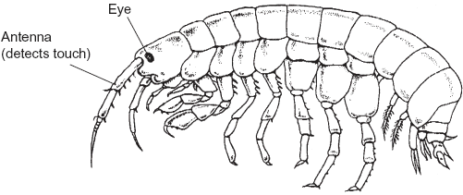

Biologists collected shrimps from a stream inside a cave and from the same stream when it was in the open.

They measured the maximum diameter of each shrimp’s eye. They also measured the length of its antenna. From these measurements they calculated the mean values for each site. **Figure 2** shows their results.

**Figure 2**

|  |  |  |
| --- | --- | --- |
|  | Shrimps from the stream | |
|  | Inside the cave | In the open |
| Mean diameter of eye /mm | 0.09 | 0.24 |
| Mean length of antenna /mm | 8.46 | 5.81 |

(a)     The biologists measured the maximum diameter of each shrimp’s eye.

Explain why they measured the **maximum** diameter.

___________________________________________________________________

___________________________________________________________________

___________________________________________________________________

**(1)**

(b)     A scientist working many years earlier suggested that animals which live in caves had similar adaptations. These adaptations included

•        smaller eyes

•        greater use of sense organs such as those involved in detecting touch.

(i)      Do the data in **Figure 2** support this scientist’s suggestion? Explain your answer.

______________________________________________________________

______________________________________________________________

______________________________________________________________

______________________________________________________________

______________________________________________________________

**(2)**

(ii)     The data in **Figure 2** are mean values. Explain how standard deviations of these mean values would help you to interpret the data in **Figure 2**.

______________________________________________________________

______________________________________________________________

______________________________________________________________

______________________________________________________________

______________________________________________________________

**(2)**

(c)     The biologists investigated shrimps living in other streams. They measured the length of the antennae of these shrimps. They also measured their body length. **Figure 3** shows the mean antenna length plotted against mean body length for each site.

**Figure 3**

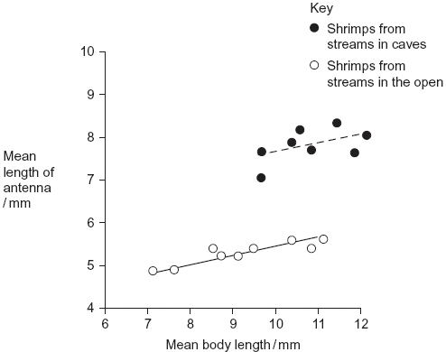

(i)      What does the information in the graph suggest about the body lengths of shrimps living in caves and living in the open?

______________________________________________________________

______________________________________________________________

______________________________________________________________

______________________________________________________________

______________________________________________________________

**(2)**

(ii)     Do the data in the graph support the conclusion that shrimps with longer bodies have longer antennae? Give the reason for your answer.

______________________________________________________________

______________________________________________________________

______________________________________________________________

**(1)**

Other biologists investigated the genetic diversity of these shrimps. **Figure 4** shows some of the data they collected.

**Figure 4**

|  |  |  |  |
| --- | --- | --- | --- |
| **Gene** | **Allele** | **Percentage of shrimps with this allele in steam** | |
| **Inside a cave** | **In the open** |
| PGI | **A** | 0.9 | 2.5 |
| **B** | 0.0 | 3.3 |
| **C** | 98.2 | 66.4 |
| **D** | 0.9 | 6.6 |
| **E** | 0.0 | 21.3 |
|  | | | |
| ACO2 | **J** | 0.0 | 5.6 |
| **K** | 0.0 | 76.7 |
| **L** | 100.0 | 17.8 |

(d)     The biologists concluded that the shrimps in the open had a higher genetic diversity than those in the cave. Explain how the data in **Figure 4** support this conclusion.

___________________________________________________________________

___________________________________________________________________

___________________________________________________________________

**(1)**

(e)     The percentage of shrimps with allele **L** in the cave is different from the percentage of shrimps with allele **L** in the open. Use your knowledge of the founder effect to suggest a reason for this difference.

___________________________________________________________________

___________________________________________________________________

___________________________________________________________________

___________________________________________________________________

___________________________________________________________________

___________________________________________________________________

**(3)**

(f)      The biologists who studied these shrimps wanted to know if the shrimps living in the cave were the same species as those living in the open. They used breeding experiments to investigate this.

(i)      Describe how the biologists should carry out these breeding experiments.

______________________________________________________________

______________________________________________________________

______________________________________________________________

______________________________________________________________

(ii)     The results of breeding experiments would help the biologists to decide whether the shrimps were the same species. Explain how.

______________________________________________________________

______________________________________________________________

**(3)**

**(Total 15 marks)**