**3.4.6 & 3.4.7 Biodiversity Within a Community & Measuring Diversity**

**Section 1 – Recall**

**What does this section contain and why?** Activities to develop your recall of information you covered in the previous topics that are linked to diversity. You should do this before you start the work on these topics. Once you have done the recall activity quickly check what you have done with the student booklets from that topic.

**Topics covered:** Biological molecules, meiosis and protein synthesis

|  |  |  |  |
| --- | --- | --- | --- |
| **Topic** | **Recall activities** | **Understanding**  *Please write down any questions you have when completing this activity.* | **Completed** |
| **Biological molecules** | On the MWB/scrap paper draw an amino acid |  |  |
| On the MWB/scrap paper describe and explain protein structure |  |  |
| **Genetic code** | On the MWB/scrap paper draw a diagram so show transcription and translation of a gene |  |  |
| On the MWB/scrap paper define the term genome |  |  |
| On the MWB/scrap paper write the definition of a species |  |  |

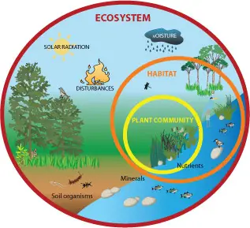

**Section 2 Independent pack framework**

|  |  |  |  |  |
| --- | --- | --- | --- | --- |
| **Key Info** | **Topic**: Biodiversity within a community & measuring diversity  **Synoptic link** : Biological Molecules, Mitosis, Meiosis, Cells and protein synthesis, Taxonomy, Genetic code | | | |
| **Step 1** | **Use the tutorial (GOL) presentation, video links and textbook to complete the independent pack** | | | |
| **Step 2** | **Learning outcome** | I understand this | I can recall this | I need to revisit this |
| Understand that biodiversity can relate to a range of habitats, from a small local habitat to the Earth. |  |  |  |
| Can you explain that species richness is a measure of the number of different species in a community. |  |  |  |
| Can calculate Simpsons diversity index |  |  |  |
| Can explain that farming techniques reduce biodiversity and understand the balance between conservation and farming. |  |  |  |
| Understand that genetic diversity within, or between species, can be made by comparing:  • the frequency of measurable or observable characteristics  • the base sequence of DNA  • the base sequence of mRNA  • the amino acid sequence of the proteins encoded by DNA  and mRNA. |  |  |  |
| Can appreciate that gene technology has caused a change in the methods of investigating genetic diversity; inferring DNA  differences from measurable or observable characteristics  has been replaced by direct investigation of DNA sequences. |  |  |  |
| Understand that quantitative investigations of variation within a species involve:  • collecting data from random samples  • calculating a mean value of the collected data and the  standard deviation of that mean  • interpreting mean values and their standard deviations |  |  |  |
| **Step 3** | **In Lesson** : You will be undertaking activities to develop your understanding of the learning objectives and able to add to your notes | | | |

**3.4.6 Diversity within a community**

**Write the definitions for the terms below.**

Biodiversity is a general term used to describe variety in the living world. It refers to the number and variety of living organisms in a particular area and has 3 components:

1. **Species diversity**

____________________________________________________________________________________________________________________________________________________________

1. **Genetic diversity**

____________________________________________________________________________________________________________________________________________________________

1. **Ecosystem diversity**

____________________________________________________________________________________________________________________________________________________________

How does low habitat diversity affect the species biodiversity of an ecosystem?

_________________________________________________________________________________

What is species richness?

__________________________________________________________________________________________________________________________________________________________________

What is species evenness?

__________________________________________________________________________________________________________________________________________________________________

What is importance of having high species biodiversity within an ecosytem?

___________________________________________________________________________________________________________________________________________________________________________________________________________________________________________________

**Measuring Diversity**

Why is just using species richness as an indicator of diversity misleading?

___________________________________________________________________________________________________________________________________________________________________________________________________________________________________________________

**Simpsons Index of Biodiversity**

An index of diversity describes the relationship between the number of species in a community and the number of individuals in each species.

What 2 bits of data do you need to calculate Simpsons diversity index?

__________________________________________________________________________________________________________________________________________________________________

Calculation of an index of diversity (*d*) from the formula

d = index of diversity

*N* = total number of organisms of all species

*n* = total number of organisms of each species.

∑ = the sum of

Data from different habitats may appear to have the same number of species but the proportions may differ indicating a very different level of biodiversity. The diversity index is used to measure the species diversity.

What does a larger number of d indicate about diversity?

_________________________________________________________________________________

What is lowest possible number for d and what does it represent?

__________________________________________________________________________________________________________________________________________________________________

What is maximum value possible for d?

__________________________________________________________________________________________________________________________________________________________________

**Worked Example**

The table below shows the number and type of species found in 2 different habitats within the same ecosystem.

|  |  |  |
| --- | --- | --- |
| **Species found** | **Numbers found in habitat X** | **Numbers found in habitat Y** |
| A | 10 | 3 |
| B | 10 | 5 |
| C | 10 | 2 |
| D | 10 | 36 |
| E | 10 | 4 |
| No. of species (n) | 5 | 5 |
| Total no. of organisms (N) | 50 | 50 |

Use the index to calculate the species diversity of the 2 habitats in the table above.

You must first calculate n(n-1) for each species in each habitat.

Then you can calculate ∑n(n-1)

|  |  |  |  |  |
| --- | --- | --- | --- | --- |
| **Species** | **Numbers (n) found in habitat X** | **n(n-1)** | **Numbers (n) found in habitat Y** | **n(n-1)** |
| A | 10 | 10(9) = 90 | 3 | 3(2) = 6 |
| B | 10 | 10(9) = 90 | 5 | 5(4) = 20 |
| C | 10 | 10(9) = 90 | 2 | 2(1) = 2 |
| D | 10 | 10(9) = 90 | 36 | 36(35) = 1260 |
| E | 10 | 10(9) = 90 | 4 | 4(3) = 12 |
|  | ∑n(n-1) | 450 | ∑n(n-1) | 1300 |

You can now calculate species diversity index for each habitat using the equation above.

Habitat X: d = 50 (49) = 2450 = 5.44

450 450

Habitat Y d = 50 (49) = 2450 = 1.88

1300 1300

The **higher** the value of d, the **greater** the species diversity. So, in the case above, although the total number of organisms of each species and total number of individuals are the same in both habitats, the species diversity of habitat X is much greater.

**Question**

Calculate the index of diversity for the following data samples and comment on which population has a greater species diversity

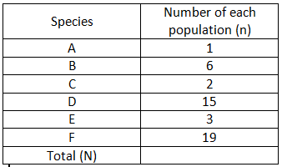Population A Population B

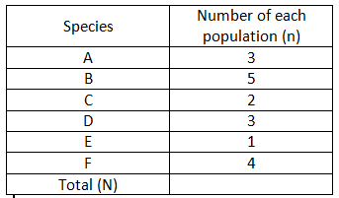

Answer - show all your working.

**Biodiversity, Farming and Conservation**

Biodiversity reflects how well an ecosystem is likely to function. The higher the diversity index the more stable an ecosystem is and the less it is affected by change. If there was a drought at least 1 species would be able to tolerate the drought. In extreme environments the diversity index is usually low

Research Task:

Research the following questions below and write summary notes in the space provided. Use suitable sub-headings.

* + What is a monoculture?
  + How does farming as a monoculture affect the biodiversity of the land?
  + How do farmers increase the yield of the crops or livestock?
  + What environmental problems arise from these practises?
  + How can farmers increase biodiversity on their agroecosystems?
  + What alternative farming practises could be used to do this?

**3.4.7 Investigating Diversity**

**Measuring Genetic diversity**

Genetic diversity within, or between species, can be made by comparing:

1. the frequency of measurable or observable characteristics
2. the base sequence of DNA
3. the base sequence of mRNA
4. the amino acid sequence of the proteins encoded by DNA and mRNA.

**Task:** Read the presentation on GOL and watch the 2 videos, then make notes on each of these ways of measuring genetic diversity.

Frequency of measurable or observable characteristics

Comparing the base sequence of DNA

Comparing the base sequence of DNA (continued)

Comparing the base sequence of mRNA

Comparing the amino acid sequence.

| **Question** | **Answer** |
| --- | --- |
| 1) Genetic diversity can be studied indirectly by observing anatomical and behavioural characteristics of animals.  Name one advantage of this method. |  |
| 2) Referring specifically to human height, name two disadvantages of this method. |  |
| 3) Name one advantage of DNA sequencing. |  |
| 4) Below are diagrams of outputs from different forms of sequencing.  U  U  C  G  C  A  G  A  U  A  A  G  C  G  T  C  T  A  A.  B.  C.  i) Name methods A, B and C.  ii) Identify one advantage that methods B) and C) have over method A. | i)  ii) |
| 5) A key enzyme is studied from four cats: A –jaguar, B – domestic cat, C – leopard, D – tiger. All the differences between the sequences are shown below.   |  |  |  |  |  |  | | --- | --- | --- | --- | --- | --- | |  | Amino Acid 12 | Amino Acid 13 | Amino Acid 34 | Amino Acid 59 | Amino Acid 66 | | A | Glu | Ile | Val | Ser | Pro | | B | Glu | Thr | Ala | Trp | Leu | | C | His | Thr | Ala | Trp | Pro | | D | Glu | Ile | Gly | Phe | Pro |   i) How many amino acid differences are there between the enzyme in the leopard and the domestic cat?  ii) How many differences are there between the domestic cat and the tiger?  iii) Using only the information above, draw a phylogenetic tree showing how these animals might be related.  iv) Another species, *Hyena hyaena*, is assessed for the same enzyme and is found to differ from at least one of the species above at 12 amino acid positions.  Where would you put this species on your tree diagram? Justify your decision. | i)  ii)  iii)    iv) |

**Quantitative investigations of variation**

**Ways of measuring variation in a population or community– Random Sampling**

This involves taking measurements of individuals from a population and should be representative of the population as a whole.

Why is it important to avoid bias when collecting data?

_________________________________________________________________________________

How would you ensure that your data is representative of the population as a whole?

_________________________________________________________________________________

There are 2 ways of sampling:

1. Random sampling

2. Systematic sampling

**Random Sampling**

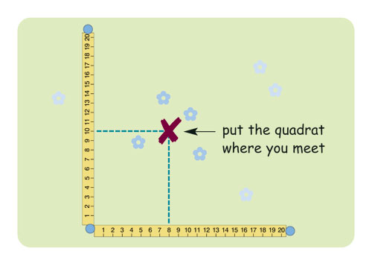**Method:**

__________________________________________

__________________________________________

__________________________________________

__________________________________________

__________________________________________

__________________________________________

__________________________________________

__________________________________________

**Systematic Sampling**

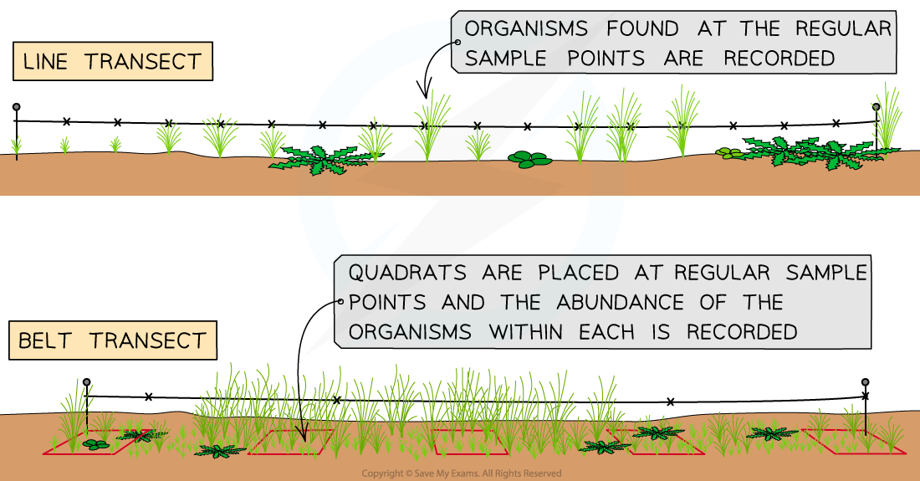

**Method:**

_________________________________________________________________________________

_________________________________________________________________________________

__________________________________________________________________________________________________________________________________________________________________

_________________________________________________________________________________

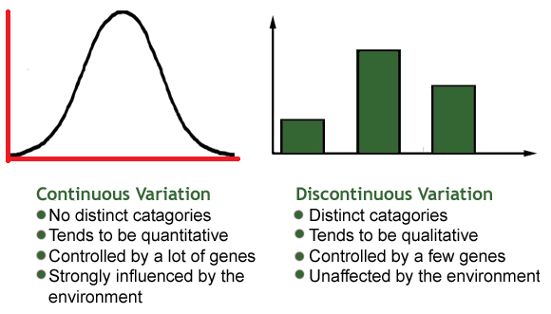**Mean and Standard Deviation**

**Types of variation.**

Variation is the result of either genetic differences or environmental factors or a combination of both.

**The normal distribution**

Bell-shaped curve that shows continuous variation. It can be skewed to one side.

Mean, mode and median are associated with normal distributions

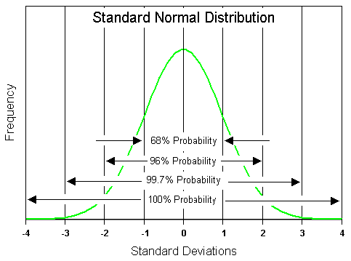

**Mean**

Calculated by the sum of all sampled values divided by the number of values themselves.

**Mode**

The single value that occurs the most in a data set.

**Median**

The central or middle value in a set of values. You need to arrange the values in ascending order to calculate this.

**Standard Deviation**

What does the standard deviation measure?

_________________________________________________________________________________

[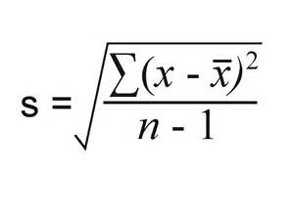](https://www.bing.com/images/search?q=standard+deviation&view=detailv2&&id=78963231044AC72965DFA9A3A17E0C70CB4347A3&selectedIndex=10&ccid=qO6xHONw&simid=608033659125632400&thid=OIP.Ma8eeb11ce370810d2b3da4af67966397o0)The formula for standard deviation is:

Where ∑ = sum of

X = measured value (from sample)

X = mean value

n = total number of values in the sample

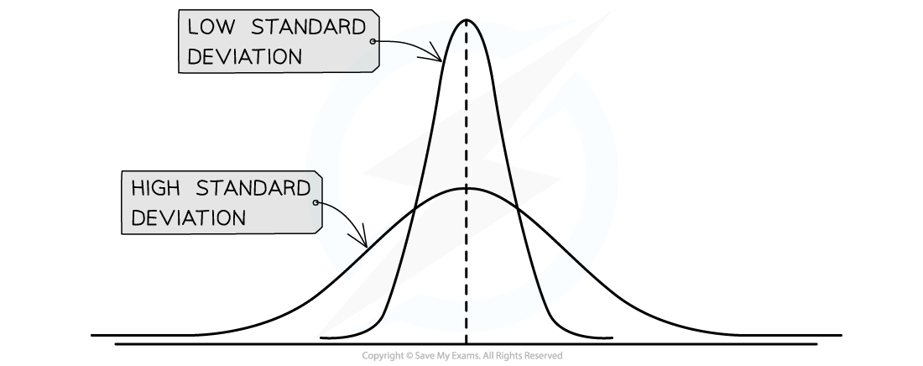

What does a small standard deviation indicate about the results?

What does a large standard deviation indicate about the results?

You **will not have to calculate standard deviation in your exam** but you will need to interpret it and explain what it shows.

**Comparing 2 sets of data using standard deviations**

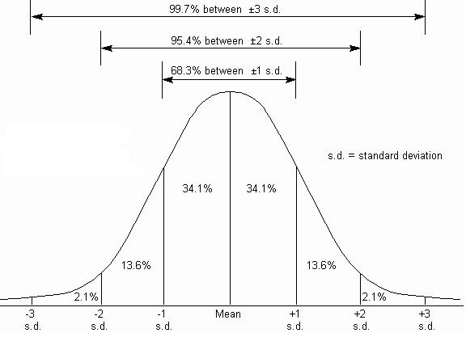

Whether or not the standard deviations of different data sets overlap can provide a lot of information:

1. If there is an overlap between the standard deviations then it can be said that the results are not significantly different.
2. If there is no overlap between the standard deviations then it can be said that the results are significantly different.

When looking at overlap, +/- 2standard deviations are used as this incorporates 95% of the data set.

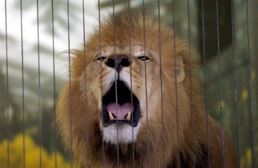

**Worked Example 1**

You have found the following ages of lions in two different zoos. The lions were randomly selected from all the lions in each zoo.

|  |  |
| --- | --- |
| Age of Lions at Bristol Zoo (months) | Age of Lions at London Zoo (months) |
| 36 | 46 |
| 31 | 50 |
| 35 | 48 |
| 24 | 49 |
| 21 | 51 |
| 47 | 49 |

Calculate the mean and standard deviation.

The standard deviation is calculated using the formula:

The best way to show these calculations is in do this is in a table.

|  |  |  |
| --- | --- | --- |
|  | **Bristol Zoo** | **London Zoo** |
| **mean** | 32.3 | 48.8 |
| **SD** | 9.3 | 1.7 |
| **2 x SD** | 18.6 | 2.4 |
| **Mean + (2 x SD)** | 50.9 | 51.2 |
| **Mean - (2 x SD)** | 13.7 | 46.4 |

**Describing the results**

We can draw a bar chart of the mean and plot the ± 2 Standard deviations from the mean and look at the overlap of the bars.

[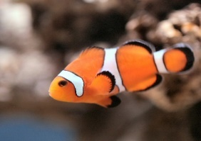](http://dreamatico.com/fish/4/)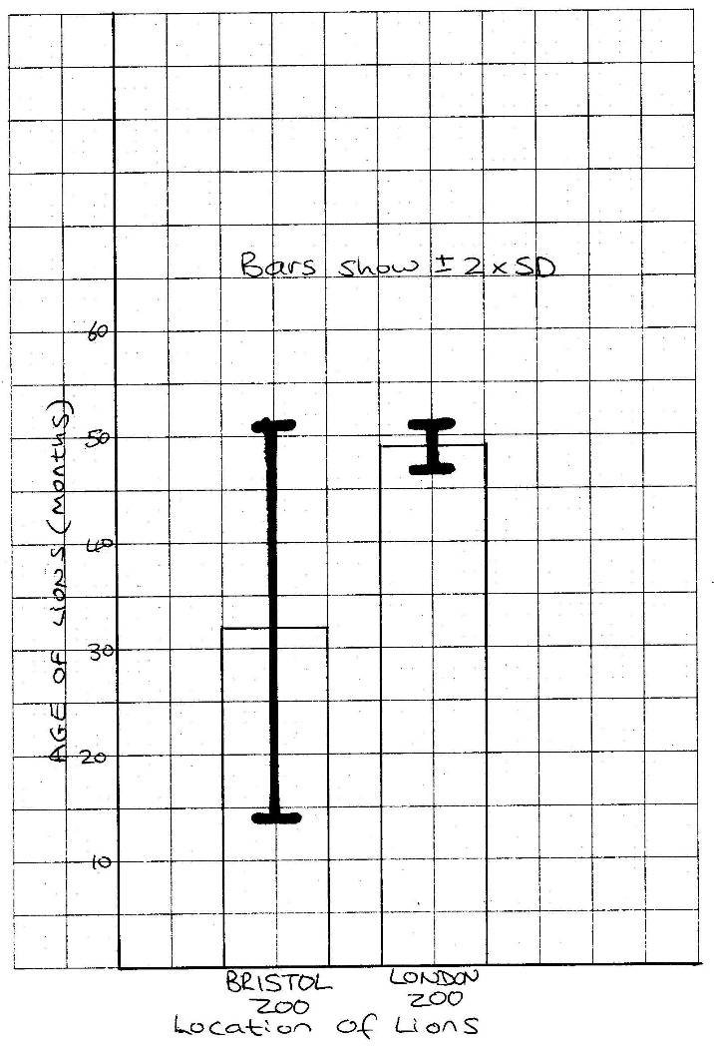

There is an overlap in the (±2 SD) bars.

This indicates that the differences in the means (the age of the Lions at Bristol zoo and London zoo) not **likely** to be significant.

**Worked Example 2**

You have measured the sizes of the different genders of a species of tropical fish.

|  |  |
| --- | --- |
| Length of female fish (cm) | Length of male fish (cm) |
| 18 | 8 |
| 18 | 10 |
| 21 | 10 |
| 23 | 12 |
| 25 |  |

Now calculate the mean and standard deviation.

|  |  |  |
| --- | --- | --- |
|  | **Female** | **Male** |
| **mean** | 21 | 10 |
| **SD** | 3 | 1.6 |
| **2 x SD** | 6 | 3.2 |
| **Mean + (2 x SD)** | 27 | 13 |
| **Mean - (2 x SD)** | 15 | 7 |

**Describing the results**

We can draw a bar chart of the mean and plot the ± 2 Standard deviations from the mean and look at the overlap of the bars.

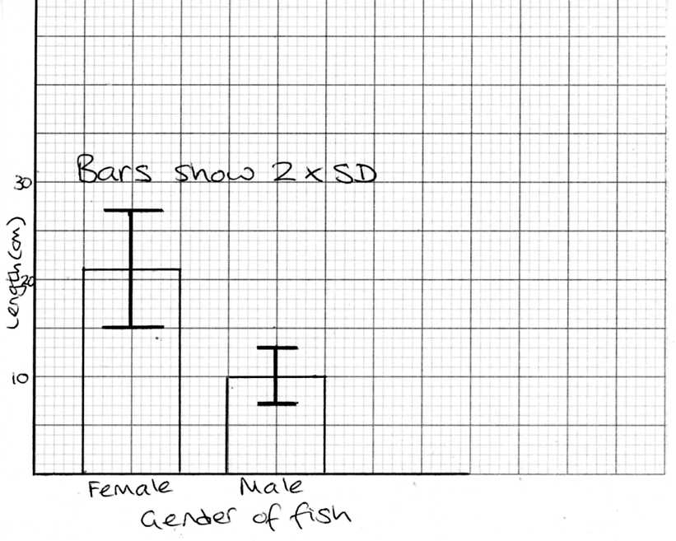

There is no overlap in the (±2 SD) bars.

This indicates that the differences in the means (the size of the fish) is **likely** to be significant.