**Q1.**

New alleles arise as a result of mutations in existing genes. These mutations may occur during DNA replication.

(a)     Explain what is meant by an allele.

___________________________________________________________________

___________________________________________________________________

**(1)**

(b)     Explain why a mutation involving the deletion of a base may have a greater effect than one involving substitution of one base for another.

___________________________________________________________________

___________________________________________________________________

___________________________________________________________________

___________________________________________________________________

___________________________________________________________________

___________________________________________________________________

**(3)**

**(Total 8 marks)**

**Q2.**

The diagram represents a cell from a fruit fly in which the diploid number is eight.

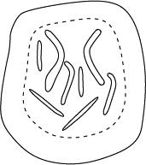

(a)     Draw a diagram to show

(i)      this cell during anaphase of mitosis;

**(2)**

(ii)     the chromosomes in a gamete produced from this cell by meiosis.

**(2)**

(b)     Explain why meiosis is important in sexual reproduction, apart from producing gametes that are genetically different.

___________________________________________________________________

___________________________________________________________________

___________________________________________________________________

___________________________________________________________________

**(2)**

**(Total 6 marks)**

**Q3.**

(a)     What name is used for the non-coding sections of a gene?

___________________________________________________________________

**(1)**

**Figure 1** shows a DNA base sequence. It also shows the effect of two mutations on this base sequence. **Figure 2** shows DNA triplets that code for different amino acids.

**Figure 1**

|  |  |  |  |  |  |  |  |  |  |  |  |  |
| --- | --- | --- | --- | --- | --- | --- | --- | --- | --- | --- | --- | --- |
| Original DNA base sequence | A | T | T | G | G | C | G | T | G | T | C | T |
| Amino acid sequence |  | | |  | | |  | | |  | | |
| Mutation **1** DNA base sequence | A | T | T | G | G | A | G | T | G | T | C | T |
| Mutation **2** DNA base sequence | A | T | T | G | G | C | C | T | G | T | C | T |

**Figure 2**

|  |  |
| --- | --- |
| **DNA triplets** | **Amino acid** |
| GGT, GGC, GGA, GGG | Gly |
| GTT, GTA, GTG, GTC | Val |
| ATC, ATT, ATA | Ile |
| TCC, TCT, TCA, TCG | Ser |
| CTC, CTT, CTA, CTG | Leu |

(b)     Complete **Figure 1** to show the sequence of amino acids coded for by the original DNA base sequence.

**(1)**

(c)     Some gene mutations affect the amino acid sequence. Some mutations do not.  
Use the information from **Figure 1** and **Figure 2** to explain

(i)      whether mutation **1** affects the amino acid sequence

______________________________________________________________

______________________________________________________________

______________________________________________________________

**(2)**

(ii)     how mutation **2** could lead to the formation of a non-functional enzyme.

______________________________________________________________

______________________________________________________________

______________________________________________________________

______________________________________________________________

______________________________________________________________

**(3)**

(d)     Gene mutations occur spontaneously.

(i)      During which part of the cell cycle are gene mutations most likely to occur?

______________________________________________________________

**(1)**

(ii)     Suggest an explanation for your answer.

______________________________________________________________

______________________________________________________________

**(1)**

**(Total 9 marks)**

**Q4.**

Two pairs of alleles **A** and **a**, and **B** and **b** are found on one pair of homologous chromosomes. A person has the genotype **AaBb**. **Figure 1** shows the chromosomes at an early stage of meiosis. The position of two of the alleles is shown.

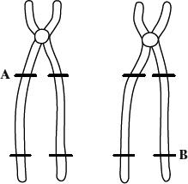

**Figure 1**

(a)     Complete **Figure 1** to show the alleles present at the other marked positions.

**(1)**

Crossing over occurs as shown in **Figure 2**.

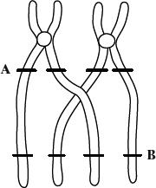

**Figure 2**

(b)     What term is used to describe the pair of homologous chromosomes shown in **Figure 2**?

___________________________________________________________________

**(1)**

(c)     From **Figure 2**, give the genotypes of the gametes produced containing the chromatids

(i)      that have **not** crossed over;

______________________________________________________________

(ii)     that have crossed over.

______________________________________________________________

**(2)**

(d)     Give **two** processes, other than crossing over, which result in genetic variation. Explain how each process contributes to genetic variation.

Process ____________________________________________________________

Explanation _________________________________________________________

___________________________________________________________________

Process ____________________________________________________________

Explanation _________________________________________________________

___________________________________________________________________

**(4)**

**(Total 8 marks)**

**Q5.**

(a)     Apart from increasing genetic variation, explain why meiosis is important in organisms which reproduce sexually.

___________________________________________________________________

___________________________________________________________________

___________________________________________________________________

**(2)**

(b)     **Figure 1** shows the chromosomes in a diploid cell.

**Figure 1**

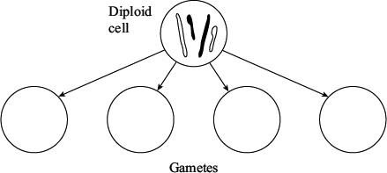

Complete **Figure 1** to show the four different combinations of these chromosomes in the gametes produced by meiosis.

**(2)**

(c)     **Figure 2** shows the main stages in the production of pollen grains in a flowering plant.

**Figure 2**

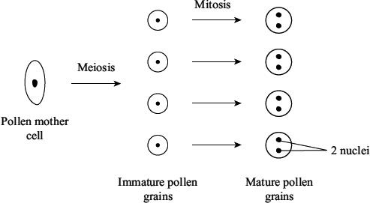

The diploid number of chromosomes in this plant is sixteen. How many chromosomes would there be in

(i)      the nucleus of an immature pollen grain;

______________________________________________________________

(ii)     one of the nuclei of a mature pollen grain?

______________________________________________________________

**(2)**

(d)     In tissues that produce gametes, there is a greater proportion of cells undergoing meiosis in male tissue than in female tissue. Suggest **one** advantage of this.

___________________________________________________________________

___________________________________________________________________

**(1)**

**(Total 7 marks)**

**Q6.**

**Figure 1** shows a pair of chromosomes at the start of meiosis. The letters represent alleles.

**Figure 1**

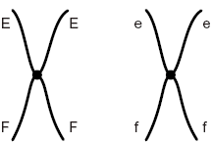

(b)     Explain the appearance of one of the chromosomes in **Figure 1**.

___________________________________________________________________

___________________________________________________________________

___________________________________________________________________

___________________________________________________________________

**(2)**

(c)     The cell containing this pair of chromosomes divided by meiosis. **Figure 2** shows the distribution of chromosomes from this pair in four of the gametes produced.

**Figure 2**

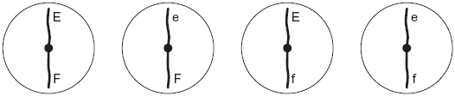

(i)      Some of the gametes formed during meiosis have new combinations of alleles.

Explain how the gametes with the combinations of alleles Ef and eF have been produced.

______________________________________________________________

______________________________________________________________

______________________________________________________________

**(2)**

(ii)     Only a few gametes have the new combination of alleles Ef and eF. Most gametes have the combination of alleles EF and ef. Suggest why only a few gametes have the new combination of alleles, Ef and eF.

______________________________________________________________

______________________________________________________________

**(1)**

(d)     **Figure 3** shows a cell with six chromosomes.

**Figure 3**

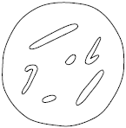

(i)      This cell produces gametes by meiosis. Draw a diagram to show the chromosomes in one of the gametes.

**(2)**

(ii)     How many different types of gametes could be produced from this cell as a result of different combinations of maternal and paternal chromosomes?



**(1)**

**(Total 9 marks)**

**Q7.**

(a)    **Figure 1** shows one pair of homologous chromosomes.

**Figure 1**

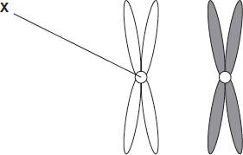

(i)      Name **X.**

______________________________________________________________

**(1)**

(ii)     Describe the role of **X** in mitosis.

______________________________________________________________

______________________________________________________________

______________________________________________________________

______________________________________________________________

**(2)**

(iii)    Homologous chromosomes carry the same genes but they are **not** genetically identical.Explain why.

______________________________________________________________

______________________________________________________________

______________________________________________________________

**(1)**

(b)     **Figure 2** shows three pairs of homologous chromosomes in a cell at the end of cell division.

**Figure 2**



(i)      The appearance of each chromosome in **Figure 2** is different from those shown in **Figure 1.** Explain why.

______________________________________________________________

______________________________________________________________

**(1)**

(ii)     Complete the diagram to show the chromosomes in one cell that could be produced from the cell in **Figure 2** as a result of meiosis.

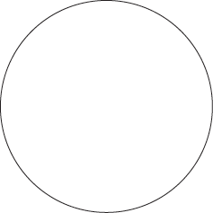

**(2)**

(iii)    Other than independent segregation, give **one** way in which meiosis allows the production of genetically different cells.

______________________________________________________________

______________________________________________________________

______________________________________________________________

**(1)**

**(Total 8 marks)**

**Q8.**

(a)     (i)      Why is the genetic code described as being universal?

______________________________________________________________

______________________________________________________________

**(1)**

(ii)     The genetic code uses four different DNA bases. What is the maximum number of different DNA triplets that can be made using these four bases?



**(1)**

Transcription of a gene produces pre-mRNA.

(b)     Name the process that removes base sequences from pre-mRNA to form mRNA.

___________________________________________________________________

**(1)**

(c)     The figure below shows part of a pre-mRNA molecule. Geneticists identified two mutations that can affect this pre-mRNA, as shown in the figure.

|  |  |  |
| --- | --- | --- |
| Base sequence coding for amino acids | Base sequence removed from pre-mRNA | Base sequence coding for amino acids |

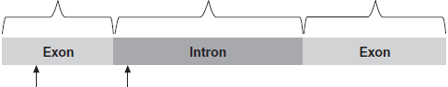

|  |  |
| --- | --- |
| **Mutation 1, single base deletion** | **Mutation 2, single base substitution** |

(i)      **Mutation 1** leads to the production of a non-functional protein.

Explain why.

______________________________________________________________

______________________________________________________________

______________________________________________________________

______________________________________________________________

______________________________________________________________

______________________________________________________________

**(3)**

(ii)     What effect might **mutation 2** have on the protein produced?

Explain your answer.

______________________________________________________________

______________________________________________________________

______________________________________________________________

______________________________________________________________

**(2)**

**(Total 8 marks)**