**Q1.**

A meadow is an area of grassland with a wide range of plant and animal species.

A student investigated whether cutting some of the plants in a meadow had any effect on the biodiversity of insects in that meadow.

The student created two sample areas, called plots, in the meadow. Each plot measured 10 m × 5 m

The student:

•   did not cut plants in **plot 1**

•   cut the plants in **plot 2** with a lawn mower once a week.

After 10 weeks, the student captured all of the organisms of four insect species found in each of these plots.

The figure below shows the student’s results.

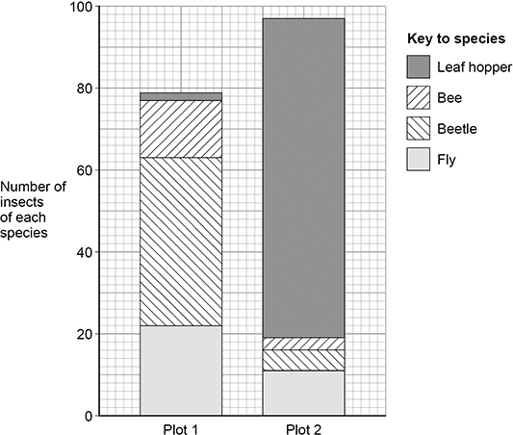

(a)  Use the information in the figure above to calculate the index of diversity for the insects captured in **plot 1**.

The formula to calculate the index of diversity (*d*) is



where *N* is the total number of insects of all species and *n* is the total number of insects of each species.

Give the answer to **2** significant figures and show your working.

*d =* _______________

**(2)**

(b)  The student concluded that cutting plants with a lawn mower increased the species richness of insects in that meadow.

Use information in the diagram above to explain why the student’s conclusion is incorrect.

___________________________________________________________________

___________________________________________________________________

___________________________________________________________________

**(1)**

(c)  The student wanted to use the data from **plot 1** to estimate the total number of the beetle species in the meadow.

Suggest how the student should use the data from **plot 1** and other information provided to estimate the total number of the beetle species in the meadow.

___________________________________________________________________

___________________________________________________________________

___________________________________________________________________

___________________________________________________________________

___________________________________________________________________

___________________________________________________________________

___________________________________________________________________

___________________________________________________________________

___________________________________________________________________

___________________________________________________________________

___________________________________________________________________

___________________________________________________________________

**(4)**

**(Total 7 marks)**

**Q2.**

Scientists investigated the species of insects found in a wood and in a nearby wheat field. The scientists collected insects by placing traps at sites chosen at random both in the wood and in the wheat field.

The table shows the data collected in the wood and in the wheat field.

|  |  |  |
| --- | --- | --- |
| **Species of insect** | **Number of organisms of each species** | |
| **Wood** | **Wheat field** |
| Bird-cherry oat aphid | 0 | 216 |
| Beech aphid | 563 | 0 |
| Large white butterfly | 20 | 0 |
| Lacewing | 12 | 3 |
| 7-spot ladybird | 36 | 0 |
| 2-spot ladybird | 9 | 1 |
| Total number of organisms of all species | 640 | 220 |

(a)     The scientists collected insects at sites chosen at random. Explain the importance of the sites being chosen at random.

___________________________________________________________________

___________________________________________________________________

___________________________________________________________________

**(1)**

(b)     (i)      Use the formula



to calculate the index of diversity for the insects caught in the wood, where

*d* = index of diversity  
*N* = total number of organisms of all species  
*n* = total number of organisms of each species

Show your working.

Answer ____________________

**(2)**

(ii)     Without carrying out any further calculations, estimate whether the index of diversity for the wheat field would be higher or lower than the index of diversity for the wood.

Explain how you arrived at your answer.

______________________________________________________________

______________________________________________________________

______________________________________________________________

______________________________________________________________

______________________________________________________________

**(2)**

(c)     A journalist concluded that this investigation showed that farming reduces species diversity.  
Evaluate this conclusion.

___________________________________________________________________

___________________________________________________________________

___________________________________________________________________

___________________________________________________________________

___________________________________________________________________

**(2)**

(d)     Farmers were offered grants by the government to plant hedges around their fields.  
Explain the effect planting hedges could have on the index of diversity for animals.

___________________________________________________________________

___________________________________________________________________

___________________________________________________________________

___________________________________________________________________

___________________________________________________________________

**(2)**

**(Total 9 marks)**

**Q3.**

The UK government pays farmers to leave grassy strips around the edges of fields of crops. These grassy strips contain a variety of plant species. Leaving the strips is an attempt to encourage biodiversity of animals.

(a)     Give **two** reasons why the grassy strips increase the biodiversity of animals.

1. _________________________________________________________________

2. _________________________________________________________________

**(2)**

A group of scientists investigated the effect of grassy strips on the biodiversity of soil animals.

•        They divided a field into plots measuring 25 m × 5 m, with a 5-metre-wide grassy strip of land between each plot.

•        Each year, they planted wheat in each of the plots.

•        In the fifth year, they removed samples of soil from each plot where wheat was growing and from the grassy strips around them.

•        They sorted each soil sample by hand for 40 minutes to collect the soil animals within the sample.

(b)     The scientists decided to collect animals from the soil samples for 40 minutes.

Suggest how the scientists decided that 40 minutes was an appropriate time.

___________________________________________________________________

___________________________________________________________________

___________________________________________________________________

___________________________________________________________________

___________________________________________________________________

**(2)**

(c)     The table below shows how the scientists published their results. They calculated mean values and two times the standard deviation (SD) of the mean.

Two standard deviations above and below the mean includes 95.4% of the data.

|  |  |  |  |  |
| --- | --- | --- | --- | --- |
| **Group of animals** | **Mean number of animals per m2**  **(± 2 × SD)** | | **Mean number of species per m2**  **(± 2 × SD)** | |
| **Soil under wheat crop** | **Soil under grassy strips** | **Soil under wheat crop** | **Soil under grassy strips** |
| Beetles | 41.2 (± 6.4) | 80.1 (± 10.1) | 10.0 (± 1.6) | 17.3 (± 1.0) |
| Centipedes | 18.4 (± 3.6) | 13.5 (± 1.0) | 1.8 (± 0.3) | 2.1 (± 0.2) |
| Earthworms | 244.5 (± 27.1) | 281.2 (± 39.4) | 3.8 (± 0.3) | 5.1 (± 0.2) |
| Millipedes | 38.4 (± 12.2) | 36.2 (± 2.9) | 3.5 (± 0.3) | 3.2 (± 0.2) |
| Woodlice | 0.0 | 73.9 (± 8.5) | 0.0 | 2.8 (± 0.2) |

It would **not** be possible to calculate an index of diversity from the results in the table.

Explain why.

___________________________________________________________________

___________________________________________________________________

___________________________________________________________________

**(1)**

A summary of this research was published in a farming magazine. The journalist concluded that creating grassy strips around fields had little effect on the diversity of soil animals.

Do you agree with this conclusion?

Use evidence from the table to justify your answer.

___________________________________________________________________

___________________________________________________________________

___________________________________________________________________

___________________________________________________________________

___________________________________________________________________

___________________________________________________________________

___________________________________________________________________

___________________________________________________________________

___________________________________________________________________

___________________________________________________________________

**(4)**

**(Total 9 marks)**

**Q4.**

Scientists investigated the effect of different types of animal farming on the diversity and number of dung beetles. They determined the number of dung beetle species and their total number on intensive (**I**), rough grazing (**R**) and organic (**O**) farms.

**Figure 1** and **Figure 2** show some of their results.

|  |  |
| --- | --- |
| **Figure 1** | **Figure 2** |
|  |  |



(a)     What is the mean species richness for dung beetles on the rough grazing farms?

___________________________________________________________________

**(1)**

(b)     In addition to the information provided in **Figures 1** and **2**, what other measurement is required to calculate an index of diversity for dung beetles?

___________________________________________________________________

___________________________________________________________________

**(1)**

(c)     Explain what the standard deviations suggest about the difference in mean total number of dung beetles between the different types of farm.

___________________________________________________________________

___________________________________________________________________

___________________________________________________________________

___________________________________________________________________

___________________________________________________________________

**(2)**

(d)     The scientists placed traps to collect the dung beetles at sites chosen at random.

Explain the importance of the sites being chosen at random.

___________________________________________________________________

___________________________________________________________________

**(1)**

(e)     On the intensive farms, the farmers had removed hedges to increase land for grazing. This resulted in a decrease in the diversity of birds on these farms.

Explain why the removal of hedges caused a decrease in the diversity of birds.

___________________________________________________________________

___________________________________________________________________

___________________________________________________________________

___________________________________________________________________

___________________________________________________________________

___________________________________________________________________

___________________________________________________________________

___________________________________________________________________

___________________________________________________________________

**(3)**

**(Total 8 marks)**

**Q5.**

(a)     Complete **Table 1** to show **three** differences between DNA in the nucleus of a plant cell and DNA in a prokaryotic cell.

|  |  |
| --- | --- |
| **Table 1** | |
| **DNA in the nucleus of a plant cell** | **DNA in a prokaryotic cell** |
| 1 |  |
| 2 |  |
| 3 |  |

**(3)**

(b)     Scientists investigated the genetic diversity between several species of sweet potato. They studied non-coding multiple repeats of base sequences.

Define ‘non-coding base sequences’ and describe where the non-coding multiple repeats are positioned in the genome.

___________________________________________________________________

___________________________________________________________________

___________________________________________________________________

___________________________________________________________________

**(2)**

The percentage similarities in the non-coding multiple repeats of base sequences of four species of carrot are shown in **Table 2**.

|  |  |  |  |  |
| --- | --- | --- | --- | --- |
| **Table 2** | | | | |
| **Species of carrot** | **Percentage similarity between non-coding multiple repeat base sequences** | | | |
| **C** | **D** | **I** | **N** |
| **C** |  | 51.3 | 23.1 | 61.2 |
| **D** | 51.3 |  | 32.7 | 51.5 |
| **I** | 23.1 | 32.7 |  | 37.4 |
| **N** | 61.2 | 51.5 | 37.4 |  |

(c)     Use the information in **Table 2** to complete the phylogenetic tree shown in the diagram below.

Write the letter that represents the correct species into each box.

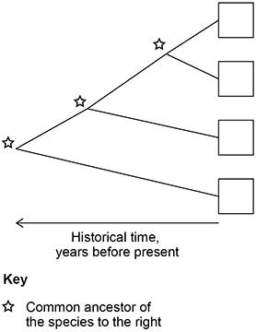

**(1)**

(d)     The scientists studied five individuals from each species. Within the five individuals of **species N** they found a percentage similarity of 66%.

Use **Table 2** to evaluate how this information affects the validity of the phylogenetic tree.

___________________________________________________________________

___________________________________________________________________

___________________________________________________________________

___________________________________________________________________

___________________________________________________________________

**(2)**

**(Total 8 marks)**

**Q6.**

(a)     The genetic diversity of species is measured by comparing differences in the base sequence of DNA or differences in the base sequence of mRNA.

Give **two** other ways in which genetic diversity between species is measured.

1  _________________________________________________________________

___________________________________________________________________

___________________________________________________________________

___________________________________________________________________

2  _________________________________________________________________

___________________________________________________________________

___________________________________________________________________

___________________________________________________________________

**(2)**

Scientists investigated differences between 260 North American bird species by comparing the base sequence of a gene in mitochondrial DNA. They compared the gene base sequence of each bird with all of the other 259 species. For each comparison they calculated the percentage difference in base sequence.

(b)  **Figure 1** shows the base sequence for part of the gene in two species.

**Figure 1**

Species 1  A G C T G C C T A G A

Species 2  A T G T G G C A A G A

Calculate the percentage difference in base sequence for these base sequences.

Answer = _________________________%

**(1)**

(c)  The scientists compared base sequences in:

•   birds of the same species

•   birds of different species in the same genus

•   birds of different species in the same family.

The scientists’ results are shown in **Figure 2**.

**Figure 2**

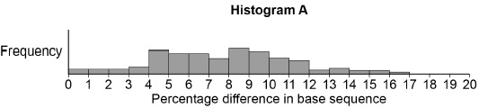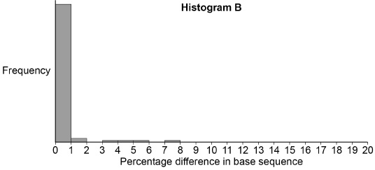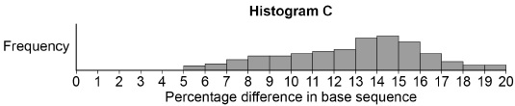

(c)  Complete the table by writing **A**, **B** or **C** in the box to correctly match the statement to each histogram shown in **Figure 2**.

|  |  |
| --- | --- |
| **Statement** | **Histogram** |
| Base sequences of birds of the same species. |  |
| Base sequences of birds of the same genus. |  |
| Base sequences of birds of the same family. |  |

**(1)**

**(Total 4 marks)**

**Q7.**

(a)     Contrast how an optical microscope and a transmission electron microscope work **and** contrast the limitations of their use when studying cells.

___________________________________________________________________

___________________________________________________________________

___________________________________________________________________

___________________________________________________________________

___________________________________________________________________

___________________________________________________________________

___________________________________________________________________

___________________________________________________________________

___________________________________________________________________

___________________________________________________________________

___________________________________________________________________

___________________________________________________________________

**(6)**

(b)     The diagram shows an image from an optical microscope of meiosis occurring in a flower bud of a flowering plant. **W** and **Z** are undergoing meiosis.

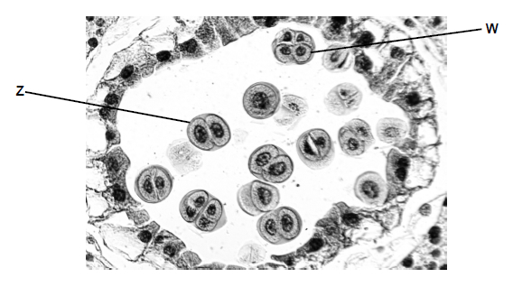

Explain the appearance of **W** and **Z**.

___________________________________________________________________

___________________________________________________________________

___________________________________________________________________

___________________________________________________________________

___________________________________________________________________

___________________________________________________________________

___________________________________________________________________

___________________________________________________________________

**(4)**

(c)     An environmental scientist investigated a possible relationship between air pollution and the size of seeds produced by one species of tree.

He was provided with a very large number of seeds collected from a population of trees in the centre of a city and also a very large number of seeds collected from a population of trees in the countryside.

Describe how he should collect and process data from these seeds to investigate whether there is a difference in seed size between these two populations of trees.

___________________________________________________________________

___________________________________________________________________

___________________________________________________________________

___________________________________________________________________

___________________________________________________________________

___________________________________________________________________

___________________________________________________________________

___________________________________________________________________

___________________________________________________________________

___________________________________________________________________

**(5)**

**(Total 15 marks)**