Q1.
Figure 1 shows three cells, B, C and D, from tissues in the same organism. Each cell is in a stage of either mitosis or meiosis.
Figure 1
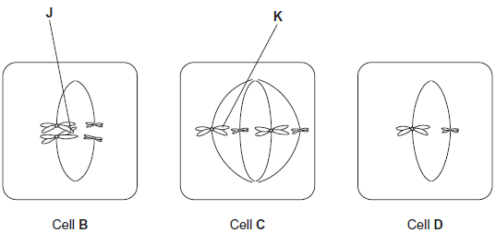
(a) Complete the table with a tick if the cell shows the feature.

 | Cell B | Cell C | Cell D
homologous chromosomes are present
a stage of mitosis
(2)
(b) Describe and explain the appearance of chromosome K in cell C.
___________________________________________________________________
___________________________________________________________________
___________________________________________________________________
___________________________________________________________________
(2)
(c) Explain what is happening at point J in cell B.
___________________________________________________________________
___________________________________________________________________
___________________________________________________________________
___________________________________________________________________
(2)
(d) Use information from all three cells in Figure 1 to explain how the number of chromosomes in cell D was produced.
___________________________________________________________________
___________________________________________________________________
___________________________________________________________________
(1)
(e) Figure 2 shows the mass of DNA present in cells of a population of healthy cells where mitosis is occurring.
Figure 2
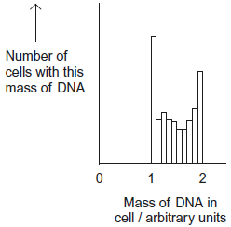
Explain why some cells contain a mass of DNA between 1 and 2 arbitrary units.
___________________________________________________________________
___________________________________________________________________
___________________________________________________________________
(1)
(Total 8 marks)
Q2.
(a) Describe the appearance and behaviour of chromosomes during mitosis.
___________________________________________________________________
___________________________________________________________________
___________________________________________________________________
___________________________________________________________________
___________________________________________________________________
___________________________________________________________________
___________________________________________________________________
___________________________________________________________________
___________________________________________________________________
___________________________________________________________________
(5)

(b) Describe and explain the processes that occur during meiosis that increase genetic variation.
___________________________________________________________________
___________________________________________________________________
___________________________________________________________________
___________________________________________________________________
___________________________________________________________________
___________________________________________________________________
___________________________________________________________________
___________________________________________________________________
___________________________________________________________________
___________________________________________________________________
(5)
(Total 10 marks)
Q3.
The figure below shows some cells from an onion root tip at different stages of the cell cycle.
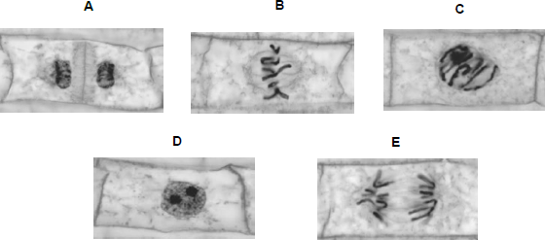
© Ed Reschke/Oxford Scientific/Getty Images
(a) Place stages A to E in the correct order. Start with stage D.
D
___________________________________________________________________
(1)
To obtain these images, the onion root tip was cut off, stained and put on a microscope slide. A cover slip was placed on top. The root tip was then firmly squashed and viewed under an optical microscope.

(b) Complete the table below to give one reason why each of these steps was necessary.

Step | Reason
Taking cells from the root tip
Firmly squashing the root tip
(2)
The figure below shows how the amount of DNA per cell changed during interphase and meiosis in an animal.
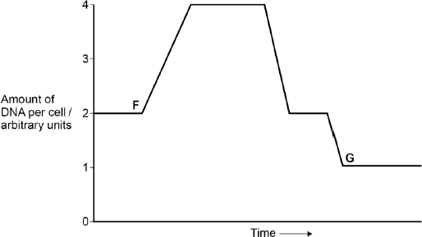
(c) Explain how the behaviour of chromosomes causes these changes in the amount of DNA per cell between F and G.
___________________________________________________________________
___________________________________________________________________
___________________________________________________________________
___________________________________________________________________
___________________________________________________________________
___________________________________________________________________
(3)

(d) What would happen to the amount of DNA per cell at fertilisation of cell G?
___________________________________________________________________
___________________________________________________________________
(1)
(Total 7 marks)
Q4.
Patau syndrome is a condition caused by a mutation affecting chromosome number. All the cells of the body will have this mutation.
Figure 1 shows the chromosomes from one of the cells of a female who has Patau syndrome.
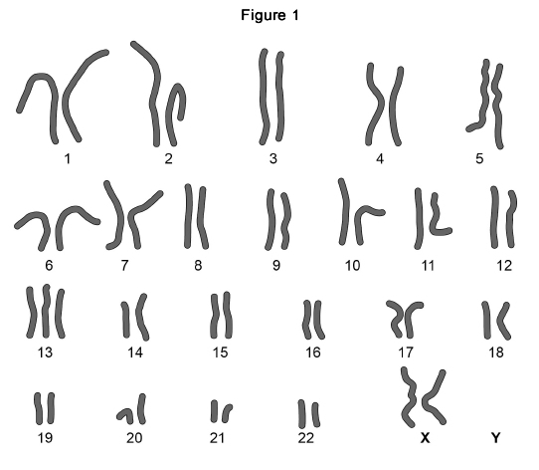
(a) What is the effect of Patau syndrome on the chromosomes of this female?
___________________________________________________________________
___________________________________________________________________
(1)
(b) Describe how the change in chromosome number in Patau syndrome was produced.
___________________________________________________________________
___________________________________________________________________
___________________________________________________________________
___________________________________________________________________
___________________________________________________________________
___________________________________________________________________
(2)
(c) Explain why all the cells of the body will have this mutation.
___________________________________________________________________
___________________________________________________________________
___________________________________________________________________
___________________________________________________________________
___________________________________________________________________
___________________________________________________________________
___________________________________________________________________
(2)
(Total 8 marks)
Q5.
Division of the nucleus by meiosis produces haploid cells from a diploid cell. Nuclei produced by mitosis have the same number of chromosomes as the parent nucleus.
(a) What is the biological importance of reducing the chromosome number when the cell divides by meiosis?
___________________________________________________________________
___________________________________________________________________
___________________________________________________________________
___________________________________________________________________
(2)
(b) The table gives one difference between meiosis and mitosis. Complete the table by giving three further differences.

 | Meiosis | Mitosis
1 | Reduces the chromosome number | Maintains the same chromosome number as in the parent nucleus
2
3
4
(3)
(Total 5 marks)

Q6.
The diagram shows part of the metabolic pathway involved in the clotting of blood in response to an injury.
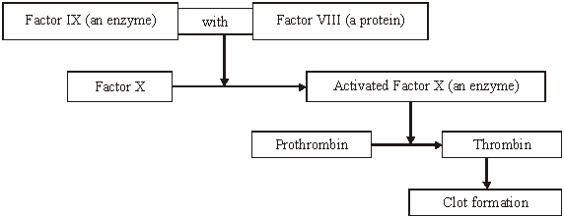
Haemophilia is a condition in which blood fails to clot. This is usually because of a mutant allele of the gene for Factor VIII.
(a) Explain how mutation could lead to faulty Factor VIII.
___________________________________________________________________
___________________________________________________________________
___________________________________________________________________
___________________________________________________________________
(2)
(b) Use information in the diagram to explain how faulty Factor VIII causes haemophilia.
___________________________________________________________________
___________________________________________________________________
___________________________________________________________________
___________________________________________________________________
(2)
(c) A boy had haemophilia caused by faulty Factor IX. When his blood was mixed with blood from a haemophiliac with faulty Factor VIII, the mixture clotted. Suggest an explanation for clotting of the mixture.
___________________________________________________________________
___________________________________________________________________
___________________________________________________________________
___________________________________________________________________
(2)
(Total 6 marks)
Q7.
(a) Complete the table to describe some of the events during the cell cycle.

Stage of cell cycle | Main event which takes place
Metaphase
 | Chromosomes coil and shorten
 | Daughter chromosomes move to poles of the cell
S-phase
 | Nuclear envelope re-forms
(5)
(b) The diagram shows the life cycle of an organism. The numbers show how many chromosomes are present in one cell at each stage of the life cycle.
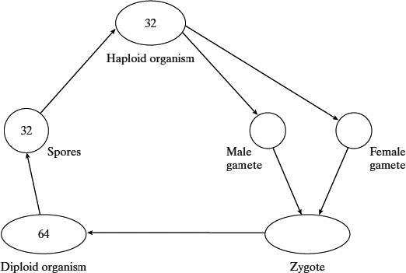
(i) Name the type of cell division that must be involved in producing the spores.
______________________________________________________________
(1)
(ii) How many chromosomes are there in a male gamete from this organism?
______________________________________________________________
(1)
(Total 7 marks)

Q8.
The figure below summarises the process of meiosis. The circles represent cells and the structures within each cell represent chromosomes.
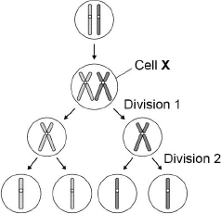
(a) Describe and explain the appearance of one of the chromosomes in cell X.
___________________________________________________________________
___________________________________________________________________
___________________________________________________________________
___________________________________________________________________
___________________________________________________________________
___________________________________________________________________
___________________________________________________________________
(3)
(b) Describe what has happened during division 1 in the figure above.
___________________________________________________________________
___________________________________________________________________
___________________________________________________________________
___________________________________________________________________
___________________________________________________________________
___________________________________________________________________
(2)
(c) Identify one event that occurred during division 2 but not during division 1.
___________________________________________________________________
(1)

(d) Name two ways in which meiosis produces genetic variation.
1. _________________________________________________________________
2. _________________________________________________________________
(2)
(Total 8 marks)
Q9.
In women, the first division of meiosis produces one daughter cell that has almost all of the cytoplasm. The other daughter cell consists of a nucleus surrounded by a very small amount of cytoplasm and a cell-surface membrane. This very small daughter cell is called a polar body. Polar bodies do not usually divide. The same process occurs in the second division of meiosis, resulting in one egg cell and two polar bodies.
The diagram shows the formation of an egg cell and two polar bodies during meiosis. It also shows what happens to one pair of homologous chromosomes. This pair carries two alleles of gene A.
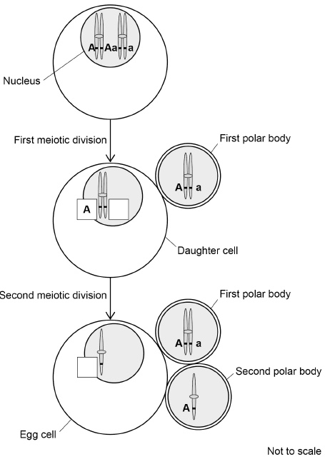
(a) Complete the diagram by putting A or a in the boxes. One box has been completed for you with A.
(1)

(b) Put a tick (✓) in the box next to the name of the process that produced the combination of alleles on the chromosome in the first polar body in the diagram.

Anaphase | 
Crossing over
Independent assortment
Semi-conservative replication
(1)
(c) A scientist measured the diameter of a polar body and the diameter of the nucleus inside it. The diameter of the polar body was 10.4 μm and the diameter of the nucleus was 7.0 μm. The density of mitochondria in the cytoplasm of the polar body (outside of the nucleus) was 0.08 mitochondria per μm³.
Calculate the number of mitochondria in the polar body. You should assume polar bodies and nuclei are spherical.
The formula for the volume of a sphere is πr³ where π = 3.14
Show your working.

Number of mitochondria =____________________
(2)
(d) Mitochondrial diseases are caused by faulty mitochondria. All of a person’s mitochondria are inherited from their mother via the egg cell. An egg cell contains approximately 3 × 10⁵ mitochondria.
One proposed treatment to prevent passing on faulty mitochondria involves
• removing the nucleus from an egg cell donated by a woman with healthy mitochondria
• replacing this nucleus with the contents of the polar body from a woman whose egg cells are affected by mitochondrial disease.
Suggest how this treatment prevents inheritance of mitochondrial diseases.
___________________________________________________________________
___________________________________________________________________
___________________________________________________________________
___________________________________________________________________
___________________________________________________________________
(2)
(e) If most of the mitochondria in a cell are faulty, this prevents many important enzyme-catalysed reactions taking place or slows them down.
Suggest and explain one reason why.
___________________________________________________________________
___________________________________________________________________
___________________________________________________________________
___________________________________________________________________
___________________________________________________________________
___________________________________________________________________
___________________________________________________________________
___________________________________________________________________
___________________________________________________________________
___________________________________________________________________
(2)
(Total 8 marks)

Q1.
(a)
 | Cell B | Cell C | Cell D
homologous chromosomes are present | ✔ | ✔
a stage of mitosis |  | ✔
Mark horizontally
1 mark for each correct row
2
(b) Mark as pairs, do not mix and match
1. (Chromosomes consist of) two chromatids connected at centromere;
Accept: sister chromatids for two chromatids
2. (Because) DNA has replicated;
OR
3. K is on equator of spindle;
Ignore: ‘middle’
4. (because) attached at centromere;
Ignore reference to meiosis / bivalents / homologous pairs
2
(c) 1. Crossing over / exchange of alleles /lengths of DNA / recombination;
Accept: description of crossing over eg sections of chromatids break and re-join
Accept: reference to chiasma/ chiasmata
2. Between (chromatids of) homologous chromosomes;
Accept: ‘between non-sister chromatids’
Accept: ‘bivalent’ for homologous
Ignore: genes exchanged
2
(d) Separation/segregation of pairs/homologous chromosomes;
Accept: result of meiosis I / result of division of cell B
Accept: pulled to opposite poles for ‘separation’
Ignore ref to chromatids
1
(e) (DNA) replication taking place/not finished;
Accept: they are cells in S phase
1
[8]
Q2.
(a) (During prophase)
1. Chromosomes
coil / condense / shorten / thicken / become visible;
2. (Chromosomes) appear as (two sister) chromatids joined at the centromere;
(During metaphase)
3. Chromosomes line up on the equator / centre of the cell;
4. (Chromosomes) attached to spindle fibres;
5. By their centromere;
(During anaphase)
6. The centromere splits / divides;
7. (Sister) chromatids / chromosomes are pulled to opposite poles / ends of the cell / separate;
(During telophase)
8. Chromatids / chromosomes
uncoil / unwind / become longer / thinner.
No marks for naming the stages
Reject references to homologous chromosomes / pairing of chromosomes
Ignore references to spindle formation during prophase
5 max
(b) 1. Homologous chromosomes pair up;
2. Independent segregation;
3. Maternal and paternal chromosomes are re-shuffled in any combination;
4. Crossing over leads to exchange of parts of (non-sister) chromatids / alleles between homologous chromosomes;
5. (Both) create new combinations of alleles;
5
[10]
Q3.
(a) (D)CBEA.
1
(b)
Step | Reason
(Taking cells  from the root  tip) | Region where  mitosis / cell division  occurs;
(Firmly  squashing  the root tip) | To allow light through /  make tissue layer thin;
2
(c) (Increase)
1. Chromosomes / DNA replicates;
(First decrease)
2. Homologous chromosomes separate;
(Second decrease)
3. Sister chromatids separate.
3
(d) 1. (DNA would) double / go to 2 (arbitrary units).
1
[7]
Q4.
(a) Three of chromosome 13 / an extra chromosome 13;
Accept trisomy 13
Accept circle around three chromosomes or any other correct indication on Figure 1
Do not allow references to any other chromosomes.
Do not accept chromatids for chromosomes.
1
(b) 1. In meiosis;
2. Homologous chromosomes / sister chromatids do not separate;
2. Accept non-disjunction
2 max
(c) 1. Mutation / extra chromosome in gamete / egg / sperm (that formed zygote);
2. All cells derived (from a single cell / zygote) by mitosis;
OR
3. All cells derived from a single cell / zygote by mitosis;
4. Mitosis produces genetically identical cells / a clone;
Mark points 1 and 2 OR 3 and 4
4. Accept: have same DNA / same alleles
2
(d) 1. (Some) oxygenated blood (from the aorta) flows into pulmonary artery;
OR
Less oxygenated blood flows out through aorta;
OR
Lower blood pressure in aorta;
2. Less oxygen delivered to cells / tissues / organs / named organ / via named blood vessel;
3. So less / not enough oxygen for aerobic respiration (in cell / tissue / organ);
4. Tissue / organ doesn’t grow / develop properly (causing death);
OR
Tissue dies / organ stops working (causing death);
1. Accept mixing of deoxygenated with oxygenated blood in pulmonary artery
2. Do not accept “no oxygen”
3. Do not accept “produce energy”
3 max
[8]
Q5.
(a) Later fertilisation / cell fusion; (NOT just ‘sexual reproduction’)
Restoring diploid / original number / not doubling chromosome number;
ALLOW ref ‘½ + ½’
2
(b) Any three pairs from:
need comparison of meiosis and mitosis each time

Meiosis | Mitosis
(Homologous) chromosomes associate in pairs | (Homologues) independent / do not pair  (IGNORE ref. separation
Crossing-over / chiasmata formation | No crossing-over;
Two / (nuclear stages) divisions / → 4 offspring cells | One / (nuclear stage) division / → 2 offspring cells;
Genetically different (product) | Genetically identical (product);
IGNORE refs. To location
max 3
[5]
Q6.
(a) mutation changes the amino acid sequence / primary structure of Factor VIII protein;
changes the tertiary structure / 3D shape;
2
(b) (mutant) Factor VIII protein is non-functional / does not work with Factor IX;
so no conversion of Factor X to active form and pathway blocked;
2
(c) boy’s blood contains (active) Factor VIII;
Factor VIII haemophiliac’s blood contains (active) Factor IX;
the mixture has both Factors and so the pathway can
complete / blood clots;
2 max
[6]
Q7.
(a) Chromosomes attach to equator / middle of cell / spindle;
Prophase;
Anaphase;
DNA replication / synthesis / chromosome copying / duplication;
Telophase;
5
(b) (i) Meiosis;
1
(ii) 32;
1
[7]

Q8.
(a) 1. Chromosome is formed of two chromatids;
2. (Because) DNA replication (has occurred);
3. (Sister) chromatids held together by centromere.
3
(b) 1. Chromosomes in homologous pair;
2. One of each into daughter cells / haploid number.
2
(c) Separation of (sister) chromatids / division of centromere.
1
(d) 1. Independent segregation (of homologous chromosomes);
Accept random assortment
2. Crossing over / formation of chiasmata.
2
[8]
Q9.
(a) Lowercase a in both boxes
1
(b) Tick in box next to ‘Crossing over’;
1
(c) 32.73 / 32.7 / 32 / 33;;
Award 1 max for either
409 (409.2) for difference in volume (but incorrect number of mitochondria);
OR
Answer of 262 (261.9) (using diameter, rather than radius);
2
(d) 1. Egg (created) has nucleus / DNA / genes of (affected) woman / mother;
Accept ref. to zygote / embryo / child for egg
Accept genetic information
Ignore references to alleles
Reject if nucleus from wrong egg / woman
2. It has mostly / many / lots of normal mitochondria (of unaffected woman)
OR
There are few faulty mitochondria;
Reject ref. to production of healthy mitochondria as result of treatment
2
(e) 1. Not enough / little ATP produced;
One reason asked for, so list rule applies
Ignore ref. to no ATP produced
2. ATP provides energy for (enzyme) reactions
OR
ATP phosphorylates substrates / enzymes, so making them (more) reactive;
Accept (leads to) lower activation energy for reaction
Reject if mention energy produced
2 max
[8]

