**Q1.**

Lacewings are insects that feed on aphids and mites, which are crop pests. The numbers of six species of lacewings, **A** to **F**, were counted on samples of apple and strawberry crops. The results are shown in the table.

|  |  |  |  |  |  |  |  |
| --- | --- | --- | --- | --- | --- | --- | --- |
| **Crop** | **Number of adults of each species of lacewing** | | | | | | **Diversity index** |
| **A** | **B** | **C** | **D** | **E** | **F** |
| Strawberry | 31 | 0 | 3 | 29 | 17 | 1 | 3.2 |
| Apple | 10 | 1 | 1 | 7 | 0 | 1 |  |

The diversity index (*d*) is calculated from the formula



where *N* is the total number of organisms of all species  
and *n* is the total number of organisms of each species.

(i)      Calculate the diversity index for lacewing species in the apple crop and write the figure in the table. Show your working.

**(2)**

(ii)      Suggest a reason why the diversity index for the lacewings is different between the two crops.

___________________________________________________________________

___________________________________________________________________

**(1)**

**(Total 3 marks)**

**Q2.**

A hedgerow is a line of shrubs and trees bordering a field, together with the herbaceous plants at their base. In the last 50 years farmers have removed many hedgerows.

(a)     Explain **two** advantages for a farmer of removing hedgerows.

1. _________________________________________________________________

___________________________________________________________________

2. _________________________________________________________________

___________________________________________________________________

**(2)**

(b)     In recent years some hedgerows have been replanted. Ground beetles, which are unable to fly, are predators of crop pests. The beetles overwinter in the shelter of grasses at the base of the hedgerow. In some large fields, a permanent strip of grass is left as shown in the diagram.

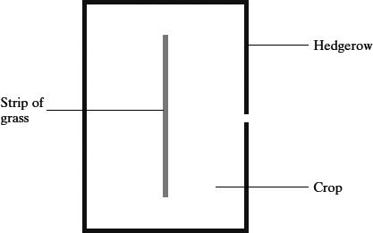

Suggest and explain the advantage of leaving the strip of grass in the middle of the field.

___________________________________________________________________

___________________________________________________________________

___________________________________________________________________

___________________________________________________________________

**(2)**

(c)Apart from providing a habitat for predators of crop pests, give **two** biological benefits of replanting hedgerows.

1. _________________________________________________________________

___________________________________________________________________

2. _________________________________________________________________

___________________________________________________________________

**(2)**

**(Total 6 marks)**

**Q3.**

Parts of the sea shore form a very hostile environment for living organisms. Twice each day the incoming and outgoing tides alternately cover the organisms on the sea shore with water and then leave them exposed. The force of the waves could also dislodge any organisms that were not firmly attached.

The diagram shows a section through a rocky shore. Two sites were studied: site **A** was on the upper shore and site **B** on the lower shore.

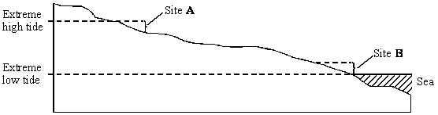

The table shows the seaweeds that were found growing at sites **A** and **B**.

|  |  |  |  |
| --- | --- | --- | --- |
| **Site A: upper shore** | **Mean number per m2** | **Site B: lower shore** | **Mean number per m2** |
| *Ascophyllum nodosum Fucus spiralis Fucus vesiculosus Pelvetia canaliculata* | 2 10 4 6 | *Corallina officinalis Fucus serratus Laminaria digitata Laminaria hyperborea Laminaria saccharina Laurencia pinnatifida Palmaria palmata* | 31 8 15 3 6 18 6 |
| Index of diversity |  | Index of diversity | 4.77 |

(a)     (i)      Use the formula



where       **d** = index of diversity  
**N** = total number of organisms of all species  
**n** = total number of organisms of a particular species

to calculate the index of diversity for the seaweeds growing at site **A**.  
Show your working.

Index of diversity at site **A** = ____________________

**(2)**

(ii)     Give **one** advantage of calculating the index of diversity rather than just recording the number of species present.

______________________________________________________________

______________________________________________________________

**(1)**

(b)     Availability of water is one abiotic factor which determines the distribution of seaweeds. The graph shows loss in mass due to water evaporation for two of the seaweed species. The two seaweeds belong to the same genus but one was found only on the upper shore and the other only on the lower shore.

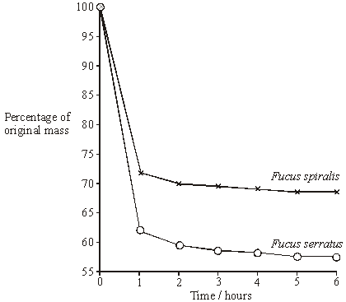

Explain how the results shown in the graph relate to the distribution of these two seaweeds on the sea shore.

___________________________________________________________________

___________________________________________________________________

___________________________________________________________________

___________________________________________________________________

___________________________________________________________________

**(3)**

**(Total 6 marks)**

**Q4.**

(a)     Heath is a community of plants and animals. A student investigated the species diversity of plants in this community. The table shows her results.

|  |  |
| --- | --- |
| **Plant species** | **Number of plants per m2** |
| Heath rush | 1 |
| Bilberry | 1 |
| Sheep’s sorrel | 5 |
| Ling | 2 |
| Bell heather | 1 |
| Heath bedstraw | 8 |
| Mat-grass | 11 |

(i)      The index of diversity can be calculated from the formula

*d* =



where

*d* = index of diversity

*N* = total number of organisms of all species

*n* = total number of organisms of each species.

Use this formula to calculate the index of diversity for the plants on the heath.

Show your working.

Answer ____________________

**(2)**

(ii)     Explain why it may be more useful to calculate the index of diversity than to record only the number of species present.

______________________________________________________________

______________________________________________________________

______________________________________________________________

______________________________________________________________

**(2)**

(b)     The demand for increased food production has led to areas of heath being used to grow wheat. Explain the effect of this on

(i)      the species diversity of plants

______________________________________________________________

______________________________________________________________

______________________________________________________________

______________________________________________________________

______________________________________________________________

______________________________________________________________

**(2)**

(ii)     the species diversity of animals.

______________________________________________________________

______________________________________________________________

______________________________________________________________

______________________________________________________________

______________________________________________________________

**(2)**

**(Total 8 marks)**

**Q5.**

Mayflies are insects which lay their eggs in streams and rivers. The nymphs which hatch from the eggs live in the water for several years.

Mayfly nymphs were collected by disturbing the gravel of a stream bed. A net placed immediately downstream caught any animals which were washed out of the gravel. Eight samples were collected from shallow, fast-flowing parts of the stream and eight from deeper, slow-flowing parts. Nymphs from two different families of mayfly were found. The results are given in the table.

|  |  |  |  |  |
| --- | --- | --- | --- | --- |
|  | **Family Caenidae** | | **Family Baetidae** | |
|  | **Shallow water** | **Deep water** | **Shallow water** | **Deep water** |
| **Mean number of nymphs** | 2.38 | 12.88 | 24.50 | 6.00 |
| **Standard deviation** | 1.51 | 7.92 | 6.72 | 1.51 |

(a)     Describe how you would have collected the samples in order to ensure they were representative of the habitats being investigated and could be compared with each other.

___________________________________________________________________

___________________________________________________________________

___________________________________________________________________

___________________________________________________________________

___________________________________________________________________

___________________________________________________________________

**(3)**

(b)     Which **one** of the four samples showed the greatest variation within the sample? Give evidence from the table for your answer.

___________________________________________________________________

___________________________________________________________________

**(1)**

(c)     The two families of mayfly nymph occupy different ecological niches.

(i)      What is meant by the term *ecological niche*?

______________________________________________________________

______________________________________________________________

**(1)**

(ii)     Describe the evidence in the table which suggests that the two families of mayflies occupy different ecological niches.

______________________________________________________________

______________________________________________________________

**(1)**

(iii)     Explain the advantage to these two families of mayflies of occupying different ecological niches.

______________________________________________________________

______________________________________________________________

______________________________________________________________

______________________________________________________________

**(2)**

**(Total 8 marks)**

**Q6.**

The drawings show two dogwhelks taken from two different populations. Dogwhelk **A** came from a sheltered shore and dogwhelk **B** from a shore exposed to heavy wave action. The dogwhelks attach themselves to rocks with a muscular foot which comes out through the aperture. The shell length : aperture length ratios (L/A) were calculated. The mean and standard deviation for each population are shown under the drawings.

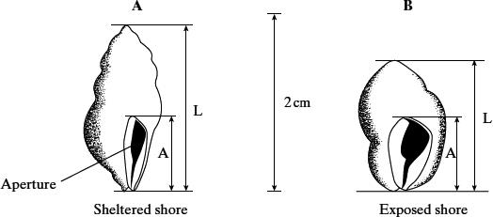

         mean L/A ratio          = 1.91                       mean L/A ratio          = 1.78  
standard deviation    = 0.19                       standard deviation    = 0.10

(a)     Describe how you would collect a random sample of each population.

___________________________________________________________________

___________________________________________________________________

___________________________________________________________________

___________________________________________________________________

___________________________________________________________________

___________________________________________________________________

**(3)**

(b)     What do the standard deviations tell you about the two populations of dogwhelks?

___________________________________________________________________

___________________________________________________________________

___________________________________________________________________

___________________________________________________________________

**(2)**

(c)     Suggest how the effect of wave action on the two populations of dogwhelks could result in differences between

(i)      the mean L/A ratios;

______________________________________________________________

______________________________________________________________

______________________________________________________________

______________________________________________________________

(ii)     the standard deviations.

______________________________________________________________

______________________________________________________________

______________________________________________________________

______________________________________________________________

**(4)**

**(Total 9 marks)**

**Q7.**

(a)  Describe how organisms are grouped in a phylogenetic classification system.

___________________________________________________________________

___________________________________________________________________

___________________________________________________________________

___________________________________________________________________

**(2)**

**Table 1** shows some of the taxa in the phylogenetic classification of a rhinoceros species.

|  |  |
| --- | --- |
| **Table 1** | |
| **Taxon name** | **Scientific name** |
| Class | Mammalia |
| Order | Perissodactyla |
| Family | Rhinocerotidae |
| Genus | *Rhinoceros* |
| Species | *unicornis* |

The figure below shows the relationship between the taxa in the classification of two rhinoceros species: *Rhinoceros unicornis* and *Dicerorhinus sumatrensis*.

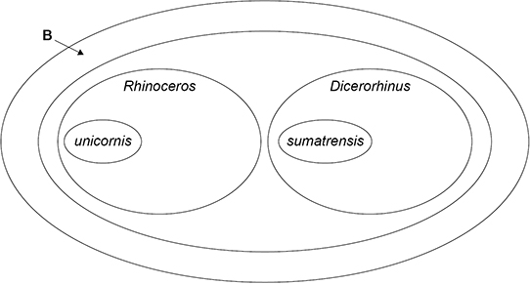

(b)  Use information in **Table 1** to give the **scientific** name of the taxon labelled **B** in the figure above.

___________________________________________________________________

**(1)**

(c)  Draw an oval on the figure above to show the species *Rhinoceros sondaicus*.

**(1)**

Scientists investigated a phylogenetic relationship between individuals of five species of rhinoceros.

The scientists:

•   determined the DNA base sequence of the *cyt b* gene of each rhinoceros

•   compared each *cyt b* DNA base sequence with that of **one** Indian rhinoceros (called the reference rhinoceros)

•   calculated the percentage difference between each *cyt b* DNA base sequence and that of the reference rhinoceros.

**Table 2** shows their results.

|  |  |
| --- | --- |
| **Table 2** | |
| **Investigated species of rhinoceros** | **Percentage difference in DNA base sequences compared with the reference Indian rhinoceros** |
| Indian | 2 |
| Javan | 5 |
| Sumatran | 13 |
| White | 14 |
| Black | 14 |

(d)  What can you conclude about the likely phylogenetic relationships between these species? Evaluate your conclusion.

___________________________________________________________________

___________________________________________________________________

___________________________________________________________________

___________________________________________________________________

___________________________________________________________________

___________________________________________________________________

___________________________________________________________________

___________________________________________________________________

___________________________________________________________________

___________________________________________________________________

___________________________________________________________________

**(4)**

(e)  A scientist obtained a rhinoceros horn confiscated from poachers and wanted to identify the species of rhinoceros that was killed for its horn.

He used the procedure described in part (d) and calculated the difference in *cyt b* DNA as 14%.

What can you conclude from this result? Explain your answer.

Suggest a change to the procedure that will more precisely identify the rhinoceros species that provided the horn.

Conclusion and explanation  ___________________________________________

___________________________________________________________________

___________________________________________________________________

___________________________________________________________________

Suggested change to the procedure  _____________________________________

___________________________________________________________________

___________________________________________________________________

___________________________________________________________________

**(2)**

**(Total 10 marks)**

**Q8.**

(a)     Explain the principles which biologists use to classify organisms into groups.

___________________________________________________________________

___________________________________________________________________

___________________________________________________________________

___________________________________________________________________

___________________________________________________________________

___________________________________________________________________

**(3)**

Cytochrome c is a protein with about 100 amino acids and is present in all eukaryotic organisms. It has the same three-dimensional shape in all species, but only 30 of the amino acids are the same in all species. The amino acid sequence of cytochrome c has been used to construct the phylogenetic tree shown below.

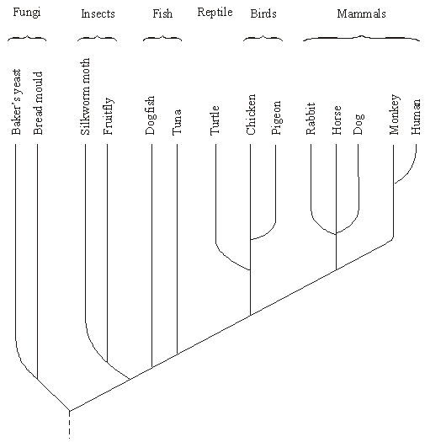

(b)     Name the kingdoms represented in this phylogenetic tree.

___________________________________________________________________

**(1)**

(c)     What does the phylogenetic tree show about the evolutionary relationship between fungi and insects?

___________________________________________________________________

___________________________________________________________________

___________________________________________________________________

___________________________________________________________________

**(2)**

(d)     Suggest how information on amino acid sequences is used to construct a phylogenetic tree.

___________________________________________________________________

___________________________________________________________________

___________________________________________________________________

___________________________________________________________________

**(2)**

(e)     Suggest **one** advantage and **one** disadvantage of using cytochrome c to construct a phylogenetic tree.

Advantage

___________________________________________________________________

___________________________________________________________________

Disadvantage

___________________________________________________________________

___________________________________________________________________

**(2)**

**(Total 10 marks)**

Mark schemes

**Q1.**

(i)      for correct use of sigma;  
numerator = 380 and denominator = 132;

**2**

2.87 to 2.9 gains 2 marks

*(do not allow 2.8 or denominator = 135)*

(ii)      more types of prey found on strawberries;

**1**

**[3]**

**Q2.**

(a)     source of pests / animals, and effect on crop;  
source of weeds / no longer taking nutrients, hence competition /   
reduced yield; creation of larger fields / leaving room,  
hence more efficient use of machinery / grow more crops;  
hedgerows have to be maintained, so removal saves time / money;

**2 max**

(b)     allows beetles to remain / survive / over winter in the middle of the  
field / strip of grass;  
effect on distribution, e.g. do not normally reach the centre of the field  
/ can reach all parts;

**2**

(c)     increases biodiversity;  
source of food for animals;  
habitat / nest for animals;  
reduce need for insecticides / attracts insects away from crop;  
windbreaks / prevent erosion / run-off / leaching;  
migratory corridors;

**2 max**

**[6]**

**Q3.**

(a)     (i)      EITHER:     Correct answer: 3.45 / 3.44 / 3.4            = 2 marks  
OR:            Understanding of ∑n(n-1) / use of  
                   134 / (2 + 90 + 12 + 30)  
                   + wrong answer                                      = 1 mark

**max 2**

(ii)     Takes account of number of individuals / abundance /   
population size (as well as number of species);

**1**

(b)     The species at A /  *F.spiralis* loses less water /   
loses water less rapidly / loses less mass;

The species at A / *F.spiralis* better adapted to / can survive where   
exposed for longer / to drier conditions;

The species at A / *F.spiralis* avoids competition For named aspect  
– e.g. light / substratum / space / CO2;

*ACCEPT converse argument re. F. serratus*

**3**

**[6]**

**Q4.**

(a)     (i)      Two marks for correct answer of 4.3;

***Q*** *An answer of 4 scores 1 mark*

One mark for incorrect answer that clearly shows understanding of ∑n(n – 1) / 188 as denominator;

**2**

(ii)     Measures number of individuals (of each species) and number of species;

***Q*** *First marking point can only be awarded if there is a reference to species.*

Some species only present in small numbers;

**2**

(b)     (i)      Reduced as one crop / species grown / other species removed;

Use of herbicides / weeding / ploughing / wheat (better) competitor for named factor e.g. light / nutrients;

**2**

(ii)     (Reduced) as less variety of food sources;

(Reduced) as fewer habitats / niches;

***Q*** *Answers only referring to ‘less food’ should not be credited*

**2**

**[8]**

**Q5.**

(a)     Samples collected at random;  
Method for choosing random sites – random  
coordinates / position from tables / calculator / other suitable  
means;

Other named factor constant e.g.:

Same size of net / same width of opening of net / use of one  
quadrat / Quadrats of same size / of stated size / same area  
disturbed / collect each   
Sample for same time;

**3**

(b)     *Caenidae* in deep water – because highest standard  
deviation / ‘S.D.= 7.92’

**1**

(c)     (i)      An organism’s role / in the ecosystem / community;  
[ALLOW refs. To trophic levels / named]

*(IGNORE refs. To habitat)*

**1**

(ii)     *Caenidae* found mainly in deep water AND *Baetidae* in  
shallow water / one family mainly in deep water AND the  
other in shallow water;

**1**

(iii)     Reduces competition for named factor – e.g. food / shelter / O2 ;  
To ensure both types survive / otherwise better adapted   
type displaces other type;  
OR  
Ref. to ‘Competitive exclusion principle’ = 2 marks

**max 2**

**[8]**

**Q6.**

(a)     generation of random co-ordinates;  
use of 10 or more quadrats;  
collection of all dog whelks in quadrat;

**3**

(b)     greater variation for sheltered population / population A;  
range / spread around the mean;

*(or converse)*

**2**

(c)     (i)      smaller ratio means relatively larger foot / population B has  
relatively large foot;  
better able to grip;  
larger / longer shells have greater area exposed / are subject  
to greater force;

(ii)     wave action limits the max. L / A ratio / extremes;  
valid point about age, e.g. greater age range on sheltered  
shore / live longer on sheltered shore;

*(allow shell size marking point in either (c)(i)  
or (c)(ii) but only credit once)*

**4 max**

**[9]**

**Q7.**

(a)     1.      Hierarchy (of groups) **with** no overlaps;

*Accept description of hierarchy, eg smaller groups in larger groups*

2.      (Grouped) according to evolutionary origins/relationships;

*Accept evolutionary history*

**2**

(b)     Perissodactyla;

*Accept incorrect spellings provided the word looks close to Perissodactyla*

*Ignore upper/lowercase letters*

*Accept order*

(c)     Oval/shape drawn inside the *Rhinoceros* oval **and** not touching the *unicornus* oval **or** the *Rhinoceros* oval;

**1**

(d)     1.      Genetic variation (exists) between Indian rhinos;

2.      Indian rhinos (most) closely related to Javan rhinos;

3.      Indian rhinos less (closely) related to White/Black/Sumatran rhinos;

4.      Correct use of figures to support finding on relative closeness of relationship;

5.      Comparisons only made to (one) Indian rhino;

6.      Sample size not known;

*Accept more recent common ancestor for ‘more closely related’*

**4 max**

(e)     1.      (Likely) either White or Black (rhinoceros) as identical percentage

**OR**

Not from Indian/Javan (rhinoceros) as very different percentages

**OR**

Cannot be certain as White, Black and Sumatran have similar percentages;

2.      Use a different reference (species of) rhinoceros

**OR**

Use a different gene

**OR**

Use more than one gene

**OR**

Compare (DNA) base sequence not percentage differences;

**2**

**[10]**

**Q8.**

(a)     large groups are divided into smaller groups;  
(*not just ‘hierarchical’*)  
members of a group have features in common based on anatomy  
/ fossils / embryology / DNA / specific aspect of cell biology  
/ homologous structures;

reflects evolutionary history;

**3**

(b)     fungi and animals;

**1**

(c)     (insects and fungi) have common ancestor;  
they diverged a long time ago / before others referred to in phylogenetic tree;

**2**

(d)     those with similar sequences put in same groups / are more closely related;  
the greater difference in amino acid sequence the longer ago the groups  
diverged;

**2**

(e)     A - present in all (eukaryotic) species or organisms / quantifiable;  
D - extinct species not considered / no timing of events available / only limited number of amino acid sequences / can’t include prokaryotic species

**2**

**[10]**