3.4.1 DNA, genes and chromosomes

In prokaryotic cells, DNA molecules are short, circular and not associated with proteins.

In the nucleus of eukaryotic cells, DNA molecules are very long, linear and associated with proteins, called histones.

Together a DNA molecule and its associated proteins form a chromosome.

The mitochondria and chloroplasts of eukaryotic cells also contain DNA which, like the DNA of prokaryotes, is short, circular and not associated with protein.

**The Genetic Code**

* DNA controls the cell’s activities because DNA is a code for synthesising proteins, enzymes are proteins, enzymes catalyse all cell’s reactions and therefore activities
* DNA determines the primary structure of a protein because the **sequence of DNA bases** determines the **specific sequence of amino acids** in the polypeptide chain (**primary structure**).
* The **sequence** **of Bases** in DNA (genetic code) determines the **sequence of Amino Acids** in a protein. The code is a **3 letter** (base) or **Triplet code**, where each sequence of **3 bases** codes for one **specific** **amino acid**. *N.B. one amino acid can be coded for by more than one type of triplet, called the **degenerate (simple) code**.
* The code must be based on 3 bases because (Boardworks Genetic code):
  + 1 base code generates only 4 combinations i.e. 41
  + Whereas a 2 base code generates **only 16** possible combinations i.e. 42
  + A 3 base code generates **64 possible combinations** i.e. 43 to accommodate the **20** different amino acids and
  + **Start/Stop triplet codes** ensure that the **code is read in the correct direction**
  + A 4 base code generates **256 possible combinations** i.e. 44, which means that **errors** in copying the code would occur **more frequently!**
* When a polypeptide is required, the DNA triplet code of its gene is converted into a molecule of **messenger RNA** (**mRNA**), by **complementary base paring**. The triplet code in mRNA is called a **codon:**

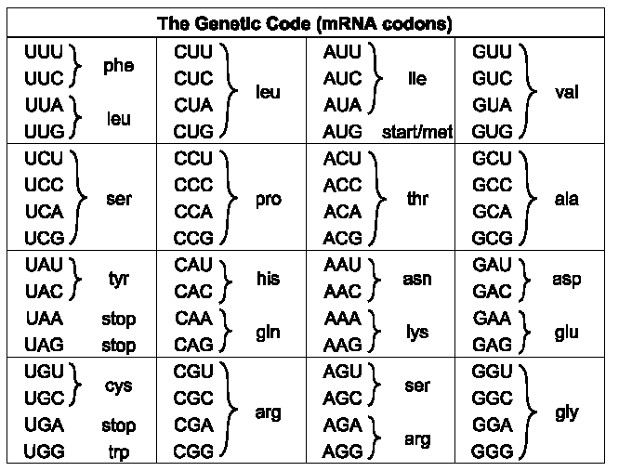

Codon

Amino Acid

* The portion of DNA which codes for a **whole polypeptide** is called a **gene or cistron**. This is the basis of the ‘**one gene one polypeptide’** hypothesis
* A gene occupies a fixed position, called a locus, on a particular DNA molecule.
* All the triplet codes/codons are **universal** i.e. exactly the same for every organism
* The code is **non-overlapping** in that each triplet is read separately
* In eukaryotes, much of the nuclear DNA does not code for polypeptides. There are, for example, non-coding multiple repeats of base sequences between genes. Even within a gene only some sequences, called exons, code for amino acid sequences. Within

the gene, these exons are separated by one or more non-coding sequences, called introns.

3.4.2 DNA and Protein synthesis

# Protein synthesis

* Protein synthesis consists of two stages in different parts of the cell:
  + Transcription – the formation of messenger RNA (mRNA)
  + Translation – the translation of the code into primary structure protein
* Both mRNA and tRNA are used in protein synthesis:

**Transcription** – Transcription is the mechanism by which the base sequence of a gene on a DNA strand is converted into the complementary base sequence of mRNA [(Transcription and Translation animation)](http://www.youtube.com/watch?v=NJxobgkPEAo&feature=related)

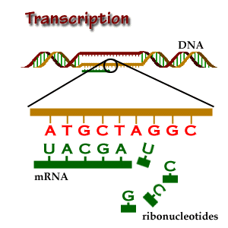

* DNA is physically too big to leave the nucleus via the nuclear pores
* **RNA Polymerase binds to the DNA at** the **gene** or **cistron** (Specific sequence of DNA bases) to be copied and **unwinds**
* **DNA unzips**
* Only **one of the DNA strands** is used as a **template**
* **Free RNA nucleotides** align themselves the opposite the **complementary DNA base**
* and joins guanine to exposed cytosine, but joins **uracil to the DNA’s adenine**
* **RNA Polymerase** moves along the strand joining nucleotides forming **single stranded mRNA**
* The mRNA now carries complementary **codons**, which codes for **specific amino acids**
* At the end of the sequence the mRNA is detached and the DNA **rewinds**
* mRNA transfers nucleotides through the **nuclear pores** to the cytoplasm where it attaches to **ribosomes** consisting of **ribosomal RNA and protein**.

**Translation** – mRNA code is converted into Amino Acid sequence (protein primary

structure -(Boardworks Translation) [(Translation animation)](http://www.youtube.com/watch?v=B6O6uRb1D38&feature=related)

* tRNA (transfer RNA) this is a single strand but forms a ‘**clover leaf’** shape due to **base pairing** being possible in certain sections of the molecule.
* Exposed bases at the bottom of the molecule called the **ANTI CODON** and is important for two reasons:
  + It determines the **specific AA** that attaches to that tRNA molecule,

therefore the **sequence of AA in the polypeptide chain**

* + Only the anti codon can base pair with the codon on the mRNA which is

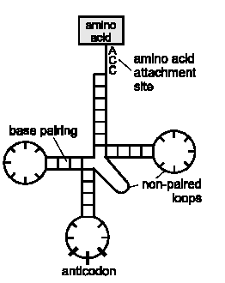 complementary

Translation involves:

* mRNA strand moves out of the nucleus via **nuclear pores** to the cytoplasm
* A **Ribosome attaches** to the **mRNA strand** which is held in place

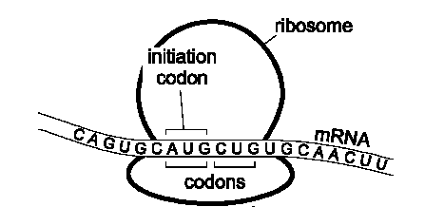

* In the surrounding cytoplasm an **amino acid** is **activated** by **ATP** and is attached

to a **specific tRNA molecule via a specific linkage**, which carries amino acid at one end and an **anticodon** at the other

* tRNA molecules bring **specific AAs** to the mRNA
* The **Anti codon** of the tRNA **complementary base pairs** to the **start codon** of the **mRNA**
* tRNA forms **Hydrogen bonds** with mRNA

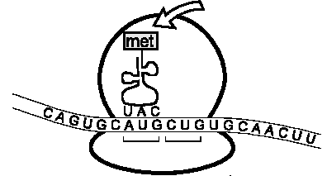

* Another tRNA **complementary base pairs to the second codon of the mRNA**

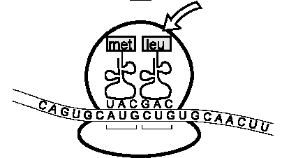

* A **ribosomal enzyme** catalyses peptide bond (**requiring ATP**) formation between an amino acid on one tRNA and the growing polypeptide on the other tRNA

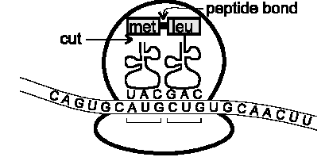

* The first tRNA is released and returns to the **cytoplasmic pool** to join to the **same specific AA**

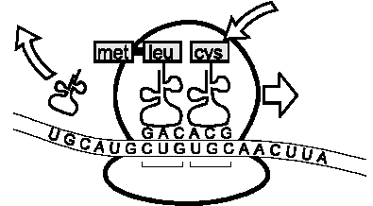

* A ribosome passes along mRNA, one codon at a time, tRNA with the appropriate anticodon fills the **vacant slot** and the amino acid forms a **peptide bond with the last member of the chain using energy from ATP**, until a **stop codon** is reached

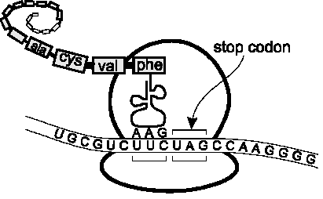

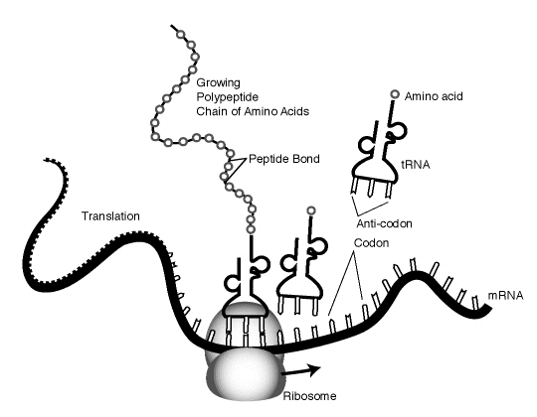

* The polypeptides may be further modified and a protein may consist of more

than one polypeptide

* The ribosome acts as a framework moving along the mRNA, reading the code,

holding the **codon-anti codon complex** together until the two amino acids join

* Candidates should revisit unit BY1 to understand that these modifications to

the primary structure involve the Golgi body

* * N.B. all body cells contain the same chromosomes, and therefore genes, but they can differ in appearance i.e. nerve cell/epithelial cell. This is because DIFFERENT genes are EXPRESSED (transcribed/translated) in each, therefore different proteins/enzymes are produced, giving different characteristics.

Meiosis [(Meiosis animation)](http://highered.mcgraw-hill.com/olcweb/cgi/pluginpop.cgi?it=swf::535::535::/sites/dl/free/0072437316/120074/bio19.swf::Stages%20of%20Meiosis) [(Meiosis tutorial)](http://www.sumanasinc.com/webcontent/anisamples/majorsbiology/meiosis.html)

* Humans have 23 pairs of homologous chromosomes. The total number of chromosomes is called the **diploid** (2n) number (46 in humans). Sex cells, or gametes, have half the diploid number; this is called **haploid** number (n). So human gametes have 23 chromosomes
* Meiosis cell division is used to create **gametes** from somatic body cells and ensures that the gametes have:
  + **Haploid (half) number of chromosomes** (Caused by 2 cell divisions)
  + **Variation in Genotype** (Caused by **Random Assortment**/**Crossing Over**)
* Meiosis takes place in a series of Phases over 2 cell divisions:
* Interphase I
* Chromosomes not visible (chromatin), DNA replicates itself so that there are now 4 copies of each chromosome (2 maternal/2 paternal)
* Prophase I
  + - **DNA condenses** and chromosomes become

**visible**

* + - Nuclear membrane breaks down
    - One chromosome has become two **sister**

**chromatids**

* + - Held together by the **centromere**
    - **Homologous chromosomes** pair up

forming **Bivalents**. Each bivalent consists

of 4 chromatids, made up from 2

**Bivalent**

chromosomes which replicated

themselves

* + - Chromosomes **entwine** forming **chiasmata**
    - **Crossing over** occurs by **breaking of maternal and**

**paternal DNA** which is then interchanged

* Metaphase I
  + - Centrioles move to opposite poles of cell
    - **Spindle fibres** are produced
    - **Bivalents** move to the **equator**
    - Chromosomes attach to the spindle at

**Centromeres**

* + - **Random Assortment** occurs
* Anaphase I
  + - **Centromeres divide,** sister chromatids

separate

* + - **Spindle fibres contract** pulling

**chromosomes** to **opposite poles**



* Telophase I
  + - Spindle fibre breaks down
    - Cell enters prophase II
* Prophase/Metaphase II



* + - A new spindle forms at right angles

to the first

* + - Each of the pair of sister

chromatids (chromosomes) move to

the equator of the cell

* + - Each chromosome attaches to the

Spindle fibre by the **centromere**

* Anaphase II

* + - The **centromeres** divide
    - The **spindle fibres contract** to pull

the two chromatids to the opposite

poles

* Telophase II
  + - The chromosomes **lengthen** becoming **chromatin**
    - The spindle fibre **breaks down**
    - Nuclear membrane **reforms**
    - **Cytokinesis** occurs resulting in **4 haploid cells** being formed which

show **genetic variation**



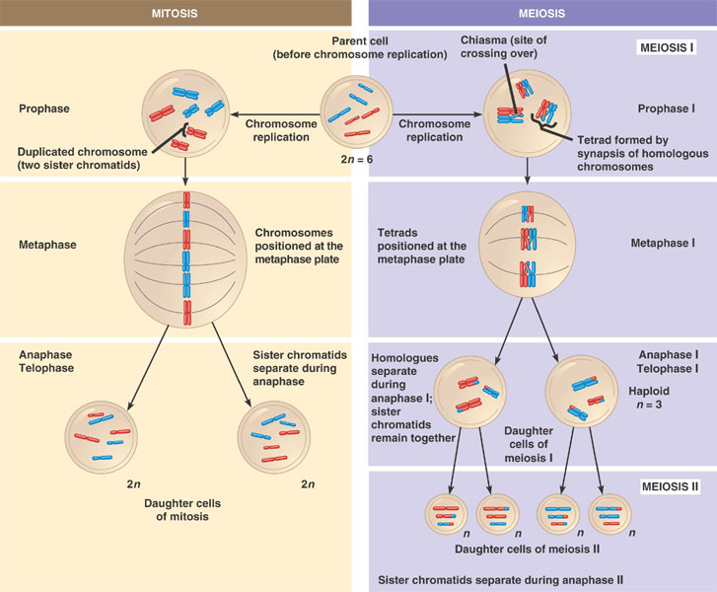

* Significance of meiosis
* Meiosis generates variety via:

|  |  |
| --- | --- |
| Meiosis feature | Detail |
| Haploid gametes for random fertilisation | During sexual reproduction the **genotype of one parent is mixed with that of the other when haploid gametes randomly fuse** |
| Random/Independent Assortment | The different pairs of **homologous chromosomes** arrange themselves on the spindle fibre during **metaphase I** of meiosis. When they **separate** they do so **independently** of each other, so daughter cells have **different combinations** of maternal and paternal chromosomes |
| Crossing Over | **Crossing over** during **chiasmata** in **prophase I** of meiosis causes equal parts of homologous chromosomes may be **exchanged**  producing **new combinations** and **separation of linked genes** |

* + Random/independent assortment detail [(Independent Assortment of Alleles animation)](http://www.sumanasinc.com/webcontent/anisamples/majorsbiology/independentassortment.html)

Crossing over generates variation within gametes; another is random assortment of the chromosome pairs in Metaphase I when they move to the equator:

* + e.g. look at the two homologous pairs of chromosomes with one gene locus on each:

R r

T t

* + DNA replicates

R R r r

T T t t

* + Each pair now moves to the equator of the cell, but there is independent assortment which means each pair is randomly arranged giving two possibilities:

R R r r R R r r

OR

T T t t t t T T

* + After meiosis I the pairs separate to opposite poles:

R R T T r r t t R R t t r r T T

and OR and

* + Then after Meiosis II the chromatids are pulled apart to form the haploid cells:

R T r t R t r T

and and OR and and

R T r t R t r T

e.g. Random assortment PPQ

