**3.4.3 Mutations**

Mutation refers to the change in amount, arrangement, or structure in the DNA of an organism. Mutations are spontaneous random events which may provide a source of material for **natural selection pressures** and therefore **evolution**. There are two types of mutation:

* Chromosome mutation
* Gene mutation
* Gene mutation

Gene mutation refers to a change in the **sequence of DNA bases** for a gene. Since a gene is a ‘specific sequence of DNA bases coding for a specific protein’, if the sequence is changed a different protein is coded for which may be non functional because:

* + The mutation changes the **sequence of nucleotides**
  + Which changes the **sequence of amino acids** in the polypeptide chain
  + Therefore producing a **different Tertiary structure** in the protein due to changes in hydrogen, ionic or disulphide bonds
  + Which means the 3D **shape/shape of active site in enzymes alters**
  + Resulting in the protein being **non-functional**
  + Therefore the **phenotype** may alter

There are three types of **point gene mutation** (mutation of **single base pair**):

* + Substitution when a nucleotide in a DNA molecule is replaced by another nucleotide which has a different base
  + Addition adding a nucleotide
  + Deletion deleting a nucleotide
* Consider this DNA base sequence:

DNA AGT CGC TAA CCC

mRNA UCA GCG AUU GGG

Amino acid Ser Ala Ile Gly

* Addition/Deletion – the effect of adding/deleting a DNA base is to **change** the amino acid sequence, and therefore the resulting protein, as **all** the DNA/mRNA codons have been changed from the point mutation onwards (**frame shift to the left or right**): One added or deleted nucleotide causes all triplets in a sequence to be read differently because each has shifted to either the left or the right

Addition Deletion

DNA AGT CGC TAA CCC AGT CGC TAA CCC

Mutated DNA AGT CAG CTA ACC C AGT* GCT AAC CC

mRNA UCA GUC GAU UGG G UCA CGA UUG GG

## Amino acid Ser Val Asp Trp Ser Arg Leu

* Substitution – this may have no or little effect on protein primary structure:

DNA AGT CGC TAA CCC

Mutated DNA AGT CGA TAA CCC

mRNA UCA GCU AUU GGG

Amino acid Ser Ala Ile Gly

There has been **no change** to the amino acid sequence (as more than one triplet code for one amino acid called **degenerate code**) or **only one amino acid** is changed!

* **Sickle Cell Anaemia** is an example of a **substitution gene mutation** which occurs in the gene producing haemoglobin. The replacement of one DNA base results in:
  + 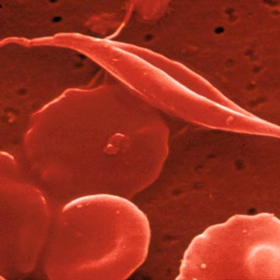The wrong amino acid being incorporated into 2 of the polypeptide chains which makes up haemoglobin
  + **Haemoglobin A** (HbA) which is normal functioning haemoglobin has **glutamic acid** (amino acid) at the 6th amino acid position, coded for by DNA triplet code (C**T**T/C**T**C)
  + **Haemoglobin S** (HbS) is produced instead of HbA due to (C**A**T/C**A**C) being replaced by **valine**

HbA DNA triplet code CTT CTC

HbS DNA triplet code CAT CAC

Amino Acid Glu Glu

Amino Acid Val Val

* + The substitution of **Adenine** for **Thymine** as **second base** will form **haemoglobin S**, which results in **red blood cells** becoming sickle-shaped, resulting in anaemia and possibly death.
  + The mutant allele is **codominant**. In the homozygous state the individual suffers the disease, but in the **heterozygous** state the individual has 30-40% sickle cells, the rest normal – this is referred to as **sickle-cell trait**.
* Chromosome mutation

Mutations causing changes in the **structure** or **number** of **whole chromosomes** in cells are known as chromosome mutations. These most likely occur during **meiosis,** where errors occur resulting in chromosomes not being equally shared between daughter cells.

**Changes in whole sets of chromosomes** occur when organisms have three or more sets of chromosomes rather than the usual two (i.e. one homologous pair of each chromosome). This condition is called **polyploidy** and occurs mostly in plants.

**Changes in the number of individual chromosomes.** Sometimes individual homologous pairs of chromosomes fail to separate during meiosis. This is known as **Non-disjunction.** Non-disjunction is a process in which faulty cell division means that one of the daughter cells receives 2 copies of a chromosome, whereas the other gets none! For example, **Down’s Syndrome**:

* + Chromosome 21 is affected
  + **Non-disjunction** (bivalents do not separate during anaphase I) occurs in the **ovaries**, resulting in an **oocyte** with either **no chromosome number 21** or with **2 chromosome number 21**
  + Oocytes with **no chromosome number 21** will die, oocytes with **2 chromosome number 21s** survive and may be fertilised
  + The resulting zygote has 3 chromosomes 21s with a total of **47 chromosomes**. This condition is known as **trisomy 21** and the zygote will develop a child with Down’s syndrome.
  + Down’s syndrome occurs in approximately 1/700 births and the incidence of mutation is related to the age of the mother:

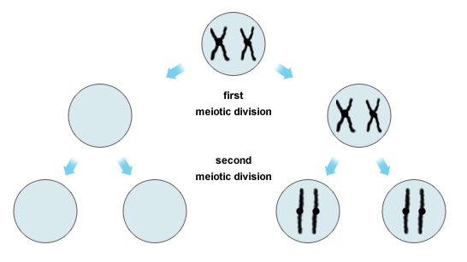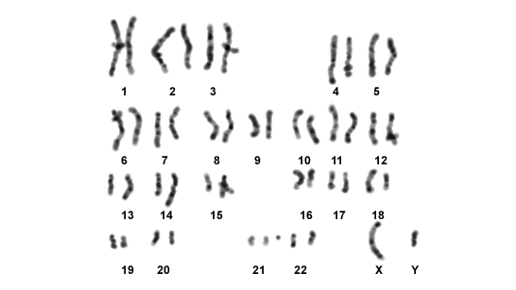

Trisomy

* Mutagens

Mutations occur naturally at random. There are certain factors which increase the **rate** of mutations, called **Mutagens**:

* + Ionising Radiation UV/X rays
  + Particles Alpha/Beta
  + Chemicals Benzopyrene in tobacco smoke

A mutagen which causes cancer is a **carcinogen** e.g. **polycyclic hydrocarbons in tobacco smoke:**

* + Genes normally control cell division and division is halted by **tumour suppressor gene**s when sufficient cells have been produced for growth and repair.
  + Carcinogens may cause **tumour suppressor genes to mutate**, along with other **oncogenes**, leading to uncontrolled division forming cancerous tumours.