**3.4.4 Genetic diversity and adaptation**

Variation

If a species is to survive a constantly changing environment and to colonise new environments sources of **variation** are needed.

The **genotype** of an organism gives it the **potential** to show a particular **characteristic**. The degree to which the characteristic is shown can be affected by the organism’s **environment**.

* Types of variation

Characteristics can be show **2 types** of variation depending on the number of genes coding for them:

* + **Continuous variation** A characteristic controlled by **many genes**

(polygenic effect) shows **gradual change** in the population from one extreme to the other e.g. **height**

Frequency

Height of student

# Discontinuous variation A characteristic controlled by one or two genes

# shows clear cut differences in the population e.g. tongue rolling controlled by one gene/two alleles: RR + Rr = tongue roller, rr = non roller

Frequency

Rollers non rollers

* Non-heritable Variation i.e. environmental factors

The environment has a role in determining phenotypic variation e.g. a human may inherit genes which give it a theoretical maximum height but poor diet may limit this e.g.

* + Women in Victorian times had an average height of 4ft 10” even though they had the same genotype for height as women today. There has been no evolution of taller women, but due to environmental factors such as more food, better medical facilities the phenotype expression has changed a great deal!
  + This **non-heritable variation** is largely responsible for **continuous variation**
* Heritable Variation i.e. inherited variation

The environment has no affect on **discontinuation variation**. Inherited variation results in genetic changes i.e. to genotype of an organism, by:

* **Crossing over** between homologous chromosomes during **Prophase I of meiosis**
* **Random/independent assortment** of chromosomes in **Metaphase I of meiosis**
* **Random fusion of haploid gametes** from two parental genotypes
* **Mutation**

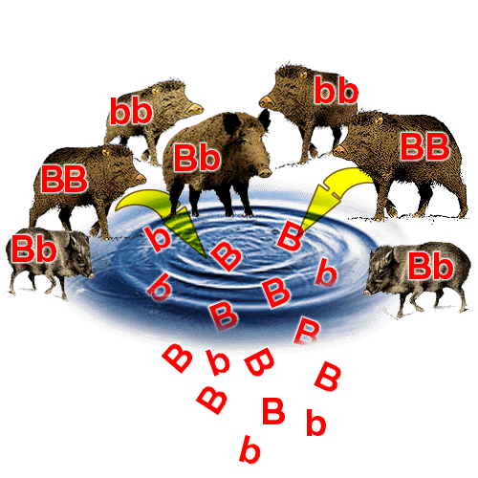**Population genetics**

Population genetics is concerned with determining the **relative proportions of the various genotypes** present in a population, from which can be calculated the **relative proportions of alleles** in the population, called the **allele frequency. All of the alleles within a population is called the Gene Pool**.

**Types of selection**

Directional selection, exemplified by antibiotic resistance in bacteria, and stabilising selection, exemplified by human birth weights.

Natural selection results in species that are better adapted to their environment. These adaptations may be anatomical, physiological or behavioural.

Natural Selection and The Theory of Evolution

Evolution is the process by which new species are formed from pre-existing ones over a period of time. Darwin’s observations of variation within a population lead to the development of **Natural Selection**:

* + Darwin recognized that **species changed**
  + Proposing the theory of **natural selection** to explain why it happened
  + Organisms **overproduce offspring**
  + So that there is a **large variation of genotypes** in population
  + However, **numbers on the population remain constant**
  + Therefore there is a **high mortality rate**
  + Because **changes to environmental conditions** bring new **selection pressures** i.e. a factor which increases the chances of a beneficial allele being passed onto the next generation e.g. **competition**/**predation/disease**
  + Only those individuals with **beneficial alleles** have a **selective advantage** e.g. **white fur in arctic**, therefore are **more likely to survive**
  + These individuals then **reproduce**
  + Offspring are likely to **inherit the beneficial alleles, therefore characteristic**
  + This process **repeats generation after generation**
  + Therefore the **beneficial allele frequency increases** within the **gene pool**
  + e.g. Darwin found **adaptive radiation** in the finch population of the Galapagos islands**,** which describes the evolutionary **diversification** of many species from a **single common ancestor**

Genetic diversity as the number of different alleles of genes in a population. Genetic diversity is a factor enabling natural selection to occur.

**The principles of natural selection in the evolution of populations.**

• Random mutation can result in new alleles of a gene.

• Many mutations are harmful but, in certain environments, the new allele of a gene might benefit its possessor, leading to increased reproductive success.

• The advantageous allele is inherited by members of the next generation.

• As a result, over many generations, the new allele increases in frequency in the population.

Directional Selection

In population genetics, directional selection is a mode of natural selection in which an extreme phenotype is favored over other phenotypes, causing the allele frequency to shift over time in the direction of that phenotype. Under directional selection, the advantageous allele increases as a consequence of differences in survival and reproduction among different phenotypes.

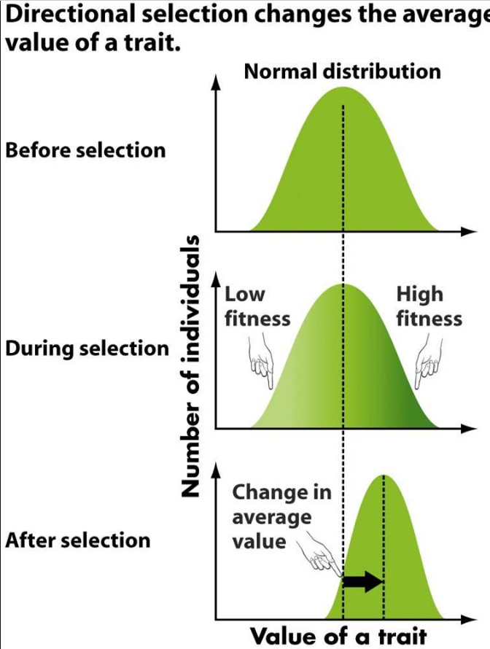

Antibiotic Resistance

The widespread use of antibiotics has lead to the development of resistance in many species of bacteria. The resistance has arisen due to random mutations producing generally recessive alleles and are not expressed when in combination with a dominant allele. However, due to repeated exposure to antibiotics has lead to more bacteria surviving and passing on resistant alleles.

* + Some bacteria have developed a gene which codes for the synthesis of the enzyme Penicillinase, which causes penicillin to be ineffective.
  + In the presence of penicillin non resistant bacteria are destroyed, therefore there is a selective advantage favouring the resistant bacteria.

Stabilising selection

Stabilizing selection is a type of natural selection in which the population mean stabilizes on a particular non-extreme trait value. This is thought to be the most common mechanism of action for natural selection because most traits do not appear to change drastically over time. Stabilizing selection commonly uses negative selection to select against extreme values of the character, leading to a decrease in genetic diversity. It reduces phenotypic variation and maintains the status quo. Natural selection tends to remove the more severe phenotypes, resulting in the reproductive success of the norm or average phenotypes. Because most traits change little over time, stabilizing selection is thought to be the most common type of selection in most populations.

Studies of birth weight in humans have provided good examples of stabilizing selection. Babies that are heavier or lighter than average did not survive as well as babies of average weight.

Stabilizing selection has probably operated on birth weight in human populations from the time of the evolutionary expansion of our brains about 1 - 2 million years ago until the 20th century. In most of the world it still does. However, the force of stabilizing selection on birth weight has relaxed in recent times because of improved care for premature deliveries (the main cause of lighter babies) and increased frequencies of Caesarean deliveries for babies that are large relative to the mother (the lower survival of heavier babies was mainly due to injury to the baby or the mother during birth).

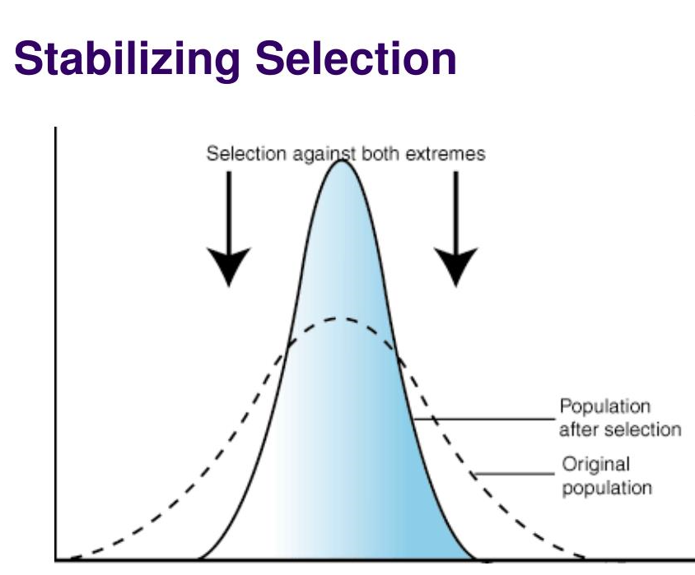

Natural selection results in species that are better adapted to their environment. These adaptations may be:

Anatomical – such as shorter ears and thicker fur in artic foxes compared to foxes in warmer climates

Physiological – oxidixing of fat rather than carbohydrate in kangaroo rats to produce additional water in a dry desert environment

Behavioural – autumn migration of swallows from the UK to Africa to avoid food shortages in the UK winter

# 3.4.5 Species and taxonomy

# Millions of organisms can be organised into a classification system which also helps to understand the relationships between organisms i.e. how recently 2 organisms evolved from a common ancestor

A phylogenetic classification system attempts to arrange species into groups based on their evolutionary origins and relationships. It uses a hierarchy in which smaller groups are placed within larger groups, with no overlap between groups. Each group is called a taxon (plural taxa). One hierarchy comprises the taxa: domain, kingdom, phylum, class, order, family, genus and species. Each species is universally identified by a binomial consisting of the name of its genus and species, eg, Homo sapiens.

* Organisms can be organised into a classification system (Taxonomy), which works using the principle of Hierarchy [(Biology Hierarchy Activity)](http://moodle.godalming.ac.uk/learning/file.php/932/Unit%202/2.1%20Organisms%20Evolutionary%20History/Notes/2.1%20Activities/Biology%20Hierarchy%20Activity.doc):
  + A hierarchy involves
    - A large group of organisms divided into smaller groups
    - Where members of a group share Common Features
    - e.g. genotype/phenotype
    - There is NO overlap between groups in a hierarchy i.e. an organism is either a bird or a mammal

fish

mammals

animals

birds

* + Phylogenetics – This is a classification system which differs to a simple Hiearchy as it is:
    - Based on Evolutionary History of the organisms
    - It shows the Ancestry of groups or Points of Divergence
    - E.g. mammals and birds are more closely related than fish
    - Organisms are classified on the basis of similar or shared characteristics e.g. phenotype/DNA Fingerprinting)
    - DNA Fingerprinting can be used to assess how related organisms are i.e. more closely related, fewer number of differences / high number of shared genes

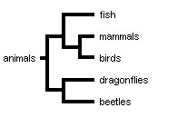

* The most commonly used hierarchy is:
  + Kingdom Kids e.g. Animalia
  + Phylum Play Chordata/Vertebrata
  + Class Carelessly Mammalia
  + Order Over Primates
  + Family Farmer Hominidae
  + Genus Giles’ Homo
  + Species Stiles sapiens

* Each group in KPCOFGS is known as a Taxon. Organisms are more closely related with progression from kingdom to species.

**Binomial System**

* The last two taxa, Genus and species are used to give the organism a name, called the binomial system and organisms are named using binomial nomenclature:
  + *Homo sapien*s = man
  + *Rattus norvegicus* = Brown rat
  + *Rattus rattus* = Black rat

**\*N.B.** Two organisms belong to the same species if they are able to produce fertile offspring.

Courtship behaviour is a necessary precursor to successful mating by:

Helping individuals recognize members of their own species

Identify a mate capable of breeding

Form a pair bond

Synchronise mating

Become able to breed

* **Evidence for Common ancestry and natural selection**
* Closely related species are recognised by their **similar morphology** (body structure), e.g. the **fossil record**
  + **Homologous** **structures** like that of the **pentadactyl limb** in vertebrates can be used as evidence to show that organisms evolved from **common ancestors**.
  + **Analogous** **structures** such as the wings of a bird and insect are not an indication of relatedness:

**Homologous** structure - pentadactyl limb **Analogous** structures

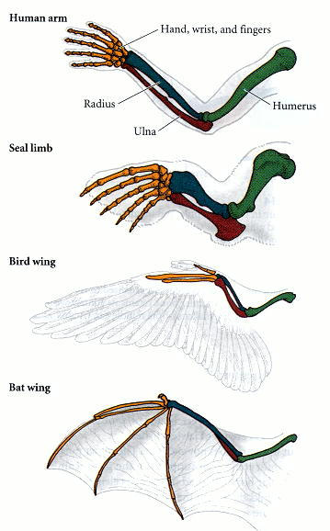 dorsal fin

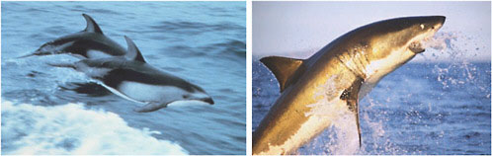

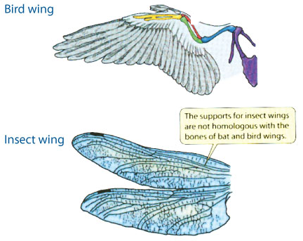

* Biochemical techniques
  + Compare the **sequence of bases in DNA of genes** (**DNA Fingerprinting**) - the **more similar the sequence** the **more closely related the species** *N.B. The best/most accurate technique for establishing relatedness

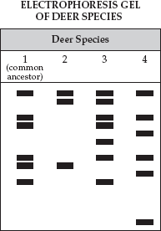

DNA is most similar, so most

closely related

* + Compare the base sequences of mRNA
  + Compare the **sequence of amino acids in proteins** – the **more similar the sequence** the **more closely related the species**
  + **Immunological comparisons of proteins - Closely related species will have antibodies that recognise and bind with the same protein antigens, such as the protein albumin (found in blood serum) of a different species**

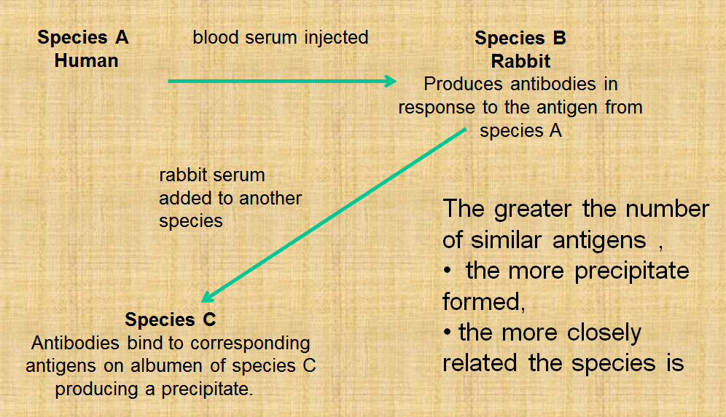

3.4.6 Biodiversity within a community

Biodiversity can relate to a range of habitats, from a small local habitat to the Earth.

**Species richness** is a measure of the number of different species in a community.

An index of diversity describes the relationship between the number of species in a community and the number of individuals in each species.

Calculation of an index of diversity (d) from the formula:

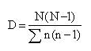

where N = total number of organisms of all species and n = total number of organisms of each species.

# Biodiversity and endangered species

* **Biodiversity is a measure of the number of species on the planet**. The number of species per square kilometer **increases** as one move from the **poles to the tropics**. Tropical rain forests and coral reefs are the **most diverse** habitats on the planet.
* Endangered species

At present human activity is the main cause of extinction. Larger mammals such as gorillas are threatened due to:

* Loss of habitat e.g. deforestation
* Over-hunting by humans e.g. Whales
* Competition from introduced domestic species

Other species are threatened by:

* Natural Selection
* Deforestation/Loss of Hedgerows
* Pollution e.g. PCBs and oil
* Drainage of wetlands
* Species Conservation

The conservation of species ensures the conservation of existing gene pools. For ethical reasons it is important to conserve potentially useful genes for future generations of humans as well as for the survival of the species itself. Each species genes represent an important human asset as they are a potential source of:

* + Food
  + Chemicals
  + Disease resistant genes
  + Medicines

The following steps have been taken to reduce the extinction of endangered species:

* + Stocks of seeds of traditional varieties of plants are stored in seed banks
  + Establishment of sperm banks
  + Founding of rare breed societies to maintain old, less commercial varieties of animals
  + The protection and breeding of endangered species in zoos
  + Reintroduction programmes e.g. red kites in mid Wales
  + Habitat protection by nature reserves and SSI
  + International cooperation restricting trade e.g. in ivory and whaling

**Agricultural exploitation**

* **Agricultural exploitation** refers to the way in which food production has increased in efficiency and intensity to maximise the Yield from the land to meet human needs. This can lead to **conflicts** between farming and conservation:
  + **Larger fields** required **hedgerows to be removed**, to allow **machinery** to manoeuvre and **more land** used to **grow crops**
  + **Monoculture** involves the growing of a **single species** of crop e.g. wheat, however this provides ideal conditions for **crop pests and parasites**, therefore **herbicides** and **pesticides** are used
  + Harvesting of the crop reduces recycling of nutrients, leading to a **reduction in soil fertility**. Therefore **inorganic fertilisers** are used which can lead to **eutrophication** of waterways.
  + Filling in ponds and draining marshland and other wetland
  + Over-grazing of land

Ways to reduce the impacts of farming

* Maintain existing hedgerows
* Plant hedges instead of erecting fences as field boundaries
* Maintain existing ponds and create new ones
* Leave wet corners of fields rather than draining them
* Plant native trees on land with low species diversity
* Reduce the use of pesticides
* Use organic rather than inorganic fertilisers
* Use crop rotation which includes a nitrogen fixing crop such as legumes to increase fertility of soil
* Use intercropping rather than herbicides to control weeds
* Create natural meadows and use hay rather than grasses for silage
* Leave the cutting of verges and field edges until after flowering so seeds have dispersed
* Introduce conservation headlands – areas at the side of fields which aren’t farmed so wilds flowers can grow and insects can breed.