**3.5.4 Nutrient Cycles and Fertilisers**

**Section 1 – Recall**

**What does this section contain and why?** Activities to develop your recall of information you covered in the previous topics that are linked to inheritance. If you don’t have a mini whiteboard (MWB) please do invest in one, they are great for revision and recall. Once you have done the recall activity quickly check what you have done with the student booklets from that topic.

**Topics covered**: Nutrient cycle and fertilisers

|  |  |  |  |
| --- | --- | --- | --- |
| **Topic** | **Recall activities** | **Understanding**  *Please write down any questions you have when completing this activity.* | **Completed** |
| **Biological molecules** | Draw an amino acid and describe the structure of proteins |  |  |
| Draw a nucleotide and show the components of DNA and RNA. |  |  |
| List the main inorganic ions found in organisms and their roles |  |  |
| **Cells** | Draw & label a diagram of a prokaryotic cell and state the function of each structure labelled |  |  |
| **Biodiversity within a community** | List all the farming techniques that reduce biodiversity |  |  |
| List ways conservation techniques in farming can help increase biodiversity |  |  |

**[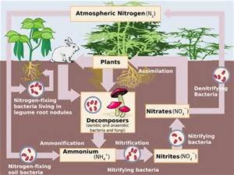](http://www.bing.com/images/search?q=nitrogen+cycle&view=detailv2&&id=AEED904D9A595AED0BAD5353ED5EE865FD10A644&selectedIndex=0&ccid=%2bHKEwhrX&simid=608019030727393522&thid=OIP.Mf87284c21ad74d82136b883fbafd2cf7H0)[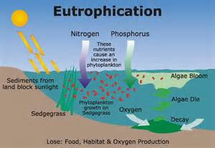](http://www.bing.com/images/search?q=eutrophication&view=detailv2&&id=7D341C7DE2E1339BEAEE303778B8A6263690358F&selectedIndex=7&ccid=8KS9RF8r&simid=608007571764087815&thid=OIP.Mf0a4bd445f2baf0128bc30fd76ecb480o0)**

**Section 2 – Student booklet framework**

Once you have finished learning this topic ensure that you go through the table below to check your knowledge and highlight areas that you need to revisit

|  |  |  |  |  |
| --- | --- | --- | --- | --- |
| **Key info** | **Topic:** Nutrient cycles  **Synoptic Link:** Biological molecules, prokaryotic cells and biodiversity  **Text book pages:** 306-314 | | | |
| **Step 1** | **Use the tutorial (GOL), presentation (GOL), video links and text book to complete the pack.** | | | |
| **Step 2** | **Learning outcome** | **I understand this** | **I can recall this** | **I need to revisit this** |
| Understand that nutrients are recycled within natural ecosystems |  |  |  |
| Be able to draw a fully labelled and annotated diagram of the nitrogen cycle |  |  |  |
| Be able to draw a fully labelled and annotated diagram of the phosphorus cycle |  |  |  |
| Understand the role of saprobionts in decomposition |  |  |  |
| Understand the role of mycorrhizae in facilitating the uptake of water and inorganic ions by plants. |  |  |  |
| Understand the role of bacteria in the nitrogen cycle in sufficient detail to illustrate the processes of saprobiotic nutrition,  ammonification, nitrification, nitrogen fixation and denitrification. |  |  |  |
| Understand how the use of natural and artificial fertilisers can replace the nitrates and phosphates lost by harvesting plants and removing livestock. |  |  |  |
|  | Describe the environmental issues arising from the use of fertilisers including leaching and eutrophication. |  |  |  |
| **Step 3** | **In lesson:** you will be undertaking activities to develop your understanding of the learning objectives and able to add to your notes. | | | |

**Nutrient Cycles**

Decomposition is a vital part of nutrient cycles. Decomposers are organisms that will break down dead organic material. They can be detritivores or saprobionts. Outline the difference between these 2 groups of organism.

**Detritivores**

……………………………………………………………………………………………………………………………………………………………………………………………………………………………………………………………………………………………………………………………………………………………………………………………………………………………………………………………………………………………..……………………………………………………………………………………………………………………………………………………………..

**Saprobionts**

……………………………………………………………………………………………………………………………………………………………………………………………………………………………………………………………………………………………………………………………………………………………………………………………………………………………………………………………………………………………..……………………………………………………………………………………………………………………………………………………………..

**Mychorrhizae and Nutrient Cycling**

In the space below explain what mychorrhizae are and how they are used in nutrient cycles.

……………………………………………………………………………………………………………………………

……………………………………………………………………………………………………………………………

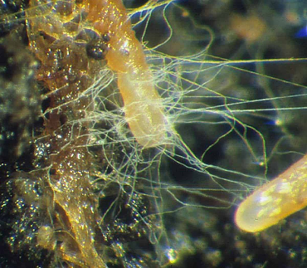……………………………………………………………………………………………………………………………

……………………………………………………………………………………………………………………………

……………………………………………………………………………………………………………………………

……………………………………………………………………………………………………………………………

……………………………………………………………………………………………………………………………

……………………………………………………………………………………………………………………………

……………………………………………………………………………………………………………………………

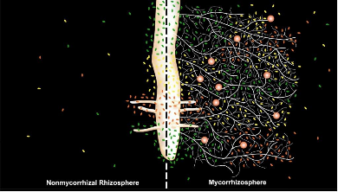……………………………………………………………………………………………………………………………

……………………………………………………………………………………………………………………………

……………………………………………………………………………………………………………………………

……………………………………………………………………………………………………………………………

……………………………………………………………………………………………………………………………

……………………………………………………………………………………………………………………………

**Phosphorus Cycle**

Draw the phosphorus cycles and add notes to explain the main processes involved in the cycle. Use A level specific resources to help you do this task.

**Nitrogen cycle**

Draw the nitrogen cycles and add notes to explain the main processes involved in the cycle. Ensure that you have explained the processes involved in **ammonification, nitrification, nitrogen fixation** and **denitrification**. Use A level specific resources to help you do this task.

**Natural and Artificial Fertilisers**

**The need for fertilisers**

When crops are grown and harvested year after year, there is a need to replace the lost nutrients if soil fertility is to be maintained.

Fertiliser can be either:

**Organic –** farmyard manure (faeces of farm animals mixed with strawa0

**Inorganic** – manufactured fertilisers that contain nitrates and phosphates

Fertilisers replace the nutrients that are lost from the soil. Inorganic fertilisers are composed of concentrated sources of macronutrients that can be spread evenly over the crop.

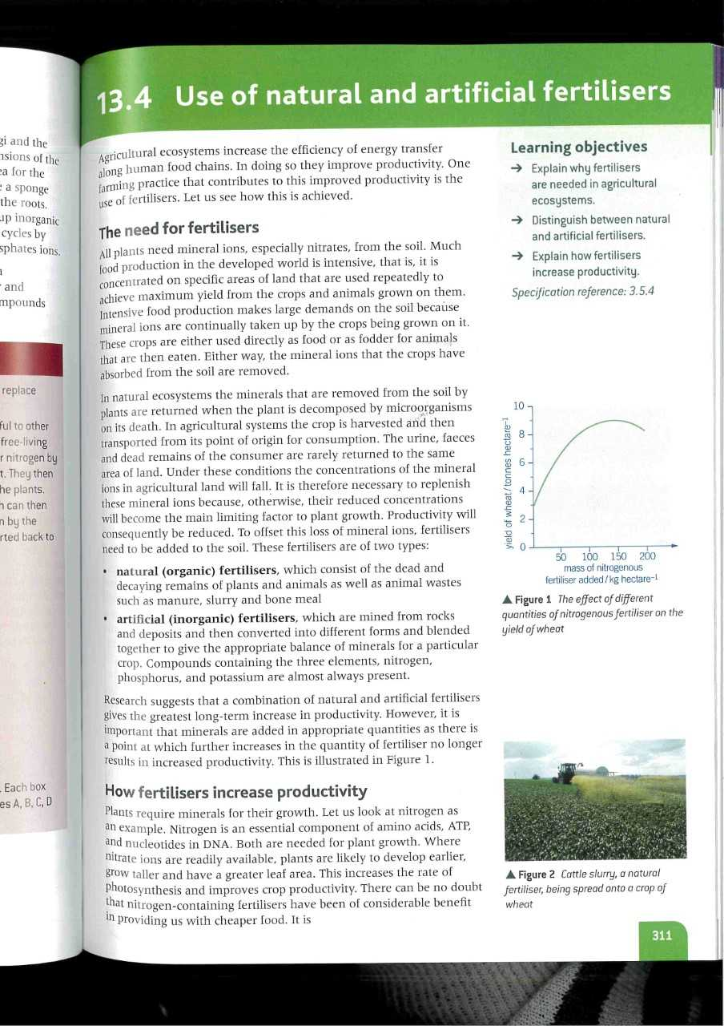Describe and explain the graph.

…………………………………………………………………………………………………………

…………………………………………………………………………………………………………

…………………………………………………………………………………………………………

…………………………………………………………………………………………………………

…………………………………………………………………………………………………………

…………………………………………………………………………………………………………

…………………………………………………………………………………………………………

…………………………………………………………………………………………………………

Complete the table below showing the advantages and disadvantages of fertiliser use.

|  |  |
| --- | --- |
| **Organic Fertiliser** | |
| Advantages |  |
| Disadvantages |  |
| **Inorganic Fertiliser** | |
| Advantages |  |
| Disadvantages |  |

**How fertilisers increase productivity**

Nitrates are needed for DNA and proteins, both for plant growth. Plants are likely to develop earlier and grow taller, with an increased rate of photosynthesis and increased crop productivity.

**Answer the questions**

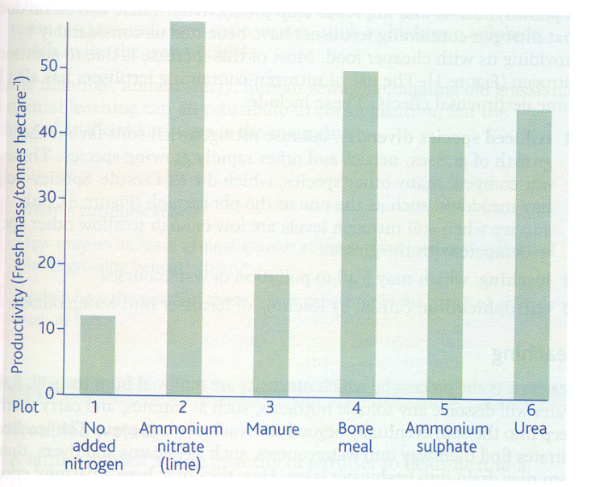

The graph below represents data from an investigation in which the same crop was grown on 6 identical plots of land, in the same area.

The land was treated with 5 types of fertiliser at a controlled application rate of 140kg total nitrogen per hectare.

1. Which forms of nitrogen used in the investigation were “natural fertilisers”? [1]

....................................................................................................................................................................

1. What was the purpose of plot 1? [1]

...................................................................................................................................................................

1. Suggest why added nitrogen increased productivity irrespective of the form it was added. [2]

......................................................................................................................................................................................................................................................................................................................................

1. The actual mass of each fertiliser added was different. Explain why. [2]

......................................................................................................................................................................................................................................................................................................................................

1. Fertiliser manufacturers often claim that nitrogen added in the form of ammonium salts increases crop productivity better than other forms of fertiliser. State whether or not this experiment supports this claim. [3]

............................................................................................................................................................................................................................................................................................................................................................................................................................................................................................................................................................................................................................................................................

**Effects of nitrogen-containing fertilisers**

**1. Reduced species diversity**

Inorganic fertilisers favour the growth of grasses, nettles and rapidly growing species which will out-compete other plant species. Meadows (which are species rich) often have low nitrogen levels in the soil so will not survive if nitrate levels increase.

**2. Leaching**

Process whereby nutrients are removed from soils. Rainwater dissolves soluble nutrients and carries them deep into soils out reach of plant roots. Eventually they run into water ways such as rivers and lakes.

High nitrate ion levels in drinking water may be harmful to humans (e.g. preventing efficient oxygen transport in babies and linked to stomach cancer).

High nitrate ion concentration will lead to eutrophication in water ways.

**3. Eutrophication**

Eutrophication refers to the effects of increase nutrients concentration on aquatic ecosystems.

The main causes are fertilisers leaching off farm fields into the surrounding water course, and sewage (liquid waste from houses and factories). These both contain dissolved minerals, such as nitrates and phosphates.

**Task:** Draw a flow diagram below showing the stages of eutrophication

**Consolidation Activity.** Complete the sentences using the words in bold.

**aerobic aerobic amino acids ammonia ammonia ammonification ATP bacteria bacteria broken down carbohydrates cleaner competition composition denitrifying dies diversity DNA eutrophication farming fertilisers fish food chain free-living Haber harvested inorganic lakes light lightning mutualistic nitrates nitrate nitrites nitrogen-fixing nucleic acids oxygen photosynthesise productivity proteins replenish respiration rivers RNA saprobiontic soluble urea waste waterlogged**

Plants and animals need nitrogen to synthesise some essential _________ ________ (to make ___________) and _____________ _______ (to make ______, ______ and ______). As with carbon, the ultimate source of nitrogen in the ________ ________ is from the atmosphere via plants, however, although the atmosphere is 78% nitrogen (N2), plants can't use it in that form. Instead they need ____________ to convert it into usable nitrogen compounds first.

1. Nitrogen fixation

* _____________ bacteria, found in root nodules of leguminous plants (peas, beans), can fix nitrogen into ____________ (NH3) which can then be converted into other nitrogenous compounds and used directly by the plant (in return the plants provides the bacteria with ______________)
* Alternatively, free-living ___________-__________ bacteria can convert atmospheric gas into _____________ which then undergoes nitrification. This process normally happens under ________________ conditions
* Nitrogen fixation can also happen spontaneously when _____________ passes through the atmosphere, again this will then undergo nitrification
* Nitrogen fixation can also be conducted artificially on an industrial scale. The _______ process produces ammonia from atmospheric nitrogen to make fertilisers

2. Ammonification

* Nitrogen compounds from dead organisms are turned into ammonia by _____________ bacteria
* Animal waste also contains compounds (such as ________) that are turned into ammonia

3. Nitrification

* This is the conversion of ammonia into _________ ions by nitrifying bacteria, which can then be used by the plant - the ammonia comes either from nitrogen fixation by _______-__________ nitrogen-fixing bacteria or ________________ by decomposing bacteria
* Firstly, certain species of nitrifying bacteria synthesise __________ (NO2-) from ammonia
* Secondly, other species of nitrifying bacteria convert the nitrite into to ___________ (NO3-)
* This process requires oxygen so _____________ conditions are essential. Nitrification is therefore most efficient in soil with lots of air spaces by ploughing and good drainage

4. Denitrification

* Nitrates in the soil may be converted back into nitrogen gas by ______________ bacteria before they are used by the plants
* These bacteria use the nitrates to carry out ______________ and produce nitrogen gas. This happens under anaerobic conditions such as in ________________ soil.

**Complete the diagram with the name and formula of the missing nitrogen compounds**

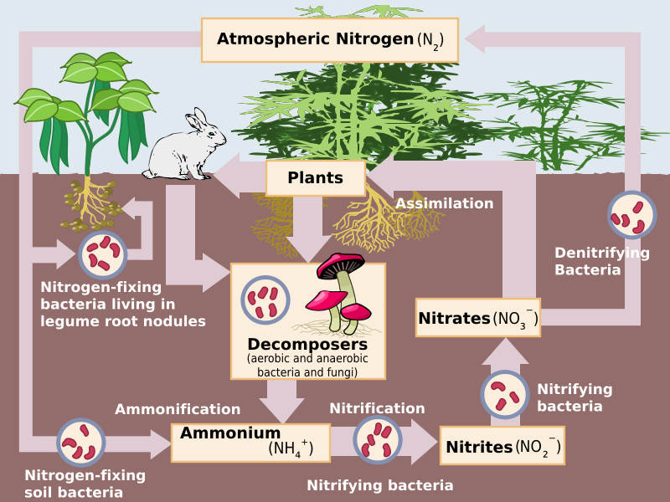

______________ makes large demands on soil because mineral ions (such as nitrates) are continually being taken up by the crops. In natural ecosystems the minerals are returned when the plant ________ and is decomposed but in agricultural ecosystems the plants are ______________ and transported away for consumption (taking the mineral ions with them) and are rarely returned to the same area. This makes it necessary to _____________ the minerals or plant growth will be affected.

As a result, farmers use ______________ containing mostly nitrogen, phosphorus and potassium compounds. Organic (natural) fertilisers include animal ___________ (manure), composted plant matter and bone meal, while _____________ (artificial) fertilisers are mostly derived from the Haber process.

Fertilising the land results in plants that develop earlier, grow taller and have a greater leaf area; collectively this increases the rate of photosynthesis and so increases ____________. Inorganic fertilisers have a number of benefits, such as having a known ________________, being ____________ to apply, being more concentrated so they are easier to transport and more immediately releasing the nutrients, but they are also more expensive and are more likely to be leached out of soils (dissolved in water and washed away) and can cause _________________.

* Nitrates leached from fertilised fields stimulate growth of algae in _________ and __________
* Large amounts of algae block _________ from reaching the plants below and plants die as they are unable to _______________
* ___________ feed on the dead plant matter and an increased numbers of bacteria reduce the ____________ concentration in water by carrying out aerobic respiration
* _________ and invertebrate organisms die as there isn't enough oxygen resulting in a significant reduction in species _____________

This occurs particularly with inorganic fertilisers because they are more ____________ than organic fertilisers and they do not need to be __________ __________ into more simple compounds.

Reduced species diversity can also occur on land since nitrogen-rich soils favour the growth of grasses, nettles and other rapidly growing species. This causes more ______________ against other species, which may then die out.

**Glossary of terms**

|  |  |
| --- | --- |
| **Term** | **Definition** |
| **Ammonification** |  |
| **Nitrification** |  |
| **Nitrogen fixation** |  |
| **Denitrification** |  |
| **Mycorrhizae** |  |
| **Mutualistic** |  |
| **Legume** |  |
| **Eutrophication** |  |
| **Leaching** |  |

**Exam Questions**

**Q1.**

Arbuscular mycorrhiza fungi (AMF) are fungi which grow on, and into, the roots of plants. AMF can increase the uptake of inorganic ions such as phosphate.

(a)     Suggest **one** way in which an increase in the uptake of phosphate could increase plant growth.

_________________________________________________________________

_________________________________________________________________

**(1)**

(b)     Suggest **one** way in which AMF may benefit from their association with plants.

_________________________________________________________________

_________________________________________________________________

**(1)**

(c)     Scientists investigated the effects of different AMF species on the productivity of the plant community of a prairie grassland ecosystem when growing in/on soil containing different phosphate concentrations.

The scientists set up identical plots of prairie grassland soil containing seeds of the plant species found in the ecosystem. The scientists added different AMF species and different concentrations of phosphate to particular plots. Control plots without AMF species were also set up. After 20 weeks the scientists determined the shoot biomass for each plot.

The results the scientists obtained are shown in the graph.

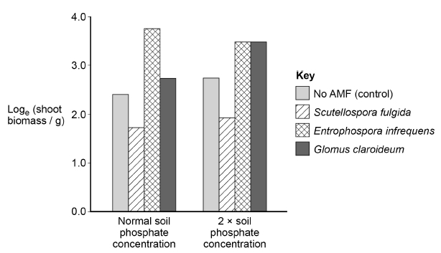

Explain why an increase in shoot biomass can be taken as a measurement of **net** primary productivity.

_________________________________________________________________

_________________________________________________________________

_________________________________________________________________

_________________________________________________________________

_________________________________________________________________

_________________________________________________________________

**(2)**

(d)     Using the data from the graph in part (c), evaluate the effect on plant productivity of adding AMF species and adding phosphate to the soil.

_________________________________________________________________

_________________________________________________________________

_________________________________________________________________

_________________________________________________________________

_________________________________________________________________

_________________________________________________________________

_________________________________________________________________

_________________________________________________________________

**(4)**

(e)     Using the ex button on your calculator, determine the rate of shoot biomass production in grams per day for the control plot in soil with normal phosphate concentration.

Answer = ____________________ g day−1

**(2)**

**(Total 10 marks)**

**Q2.**

Read the following passage.

|  |  |
| --- | --- |
| Plants require phosphate ions that they get from soil. These ions are often in poor supply and this results in poor growth of the plants. Most plants have mycorrhizae that help the plants to obtain nitrates. Mycorrhizal networks can connect the roots of plants growing next to each other. The use of fertilisers containing phosphate and nitrates in farming inhibits the growth of mycorrhizae. As a result, intensively farmed crop plants do not have mycorrhizae.  Plants can defend themselves by producing defensive enzymes that destroy pathogens such as bacteria. Some plants express the genes for defensive enzymes in response to signal proteins secreted by other plants that are being attacked by a pathogen. These signal proteins can be released into the air.  Scientists have discovered that tomato plants increase production of defensive enzymes if plants next to them become infected with a pathogen. These tomato plants were connected by a mycorrhizal network that can carry signal proteins between them. The largest increase in defensive enzyme secretion that the scientists found in a tomato plant in response to the signal protein was by 122.6 per cent. | 5      10      15 |

Use the information in the passage and your own knowledge to answer the following questions.

(a)     Suggest and explain **two** reasons why a poor supply of phosphate ions results in poor growth of plants (lines 1–2).

1. _________________________________________________________________

_________________________________________________________________

2. _________________________________________________________________

_________________________________________________________________

**(2)**

(b)     Suggest how defensive enzymes produced by plants destroy bacteria (lines 8–9).

_________________________________________________________________

_________________________________________________________________

_________________________________________________________________

_________________________________________________________________

_________________________________________________________________

**(2)**

(c)     The signal proteins secreted into the air by a plant being attacked by a pathogen act as stimuli leading to the expression of genes for defensive enzymes in other plants (lines 9–12).

Suggest how they lead to the expression of these genes.

_________________________________________________________________

_________________________________________________________________

_________________________________________________________________

_________________________________________________________________

_________________________________________________________________

_________________________________________________________________

_________________________________________________________________

**(3)**

(d)     Suggest and explain **the** advantage to tomato plants of transmitting signal proteins through mycorrhizal networks, rather than releasing them into the air (line 11–12 and lines 14–16).

_________________________________________________________________

_________________________________________________________________

_________________________________________________________________

_________________________________________________________________

_________________________________________________________________

**(2)**

(e)     The largest increase in defensive enzyme secretion that the scientists found in a tomato plant in response to the signal protein was by 122.6 percent (lines 16–18).

The rate of secretion of the defensive enzymes before the signal protein was produced was 450 µmol dm−3 g−1 hour−1.

Calculate the rate of secretion **per second** after the response to the signal protein.

Answer = _________________________ µmol dm−3 g−1 second−1

**(2)**

(f)      A student who read this passage concluded that farmers should **not** use fertilisers to increase yields when growing tomato plants.

Evaluate his conclusion.

_________________________________________________________________

_________________________________________________________________

_________________________________________________________________

_________________________________________________________________

_________________________________________________________________

_________________________________________________________________

_________________________________________________________________

_________________________________________________________________

_________________________________________________________________

_________________________________________________________________

**(4)**

**(Total 15 marks)**

**Q3.**

The diagram shows a river system in an area of farmland. The numbers show the nitrate concentration in parts per million (ppm) in water samples taken at various locations along the river. Concentrations above 250 ppm encourage eutrophication in the river.

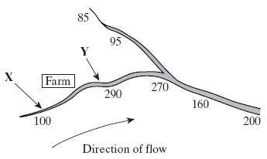

(i)      Explain how farming practices might be responsible for the change in nitrate concentration in the water between point **X** and point **Y**.

_________________________________________________________________

_________________________________________________________________

_________________________________________________________________

_________________________________________________________________

**(2)**

(ii)      Describe the effect the nitrate concentration may have in the river at point **Y**.

_________________________________________________________________

_________________________________________________________________

_________________________________________________________________

_________________________________________________________________

_________________________________________________________________

_________________________________________________________________

_________________________________________________________________

_________________________________________________________________

_________________________________________________________________

_________________________________________________________________

**(5)**

**(Total 7 marks)**

**Q4.**

The diagram shows part of the nitrogen cycle.

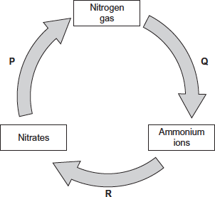

(a)     Which **one** of the processes **P**, **Q** or **R** involves nitrification?



**(1)**

(b)     The diagram above includes one process in which microorganisms add ammonium ions to soil.

Describe another process carried out by microorganisms which adds ammonium ions to soil.

_________________________________________________________________

_________________________________________________________________

_________________________________________________________________

_________________________________________________________________

_________________________________________________________________

**(2)**

(c)     Denitrification requires anaerobic conditions. Ploughing aerates the soil.  
Explain how ploughing would affect the fertility of the soil.

_________________________________________________________________

_________________________________________________________________

_________________________________________________________________

_________________________________________________________________

_________________________________________________________________

**(2)**

(d)     One farming practice used to maintain high crop yields is crop rotation. This involves growing a different crop each year in the same field.

Suggest **two** ways in which crop rotation may lead to high crop yields.

1. _________________________________________________________________

_________________________________________________________________

_________________________________________________________________

2. _________________________________________________________________

_________________________________________________________________

_________________________________________________________________

**(2)**

**(Total 7 marks)**

**Q5.**

Upwelling is a process where water moves from deeper parts of the sea to the surface. This water contains a lot of nutrients from the remains of dead organisms.

(a)     (i)      Nitrates and phosphates are two of these nutrients. They provide a source of nitrogen and phosphorus for cells.

Give a biological molecule that contains:

1. nitrogen____________________________________________________

2. phosphorus__________________________________________________

**(2)**

(ii)     Describe the role of microorganisms in producing nitrates from the remains of dead organisms.

_____________________________________________________________

_____________________________________________________________

_____________________________________________________________

_____________________________________________________________

_____________________________________________________________

_____________________________________________________________

**(3)**

(b)     Upwelling often results in high primary productivity in coastal waters.  
Explain why some of the most productive fishing areas are found in coastal waters.

_________________________________________________________________

_________________________________________________________________

_________________________________________________________________

_________________________________________________________________

**(2)**

**(Total 7 marks)**

**Q6.**

Answers should be written in continuous prose, where appropriate.

A large lake is surrounded by fields. These fields are separated from each other by hedges. One hundred years ago the lake was a habitat for many plants, invertebrates and fish. Today the lake has no fish and few plants or invertebrates.

Explain how increased use of inorganic fertilisers on the fields may have led to these changes.

_____________________________________________________________________

_____________________________________________________________________

_____________________________________________________________________

_____________________________________________________________________

_____________________________________________________________________

_____________________________________________________________________

_____________________________________________________________________

_____________________________________________________________________

**(Total 5 marks)**

**Q7.**

The diagram shows a hedgerow and part of a field with a crop. The land is farmed in a way that conserves wildlife. The strip of bare ground next to the hedgerow is ploughed frequently to prevent any plants from growing. The first 6 m of the field, called the conservation headland, is sprayed with a selective herbicide to control some kinds of weeds. The rest of the field is sprayed with herbicide to kill all weeds.

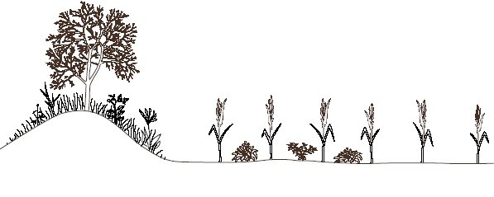

|  |  |  |  |
| --- | --- | --- | --- |
|  |  |  |  |
|  |  |  |  |

Hedgerow                   Bare                  Conservation                            Crop

 ground                  headland

(2 m wide)              (6 m wide)

(a)     Suggest **one** advantage of leaving a strip of bare ground between the hedgerow and the field.

_________________________________________________________________

_________________________________________________________________

**(1)**

(b)     Suggest the benefit of allowing some weeds to grow in the conservation headland.

_________________________________________________________________

_________________________________________________________________

_________________________________________________________________

_________________________________________________________________

**(2)**

(c)     After harvesting the crop, the farmer digs the unwanted stems and roots into the soil. Explain how the nutrients contained in these plant parts become available for use by other organisms.

_________________________________________________________________

_________________________________________________________________

_________________________________________________________________

_________________________________________________________________

_________________________________________________________________

_________________________________________________________________

_________________________________________________________________

_________________________________________________________________

**(4)**

**(Total 7 marks)**