Q1.
Arbuscular mycorrhiza fungi (AMF) are fungi which grow on, and into, the roots of plants. AMF can increase the uptake of inorganic ions such as phosphate.
(a) Suggest one way in which an increase in the uptake of phosphate could increase plant growth.
_________________________________________________________________
_________________________________________________________________
(1)
(b) Suggest one way in which AMF may benefit from their association with plants.
_________________________________________________________________
_________________________________________________________________
(1)
(c) Scientists investigated the effects of different AMF species on the productivity of the plant community of a prairie grassland ecosystem when growing in/on soil containing different phosphate concentrations.
The scientists set up identical plots of prairie grassland soil containing seeds of the plant species found in the ecosystem. The scientists added different AMF species and different concentrations of phosphate to particular plots. Control plots without AMF species were also set up. After 20 weeks the scientists determined the shoot biomass for each plot.
The results the scientists obtained are shown in the graph.
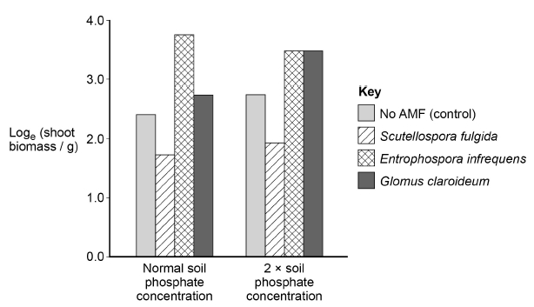

Explain why an increase in shoot biomass can be taken as a measurement of net primary productivity.
_________________________________________________________________
_________________________________________________________________
_________________________________________________________________
_________________________________________________________________
_________________________________________________________________
_________________________________________________________________
(2)
(d) Using the data from the graph in part (c), evaluate the effect on plant productivity of adding AMF species and adding phosphate to the soil.
_________________________________________________________________
_________________________________________________________________
_________________________________________________________________
_________________________________________________________________
_________________________________________________________________
_________________________________________________________________
_________________________________________________________________
_________________________________________________________________
(4)
(e) Using the e^{x} button on your calculator, determine the rate of shoot biomass production in grams per day for the control plot in soil with normal phosphate concentration.
Answer = ____________________ g day⁻¹
(2)
(Total 10 marks)

Q2.
Read the following passage.

Plants require phosphate ions that they get from soil. These ions are often in poor supply and this results in poor growth of the plants. Most plants have mycorrhizae that help the plants to obtain nitrates.  Mycorrhizal networks can connect the roots of plants growing next to each other. The use of fertilisers containing phosphate and nitrates in farming inhibits the growth of mycorrhizae. As a result, intensively farmed crop plants do not have mycorrhizae.  Plants can defend themselves by producing defensive enzymes that destroy pathogens such as bacteria. Some plants express the genes for defensive enzymes in response to signal proteins secreted by other plants that are being attacked by a pathogen. These signal proteins can be released into the air.  Scientists have discovered that tomato plants increase production of defensive enzymes if plants next to them become infected with a  pathogen. These tomato plants were connected by a mycorrhizal network that can carry signal proteins between them. The largest increase in defensive enzyme secretion that the scientists found in a tomato plant in response to the signal protein was by 122.6 per cent. | 5  10  15
Use the information in the passage and your own knowledge to answer the following questions.
(a) Suggest and explain two reasons why a poor supply of phosphate ions results in poor growth of plants (lines 1–2).
1. _________________________________________________________________
_________________________________________________________________
2. _________________________________________________________________
_________________________________________________________________
(2)
(b) Suggest how defensive enzymes produced by plants destroy bacteria (lines 8–9).
_________________________________________________________________
_________________________________________________________________
_________________________________________________________________
_________________________________________________________________
_________________________________________________________________
(2)

(c) The signal proteins secreted into the air by a plant being attacked by a pathogen act as stimuli leading to the expression of genes for defensive enzymes in other plants (lines 9–12).
Suggest how they lead to the expression of these genes.
_________________________________________________________________
_________________________________________________________________
_________________________________________________________________
_________________________________________________________________
_________________________________________________________________
_________________________________________________________________
_________________________________________________________________
(3)
(d) Suggest and explain the advantage to tomato plants of transmitting signal proteins through mycorrhizal networks, rather than releasing them into the air (line 11–12 and lines 14–16).
_________________________________________________________________
_________________________________________________________________
_________________________________________________________________
_________________________________________________________________
_________________________________________________________________
(2)
(e) The largest increase in defensive enzyme secretion that the scientists found in a tomato plant in response to the signal protein was by 122.6 percent (lines 16–18).
The rate of secretion of the defensive enzymes before the signal protein was produced was 450 µmol dm⁻³ g⁻¹ hour⁻¹.
Calculate the rate of secretion per second after the response to the signal protein.
Answer = _________________________ µmol dm⁻³ g⁻¹ second⁻¹
(2)

(f) A student who read this passage concluded that farmers should not use fertilisers to increase yields when growing tomato plants.
Evaluate his conclusion.
_________________________________________________________________
_________________________________________________________________
_________________________________________________________________
_________________________________________________________________
_________________________________________________________________
_________________________________________________________________
_________________________________________________________________
_________________________________________________________________
_________________________________________________________________
_________________________________________________________________
(4)
(Total 15 marks)
Q3.
The diagram shows a river system in an area of farmland. The numbers show the nitrate concentration in parts per million (ppm) in water samples taken at various locations along the river. Concentrations above 250 ppm encourage eutrophication in the river.
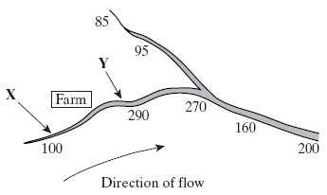
(i) Explain how farming practices might be responsible for the change in nitrate concentration in the water between point X and point Y.
_________________________________________________________________
_________________________________________________________________
_________________________________________________________________
_________________________________________________________________
(2)

(ii) Describe the effect the nitrate concentration may have in the river at point Y.
_________________________________________________________________
_________________________________________________________________
_________________________________________________________________
_________________________________________________________________
_________________________________________________________________
_________________________________________________________________
_________________________________________________________________
_________________________________________________________________
_________________________________________________________________
_________________________________________________________________
(5)
(Total 7 marks)
Q4.
The diagram shows part of the nitrogen cycle.
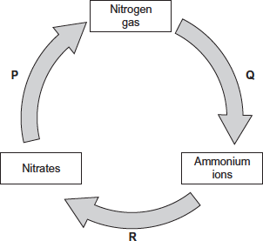
(a) Which one of the processes P, Q or R involves nitrification?

(1)

(b) The diagram above includes one process in which microorganisms add ammonium ions to soil.
Describe another process carried out by microorganisms which adds ammonium ions to soil.
_________________________________________________________________
_________________________________________________________________
_________________________________________________________________
_________________________________________________________________
_________________________________________________________________
(2)
(c) Denitrification requires anaerobic conditions. Ploughing aerates the soil.
Explain how ploughing would affect the fertility of the soil.
_________________________________________________________________
_________________________________________________________________
_________________________________________________________________
_________________________________________________________________
_________________________________________________________________
(2)
(d) One farming practice used to maintain high crop yields is crop rotation. This involves growing a different crop each year in the same field.
Suggest two ways in which crop rotation may lead to high crop yields.
1. _________________________________________________________________
_________________________________________________________________
_________________________________________________________________
2. _________________________________________________________________
_________________________________________________________________
_________________________________________________________________
(2)
(Total 7 marks)

Q5.
Upwelling is a process where water moves from deeper parts of the sea to the surface. This water contains a lot of nutrients from the remains of dead organisms.
(a) (i) Nitrates and phosphates are two of these nutrients. They provide a source of nitrogen and phosphorus for cells.
Give a biological molecule that contains:
1. nitrogen____________________________________________________
2. phosphorus__________________________________________________
(2)
(ii) Describe the role of microorganisms in producing nitrates from the remains of dead organisms.
_____________________________________________________________
_____________________________________________________________
_____________________________________________________________
_____________________________________________________________
_____________________________________________________________
_____________________________________________________________
(3)
(b) Upwelling often results in high primary productivity in coastal waters.
Explain why some of the most productive fishing areas are found in coastal waters.
_________________________________________________________________
_________________________________________________________________
_________________________________________________________________
_________________________________________________________________
(2)
(Total 7 marks)

Q6.
Answers should be written in continuous prose, where appropriate.
A large lake is surrounded by fields. These fields are separated from each other by hedges. One hundred years ago the lake was a habitat for many plants, invertebrates and fish. Today the lake has no fish and few plants or invertebrates.
Explain how increased use of inorganic fertilisers on the fields may have led to these changes.
_____________________________________________________________________
_____________________________________________________________________
_____________________________________________________________________
_____________________________________________________________________
_____________________________________________________________________
_____________________________________________________________________
_____________________________________________________________________
_____________________________________________________________________
(Total 5 marks)
Q7.
The diagram shows a hedgerow and part of a field with a crop. The land is farmed in a way that conserves wildlife. The strip of bare ground next to the hedgerow is ploughed frequently to prevent any plants from growing. The first 6 m of the field, called the conservation headland, is sprayed with a selective herbicide to control some kinds of weeds. The rest of the field is sprayed with herbicide to kill all weeds.
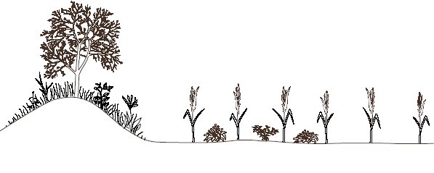
Hedgerow Bare Conservation Crop
ground headland
(2 m wide) (6 m wide)
(a) Suggest one advantage of leaving a strip of bare ground between the hedgerow and the field.
_________________________________________________________________
_________________________________________________________________
(1)
(b) Suggest the benefit of allowing some weeds to grow in the conservation headland.
_________________________________________________________________
_________________________________________________________________
_________________________________________________________________
_________________________________________________________________
(2)
(c) After harvesting the crop, the farmer digs the unwanted stems and roots into the soil. Explain how the nutrients contained in these plant parts become available for use by other organisms.
_________________________________________________________________
_________________________________________________________________
_________________________________________________________________
_________________________________________________________________
_________________________________________________________________
_________________________________________________________________
_________________________________________________________________
_________________________________________________________________
(4)
(Total 7 marks)

