**Nutrient Cycles**

**All nutrient cycles have one common sequence:**

* **Nutrient is taken up by producers as simple, inorganic molecules.**
* **Producer incorporates nutrient into complex organic molecules.**
* **When the producer is eaten, the nutrient passes into consumers.**
* **Nutrient then passes onto secondary, tertiary or quaternary consumers.**
* **When the producers and consumers die, their complex molecules are broken down by saprobionts in decomposition that release the nutrient in its original simple form.**

For the exam you need to be able to describe both the phosphorous and the nitrogen cycle including the role of microorganisms within each cycle. At the heart of both the **phosphorus** and **nitrogen** cycles are microorganisms such as bacteria. These key nutrients pass from plants to animals through ingestion and digestion (eating!) in a very straightforward way, but what happens after those organisms die is a far more interesting tale.

You need to be able to describe how the recycling of nutrients enables their transfer between living and non-living elements on the planet: water, land, air and populations in different places and of different trophic levels.

**Phosphorus cycle**

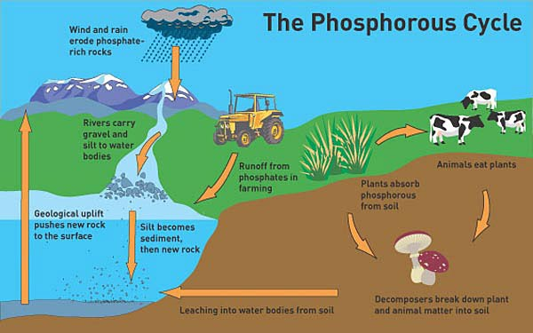Phosphorus is an essential element present in nucleic acids, ATP and phospholipids. There is no gaseous phosphorous in the atmosphere and so the main reservoir is in the Earth’s rocks.

Phosphorous exists mostly as phosphate ions (PO43-) in sedimentary rocks. These are formed in the sea but are brought to the surface by a phenomenon known as geological uplift which shifts rocks from the water bodies up into landmass. These rocks are then eroded and weathered which transfers these phosphate ions into water and then soil.

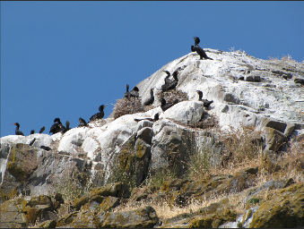Then, they are absorbed into plants via their roots so the plant can incorporate the phosphate ions into biological molecules and become part of the plant’s biomass which can be spread via ingestion to organisms higher up the food web.

Excess phosphate is excreted by animals and mat accumulate in waste products such as guano formed from excretory products of some sea birds.

When plants and animals die, bacteria and fungi decompose the organic material releasing phosphates back into the soil. These phosphates can then be reabsorbed by other plants of might dissolve in water and be transferred to rivers or the ocean. Some phosphate remain in bones and shells and can take longer to decompose.

Once in the ocean these phosphates can form sedimentary rocks and the cycle starts again.

Since phosphorus is present in fertilisers used to supplement plants, this too is subject to running off into bodies of water.

**Nitrogen cycle**

Nitrogen is an important element in organisms, taking part in one of their most important building blocks – **amino acids**. That’s not to mention **DNA** itself…

In the nitrogen cycle there are two stages of Nitrogen presence: the atmosphere and the ground. Whenever Nitrogen is in the atmosphere it’s in the form of **nitrogen gas, N2** which of course is what most of the air is made of (78%). In the ground, Nitrogen is found in **ammonia (NH3)**, **nitrite (NO2-)** and **nitrate (NO3-)**.

Find it hard to distinguish the formulae for nitrite and nitrate? Needn’t be! ***A*** *is l****a****rge (3-) and* ***i*** *is l****i****ttle (2-), former’s nitr****a****te, latter nitr****i****te.*

Very few plants animals can use the nitrogen from the atmosphere directly. It needs to be converted to a form that plants can use. Most plants take up nitrogen as nitrate ions by active transport into their roots. Microorganisms are needed to fix and then oxidise nitrogen to a form that plants can use. Animals then eat the plants to obtain their source of nitrogen containing compounds.

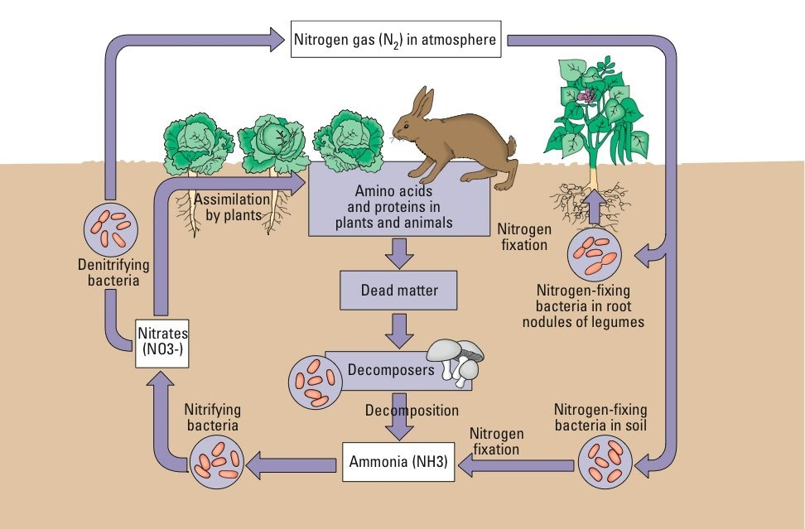**Nitrogen fixation**

* Both **nitrogen-fixing bacteria** and **lightning** can take the nitrogen gas in the air and *fix* it into nitrogen containing compounds which the bacteria use to make amino acids. When the bacteria die the nitrogen containing compounds are released into the soil as ammonia.
* This process can also be done industrially (the Haber process take nitrogen and hydrogen to form ammonia)
* Mutualistic nitrogen fixing bacteria can be found on root nodules of plants such as beans and peas (these plants are called legumes). The bacteria obtain carbohydrates from the plants and the plants obtain nitrogen containing compounds from the bacteria in the form of ammonia.

**Nitrification**

Ammonium ions in the soil are oxidised by soil bacteria which provides energy to the bacteria. This oxidation takes place in two steps.

1. Ammonium ions are oxidised to nitrite ions (**NO2-**)
2. Nitrite ions are oxidised to nitrate ions (NO3-)

The bacteria which carry out these reactions are called nitrifying bacteria and they require oxygen to carry out these processes. Therefore the soil they live in must have air spaces. Farmers encourage the presence of these bacteria by draining and ploughing fields .

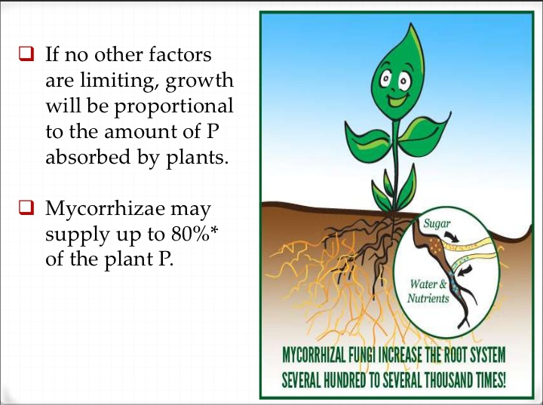Plants take it up nitrates from the soil via their roots in active transport (nitrate assimilation) and pass it on through the trophic levels to other organisms when the plants are eaten. **Mycorrhizae** are symbiotic associations between fungi and plant roots which benefit the fungus in terms to access to carbohydrates, and benefit the plant by improving nutrient and water uptake from the soil. The mycorrhiza act like a sponge and so holds water and minerals in the neighbourhood of the roots.

This is especially beneficial to plants in nutrient poor soil. Fungi may be able to better extract nutrients such as nitrates and phosphates from the soil on behalf of the plant due to a smaller diameter of protruding extensions that can explore more soil as well as being able to chemically bind target nutrients.

**Ammonification**

Upon death of plants and animals, saprobiotic bacteria and fungidecompose the remains and produce ammonia which then undergoes **nitrification** to NO2- and NO3- by **nitrifying bacteria**. Urine (which contains Urea from the breakdown of excess amino acids. This breakdown takes place in the liver and is called deamination) and faeces (which contains proteins, nucleic acids and vitamins) are also decomposed by saprobiontic bacteria and fungi converting these nitrogen containing compounds to ammonia which can then be oxidised to nitrites and then nitrates.

**Denitrification**

**Denitrifying bacteria in the soil** turn soil nitrates into nitrogen gas again, so the cycle may begin once more! These denitrifying bacteria are anaerobic so will reproduce and survive best in soils with little oxygen. If a field becomes waterlogged and compacted these bacteria will thrive removing nitrates from the soil and reducing the fertility of the soil. There are fewer nitrogen containing compounds available for plants so less plant growth.

 Both the nitrogen and phosphorous cycles are maintained in a fine balance. Human activities can easily upset this balance.

**The need for fertilisers**

All plants need mineral ions such as phosphates and nitrates. When crops are grown either for human consumption or for animal food the crops take up minerals from the soil via their roots and the crops are then harvested from the soil. This means the minerals are not returned to the soil and the soil slowly becomes depleted. Fertilisers are used to replace these lost minerals.

This same issue can be seen with livestock farming too. In a natural ecosystem faeces, urine and the dead remains of animals are decomposed and minerals are returned to the soil. In farming these animals are removed from human consumption so the minerals are not returned to the soil.

**Organic fertilisers** consist of dead and decaying remains of plants and animals as well as animal wastes. These can be added to soil so that saprobiotic bacteria can decompose this organic material and return phosphates and ammonia to the soil.

**Artificial (inorganic) fertilisers** are mined from rocks and blended together to give an appropriate balance of minerals or are created by the haber pricess.

Fertilisers increase productivity by providing the minerals plants need to synthesise specific biological molecules. The increase in biological molecules in a plants increases the plant’s biomass i.e. the plant grows! As a plant grows taller and has a greater leaf area the rate of photosynthesis increases and improves crop productivity.

**Effects of nitrogen-containing fertilisers**

**Reduced species diversity.** Nitrogen rich soils favour he growth of grasses, nettles and othe fast growing species which can out compete other species which then die. This will reduce species diversity.

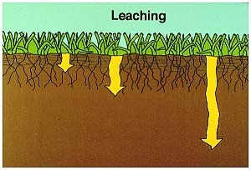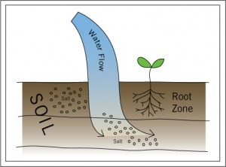**Leaching.** This is how fertilisers can reach further areas than planned, by the action of *rain* and *irrigation*. Nitrates are very water soluble so will dissolve easily in rain water. Fertilisers are easily leached (washed out of) from fields into waterways causing pollution.

**Eutrophication**

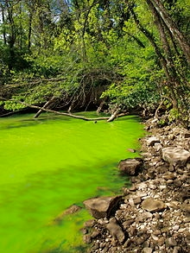Eutrophication is the process of artificial or natural chemicals reaching bodies of water and changing their *ecosystem*.

 Fertilisers will cause the algae to grow aggressively and cover the surface of the water. This is called an algal bloom.

This dense layer of algae absorbs light and prevents it from reaching plants below the surface of the water.

These plants then die (as will some algae) which increases the quantity of organic material in the water.

Saprobiotic bacteria will digest this organic material and due to the excess of food for the bacteria their population will increase.

Saprobiotic bacteria respire aerobically and due to the large number of these bacteria they use up all the oxygen in the water.This lack of oxygen will affect all other aerobic organisms in the water such as fish. The fish will die due to the lack of oxygen.

[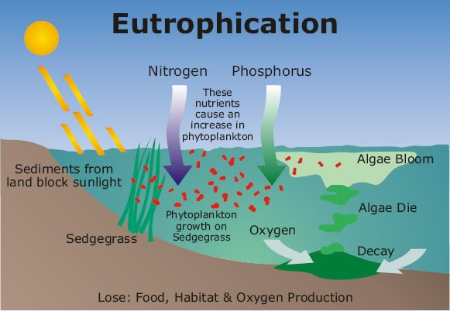](https://sites.google.com/site/thealevelbiologistyourhub/nitrogen/eutroph.jpg?attredirects=0)

An algal bloom is super beautiful, but all the organisms within the body of water are being deprived of oxygen, causing **hypoxia**.

The oxygen is depleted. While certain species die and others thrive, the balance of the ecosystem is shifted dramatically. This can have unprecedented and unpredictable effects on the wider community.