AQA Practical Handbook

Practical handbook Godalming College

[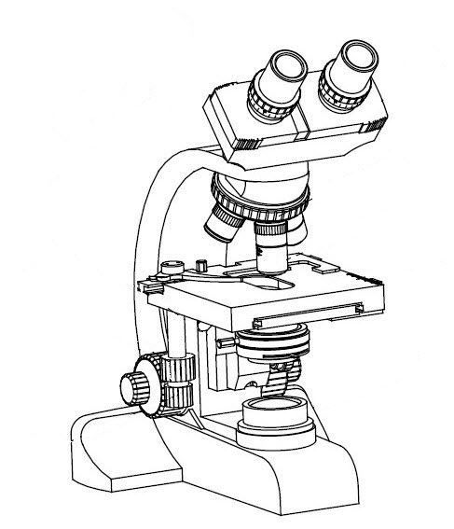](http://www.google.co.uk/url?sa=i&rct=j&q=&esrc=s&source=images&cd=&cad=rja&uact=8&ved=0CAcQjRw&url=http://www.medicalexpo.com/prod/accubiotech/laboratory-microscope-optical-upright-binocular-67481-555789.html&ei=U0ZcVaeCBMvXU53PgJAC&bvm=bv.93756505,d.d24&psig=AFQjCNEdA0YIyCGAOlHRu7xaE-OFEdXvzw&ust=1432197042376180)

Practical work brings science to life. During your time at Godalming College you will be asked to buy a practical folder which you will use to record practical techniques and analyse your results. You will need to keep your practical folder neat and tidy as it will be used to assess your competencies, which are used to award the practical endorsement, as well as being used for revision. Practical work will be assessed in **two ways**:

1. **Questions in the written papers, assessed by AQA**

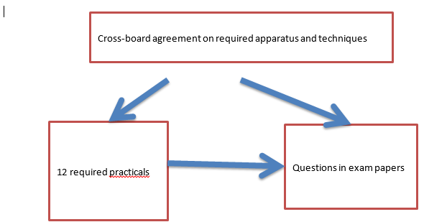

1. **The practical endorsement, directly assessed by teachers**

Teachers will assess their students’ competence at carrying out practical work. We will assess each student on at least 12 different occasions. These could be the 12 required practicals, or could be during other practical work.

At the end of the course, teachers will decide whether or not to award a pass in the endorsement of practical skills. The teacher must be confident that the student has shown a level of mastery of practical work good enough for the student to go on to study science subjects at university.

Students’ practical skills in at least 12 practicals

12 required practical activities

Teacher devised practical experiences

5 competencies:

1. Follows written instructions

2. Applies investigative approaches and methods when using instruments and equipment

3. Safely uses a range of practical equipment and materials

4. Makes and records observations

5. Researches, references and reports

Endorsement of practical skills

**Fifteen percent** of your AS Biology marks will come from assessment of practical skills in exams. The practical’s you complete could be examined in the end of year written exams so it is important that you use your practical folders to revise practical methods as well as be able to draw conclusions from data and explain the biological significance. Students do **not** need to write up every practical that they do in detail. However, it is good practice to have a record of everything you do.

A Full write would need to include the following:-

1. Date
2. Title of the investigation
3. Objectives of the experiment
4. Risk assessment-this includes identifying the hazard, describing the risk, and describing what you will do to prevent the risk.
5. Method which may be given to you or you will have to design including all details (eg temperatures, volumes, settings of pieces of equipment) with justification where necessary
6. Data and observations input to tables (or similar) while carrying out the experiment
7. Calculations-annotated to show thinking
8. Graph and charts
9. Summary, discussion and conclusion – describe the biological significance of your results
10. Cross-references to earlier data and references to external information

Teachers will assess you using the Common Practical Assessment Criteria (CPAC). If you demonstrate the required standard you will gain a pass grade. This will be vital for those applying for university places as the universities may request a pass in the practical endorsement. You will only be entered for the practical endorsement if you continue with Biology to A’level.

Over the two years you are required to complete at least 12 assessed practicals. During these practicals your teacher will assess you against five key Competencies. You must demonstrate that you are competent in:-

1. Following written procedures
2. That you can apply investigative approaches and methods when using instruments and equipment
3. That you can safely use a range of practical equipment and materials (risk assessments)
4. That you can make and record accurate observations
5. That you can research, reference and report on your results

You will also be assessed on a number of different practical skills.

**Students who miss a required practical activity**

**1. Written exam papers**

The required practical activities are part of the specification. As such, exam papers could contain questions about the activities and assume that students understand those activities. A student who misses a particular practical activity may be at a disadvantage when answering questions in the exams.

It will often be difficult to set up a practical a second time for students to catch up. Teachers will decide on a case by case basis whether they feel it is important for the student to carry out that particular practical. It is the responsibility of the student to discuss this with their teacher.

**2. Endorsement**

To fulfil the requirements of the endorsement, every student must carry out 12 practicals. A student who misses one of the required practicals must carry out another practical to be able to gain the endorsement.

In most cases, this can be any experiment of A-level standard. However, students must have experienced use of each of the apparatus and techniques. In some cases, a particular apparatus and technique is only covered in one required practical activity. If a student misses that activity, the teacher will need to provide an opportunity for the student to carry out a practical that includes that activity.

Note: there is a possibility that the student could be asked questions about the required activity in written papers that would not be fully understood by carrying out the alternative. It is really important that you only miss your required practicals in exceptional circumstances.

**Practical Skills assessment criteria**

|  |  |
| --- | --- |
|  | Apparatus and technique |
| ATa | Use appropriate apparatus to record a range of quantitative measurements (include mass, time, volume, temperature) |
| ATb | Use appropriate instrumentation to record quantitative measurements (colorimeter or photometer) |
| ATc | Use of laboratory glassware |
| ATd | Use of a light microscope, including use of graticle |
| ATe | Produce scientific drawings from observation with annotations |
| ATf | Use qualitative reagents to identify biological molecules |
| ATg | Separate biological compounds using chromatography or electrophoresis |
| ATh | Safely and ethically use organisms to measure:   * Plant or animal responses * Physiological functions |
| ATi | Use microbiological aseptic techniques with broth and agar |
| ATj | Safely use instruments for dissection |
| ATk | Use sampling techniques in field work |
| ATl | Use ICT to process data (Microsoft Excel) |

To gain a pass in the practical endorsement you need to include the following information in your practical folder and ensure it is up to date:

1. a record of each practical activity undertaken and the date when this was completed;
2. a record of the criteria being assessed in that practical activity;
3. a record of criteria met for each practical
4. Student work showing evidence required for the particular task with date;
5. Any associated materials provided for the practical activity e.g. written instructions given.

**Examiners like you to comment on experimental design, how a method could be improved, and how you could make the results more precise.**

**Practical skills**

1. **Planning an experiment**

**Testing a theory**-before you start to plan your investigation you need to be clear about what you are trying to find out. You must start off by making a **prediction** or **hypothesis.** You then need to plan an experiment that will provide evidence to help you support your prediction or disprove it.

To get good results you need to be precise, create an experiment that is both repeatable and reproducible and gives valid and accurate results.

When designing an experiment you need to identify the independent variable (the one you are going to change) and the dependent variable (the variable you are going to measure). All the other variables should be controlled as much as possible so it is only change in the independent variable which is affecting the dependent variable.

**Controls**- there are three types of controls

1. Negative controls-used to check that it is only the independent variable that is affecting the dependent variable. A negative control gives will not cause a change in the dependent variable.

An example is in an enzyme experiment investigating how temperature affects enzyme activity. The negative control will contain everything except it will have denatured enzyme rather than active enzyme so no enzyme activity should be observed.

1. Positive control- They show what positive result of the experiment should look like. If your positive control hasn’t worked then you know something has gone wrong with the experiment and it needs repeating.
2. Control group- A control group is used typically in a drug trial where a control group may be given a placebo (no drug) to test the effect of the drug on the experimental groups ( ones given the drug)

**Repeats**-When you design your experiment you must consider how many repeats you are going to carry out. By doing repeats and calculating the mean you reduce the effect of random error. Usually 3 repeats are carried out at each independent variable.

**Accuracy**- When you design an experiment you need to use the most appropriate apparatus e.g. if you are measuring small amounts (0.5cm3) of fluid you would want to use a 1cm3 pipette rather than a 10cm3 pipette.

**Risk assessment**- This must be carried out before you start any experiment. You need to look at all the potential hazards in your experimental design and identify the risk associated with each hazard and suggest ways to reduce the risk. . For example sharps, glass pipettes, hot fluid and hazardous chemicals. You need to:-

1. List all Hazards or risks in the experiment
2. Who is at risk (you, your partner, the rest of the people in the laboratory or building
3. What can be done to reduce the risk-PPE (personnel protective equipment)

**Ethical Issues**-you need to consider if there are any ethical issues in your experiment. For example are you using any live animals? They need to be treated with respect and handled appropriately. This will also have to be written in your experimental design.

1. **Recording data**

Results should be recorded in a table. It is important to keep a record of data whilst carrying out practical work. Tables should have clear headings with units indicated by a forward slash (/) before the unit.

It is good practice to draw a table before the experiment begins and then enter data straight into the table. Your independent variable should be in the left hand column in a table with the following columns showing the dependent variable.

The dependent variable

Units in heading NOT in body of text

The independent variable

|  |  |  |  |  |
| --- | --- | --- | --- | --- |
| Time/s | Volume of oxygen released/cm3 | | | |
| 0 | Trial 1 | Trial 2 | Trial 3 | Mean |
| 30 | 0 | 0 | 0 | 0 |
| 60 | 2.5 | 3.1 | 2.8 | 2.8 |
| 90 | 5.8 | 6.0 | 6.2 | 6.0 |

Each reading is taken to the same number of decimal places

If one of the readings is clearly wrong and does not fit the pattern shown by others, then treat this as an anomalous result. At A-level students should think carefully about what could have caused the unexpected result. For example, if a different experimenter carried out the experiment. Similarly, if a different solution was used or a different measuring device. Alternatively, the student should ask if the conditions the experiment took place under had changed (for example at a different temperature). Finally, whether the anomalous result was the result of an accident or experimental error. In the case where the reason for an anomalous result occurring can be identified, the result should be ignored. In presenting results graphically, anomalous points should be plotted but ignored when the line of best fit is being decided.

Anomalous results should also be ignored where results are expected to be the same (for example in when repeat readings of pH are taken of the same sample).

Where there is no obvious error and no expectation that results should be the same, anomalous results should be included. This will reduce the possibility that a key point is being overlooked.

Please note: when recording results it is important that all data are included. Anomalous results should only be ignored at the data analysis stage.

It is best practice whenever an anomalous result is identified for the experiment to be repeated. This highlights the need to tabulate and even graph results as an experiment is carried out.

**Tabulating logarithmic values**

When the logarithm is taken of a physical quantity, the resulting value has no unit. However you need to put the original unit (in brackets) in the logarithmic column.

|  |  |  |
| --- | --- | --- |
| Reading number | Time/s | **Log (time/s)** |
| 10 | 2.3 | 0.36 |
| 20 | 3.5 | 0.54 |
| 30 | 5.6 | 0.75 |

Data should be written in tables to the same number of significant figures. This number should be determined by the resolution of the device being used to measure the data or the uncertainty in measurement. Therefore all data in the table **MUST** be written to the same number of decimal places.

1. **Processing Data**

**Summarising your data**

1. **Mean** When you have done repeats of an experiment you should always calculate mean (add together all the data values and divide the total number of values in the sample.)
2. **Mode**-is the most frequent value found in a data set
3. **Medium**-Is the middle value of data set. To work out the medium the data has to be put in order with the median being the **middle** value.
4. **Range, standard deviation and standard error of the mean**

In biology the data sets you will work with are said to be dispersed which means they are often spread out. The simplest measure of spread is to measure the **range** of the data which is the difference between the smallest and largest value in your data for each independent variable.

However, it is often more useful to calculate the standard deviation. **Standard deviation** (SD) gives an indication of the spread of values around the mean of those values (dispersion). Standard deviation takes into account all the values not just the two most extreme ones. Thus this is a more useful measure.

You do not need to be able to calculate this using an equation, your calculator may have a standard deviation function where you simply key in the list of individual readings and it does the whole calculation for you. You can also do it using Microsoft Excel or other programmes. However you might be given a table and the equation and be asked to calculate SD so make sure you can use the equation.

[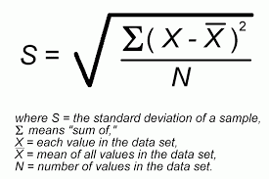](http://www.google.co.uk/imgres?imgurl=https://sites.google.com/site/piggraphy/_/rsrc/1418907523432/home/statistical-skills/standard-deviation/Standard%20Deviation.gif?height%3D414%26width%3D613&imgrefurl=https://sites.google.com/site/piggraphy/home/statistical-skills/standard-deviation&h=400&w=600&tbnid=RMbWVS_Hy7t37M:&docid=T0QIy_psjU4xrM&ei=M7PPVbuXIJT77AbCz7CoDw&tbm=isch&ved=0CEoQMygUMBRqFQoTCPv8k4GIrMcCFZQ92wodwicM9Q) The equation is as follows:-

You can use standard deviation to draw error bars on a graph of mean values. Error bars extend one standard deviation above and one standard deviation below the mean. The longer the bar the larger the standard deviation and the more spread out the sample data is from the mean.

**Standard error of the mean** (SE) gives an indication of how close the mean of the sample might be to the mean of the population, from which the sample was taken.

**SE=** ___ SD___

√mean sample size.

SE enables us to use **confidence intervals**. The confidence interval is one way of conveying our uncertainty about a result. To work this out you multiply the SE by 1.96. Subtract this value from the mean gives the lower 95% confidence limit and adding to the sample mean gives the upper 95% confidence limit.



95% confidence levels can be used to state that :

* You are 95% confident that the true mean value of a population from which the sample was taken lies between the upper and lower confidence limits
* If the intervals of two calculated means do not overlap, we are 95% confident that these two means are different

1. **Calculating percentages**

To calculate one number as a percentage of another divide one number by the other and multiply by 100.

e.g. Out of a population of 235 animals, 43 have black fur. What percentage have black fur?

Percentage with black fur = 43/235 x 100 = 18.30%

1. **Percentage Change**

To calculate percentage change, calculate the change between the two values and divide by the original value.

Percentage change = final value-original value x100

Original value

e.g. The mass of a piece of potato tissue immersed in a sucrose solution changed from 0.67g to 0.52g. What is the percentage change in the mass of potato tissue

Change=0.67-0.52 = 0.15g decrease

Percentage decrease = 0.15/0.67 x 100 (change/original x100).

=22.4% decrease

1. **Ratios**

Ratios can be used to compare different types of quantities. E.g. An organism with a surface are to volume ratio of 2:1 will have a surface area double the size as its volume.

Ratios are most useful in their simplest form by dividing each side by the same number until there is nothing left to divide. To simplify X:Y divide both sides by Y giving the ratio X:1.

g) **Standard form or scientific notation.**

When processing data you may need to convert very large or very small numbers to standard form which is much more manageable. Standard form is essentially expressing numbers to the power of 10. Standard form of 570000000 is 5.7 x 107.

Write the smallest number between 1 and 10 and then write the number of times the decimal place will have to shift to expand this to the original number as powers of 10.

1. **Rounding**

Sometimes you may want to round your numbers to two decimal places or less. When rounding when the number is a 5 or more round up, while if it is 4 or less round down. For example 4.35 will round to 4.4 while 4.34 would round to 4.3.

1. **Statistics**

Students taking A-level Biology should be familiar with the language of statistics and understand the need to devise random sampling procedures that avoid observer bias.

Students will be expected to be familiar with the following types of statistics.

• **Descriptive statistics** that provide an understanding of the data. (mean, mode standard error and standard deviation)

• **Inferential statistics** that enable inferences about a population based on the sample of data that has been collected (Chi Squared, correlation coefficients, and Students T test).

To use inferential statistics to manipulate data you must test a theory known as a hypothesis. You have to write a **null hypothesis.** A null hypothesis is where you expect no difference between samples to occur. For example:-

‘There is no difference between the number of slugs found in wet and dry areas’

Then you will either accept or reject this hypothesis depending on your statistical analysis of your results.

Significance levels: given the results of an experiment, we need to know if any difference between the results we predicted from our null hypothesis and those we obtained could be due to chance. If this difference is likely to be due to chance, it is said to be ‘non-significant’ and the null hypothesis cannot be rejected. On the other hand, if this difference is not likely to be due to chance, it is said to be significant and the null hypothesis can be rejected.

Each statistical test is associated with a table that enable us to calculate a significance level. For convenience, students can assume that if the probability (p) of the results being due to chance is equal to, or less than, 1 in 20 (p ≤ 0.05), the difference **is** **significant**.

You do not need to show how to calculate the more complicated statistics but in your exam you will need to identify or justify which test can be used for a set of data and be able to manipulate data using a calculator.

The three statistical tests you need to know about are:-

1. **Correlation coefficient** (looking for association in scattergrams)
2. **Chi squared test** (Comparing frequencies-comparing observed vs theoretical e.g. genetic ratios)
3. **Students t test** (Use this test to compare two small sets of quantitative (over 25) data when samples are collected independently of one another i.e. when you are **not** looking for either an association or comparing frequencies)

**Correlation coefficient**

The correlation coefficient tells you how closely two variables are related to one another. There are two that you need to know about:

* Pearson’s linear correlation coefficient
* Spearman’s rank correlation

**Pearson’s linear coefficient** is used when you have two sets of paired data-for example the numbers of monkeys in several different areas of forest and the number of nut trees in the same areas. A scattergram graph suggest that there might be a linear relationship between the two sets of data and you want to find out if that is the case.

**Spearman’s rank coefficient** is used for two sets of paired data-for example the surface area of a fruit and the time it takes to fall to the ground. Again a scattergram suggest a relationship between the two sets of data however this time the relationship may not be linear.

**Chi Squared**

You have two sets of quantitative data (numerical) results in which you have counted numbers or things in two or more categories. For example the number of tomato plant leaves with smooth or serrated leaves, or the number of people who smoke or don’t smoke. You want to see if your observed results differ significantly from expected results that you predict in your null hypothesis.

**Students t test**

Used when comparing two sets of data and you want to find out if the means of the two sets of data are significantly different from one another e.g. If the reaction time of students who have drunk coffee are shorter than the reaction times of students that have drunk water.

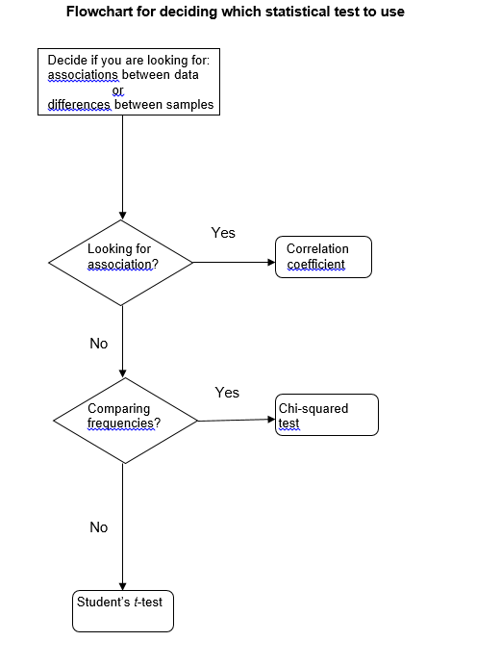

**We will cover statistical tests more thoroughly in class**

1. **Presenting data (graphs)**

**Graphs-general rules**

* Axes should always be labelled with the IV (x axis) and **mean** DV (y axis) including the units. These should be separated with a forward slash mark. Axes should be drawn with easy scale markings (2, 5 or 10).
* The graph needs to be at least half a page.
* Zero doesn’t have to be the origin, but there must be a value for the origin included.
* Data points should be marked with a cross (x).
* Best fit line only drawn when a scatter plot is drawn to compare two continuous variables.
* Join points with a ruler.
* No extrapolation to zero unless stated.
* Histograms are used to show the distribution of a continuous variable.
* Bar graphs used when the data is discontinuous.
* Most graphs you will plot will be dot to dot graphs which plots continuous variables.

This graph has well-spaced marking points and the data fills the paper.

Each point is marked with a cross (so points can be seen even when a line of best fit is drawn).

**Qualitative and discrete data**

**Qualitative data** is non-numerical data such as blood group or hair colour, while **discrete data** is numerical data that can only take certain values. For example the number of students in a class (you can’t have half a student) or shoe size. You can use **bar charts** or **pie charts** to present this type of data

**Continuous data** is numerical data that can take any value. You can use **line graphs** or **histograms.** Histograms are used to show the distribution of a continuous variable.

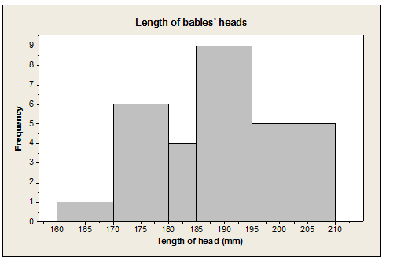

**Dot – to – dot graphs**

In Biology, it is generally accepted that, where the interim values of a continuously changing variable are not known, data points should be joined by straight lines**.**

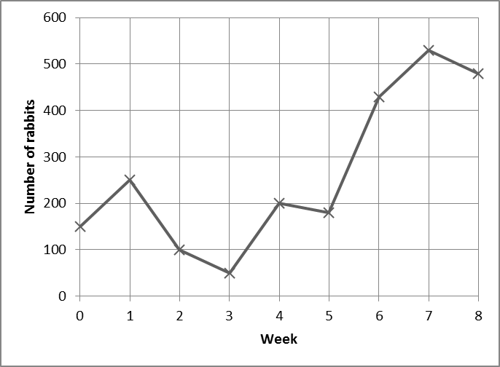

**Scattergrams** are used to show how two continuous variables are related. Both variables must be numbers. Draw a line of best fit to show a trend in the data however correlation does not always mean causation.

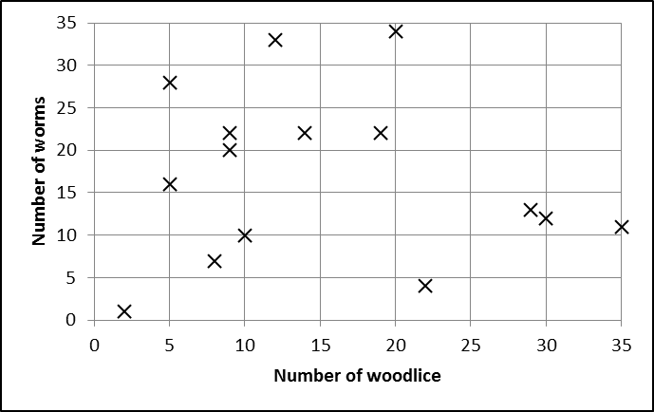

**Lines of best fit**

Lines of best fit should be drawn when appropriate. Students should consider the following when deciding where to draw a line of best fit:

* Are the data likely to have an underlying equation that it is following (for example, a relationship governed by a physical law)? This will help decide if the line should be straight or curved.
* Are there any anomalous results?
* Are there uncertainties in the measurements? The line of best fit should fall within error bars if drawn.

There is no definitive way of determining where a line of best fit should be drawn. A good rule of thumb is to make sure that there are as many points on one side of the line as the other. Often the line should pass through, or very close to, the majority of plotted points. Graphing programs can sometimes help, but tend to use algorithms that make assumptions about the data that may not be appropriate.

Lines of best fit should be continuous and drawn with a thin pencil that does not obscure the points below and does not add uncertainty to the measurement of gradient of the line.

Not all lines of best fit go through the origin. Students should ask themselves whether a 0 in the independent variable is likely to produce a 0 in the dependent variable. This can provide an extra and more certain point through which a line must pass. A line of best fit that is expected to pass through (0,0) but does not would some systematic error in the experiment. This would be a good source of discussion in an evaluation.

**How to calculate rate from a graph**

Rate is a measure of how something is changing over time. Calculating a rate can be useful when analysing your data especially if you want to find out the rate of a reaction. For an enzyme reaction the rate is as follows:

Enzyme reaction = Amount of product formed

time

**Linear graph**-To calculate rate from a **linear graph** use the following calculation

You can measure rate on your graph by measuring the gradient where

Gradient=∆y (change in y)

∆x (change in x)

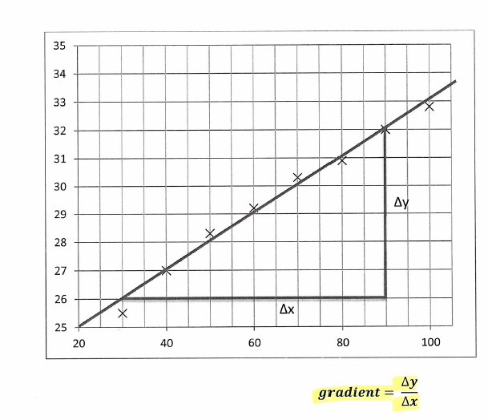

Draw a vertical line down from one point and a horizontal line across the other to make a triangle.

Use the scales on the axis to work out the length of each line to give you ∆y and ∆x.

**Curved graphs-**To find the rate in a curved graph need to draw a tangent.

Use a ruler and place it on the part you want to know the rate of reaction for. Draw a line and then calculate rate in the same way as with a linear graph. Draw a triangle and get a value for ∆y and ∆x.

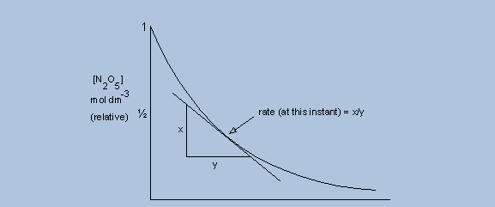

1. **Evaluation and conclusion.**

You need to be able to draw conclusions from your results and evaluate them. This means you need to explain your results using your scientific knowledge. In some cases you may be asked to research an area and use your research to help you explain your results. In this case you will need to reference your sources of research.

Remember when drawing a conclusion you can’t make broad generalisations you can only conclude what your results show.

**Correlation and causation-**a correlation between two variables does not always mean that there is a correlation (i.e. one variable is causing the other to change) the correlation could be by chance and usually further experiments would have to be carried out to prove causation.

If there is a relationship between two variables, the relationship is known as a **causal relationship**

*Evaluation is a structured process of assessing the success of a project in meeting its goals and to reflect on lessons learned*.

When you evaluate your data you must think about **any uncertainties**, how you would **minimise errors in your data** and **evaluate** your results and method.

**Uncertainty in data** – discuss the uncertainty in the amount of error your measurements might have. There will always be uncertainty in measurements due to the degree of sensitivity of the apparatus you are using.

This is known as the **margin of error**. For example a 10cm3 graduated pipette has graduations to mark 0.1cm3. Therefore if you are measuring a volume you are measuring to the nearest 0.1cm3. The uncertainty of the pipette is +/- 0.05cm3, so its margin of error is 0.1cm3

You should understand that every measurement has some inherent uncertainty. When you use equipment you need to make sure you write down the uncertainty in the measurements you are taking.

To ascertain the uncertainty in a measurement assume that the **uncertainty in a measurement is half of the value of the smallest measurement on the scale**

For example a thermometer is likely to have an uncertainty of +/-0.5ºC if the graduations are 1ºC apart.

**Taking multiple measurements reduces uncertainty**. To measure uncertainty when there have been repeats is shown by the equation below:-

Uncertainty = Maximum value- minimum value

1/2n

Where n = number of repeats

For example:

|  |  |  |  |  |
| --- | --- | --- | --- | --- |
| Repeat | 1 | 2 | 3 | 4 |
| Distance | 1.23 | 1.32 | 1.27 | 1.22 |

Uncertainty =1.32-1.22 = 0.05

2

Mean distance: (1.26 +/- 0.05) m

If you are **combining measurements** you will need to combine their uncertainties. This is important when carrying out serial dilutions. For example if you are diluting a glucose solution and you are taking 1cm3 of glucose using a graduated pipette that measures to the nearest 0.5cm3 and it is added to 10 cm3 of water that is measured using a graduated cylinder which measures to the nearest 1 cm3.

The uncertainty of the pipette = 0.5/2 = +/-0.25 cm3

The uncertainty of the cylinder = ½= +/- 0.5 cm3

The total uncertainty = 0.25 + 0.5 = +/-0.75 cm3

**Calculating percentage uncertainty/error**

If you know your uncertainty value you can calculate percentage error using the following equation:-

Percentage uncertainty (error) = uncertainty x100

reading

For example if you have used a graduated pipette to measure 23cm3. The scale was marked at 1mm3 intervals so your uncertainty in measurement is 0.5cm3. The percentage error is therefore:

0.5 x 100 =2.17%

23.0

Once you have identified your uncertainties you need to explain how you would change the method to **minimise errors in the data**. This could mean using a graduated pipette rather than a syringe to measure volumes of a fluid (a graduated pipette is more accurate-you need to show your uncertainty calculation for both pieces of equipment).

You also need to evaluate your method, how else could you improve your experimental design?

For example did you control temperature? If not you could control temperature by using an electronically controlled water bath? Did you control pH using buffers?. Was your sample size large enough? Could you have used more sensitive equipment for measurements? Did you observe a colour change-could this be measured by more sensitive equipment like a colorimeter?

Do you have confidence in your conclusion? Look at your error/range bars. Do they have a large or small spread? The smaller the spread the more confident you will be in your data. Are your results **repeatable** (did you take enough repeats), **reproducible** (can you compare your results to other peoples results and if so were they similar?), and **valid** (does your data answer the question you were investigating, were all variables controlled?)

In an exam question you might be given a conclusion for a data set and you will be asked to evaluate it i.e. give reasons if the conclusion valid or how far the data supports the conclusion.

Remember when you write a conclusion you need to **quote data.**

**Biological drawings**

The purpose of drawing in the teaching of Biology is the development of observational skills. A student must look very closely at a specimen in order to draw it accurately and must have sound knowledge of the component structures in order to choose what to draw and what to omit from the drawing.

Drawings should always be in pencil. Fine detail cannot be represented accurately unless the pencil has a sharp point.

**Rules of drawings**

* Outlines of structures should be drawn
* No shading or colouring
* Sizes should be accurate (measured with a graticle)
* Label with brief annotation about their function and interrelationships
* Title
* Indication of real size
* Magnification used

If required, the drawn structures should be labelled with brief annotations about their functions or interrelationships.

The drawing should have an explanatory title and an indication of the real size of the structures drawn or of the magnification used.

During an AS or A-level Biology course, students are likely to make three types of drawing.

1. **Cell drawing**

The purpose of this drawing is to show accurately the components of individual cells observed using an optical microscope. The drawing should be detailed but should not show more than two or three cells.

1. **Tissue map**

The purpose of a tissue map is to show the location and extent of tissues in an organ or in a whole organism. Cellular detail of any of the tissues should not be shown. Instead, the outline of each tissue should be drawn. This often presents a problem, since cell differentiation is seldom discrete. Students must use their background knowledge and understanding to interpret what they see.

1. **Body plan**

Following dissection, a morphological drawing should provide a lifelike representation of the main body parts exposed by the dissection.

**Common errors in biological drawing**

The table shows errors that commonly occur when students begin to practise drawings of biological material. Each would reduce the value of the drawing and result in loss of credit being awarded. Most result from lack of attention or care and are easily solved.

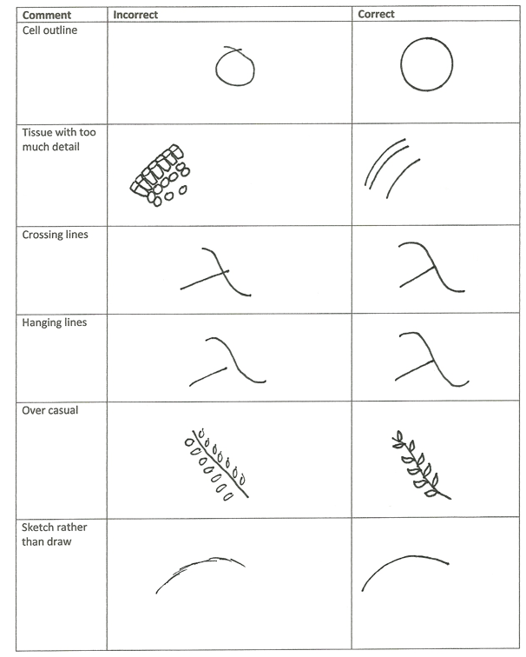

**Calculating magnification**

To calculate the magnification of image size you need to multiply the magnification on the eyepiece lens (for all the microscopes in the department the magnification of the eyepiece lens is 10x) with the magnification of the objective lens (there are three objective lenses x4, x10 and 40) with a 40x objective lens and a x10 eyepiece lens the magnification would be:-

[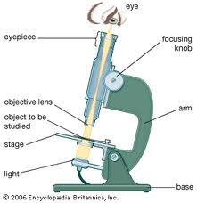](http://www.google.co.uk/imgres?imgurl=http://media.web.britannica.com/eb-media/29/85429-034-CE5B7686.gif&imgrefurl=http://kids.britannica.com/elementary/art-88118/In-an-optical-microscope-light-traveling-through-special-lenses-makes&h=310&w=300&tbnid=U7470FS5PIMBVM:&zoom=1&docid=rQjJwDAZ61C-gM&ei=IKJcVbazJOm57gb_6oGADg&tbm=isch&ved=0CF0QMygkMCQ)

Magnification= objective x eyepiece

Magnification would be 10 x 40

= 400x

[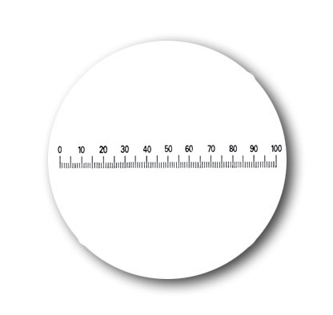](http://www.google.co.uk/url?sa=i&rct=j&q=&esrc=s&source=images&cd=&cad=rja&uact=8&ved=0CAcQjRw&url=http://www.askania.de/data/index.php?option%3Dcom_content%26task%3Dview%26id%3D267%26lang%3Den&ei=8qJcVfOWNbSt7AapxYDQDw&bvm=bv.93756505,d.ZGU&psig=AFQjCNF27R3EwzWLRMvnN3o_ZMP6Df7ERQ&ust=1432220722266475)When you look down the microscope you will observe a graticule which is part of your eyepiece lens

Each division is known as an eye piece unit (epu). By lining up the graticule with the specimen you will be able to work out the size of your specimen in epu. This will be shown to you in class. By using these measurements you will be able to accurately determine the relative size of different organelles or tissues that you are drawing.

To know what length each division on a graticule represents you need to use a stage micrometer. This is a microscope slide on which the object line is 1mm long.

To accurately calcualte the size of an eyepiece unit for each magnification you line up the stage micrometer with the graticule and assess the relationship between the two. See below:

[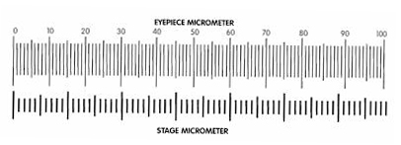](https://www.microscopeworld.com/t-calibration.aspx)

You need to know the magnification on your objective lens. Say if 20 micrometer divisions line up with 80 eye piece divisions with a 40x objective lens then:

1. 80 eyepiece units=20 stage micrometer units
2. 1epu=20/80=0.25 stage micrometer units (SMU)
3. 1smu=0.01mm (known)
4. 1epu=0.25x0.01= 0.0025mm or 2.5µm
5. Using this calculation you can now accurately measure parts of your drawings in epu and calculate an exact size.

**Referencing**

When you write your discussion you will need to look up information to be able to properly discuss the relevant biology associated with the practical. You mustn’t directly copy this material as that is known as **PLAGERISM** and is against college and exam board rules. If you quote material or reword material from a source you need to reference this material. This is one of your core competencies that will be assessed. You can do this easily in Microsoft word.

When you need to add a reference go to the top bar in Microsoft word and click on references.

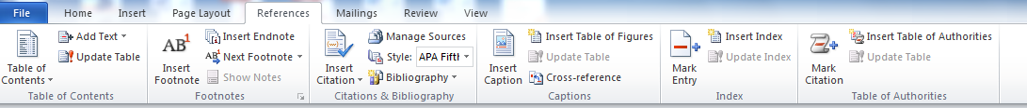

Change the style to Harvard Anglia 2008

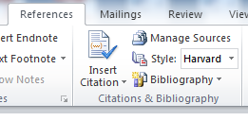

Then click on insert citation



Then click on insert citation (you will have a choice of two) and pick your source which can be a web page/book or a journal.

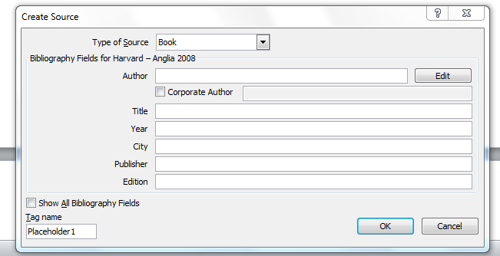

Fill in as much information as you can on your source. Remember that if you are referencing a web page that you must write when you accessed it. Then press ok and your source will be automatically entered into your text.

Once you have finished writing your document you will need to insert the bibliography. This is done by selecting references but this time click on bibliography.

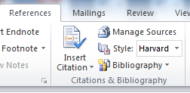

You will see a drop down menu and at the bottom it will say ‘insert bibliography’. Click on this and your bibliography will be automatically entered into your document.

**Example of an exam question**

|  |
| --- |
| Some mice have diabetes. The diabetes causes the blood glucose concentration to become very high after a meal. Scientists investigated the use of an inhibitor of amylase to treat diabetes.  The scientists took 30 mice with diabetes and divided them into two groups, **A** and **B**.  •        **Group A** was given yoghurt **without** the inhibitor of amylase each day.  •        **Group B** was given yoghurt **with** the inhibitor of amylase each day.  Apart from the yoghurt, all of the mice were given the same food each day.  The scientists measured the blood glucose concentration of each mouse, 1 hour after it had eaten. This was done on days 1, 10 and 20 after the investigation started.  The following figure shows the scientists’ results.  http://content.doublestruck.eu/getPicture.asp?sub=AA_BIOL&CT=Q&org=b5a69a2fdd9c5a31b56ff3bc804be010&folder=QS14106_files&file=img01.png         Days after the investigation started  (a)     **Group A** acted as a control in this investigation.  Explain the purpose of this group.  ........................................................................................................................  ........................................................................................................................  ........................................................................................................................  ........................................................................................................................  **(2)**  (b)     Apart from the yoghurt, it was important that all of the mice were given the same food each day.  Give **two** reasons why it was important that all of the mice were given the same food each day.  1 .....................................................................................................................  ........................................................................................................................  2 .....................................................................................................................  ........................................................................................................................  **(2)**  (c)     The scientists’ hypothesis was that adding the inhibitor of amylase to the food would lead to a lower blood glucose concentration.  Use your knowledge of digestion to suggest how the addition of the inhibitor could lead to a lower blood glucose concentration.  ........................................................................................................................  ........................................................................................................................  ........................................................................................................................  ........................................................................................................................  **(2)**  (d)     Give **one** reason why these results may **not** support the use of the inhibitor of amylase to treat diabetes in mice.  ........................................................................................................................  ........................................................................................................................  ........................................................................................................................  ........................................................................................................................  **(2)**  **(Total 8 marks)** |
| **Mark scheme**  a)     1.      To show the effect of the inhibitor / drug;  2.      To show the effect of yoghurt (on its own does not affect blood glucose);  **2**  (b)     1.      Food is a factor affecting blood glucose / different foods contain  different amounts of starch / glucose / sugar / carbohydrate;  *Accept converse*  2.      To keep starch / fibre intake the same / similar;  *Accept something in food which affects the inhibitor*  **2**  (c)     1.      Fewer E-S complexes formed;  2.      (With inhibitor) less / no starch digested to maltose ;  *Require knowledge that maltose comes from starch*  3.      (So) less / no glucose from maltose;  *Require knowledge that glucose comes from maltose*  *Accept no glucose*  4.      (So) less absorption of glucose (from gut);  **2 max**  (d)     **Suitable reason; with explanation;**  Paired responses – do not mix and match  *Ignore references to correlation does not prove causation,  it could be due to other factors*  Examples,  1.      Need larger sample / only 30 mice / only 15 mice in each group;  *Accept small sample size*  2.      Might not be representative / anomalies might have a bigger or  smaller effect;  *Accept mean not reliable*  ***OR***  3.      Investigation only lasted 20 days;  *Experiment was not long enough*  4.      Can’t see what longer term effects are;  ***OR***  5.      Fall in blood glucose is small / numbers from graph;  6.      Mice with inhibitor still have a large rise in blood glucose / so don’t  know if differences significant;  *Accept differences are due to chance*  ***OR***  7.      No stats / SDs / SEs;  8.      So don’t know if differences significant;  ***OR***  9.      Blood glucose could continue to fall;  10.    which could be harmful;  ***OR***  11.     No group without yoghurt;  12.     So cannot compare to other groups; |
|  |

**Glossary**

The following subject specific vocabulary provides definitions of key terms used in AQA's AS and A-level Biology, Chemistry and Physics specifications.

#### Accuracy

A measurement result is considered accurate if it is judged to be close to the true value.

#### Calibration

Marking a scale on a measuring instrument.

This involves establishing the relationship between indications of a measuring instrument and standard or reference quantity values, which must be applied.

For example, placing a thermometer in melting ice to see whether it reads 0⁰C, in order to check if it has been calibrated correctly.

#### Data

Information, either qualitative or quantitative, that have been collected.

#### Errors

See also uncertainties.

#### measurement error

The difference between a measured value and the true value.

#### anomalies

These are values in a set of results which are judged not to be part of the variation caused by random uncertainty.

#### random error

These cause readings to be spread about the true value, due to results varying in an unpredictable way from one measurement to the next.

Random errors are present when any measurement is made, and cannot be corrected. The effect of random errors can be reduced by making more measurements and calculating a new mean.

#### systematic error

These cause readings to differ from the true value by a consistent amount each time a measurement is made.

Sources of systematic error can include the environment, methods of observation or instruments used.

Systematic errors cannot be dealt with by simple repeats. If a systematic error is suspected, the data collection should be repeated using a different technique or a different set of equipment, and the results compared.

#### zero error

Any indication that a measuring system gives a false reading when the true value of a measured quantity is zero, eg the needle on an ammeter failing to return to zero when no current flows.

A zero error may result in a systematic uncertainty.

#### Evidence

Data that have been shown to be valid.

#### Fair test

A fair test is one in which only the independent variable has been allowed to affect the dependent variable.

#### Hypothesis

A proposal intended to explain certain facts or observations.

#### Interval

The quantity between readings eg a set of 11 readings equally spaced over a distance of 1 metre would give an interval of 10 centimetres.

#### Precision

Precise measurements are ones in which there is very little spread about the mean value.

Precision depends only on the extent of random errors – it gives no indication of how close results are to the true value.

#### Prediction

A prediction is a statement suggesting what will happen in the future, based on observation, experience or a hypothesis.

#### Range

The maximum and minimum values of the independent or dependent variables;

For example a range of distances may be quoted as either:

'From 10cm to 50 cm' or

'From 50 cm to 10 cm'

#### Repeatable

A measurement is repeatable if the original experimenter repeats the investigation using same method and equipment and obtains the same results.

#### Reproducible

A measurement is reproducible if the investigation is repeated by another person, or by using different equipment or techniques, and the same results are obtained.

#### Resolution

This is the smallest change in the quantity being measured (input) of a measuring instrument that gives a perceptible change in the reading.

#### Sketch graph

A line graph, not necessarily on a grid, that shows the general shape of the relationship between two variables. It will not have any points plotted and although the axes should be labelled they may not be scaled.

#### True value

This is the value that would be obtained in an ideal measurement.

#### Uncertainty

The interval within which the true value can be expected to lie, with a given level of confidence or probability eg “the temperature is 20 °C ± 2 °C, at a level of confidence of 95 %”.

#### Validity

Suitability of the investigative procedure to answer the question being asked. For example, an investigation to find out if the rate of a chemical reaction depended upon the concentration of one of the reactants would not be a valid procedure if the temperature of the reactants was not controlled.

#### Valid conclusion

A conclusion supported by valid data, obtained from an appropriate experimental design and based on sound reasoning.

#### Variables

These are physical, chemical or biological quantities or characteristics.

#### categoric variables

Categoric variables have values that are labels eg names of plants or types of material or reading at week 1, reading at week 2 etc.

#### continuous variables

Continuous variables can have values (called a quantity) that can be given a magnitude either by counting (as in the case of the number of shrimp) or by measurement (eg light intensity, flow rate etc).

#### control variables

A control variable is one which may, in addition to the independent variable, affect the outcome of the investigation and therefore has to be kept constant or at least monitored.

#### dependent variables

The dependent variable is the variable of which the value is measured for each and every change in the independent variable.

#### independent variables

The independent variable is the variable for which values are changed or selected by the investigator.

#### nominal variables

A nominal variable is a type of categoric variable where there is no ordering of categories (eg red flowers, pink flowers, blue flowers)