**Biological molecules**

**Explain what is meant by a polymer.**

(Molecule) made up of many identical/similar molecules/monomers/  
subunits;

**Describe the structure of an amino acid molecule and explain how amino acids link together.**

1 Amino acid based on carbon with four groups attached;

2 Amino/ NH2 and carboxyl / COOH;

3 R-group/ side chain + hydrogen;

4 R-group differs from one amino acid to another;

5 Amino acids joined by condensation;

6 Bond formed between NH2 and COOH;

7 Involves removal of molecule of water;

8 H from NH2 and OH from COOH;

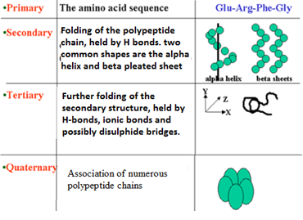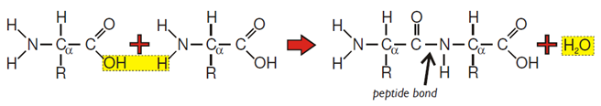

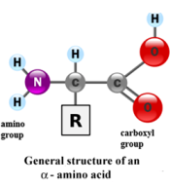

**Explain how proteins are suited for their roles as receptor molecules.**

Many different sorts of proteins;  
Different primary structures/sequences of amino acids;  
Tertiary structure;  
Shape; allowing formation of receptor/binding site/site into which  
substance/substrate fits;

**Explain how the structure of fibrous proteins is related to their functions.**

Long chains of aa;  
Folding of chain into a coil / folds / helix / pleated sheet;

Association of several polypeptide chains together;  
Formation of fibres / sheets explained; 2

H bonds / Disulphide bonding (*In context*);  
Fibres provide strength (and flexibility);  
Sheets provide flexibility;  
Example e.g. keratin in hair, collagen in bone; (*MUST be in context*)  
Insoluble because external R-groups are non-polar;

**Describe how you would use a biochemical test to show that a solution contained protein.**

Biuret / alkali + copper sulphate;  
Lilac/purple/mauve/violet;

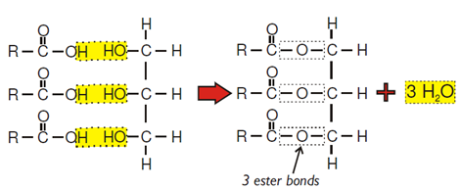

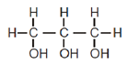

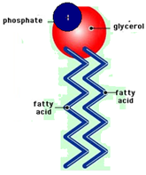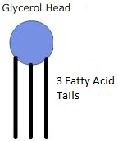

**With reference to named parts of the diagram, explain the difference between the terms:**

***Triglyceride* and *phospholipid;***

Phospholipid has (one) phosphate / Phosphoric acid;   
replacing fatty acid;

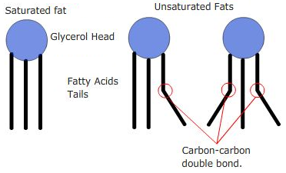

***Saturated* and *unsaturated.***

Saturated – all valencies of C filled / saturated with hydrogen / all (C–C)  
single bonds / no double bonds;  
fatty acid 1 is saturated/fatty acids 2 and 3 are unsaturated;

**Describe a chemical test you could carry out to show that a piece of coconut contains lipids.(3)**

(Crush in) ethanol / alcohol;  
Add (to) water (*Order of adding is critical for this point*);  
Emulsion / white colour

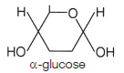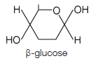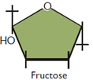

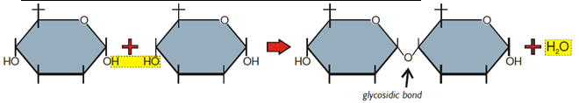

**Describe how you could use Benedict’s reagent to test a urine sample for the presence of glucose.**

Add (Benedict’s) reagent (to urine sample) and heat / heat the mixture;  
red/ brown/ orange/ green/ yellow;

**Describe a further biochemical test to find out if a substance is a non-reducing sugar.**

Heat with acid, then neutralise / hydrolyse using enzyme;  
(heat) with Benedict’s (solution);Because all amino acids have different ‘R’ groups they have different solubilities and different affinities for solids. For this reason they can be separated by chromatography.

* A container is filled to a depth of 2 cm with a suitable chromatography solvent. The container is sealed and left to allow the solvent to saturate the atmosphere. This is important because solvent must not evaporate from the chromatogram as it is running.
* A strip of chromatography paper has a pencil line drawn on it slightly more than 2 cm from the bottom and small crosses are drawn on it to indicate where to add the amino acids.

It is important not to touch the paper as there are amino acids on your fingers.

* A spot of amino acid is applied to a cross on the line using a capillary tube, the spot must not exceed 2mm in diameter.
* The spot is dried with a hair drier and another is applied over the top. This is done until a small but concentrated dot of amino acid has been built up on the cross.
* The nature of the amino acid is indicated by writing in pencil below the spot.
* This is repeated until each amino acid dot has been added.
* The strip of chromatography paper is placed in the container, making sure that the solvent doesn’t splash above the line.
* The solvent is drawn up the paper by capillary action but does not evaporate from it due to the saturated air around it. The amino acid was be carried by the solvent and each will travel at different speeds.
* When the solvent has nearly reached the top the paper is removed and a line is drawn to show where the solvent has reached, this is the solvent front.
* The chromatogram is dried in a fumes cupboard and then sprayed with ninhydrin spray. When the chromatogram dries, the amino acids will appear as purple spots at different distances up the chromatogram.
* The distance each spot has traveled from the centre of the cross to the centre of the spot is measured, call this D1.
* The distance the solvent front has traveled from the cross is measured, call this S.
* The Rf value can then be calculated as **Rf = D1/ S**
* 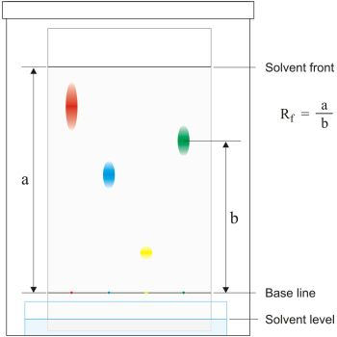Each amino acid will have a unique Rf value and as the Rf values for all amino acids are known they can be identified knowing the Rf value

Enzymes

**Many reactions take place in living cells at temperatures far lower than those required for the same reactions in a laboratory. Explain how enzymes enable this to happen.**

lowers activation energy;  
relevant mechanism *e. g. brings molecules close together / reaction in smaller*  
*steps / change in charge distribution / proton donation or acceptance / induced*  
*fit ensuring substrates brought in correct sequence;*including relevant reference to active site;

**Explain how a substrate is broken down by the enzyme.**

Substrate enters active site;  
Complimentary shapes / Lock and Key;  
(Binding) to form enzyme-substrate complex;  
Lowering of activation energy;  
Conformational / shape change;  
Breaking of bonds in substrate;  
Products no longer fit active site and so are released;

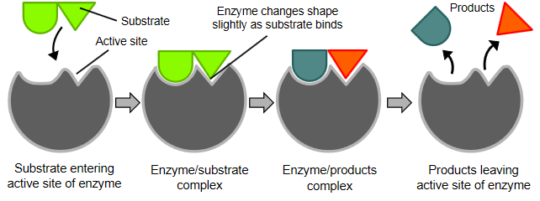

**Describe how the condensation reaction can be catalysed by an enzyme.**

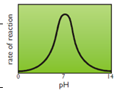enzyme has an active site;  
with a complementary shape to the substrate molecules;  
enzyme-substrate complex formed;  
lowering the (activation) energy for the reaction;  
glycosidic bond formed/bringing together hydroxyl groups/water  
molecule removed;  
products leave the active site;  
enzyme unchanged;

**Explain how a change in pH affects enzymes activity**

(decrease in pH) increases H+ ions/protons;  
5 attach/attracted to amino acids;  
6 hydrogen/ionic bonds disrupted/broken;  
7 denatures enzyme / changes tertiary structure;  
8 changes shape/charge of active site;  
9 active site/enzyme unable to combine/fit with starch/enzyme-substrate  
complex no longer able to form decreases rate of breakdown of starch/rate of reaction/carbohydrase activity

**Describe and explain how an increase in temperature affects the rate of an enzyme controlled reaction.**

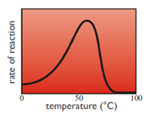Temperature  
Rate of reaction increases;  
Increasing temperature increases rate of movement of molecules/  
kinetic energy;  
Collide more often/substrate enters active site more often/more  
enzyme-substrate complexes formed;  
Up to optimum;  
Rate of reaction decreases;  
High temperatures cause denaturation/loss of tertiary structure/3D structure;  
By breaking specified bonds (not peptide bond);  
Active site altered/substrate cannot bind/fit/

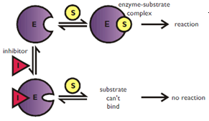**Explain how inhibitors affect the rate of enzyme-controlled reactions.**

1 Statement about two types, competitive and non-competitive;  
*Note. Award points 2 –5 only in context of competitive and  
non-competitive inhibition*  
Competitive  
2 Similarity of shape of inhibitor and substrate;  
3 Inhibitor can enter/bind with active site (of enzyme);

Non-competitive  
4 Affect/bind to enzyme other than at active site;  
5 Distorts shape of active site;

Inhibitors  
6 Prevent entry of/binding of substrate to active site;  
7 Therefore fewer/no enzyme-substrate complexes formed;

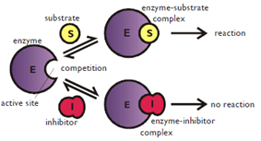

**Use your knowledge of protein structure to explain why enzymes are specific and may be affected by non-competitive inhibitors.**

1 each enzyme/protein has specific primary structure / amino acid sequence;  
2 folds in a particular way/ has particular tertiary structure;  
3 active site with unique structure;  
4 shape of active site complementary to/ will only fit that of substrate;  
*maximum of three marks for inhibition, points 5 – 8*5 inhibitor fits at site on the enzyme other than active site;  
6 determined by shape;  
7 distorts active site;  
8 so substrate will no longer fit / form enzyme-substrate complex;

**DNA**

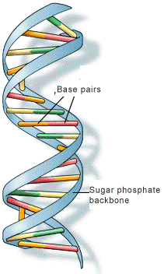

In eukaryotes, DNA is linear and associated with proteins.

In prokaryotes, DNA molecules are smaller, circular and are not associated with proteins.

**Describe two features of DNA which make it a stable molecule.**

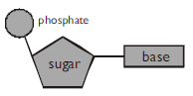Two strands with specific base pairing;  
large number of hydrogen bonds (between strands);  
helix/coiling reduces chance of molecular damage / protects H bonds;  
strong sugar-phosphate backbone;

**Describe the molecular structure of DNA**

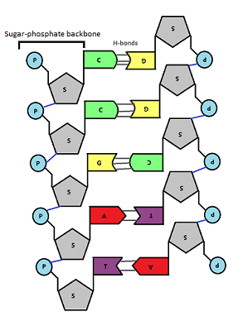Long polymer of nucleotides;  
composition of a nucleotide (pentose sugar, phosphate and N containing base)  
4 bases named (A, T, C and G) (Uracil (U) is a base in RNA that replaces T), A, G are purine bases (2 ring structure) T, C and U are pyrimidine bases (single ring structures)  
sugar-phosphate ‘backbone’;   
two (polynucleotide) strands;  
specific base-pairing;  
example e.g. A–T / C–G; there are 2 H bonds between A/t and three H bonds between C/G  
hydrogen bonding between bases

**Explain how the structure of DNA is related to its function.(6)**

sugar - phosphate backbone gives strength (phosphodiester bonds)  
(coiling gives) compact shape;  
sequence of bases allows information to be stored;  
long molecule stores large amount of information;  
information can be replicated / complementary base pairing;  
(double helix protects) weak hydrogen bonds / double helix makes molecule stable prevents code being corrupted;  
chains held together by weak hydrogen bonds;  
chains can split for replication / transcription

Complementary base pairing enables information to be replicated / transcribed;  
Many hydrogen bonds together give molecule stability;  
Hydrogen bonding allows chains to split for replication / transcription OR molecule unzips easily for replication / transcription.

**Some definitions**

**Locus:** Position of a gene on a strand of DNA.

**Genes**: are short sections of DNA that contain coded information as a specific sequence of bases. Genes code for polypeptides that determine the nature and development of organisms.

**Mutation:** A change in the base sequence of a gene

**Alleles:** alternative forms of a gene (created through mutations).

**Codon:** A sequence of three bases (called a triplet) that codes for a specific amino acid.

The base sequence of a gene determines the amino acid sequence in a polypeptide.

**Exons:** sequences of bases in a gene that code for the polypeptide

**Introns:** (In eukaryotes), sequences of bases in a gene that do not code for polypeptides.

Differences in base sequences of alleles of a single gene may result in non-functional proteins, including non-functional enzymes.

Non-overlapping: each base is part of only one codon

Degenerate genetic code: there are 20 amino acids and 64 codons, so most amino acids have more than one codon. There are 3 stop codons and 1 start codon.

In eukaryotes, DNA is linear, associated with proteins and large compared to the smaller, circular DNA in prokaryotic cells that also have no proteins associated with it.

**Explain how DNA replicates.(5)**

hydrogen bonds broken;  
semi-conservative replication / both strands used (as templates);  
nucleotides line up;  
complementary / specific base pairing / A and T / C and G;  
DNA polymerase;

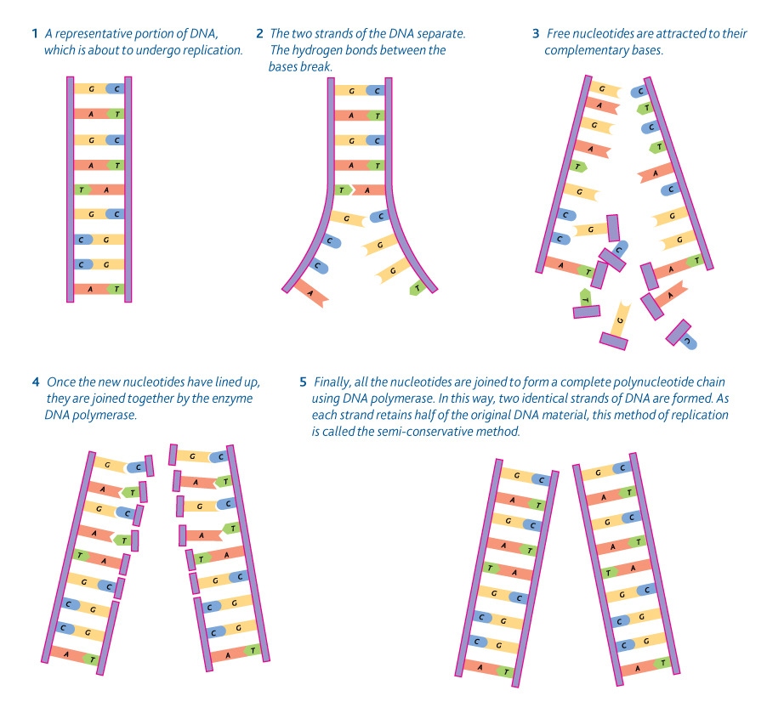

**ATP**

**Give three uses of energy from ATP in a liver cell.**

Active transport; Phagocytosis; Synthesis of glycogen; Protein / enzyme; DNA / RNA; Lipid / cholesterol;

Urea in glycolysis; Bile production; Cell division;

**ATP is useful in many biological processes. Explain why.(5)**

1. Releases energy in small / manageable amounts;

2. (Broken down) in a one-step / single bond broken;

3. Immediate energy compound/makes energy available rapidly;

4. Phosphorylates/adds phosphate;

5. Makes (phosphorylated substances) more reactive / lowers activation energy;

6. Reformed/made again;

**ATP is sometimes described as an *immediate* source of energy. Explain why.**

(Energy release) only involves a single reaction/one-step/  
(energy released) in ATP 🡪ADP (+Pi)/  
energy transfer direct to reaction requiring energy;

# Explain why humans make more than their body mass of ATP each day

1. ATP is unstable;

2. ATP cannot be stored / is an immediate source of energy;

3. Named process uses ATP ;

4. ATP only releases a small amount of energy at a time;

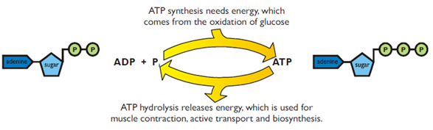Water: Properties and benefit for life

**Liquid at normal temperatures;**

Hydrogen bonding (cohesion) between water molecules;

Molecules more difficult to separate;

Ice floats on water / **water freezes from top down**;

Insulates water beneath;

Large bodies of water don’t freeze completely / animals can still swim etc.;

(Change in density with temperature) causes currents to circulate nutrients;

Water is transparent to light; so photosynthesis possible (in shallow water); wavelength of light varies with depth;

Water has high specific heat capacity;  
much energy needed to break hydrogen bonds;

(High) thermal stability / temperature remain fairly constant;

**High latent heat of vaporisation**, (a lot of energy is needed to cause evaporation) thus sweating is highly effective as the body can be cooled considerably with only a minimal loss of water

The density changes in water will also set up currents in the water circulating nutrients.

**Solvent** for, polar / ionic, substances;

**Solubility** of gases in environment;

**Allows reactions** to take place;

**Transport medium**; e.g. (glucose, amino acids);

Transport medium for,gametes / blood cells;

Not easily compressed, acts as hydroskeleton

**Inorganic ions**

Potassium salts are very soluble and are important in the correct functioning of nerves and muscles. They are osmotically active in that they reduce the water potential.

Calcium salts are insoluble and they are often structurally important. They are a component of bone and teeth as a complex salt of phosphorous. Calcium pectate acts as a ‘glue’ sticking plant cell walls together. A flow of calcium ions is a component in the functioning of the muscles.

Magnesium is the metal ion in the porphyrin ring in chlorophyll is magnesium. It is a constituent of the mineral component of bones and teeth

Iron is the metal ion in the porphyrin ring in haemoglobin is iron. It is involved in the cytochromes involved in the electron transport chain in respiration.

Hydrogen carbonate is involved in buffering systems in the blood.

Nitrates are essential nutrients, they are component in many biologically important compounds such as amino acids which make up proteins and in the organic bases which are in all nucleotides which in nucleic acids (DNA, RNA, NAD and ATP). Nitrogen is also in the porphyrin rings of chlorophyll and haem molecules.

Phosphates are a component in many biologically important compounds such as nucleic acids, ATP, FAD, NAD and NADP. It is also a component of the complex calcium salt in bones and teeth. Phospholipids are compounds of fat and phosphate and all cell membranes are made of these.

**Prokaryotic cells Vs Eukaryotic cells**

**The structure of a cholera bacterium is different from the structure of an epithelial cell from the small intestine. Describe how the structure of a cholera bacterium is different.**

1 Cholera bacterium is prokaryote;

2 Does not have a nucleus/nuclear envelope/ has DNA free in cytoplasm/has loop of DNA;

3 and 4 Any two from

No membrane-bound organelles/no mitochondria / no golgi/ no endoplasmic reticulum/etc;

5 Small ribosomes only;

6 and 7 Any two from

Capsule/flagellum/plasmid / cell wall/etc;

**Give 2 ways in which pathogens can cause disease when they enter the body of their host.**

Damage/destruction of cells/tissues Production of toxins;

**Describe the difference between an endotoxin and an exotoxin.**

Endotoxins produced from the breakdown of bacteria (cell walls);  
(*allow burst / lyse – do not allow decompose*)  
exotoxins secreted / released (from living cells) (*not produced*);  
endotoxins are lipopolysaccharides;  
exotoxins are protein;

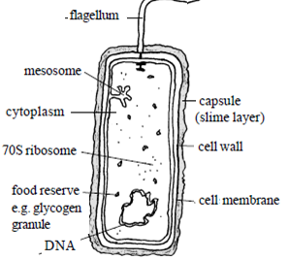

**Parts of the prokaryotic cell**

Cell (surface) membrane: regulates entry/exit/selectively permeable;

Mesosome: respiration/cell division;

Cell wall: (mechanical) protection/prevents (osmotic) lysis;

Slime layer/capsule: protection (against e.g. antibiotics);

Flagellum, movement of cell;

DNA molecule/bacterial chromosome, genetic information;

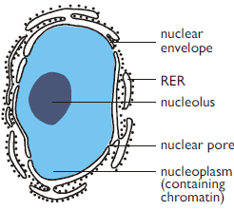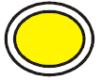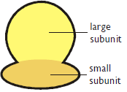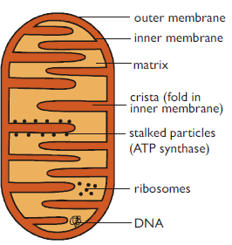

**Nucleus.** This is the largest organelle. It is surrounded by a nuclear envelope, which is a double membrane with nuclear pores – large holes containing proteins that control the exit of substances from the nucleus. The interior is called the nucleoplasm, which is full of chromatin – the DNA/protein complex (see unit 2). During cell division the chromatin becomes condensed into discrete observable chromosomes. The nucleolus is a dark region of chromatin, involved in making ribosomes.

**Lysosomes**: These are small membrane-bound vesicles formed from the RER containing a cocktail of hydrolytic enzymes. They are used to break down unwanted chemicals, toxins, organelles or even whole cells, so that the materials may be recycled. They can also fuse with a feeding vacuole to digest its contents.

**Ribosomes:** These are the smallest and most numerous of the cell organelles, and are the sites of protein synthesis. Ribosomes are either found free in the cytoplasm, where they make proteins for the cell's own use, or they are found attached to the rough endoplasmic reticulum, where they make proteins for export from the cell. All eukaryotic ribosomes are of the larger, "80S", type.

**Mitochondrion:** This is a sausage-shaped organelle (8Vm long), and is where aerobic respiration takes place in all eukaryotic cells (anaerobic respiration takes place in the cytoplasm). Mitochondria release energy (in the formATP) from carbohydrates, lipids and other energy rich molecules. Cells that use a lot of energy (like muscle cells) have many mitochondria.

Mitochondria are surrounded by a double membrane: the outer membrane is simple and quite permeable, while the inner membrane is highly folded into cristae, which give it a large surface area. The space enclosed by the inner membrane is called the mitochondrial matrix, and contains small circular strands of DNA. The inner membrane is studded with stalked particles, which are the enzymes that make ATP.

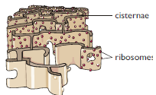

**Endoplasmic Reticulum (ER**). This is a series of interconnected membrane channels involved in synthesising and transporting materials. Rough Endoplasmic Reticulum (RER) is studded with numerous ribosomes, which give it its rough appearance. The ribosomes synthesise proteins, which are processed in the RER (e.g. by enzymatically modifying the polypeptide chain, or adding carbohydrates), before being exported from the cell via the Golgi Body.

Smooth Endoplasmic Reticulum (SER) does not have ribosomes and is used to process materials, mainly lipids, needed by the cell.

**Golgi Body** (or Golgi Apparatus). Another series of flattened stacks of membrane vesicles, formed from the endoplasmic reticulum. Its job is to transport proteins from the RER to the cell membrane for export. Parts of the RER containing proteins fuse with one side of the Golgi body membranes, and are modified (carbohydrate is added to form glycoproteins), while at the other side small vesicles bud off and move towards the cell membrane, where they fuse, releasing their contents by exocytosis.

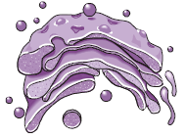

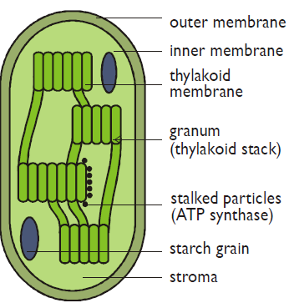

**Chloroplast**

Membranes arrangement and disc shape provides large surface for light absorption;  
layering of membrane allows a lot of pigment;  
Permeable membrane allows diffusion of gases /carbon dioxide;  
membranes provide surface for attachment of electron / hydrogen acceptors;  
Contains chlorophyll for light absorption;  
Contains different pigments to absorb different wavelengths;  
Stacking / arrangement of grana/thylakoids maximises light catchment;  
Stroma contains enzymes for photosynthesis;  
Outer membrane keeps enzymes in chloroplast;  
Starch grains / lipid droplets store products of photosynthesis;  
Ribosomes / DNA for enzyme/protein synthesis;  
Shape of chloroplast gives large surface area for CO2, absorption.

**Microscopes**

**What is resolution and why is it better in Electron |Microscopes than in light**

Ability to distinguish points (close together), Electrons have a shorter wavelength;

**Scientists use optical microscopes and transmission electron microscopes (TEMs) to investigate cell structure. Explain the advantages and the limitations of using a TEM to investigate cell structure.**

Advantages:

1 Small object can be seen;

2 TEM has high resolution;

3 Wavelength of electrons shorter;

Limitations:

4 Cannot look at living cells;

5 Must be in a vacuum;

6 Must cut section / thin specimen;

7 Preparation may create artefact

8 Does not produce colour image;

**Measuring the size of an object under a microscope**

Measure with an eyepiece graticule

Calibrate with the stage mcirometer (an object of a known size)

Repeat and calculate an average

Cell fractionation

Starting with some lettuce leaves, describe how you would obtain a sample of undamaged chloroplasts. Use your knowledge of cell fractionation and ultracentrifugation to answer this question.

1. Chop up (accept any reference to crude breaking up);

2. Cold; (reduces enzyme activity)

3. Buffered solution; (prevents pH affecting enzymes)  
4. Isotonic / same water potential; (prevents osmosis and possible lysis or shrinkage of organelles)

5. Filter and centrifuge filtrate;  
6. Centrifuge supernatant;

7. At higher speed;

8. Chloroplasts in (second) pellet;

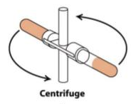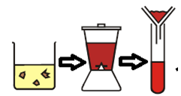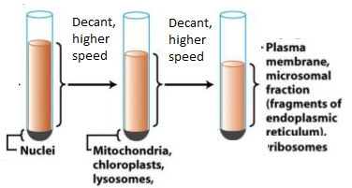

**Mitosis, replication of DNA and Cell Cycle**

**Mitosis is important in the life of an organism. Give two reasons why.**

1. Growth / increase in cell number;

2. Replace cells / repair tissue / organs /body;

3. Genetically identical cells;

4. Asexual reproduction /cloning;

**Describe the behaviour of chromosomes during mitosis and explain how this results in the production of two genetically identical cells. (7)**

1 chromosomes shorten/thicken/supercoiling;

2 chromosomes (each) two identical chromatids/strands/copies   
(due to replication);

3 chromosomes/chromatids move to equator/middle of the spindle/cell;

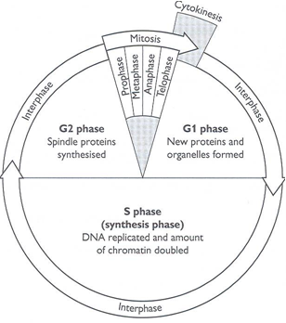4 attach to individual spindle fibres;

5 spindle fibres contract / centromeres divide / repel;

6 (sister) chromatids/chromosomes (separate)   
move to opposite poles/ends of the spindle;

7 each pole/end receives all genetic information/  
identical copies of each chromosome;

8 nuclear envelope forms around each group of chromosomes/ chromatids/at each pole

**Describe what happens to the chromosomes during each of the following stages of mitosis. Prophase, Metaphase, Anaphase, Telophase.**

prophase – coil up/spiralise/condense;  
(*allow shorter/contract/become visible*)metaphase – move to equator or centre of cell / attach to spindle;  
(*reject if reference to pairing*)anaphase – chromatids separate/centromeres divide;  
(*reject chromosomes move to poles without further explanation*)telophase – uncoil; (*allow lengthen/becomes less visible*)

**Describe two events which occur during interphase.**

Increased in volume of cell / amount of cytoplasm / increase in mass /cell bigger;  
Increase in number of organelles;  
Protein synthesis / specific example;  
DNA replication / chromosomes become chromatids / chromosomes copy;  
**I** references to G1, G2 and S phases)

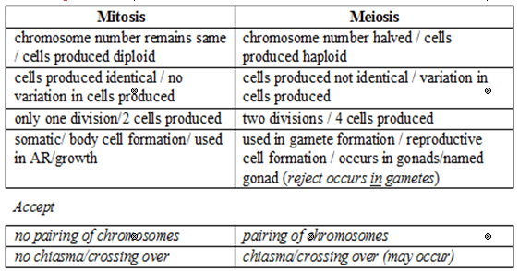Increase in volume of cell/volume of cytoplasm / increase in mass / cell bigger; increase in number of organelles;  
synthesis of protein/named protein;  
DNA replication/increase / chromosomes copied;  
ATP synthesis / respiration;

**Comparing mitosis and meiosis**

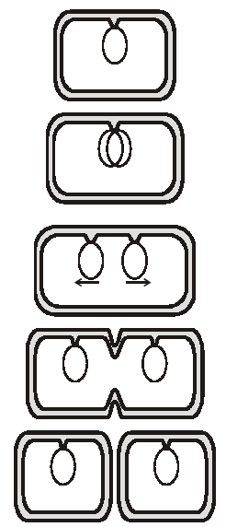

Bacteria always reproduce asexually, using binary fission ("splitting in two").

**1** The DNA in a bacterium is always circular (or rather a closed loop), and is often attached to an invagination of the cell membrane.

**2** Before cell division the DNA is replicated. Unlike eukaryotic cells, there are no histone proteins, and the DNA is not coiled into chromosomes.

**3** The cell elongates from the middle, separating the two DNA molecules, which are attached to different parts of the membrane.

**4** A new cell wall, or septum, is formed down the middle of the elongated cell.

**5** Eventually the septum meets, dividing the cell in two.

Although this looks a bit like mitosis in eukaryotic cells, it isn't. There is no nucleus, no chromatids, no centrioles and no spindle. Binary fission is very fast and bacteria can double every 10 min under optimum conditions, though the doubling time is usually slower.

**Bacterial Spores**

Many bacteria can produce spores. These are specialised dormant cells formed in response to adverse conditions, and they can survive long periods of high temperatures (even boiling), desiccation, low nutrients, radiation and chemicals. When conditions return to normal the spores "germinate" and develop into normal cells. Although spores are a little like plant seed they are not used for reproduction. Because they are so difficult to kill, spores can cause problems for sterilisation.

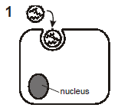

Viruses can only reproduce inside host cells. The general strategy is to use the host cell enzymes to replicate and translate viral DNA, making more virus particles, which then burst out of the cell.

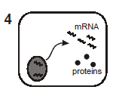

The virus attaches to the host cell membrane, which stimulates endocytosis.

The mRNA is now used to synthesise more viral

RNA and capsid proteins.

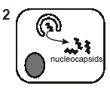

The RNA and proteins are assembled into new

virus particles (without envelopes). The glycoproteins

migrate to the cell membrane.

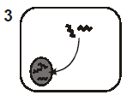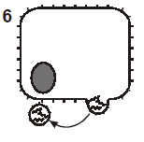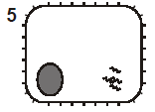

The RNA enters the nucleus, where it is

replicated to form mRNA, using the viral

RNA polymerase enzyme.

The virus particles are released by exocytosis,

collecting the lipid envelope from the cell membrane. This kills the host cell

The viral envelope fuses with the vesicle membrane, releasing the nucleocapsid into the cytoplasm.

**Membranes and movement**

**Suggest why the model of the membrane is described as a *fluid mosaic*.**

Molecules within the membrane able to move;  
mixture of phospholipid and protein / arrangement of protein;

**Describe the structure of a phospholipid molecule and explain how phospholipids are arranged in a plasma membrane.**

1 Phosholipid consists of glycerol;  
2 (To which are joined) two fatty acids;  
3 And phosphate;  
4 By condensation/elimination of water molecules;  
5 Arranged as bilayer in membrane;  
6 Head/phosphate hydrophilic/polar and tail/fatty acid   
 hydrophobic/non-polar;  
7 Heads outside and tails attracted to each other/inside;

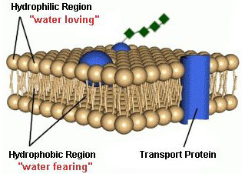**Describe the structure of a cell membrane. (5)**

Double layer of phospholipid molecules;  
Detail of arrangement of phospholipids;  
Intrinsic proteins/protein molecules passing right through;  
Some with channels/pores;  
Extrinsic proteins/proteins only in one layer/on surface;  
Molecules can move in membrane/dynamic/membrane contains  
cholesterol;  
Glycocalyx/carbohydrates attached to lipids/proteins;

**Describe the part played by cell surface membranes in regulating the movement of substances into and out of cells. (6)**

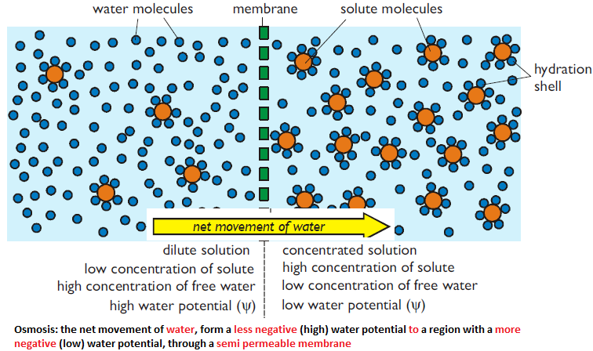Non-polar/lipid soluble molecules move through phospholipid layer/bilayer;  
Small molecules/water/gases move through phospholipid layer/bilayer;  
Ions/water soluble substances move through channels in proteins;  
Some proteins are gated;  
Reference to diffusion;  
Carriers identified as proteins;  
Carriers associated with facilitated diffusion;  
Carriers associated with active transport/transport with ATP/pumps;  
Different cells have different proteins;  
Correct reference to cytosis;

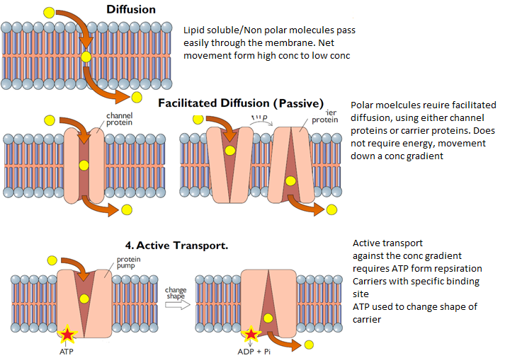

**Explain how three features of a plasma membrane adapt it for its functions.**

1. Phospholipid bilayer (as a barrier);

2. Forms a barrier to water soluble / charged substances / allows non-polar substances to pass

OR

Maintains a different environment on each side / compartmentalisation;

3. Bilayer is fluid;

4. Can bend to take up different shapes for phagocytosis / form vesicles / self-repair;

5. Channel proteins (through the bilayer)/intrinsic protein;

6. Let water soluble/charged substances through / facilitated diffusion;

7. Carrier proteins (through the bilayer);

8. Allow facilitated diffusion / active transport;

9 surface proteins / extrinsic proteins, glycoproteins / glycolipids;

10 cell recognition / act as antigens / receptors;

11cholesterol;

12 regulate fluidity / increases stability;

**Describe how the distribution of cell membranes in a prokaryotic cell such as a bacterium differs from that in a cell from a plant leaf. (4)**

Absence of nuclear envelope/membrane;  
Membrane bounded organelles;  
Such as mitochondria/chloroplast/vacuole/lysosome;  
and membrane systems/endoplasmic reticulum/Golgi;  
Mesosomes in prokaryotes;

Immunity

**Phagocytes and lysosomes are involved in destroying microorganisms. Describe how.**

Phagocytes engulf pathogens/microorganisms;

Enclosed in a vacuole / vesicle/ phagosome;

Fuses with lysomsome to for a phagolysosome

Lysosomes have enzymes;

That digest/hydrolyse molecules/proteins/lipids/microorganism;

**What is an *antigen*?**

Molecule/part of molecule/protein/glycoprotein;  
Stimulates immune response;

**What is an antibody?(2)**

Protein/immunoglobulin;  
specific to antigen;  
idea of “fit’/complementary shape;

**Antibodies are protein molecules. Explain why protein molecules are particularly well suited to carry out the role of antibodies.**

Large variety of different molecules;  
range of shapes;

Tertiary shape;  
locks onto / complements specific antigen;

**Vaccines protect people against disease. Explain how.(5)**

1. Vaccines contain antigens / antigens are injected;

2. Dead pathogens / weakened pathogens;

3. Memory cells made;

4. On second exposure memory cells produce antibodies / become active / recognise pathogens;

5. Rapidly produce antibodies / produces more antibodies;

6. Antibodies destroy pathogens;

7. Herd effect / fewer people to pass on disease;

**What is vaccination?**

Injection of antigens/toxoids;

(Antigen from) attenuated microorganism/non-virulent microorganisms/dead

Microorganisms/isolated from microorganism;

Stimulates the formation of memory cells;

**Give two other methods used to prepare vaccines.**

Killed microorganism;  
modified toxin;  
attenuated/heat treated/UV treated microorganism;  
genetically engineered antigens;  
isolated antigen;

**Vaccines protect against disease by stimulating the production of memory cells. Describe how memory cells protect the body from disease.**

On further exposure to same microorganism;  
Antigen recognised;  
Faster response;  
Greater production of antibodies;

**What is a *monoclonal* antibody? (2)**

Reference to hybrid cell from tumour / cancer and  
B-lymphocyte/hybridoma;  
antibodies all the same / from one type of plasma cell;  
specific to / complementary to / fits only one antigen

**Immunisation programmes may use either attenuated or dead microorganisms. Suggest why there might be problems for the patient when using these vaccines**.

Process of killing organisms might not be 100% efficient;  
live organisms might give rise to full-blown disease;  
attenuated organisms are non-virulent;  
but might mutate to virulent forms;  
immunity can decline - booster injections required;  
named side effects, eg allergies;  
less effective due to changed antigens;

**Suggest two reasons why parents may decide against vaccination for their children.**

consider vaccines to be unsafe / have side effects / damage immune system;  
consider natural immunity to be more effective; allow in (a) if not here  
religious / ethical objections **qualified** e.g. objections to use of fetal /  
animal tissue;  
consider low risk of disease when high percentage of population already  
vaccinated/Ref. to ‘Head Effect’

**Explain how the defence mechanisms of the body reduce the chance of entry by a pathogen.**

Epidermis of skin is dead / keratinised so pathogens cannot penetrate;  
mucus in respiratory system is trapping sticky pathogens;  
cilia move fluid / mucus removing pathogens;  
tears / saliva / mucus contain lysozyme breaking down bacterial cell wall;  
stomach contains hydrochloric acid which destroys bacteria;  
blood clot prevents entry;  
fluid nature of tears wash away bacteria;  
vaginal acid destroys bacteria;  
commensal bacteria on skin compete with pathogen;  
sebum (fatty acid) inhibits bacterial growth;

**Explain how the body responds both generally and specifically to pathogens that enter the blood.**

action of phagocytes;  
Interferon production;  
body temperature increased;  
ref to B or T lymphocytes;  
activated by non-self-antigen;  
either clone / divide by mitosis;  
T helper cells role;  
B plasma cells produced;  
which produces antibodies;  
any specific effect (e.g. immobilise /agglutinate / lysis /coat for recognition /  
neutralise toxins);  
T killer / cytotoxic cell;  
perform produced;  
memory cell produced;

**Explain the role of B-lymphocytes and T-lymphocytes in the defence of the body against a virus infection.**

B lymphocytes produce antibodies/involved in humoral response;  
T lymphocytes involved in cell mediated immunity;  
Macrophages present antigens;  
(specific) B lymphocytes recognise/bind to antigen;  
increase in numbers by mitosis;  
produce plasma cells (which make antibodies);  
antibodies bind to and clump/ agglutinate virus;  
memory cells produced by 1st exposure/cloned on 2nd exposure;  
T lymphocytes(helpers) produce lymphokines/chemicals;  
which aid B lymphocyte cloning;  
encourages phagocytes to engulf clumped virus;  
killer T cells kill virus infected cells;

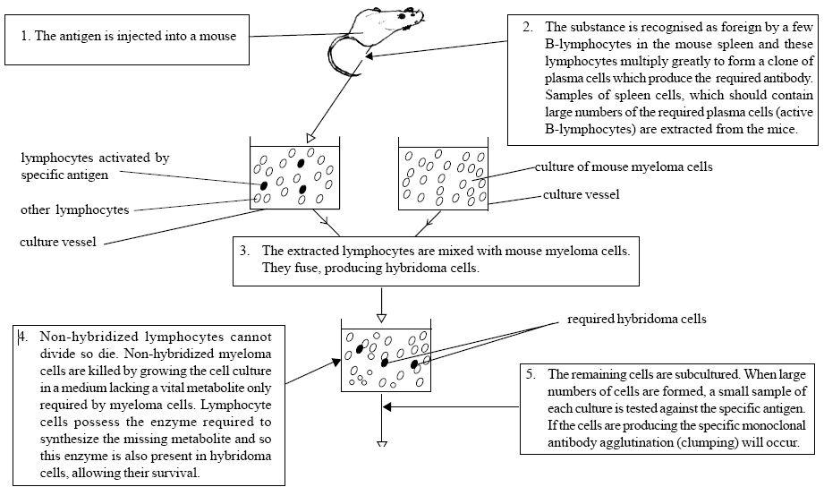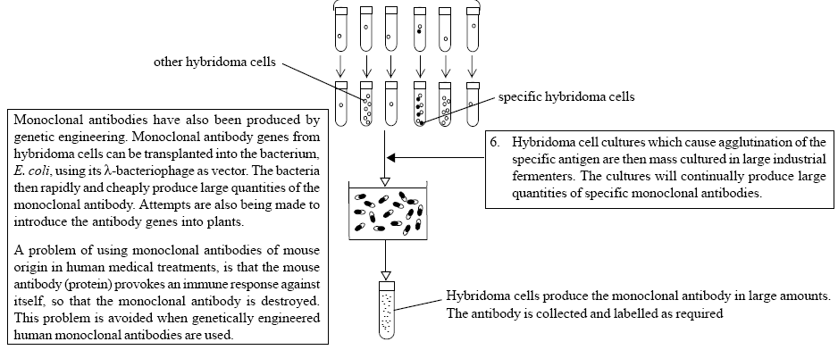

**Monoclonal Antibodies**

The unique tertiary structure of each antibody protein allows it to bind specifically and tightly to one particular antigen. Scientists quickly realised that the remarkable specific binding property of antibody proteins in vivo would make them very useful tools in medicine and research in vitro. [In vivo means “in life”, i.e. in a living organism; and in vitro means “in glass”, i.e. in a test tube.] Monoclonal antibodies are antibodies of one particular shape made by a clone of a single B-lymphocyte.

**Making Monoclonal Antibodies**

Antibody proteins are far too complicated to be synthesised chemically in vitro: they have to be made by living cells. In 1975 Kohler and Milstein developed a method to make monoclonal antibody proteins using mice.

1. Inject a mouse with the antigen protein that you want antibodies for. The mouse will show a primary immune response and make a clone army of B-lymphocytes with antibodies specific for that antigen.

2. After a few days, extract B-lymphocyte cells from the rabbit’s blood. The blood contains a mixture of thousands of different B-cells, each making their own specific antibodies, so we need to isolate the B-cell we want. Dilute the blood cells into hundreds of wells in an immunoassay plate, so that there is just one cell per well. The cells multiply in their wells and secrete antibodies – a different antibody in each well.

3. Test each well for production of the antibody required and row the B-cells from that well in a culture flask, where they multiply by mitosis, making millions of identical cloned cells, each secreting identical antibodies – monoclonal antibodies.

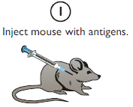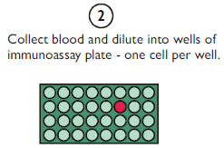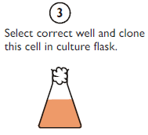

**Using Monoclonal Antibodies**

Monoclonal antibodies have many uses, but they are all based on the same principle. If monoclonal antibodies are mixed with a sample containing a mixture of proteins, the antibodies will bind specifically and tightly to only one protein in the sample.

The monoclonal antibodies can have another molecule chemically attached to the constant region, which can make the antibody coloured, or fluorescent, or attach it to a surface. This allows the target protein to be visualised.

Some uses of monoclonal antibodies include:

• Antibodies can be used as a “magic bullet” to target drugs to one specific cell type in the body. Monoclonal antibodies are made to an antigen only found on the target cell, and the drug is bound to the constant region of the antibody. The antibody/drug complex is then be injected into the patient and the antibody will ensure that the agent is carried only to the target cells and nowhere else.

• Antibodies can be made to target a toxic agent (e.g. a radioactive substance) to cancer cells and nowhere else in the body.

• Antibodies to the protein hormone hCG, produced in pregnancy, are bound to a test strip and used to detect the presence of hCG in urine in a pregnancy test strip.

• Antibodies are used to detect the presence of specific proteins in very low concentrations in the ELISA assay.

• Fluorescent antibodies are used to stain particular cell organelles in microscope slides.

• Antibodies can be used directly in passive immunity to help the body's normal immune response to a serious infection

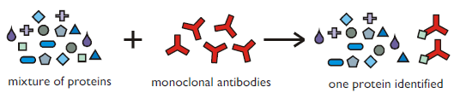

**What is a monoclonal antibody**

A hybrid cell from tumour (cancerous, myeloma) and B-lymphocyte called a hybridoma it produces the same antibodies as it is derived from one type of plasma cell;  
this means the antibodies are specific (complementary) to fits only one antigen

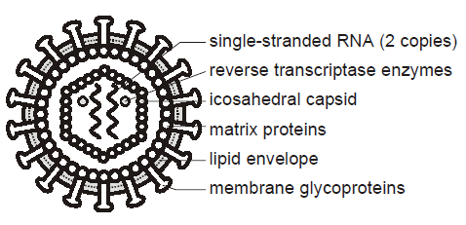

HIV (human immunodeficiency virus)

AIDS (Acquired Immune deficiency syndrome)

The human immunodeficiency virus (HIV) is a lipid membrane enveloped retrovirus. The membrane not made by the virus itself, but derived from a host cell membrane.

It comprises 2 copies of single-stranded RNA together with some enzymes, surrounded by an icosahedral capsid, which is in turn surrounded by a sphere of matrix proteins attached to a lipid envelope.

A retrovirus is one that contains single stranded RNA and the enzyme reverse transcriptase

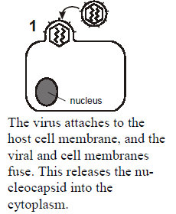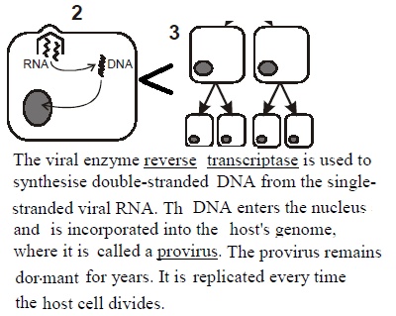

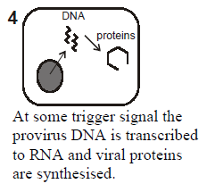

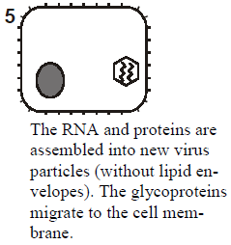

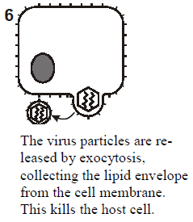

**Transmission Through infected semen or vaginal** secretions during sexual activity, or through infected blood in transfusions or contaminated needles. Infected mothers can also pass the virus on to their children through the placenta or milk. Before 1985 many hospital patients, especially haemophiliacs, became infected through blood transfusions, but since 1985 all blood donations in the UK are tested for HIV. Many drug addicts have been infected through sharing needles. By far the most important method of transmission of HIV world-wide is unprotected sexual intercourse. HIV cannot survive in air and therefore cannot be transmitted by skin contact or kissing.

**Infection mechanism**

HIV in the blood attaches to cells that carry the "CD4" antigen, including the T lymphocyte and macrophage white blood cells. After entering these cells it becomes a provirus in the nuclear DNA, remaining dormant but being replicated for a long latency period of 8-10 years. Eventually the virus particles are re-assembled and emerge into the blood, rupturing and killing the T cells in the process. The lack of T cells leaves the immune system severely compromised.

It targets TH cells as they are the cells with the complimentary receptor and the destruction of these cells means that the B and T cells cannot be activated to mount an immune response

**Signs and Symptoms**

Like other retroviruses, HIV has a long latency of 8-10 years, during which time there are no symptoms, but the individual is infectious. After this period the person starts to shows mild symptoms of the AID-related complex (ARC), such as tiredness, fever, weight loss and diarrhoea. This is followed by the more serious symptoms of full-blown AIDS. Since the immune system no longer functions the patient has no defence against a variety of opportunistic infections. The most common of these are Kaposi's sarcoma (a skin cancer), TB and pneumonia, which is usually fatal.

HIV does not become AIDS immediately; time between HIV positive and AIDs varies. (depending on things like age and access to healthcare and the strain of the virus). A person has ‘AIDs’ when symptoms of the immune system failure begin. Initially affecting the mucus membranes, progression to TB, Chronic diarrhoea and bacterial infections and culminating in more serious

**Treatment There is as yet no cure or vaccination for AIDS, though drugs like AZT can delay its onset for many years.**

Prevention Vaccinations are difficult because the HIV genome is highly variable (probably because reverse transcriptase makes many base copying errors). Prevention of AIDS has concentrated on "safe sex" education (using condoms and reducing promiscuity), not sharing needles, and screening blood transfusions.

**Infection mechanism:**

Attaches to host cell, releases the capsid into the cell which includes RNA and enzymes. Reverse transcriptase converts RNA to cDNA and then the double stranded DNA is inserted into the human DNA. Host cells will manufacture viral proteins and new viruses are assembled and eventually bud from the cell.

**Antibiotics kill bacteria by interfering with metabolic processes.** Viruses are acellular, do not have their own metabolic processes and organelles and make use of human enzymes and ribosomes, thus antibiotics will not target them

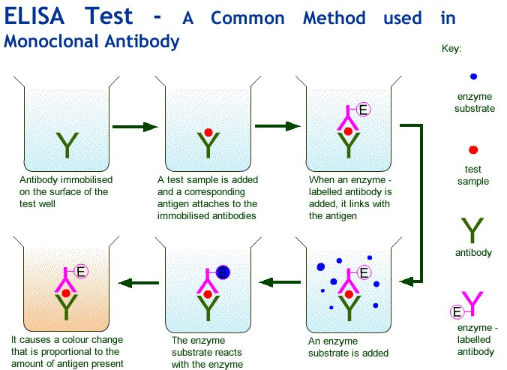

**ELISA (enzyme-linked immunosorbent assay)**

This technique is performed to detect the presence and/or amount of a target protein/antigen of interest. Or it can be used to detect if a person contains antibodies for a certain antigen.

This process can be used to detect for allergies or infection.

An antibody is used which has an enzyme attached to it; this will catalyse the conversion of a substrate to a coloured product. The intensity of the colour can be an indicator of the quantity of antigen/antibody

**Mechanism of the direct ELISA test**

Antibody is bound inside the tray (complementary to the antigen under investigation)

Blood sample is added that may or may not contain the antigen

A detection antibody is added that is (complementary to the antigen in question). This antibody contains an attached enzyme.

The tray is washed to remove any unbound antibodies and samples, particularly the antibody attached to the enzyme

If the antigen was present it will be bound to the immobilised antibody and the detection antibody will also bind to it.

Finally a substrate solution is added and any enzyme that has been bound will react with this producing a colour change and a positive result.

The antibodies are often generated using animals; clearly this raises some ethical issues.