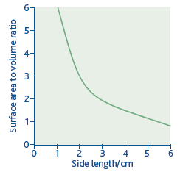**Surface area to volume ratio**

**Explain the link between the size of an organism and the way in which its cells are supplied with oxygen.(6)**

Small organisms have large surface/volume ratio;  
as, for example, single-celled organisms;  
diffusion/exchange over body surface/skin;  
(the need for) specialised respiratory/gas-exchange surfaces in larger animals;  
diffusion is a slow process;  
cells of larger organisms are a long way from gas exchange surface;  
must be supplied by transport system/circulatory system/blood;

**Many large animals have blood systems. Explain why these animals need blood systems to supply their cells with oxygen.**

Gas exchange surface long distance from (some) respiring tissues;  
Blood system allows rapid transport/faster supply;  
Diffusion is slow;

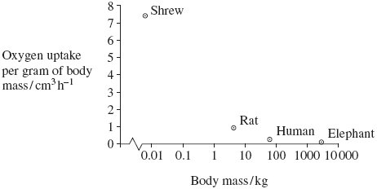

The graph shows there is a decrease in oxygen uptake with an increase in body mass

**Heat from respiration helps mammals to maintain a constant body temperature. Use this information to explain the relationship between body mass and oxygen uptake shown in the graph.**

Smaller animals have a large surface area to volume ratio

Lose more heat per gram of tissue

Respire faster to maintain body temperature

Oxygen demand increases

**Many of the mammals found in cold parts of Finland have a larger size and body mass than related species found in warmer regions. Explain the importance of this to their survival.(4)**

Large animals have small surface area to volume ratio;  
Large mammals are homoiothermic;  
Lose less heat to environment;  
By radiation/convection/conduction;  
Fat;  
For insulation;

Gas Exchange

**Describe and explain how the structure of the mammalian breathing system enables efficient uptake of oxygen into the blood.(6)**

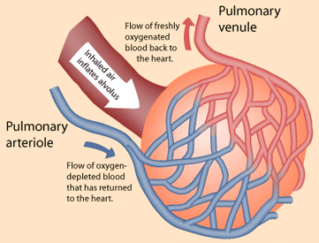1. Alveoli provide a large surface area;  
2. Walls of alveoli thin to provide a short diffusion pathway;  
3. Walls of capillary thin/close to alveoli provides  
 a short diffusion pathway;  
4. Walls (of capillaries/alveoli) have flattened cells;  
5. Cell membrane permeable to gases;  
6. Many blood capillaries provide a large surface area;  
7. Intercostal/chest muscles/diaphragm muscles / to ventilate lungs / maintain a diffusion/concentration gradient;  
8. Wide trachea / branching of bronchi/bronchioles for efficient flow of air;  
9. Cartilage rings keep airways open;

**Describe how muscles in the thorax (chest) cause air to enter the lungs during breathing.**

Diaphragm/intercostal muscles contract;  
Increases volume of thorax/chest/lungs;  
Negative/lower pressure in lungs;

**In normal breathing, describe the part played by the intercostal muscles**

Contract;  
ribs move upwards/out;  
increasing volume/decreasing pressure in chest/thorax/lungs

**Describe the difference in the composition of gases in inhaled and exhaled air. Explain how these differences are caused.**

1 inhaled air contains more oxygen than exhaled air;  
2 inhaled air contains less carbon dioxide than exhaled air;  
3 inhaled air contains less water (vapour);  
4 relative amount/percentage of nitrogen also changes;  
5 respiration results in lower blood oxygen / higher blood carbon dioxide;  
6 oxygen enters blood / carbon dioxide leaves blood in alveoli;  
7 by diffusion;  
8 water vapour diffuses from moist surface;

**Describe how the structure of the lungs and the red blood cells enable efficient diffusion and transport of oxygen.**

1 Large surface area produced by many alveoli;  
2 Single layer of epithelial cells / very thin epithelium / squamous / pavement;  
3 Capillary walls one cell thick;  
4 Giving short diffusion pathway;  
5 RBC thin / flattened / disc-shaped so large surface area;  
6 No nucleus / mitochondria;  
7 Haemoglobin for transport of oxygen;  
8 Red cell close to capillary wall;

**Pulmonary tuberculosis is a disease of the lungs. Describe the transmission and course of infection of pulmonary tuberculosis.**

1 (Bacteria transmitted in) droplets / aerosol;

2 (Bacteria) engulfed / ingested by phagocytes / macrophages;

3 (Bacteria) encased in named structure e.g. wall /

tubercle / granuloma / nodule;

4 (Bacteria) are dormant / not active / not replicating;

5 If immunosuppressed, bacteria activate / replicate / released;

6 Bacteria destroy alveoli / capillary / epithelial cells;

7 (Leads to) fibrosis / scar tissue / cavities /calcification;

8 (Damage) leads to less diffusion /less surface area / increases diffusion distance;

9 (Activation / damage allows bacteria) to enter blood / spreads (to other organs);

**Emphysema is another disease of the lungs. People with emphysema may feel weak and tired. Explain why.**

1 Alveoli break down / collapse / rupture / walls thicken;

2 Less surface area / increases diffusion distance / less diffusion;

3 Loss of elastin / elastic tissue / elastase involved;

4 (Alveoli / lungs) cannot recoil / spring back / have reduced elasticity / more difficult to expel air;

5 Reduced diffusion gradient / air not replenished / less air leaves lungs;

6 Less oxygen enters blood / tissues;

7 Less respiration / less energy released / less ATP produced;

**Pulmonary fibrosis**: when scars form on the epithelia that are damaged, increasing the diffusion pathway, loss of elasticity in lung tissue, which reduces the concentration gradient, narrowing of vessels, reducing air flow and concentration gradient. Results in shortness of breath, dry cough, tiredness (insufficient oxygen for respiration)

**Asthma** is caused by physical factors called allergens in the environment. These allergens include pollen, dust mites faeces and fur.

These allergens trigger an inflammatory response by the immune system.

White blood cells called mast cells release histamines, which cause the smooth circular muscles of the bronchioles to contract, narrowing the airways (bronchoconstriction).

The epithelial cells also secrete more mucus, which further blocks the airways.

The constricted bronchioles stimulate wheezing and coughing as the lungs try to loosen the mucus. The constrictions reduce the tidal volume, so alveolar air is only replaced slowly. The oxygen concentration gradient across the alveolar epithelium is reduced, so the rate of diffusion in the alveoli is reduced by Fick’s law. Less oxygen diffuses into the blood, so less oxygen is available for cellular respiration throughout the body.

**A fish uses its gills to absorb oxygen from water. Explain how the gills of a fish are adapted for efficient gas exchange.**

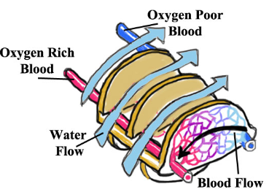1 Large surface area provided by lamellae/filaments;

2 Increases diffusion/makes diffusion efficient;

3 Thin epithelium/distance between water and blood;

4 Water and blood flow in opposite directions/countercurrent;

5 maintains concentration gradient (along gill)/equilibrium  
not reached;

*5 Not enough to say gives steep concentration gradient*

6 As water always next to blood with lower concentration of oxygen;

7 Circulation replaces blood saturated with oxygen;

8 Ventilation replaces water (as oxygen removed);

**Describe and explain how fish maintain a flow of water over their gills.**

1. mouth opens, operculum/opercular valve shuts;  
2. floor of mouth lowered;  
3. water enters due to decreased pressure / increased volume;  
4. mouth closes, operculum/opercular valve opens;  
5. floor raised results in increased pressure / decreased volume;  
6. high/increased pressure forces/pushes water over gills;

**Explain how the countercurrent principle helps fish to extract oxygen from water.**

Water flows in opposite direction to blood;  
across (gill) lamellae;  
so difference in concentration maintained;  
diffusion gradient maintained / diffusion over full length.

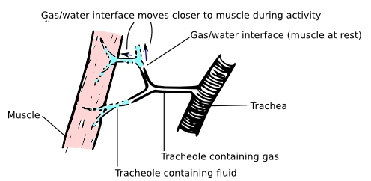**Insect have more than 1.5 million tracheoles. The distance between the ends of the tracheoles in the muscle is approximately 4 µm. Explain how these features allow efficient oxygen supply.**

Large number gives large (total) surface area;  
For diffusion;  
Short distance between tracheoles gives short pathway;  
Movement/diffusion through muscle is slow;

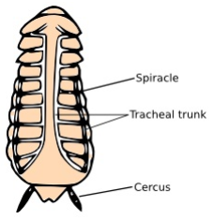

**An insect lives in air. Describe how the insect is able to obtain oxygen and limit water loss.**

1 Air enters through (open) spiracles;  
2 Through tracheae;  
3 Diffusion gradient in trachea  
4 Tracheae associated with all cells/closely associated with cells;  
5 Oxygen diffuses into cells;  
6 Ventilation replacing air in tracheae;  
7 Body covered with (waterproof) waxy layer/cuticle;  
8 Spiracles are able to close open in response to carbon dioxide at a critical level;

Fluid filled tracheoles allow some control over gas exchange. When the insect is at rest the fluid is in the tracheoles. This slows down the diffusion of oxygen to the muscles, this slows down respiration and thus the production of CO2. It means CO2 levels will rise slowly and limit the number of times the spiracles open, thus reducing water loss. When the insect starts to move, the muscles produce lactic acid, this lowers the water potential of the muscles, which draws the fluid out of the tracheoles (by osmosis) and now diffusion of oxygen will be faster through the air filled tracheoles.

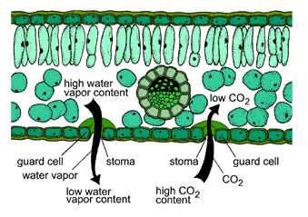**Describe how carbon dioxide in the air outside a leaf reaches mesophyll cells inside the leaf.**

1. (Carbon dioxide enters) via stomata;

2. (Stomata opened by) guard cells;

3. Diffuses through air spaces;

4. Down diffusion gradient;

Digetsion

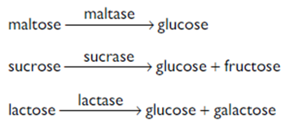

**Describe the role of the enzymes of the digestive system in the complete breakdown of starch.**

Amylase;(salivary/pancreatic)

(Starch) to maltose:

Maltase;(built into the membrane of the small intestine)

Maltose to glucose;

Hydrolysis;

(Of) glycosidic bond;

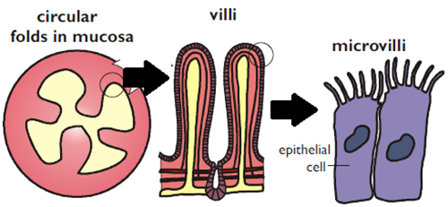**Explain how the small intestine is adapted to its function in the absorption of the products of digestion.**

Large surface area provided by villi / microvilli;  
long / folds increase surface area / time for absorption;  
thin epithelium;  
short diffusion pathway;  
capillary network absorbs amino acids / sugars;  
lacteal for absorption of digested fats;

Maintains a steep concentration gradient  
mitochondria supply ATP / energy for active transport;  
carrier proteins (in membranes);

**Protein digestion**

**Begins in the stomach**

**Pepsin** an **endopeptidases** hydrolyses peptide bonds within the polypeptide chain, breaking it into smaller chains (6-12 amino acids long), forms many ends 9starting points) for other proteases, exopeptidases.

Pepsin has an optimum pH around pH2-3

Pancreas produces other endopeptidases which continue protein digestion in the duodenum. Different endopeptidases have different peptide bonds that they target and so all proteins are hydrolysed to shorter chains. Different enzymes have different tertiary structures, and thus different active sites, and so bind with different substrates, the amino acids have different shapes due to the R groups

Exopeptidases in the small intestine hydrolyse the terminal peptide bonds releasing amino acids. There are aminopeptidases working from the N terminal end, and carboxypeptidases working from the C terminal end. Dipeptidases cut the dipeptides in half.

Exopeptidases and endopeptidases are can be bound to the membranes of the microvilli

endopeptidase exopeptidase

Protein 🡪 smaller polypeptides 🡪 amino acid

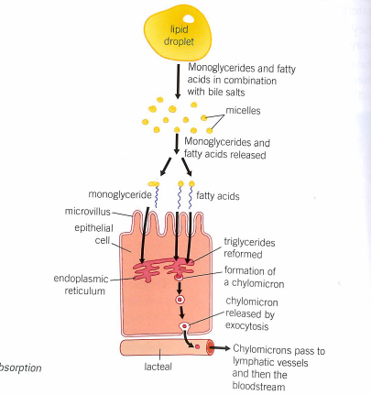

**Digestion and absorption of fats**

1Bile emulsifies triglycerides to smaller droplets;

2 provide large surface area for faster digestion;

3 Lipase (hydrolyses the ester bonds in triglycerides);

4 producing fatty acids and glycerol (monoglycerides)

5 Fatty acids and glycerol are; lipid soluble and pass through the membrane by simple diffusion

7 once inside the epithelial cells these components are recombined into triglycerides (at the SER)

8 Chylomicrons formed where the lipid is coated by proteins (occurs at the Golgi);

9 these then leave the epithelial cell (by exocytosis) and move into the lacteals

**Absorption of amino acids and monosaccharides.**

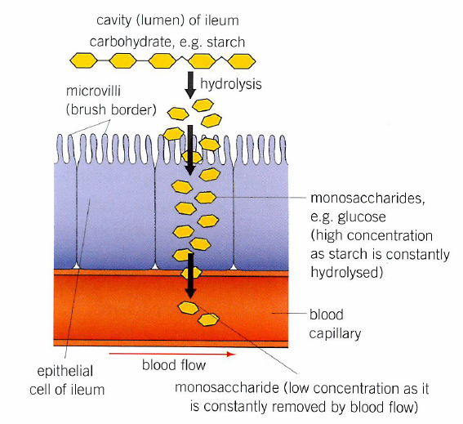

Absorption of monosaccharides by diffusion Co-transport of a glucose molecule

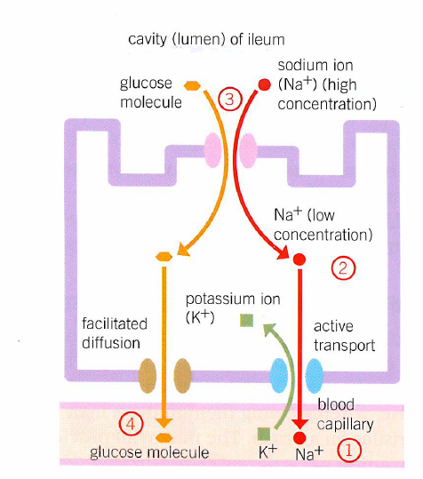

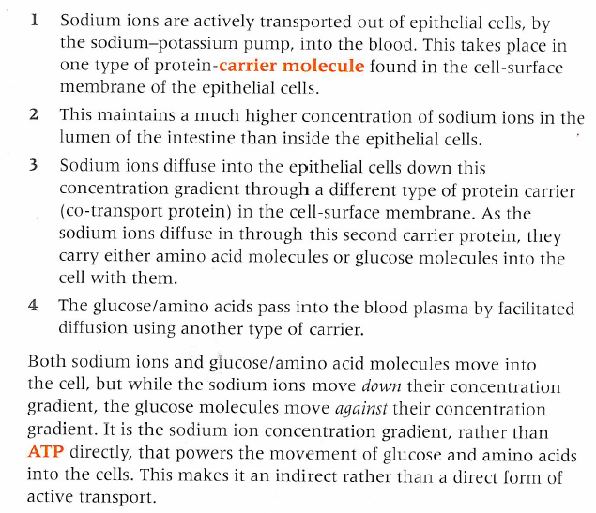

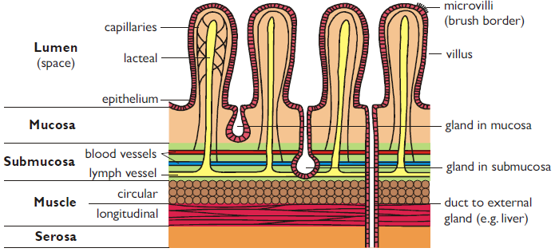

1. Mouth (Buccal cavity). The teeth and tongue physically break up the food into small pieces with a larger surface area, and form it into a ball or bolus. The salivary glands secrete saliva, which contains water to dissolve soluble substances, mucus for lubrication, lysozymes to kill bacteria and salivary amylase to digest starch. The food bolus is swallowed by an involuntary reflex action through the pharynx (the back of the mouth). During swallowing the trachea is blocked off by the epiglottis to stop food entering the lungs.

2. Oesophagus (gullet). This is a simple tube through the thorax, which connects the mouth to the rest of the gut. No digestion takes place here. There is a epithelium, no villi, a few glands secreting mucus, and a thick layer of circular and longitudinal muscle to propel the food by peristalsis. Peristalsis is a wave of circular muscle contraction, which passes down the gut and is completely involuntary. The oesophagus is a soft tube that can be closed, unlike the trachea, which is a hard tube, held open by rings of cartilage.

The mucosa, which secretes digestive juices and absorbs digested food. It is often folded to increase its surface area. There is a layer of columnar epithelial cells lining the mucosa. These epithelial cells contain microvilli, membrane proteins for facilitated diffusion and active transport, mitochondria, and membrane-bound enzymes. Epithelial cells are constantly worn away by friction with food moving through the gut, so are constantly being replaced.

• The submucosa, which contains blood vessels, lymph vessels and nerves to control the muscles. It may also contain secretory glands.

• The muscle layer, which is made of smooth muscle, under involuntary control. It can be subdivided into circular muscle (which squeezes the gut when it contracts) and longitudinal muscle (which shortens the gut when it contracts). These two muscles therefore have opposite effects and so are antagonistic. The combination of these two muscles allows food to be pushed along the gut by peristalsis.

• The serosa, which is a thin, tough layer of connective tissue that holds the gut together, and attaches it to the abdomen.

3. Stomach. This is an expandable bag where the food is stored for up to a few hours. There are three layers of muscle to churn the food into a liquid called chyme. This chime is gradually released in to the small intestine by a sphincter, a region of thick circular muscle that acts as a valve. The mucosa of the stomach wall has no villi, but does have numerous gastric pits (104 cm-2) leading to gastric glands in the mucosa layer. These glands secrete gastric juice, which contains: hydrochloric acid (pH 1) to kill bacteria (the acid does not help digestion, in fact it hinders it by denaturing most enzymes); mucus to lubricate the food and to line the epithelium to protect it from the acid; and some protease enzymes. No other digestion takes place in the stomach.

4. Small Intestine. The first 30cm of the small intestine is called the duodenum. Although this is short, almost all the digestion takes place here, due to two secretions: pancreatic juice and bile. Pancreatic juice is secreted by the pancreas into the duodenum through the pancreatic duct. Pancreatic juice contains numerous amylase, protease and lipase enzymes. Bile is secreted by the liver, stored in the gall bladder, and released into the duodenum through the bile duct. Bile doesn’t contain any enzymes, but it does contain bile salts to aid lipid digestion, and the alkali sodium hydrogen carbonate to neutralise the stomach acid. This alkali gives chyme in the duodenum a pH of around 7.5, so the pancreatic enzymes can work at their optimum pH. The mucosa of the duodenum has few villi, since there is no absorption, but the submucosa contains glands secreting mucus and sodium hydrogen carbonate. The rest of the small intestine is called the Ileum. This is the site of final digestion and absorption. To maximise the rate of absorption the ileum has the three features dictated by Fick’s law: large surface area, short diffusion distance and a steep cponcentrtain gradient sustained by movement of fluids on both sides of exchange surface (see sheet above for detail).

5. Large Intestine. The large intestine comprises the caecum, appendix, colon and rectum. Food can

spend 36 hours in the large intestine, while water is absorbed to form semi-solid faeces. The mucosa contains villi but no microvilli, and there are numerous glands secreting mucus. Faeces is made up of plant fibre (cellulose mainly), cholesterol, bile, mucus, mucosa cells (250 g of cells are lost each day), bacteria and water, and is released by the anal sphincter. This is a rare example of an involuntary muscle that we can learn to control (during potty training).

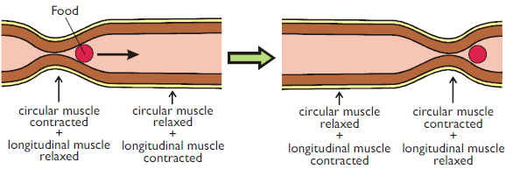

**Haemoglobin**

**Describe how haemoglobin normally loads oxygen in the lungs and unloads it in a tissue cell.**

Oxygen combines (reversibly) to produce oxyhaemoglobin;  
each haemoglobin molecule/ one haemoglobin may transport 4molecules of oxygen;  
high partial pressure of oxygen / oxygen tension / concentration in lungs;  
haemoglobin (almost) 95%/ 100% saturated;  
unloads at low oxygen tension(in tissues);  
presence of carbon dioxide displaces curve further to right / increases oxygen  
dissociation;  
allows more O2 to be unloaded;  
increase temp/ acidity allows more O2 to be unloaded;  
low pO2 / increase CO2 / increase term / increase acid occur in vicinity of  
respiring tissue;

**Describe how haemoglobin is involved in absorbing oxygen in the lungs and transporting it to respiring tissues**.

1. Diffusion of oxygen into red cell / haemoglobin in red cells;  
2. High affinity of haemoglobin in high oxygen concentration;  
3. (Therefore) loads / becomes saturated in lungs / where oxygen abundant;  
4. oxyhaemoglobin formed;  
5. Reference to role of haem e.g. energy changes /role of Fe2+ ions /Hb molecule combines with fewer oxygen molecules;  
6. Unloads / low affinity in low concentration;  
7. Explanation in terms of dissociation curve i.e. small changes in concentration gives large changes in saturation;  
8. Respiration in tissues gives high CO2 concentration / high temperature / high H+ concentration / low pH  
9. Dissociation curve shifts to right / oxyhaemoglobin dissociation at higher partial pressure

**The blood leaving a muscle has a lower pH than the blood entering it. During vigorous exercise, the fall in pH is even greater. Explain what causes this greater fall in pH.**

(in exercise) - faster respiration rate;  
more CO2 production;  
CO2 is acidic / forms carbonic acid;  
lactic acid production;  
release of H+ ions;

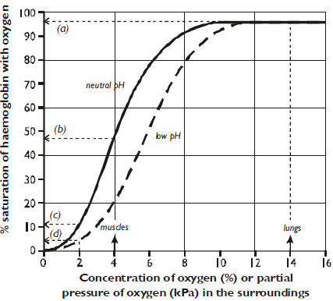

**During exercise, the rate of respiration of muscle cells increases. Explain what causes human haemoglobin to unload more oxygen to these cells.**

Partial pressure on oxygen in muscle falls more;  
high / more carbon dioxide produced;  
lowers PH;  
increase in temperature;  
percentage saturation of Hb falls / lowers affinity /  
increase dissociation;  
displaces curve to right / results in Bohr shift;

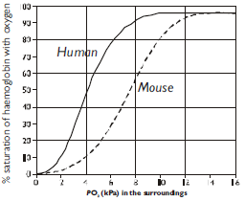

**There is an advantage to the shrew in having haemoglobin with a dissociation curve shifted to the right. Explain this advantage.**

(at the tissues at low pp oxygen) the shrew’s haemoglobin is less  
saturated with oxygen / has reduced affinity;  
oxyhaemoglobin dissociates more readily / haemoglobin releases  
oxygen more readily / more oxygen released;  
allowing greater demand / respiration rate;

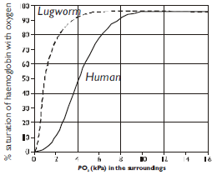

**Suggest the advantage to a ground squirrel of having haemoglobin that has an oxygen dissociation curve to the left of the curve for human haemoglobin.**

In ground squirrel lower partial pressure of oxygen in lungs;  
Haemoglobin can be saturated/load more oxygen;  
at lower partial pressure of oxygen;

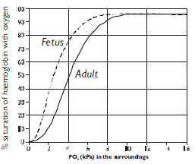

**Explain how the foetal haemoglobin makes it possible for the foetus to take oxygen from the mother’s blood.**

Foetal haemoglobin has greater affinity for/binds more readily to oxygen;  
at same ppO2/concentration of oxygen, foetal has higher saturation;  
correct use of figures from graph (% and pp);  
maintains diffusion gradient across placenta.

**The Blood Vessels**

**Names are require only of the coronary arteries, blood vessels entering an leaving the heart, liver and kidneys**

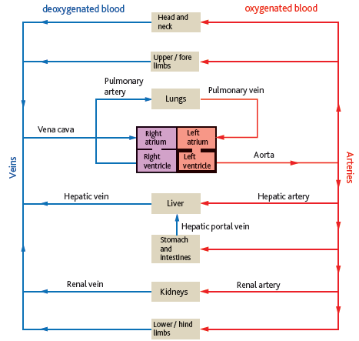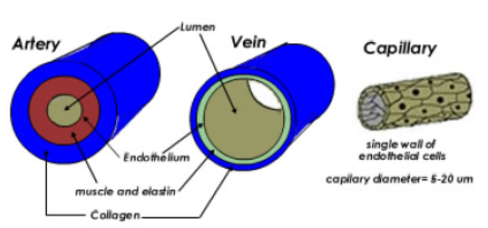

**Artery (away from the heart)**

Thickest wall, enabling it to carry blood at high pressure / withstand  
pressure surges;  
 most elastic tissue, which smoothes out flow / maintains pressure;  
 most muscle which maintains pressure;  
muscle in wall to control blood flow;

Endothelium that reduces friction;

**Vein (into the heart)**

Thin wall does not have to withstand high pressure; so they have less elastic tissue and muscle tissue, but have a larger lumen to reduce friction as blood is under lower pressure

Presence of valves to reduce back flow

Blood flow is a result of muscle contraction, squeezing it along vessels

Endothelium that reduces friction;

**Capillary**

Thin wall, allowing diffusion/exchange;  
only endothelium present, allowing short diffusion pathway;

Fenestrations to allow materials to be exchange

Narrow lumen slows down red blood cells and

Presses them against the walls of the capillary allowing more time and increasing the surface area for exchange

Endothelium that reduces friction;

**The structure of arteries, veins and capillaries in relation to their function**

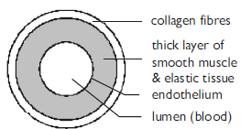**Arteries and arterioles take blood away from the heart. Explain how the structures of the walls of arteries and arterioles are related to their**

**f**unctions.

Elastic tissue

1 Elastic tissue stretches under pressure/when heart beats;

2 Recoils/springs back;

3 Evens out pressure/flow;

Muscle

4 Muscle contracts;

5 Reduces diameter of lumen/vasoconstriction/constricts vessel;

6 Changes flow/pressure;

Epithelium

Artery 🡪 arterioles: elastic fibres decrease and muscle fibres increase.

7 Epithelium smooth;

8 Reduces friction/blood clots/less resistance;

**The thickness of the aorta wall changes all the time during each cardiac cycle. Explain why.**

1. (Aorta wall) stretches;

2. Because ventricle/heart contracts / systole / pressure increases;

3. (Aorta wall) recoils;

4. Because ventricle relaxes / heart relaxes /diastole / pressure falls;

5. Maintain smooth flow / pressure

**Explain the difference in thickness between the pulmonary artery (thicker) and the pulmonary vein (thinner).**

High pressure / smooth out blood flow / artery wall contains more collagen / muscle / elastic (fibres) / connective tissue;

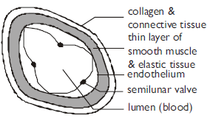**Describe two ways by which blood flow in the veins is maintained.**

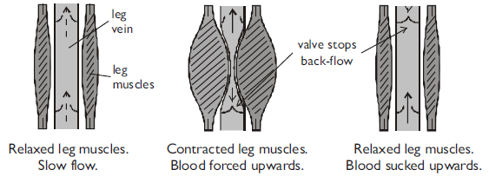Valves prevent backflow;  
effect of (skeletal) muscle contraction

Residual blood pressure from heart;  
negative pressure from thorax;  
‘suction effect’ from heart;

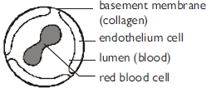

**Describe and explain ways in which a capillary adapts for exchange**

1. Permeable capillary wall/membrane;  
2. Single cell thick/thin walls, reduces diffusion distance;  
3. Flattened (endothelial) cells, reduces diffusion distance;  
4. Fenestrations, allows large molecules through;   
5. Small diameter/ narrow, gives a large surface area to volume/ short diffusion distance;  
6. Narrow lumen, reduces flow rate giving more time for diffusion;  
7. Red blood cells in contact with wall/ pass singly, gives short diffusion distance / more time for diffusion;  
(*allow 1 mark for 2 features with no explanation*)

**Explain two ways in which the small diameter of the capillaries results in the efficient transfer of oxygen from the alveoli to the red blood cells.**

Red blood cells close to capillary wall/ thin capillary wall;  
Short diffusion path/ distance for oxygen to diffuse;  
Longer time for diffusion to take place/ diffusion is slow;

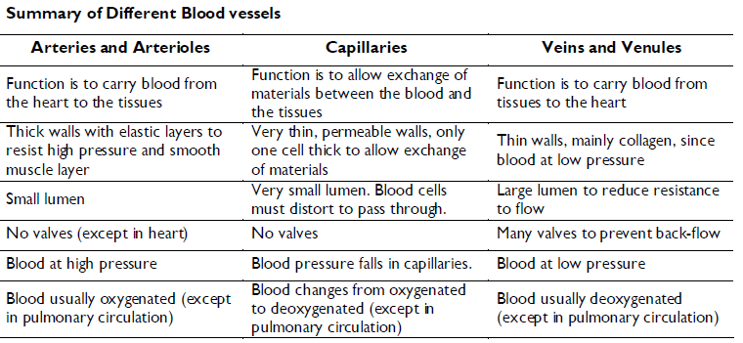

**Tissue Fluid Formation**

[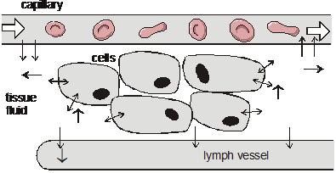](http://biogeo.in/wp-content/uploads/2013/09/blood1.png)

**Explain how tissue fluid is formed and how it may be returned to the circulatory system.**

1. (Hydrostatic) pressure of blood high at arterial end;  
2. Fluid/water/soluble molecules pass out (*reject plasma*);  
3. Proteins/large molecules remain;  
4. This lowers the water potential / water potential becomes more negative;  
5. Water moves back into venous end of capillary (*reject tissue fluid*);  
6. By osmosis / diffusion;   
7. Lymph system collects any excess tissue fluid;  
8. (Lymph) returns to blood / circulatory system / link with vena cava/returns tissue fluid to vein;

**Describe how tissue fluid is formed and how it is returned to the circulatory system.**

**Formation**

1. High blood / hydrostatic pressure / pressure filtration;

2. Forces water / fluid out;

3. Large proteins remain in capillary;

**Return**

4. Lower water potential in capillary / blood;

5. Due to (plasma) proteins;

6. Water enters capillary / blood;

7. (By) osmosis;

8. Correct reference to lymph collecting excess fluid returning blood to main circulation

**Describe the part played by proteins in the plasma in returning tissue fluid to the capillary.**

Produces lower water potential; Water moves into capillary; By osmosis/diffusion;

**Describe and explain one way in which the composition of tissue fluid differs from that of plasma.**

Contains little/no protein;

Molecules too large (to pass through capillary wall);

Contains less glucose;  
some will have entered tissue cells;

**The tissues of people who are starving often swell because of the accumulation of tissue fluid. Explain what causes this accumulation of tissue fluid.**

Starvation linked to low protein content of diet/Low protein concentration  
in plasma/blood;  
Water potential of blood higher/smaller water potential gradient;  
Tissue fluid formed faster than returned/less tissue fluid returned to blood;

**Histamine increases the permeability of capillary walls so that** large molecules can pass through. Explain how this change in permeability results in swelling round the bite.

Proteins can move into tissue fluid;  
Lowers water potential of tissue fluid;  
Increases tendency to draw water/fluid out/  
Reduces tendency to reabsorb water;

**Suggest an explanation for the link between high blood pressure and the accumulation of tissue fluid.**

High blood pressure increases rate of filtration / forces more fluid out;  
Lymph system cannot cope / higher pressure reduces reabsorption

**Heart and heart Disease**

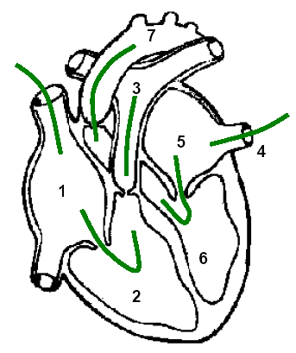

1) Right atria receiving deoxygenated blood from the vena cava

2) Right ventricle. Separated from the atria (1) by the tricuspid valve. This wall is thinner than the left ventricle as it pumps blood only to the lungs (pulmonary circulation)

3) Pulmonary artery, separated from the ventricle by the semi lunar valve carries blood to lungs.

4) Pulmonary vein, returning oxygenated blood to the heart. Now under much lower pressure as it has passed through capillaries in the lungs, so it needs re-pumped.

5) Left atrium.

6) Left ventricle. Separated from the atria (5) by the mitral/bicuspid valve. This has a thicker wall as it pumps blood a greater distance.

7) Aorta. Separated from ventricle by a semi lunar valve.

Atrioventricular valves (t**r**icuspid and bicuspid/mitral) are prevented from being turned inside out by TENDINOUS cords running from their underside to the PAPILLARY MUSCLES on the ventricle walls. This helps to increase the tension in the cords making them, resistant to back pressure. The atrioventricular valves ensure that as the ventricles contract the blood flows into the aorta and pulmonary artery only.



Curve x is the right ventricle, this is clear as the pattern is the same as that of the left ventricle, but the pressure is lower as a result of the smaller muscle content of the wall.

When the left ventricle pressure crosses the pressure line representing the aorta the blood flows through the semi-lunar valves. When ventricular pressure drops below the aorta pressure then the valves shut. This causes the second sound you can hear on a heart beat (dub).

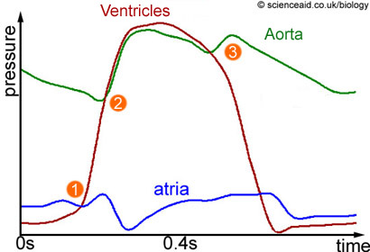

When atrial pressure is greater than ventricular pressure the atrioventricular valves are open

When ventricular pressure exceeds atrial pressure (1) then the atrioventricular valves close (tricuspid/bicuspid). The first heart sound Lub

When ventricular pressure exceeds arterial pressure (2) the semi lunar valves open

When ventricular pressure is less than arterial pressure (3) the semi lunar valves shut, this is the second sound of the heart beat (dup)

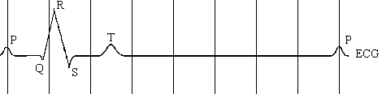

The QRS wave is associated with the spreading of electrical activity over the ventricles. This is evident as it occurs before the pressure in the ventricles begins to increase. Pressure increase in the ventricles is due to ventricular systole. **P** is the **wave** of depolarisation for atrial systole. **P🡪Q flat** line is the time

Delay for depolarisation to spread SAN 🡪 AVN 🡪 Ventricles. **T wave** ventricular repolarisation

**Explain how the heart muscle and the heart valves maintain a one-way flow of blood from the left atrium to the aorta.**

1. Atrium has higher pressure than ventricle (due to filling/contraction);

2. Atrioventricular valve opens;

3. Ventricle has higher pressure than atrium (due to filling/contraction);

4. Atrioventricular valve closes;

5. Ventricle has higher pressure than aorta;

6. Semilunar valve opens;

7. Higher pressure in aorta than ventricle (as heart relaxes);

8. Semilunar valve closes;

9. (Muscle/atrial/ventricular) contraction causes increase in pressure;

**Cardiac Output**

Cardiac Output is the amount of blood flowing through the heart each minute. It is calculated as the product of the heart rate and the stroke volume:

**Cardiac output = heart rate x stroke volume**

• The heart rate can be calculated from the pressure graph by measuring the time taken for one cardiac cycle and using the formula:

**Heart rate (beats per minute) =60 ÷cycle time (s)**

• The stroke volume is the volume of blood pumped in each beat.

Both the heart rate and the stroke volume can be varied by the body. When the body exercises the cardiac output can increase dramatically so that

• Oxygen and glucose can get to the muscles faster

• Carbon dioxide and lactate can be carried away from the muscles faster

• Heat can be carried away from the muscles faster

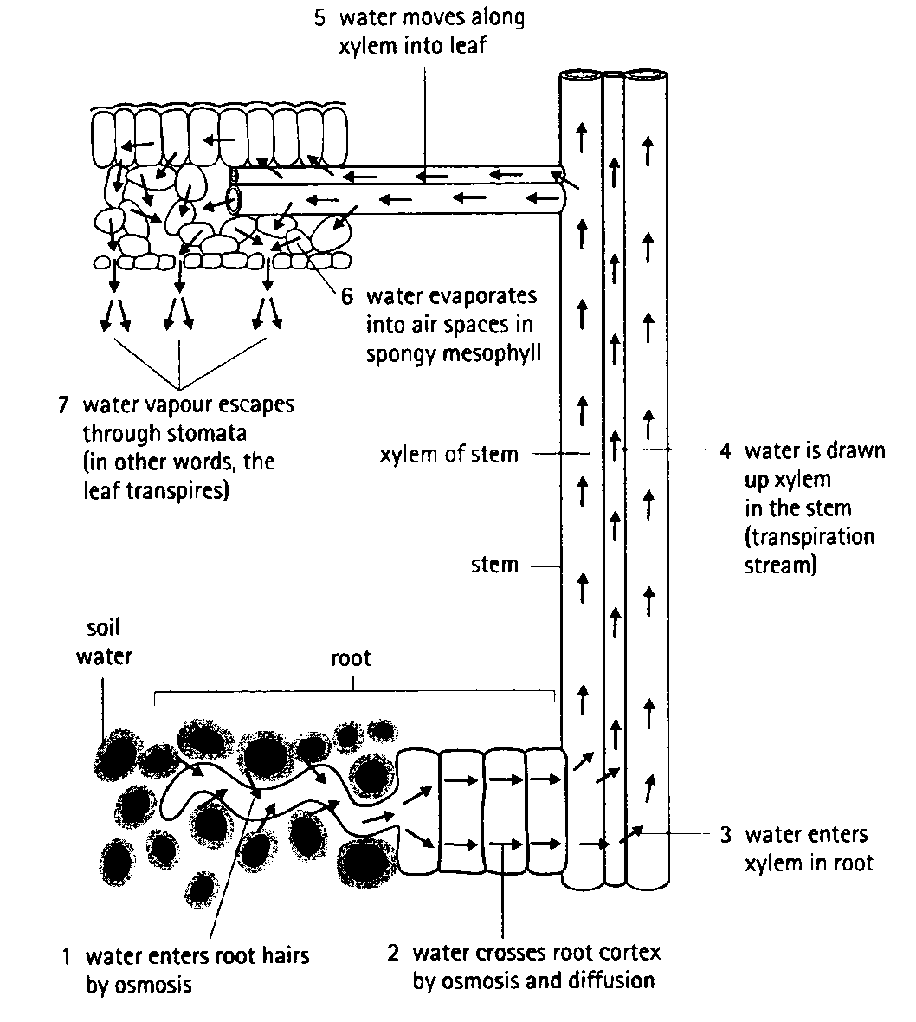

**Cohesion tension**  
Solar energy source;  
Evaporation of water from leaves through stomata  
Water potential gradient created across leaf / mesophyll cells;  
therefore water moves out of xylem (into surrounding tissues) by osmosis this creates a pull/tension on the water in xylem

Which is in a continuous column

Cohesion (or description) of water molecules maintains column;  
Due to H-bonding / polarity / charges of water molecules ;  
Column doesn’t break because of adhesion with xylem walls;

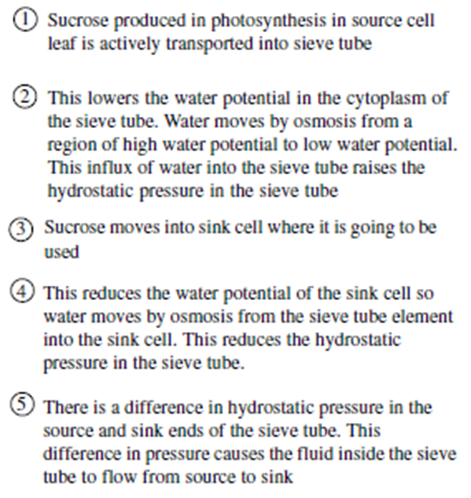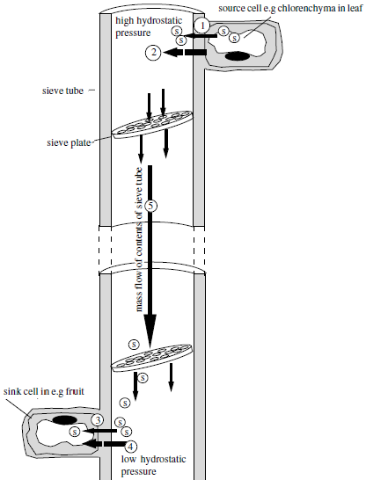Lignified walls keep xylem (vessels) open;  
capillarity due to narrow lumen of xylem (vessels);

**Some definitions**

**Locus:** Position of a gene on a strand of DNA.

**Genes**: are short sections of DNA that contain coded information as a specific sequence of bases. Genes code for polypeptides that determine the nature and development of organisms.

**Mutation:** A change in the base sequence of a gene

**Alleles:** alternative forms of a gene (created through mutations).

**Codon:** A sequence of three bases (called a triplet) that codes for a specific amino acid.

The base sequence of a gene determines the amino acid sequence in a polypeptide.

**Exons:** sequences of bases in a gene that code for the polypeptide

**Introns:** (In eukaryotes), sequences of bases in a gene that do not code for polypeptides.

Differences in base sequences of alleles of a single gene may result in non-functional proteins, including non-functional enzymes.

Non-overlapping: each base is part of only one codon

Degenerate genetic code: there are 20 amino acids and 64 codons, so most amino acids have more than one codon. There are 3 stop codons and 1 start codon.

In eukaryotes, DNA is linear, associated with proteins and large compared to the smaller, circular DNA in prokaryotic cells that also have no proteins associated with it.

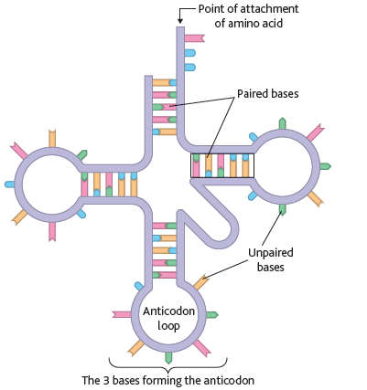

**Compare tRNA vs mRNA**

1. **tRNA**

Clover shaped

Standard length

Has an amino acid binding site

anticodon

tRNA has H bonds between complementary base pairs

Limited number of types (64)

1. **mRNA**

Linear

Variable length (depends on the length of gene)

Many different types (depends on the gene)

No H-bonding

No base pairs

# Compare DNA Vs RNA

**Similarities:**

Contain phosphate

Made up of nucleotides

Contains organic bases (A, C and G) (not T as it is replaced by U in RNA)

Pentose sugar

**Differences**

RNA single stranded

RNA has non-coding strands (introns) removed

Ribose sugar in RNA deoxyribose in DNA

U in riobose replaces the T

3 types of RNA, only one DNA

Smaller than DNA

**Compare the structures of RNA and DNA;**

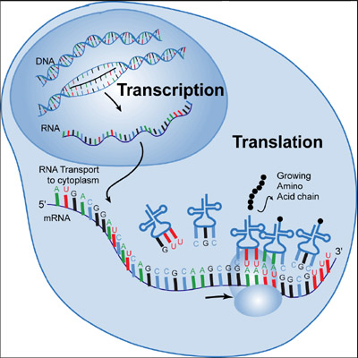Alike  
both have phosphate/phosphoric acid/PO4;  
bases/named bases/accept letters;  
nucleotides;  
pentose sugar;

Different  
DNA deoxyribose;  
DNA thymine;  
DNA double stranded;  
DNA larger/longer;  
DNA one form RNA 3 types;

**Describe translation and transcription**

Transcription

Section of DNA unwinds / uncoils;

DNA separates, h-bonds break  
RNA nucleotides align;  
complementary base pairing / example of pairing;

U replaces T  
mRNA polymerase (joins nucleotides);

mRNA is modified, introns are removed

Translation  
mRNA moves into cytoplasm / through nuclear pore / to ribosome;  
tRNA carries specific amino acid;  
mRNA read in codons / triplets;  
anticodon of tRNA matches codon of mRNA;  
ATP used in activation / joining amino acids;  
amino acids join by peptide bonds;  
tRNA used repeatedly;  
sequence of bases / codons determines sequence of amino acids;

**Describe what happens during translation.**

Codons on mRNA;  
anticodons on tRNA;  
20 types tRNA molecule  
specific amino acid attached to tRNA;  
peptide bonds formed

**Describe the role of tRNA in the process of translation.**

Anticodon complementary to codon/reads message on mRNA;

Specific amino acid;

Carried/transferred (to ribosome);

Correct sequence of amino acids along polypeptide;

**Comparison of replication and transcription**

**Similarities**

H bonds break and the DNA unzips

DNA acts as a template for complimentary base

Polymerase enzymes are involved

**Differences**

U replaces T in RNA

In replication all the DNA is copied, in transcription on sections are copied

Only one strand is used as a template in transcription (antisense strand), both strands are used in replication

RNA polymerase in transcription whereas DNA polymerase is sued in replication

mRNA is produced in transcription, DNA is produced in replication

**Meiosis**

**Explain the importance of meiosis in the life cycle of a sexually reproducing organism.**

Meiosis halves the number of chromosomes (formation of haploid gametes, eggs and sperm)  
Restoration of diploid number at fertilisation;  
Introduces variation;

**Describe what happens to chromosomes in meiosis.(6)**

1. Chromosomes condense;  
2. Chromosomes associate in homologous pairs (bivalents)  
3. Crossing-over (chiasma formation)  
4. Join to spindle (fibres) / moved by spindle ;(*)  
5. (Join via) centromere

6. (At) equator/middle of cell

7. Independent assortment”  
8. (Homologous) chromosomes move to opposite poles /  
 chromosomes separate/move apart; (*ALLOW* ‘are pulled apart’)  
9. (Pairs of) chromatids separated in 2nd division;   
  
**Describe how meiosis causes variation and explain the advantage of variation to the species.(5)**

1. Crossing-over;

2. Independent/random assortment/orientation/segregation of (homologous) chromosomes in meiosis I;  
3. Independent/random assortment/orientation/segregation of chromatids in meiosis II;

Advantages of variation, any **three** from:  
4. Different adaptations / some better adapted;  
5. Some survive / example described;  
6. To reproduce;  
7. Pass on gene/allele;  
8. Allows for changing environment/different environment/example described;

**Explain how crossing over can contribute to genetic variation.**

Sections of chromatids exchanged;  
sections have different alleles;  
new combinations of (linked) alleles;

**Give two processes, other than crossing over, which result in genetic variation. Explain how each process contributes to genetic variation.**

**Mutation**;  
different/new allele formed / genes deleted or duplicated/ sequence of genes  
changed *(reject genetic information)*;  
**random fusion of gametes** in fertilisation;  
new combination of alleles;  
**independent assortment** (of chromosomes) *(accept random)*;  
shuffling of maternal and paternal chromosomes/new combination  
of alleles;

**Explain the importance of genetic variation in the process of evolution.**

Causes variation in phenotype some organisms are better have more favourable characteristics for environment  
Natural selection of better adapted organisms survive and reproduce passing on genes  
selection is due to different phenotypes being better suited to different environments;  
eventually leads to species change/change in gene pool/change in gene frequencies

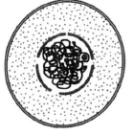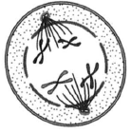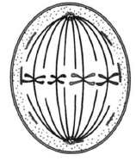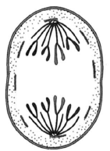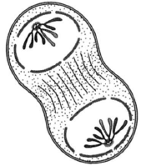

**Explain how natural selection produces changes within a species.**

variation between members of population/species;  
predation/disease/competition results in differential survival;  
some have adaptations that favour survival;  
survive to reproduce/have more offspring/ pass on their alleles/genes;  
produces changes in frequency of allele /gene pool/genotypes/phenotypes;

**Explain how resistance to an antibiotic could become widespread in a bacterial population following a gene mutation conferring resistance in just one bacterium.**

1. Frequent use of antibiotic creates selection pressure/ antibiotic kills bacteria;  
2. Bacteria with mutation/ resistance have (selective) advantage over others / described;  
3. (Survive to) reproduce more than other types;  
4. Pass on advantageous allele/ mutated allele in greater numbers;  
5. Frequency of (advantageous) allele increases in subsequent generations;

**Explain how selection can result in an insect population which is resistant to a particular insecticide.**

Insecticide resistance *already* in population;  
(resulting) from *mutation;*  
resistant insects are not killed (by insecticide)/survive;  
(And are able to) reproduce/breed;  
passing on the relevant *allele/gene* to the next generation/offspring;  
resulting in *increasing* frequency of resistance allele in population

**Describe how stabilising selection will affect the mean and standard deviation. Give the reason for your answer.**

Mean – no change;   
Standard deviation – decreases;  
Reason – selects against/removes (both) extremes/extremes die/better survival of middle nos.;

**Explain what is meant by stabilising selection and describe the circumstances under which it takes place.**

1. Occurs in an unchanging environment; 1  
2. (Initial range of values in which) mean is best adapted;  
3. Selection against extremes / selection for the mean;  
4. Mean/median/mode unaltered  
5. Range/S.D is reduced;  
6. Repeated over many generations;  
7. Increasing proportion of populations becomes well adapted to environment;

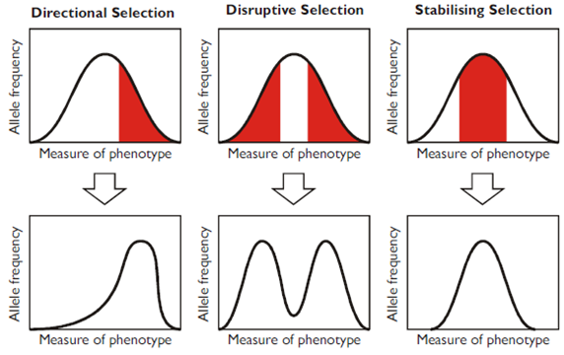**Classification/taxonomy**

Taxonomy: arranging organisms into groups based on similarities and differences.

The most common system of classification uses………………….

**8 groups** (taxonomic groups).

Domain, Kingdom, Phylum, Class, Order, Family, Genus, Species

(Remember this pneumonic: Dear, King, Philip, Came, Over, from, Germany, Swimming)

The groups are **organised into a hierarchy**

(As you move down the hierarchy there are more groups at each level, but fewer organisms in each group)

The smaller the group the more similarities between the organisms in that group

There is **no overlap between the groups**

The hierarchy ends with species

A species is a group of similar organisms able to reproduce and give fertile offspring.

**Each species is assigned a binomial name Genus and Species.**

**Q. Describe the principles on which the system of classification of living organisms is based. (4**)

Hierarchy of 8 taxonomic groups (DKPCOFGS);  
no overlap between groups;  
organisms placed in groups due to common structures / similar characteristics;  
reflecting evolutionary history (phylogeny) of organisms within a group;  
binominal nomenclature / example;  
definition of a species;

**Phylogenetics**

The study of the evolutionary history of groups of organisms, telling us who is related to whom and how close this relationship is compared to a common evolutionary ancestor.

It is closely related to classification because grouping needs to reflect evolutionary relationship

Members of one genus must be more closely related to each other than they are to organisms in a different genus.

**Q. How does a phylogenic system differ to a simple hierarchy?**

Hierarchical classification, large groups are divided into smaller groups

Process starts with species grouped into genus then grouped into family, order, class, phylum. As the groups get larger there is a more distant common ancestory

Initially this was based on shared easily observable characteristics

(phylogenetic) based on evolutionary history;  
shows ancestry of groups / points of divergence;  
members of a group have features in common; based on anatomy/fossils/embryology/DNA/specific aspect of cell biology or homologous structures, reflecting evolutionary history; phylogeny.

**Q. Explain the principles biologists use to classify organisms into groups compared to older models.**

Consider phylogeny

Look at evolutionary lineage/history

Find the point of divergence from a common ancestor

Consider, genetic, biochemical, embryology, homology of anatomy

Organisms are arranged in a hierarchy where large taxa (groups) are subdivided into smaller taxa

(D,K, P, C, O, F, G,S)

As groups get smaller the similarities between the species increase

Each species is given a binomial name using the genus and species

Older models of classification used observable features to group organisms

**Problems with classification**

Defining a species is difficult when, reproductive behaviour cannot be observed because….

They organisms are extinct

Reproduce asexually

Practical and ethical issues involved when trying to cross breed certain different species

**Genetic comparisons as a means of classification**

**Originally classification was limited to things we could observe (looks and behaviour (courtship as an example)), today we can use DNA and proteins.**

Species can be classified into the different taxonomic groups based on similarities/differences in their genes. This can be achieved by comparing their DNA and proteins (coded for by DNA). More closely related = more similar DNA and proteins.

**Comparing DNA**: 2 possible methods, DNA sequencing or DNA hybridisation

**DNA sequencing**

Directly compare DNA by looking at the order of bases (A, T, C and G). Closely related species will have a higher percentage of similarity

**DNA Hybridisation**

DNA from 2 species is collected, heated and separated into single strands (heating breaks H-bonds between the DNA bases)

The 2 separates species DNA is mixed and allowed to cool, this allows H-bonds to reform between complementary base pairs. The more similar the base sequences the more H-bonds that will form.

The similarity is measure by heating the hybrid strands and recording the temperature required to separate the strands. The higher the temperature required the more H-bonds that existed and the more closely related the DNA.

Comparing proteins can be done in 2 ways, comparing amino acid sequences, immunological comparisons.

**Comparing amino acids sequences**

Proteins are made up of amino acids. The sequence of amino acids is coded for by DNA. The closer the DNA sequences the more closely related the proteins.

**Immunological comparisons**

Uses antibody specificity to see how similar proteins are

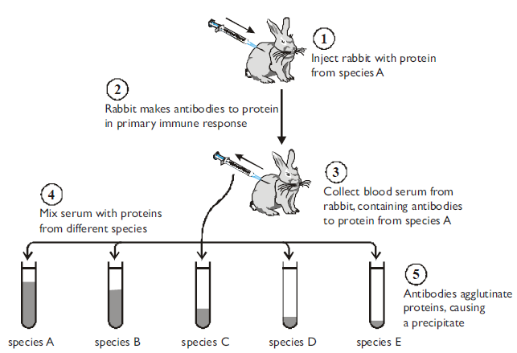

**Scientists studied two species of North American seahorse. They thought that these two species are closely related. Describe how comparisons of biological molecules in these two species could be used to find out if they are closely related.**

(Compare) DNA;

Sequence of bases/nucleotides;

DNA hybridisation;

Heat and Separate DNA strands / break hydrogen bonds;

Mix DNA/strands (of different species);

Measure Temperature/heat required to separate (hybrid) strands indicates relationship;

Higher temp more closely related

Compare same/named protein;

Sequence of amino acids /primary structure;

Immunological evidence – not a mark

Inject (seahorse) protein/serum into animal

(Obtain) antibodies/serum;

Add protein/serum/plasma from other (seahorse) species;

Amount of precipitate indicates relationship

**Biologists can also use protein structure to investigate the relationship between different species of crane. Explain why.**

1. More closely related (species) have more similarities in amino acid sequence/primary structure;

2. In same protein / named protein e.g. albumin;

3. Amino acid sequence is related to (DNA) base/triplet sequence;

***OR***

4. Similar species have a similar immune response to a protein/named protein;

5. More closely related (species) produce more ‘precipitate’ / antibody-antigen (complexes) / agglutination;

**Biodiversity**

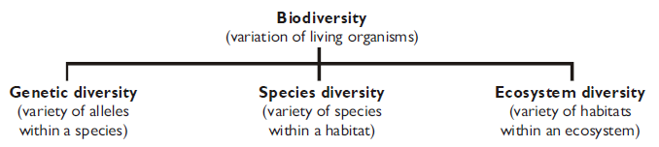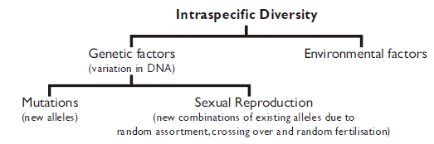

All the organisms living in a habitat are collectively called its community, and species diversity means the variety of species in a community. Species diversity is useful because it tell us about the complexity, quality and stability of an ecosystem.

The best measure of Species diversity considers the number of different species (species richness) and the abundance (number) of each species within a community.

The higher the species diversity of plants and trees, the more habitats, the more varied the food sources and the more food available which consequently means a higher diversity of insects and birds and animals.

We can calculate species diversity using the Simpson Index of Diversity

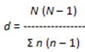**N = total number of all organisms**

**n = Total number of organisms in one species**

**∑ = sum of**

Agricultural practices (intensive farming) why things are done and the consequences of these processes

**Agriculture**

Selective breeding: done to select for certain favourable characteristics reduces genetic diversity.

Destruction of hedgerows: Makes large farms with large fields are cheaper and more efficient to run by easing the moving machinery and harvesting. Hedgerows provide habitats for at least 30 species of trees and shrubs, 65 species of nesting birds, 1500 species of insects and 600 species of wildflowers. These in turn provide food for small mammals. Hedgerows also act as wildlife corridors, allowing animals to move safely between woodlands.

Monoculture: increases the productivity by growing the best crops, which can be sowed and harvested quickly using dedicated machinery. This increases yield and reduces labour costs. It reduces genetic diversity and renders all crops in a region susceptible to disease. Reduces animal species diversity, because there are few niches.

Fertilisers: maintain soil fertility, but they can pollute surrounding groundwater causing eutrophication and killing aquatic animals.

Pesticides: are sprayed on crops to prevent attack by insects and other invertebrate animals, but many pesticides have a broad spectrum, killing a wide range of animals and so reducing diversity.

Herbicides: kill competing plants (“weeds”) that might reduce crop yield.

**Deforestation**

The Two main reasons humans clear forests are:

To use the land for agriculture, housing, mining or reservoirs

To use the timber for fuel, charcoal, paper or building materials.

Forests have a high biodiversity because a mature forest has many different species of plants in several layers; each adapted to their own conditions of light and nutrient availability. The different plants have different animals feeding on them and living in them; and the different primary consumers have different secondary consumers feeding on the. So forests contain complex food webs with high diversity.

By contrast, a field of crops has very low diversity with very few plants (often just the crop and a few weeds) and so few animals. Deforestation therefore reduces biodiversity.

As the diagram shows, forests have a deeper and more extensive root system, so binding the soil together.

Without this root system, soils can be eroded, leading to desertification (fertile land becomes desert). Forests also have a high productivity: i.e. there is a lot of plant material produced per square meter of land, and a lot of photosynthesis takes place. So deforestation reduces the rate at which carbon dioxide is removed from the atmosphere and so increases the greenhouse effect and global warming.

|  |  |  |
| --- | --- | --- |
| **Deforestation** | **benefits** | Wood and land for homes  Local areas developed by attracting business |
| **Risks** | Diversity reduced  Less carbon dioxide stored: leading to climate change  Possible sources of medicines (often found in rain forest) are lost  Natural beauty lost |
| **Agriculture** | **benefits** | More food can be produced  Food is cheaper to produce and so cheaper to buy  Attraction of local business |
| **Risks** | Diversity is reduced due to monoculture, loss hedgerows, use of herbicides and pesticide  Natural beauty lost |