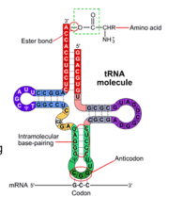[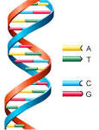](http://www.google.co.uk/url?url=http://www.astrochem.org/sci/Nucleobases.php&rct=j&frm=1&q=&esrc=s&sa=U&ved=0ahUKEwjryoCn6MXMAhWOF8AKHZRQA1UQwW4IMDAN&usg=AFQjCNGcFWM58JUqar7qvLYJIrR_h7Ramg)DNA VS RNA Revision Resource

Key Features similarities and differences

Key Features similarities and differences

Structural features

Structural features

Nucleotide features

Nucleotide features

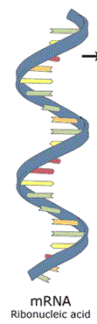[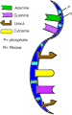](http://www.google.co.uk/url?url=http://uncyclopedia.wikia.com/wiki/RNA&rct=j&frm=1&q=&esrc=s&sa=U&ved=0ahUKEwi3p-G56MXMAhVLLcAKHX3CAQwQwW4IJDAH&usg=AFQjCNEjvxqxRARjWOTSQ7GF2S2iK1CXGA)DNA RNA tRNA mRNA