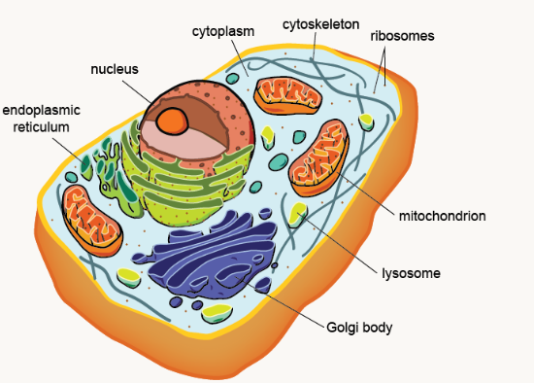Revision Resource cell structure Eukaryotic, Prokaryotic and Viruses

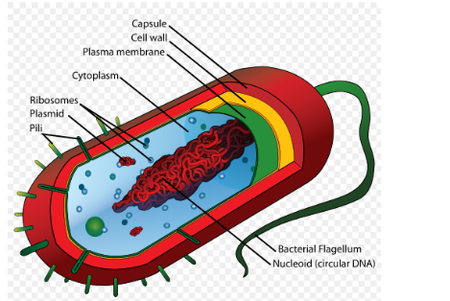[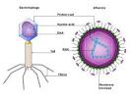](http://www.google.co.uk/url?url=http://www.bbc.co.uk/bitesize/higher/biology/cell_biology/viruses/revision/1/&rct=j&frm=1&q=&esrc=s&sa=U&ved=0ahUKEwjEkuW-48XMAhXqKMAKHU1aC5A4FBDBbggcMAM&usg=AFQjCNHPKpu0p9165vnsUg_PkAd6PIUp9g)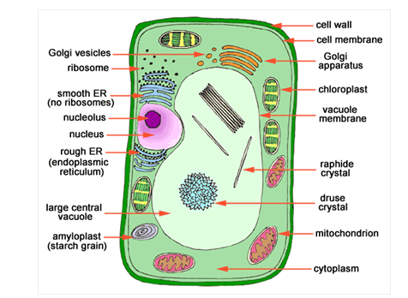Eukaryotic cells-animal Plant cell Prokaryote Virus

Features of a virus including replication

Features of a prokaryotic cell including replication

Features of a plant cell including replication

Features of an animal cell including replication