**Extra questions Nucleotides, DNA replication**

**Q1.**          The diagram shows one nucleotide pair of a DNA molecule.

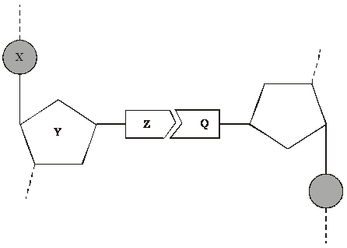

(a)     Name the parts of the nucleotide labelled **X**, **Y** and **Z**.

**X** .....................................................

**Y** .....................................................

**Z** .....................................................

**(3)**

(b)     What type of bond holds **Z** and **Q** together?

......................................................................................................................

**(1)**

(c)     A sample of DNA was analysed. 28% of the nucleotides contained thymine. Calculate the percentage of nucleotides which contained cytosine. Show your working.

Answer ....................................... %

**(2)**

**(Total 6 marks)**

**Q2.**          The diagram shows a short section of a DNA molecule.

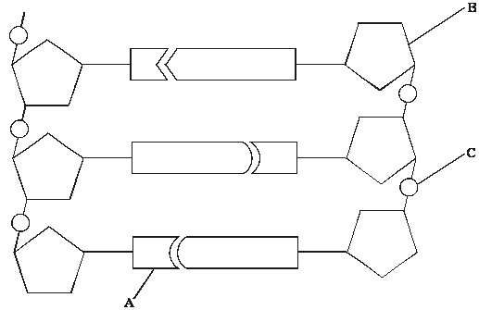

(a)     On the diagram draw a box round **one** nucleotide.

**(1)**

(b)     Use the letters in the diagram to indicate a part of the molecule which

(i)      is **not** a base and is different in an RNA molecule;

.............................................................................................................

(ii)     contains nitrogen.

.............................................................................................................

**(2)**

(c)     (i)      The sequence of bases on one strand of DNA is important for protein synthesis. What is its role?

.............................................................................................................

.............................................................................................................

**(1)**

(ii)     How are the two strands of the DNA molecule held together?

.............................................................................................................

**(1)**

(iii)     Give **one** advantage of DNA molecules having two strands.

.............................................................................................................

.............................................................................................................

**(1)**

**(Total 6 marks)**

**Q3.**          (a)     Describe and explain how the structure of DNA results in accurate replication.

......................................................................................................................

......................................................................................................................

......................................................................................................................

......................................................................................................................

......................................................................................................................

......................................................................................................................

......................................................................................................................

......................................................................................................................

**(4)**

(b)     Describe the behaviour of chromosomes during mitosis and explain how this results in the production of two genetically identical cells.

......................................................................................................................

......................................................................................................................

......................................................................................................................

......................................................................................................................

......................................................................................................................

......................................................................................................................

......................................................................................................................

......................................................................................................................

......................................................................................................................

......................................................................................................................

......................................................................................................................

......................................................................................................................

......................................................................................................................

......................................................................................................................

......................................................................................................................

**(7)**

(c)     A cancerous tumour is formed by uncontrolled mitotic division. This results in a mass of cells with an inadequate blood supply. Drugs are being developed which only kill cells in a low oxygen environment. Suggest how these drugs could be useful in the treatment of cancer.

......................................................................................................................

......................................................................................................................

......................................................................................................................

......................................................................................................................

**(2)**

**(Total 13 marks)**

**Q4.**          (a)     Explain why the replication of DNA is described as semi-conservative.

......................................................................................................................

......................................................................................................................

......................................................................................................................

......................................................................................................................

**(2)**

(b)     Bacteria require a source of nitrogen to make the bases needed for DNA replication. In an investigation of DNA replication some bacteria were grown for many cell divisions in a medium containing 14N, a light form of nitrogen. Others were grown in a medium containing 15N, a heavy form of nitrogen. Some of the bacteria grown in a 15N medium were then transferred to a 14N medium and left to divide once.

DNA was isolated from the bacteria and centrifuged.

The DNA samples formed bands at different levels, as shown in the diagram.

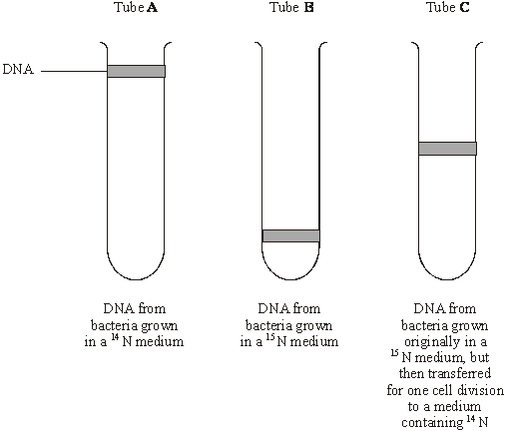

(i)      What do tubes **A** and **B** show about the density of the DNA formed using the two different forms of nitrogen?

.............................................................................................................

.............................................................................................................

**(1)**

(ii)     Explain the position of the band in tube **C**.

.............................................................................................................

.............................................................................................................

.............................................................................................................

.............................................................................................................

**(2)**

(c)     In a further investigation, the DNA of the bacterium was isolated and separated into single strands. The percentage of each nitrogenous base in each strand was found. The table shows some of the results.

|  |  |  |  |  |
| --- | --- | --- | --- | --- |
|  | **Percentage of base present** | | | |
| **DNA sample** | Adenine | Cytosine | Guanine | Thymine |
| Strand 1 | 26 |  | 28 | 14 |
| Strand 2 | 14 |  |  |  |

Use your knowledge of base pairing to complete the table.

**(2)**

**(Total 7 marks)**

**Q5.**(a)     The diagram shows a stage of mitosis in an animal cell.

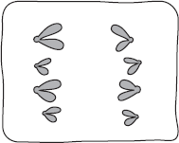

(i)      Name this stage.

...............................................................................................................

**(1)**

(ii)     Describe what happens during this stage that results in the production of two genetically identical cells.

...............................................................................................................

...............................................................................................................

...............................................................................................................

...............................................................................................................

...............................................................................................................

**(2)**

(b)     A sample of epithelial tissue from the small intestine of an animal was analysed.  
Some of the cells had 8.4 units of DNA, others had only 4.2 units.

(i)      Use your knowledge of the cell cycle to explain why some cells had 8.4 units of DNA and others had only 4.2 units.

...............................................................................................................

...............................................................................................................

...............................................................................................................

...............................................................................................................

...............................................................................................................

**(2)**

(ii)     How many units of DNA would you expect to be present in a gamete formed in this animal as a result of meiosis?



**(1)**

**(Total 6 marks)**

**Q6.**(a)    Describe how DNA is replicated.

**(6)**

(b)     The graph shows information about the movement of chromatids in a cell that has just started metaphase of mitosis.

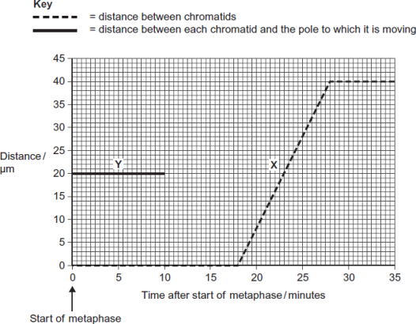

(i)      What was the duration of metaphase in this cell?

  minutes

**(1)**

(ii)     Use line **X** to calculate the duration of anaphase in this cell.

  minutes

**(1)**

(iii)    Complete line **Y** on the graph.

**(2)**

(c)     A doctor investigated the number of cells in different stages of the cell cycle in two tissue samples, **C** and **D.** One tissue sample was taken from a cancerous tumour. The other was taken from non-cancerous tissue. The table shows his results.

|  |  |  |  |
| --- | --- | --- | --- |
|  |  | **Percentage of cells in each stage of the cell cycle** | |
|  | **Stage of the cell cycle** | Tissue sample **C** | Tissue sample **D** |
|  | Interphase | 82 | 45 |
|  | Prophase | 4 | 16 |
|  | Metaphase | 5 | 18 |
|  | Anaphase | 5 | 12 |
|  | Telophase | 4 | 9 |

(i)      In tissue sample **C**, one cell cycle took 24 hours. Use the data in the table to calculate the time in which these cells were in interphase during one cell cycle. Show your working.

Time cells in interphase ...................................... hours

**(2)**

(ii)     Explain how the doctor could have recognised which cells were in interphase when looking at the tissue samples.

...............................................................................................................

...............................................................................................................

...............................................................................................................

**(1)**

(iii)    Which tissue sample, **C** or **D**, was taken from a cancerous tumour?   
Use information in the table to explain your answer.

...............................................................................................................

...............................................................................................................

...............................................................................................................

...............................................................................................................

...............................................................................................................

**(2)**

**(Total 15 marks)**

**M1.**          (a)**X**, phosphate;  
**Y**, deoxyribose / pentose / 5-carbon sugar;  
**Z**, (nitrogenous) base;

*(accept named base)*

**3**

(b)     (specific) hydrogen (bonds);

**1**

(c)     thymine 28% so adenine 28%  
therefore 44% cytosine and guanine;  
therefore 22% cytosine;

*(idea of equal amounts T and A, C and G – 1 mark, correct answer 2 marks)*

**2**

**[6]**

**M2.**          (a)     appropriately placed box;

**1**

(b)     (i)      B;

(ii)     A;

**2**

(c)     (i)      determines (sequence of) amino acids / specific protein  
produced / mRNA formation;

**1**

(ii)     hydrogen bonds;

**1**

(iii)     stability / protects bases / replication;

**1**

**[6]**

**M3.**          (a)     1       two strands therefore semi-conservative replication (possible);

2       base pairing / hydrogen bonds holds strands together

3       hydrogen bonds weak / easily broken, allow strands to separate;

4       bases (sequence) (exposed so) act as template / can be copied;

5       A with T, C with G / complementary copy;

6       DNA one parent and one new strand;

**4 max**

(b)     1       chromosomes shorten / thicken / supercoiling;

2       chromosomes (each) two identical chromatids / strands / copies   
(due to replication);

3       chromosomes / chromatids move to equator / middle of the spindle / cell;

4       attach to individual spindle fibres;

5       spindle fibres contract / centromeres divide / repel;

6       (sister) chromatids / chromosomes (separate)   
move to opposite poles / ends of the spindle;

7       each pole / end receives all genetic information /   
identical copies of each chromosome;

8       nuclear envelope forms around each group of chromosomes /   
chromatids / at each pole;

**7 max**

(c)     cancer cells killed, normal body cells survive;

cancer cells low oxygen (as blood supply cannot satisfy demand);

**2**

**[13]**

**M4.**          (a)     each strand copied / acts as a template;  
(daughter) DNA one new strand and one original / parent strand;

**2**

(b)     (i)      15N / tube **B** (DNA), more / greater density;

*(reject heavier)*

**1**

(ii)     DNA with one heavy and one light strand;  
new / synthesised strand, made with 14N / light strand;

**2**

(c)     32;  
28 32 26;

**2**

**[7]**

**M5.**(a)     (i)      Anaphase

**1**

(ii)     1.      Sister / identical chromatids / identical chromosomes;

*Reject: Homologous chromosomes separate.*

*Allow any reference to chromatids / chromosomes being identical e.g. same DNA*

2.      To (opposite) poles / ends / sides;

**2**

(b)     (i)      1.      8.4 / cells with twice DNA content = replicated DNA / late interphase / prophase / metaphase / anaphase;

*Any reference to interphase must suggest towards end of interphase.*

*'Chromosomes replicate' is not enough for DNA replicates.*

2.      4.2 = DNA not replicated / (early) interphase / telophase / cell just divided / finished mitosis;

**2**

(ii)     2.1;

**1**

**[6]**

**M6.**(a)     1.      Strands separate / H-bonds break;

*1.* ***Q*** *Neutral: strands split*

*1. Accept: strands unzip*

2.      DNA helicase (involved);

3.      Both strands / each strand act(s) as (a) template(s);

4.      (Free) nucleotides attach;

*4. Neutral: bases attach*

*4. Accept: nucleotides attracted*

5.      Complementary / specific base pairing / AT and GC;

6.      DNA polymerase joins nucleotides (on new strand);

*6. Reject: if wrong function of DNA polymerase*

7.      H-bonds reform;

8.      Semi-conservative replication / new DNA molecules contain one old strand and one new strand;

*8. Reject: if wrong context e.g. new DNA molecules contain half of each original strand*

**6 max**

(b)     (i)      18;

*Do not accept 17.5*

**1**

(ii)     10;

**1**

(iii)    1.      Horizontal until 18 minutes;

*Allow + / - one small box*

2.      (Then) decreases as straight line to 0 μm at 28 minutes;

*2. Allow lines that start from the wrong place, ending at 0 at 28 minutes*

**2**

(c)     (i)      Two marks for correct answer of 19.68 or 19.7;;

*Accept 19hrs 41mins*

One mark for incorrect answers in which candidate clearly multiplies by 0.82;

*Allow one mark for incorrect answers that clearly show 82% of 24 (hours)*

**2**

(ii)     1.      No visible chromosomes / chromatids / visible nucleus;

**1**

(iii)    **D** (no mark)

1.      Lower % (of cells) in interphase / higher % (of cells) in mitosis / named stage of mitosis;

*1. Accept: ‘less’ or ‘more’ instead of ‘%’*

*1. Do not accept: higher % (of cells) in each / all stage(s)*

2.      (So) more cells dividing / cells are dividing quicker;

*2. Accept: uncontrolled cell division*

*2. Do not award if Tissue* ***C*** *is chosen*

**2**

**[15]**